Author: Jasper Zult, 5IVA
Supervisor: Y.E. Dietzenbacher
School year: 2025-2026
School: Heerbeeck College
publication: GitHub – https://github.com/jasper576/dual-axis-solar-tracker
Energy advantages of a solar tracker in Dutch climate
Profile Research Project – Nature & Technology
Inhoud
1 Introduction 4
2 Research question 4
3 GitHub link 4
4 Literary research 4
4.1 What is a Solar panel 4
4.1.1 What factors influence the energy yield of solar panels. 5
4.1.2 How do solar tracking systems work? 6
4.1.3 What types of solar tracking systems are there? 6
4.2 What are the advantages and disadvantages of a solar tracking system compared to fixed panels? 6
4.2.1 Why are there (still) few solar tracking systems in the Netherlands? 7
4.3 How can a solar tracking system with vertical and horizontal rotation be designed and controlled? 7
4.3.1 Mechanical design 7
4.3.2 Sensors and measurements 7
4.3.3 Electronics and connections used 7
4.3.4 Control algorithm 8
4.4 What materials are needed for the solar tracking system? 8
4.4.1 Electronic parts 8
4.4.2 Mechanical parts 8
4.5 What is the optimal fixed angle and direction for solar panels in Best, Noord Brabant? 8
4.5.1. fixed angle 8
4.5.2 Fixes direction 10
Conclusion 10
4.6 Circuit 11
4.6.1 Witch resistors will be used for the LDR’s to measure the output with a voltage divider? 11
4.6.2 How will the LDRs be connected to the Arduino. 12
4.6.3 What is a voltage divider (figure 1)? 12
4.6.4 How will the output of a solar panel be read (figure 2)? 12
4.6.5 How will the servos be connected to the Arduino? 12
4.6.6 How will the mini oled display be connected to Arduino (figure 3)? 12
4.6.7 How will the 2 buttons be connected to the Arduino (figure 4)? 13
4.6.8 the circuit diagram (figure 5) 13
5 Testing the circuit + parts 14
5.1 Testing the LDRs 14
5.2 Testing the INA219 with the solar panel 14
5.3 Testing the servo’s 15
5.4 Testing the mini oled display 15
5.5 Testing the 2 buttons 16
5.6 problem INA219: 16
5.7 The updated circuit (figure 6): 17
6 Prototype 1(figure 7) 18
6.1 Code prototype 1 18
6.2 Testing prototype 1 18
7 PCB (figure 8) 19
8 Making prototype 2 19
8.1 Problems design prototype 2 19
8.1.1 Updated circuit diagram (figure 9) 20
8.1.2 Updated PCB 20
8.2 Code prototype 2 21
8.3 Final prototype 2 (figure 11) 21
8.4 Manual of prototype 2 21
8.4.1 system overview 21
8.4.2 navigating the screen 21
9 Monitor Software 22
9.1 Manual of the monitor software 22
9.1.1 connecting the solar tracker. 22
9.1.2 starting measurements 22
9.1.3 collecting data 22
10 Experiment 23
10.1 purpose of the experiment 23
10.2 research question and hypothesis 23
10.2.1 Research question 23
10.2.2 Hypothesis 23
10.3 experimental setup 23
10.3.1 Solar panel setup 23
10.3.2 measuring equipment 23
10.4 Data 24
10.4.1 Dual axis solar tracker 24
10.4.2 Single axis solar Tracker 25
10.4.3 Stationary 26
10.5 Data analysis 27
10.5.1 Summary 27
10.5.2 Results 27
10.5.3 Sub conclusion (practical part) 27
11 Conclusion 27
12 Discussion 28
13 References 29

1 Introduction
This PWS focuses on the question whether a solar tracking system can produce more energy than a fixed solar panel in the Netherlands. Solar trackers are designed to follow the sun, which would increase the energy output of the solar panel. In countries with a lot of direct sunlight, this often leads to a significant improvement in energy output. In the Netherlands however, the weather is cloudy for much of the year, which makes it uncertain whether a tracking system offers a real advantage compared to a stationary solar panel.
To investigate this, a complete dual-axis solar tracker is designed on scale and built as part of this project. The system includes a mechanical structure that can rotate in two directions (dual axis), electronics to control the movement, sensors to measure the light and the energy output, and software that can monitor the output of the solar panel.
The experiment compares three setups: a fixed solar panel, a single-axis tracker, and a dual-axis tracker. All systems are tested in around the same environment so that the differences in energy output can be measured. The goal of this research is to find out whether the extra energy yield outweighs the complexity, cost, and the moving parts of a tracking system in the Dutch climate.
This project combines technical designs, constructions, and experimental testing to find a clear answer about the usefulness of a solar tracking system in the Netherlands.
2 Research question
Does a solar tracking system provide a significant energy advantage over a fixed solar panel in the Netherlands?
3 GitHub link
All files used for this project can be viewed using this link:
https://github.com/jasper576/dual-axis-solar-tracker
4 Literary research

4.1 What is a Solar panel
A photovoltaic (pv) cell, mostly called a solar panel is a device that converts light energy into electric energy. Sunlight contains photons that have a varying amount of energy determined by their wavelength. A pv is made of a semiconducting material. When a photon hits a pv cell it either reflects, pass through or gets absorb by the semiconducting material. Only the photons that are absorbed provide energy that creates electric energy. When a photon hits an atom of a semi conducting material, an electron dislodges. The movement of these electrons which carry negative charger to the front of the PV cell, this creates an imbalance and so creates a voltage potential similar like the positive and negative terminal of a battery. When this is connected to a load via an electrical circuit, electricity will flow. (Photovoltaics and Electricity - U.S. Energy Information Administration (EIA), n.d.)
4.1.1 What factors influence the energy yield of solar panels.
There are a lot of factors that influence the energy yield of a solar panel that are listed below:
factor 1: angle of the solar panel.
The angle of the solar panel relative to the sun can drastically increase or decrease the power output of the panel. To get the maximum energy out of the solar panel it needs to be placed perpendicular to the sun.
Factor 2: shade.
if there is any shade on the solar panel the energy yield will be reduced, this is because less photons hit the solar panel resulting in less energy. That’s why it is necessary to avoid shades at all costs.
factor 3: reduction in power and yield.
the power output of every solar panel decreases a little each year. Usually this is a 10% reduction over 10 years and a 15% reduction over 25 years.

4.1.2 How do solar tracking systems work?
Solar trackers are support structures that allow a solar panel to follow the path of the sun and so absorb more energy. They can increase the efficiency of a panel from 10% to 45% depending on the type of tracker. Most of the time these solar trackers are seen on large solar projects, because of the cost, it is also far easier to install trackers on the ground than on rooftops. Most of the time solar trackers use LDR’s a light depended resister to find the optimal angle and direction for the solar panel. (Kuchta, 2021)

4.1.3 What types of solar tracking systems are there?
Trackers can follow the sun in 2 ways. A single axis tracker only follows the sun on an east-west axis, these are designed to increase the solar absorption by 25% to 35%. Dual axis trackers rotate on a north-south axis as well so it has 360-degree coverage, this can produce up to 45% more electricity.
How to tracker follows the sun depends on the model and price
- Manual, the lower cost trackers need to be shifted manually

- Liquid tilt system, this is the midrange, they use liquid that heats up and cools down to tilt the solar panel in the right direction

- An active tracker, they use motors to tilt the solar panel automatically for the best sun coverage. Most of these systems use the energy that is produced by the solar panel to tilt the panel itself. They might also use censors, GPS and software to maximise the panel’s efficiency (Kuchta, 2021)

4.2 What are the advantages and disadvantages of a solar tracking system compared to fixed panels?
Solar panels are not cheap, so the benefits need to outweigh their cost. Depending on the size of the system and whether it is a dual-axis solar tracker can add from $500 to a $1000 per panel to the entire system cost. A dual axis solar tracker can double the cost of an entire project. The increase of the may not be worth the increased cost. (Kuchta, 2021)
Many factors come into play whether a solar trackers system is profitable, when installing a tracking system, you of course don’t need as much solar panels as when you don’t have the system. For now, let’s focus on solar panels that are located at solar parks.
Table 1 comparison single axis/ dual axis and fixed solar panel
Single axis |  | Dual axis |  | Fixed
Advantages | Disadvantages | Advantages | Disadvantages | advantages | Disadvantages
More reliable | Less energy | Maximise power | More prone to malfunction | Almost no malfunctions | More surface area needed
Longer lasting | More surface area needed | Manage grid power limitations | Shorter lifespan | Lower installation costs | Less energy output
Lower complexity |  | Less area to produce the same energy | Higher maintenance costs | Higher lifespan
Fewer maintenance

Choosing between single axis dual axis and fixed comes down to balancing reliability and output against complexity and costs. Most of the time the single axis may provide the optimal trade-off, more generation and lower costs. However, if you want maximum solar output the dual axis system is needed.

4.2.1 Why are there (still) few solar tracking systems in the Netherlands?
This mostly has to do with the investment costs of these kinds of trackers, as already stated sometimes double these costs. Because the Netherlands isn’t optimal for solar panels it isn’t necessary to install tracker systems to get the extra few precent.
According to the international Energy Agency (IAE), the Netherlands is one of the most severely affected by grid congestion. The rapid growth of the solar energy has created large power peaks on sunny days with the electricity grid can’t absorb, which means that additional high output systems such as a solar tracking system could worsen the problem, therefore energy companies focus on rooftop solar panels and other renewable sources instead of investing in tracking systems. (Grid Congestion Is Posing Challenges for Energy Security and Transitions – Analysis - IEA, 2025)
In the Netherlands, weather conditions are mostly cloudy, which means that a large part of the incoming sunlight is diffuse rather than direct. Under these conditions solar tracking becomes less effective, because a solar tracker system mainly increases energy yield by following the direct beam of sunlight. When clouds scatter the sunlight, the advantages of orienting the panel to thus sun becomes irrelevant, making fixed solar panels more cost-effective in the Dutch climate. (Forecast of Solar Radiation in the Netherlands, n.d.)

4.3 How can a solar tracking system with vertical and horizontal rotation be designed and controlled?

4.3.1 Mechanical design
The solar tracking system is built as a dual axis structure so that a dual axis, single axis and fixed solar panel can be tested.
- Horizontal rotation (azimuth) is controlled by 1 servo that moves the entire top platform from left to right
- Vertical rotation (tilt) is controlled by a second servo that tilts the solar panel up and down.
The first prototype is going to be from the internet to test if everything works accordingly. Later prototypes are going to be designed using FreeCAD.

4.3.2 Sensors and measurements
The system is going to use four LDRs, later it will be discussed which LDR to use. The LDRs will help to detect the direction of the strongest light.
the system is also going to use a sensor to measure the voltage and current from the solar panel.
A display is going to be used for quick problem solving and to show values of the measurements.

4.3.3 Electronics and connections used
- LDRs
- Sensor for current and voltage measurement
- Servos
- Display
- Buttons to navigate the display

4.3.4 Control algorithm
- Reads the LDR values
- Compares the pairs
- If left LDR is brighter than right -> rotate azimuth servo to the left
- If top LDR is brighter than bottom -> tilt servo upwards
- Repeats in small steps
- Reads the voltage and current sensor
- Puts it on the display
- Uses 2 buttons for navigation

4.4 What materials are needed for the solar tracking system?

4.4.1 Electronic parts
- Microcontroller: Arduino mega
- Solar panel: mini 70x70mm epoxy solar panel
- Light Sensor: LDRs
- Resistors: 4 for the LDR, 1 for the solar panel
- Current and Voltage sensor
- Servos: SG90 2x
- Display: 0,96” I²C SSD1306 OLED display
- Buttons: 2x push buttons
- Power supply for servos: 3x 1,5v AA battery
- Cables and connections: Jumper wires, pin headers, etc.
- PCB: custom PCB designed with KiCad
- Breadboard

4.4.2 Mechanical parts
- 3d printed structure
- Shafts and fixings

4.5 What is the optimal fixed angle and direction for solar panels in Best, Noord Brabant?

4.5.1. fixed angle
Every formula used for this calculation comes from the book: Solar Engineering of Thermal Processes
According to (Latitude and Longitude Finder on Map Get Coordinates, n.d.) the latitude of Best $≈51,5°$
The formula to calculate the sun declination is $δ=23.45°\sin\left(\frac{360}{365}\left(284+n\right)\right)$ according to (Pvlib.Solarposition.Declination_Cooper69 — Pvlib Python 0.15.1.dev11+gcdf3a7b6b Documentation, n.d.)
$n=day of the year$
$δ=sun$ declination (angle of the sun relative to the equator)
The $23.45°$is the angle of the earth
We will use these values for n to calculate the optimum angle for the solar panel in Best see table 1.

Table 2 Nummer day in the year

Nummer day in the year
21 Jan | n= 21
21 Feb | n= 52
21 Mrt | n = 80
21 Apr | n= 111
21 may | n= 141
21 Jun | n= 172
21 Jul | n= 202
21 Aug | n= 233
21 Sep | n= 266
21 Oct | n= 296
21 Nov | n= 326
21 Dec | n= 355

You want the sun's rays to fall as perpendicularly as possible on the panel.
So, you get this formula: $α=90°-ϕ+δ$
$α=sunhight$
$ϕ=latitude$

We will also use this formula $β=90°-α$
Because the solar panel needs to be perpendicular to the angle of the sun

$β=angle of the solar panal$
If we combine all these formula’s we get the formula:
$β= ϕ-23.45\sin\left(\frac{360}{365 }(284+n)\right)$
$ϕ=51.5°$
All calculations will be listed in table 2
Example calculation:
$β= 51.5-23.45\sin\left(\frac{360}{365 }\left(284+21\right)\right)=71.6°$

Table 3 Degrees of the sun per month

Degrees of the sun per month
n (days) | Month | $β$(degrees)
21 | $$β_{1}(Jan)$$ | 71.6
52 | $$β_{2}(Feb)$$ | 62.7
80 | $$β_{3}(Mar)$$ | 51.9
111 | $$β_{4}(Apr)$$ | 39.9
141 | $$β_{5}(May)$$ | 31.4
172 | $$β_{6}(Jun)$$ | 28.1
202 | $$β_{7}(Jul)$$ | 31.1
233 | $$β_{8}(Aug)$$ | 39.7
266 | $$β_{9}(Sep)$$ | 52.5
296 | $$β_{10}(Oct)$$ | 63.9
326 | $$β_{11}(Nov)$$ | 72.1
355 | $$β_{12}(Dec)$$ | 74.9

to calculate the best stationary angle, we need to get an average of these values. However, for example June has more sun ours than January, so we need to take this into consideration.
according to (KNMI - Maandsommen Zonneschijnduur, Normalen, Anomalieën, n.d.) this are the everage amount of sun ours in Best, the Netherlands. See table 3
Table 4 Total sun ours per month

Total sun ours per month
Month | Sun Ours in Best
$$H_{1}(Jan)$$ | 69,0
$$H_{2}(Feb)$$ | 87,9
$$H_{3}(Mar)$$ | 139,8
$$H_{4}(Apr)$$ | 186,4
$$H_{5}(May)$$ | 214.4
$$H_{6}(Jun)$$ | 209.0
$$H_{7}(Jul)$$ | 213.2
$$H_{8}(Aug)$$ | 199.1
$$H_{9}(Sep)$$ | 161.0
$$H_{10}(Oct)$$ | 122.4
$$H_{11}(Nov)$$ | 73.4
$$H_{12}(Dec)$$ | 56.5

We can calculate the average angle with this equation:
$β_{year }=\frac{\sum_{i=1}^{12}{\left(β_{i}∙H_{i}\right)}}{\sum_{i=1}^{12}{\left(H_{i}\right)}}=45.1°$
So, the stationary solar panel should be placed on an angle of $45.1°$

4.5.2 Fixes direction
For a fixed solar panel in Best, the sun rises in the east, reaches its highest in the south, and sets in the west. Over the year the path is almost symmetric around the south, so any rotation of the panel towards the east improves the morning yield but decreases the evening yield and vice versa. Since the sun is the most powerful at his highest point, the solar panel needs to be placed at $γ_{opt}=180°$(south) (ZonnepanelenWijzer.com, 2024)

Conclusion
The optimal angle for the solar panel $β_{year }=45.1°$ and the optimal direction for the solar panel is $γ_{opt}=180°$(south)

4.6 Circuit

4.6.1 Witch resistors will be used for the LDR’s to measure the output with a voltage divider?
To calculate the resistance, the operating variation of the LDR needs to be determent. In this experiment a GL5516 – LDR will be used.
According to (GL55 Series CdS Photoresistor, n.d.) a GL5516 has a $ϒ$ of $0.5$ and a light resistance at 10 lux:$5-10 kΩ .$ Gamma ($ϒ$) is a measure of how much the resistance of an LDR changes with increasing light intensity. It indicates how sensitive the LDR is to changes in light. A light resistance at 100 lux is also needed. The formula to do this is given in the source; $ϒ= 0.5$and $R_{10 avg}≈7.5 kΩ$
$ϒ= \log\left(\frac{R_{10}}{R_{100}}\right)→0.5 = \log\left(\frac{8}{R_{100}}\right)→R_{100}=\frac{7.5}{{10}^{0.5}}≈2.4 kΩ$
LDRs respond logarithmically to light. With all this information we can make the formula: $R\left(lux\right)=A⋅{lux}^{-ϒ}→ A= \frac{R}{{lux}^{-ϒ}}→A= \frac{7.5}{{10}^{-0.5}} ≈23.7$
So $R\left(lux\right)=23.7⋅{lux}^{-0.5}$
Next, we need to know the lux output of the lamp used. The lamp has max output of$800lm$(Tweakers, n.d.). And a surface area of $0.0049m^{2}$ (7cm by 7cm)
With this we can calculate the max lux output (Lumens to Lux (Lx) Conversion Calculator, n.d.). ${lux}_{max}=163265lx$However, 100% of the light energy will never be concentrated on the solar panel.
The inverse- square law (Wikipedia contributors, 2025) states that light intensity decreases with the square of the distance from the source, so at twice the distance, the light intensity becomes four times weaker. This can be described as: $intensity ∝ \frac{1}{{distance}^{2}}$ or mathematically as: $\frac{E(d_{2})}{E(d_{1})}={\left(\frac{d_{1}}{d_{2}}\right)}^{2}→E\left(d_{2}\right)=E\left(d_{1}\right){\left(\frac{d_{1}}{d_{2}}\right)}^{2}$
For this formula we will need a starting distance for this study, we assume that $0.5cm→163265lx$
We will need to calculate the lux for the closes distance where we will be measuring from and the furthest distance, for this study that will be $10cm$ and $40cm$
$$E\left(10cm\right)=163265{\left(\frac{0.005}{0.1}\right)}^{2}≈408lx$$
$$E\left(40cm\right)=163265{\left(\frac{0.005}{0.4}\right)}^{2}≈25lx$$
With this we can calculate the resistance of the ldr at 10cm and 40cm from the light source
$$R_{10cm}\left(408\right)=23.7⋅{408}^{-0.5}≈1.17 kΩ$$
$$R_{40cm}\left(25\right)=23.7⋅{25}^{-0.5}≈4.74 kΩ$$
So, this is the working area of the ldr’s in this experiment. A resistor that is between these 2 measurements needs to be chosen to get a nice measurable voltage change. For this experiment a $3.3kΩ$ resistor will be used.

4.6.2 How will the LDRs be connected to the Arduino.
Each LDR is connected via a voltage divider – configuration so that the Arduino can measure light intensity as an analog voltage.
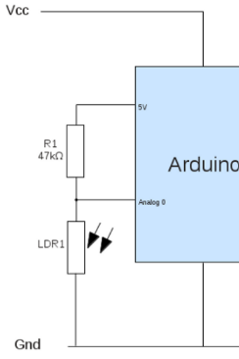
Figure 1(Measuring Light Levels With the Arduino - Electronics Information From PenguinTutor, n.d.)

4.6.3 What is a voltage divider (figure 1)?
A voltage divider is a simple circuit that consists of 2 resistors in this case a GL5516 – LDR and a $3.3kΩ$ resistor. the voltage drops across each resistor depends on its resistance. The output voltage is taken from the point between the 2 resistors. Formula of the voltage divider: $v_{out}=v_{in}\frac{R_{2}}{R_{1}+R_{2}}$
Because one resistor is fixed and the other one changes with light, the voltage in the middle changes. The Arduino reads this on an analog pin.

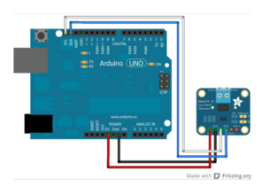
Figure 2 (Adafruit Industries & Ada, 2025)

4.6.4 How will the output of a solar panel be read (figure 2)?
The output of the solar panel will be measured using an INA219 sensor.
The INA219 will be connected to the Arduino as follows (Adafruit Industries & Ada, 2025):
VCC → 5V, GND → GND, SCL → SCL, SDA → SDA
the INA219 will be connected to the solar panel as follows:
VIN+ → positive on solar panel, VIN- → $47Ω$ resistor → negative on solar panel
Why the $47Ω$ resistor? This is because there needs to be a load, otherwise the current would be $0A$. Sins we have a $5V$ and a $100mA$ solarpanal we can do; $R=\frac{U}{I}=\frac{5}{100⋅{10}^{-3}}=50Ω$ because a $50Ω$resistor isn’t common, we will use a $47Ω$ resistor.

4.6.5 How will the servos be connected to the Arduino?
the black wire is connected to GND, the red wire to the 5V pin, and the signal wire is connected to a digital PWM pin on the Arduino (Using the SG90 Servo Motor With an Arduino - Electronics-Lab, 2022).

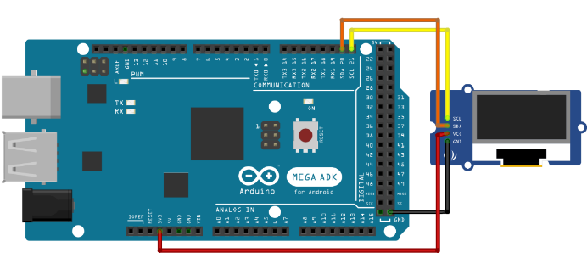
4.6.6 How will the mini oled display be connected to Arduino (figure 3)?
Figure 3 (Using I2C SSD1306 OLED Display With Arduino - Electronics-Lab, 2022)
the output of the solar panel and the ldr’s will be visible on the display.
The mini oled display will be connected to the Arduino as follows (Using I2C SSD1306 OLED Display with Arduino - Electronics-Lab, 2022)
VCC → 5V, GND → GND, SCL → SCL, SDA → SDA

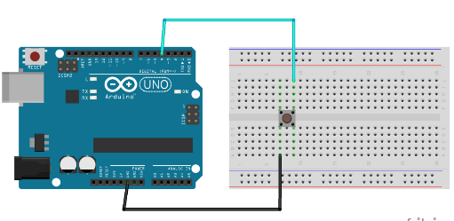
4.6.7 How will the 2 buttons be connected to the Arduino (figure 4)?
Figure 4 (Ed, 2022)
The two buttons will be to navigate the display
The 2 buttons will be connected to the Arduino as follows (Ed, 2022)
D4/5 → button → GND

4.6.8 the circuit diagram (figure 5)
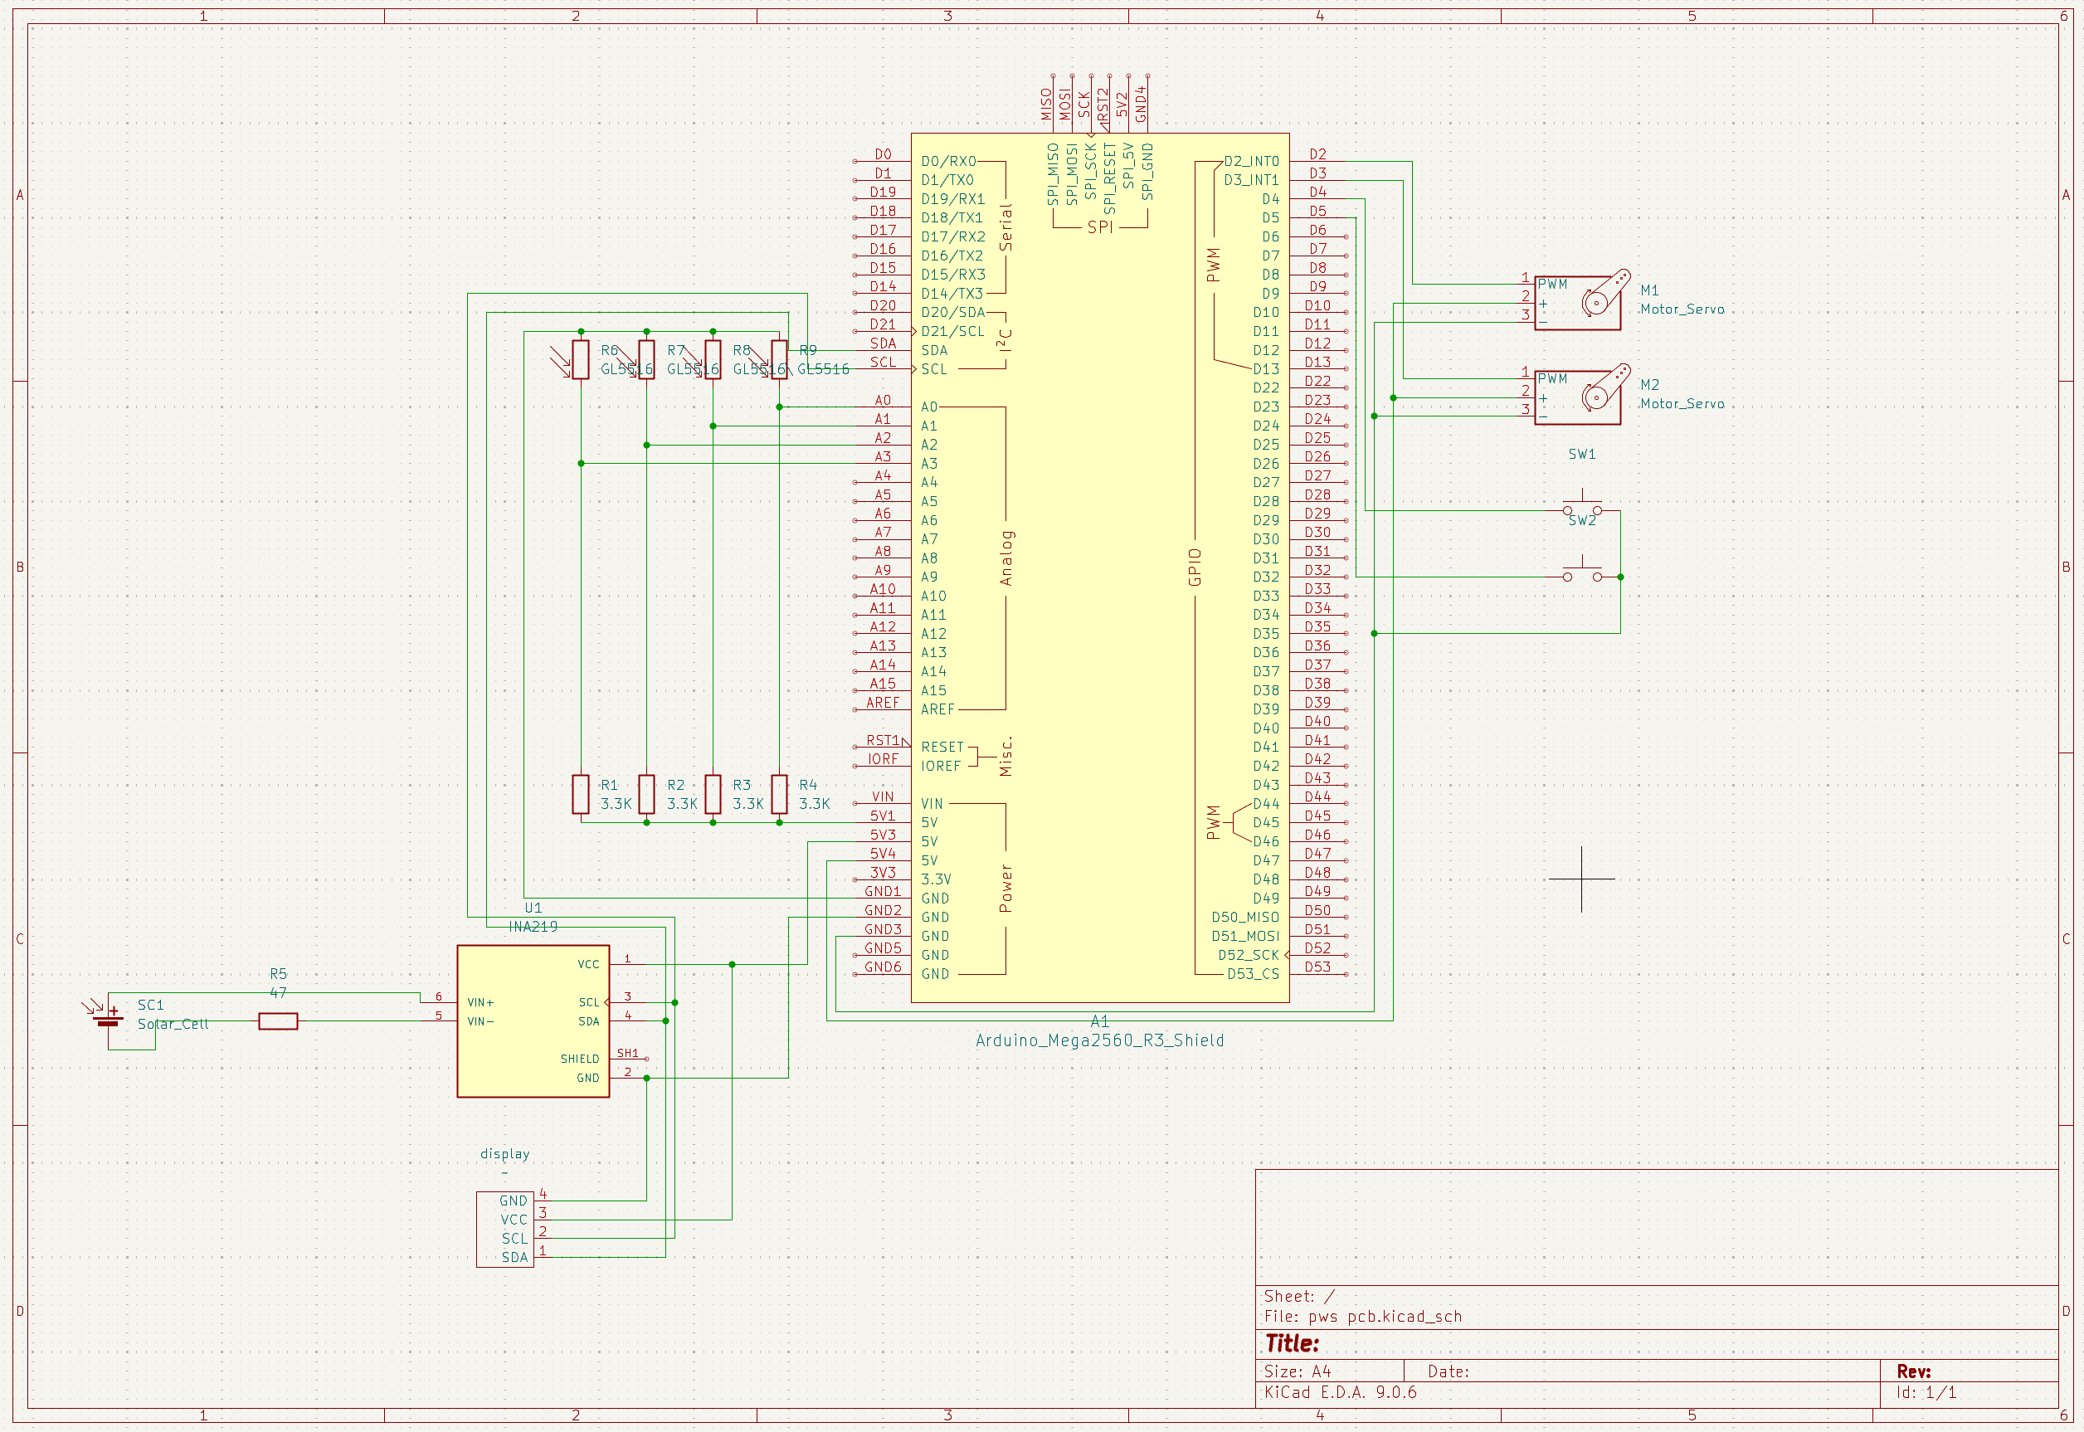
after researching all the connections, we can make the circuit diagram.
Figure 5 Circuit diagram designed with KiCad

5 Testing the circuit + parts

5.1 Testing the LDRs
The LDRs were tested with an Arduino program generated with the help of copilot. The code was uploaded to the Arduino mega, and the sensor values were monitored though the Serial Monitor.
After observing the output, it was clear that the LDRs worked as intended.
The code:
The code was formatted using the Highlight.js demo tool (Demo - Highlight.js, n.d.).
void setup() {
Serial.begin(9600);
}

void loop() {
int rawValue = analogRead(A0); // Lees de LDR-waarde (0–1023)

Serial.print("LDR waarde: ");
Serial.println(rawValue);

delay(200);
}

5.2 Testing the INA219 with the solar panel
The INA219 was tested with an Arduino program with the help of copilot. The code was uploaded to the Arduino mega, and the sensor values were monitored though the Serial Monitor. After looking at the serial monitor, it was realised that something was of, so further troubleshooting was required. This can be found in the header called: Problem INA219
The code:
The code was formatted using the Highlight.js demo tool (Demo - Highlight.js, n.d.).
#include <Wire.h>
#include <Adafruit_INA219.h>

Adafruit_INA219 ina219;

void setup() {
Serial.begin(9600);

// Start de sensor
ina219.begin();

// Standaard calibratie: 32V, 2A bereik
ina219.setCalibration_32V_2A();
}

void loop() {
// Lees waarden
float busVoltage = ina219.getBusVoltage_V(); // Spanning (V)
float shuntVoltage = ina219.getShuntVoltage_mV(); // Shunt spanning (mV)
float current_mA = ina219.getCurrent_mA(); // Stroom (mA)
float power_mW = ina219.getPower_mW(); // Vermogen (mW)

// Print overzichtelijk
Serial.print("U = ");
Serial.print(busVoltage);
Serial.print(" V I = ");
Serial.print(current_mA);
Serial.print(" mA P = ");
Serial.print(power_mW);
Serial.println(" mW");

delay(500);
}

5.3 Testing the servo’s
The INA219 was tested with an Arduino program with the help of copilot. The code was uploaded to the Arduino mega. Turing testing it was realised that the servo’s were drawing too much power, so a separate power source was needed. After installing a separate power supply of $5V$ the servo’s worked fine.
The code:
The code was formatted using the Highlight.js demo tool (Demo - Highlight.js, n.d.).
#include <Servo.h>
Servo servo1;
Servo servo2;
void setup() {
servo1.attach(2); // Servo 1 op D2
servo2.attach(3); // Servo 2 op D3
}
void loop() {
// Draai van 0° naar 180°
for (int pos = 0; pos <= 180; pos++) {
servo1.write(pos);
servo2.write(pos);
delay(10);
}
// Draai van 180° terug naar 0°
for (int pos = 180; pos >= 0; pos--) {
servo1.write(pos);
servo2.write(pos);
delay(10);
}
}

5.4 Testing the mini oled display
The mini oled display was tested with an Arduino program with the help of copilot. The code was uploaded to the Arduino mega. After testing the display worked fine.
The code:
The code was formatted using the Highlight.js demo tool (Demo - Highlight.js, n.d.).
#include <Wire.h>
#include <Adafruit_GFX.h>
#include <Adafruit_SSD1306.h>

Adafruit_SSD1306 display(128, 64, &Wire, -1);

void setup() {
display.begin(SSD1306_SWITCHCAPVCC, 0x3C);
display.clearDisplay();
display.setTextSize(2);
display.setTextColor(SSD1306_WHITE);
display.setCursor(0, 0);
display.println("Hallo");
display.display();
}

void loop() {}

5.5 Testing the 2 buttons
The 2 buttons were tested with an Arduino program with the help of copilot. The code was uploaded to the Arduino mega; the presses were monitored though the Serial Monitor. After testing the two buttons worked as intended.
The code:
The code was formatted using the Highlight.js demo tool (Demo - Highlight.js, n.d.).
void setup() {
Serial.begin(9600);
pinMode(4, INPUT_PULLUP); // knop 1
pinMode(5, INPUT_PULLUP); // knop 2
}

void loop() {
if (digitalRead(4) == LOW) {
Serial.println("Knop 1 ingedrukt");
delay(200);
}

if (digitalRead(5) == LOW) {
Serial.println("Knop 2 ingedrukt");
delay(200);
}
}

5.6 problem INA219:
during the development of the measurement setup with the INA219 sensor, the reading was off: the sensor reported very low voltages and nearly no current, even though the theoretical values were higher. At first it seemed that the sensor may be foully. But after some testing the issue turned out to be caused by the physical wiring of the breadboard used for testing.
The schematic layout was designed incorrectly. This is because there was no ground connection from the solar panel to the Arduino, meaning the system did not share a common reference point. As a result, the INA219 could not correctly measure the voltage and current.
After correcting the wiring, the measurement immediately became accurate. The voltage, current and power values matched the theoretical values, confirming that the sensor was working fine.

5.7 The updated circuit (figure 6):
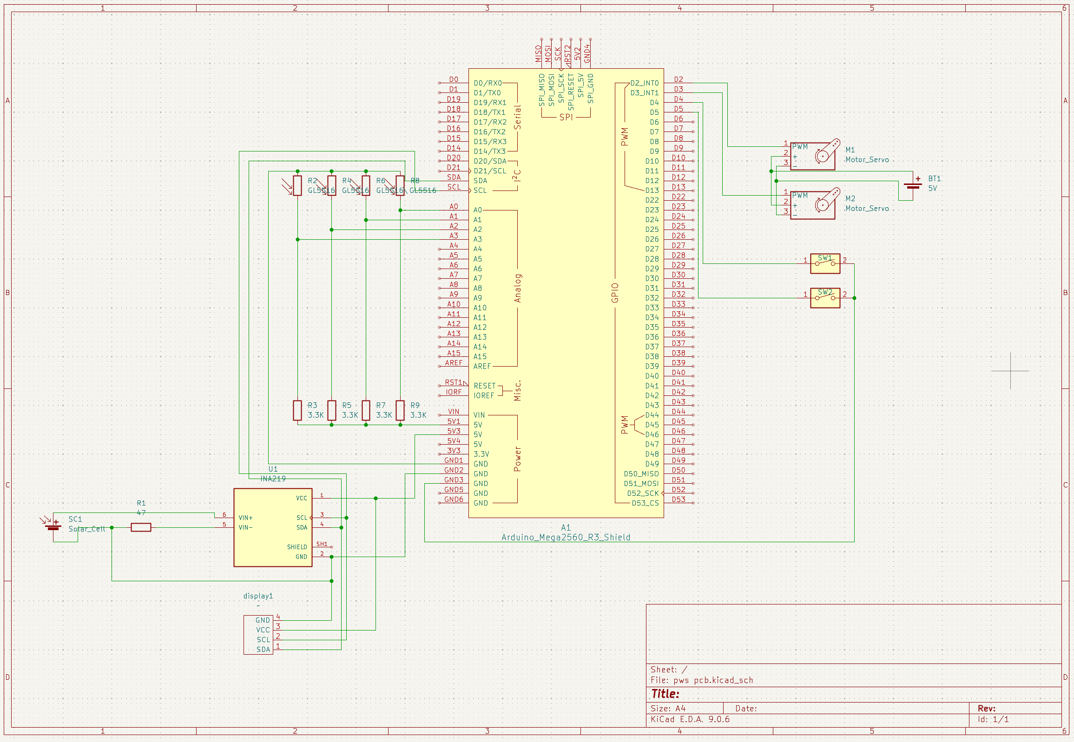
The circuit diagram can also be viewed at my GitHub repository
Figure 6 Updated circuit diagram designed with KiCad

6 Prototype 1(figure 7)
For prototype 1, a design sourced from the internet was used: https://www.thingiverse.com/thing:53321
All components were connected on a breadboard, which made it possible to test the functionality, making sure the wiring was designed correctly, and to adjust during the development phase. This setup made sure that the design of the circuit was done correctly.
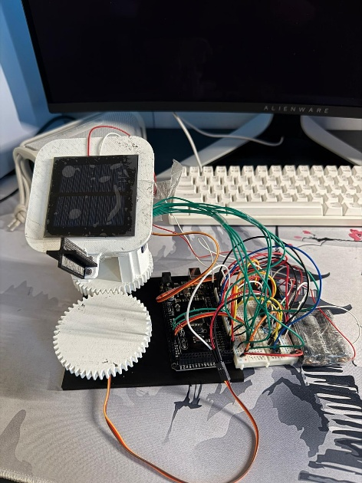
Figure 7 Prototype 1
Parts of the code used for prototype 1 were generated with Copilot. The complete version is included under the section titled Code Prototype 1.

6.1 Code prototype 1
The code for prototype 1 can be viewed at my GitHub repository.

6.2 Testing prototype 1
After testing prototype 1, there were some tweaks to consider.
Firstly, the physical design requires some refinements. At the moment, the servo’s need to work too hard to move the solar tracker. This is mainly caused by gears being too close to one another, resulting in friction, and reduced efficiency.
Secondly a PCB needs to be made. Right now, the system relies on many loose wires, which makes the setup messy and increases the chances of loos connections. A custom PCB would make the circuit far more stable, and easier to assemble/ disassemble. It would also improve the overall reliability of the solar tracking system; this makes future improvements far easier.
At last, the solar tracker still has a lot of stuttering when moving, this has to do with the code. Also, the solar tracker sometimes reacts slower or less consisted as expected. Improving these parts will help to make the movement of the solar tracker far more stable and smoother.
In conclusion, prototype 1 works, however several improvements are needed before the solar tracker can function reliable. The physical design must be improved, the wiring should be replaced with a proper PCB, and the code requires some tweaks to remove stuttering and to improve responsiveness. With all these improvements, the next prototype will hopefully be far more stable, efficient and easier to develop further.

7 PCB (figure 8)
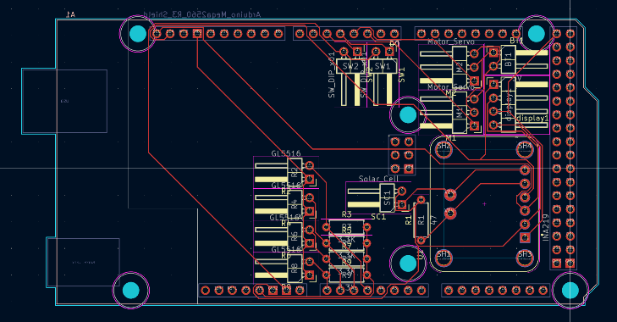
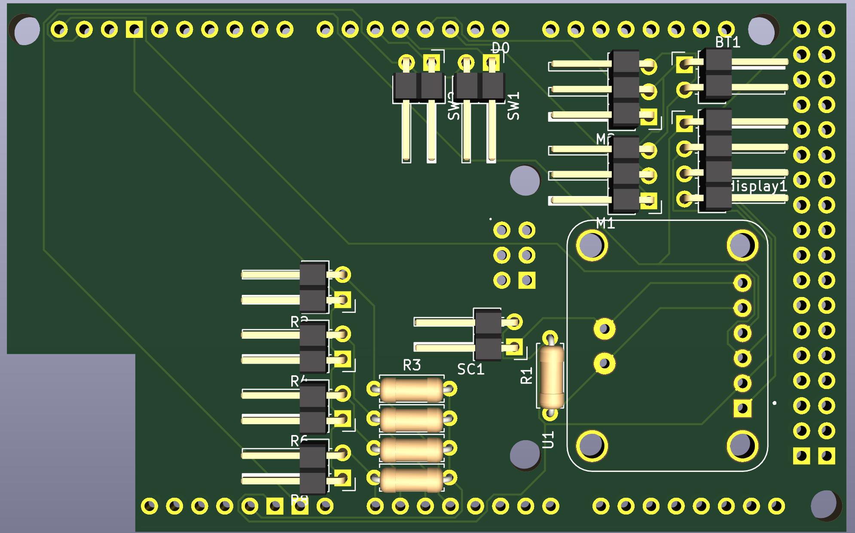
The pcb is designed with KiCad. The images below show the final design. This can also be viewed at my GitHub repository
Figure 8 PCB designed with KiCad

8 Making prototype 2
The dual-axis solar tracker was designed using Freecad 1.1, where the whol structure was modeled. All of the Freecad drawings are stored in my GitHub repository.

8.1 Problems design prototype 2
Several adjustments were made to the enclosure to ensure proper fit and reliable operation of the components.
Arduino clearance
Additional clearens was added beneath the arduino board to make clearens for the solder pins located on the underside. This allows the board to be mounted seculerly.
Button Gap
Gaps were introduced in the main compartment, that were previously forgotten.
Display clearens
Extra space was created aroud the display to accomondate the solder pins of the display to provide sufficient room for the display
Top plate support
Additional support structures were made for the top plate to make it more stirdy and reduce flexion. This makes sure that the plate remains stable when the system is in use.
Shaft opening in second gear
A shaft opening was made in the second gear to make sure that the shaft can pass true the centre, this was previously forgotten.
Hole for the servo’s to small
The holes for the servo’s were too small, so the servos didn’t fit, extra clearance was added.
Servo fitting to brittle
The servo fittings were to brittle so they snapt, extra support was added.
INA219 does not measure voltage
After installing all the parts the INA219 did not measure voltage, after a lot of testting it was concluded that the wiring was incorrect and that the solar panel needed a power guzzler in order to get voltage. The solar panel was wired using this source (
싸이피아SCIPIA, 2020). After these changes the INA219 and the solar panel worked as intended.

8.1.1 Updated circuit diagram (figure 9)
File can be obtained on my github repository
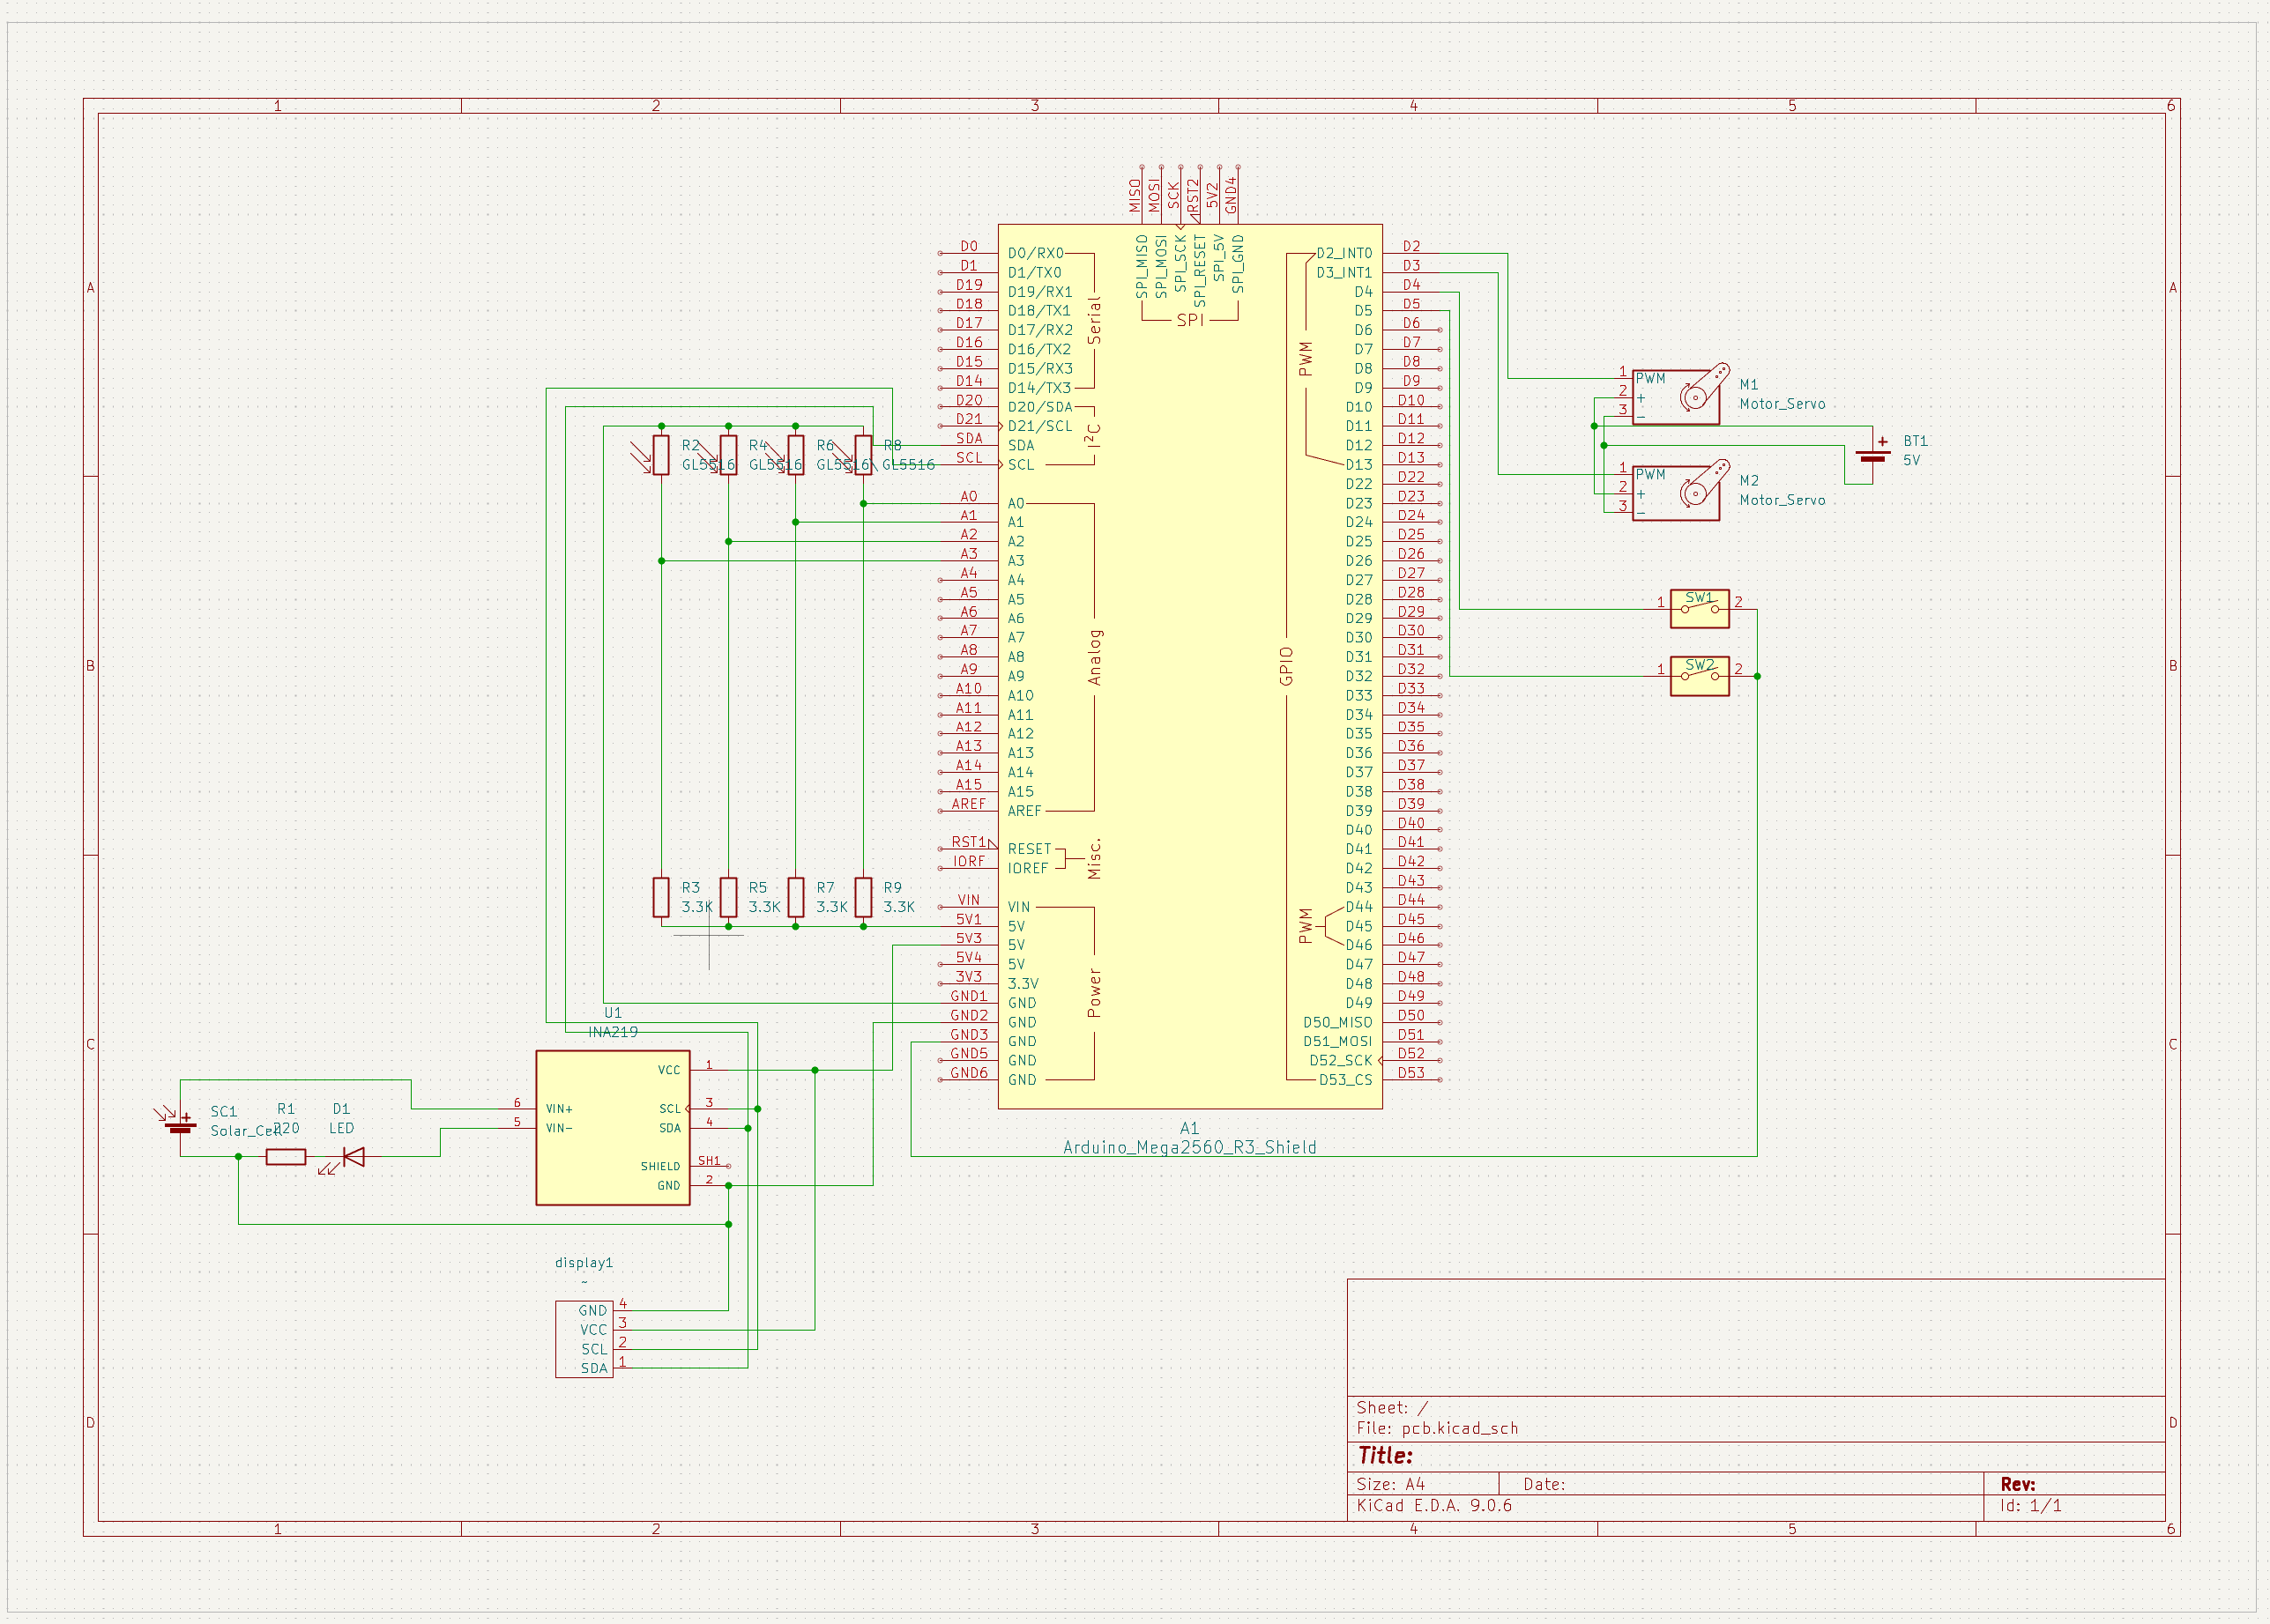
Figure 9 updated circuit diagram designed with KICAD

8.1.2 Updated PCB
File can be obtained on my github repository
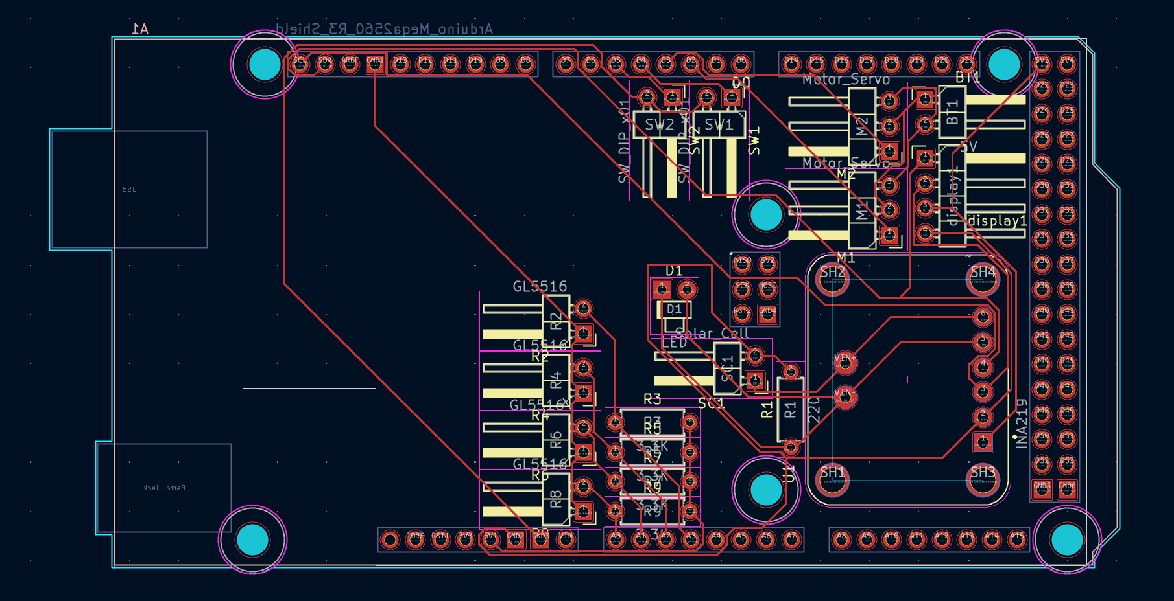
Figure 10 PCB designed with KICAD

8.2 Code prototype 2
The code can be found at my GitHub repository; the code was generated using Claude AI

8.3 Final prototype 2 (figure 11)
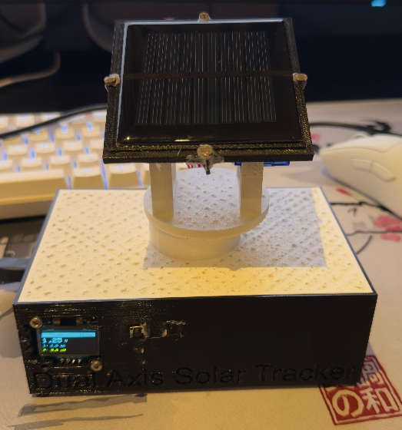
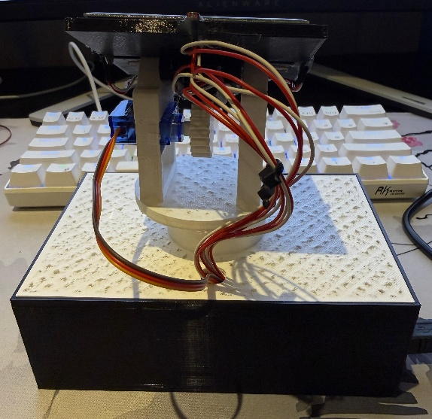
Figure 11 prototype 2

8.4 Manual of prototype 2

8.4.1 system overview
This solar tracker automatically follows the sun using for LDR light sensors and two servo motors. It also measures voltage, current, and power using an INA219 sensor and shows all the information on a small OLED screen

8.4.2 navigating the screen
Button 1:
short press: starts a small measurement of 10 seconds
long press: puts both servos at 90 degrees
Button 2:
Short press: fluctuates between the servo positions screen, power screen, and the LDR sensor screen.
long press: fluctuates between tracker modes.

9 Monitor Software
There will be software used to generate graph and calculating the overall energy output, this code is made using Claude AI
The code has values of the INA219 sensor and looks if everything works as expected. There will be a measurement button that starts a measurement of 20min.
The code can be obtained at my github repository.

9.1 Manual of the monitor software

9.1.1 connecting the solar tracker.
- Connect your solar tracker with the computer
- Press rescan
- Select the right port example: COM1
- Press connect
- On the top right should stand; connected in green

9.1.2 starting measurements
- Select a duration
- Press start measurement

9.1.3 collecting data
- After the measurement a popup should pop up
- Press yes and download the data.

10 Experiment
Experiment: compare energy yield of a stationary solar panel, single axis solar tracker and a dual axis solar tracker.

10.1 purpose of the experiment
The purpose of the experiment is to determent whether a solar tracking system has a significantly higher energy yield then a stationary solar panel under Dutch weather conditions.

10.2 research question and hypothesis

10.2.1 Research question
Does a solar tracking system provide a significant energy advantage over a fixed solar panel in the Netherlands?

10.2.2 Hypothesis
Based on the theory, it is expected that a dual axis solar tracker has the highest energy yield, followed by a single axis tracker, and a fixed solar panel. However, the difference is expected to be limited, as a large proportion of the solar radiation in the Netherlands is diffuse due to cloud cover.

10.3 experimental setup

10.3.1 Solar panel setup
For the experiment, three configurations are being tested using the same solar panel:

Setup A, stationary setup
- Angle of inclination: $45,1°$
- Direction: $180°$
- No movement during measurement

Setup B, single axis solar tracker
- Angle of inclination: $45,1°$
- Horizontal rotation (east to west)
- Movement controlled by LDR sensors

Setup C, Dual axis solar tracker
- Horizontal rotation (azimuth)
- Vertical rotation (tilt)
- Movement controlled by LDR sensors
The usage of the same solar panel prevents difference between the efficiency of the solar panel

10.3.2 measuring equipment
- solar panel: mini 70 x 70mm epoxy solar panel
- current and voltage sensor: INA219
- Microcontroller: Arduino Mega
- Measurement units: voltage (V), Current (mA), and power (mW)

10.4 Data
Note: the tables used to make the graph are in my github repository

10.4.1 Dual axis solar tracker
Table 5 averages & total energy of the dual axis solar tracker
Average current (mA) | 10,20
Average voltage (V) | 2,85
Average Power (mW) | 29,0
Total Energy (mWh) | 9,70

10.4.2 Single axis solar Tracker
Note: the laptop turned off while the measurement was in progress so there is a gap in the graph (the horizontal line).
Table 6 averages & total energy of the single axis solar tracker
Average current (mA) | 10.4
Average voltage (V) | 2.84
Average Power (mW) | 29.4
Total Energy (mWh) | 10.2

10.4.3 Stationary solar panel
Table 7 averages & total energy of the stationary solar panel
Average current (mA) | 10.1
Average voltage (V) | 2.82
Average Power (mW) | 28.4
Total Energy (mWh) | 9.67

10.5 Data analysis

10.5.1 Summary
Table 8 all measurements combined
Measurements | Dual axis | Single axis | Stationary
Avg. current (mA) | 10.20 | 10.40 | 10.10
Avg. voltage (V) | 2.85 | 2.84 | 2.82
Avg. power (mW) | 29.0 | 29.4 | 28.4
Total energy (mWh) | 9.70 | 10.20 | 9.67
Gain vs. stationary | +0.3% | +5.5% | Reference

10.5.2 Results
The single axis tracker produced the most energy (10.20mWh), followed by the dual axis solar tracker (9.70mWh) and the stationary setup (9.67mWh).
Gain vs. stationary:
- Single axis: +5.5%
- Dual axis: +0.3%

10.5.3 Sub conclusion (practical part)
Based on the measured energy output over 20 minutes, the hypothesis is rejected. The single axis solar panel produced the highest energy output, indicating that this configuration is the most effective choice within the tested Dutch conditions.

11 Conclusion
This project investigated whether a solar tracking system has a significantly higher energy advantage over a fixed solar panel in the Netherlands by designing, building, and testing a dual-axis tracker. This dual-axis tracker was compared with a single-axis solar tracker and a stationary panel. The experiment showed that the single-axis solar tracker achieved the highest energy output, followed closely by the dual-axis tracker, both clearly outperformed the fixed panel.
When combing these experiment results with the theoretical research and the sub conclusion, it becomes clear that the best solution is not only determined by the maximum energy yield, but by balancing performance, costs, and reliability. The sub conclusion concluded that the single-axis tracker often provides the optimal trade off. It significantly increases the energy output of the solar panel compared to the fixed panel, while It remains cheaper, more reliable, and less complex than the dual-axis tracker. Especially in the Dutch climate, where sunlight is often diffused by cloud cover, the additional vertical rotation does not result in a substantial increase in the energy yield.
The conclusion is that, although both tracking systems improve performance compared to a fixed panel. The single-axis solar tracker is the most optimal solution in the Netherlands, this is because it delivers the highest measured energy yield, although the theoretical research does not support this. although the single-axis has maybe slightly less performance compared to the dual-axis panel in theory, it gives a higher energy yield while also remaining cost effect and relatively simple.

12 Discussion
the results of the experiment were not straightforward. Based on the theoretical research, it was expected that the dual axis tracker should have produced the highest energy output. Despite this, the measurements showed that the single axis tracker produced the best within the twenty minute measurement period. Serval factors help explain the unexpected outcome.
The biggest factor was the dual axis tracker. During the test, the left LDR showed strange and unrealistic values compared to the other LDR’s (see table in github). This means that the sensor was probably malfunctioning. Since a dual axis tracker needs all for LDR’s to work correctly, because of one malfunctioning, the panel was probably not facing the sun properly. This would directly lower the output of the dual axis tracker, and is likely the main reason why the dual axis tracker performed worse than expected.
Another limitation was the shortness of the test, the measurements only lasted for twenty minutes. This is too short to show how the system performs during a full day with changing sunlight, clouds, and diffused light. The single axis could have got some “luck” that it was facing the right direction during the measurement.
Finally, the experiment used a small solar panel. they are more vulnerable to sudden changes such as shadows, and sensor errors than larger commercial panels. because of this, the result cannot be directly applied to full scale solar installations.

13 References
- Adafruit Industries, & Ada, Lady. (2025). Adafruit INA219 current sensor breakout.
https://cdn-learn.adafruit.com/downloads/pdf/adafruit-ina219-current-sensor-breakout.pdf
- Demo - Highlight.js. (n.d.). Highlight.js.
https://highlightjs.org/demo
- Energy Information Administration. (n.d.). Photovoltaics and electricity.
https://www.eia.gov/energyexplained/solar/photovoltaics-and-electricity.php
- Electronics-Lab. (2022a, June 22). Using I2C SSD1306 OLED display with Arduino.
https://www.electronics-lab.com/project/using-i2c-oled-display-with-arduino/
- Electronics-Lab. (2022b, June 22). Using the SG90 servo motor with an Arduino.
https://www.electronics-lab.com/project/using-sg90-servo-motor-arduino/
- GL55 Series CdS Photoresistor. (n.d.). GL55 series CdS photoresistor manual.
https://www.kth.se/social/files/54ef17dbf27654753f437c56/GL5537.pdf
- Google. (n.d.). Google Maps.
https://www.google.com/maps/@51.5075823,5.3799992,14z
- International Energy Agency. (2025, March 25). Grid congestion is posing challenges for energy security and transitions.
https://www.iea.org/commentaries/grid-congestion-is-posing-challenges-for-energy-security-and-transitions
- KNMI. (n.d.). Forecast of solar radiation in the Netherlands.
https://www.knmi.nl/kennis-en-datacentrum/project/forecast-of-solar-radiation-in-the-netherlands-1f0f3816-0854-47a6-9766-42cba229d8fb
- KNMI. (n.d.). Maandsommen zonneschijnduur, normalen, anomalieën.
https://www.knmi.nl/nederland-nu/klimatologie/geografische-overzichten/archief/maand/sq
- Kuchta, D. M. (2021, September 12). Solar trackers explained: How it works, pros and cons. Treehugger.
https://www.treehugger.com/solar-trackers-explained-5189463
- Otronic. (2025, August 26). Mini zonnepaneel 70x70mm epoxy.
https://www.otronic.nl/nl/mini-zonnepaneel-70x70mm-epoxy-140568466.html
- Penguintutor. (n.d.). Measuring light levels with the Arduino.
https://www.penguintutor.com/electronics/arduino2
- pvlib python. (n.d.). pvlib.solarposition.declination_cooper69.
https://pvlib-python.readthedocs.io/en/latest/reference/generated/pvlib.solarposition.declination_cooper69.html
- RapidTables. (n.d.). Lumens to lux conversion calculator.
https://www.rapidtables.com/calc/light/lumen-to-lux-calculator.html
- Tweakers. (n.d.). Philips Hue white and color ambiance E27 800 lumen Bluetooth (1-pack).
https://tweakers.net/pricewatch/1744154/philips-hue-white-en-color-ambiance-e27-800-lumen-bluetooth-1-pack.html
- Wikipedia contributors. (2025, December 9). Inverse-square law. Wikipedia.
https://en.wikipedia.org/wiki/Inverse_square_law
- ZonnepanelenWijzer. (2024, September 16). Zonnepanelen ligging en oriëntatie: Dit is de beste hoek.
https://zonnepanelenwijzer.com/zonnepanelen/ligging-orientatie/
- 싸이피아SCIPIA. (2020, December 8). Monitoring voltage and current of INA219 sensor with IIC LCD (ft. Arduino, solar panel, LED) [Video]. YouTube.
https://www.youtube.com/watch?v=02CfQRn7Xa0

