***Jasper Arida***

***IT Engineer***

*Malaybalay 8700*

*irvin_kerk@yahoo.com - +639265220952*

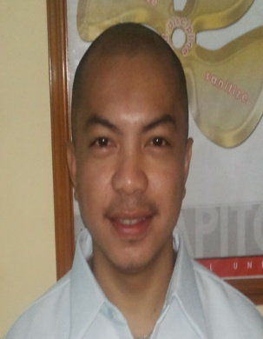

*________________________________________*

*ACADEMICS*

* *Bachelor of Science in Computer Engineering, 1998 - 2001*

*Mindanao University of Science and Technology (formerly Mindanao Polytechnic State College)*

* *Electronics and Communication Technology, 1995 -1998*

*Mindanao University of Science and Technology*

*CERTIFICATIONS*

* *Carrier Service Professional Certification (Civil Service)*
* *Professional Electronics Technician (Professional Regulation Commission)*
* *Computer Hardware Servicing NCII (TESDA)*

*WORK EXPERIENCE*

***Data Center Staff***

*Bukidnon State University - Malaybalay - July 2014 to Present*

***IT Engineer***

*Capitol University - January 2004 to June 2013*

***Technical Engineer***

*Intelisoft Microcomputer System - Malaybalay - 2002 to 2003*

Thank you and more power.

.

Yours sincerely,

Jasper P. Arida