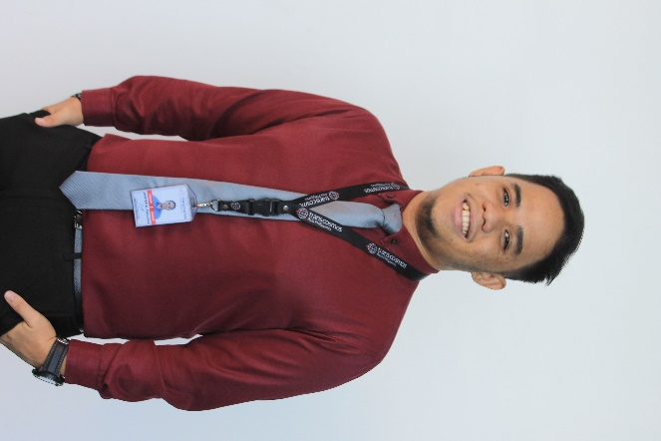**Jasper Autor Paulino**

**FRONT-END WEB DESIGNER**

2261 Visayan Ave., Sampaloc, Manila

09566986161

[jasperautorpaulino.github.io](https://jasperautorpaulino.github.io/)

[jasper.paulino10@gmail.com](mailto:jasper.paulino10@gmail.com)

**Introduction**

Hi! I’m Jasper, 23 years of age. A passionate web and graphic designer for 3 years now. I am currently employed at Transcosmos Asia Philippines as a Front end web designer since May 2019.

**Educational Background**

**Tertiary:** Bachelor of Science in Information Technology Polytechnic University of the Philippines

Sta. Mesa, Manila

(2013-2017)

**Technical Skills**

* Able to implement responsive web design using **HTML5**, **CSS3**, and **Jquery/Javascript**.
* Can produce **efficient and organized code.**
* Can create sleek web design inclusive of animations.
* Knowledgeable in using **Adobe Photoshop** (intermediate to advanced level).
* Intermediate knowledge in using **Adobe Illustrator**.
* Experienced with using **Microsoft Excel.**
* Has basic knowledge in **React JS** (functional components).
* Knowledgeable with PHP and MySQL (basics).
* Has relevant experience with Data entry and customer service.

**Personal Skills**

* Very organized especially when handling big projects.
* Excellent attention to details.
* Good multi-tasking abilities, yet very immersed on any given task/s.
* Quick to grasp new concepts with proper training.

**Professional Work Experience**

**Mapua University**

1. **Smartcard Assistant** - July 2017 - January 2019

Job description:

Responsible for managing ID printing and releasing for all Mapua students and employees for all Mapua campuses. Aside from my main duties, I also do technical support, helpdesk, and graphic design tasks when required.

1. **Web Designer** - January 2019 – May 2019

Job description:

Responsible for handling Mapua website updates coming from several departments inside Mapua university. Also provides assistance to Senior web designer when required.

**Transcosmos Asia Philippines**

**Frontend Web Designer** - May 2019 – present

Job description:

Responsible for coding websites based on client’s request. Handles regular website

updates, Mass production coding, and coding pages from scratch with pixel perfect accuracy.

**Character References**

**Morris John Louise B. Ampioco**

Manager, Digital Experience – Web integration offshore team

Transcosmos Asia Philippines

626-1400

[ampioco.morris1@trans-cosmos.co.jp](mailto:ampioco.morris1@trans-cosmos.co.jp)

**Christian V. Alde**

Team Leader

Transcosmos Asia Philippines

09956684009

[christian.alde1@trans-cosmos.co.jp](mailto:christian.alde1@trans-cosmos.co.jp)

**Leah Marie G. Alvarez**

ISS-WEBManager

Mapua University Intramuros

+63(2) 8247-5000

[lmgalvarez@mapua.edu.ph](mailto:lmgalvarez@mapua.edu.ph)

*I hereby certify that the above information is true and correct to the best of my knowledge and belief.*

Jasper A. Paulino

Applicant