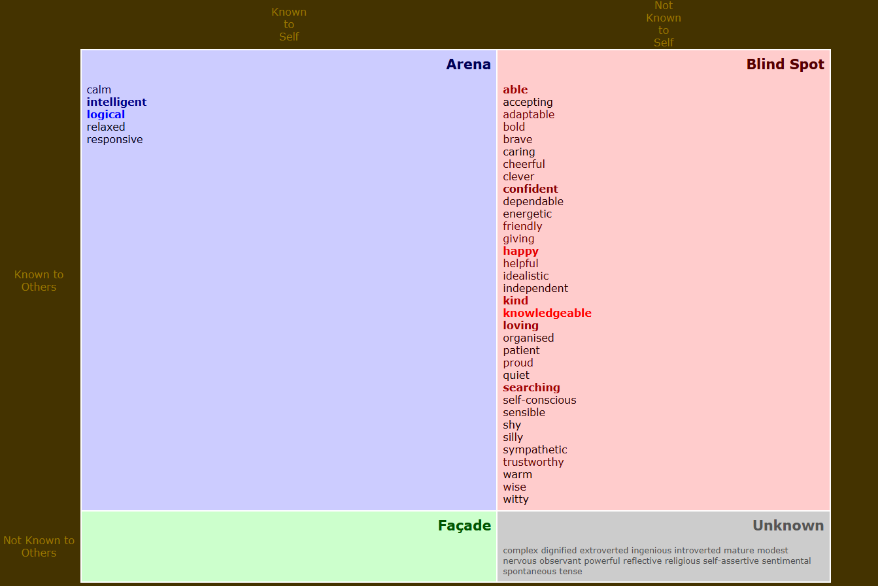

**1.Review the Johari model**

The Johari Window is a model that helps people understand themselves better by dividing their traits into four areas: Open (what both you and others know), Blind Spot (what others see but you don’t), Hidden (what you keep private), and Unknown (what neither you nor others know). By analyzing my Johari Window, I have learned more about how I see myself versus how others see me.

**2.Analyze your results**

My Open Area is small, meaning I share only a few things about myself with others. People recognize traits like calm, intelligent, logical, relaxed, and responsive in me, which I also believe to be true.

My Blind Spot was surprising. Others see me as confident, happy, loving, and knowledgeable, but I never thought of myself that way. It made me wonder if I project confidence without realizing it. Also, seeing “self-conscious” in this area made me reflect on how much my insecurities show.

My Hidden Area was empty, meaning I don’t hide much from others, or I haven't explored what I might be keeping private. My Unknown Area included traits like complex, extroverted, and powerful. This suggests I might have strengths I haven’t fully developed yet.

**3.Identify key sights**

This exercise showed me that people see me in a more positive light than I see myself. While I consider myself calm and logical, others see confidence and warmth in me, which I should embrace. It also highlighted the need to explore my Blind Spot more and uncover hidden strengths in my Unknown Area by trying new things and pushing my limits.

**4.reflect on the emotional impact**

Getting feedback about my Blind Spot was both encouraging and surprising. It felt good to be seen as confident and knowledgeable, but realizing that my self-consciousness is visible was a little uncomfortable. This made me realize I should trust positive feedback more and stop underestimating myself.

**5.Actionable steps for Personal growth**

To expand my Open Area, I will be more open with others about my thoughts and feelings. To reduce my Blind Spot, I will seek feedback from trusted people and reflect on how I present myself. I will also explore my Unknown Area by trying new experiences, such as leadership roles and public speaking, to discover hidden strengths.S

**6.Write your reflection**

This activity has helped me better understand how others see me and how I can improve my self-awareness. It has made me realize the importance of acknowledging both my strengths and weaknesses while also being more receptive to feedback. Moving forward, I will work on embracing my strengths with confidence, being more open with others about my thoughts and emotions, and making a conscious effort to step out of my comfort zone. By doing so, I hope to improve my personal relationships, enhance my communication skills, and continue my journey of self-discovery and growth.