**Computer Vision HW2 Report**

Student ID: R12521601

Name: 詹承諺

**Part 1. (10%)**

**• Plot confusion matrix of two settings. (i.e. Bag of sift and tiny image) (5%)**

**Ans:**

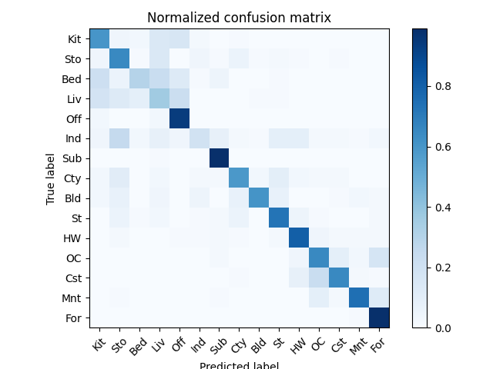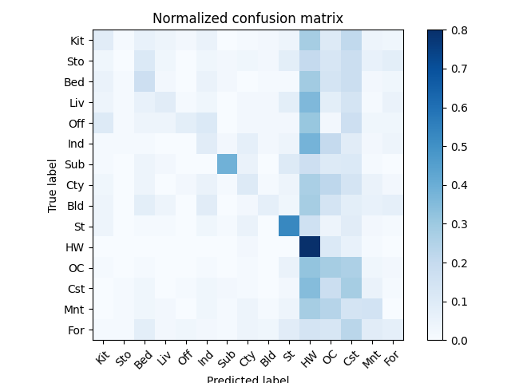

Bag of sift Tiny image

(accuracy: 0.654) (accuracy: 0.213)

**• Compare the results/accuracy of both settings and explain the result. (5%)Ans:**

**Accuracy:**

1. Bag of sift: 0.654
2. Tiny image: 0.213

**Setting:**

1. **Bag of sift:**

計算距離的部分在get_bags_of_sifts的function中cdist是用default的metric (‘euclidean’)，在每個function中都有先對image做normalization。

1. **Tiny image:**

先將image resize成16*16，再將其flatten並normalize。

1. **nearest_neighbor_classify**

先將image做normalize，在nearest_neighbor_classify的function中cdist的metric是用 'minkowski'且p設為0.5。KNN的部分則是將k設置為6。

**Result:**

Bag of sift相較於Tiny image來說準確率高了許多，Bag of sift的confusion matrix對角線顏色明顯較深，而Tiny image的confusion matrix中則較無明顯的對角線，許多圖片都會分類成HW, OC, CST。

**Part 2. (25%)**

**• Report accuracy of both models on the validation set. (2%)**

**Ans:**

(1) MyNet: 0.8440

(2) ResNet18: 0.9126

**• Print the network architecture & number of parameters of both models. What is the main difference between ResNet and other CNN architectures? (5%)**

**Ans:**

1. **MyNet**

**----------------------------------------------------------------**

**Layer (type) Output Shape Param #**

**================================================================**

**Conv2d-1 [-1, 64, 32, 32] 1,792**

**BatchNorm2d-2 [-1, 64, 32, 32] 128**

**ReLU-3 [-1, 64, 32, 32] 0**

**MaxPool2d-4 [-1, 64, 16, 16] 0**

**Conv2d-5 [-1, 128, 16, 16] 73,856**

**BatchNorm2d-6 [-1, 128, 16, 16] 256**

**ReLU-7 [-1, 128, 16, 16] 0**

**MaxPool2d-8 [-1, 128, 8, 8] 0**

**Conv2d-9 [-1, 256, 8, 8] 295,168**

**BatchNorm2d-10 [-1, 256, 8, 8] 512**

**ReLU-11 [-1, 256, 8, 8] 0**

**MaxPool2d-12 [-1, 256, 4, 4] 0**

**Conv2d-13 [-1, 512, 4, 4] 1,180,160**

**BatchNorm2d-14 [-1, 512, 4, 4] 1,024**

**ReLU-15 [-1, 512, 4, 4] 0**

**MaxPool2d-16 [-1, 512, 2, 2] 0**

**Linear-17 [-1, 1024] 2,098,176**

**ReLU-18 [-1, 1024] 0**

**Dropout-19 [-1, 1024] 0**

**Linear-20 [-1, 512] 524,800**

**ReLU-21 [-1, 512] 0**

**Dropout-22 [-1, 512] 0**

**Linear-23 [-1, 10] 5,130**

**================================================================**

**Total params: 4,181,002**

**Trainable params: 4,181,002**

**Non-trainable params: 0**

**----------------------------------------------------------------**

**Input size (MB): 0.01**

**Forward/backward pass size (MB): 3.08**

**Params size (MB): 15.95**

**Estimated Total Size (MB): 19.04**

MyNet(

(conv1): Conv2d(3, 64, kernel_size=(3, 3), stride=(1, 1), padding=(1, 1))

(batchnorm1): BatchNorm2d(64, eps=1e-05, momentum=0.1, affine=True, track_running_stats=True)

(conv2): Conv2d(64, 128, kernel_size=(3, 3), stride=(1, 1), padding=(1, 1))

(batchnorm2): BatchNorm2d(128, eps=1e-05, momentum=0.1, affine=True, track_running_stats=True)

(conv3): Conv2d(128, 256, kernel_size=(3, 3), stride=(1, 1), padding=(1, 1))

(batchnorm3): BatchNorm2d(256, eps=1e-05, momentum=0.1, affine=True, track_running_stats=True)

(conv4): Conv2d(256, 512, kernel_size=(3, 3), stride=(1, 1), padding=(1, 1))

(batchnorm4): BatchNorm2d(512, eps=1e-05, momentum=0.1, affine=True, track_running_stats=True)

(pool): MaxPool2d(kernel_size=2, stride=2, padding=0, dilation=1, ceil_mode=False)

(fc1): Linear(in_features=2048, out_features=1024, bias=True)

(fc2): Linear(in_features=1024, out_features=512, bias=True)

(fc3): Linear(in_features=512, out_features=10, bias=True)

(relu): ReLU()

(dropout): Dropout(p=0.5, inplace=False)

)

1. **ResNet18**

-**---------------------------------------------------------------**

**Layer (type) Output Shape Param #**

**================================================================**

**Conv2d-1 [-1, 64, 32, 32] 1,792**

**BatchNorm2d-2 [-1, 64, 32, 32] 128**

**ReLU-3 [-1, 64, 32, 32] 0**

**Identity-4 [-1, 64, 32, 32] 0**

**Conv2d-5 [-1, 64, 32, 32] 36,864**

**BatchNorm2d-6 [-1, 64, 32, 32] 128**

**ReLU-7 [-1, 64, 32, 32] 0**

**Conv2d-8 [-1, 64, 32, 32] 36,864**

**BatchNorm2d-9 [-1, 64, 32, 32] 128**

**ReLU-10 [-1, 64, 32, 32] 0**

**BasicBlock-11 [-1, 64, 32, 32] 0**

**Conv2d-12 [-1, 64, 32, 32] 36,864**

**BatchNorm2d-13 [-1, 64, 32, 32] 128**

**ReLU-14 [-1, 64, 32, 32] 0**

**Conv2d-15 [-1, 64, 32, 32] 36,864**

**BatchNorm2d-16 [-1, 64, 32, 32] 128**

**ReLU-17 [-1, 64, 32, 32] 0**

**BasicBlock-18 [-1, 64, 32, 32] 0**

**Conv2d-19 [-1, 128, 16, 16] 73,728**

**BatchNorm2d-20 [-1, 128, 16, 16] 256**

**ReLU-21 [-1, 128, 16, 16] 0**

**Conv2d-22 [-1, 128, 16, 16] 147,456**

**BatchNorm2d-23 [-1, 128, 16, 16] 256**

**Conv2d-24 [-1, 128, 16, 16] 8,192**

**BatchNorm2d-25 [-1, 128, 16, 16] 256**

**ReLU-26 [-1, 128, 16, 16] 0**

**BasicBlock-27 [-1, 128, 16, 16] 0**

**Conv2d-28 [-1, 128, 16, 16] 147,456**

**BatchNorm2d-29 [-1, 128, 16, 16] 256**

**ReLU-30 [-1, 128, 16, 16] 0**

**Conv2d-31 [-1, 128, 16, 16] 147,456**

**BatchNorm2d-32 [-1, 128, 16, 16] 256**

**ReLU-33 [-1, 128, 16, 16] 0**

**BasicBlock-34 [-1, 128, 16, 16] 0**

**Conv2d-35 [-1, 256, 8, 8] 294,912**

**BatchNorm2d-36 [-1, 256, 8, 8] 512**

**ReLU-37 [-1, 256, 8, 8] 0**

**Conv2d-38 [-1, 256, 8, 8] 589,824**

**BatchNorm2d-39 [-1, 256, 8, 8] 512**

**Conv2d-40 [-1, 256, 8, 8] 32,768**

**BatchNorm2d-41 [-1, 256, 8, 8] 512**

**ReLU-42 [-1, 256, 8, 8] 0**

**BasicBlock-43 [-1, 256, 8, 8] 0**

**Conv2d-44 [-1, 256, 8, 8] 589,824**

**BatchNorm2d-45 [-1, 256, 8, 8] 512**

**ReLU-46 [-1, 256, 8, 8] 0**

**Conv2d-47 [-1, 256, 8, 8] 589,824**

**BatchNorm2d-48 [-1, 256, 8, 8] 512**

**ReLU-49 [-1, 256, 8, 8] 0**

**BasicBlock-50 [-1, 256, 8, 8] 0**

**Conv2d-51 [-1, 512, 4, 4] 1,179,648**

**BatchNorm2d-52 [-1, 512, 4, 4] 1,024**

**ReLU-53 [-1, 512, 4, 4] 0**

**Conv2d-54 [-1, 512, 4, 4] 2,359,296**

**BatchNorm2d-55 [-1, 512, 4, 4] 1,024**

**Conv2d-56 [-1, 512, 4, 4] 131,072**

**BatchNorm2d-57 [-1, 512, 4, 4] 1,024**

**ReLU-58 [-1, 512, 4, 4] 0**

**BasicBlock-59 [-1, 512, 4, 4] 0**

**Conv2d-60 [-1, 512, 4, 4] 2,359,296**

**BatchNorm2d-61 [-1, 512, 4, 4] 1,024**

**ReLU-62 [-1, 512, 4, 4] 0**

**Conv2d-63 [-1, 512, 4, 4] 2,359,296**

**BatchNorm2d-64 [-1, 512, 4, 4] 1,024**

**ReLU-65 [-1, 512, 4, 4] 0**

**BasicBlock-66 [-1, 512, 4, 4] 0**

**AdaptiveAvgPool2d-67 [-1, 512, 1, 1] 0**

**Linear-68 [-1, 10] 5,130**

**ResNet-69 [-1, 10] 0**

**================================================================**

**Total params: 11,174,026**

**Trainable params: 11,174,026**

**Non-trainable params: 0**

**----------------------------------------------------------------**

**Input size (MB): 0.01**

**Forward/backward pass size (MB): 16.00**

**Params size (MB): 42.63**

**Estimated Total Size (MB): 58.64**

ResNet18(

(resnet): ResNet(

(conv1): Conv2d(3, 64, kernel_size=(3, 3), stride=(1, 1), padding=(1, 1))

(bn1): BatchNorm2d(64, eps=1e-05, momentum=0.1, affine=True, track_running_stats=True)

(relu): ReLU()

(maxpool): Identity()

(layer1): Sequential(

(0): BasicBlock(

(conv1): Conv2d(64, 64, kernel_size=(3, 3), stride=(1, 1), padding=(1, 1), bias=False)

(bn1): BatchNorm2d(64, eps=1e-05, momentum=0.1, affine=True, track_running_stats=True)

(relu): ReLU(inplace=True)

(conv2): Conv2d(64, 64, kernel_size=(3, 3), stride=(1, 1), padding=(1, 1), bias=False)

(bn2): BatchNorm2d(64, eps=1e-05, momentum=0.1, affine=True, track_running_stats=True)

)

(1): BasicBlock(

(conv1): Conv2d(64, 64, kernel_size=(3, 3), stride=(1, 1), padding=(1, 1), bias=False)

(bn1): BatchNorm2d(64, eps=1e-05, momentum=0.1, affine=True, track_running_stats=True)

(relu): ReLU(inplace=True)

(conv2): Conv2d(64, 64, kernel_size=(3, 3), stride=(1, 1), padding=(1, 1), bias=False)

(bn2): BatchNorm2d(64, eps=1e-05, momentum=0.1, affine=True, track_running_stats=True)

)

)

(layer2): Sequential(

(0): BasicBlock(

(conv1): Conv2d(64, 128, kernel_size=(3, 3), stride=(2, 2), padding=(1, 1), bias=False)

(bn1): BatchNorm2d(128, eps=1e-05, momentum=0.1, affine=True, track_running_stats=True)

(relu): ReLU(inplace=True)

(conv2): Conv2d(128, 128, kernel_size=(3, 3), stride=(1, 1), padding=(1, 1), bias=False)

(bn2): BatchNorm2d(128, eps=1e-05, momentum=0.1, affine=True, track_running_stats=True)

(downsample): Sequential(

(0): Conv2d(64, 128, kernel_size=(1, 1), stride=(2, 2), bias=False)

(1): BatchNorm2d(128, eps=1e-05, momentum=0.1, affine=True, track_running_stats=True)

)

)

(1): BasicBlock(

(conv1): Conv2d(128, 128, kernel_size=(3, 3), stride=(1, 1), padding=(1, 1), bias=False)

(bn1): BatchNorm2d(128, eps=1e-05, momentum=0.1, affine=True, track_running_stats=True)

(relu): ReLU(inplace=True)

(conv2): Conv2d(128, 128, kernel_size=(3, 3), stride=(1, 1), padding=(1, 1), bias=False)

(bn2): BatchNorm2d(128, eps=1e-05, momentum=0.1, affine=True, track_running_stats=True)

)

)

(layer3): Sequential(

(0): BasicBlock(

(conv1): Conv2d(128, 256, kernel_size=(3, 3), stride=(2, 2), padding=(1, 1), bias=False)

(bn1): BatchNorm2d(256, eps=1e-05, momentum=0.1, affine=True, track_running_stats=True)

(relu): ReLU(inplace=True)

(conv2): Conv2d(256, 256, kernel_size=(3, 3), stride=(1, 1), padding=(1, 1), bias=False)

(bn2): BatchNorm2d(256, eps=1e-05, momentum=0.1, affine=True, track_running_stats=True)

(downsample): Sequential(

(0): Conv2d(128, 256, kernel_size=(1, 1), stride=(2, 2), bias=False)

(1): BatchNorm2d(256, eps=1e-05, momentum=0.1, affine=True, track_running_stats=True)

)

)

(1): BasicBlock(

(conv1): Conv2d(256, 256, kernel_size=(3, 3), stride=(1, 1), padding=(1, 1), bias=False)

(bn1): BatchNorm2d(256, eps=1e-05, momentum=0.1, affine=True, track_running_stats=True)

(relu): ReLU(inplace=True)

(conv2): Conv2d(256, 256, kernel_size=(3, 3), stride=(1, 1), padding=(1, 1), bias=False)

(bn2): BatchNorm2d(256, eps=1e-05, momentum=0.1, affine=True, track_running_stats=True)

)

)

(layer4): Sequential(

(0): BasicBlock(

(conv1): Conv2d(256, 512, kernel_size=(3, 3), stride=(2, 2), padding=(1, 1), bias=False)

(bn1): BatchNorm2d(512, eps=1e-05, momentum=0.1, affine=True, track_running_stats=True)

(relu): ReLU(inplace=True)

(conv2): Conv2d(512, 512, kernel_size=(3, 3), stride=(1, 1), padding=(1, 1), bias=False)

(bn2): BatchNorm2d(512, eps=1e-05, momentum=0.1, affine=True, track_running_stats=True)

(downsample): Sequential(

(0): Conv2d(256, 512, kernel_size=(1, 1), stride=(2, 2), bias=False)

(1): BatchNorm2d(512, eps=1e-05, momentum=0.1, affine=True, track_running_stats=True)

)

)

(1): BasicBlock(

(conv1): Conv2d(512, 512, kernel_size=(3, 3), stride=(1, 1), padding=(1, 1), bias=False)

(bn1): BatchNorm2d(512, eps=1e-05, momentum=0.1, affine=True, track_running_stats=True)

(relu): ReLU(inplace=True)

(conv2): Conv2d(512, 512, kernel_size=(3, 3), stride=(1, 1), padding=(1, 1), bias=False)

(bn2): BatchNorm2d(512, eps=1e-05, momentum=0.1, affine=True, track_running_stats=True)

)

)

(avgpool): AdaptiveAvgPool2d(output_size=(1, 1))

(fc): Linear(in_features=512, out_features=10, bias=True)

)

)

**Main Difference:**

ResNet中Convolution的stride有(1,1)、(2,,2)兩種，但MyNet只有(1,1)一種。以Convolution層數來說，MyNet只有4層，但ResNet18有18層。ResNet18 的Trainable Parameter數比MyNet多，整體Total size也較大。

**• Plot four learning curves (loss & accuracy) of the training process (train/validation) for both models. Total 8 plots. (8%)**

**Ans:**

**MyNet**

(1) Training Loss (2) Training Accuracy

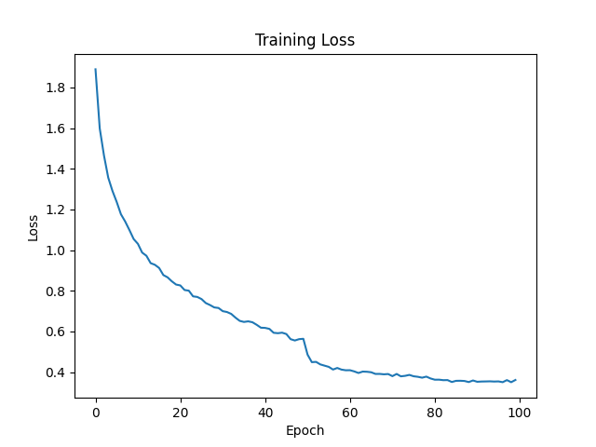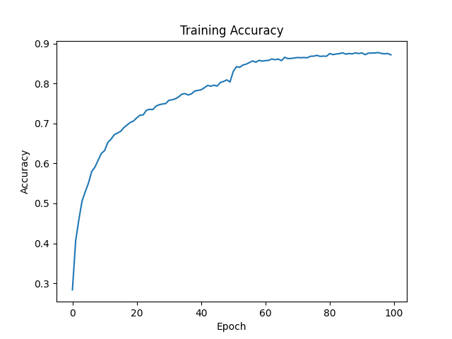

(3) Validation Loss (4) Validation Accuracy

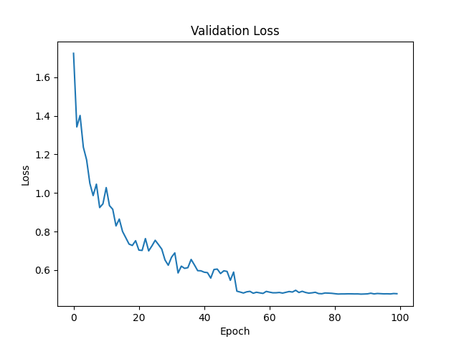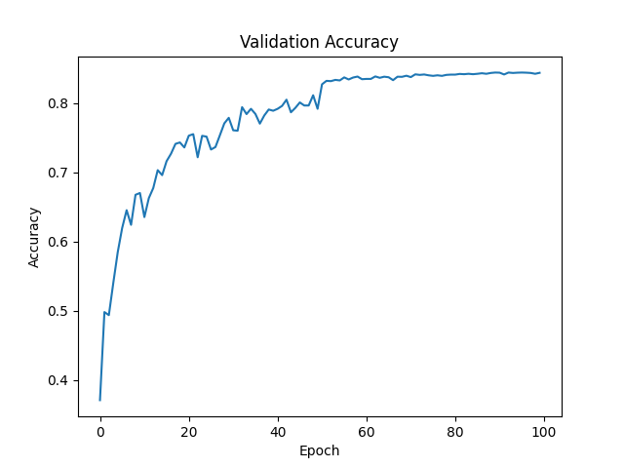**ResNet18**

(1) Training Loss (2) Training Accuracy

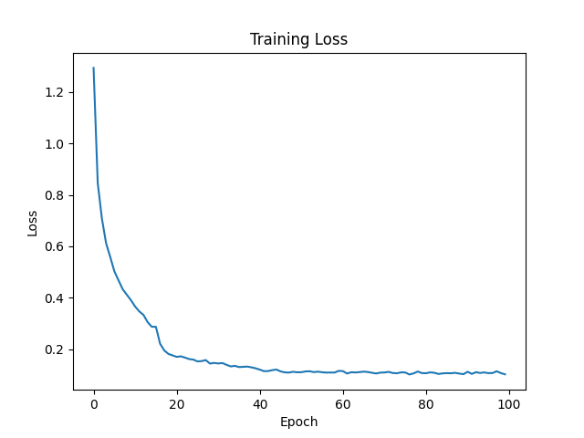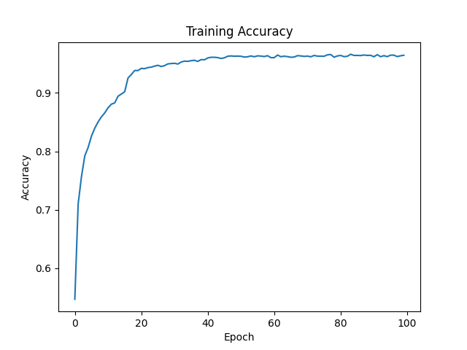

(3) Validation Loss (4) Validation Accuracy

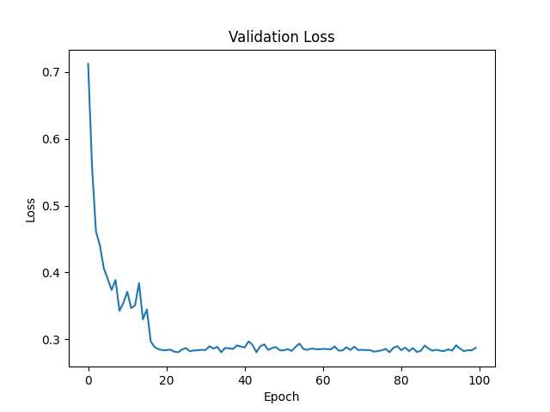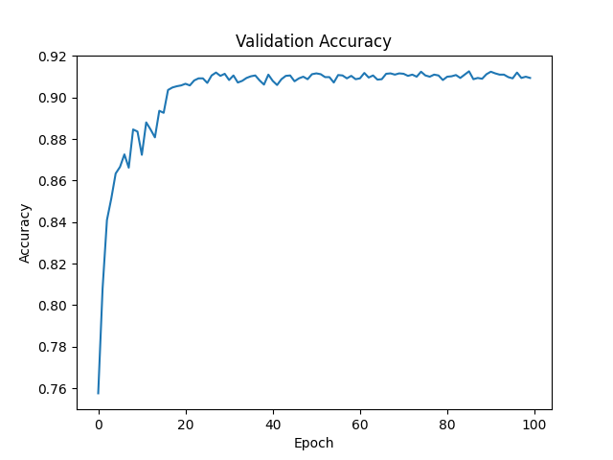

**• Briefly describe what method do you apply on your best model? (e.g. data augmentation, model architecture, loss function, etc) (10%)**

**Ans:**

**Data augmentation:**

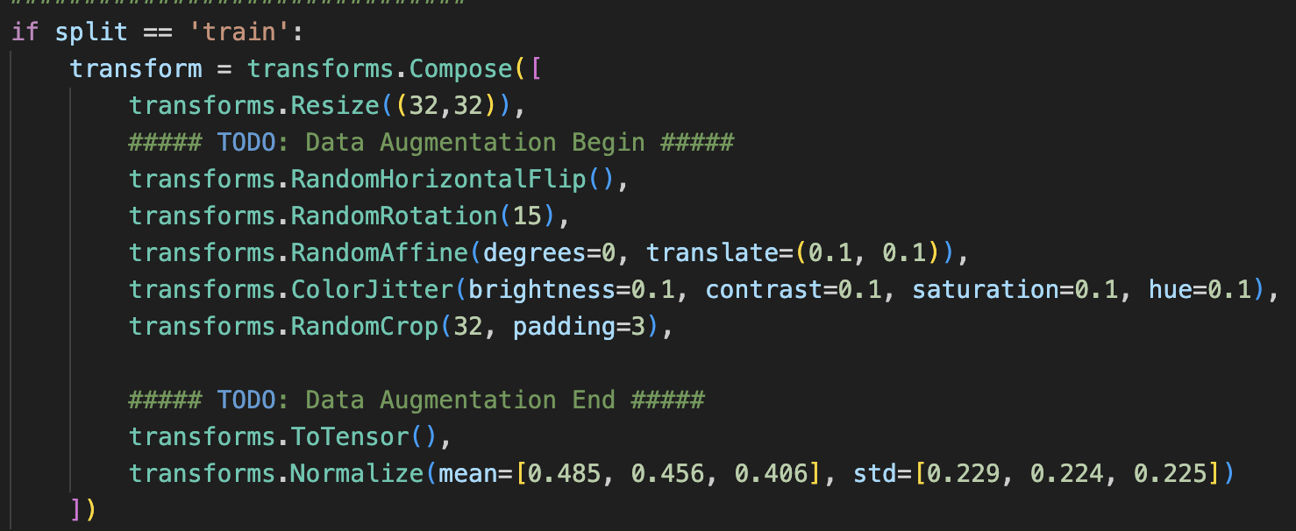

除了原有的Resize跟Normalize外，還有做RandonHorizontalFlip, RandomRotation, RandomAffine, ColorJitter, RandomCrop

**Model Architecture:**

MyNet的部分，原來前面只有四個Convolution並做Maxpooling，後來將Convolution後面做batch normalization及ReLU準確率就有顯著的進步。

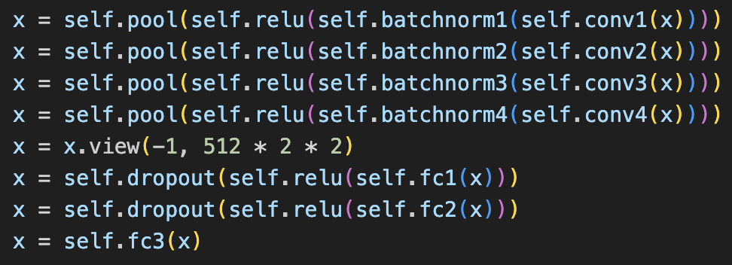

ResNet18的部分，則是在後面多加一層Convolution Layer(縮小kernel size至3)及做ReLU，並將Maxpool Layer換成Identity()，最後再加一層Fully Connected Layer。

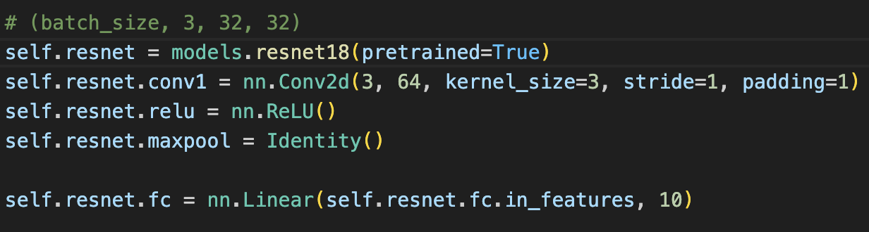

**Hyper Parameter (Config.py):**

在Config.py中，Epoch設為100，batch size調整成128。Learning rate則設為0.01，並在epoch為50, 80的時候動態減少 learning rate。