HW4

R12521601 詹承諺

HW4-1

1. What is the optimal solution?

x1: 3.000000

x2: 1.500000

Zs = 21.000000

1. What are the shadow prices and reduced costs?

reduced costs:

[0.0, 0.0]

shadow prices:

[0.75, 0.5, 0.0, 0.0]

1. What will be the objective function at the optimal state?

Z = 21 – 0.75 s1 – 0.5 s2

HW4-2

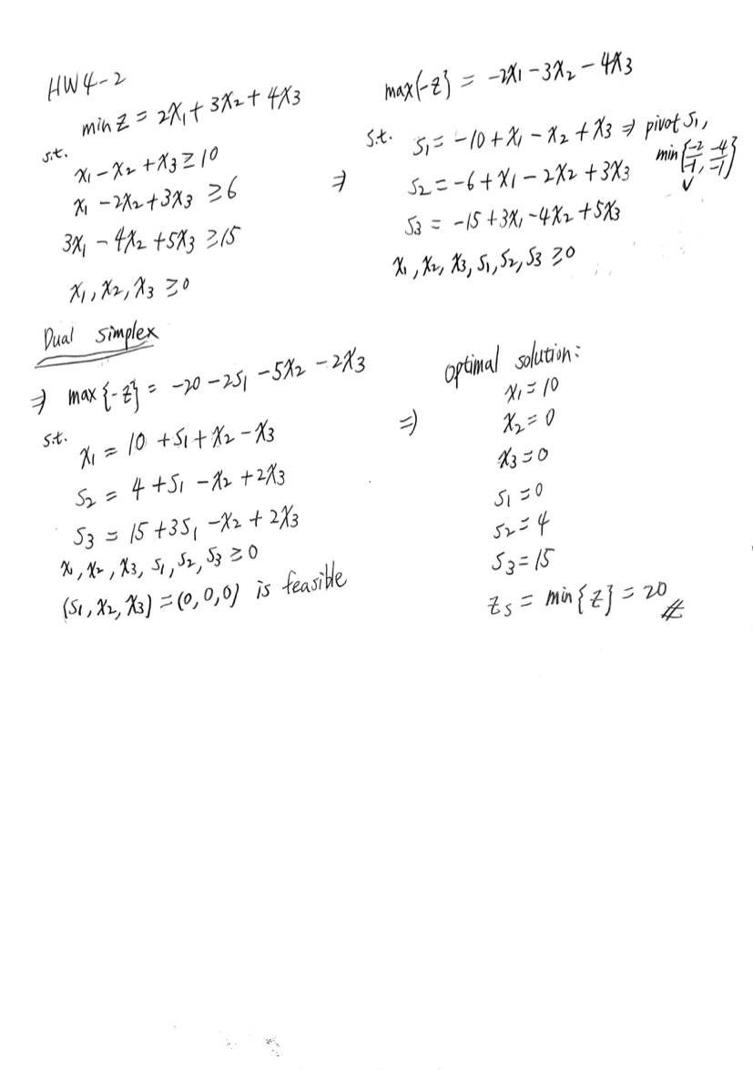

Q: Is it appropriate to use the (Primal) Simplex Method? Can you use the 2-Phase Method?

It’s not appropriate to use the (Primal) Simplex Method. If we change min{z} to max{-z}, we will get all bi < 0. To tackle this, we need to use the 2-phase Method.

Q: Would the Dual Simplex Method work?

As the handwritten sheet above, Dual Simplex Method is feasible.

Q: What if you convert the problem into its dual problem?

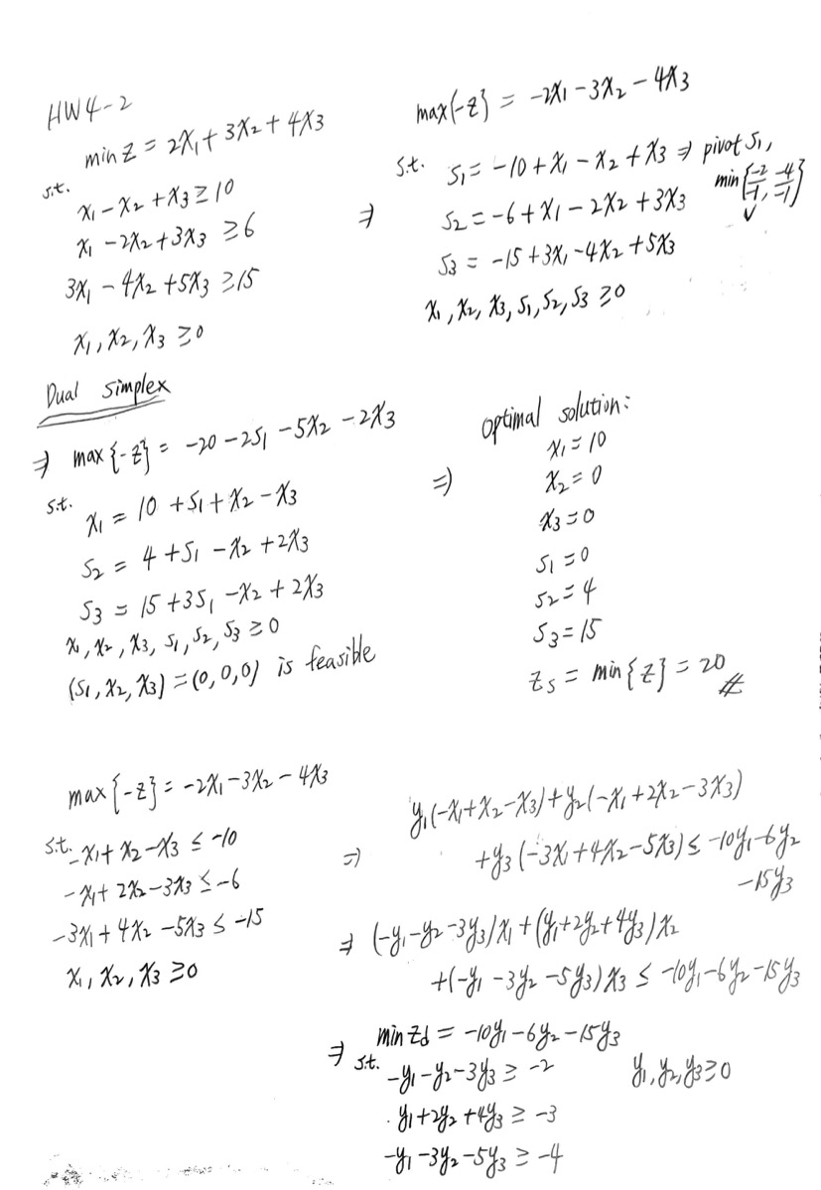

Q: Can you use the Simplex on the Dual problem?

(see next page)

