HW6

R12521601 詹承諺

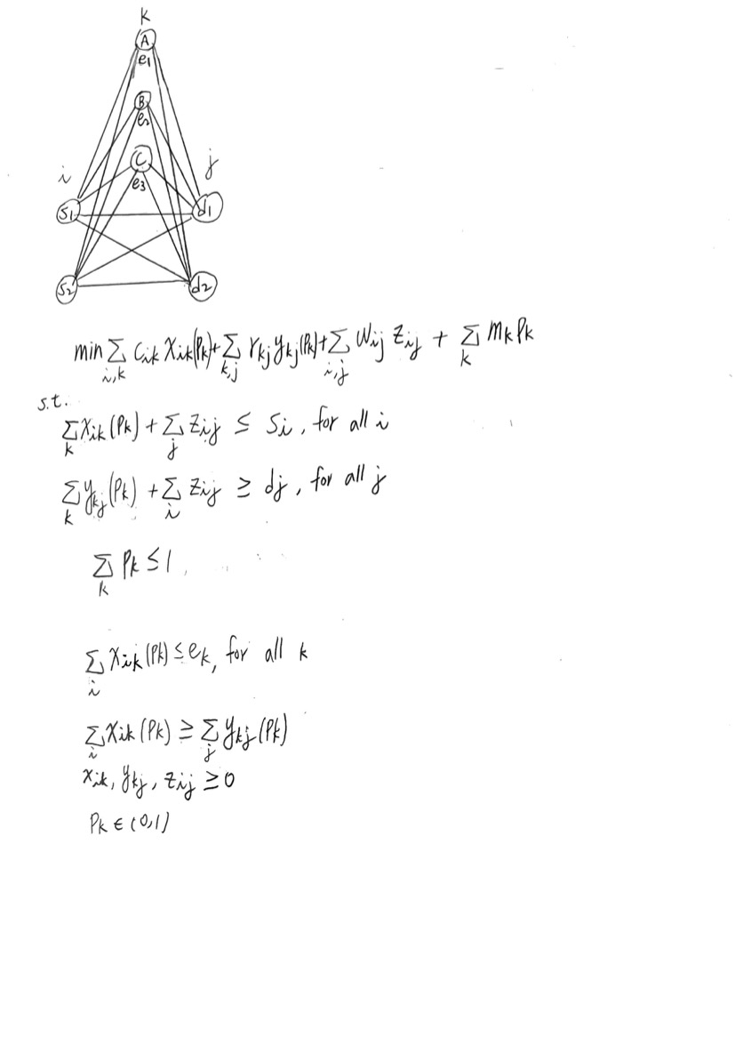

cik: the cost per unit transportation of products from supply point i to warehouse k

rkj: the cost per unit transportation of products from warehouse k to demand location j

wij: the cost per unit transportation of products from supply point i to demand location j

xik: the decision of how many units of products to be transported from supply location i to warehouse k

ykj: the decision of how many units of products to be transported from warehouse k to demand location j

zij: the decision of how many units of products to be transported from supply point i to demand location j

ek: the annual capacity of products that warehouse k can store

mk: warehouse 1-year cost

Pk: rent the warehouse or not (0 or 1)

Answer(by gurobi):

x11: 0

x12: 0

x13: 0

x21: 0

x22: 0

x23: 70

y11: 0

y12: 0

y21: 0

y22: 0

y31: 20

y32: 50

z11: 50

z12: 0

z21: 5

z22: 0

p1: 0

p2: 0

p3: 1

Obj: 623