HW9

R12521601 詹承諺

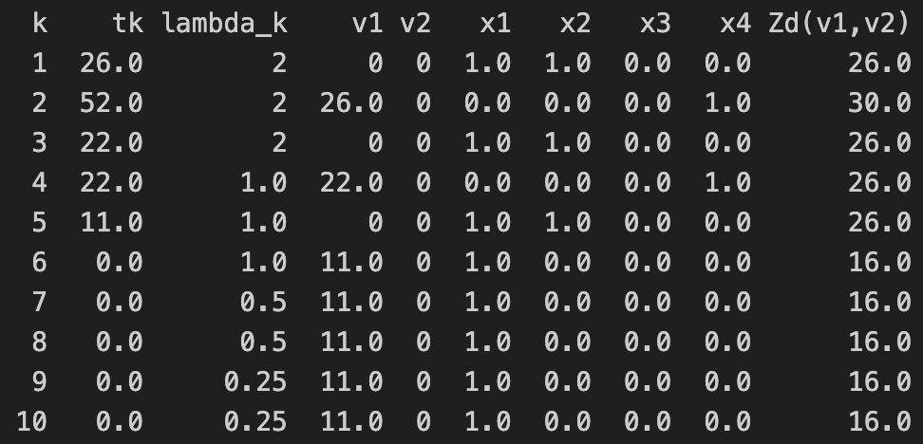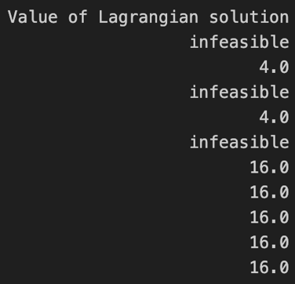

Final gap (10th iteration): ((Zd(u10)- Z\*)/Z)\*100%=0\*100%=0