Although this problem was too simple for an evolutionary algorithm, as it could be solved with a few for loops, I found that my evolutionary network was a lot faster than with the brute force method. The problem also has a good gradient curve and that would allow for a standard neural network with backpropagation to function, this would be a better solution to the problem.

I chose 100000 as a target as the optimal solution would almost reach this value and we are looking for the global optimum. I chose to use a pool size of 100 to allow enough diversity. The data is an array of 24 bits that will be splitted into 4 arrays of 6 bits. These arrays will be converted to the 4 parameters. Every cycle I retain the top 20% of my population, and I select a very low percentage of the population to be randomly picked and retained. My corssover iterates over every item in the genome data and has a 50/50 chance of taking from the mother or father. I think this is a better way of doing crossover, as this keeps working for the edges of the genome unlike other crossover methods. I also used a mutation chance of 0.01.

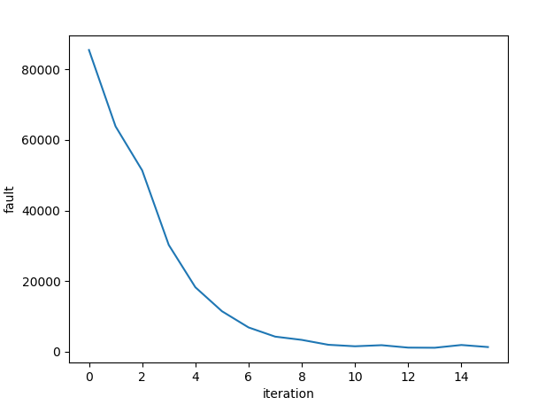Output shows the scores at each step and the final population

Output:

step 0 score: 63817.08

step 1 score: 51356.78

step 2 score: 30236.69

step 3 score: 18253.75

step 4 score: 11464.87

step 5 score: 6876.56

step 6 score: 4275.23

step 7 score: 3351.88

step 8 score: 1967.35

step 9 score: 1542.06

step 10 score: 1849.09

step 11 score: 1161.66

step 12 score: 1124.07

step 13 score: 1905.12

step 14 score: 1324.0

A: [0] B: [63] C: [0] D: [63]

A: [0] B: [63] C: [0] D: [63]

A: [0] B: [63] C: [0] D: [63]

A: [0] B: [63] C: [0] D: [63]

A: [0] B: [63] C: [0] D: [63]

A: [0] B: [63] C: [0] D: [63]

A: [0] B: [63] C: [0] D: [63]

A: [0] B: [63] C: [0] D: [63]

A: [0] B: [63] C: [0] D: [63]

A: [0] B: [63] C: [0] D: [63]

A: [0] B: [63] C: [0] D: [63]

A: [0] B: [63] C: [0] D: [63]

A: [0] B: [63] C: [0] D: [63]

A: [0] B: [63] C: [0] D: [63]

A: [0] B: [63] C: [0] D: [63]

A: [0] B: [63] C: [0] D: [63]

A: [0] B: [63] C: [0] D: [63]

A: [0] B: [63] C: [0] D: [63]

A: [0] B: [63] C: [0] D: [63]

A: [0] B: [63] C: [0] D: [63]

A: [0] B: [63] C: [0] D: [63]

A: [0] B: [63] C: [0] D: [63]

A: [0] B: [63] C: [0] D: [63]

A: [0] B: [63] C: [0] D: [63]

A: [0] B: [63] C: [0] D: [63]

A: [0] B: [63] C: [0] D: [63]

A: [0] B: [63] C: [0] D: [63]

A: [0] B: [63] C: [0] D: [63]

A: [0] B: [63] C: [0] D: [63]

A: [0] B: [63] C: [0] D: [63]

A: [0] B: [63] C: [0] D: [63]

A: [0] B: [63] C: [0] D: [63]

A: [0] B: [63] C: [0] D: [63]

A: [0] B: [63] C: [0] D: [63]

A: [0] B: [63] C: [0] D: [63]

A: [0] B: [63] C: [0] D: [63]

A: [0] B: [63] C: [0] D: [63]

A: [0] B: [63] C: [0] D: [63]

A: [0] B: [63] C: [0] D: [63]

A: [0] B: [63] C: [0] D: [63]

A: [0] B: [63] C: [0] D: [63]

A: [0] B: [63] C: [0] D: [63]

A: [0] B: [63] C: [0] D: [63]

A: [0] B: [63] C: [0] D: [63]

A: [0] B: [63] C: [0] D: [63]

A: [0] B: [63] C: [0] D: [63]

A: [0] B: [63] C: [0] D: [63]

A: [0] B: [63] C: [0] D: [63]

A: [0] B: [63] C: [0] D: [63]

A: [0] B: [63] C: [0] D: [63]

A: [0] B: [63] C: [0] D: [63]

A: [0] B: [63] C: [0] D: [63]

A: [0] B: [63] C: [0] D: [63]

A: [0] B: [63] C: [0] D: [63]

A: [0] B: [63] C: [0] D: [63]

A: [0] B: [63] C: [0] D: [63]

A: [0] B: [63] C: [0] D: [63]

A: [0] B: [63] C: [0] D: [63]

A: [0] B: [63] C: [0] D: [63]

A: [0] B: [63] C: [0] D: [63]

A: [16] B: [61] C: [0] D: [63]

A: [0] B: [63] C: [0] D: [63]

A: [0] B: [63] C: [0] D: [63]

A: [0] B: [63] C: [0] D: [63]

A: [0] B: [63] C: [0] D: [63]

A: [0] B: [63] C: [0] D: [63]

A: [0] B: [63] C: [0] D: [63]

A: [0] B: [63] C: [0] D: [63]

A: [0] B: [63] C: [0] D: [63]

A: [0] B: [63] C: [0] D: [63]

A: [0] B: [63] C: [0] D: [63]

A: [0] B: [63] C: [0] D: [63]

A: [0] B: [63] C: [0] D: [63]

A: [0] B: [63] C: [0] D: [63]

A: [0] B: [63] C: [0] D: [63]

A: [0] B: [63] C: [0] D: [63]

A: [0] B: [63] C: [0] D: [63]

A: [0] B: [63] C: [0] D: [63]

A: [0] B: [63] C: [0] D: [63]

A: [0] B: [63] C: [0] D: [63]

A: [0] B: [63] C: [0] D: [63]

A: [0] B: [63] C: [0] D: [63]

A: [0] B: [63] C: [0] D: [63]

A: [0] B: [63] C: [0] D: [63]

A: [0] B: [63] C: [0] D: [63]

A: [0] B: [63] C: [0] D: [63]

A: [0] B: [63] C: [0] D: [63]

A: [0] B: [63] C: [0] D: [63]

A: [0] B: [63] C: [0] D: [63]

A: [0] B: [63] C: [0] D: [63]

A: [0] B: [63] C: [0] D: [63]

A: [0] B: [63] C: [0] D: [63]

A: [0] B: [63] C: [0] D: [63]

A: [0] B: [63] C: [0] D: [63]

A: [0] B: [63] C: [0] D: [63]

A: [0] B: [63] C: [0] D: [63]

A: [0] B: [63] C: [0] D: [63]

A: [0] B: [63] C: [0] D: [63]

A: [0] B: [63] C: [0] D: [63]

A: [0] B: [63] C: [0] D: [63]