An XOR gate requires at least one hidden layer. An extra hidden layer adds an extra seperation, and this is needed to create a XOR gate as show in the picture below:

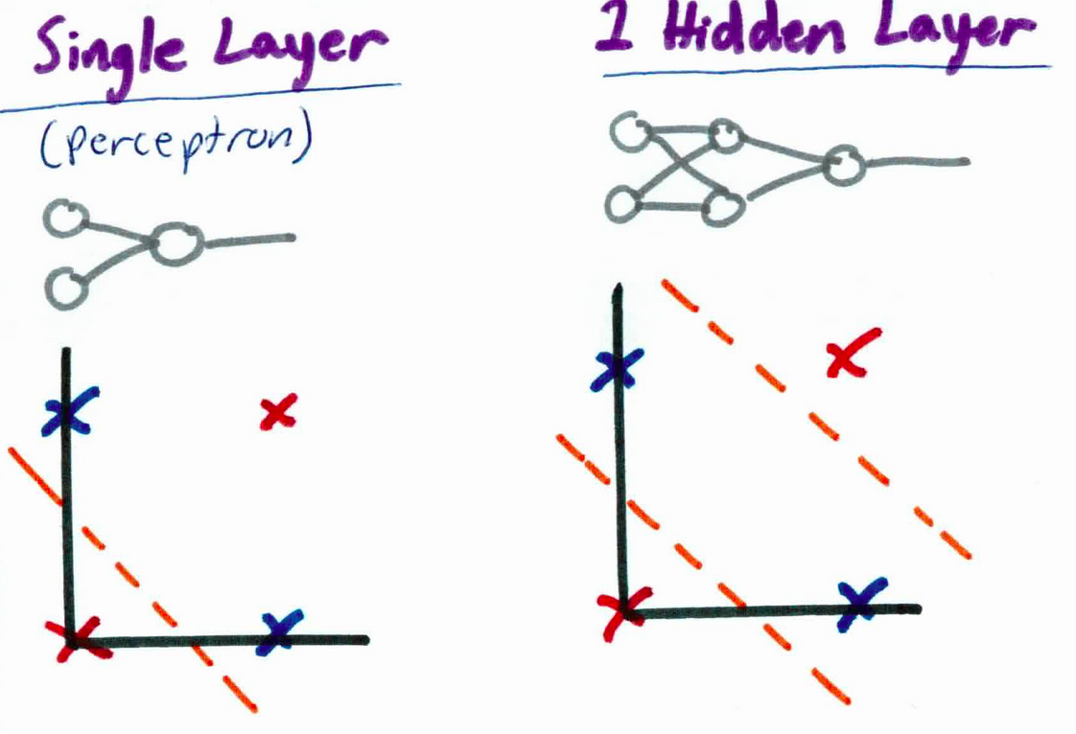

Output:

STARTING NETWORK:

hidden layer 0:

rate of change: 0.1 bias: -0.20495568931615593 weigths:[-0.82557696 0.44726723] node number: 0 output_node: False current delta: None

rate of change: 0.1 bias: -0.20495568931615593 weigths:[0.75143873 0.45534765] node number: 1 output_node: False current delta: None

output layer:

rate of change: 0.1 bias: -0.20495568931615593 weigths:[0.93993397 0.18352052] node number: 0 output_node: True current delta: None

fault: 0.1504354546764683

fault: 0.06613927969419449

fault: 0.04734070454494123

fault: 0.038388569248550185

fault: 0.03296587162309039

fault: 0.029255510794090552

fault: 0.026521639851207895

fault: 0.024404276421481748

fault: 0.022704477984714526

fault: 0.021302456354936793

fault: 0.02012133267172747

fault: 0.019109268038901436

fault: 0.018229902117000315

fault: 0.017456896366070517

fault: 0.01677065299283154

fault: 0.01615625508916466

fault: 0.015602125602623085

fault: 0.015099126791103014

fault: 0.01463993905592221

fault: 0.014218622342433089

fault: 0.013830300004512214

fault: 0.0134709267347662

fault: 0.013137115399578025

fault: 0.012826005915170906

fault: 0.012535164630333625

fault: 0.012262506180903812

fault: 0.012006232125097662

fault: 0.01176478226744001

fault: 0.011536795687650227

fault: 0.011321079271149219

fault: 0.011116582094901408

fault: 0.010922374425119879

fault: 0.01073763037806488

fault: 0.01056161351320773

fault: 0.01039366479104284

fault: 0.010233192450824798

fault: 0.010079663457221997

END NETWORK:

hidden layer 0:

rate of change: 0.1 bias: 1.9642146999692944 weigths:[-1.33291633 -1.286785 ] node number: 0 output_node: False current delta: 0.00012128140718883016

rate of change: 0.1 bias: -0.8866947677092957 weigths:[2.58511557 2.34306172] node number: 1 output_node: False current delta: 2.0119818744798838e-07

output layer:

rate of change: 0.1 bias: -0.9020776857155743 weigths:[2.79092579 2.50945635] node number: 0 output_node: True current delta: 6.495896681536709e-05

took 375368 updates and 93842.0 batches

input: [0 0] result: [4.15165613e-05] desired: [0]

input: [0 1] result: [0.995005] desired: [1]

input: [1 0] result: [0.99510159] desired: [1]

input: [1 1] result: [6.49581917e-05] desired: [0]