I wrote my own vectorised neural network and tested training a nor gate.

This is the learning curve of my nor gate classifier

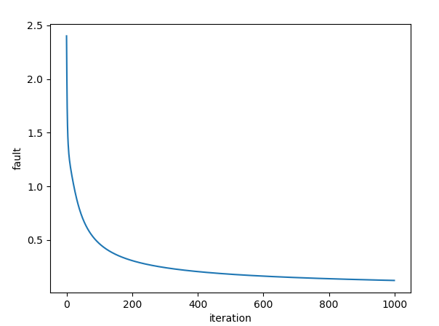Output:

[array([[0.06784816, 0.10104791, 0.84987415]])]

input: [0 0] result: [0.94502659] desired: 1

input: [0 1] result: [0.03421511] desired: 0

input: [1 0] result: [0.03428519] desired: 0

input: [1 1] result: [7.31597135e-05] desired: 0