I wrote my own vectorised neural network and tested training a xor gate.

This is the learning curve of my xor gate classifier. The bias is the first weight in the the matrix. I chose to use a network with 2 input nodes a hidden layer with 16 nodes and 1 output node to stress test my network and make use of the performance optimizations of using a vectorised network.

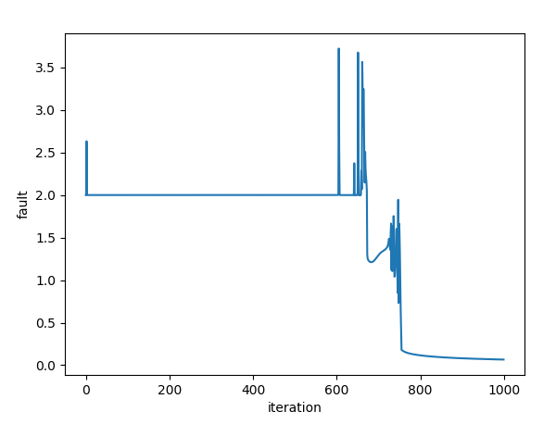

Output:

[array([[0.37831907, 0.01225668, 0.42133523],

[0.16289426, 0.71969282, 0.35999138],

[0.29164655, 0.7518964 , 0.92896387],

[0.24981432, 0.18344643, 0.988275 ],

[0.21630721, 0.46709587, 0.91717362],

[0.86005212, 0.8902431 , 0.20240678],

[0.09168292, 0.21825519, 0.51186391],

[0.93514752, 0.5947119 , 0.50445705],

[0.86452986, 0.70463244, 0.4736144 ],

[0.10764527, 0.07221093, 0.36696078],

[0.15372995, 0.4677052 , 0.34744445],

[0.09533551, 0.55239359, 0.33988849],

[0.17215499, 0.93558232, 0.26074444],

[0.75639993, 0.78675425, 0.8037097 ],

[0.90256246, 0.80274095, 0.37388418],

[0.55192904, 0.60794807, 0.80771971]]), array([[0.60503293, 0.4119201 , 0.30973824, 0.6378657 , 0.25669049,

0.06952465, 0.05653169, 0.27457478, 0.9735542 , 0.65528241,

0.27990704, 0.84324689, 0.81663416, 0.13437776, 0.81962365,

0.47126404, 0.25515927]])]

input: [0 0] result: [0.01766095] desired: [0]

input: [0 1] result: [0.98495961] desired: [1]

input: [1 0] result: [0.98347808] desired: [1]

input: [1 1] result: [0.01588274] desired: [0]