Results
This section presents all experimental results organized into five parts: (1) Exploratory Data Analysis, (2) Core Model Comparison, (3) Regional Analysis, (4) Geopolitical Event & Outlier Analysis, and (5) Concept Drift Analysis.

1. Exploratory Data Analysis
We first explore the dataset to understand price trends, volatility patterns, and feature relationships before modeling.

1.1 Price Trends
U.S. gasoline prices show strong long-term trends with several major disruptions, including the 2008 spike and the COVID-19 crash.
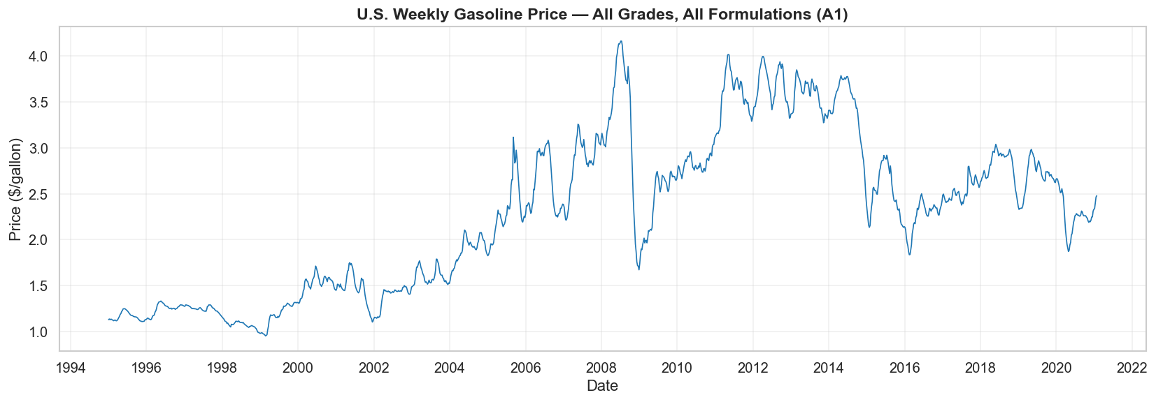
Figure 1: U.S. Weekly Gasoline Price (All Grades, 1995-2021)
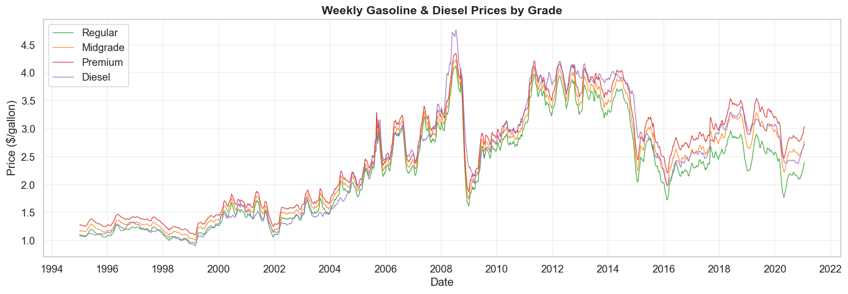
Figure 2: Weekly Gasoline & Diesel Prices by Grade

1.2 Price Distribution
Prices range from about $1 to $4 per gallon with a right-skewed distribution, reflecting occasional high-price spikes.
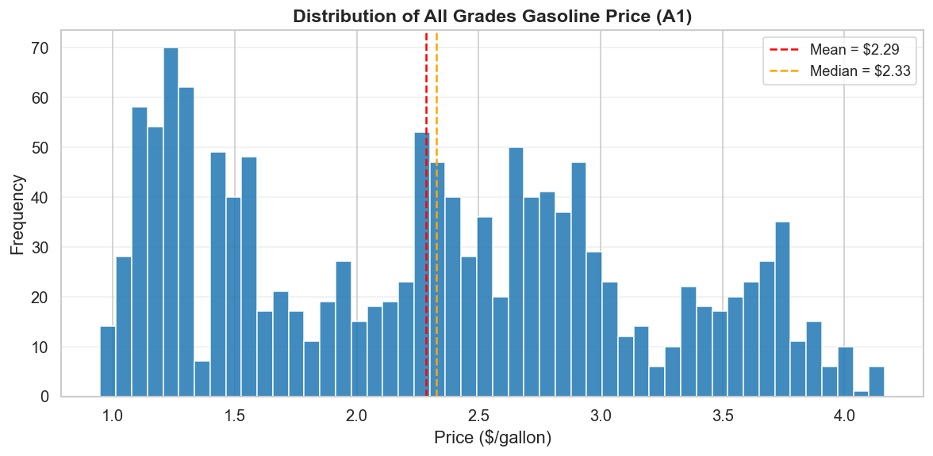
Figure 3: Distribution of All Grades Gasoline Price
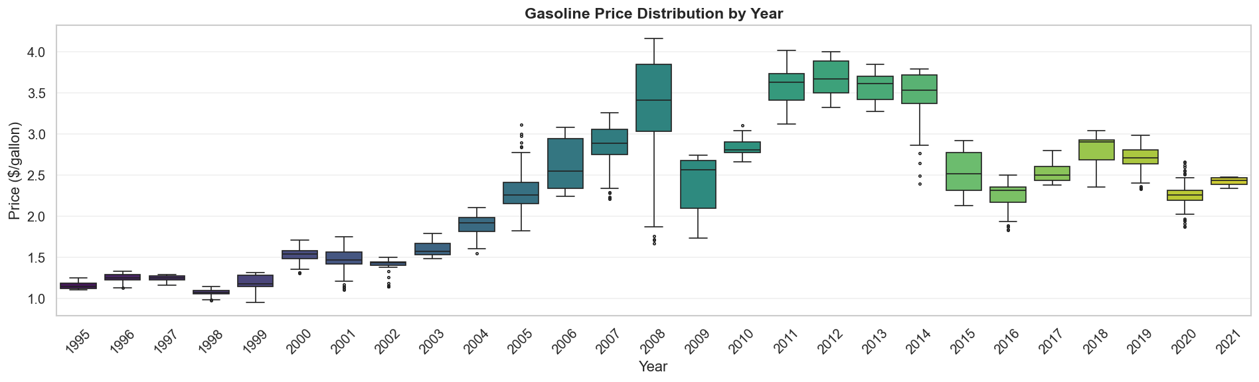
Figure 4: Gasoline Price Distribution by Year

1.3 Volatility Analysis
Weekly price changes are mostly small, but extreme swings cluster around major geopolitical events like the 2008 crisis and Hurricane Katrina.
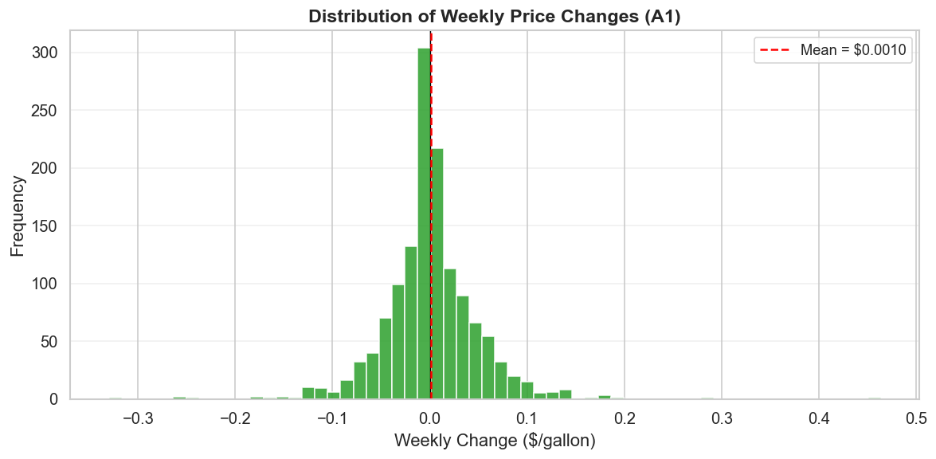
Figure 5: Distribution of Weekly Price Changes
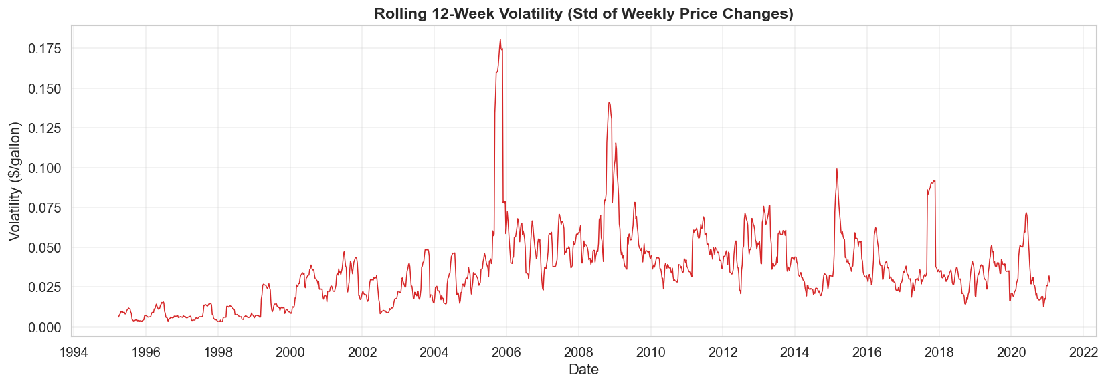
Figure 6: Rolling 12-Week Volatility
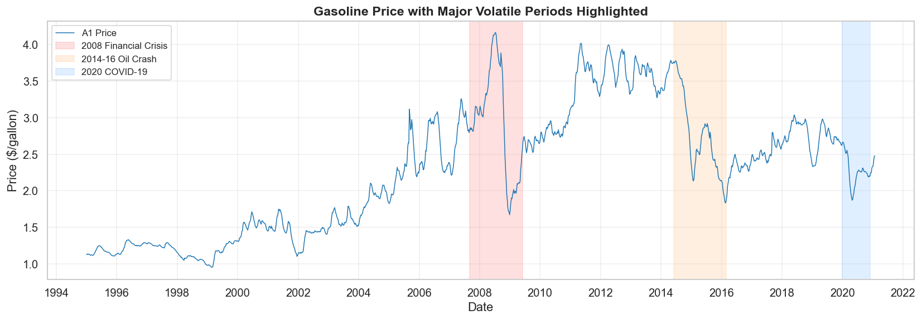
Figure 7: Gasoline Price with Major Volatile Periods Highlighted

1.4 Feature Engineering & Correlation
We engineer 30+ features including lag prices, rolling statistics, momentum indicators, and date features. Lag-1 price has the strongest correlation with the target.
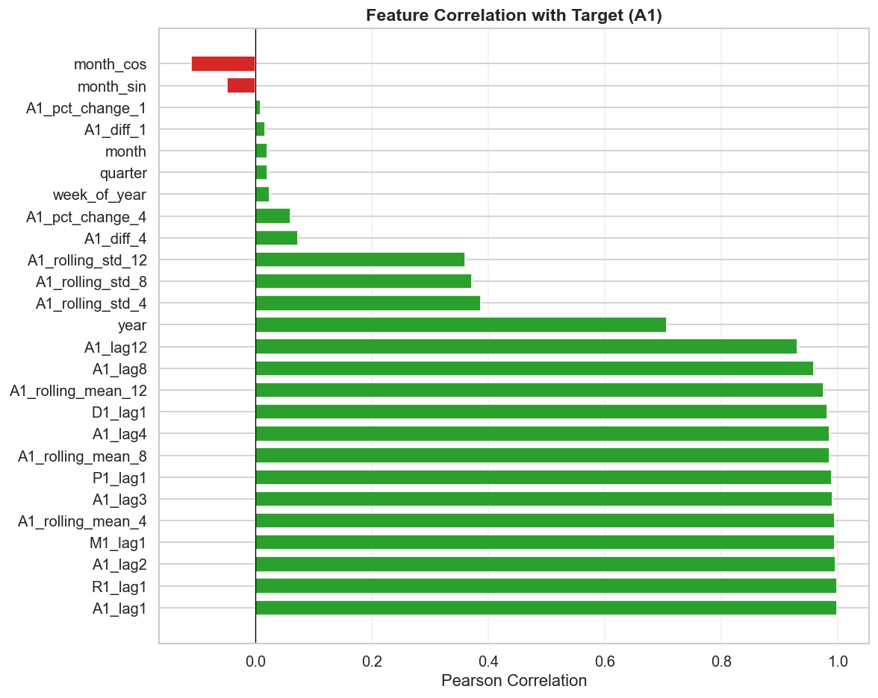
Figure 8: Feature Correlation with Target
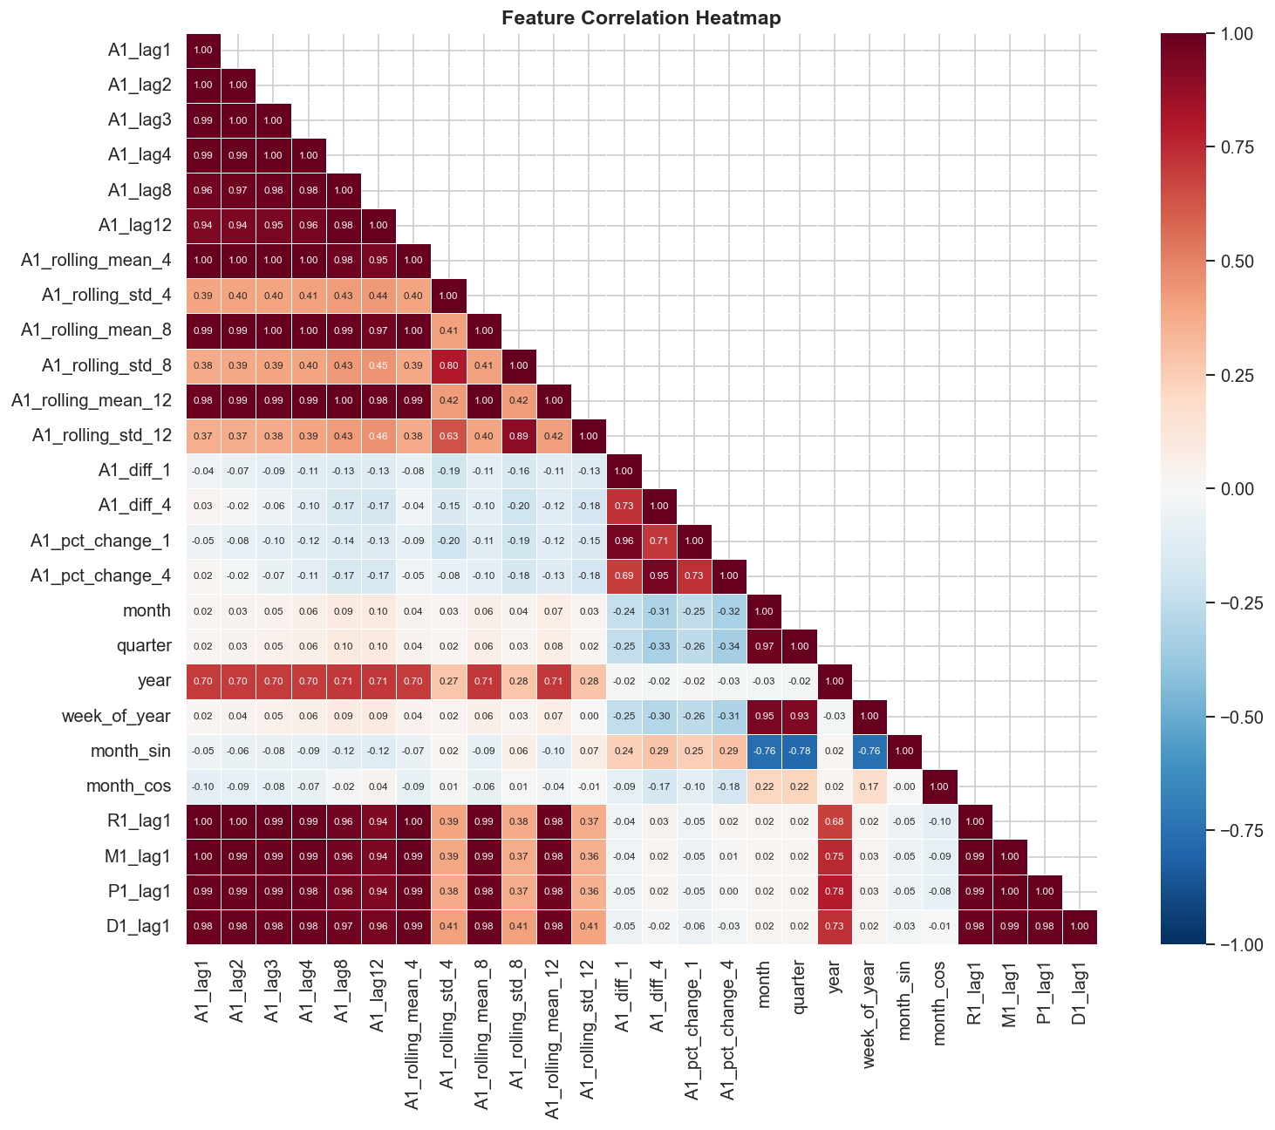
Figure 9: Feature Correlation Heatmap

1.5 Data Split
We use a chronological 70/15/15 split to respect the time series nature of the data: Train (1995-2013), Validation (2013-2017), Test (2017-2021).
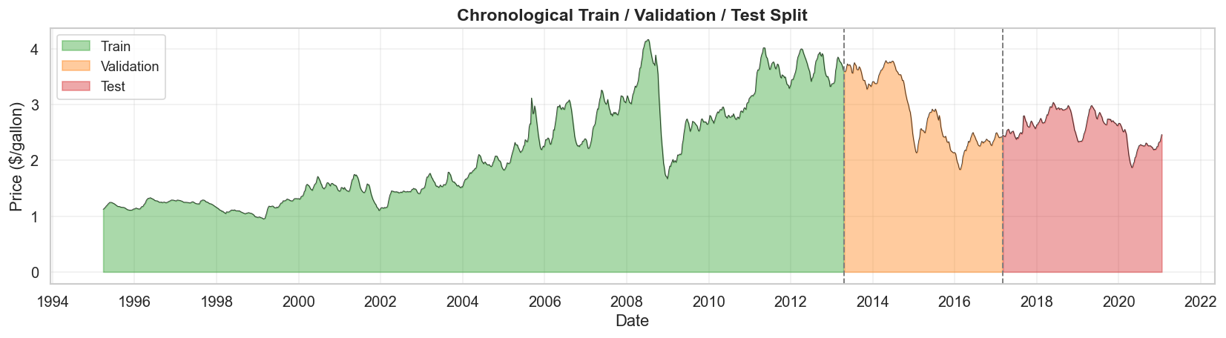
Figure 10: Chronological Train / Validation / Test Split

2. Core Model Comparison (1-Week Horizon)
We compare 15 model configurations across 5 categories. Surprisingly, Linear Regression with engineered features achieves the best overall performance.

2.1 All Models - 1-Week Horizon
Table 1 ranks all models by test RMSE. Linear Regression (full features) is the clear winner with RMSE=0.0412 and MAPE=1.18%.
Model | Features | Val RMSE | Val MAE | Val MAPE | Test RMSE | Test MAE | Test MAPE
Linear Regression | full | 0.0446 | 0.0357 | 1.33% | 0.0412 | 0.0303 | 1.18%
Lasso Regression | full | 0.0447 | 0.0359 | 1.34% | 0.0543 | 0.0452 | 1.78%
Linear Regression | basic | 0.0741 | 0.0576 | 2.10% | 0.0666 | 0.0481 | 1.86%
Naive Baseline | full | 0.0869 | 0.0681 | 2.54% | 0.0766 | 0.0576 | 2.28%
XGBoost (tuned) | full | 0.0570 | 0.0449 | 1.64% | 0.0772 | 0.0610 | 2.36%
LSTM-B (h=64,L=1,s=12) | full | 0.0709 | 0.0535 | 1.99% | 0.0921 | 0.0733 | 2.91%
GRU (h=64,L=2,s=12) | full | 0.0752 | 0.0568 | 2.09% | 0.0933 | 0.0742 | 2.91%
LSTM-A (h=32,L=1,s=8) | full | 0.0809 | 0.0623 | 2.31% | 0.0999 | 0.0818 | 3.25%
LSTM-C (h=64,L=2,s=12) | full | 0.0809 | 0.0635 | 2.41% | 0.1003 | 0.0794 | 3.25%
Random Forest (tuned) | full | 0.0797 | 0.0567 | 2.09% | 0.1065 | 0.0901 | 3.51%
LSTM-D (h=128,L=2,s=12) | full | 0.0784 | 0.0600 | 2.27% | 0.1087 | 0.0893 | 3.60%
Ridge Regression | full | 0.0567 | 0.0480 | 1.83% | 0.1119 | 0.1042 | 4.13%
MLP-Medium [128,64,32] | full | 0.1291 | 0.1073 | 3.66% | 0.1355 | 0.1065 | 4.30%
MLP-Large [256,128,64,32] | full | 0.1186 | 0.0996 | 3.68% | 0.1491 | 0.1156 | 4.87%
MLP-Small [64,32] | full | 0.1343 | 0.1117 | 4.00% | 0.1593 | 0.1317 | 5.23%
Table 1: All models - 1-week horizon, sorted by Test RMSE.

2.2 Model Category Comparison
When grouping by model type, linear models dominate. Neural networks underperform due to the small dataset size (~1,300 training samples).
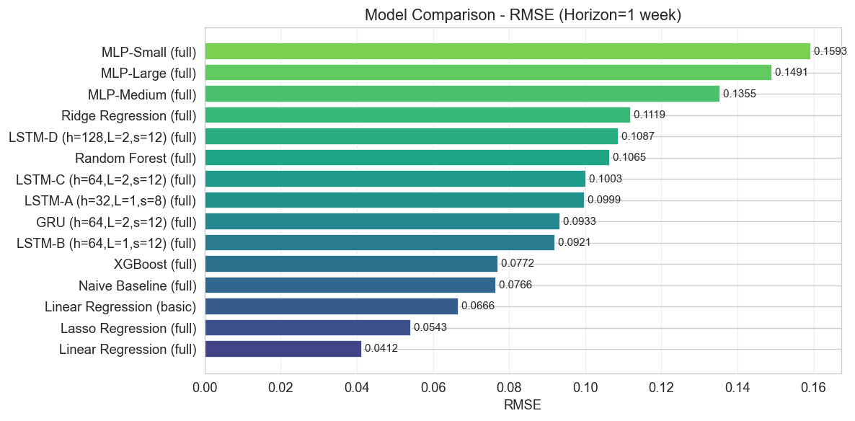
Figure 11: Model Category Comparison - 1-Week Horizon
Category | Best Model | RMSE | MAE | MAPE
Baseline | Naive Baseline | 0.0766 | 0.0576 | 2.28%
Linear | Linear Regression | 0.0412 | 0.0303 | 1.18%
Tree-Based | XGBoost | 0.0772 | 0.0610 | 2.36%
Recurrent (LSTM) | LSTM-B | 0.0921 | 0.0733 | 2.91%
Recurrent (GRU) | GRU | 0.0933 | 0.0742 | 2.91%
Feedforward (MLP) | MLP-Medium | 0.1355 | 0.1065 | 4.30%
Table 2: Best model per category.

2.3 Prediction Visualizations
The following plots show predicted vs actual prices on the test set. Linear models track the actual prices most closely.
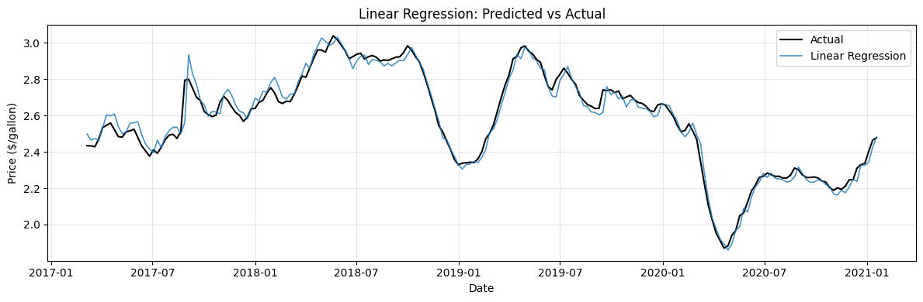
Figure 12: Linear Regression - Predictions vs Actual
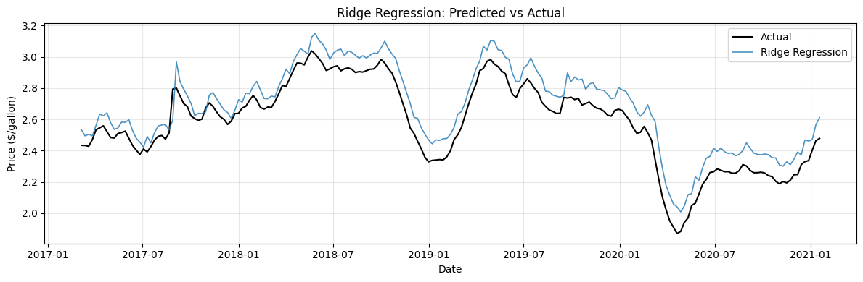
Figure 13: Ridge Regression - Predictions vs Actual
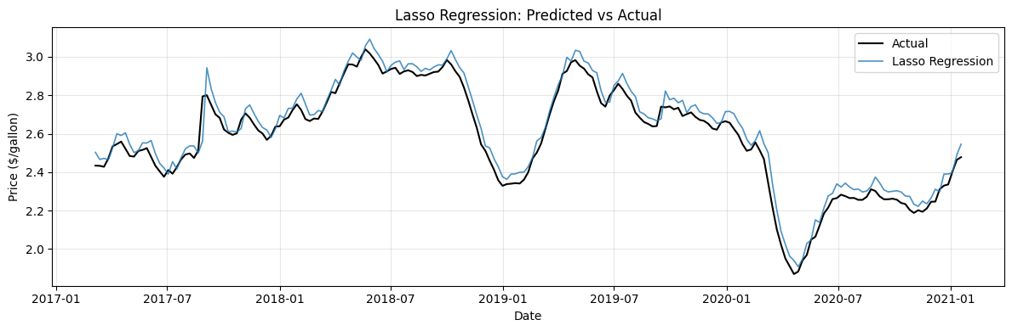
Figure 14: Lasso Regression - Predictions vs Actual
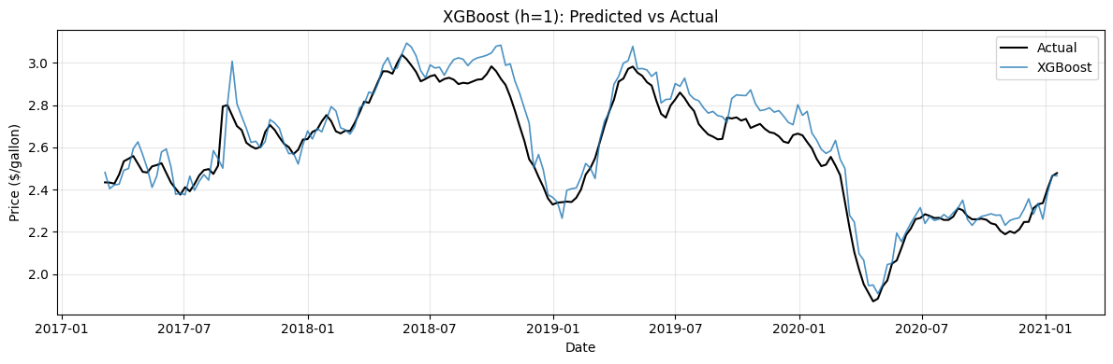
Figure 15: Tree-Based Models - Predictions vs Actual
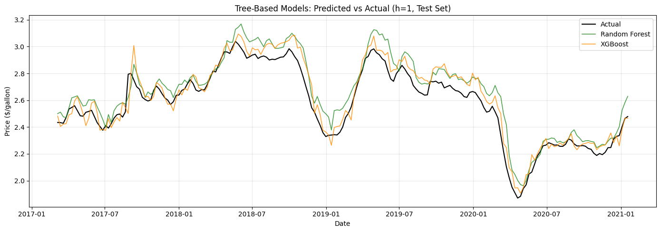
Figure 16: Tree-Based Models Overlay
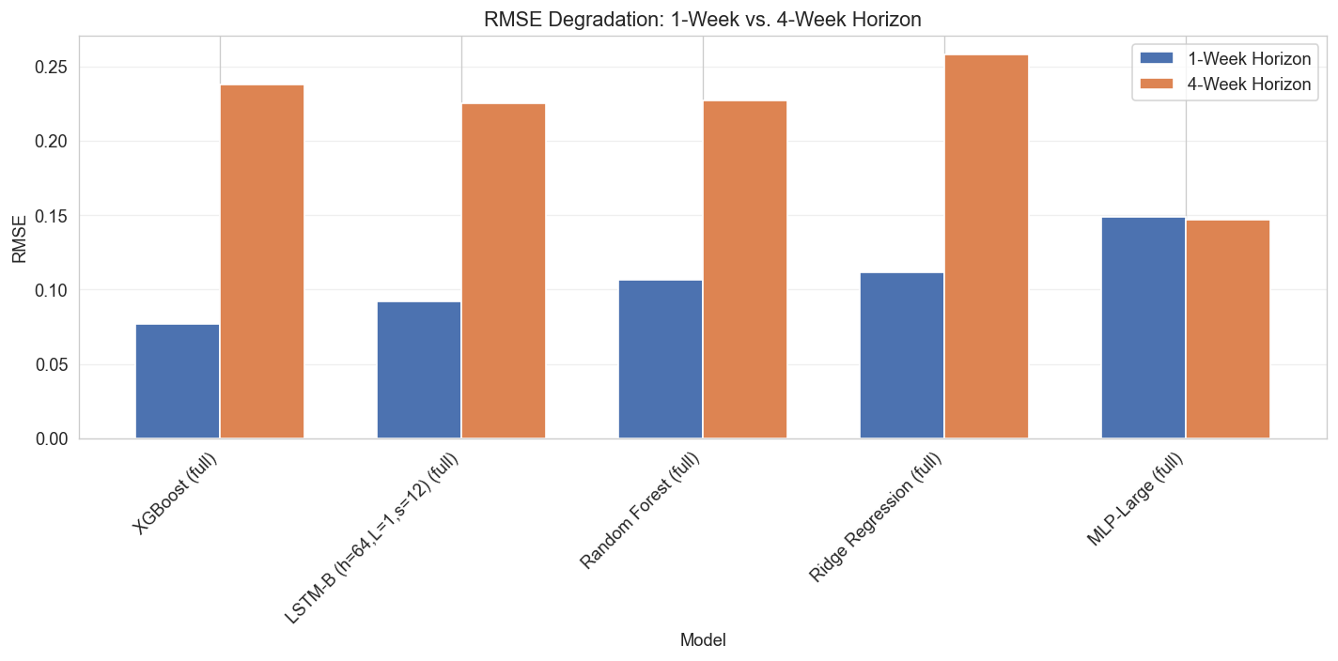
Figure 17: Top Model Predictions vs Actual

2.4 Feature Importance
Across all models, lag-1 price is by far the most important feature, confirming the strong autocorrelation in gasoline prices.
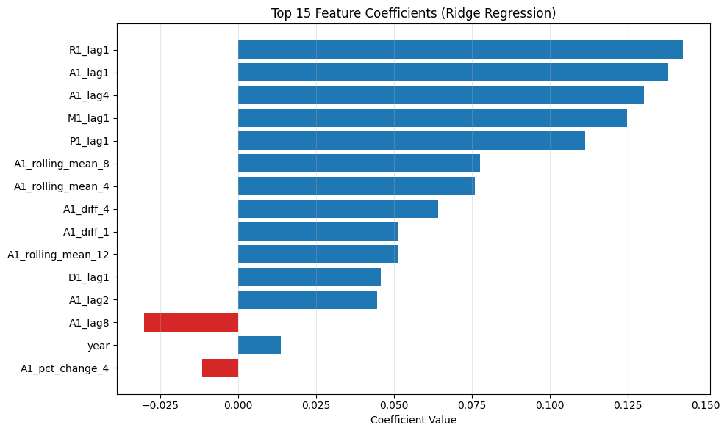
Figure 18: Top 15 Feature Coefficients (Ridge)
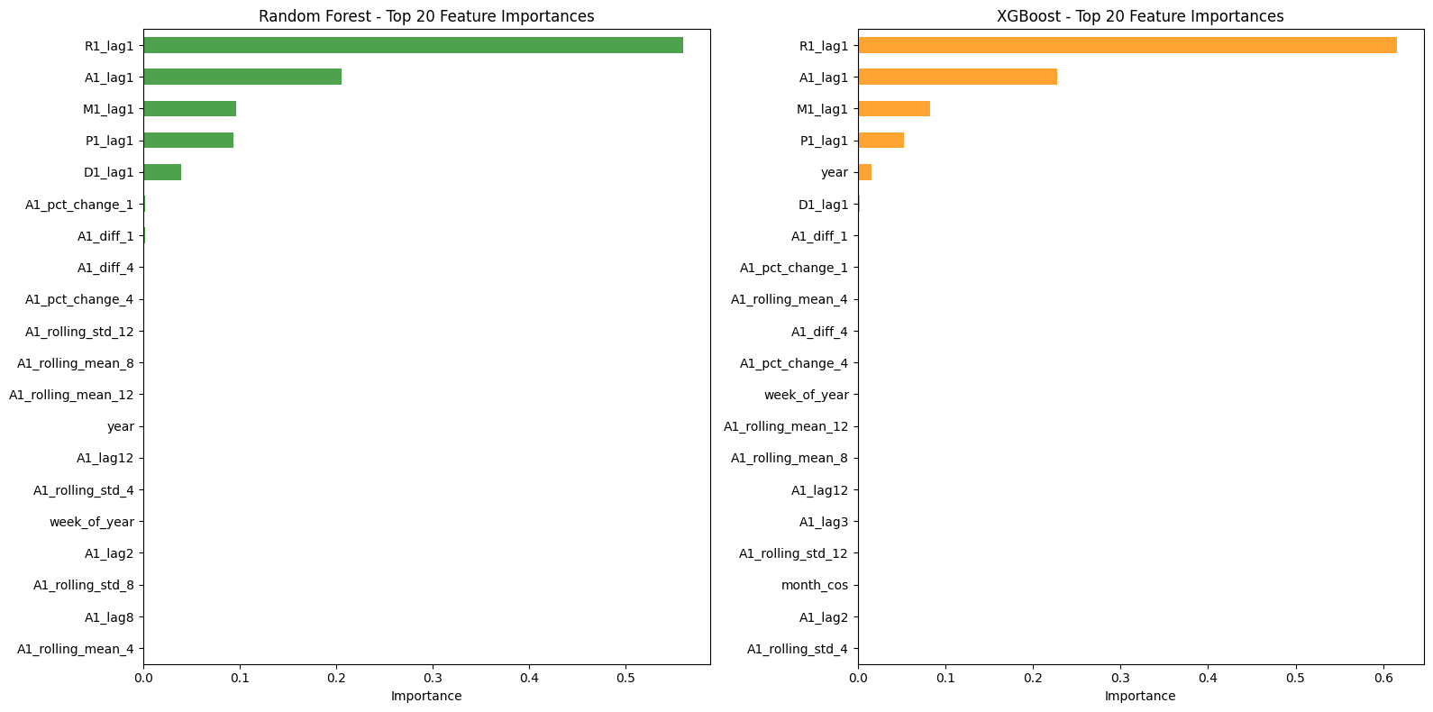
Figure 19: Random Forest - Top 20 Feature Importances
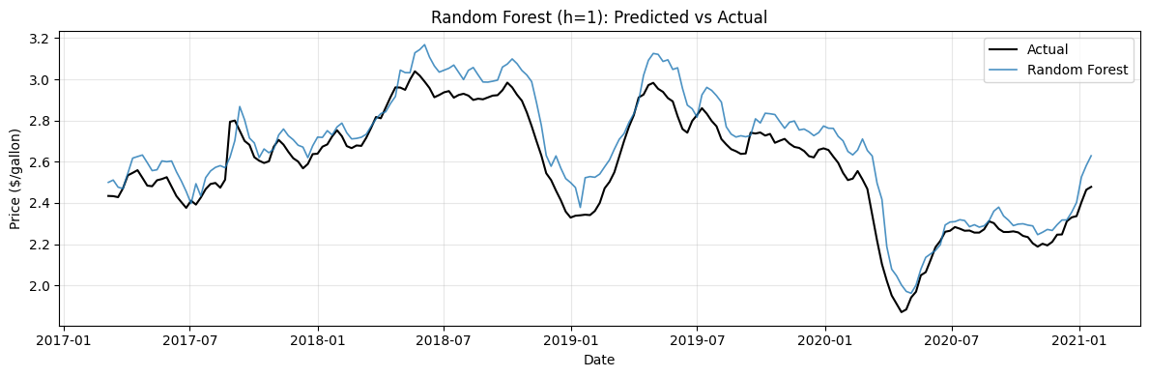
Figure 20: XGBoost - Top 20 Feature Importances

2.5 Feature Engineering Impact
Adding rolling statistics, momentum, and date features reduces Linear Regression RMSE by 38% compared to using only lag features.
Model | Basic (RMSE / MAPE) | Full (RMSE / MAPE) | Improvement
Linear Regression | 0.0666 / 1.86% | 0.0412 / 1.18% | 38.1%
Table 3: Feature engineering impact.
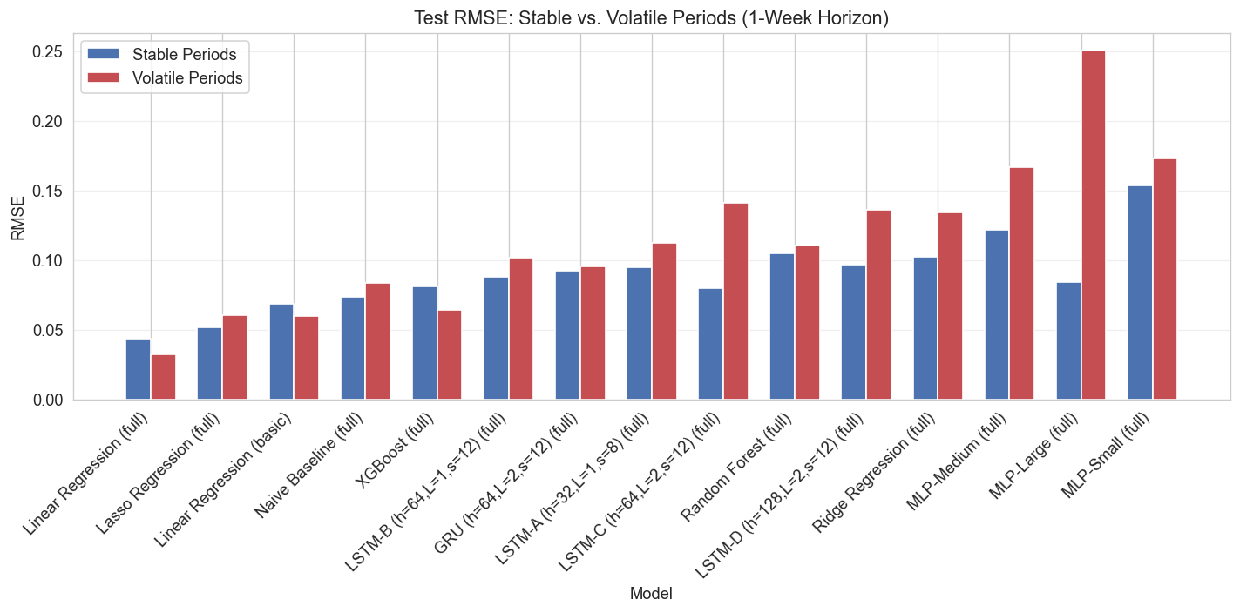
Figure 21: Impact of Feature Engineering

2.6 Stable vs Volatile Periods
All models perform worse during volatile periods (e.g., 2020 COVID crash), but linear models degrade the least.
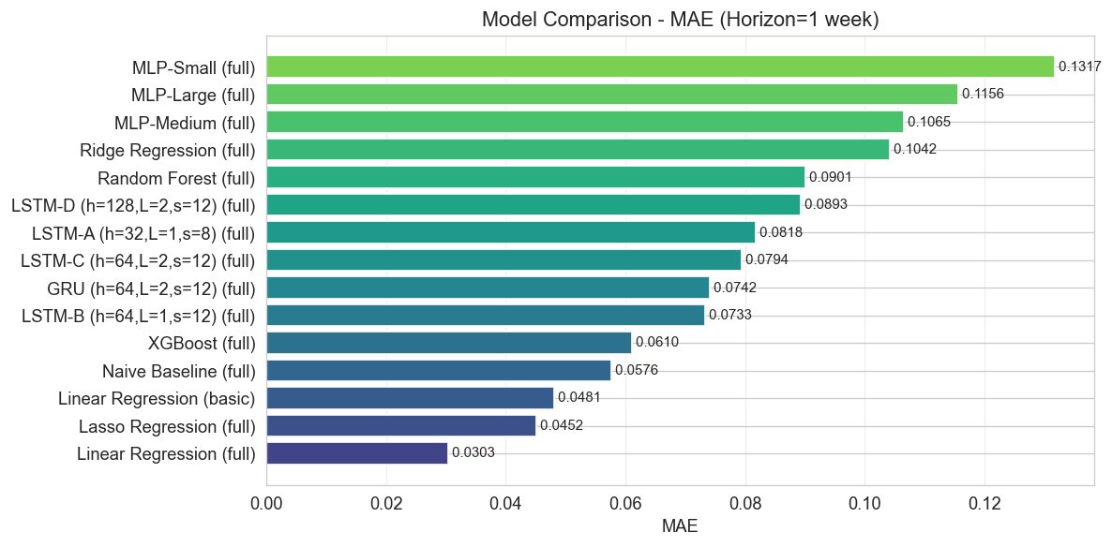
Figure 22: Test RMSE - Stable vs Volatile Periods

2.7 Horizon Comparison (1-Week vs 4-Week)
Predicting 4 weeks ahead is much harder. Most models see RMSE degrade by 100-200%, which is expected for time series with inherent uncertainty.
Model | 1-Week RMSE | 4-Week RMSE | Degradation
Ridge Regression | 0.1119 | 0.2580 | +130.6%
Random Forest | 0.1065 | 0.2269 | +113.0%
XGBoost | 0.0772 | 0.2379 | +208.2%
LSTM-B | 0.0921 | 0.2252 | +144.5%
MLP-Large | 0.1491 | 0.1471 | -1.3%
Table 4: Horizon comparison.
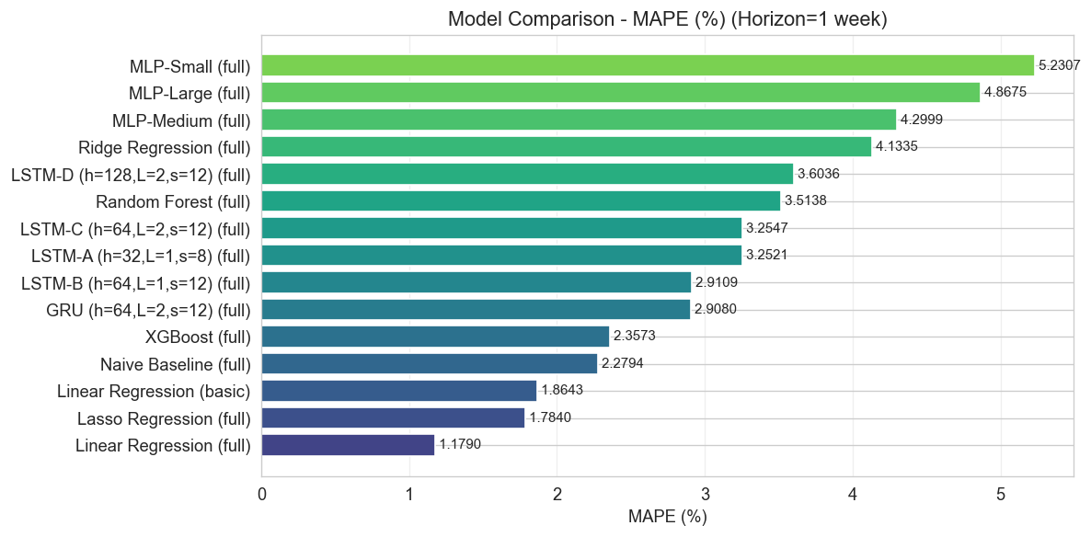
Figure 23: RMSE Degradation - 1-Week vs 4-Week
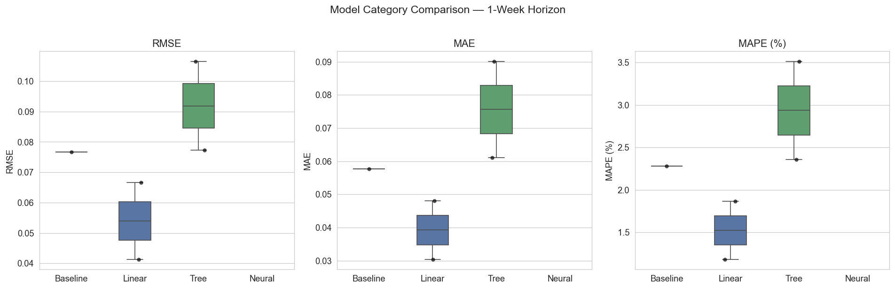
Figure 24: Accuracy Degradation Percentage
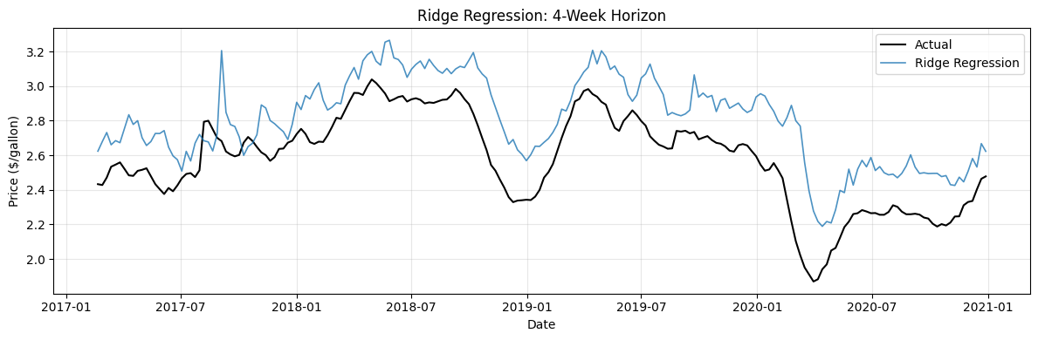
Figure 25: Ridge Regression - 4-Week Horizon

2.8 Error Analysis
Errors are generally small and centered around zero, but spike during volatile market periods like COVID-19 and the 2014 oil crash.
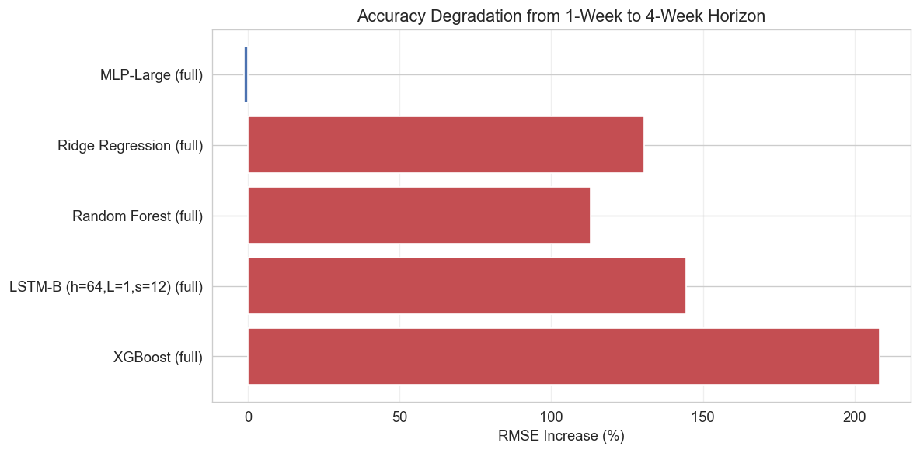
Figure 26: Residuals Over Time
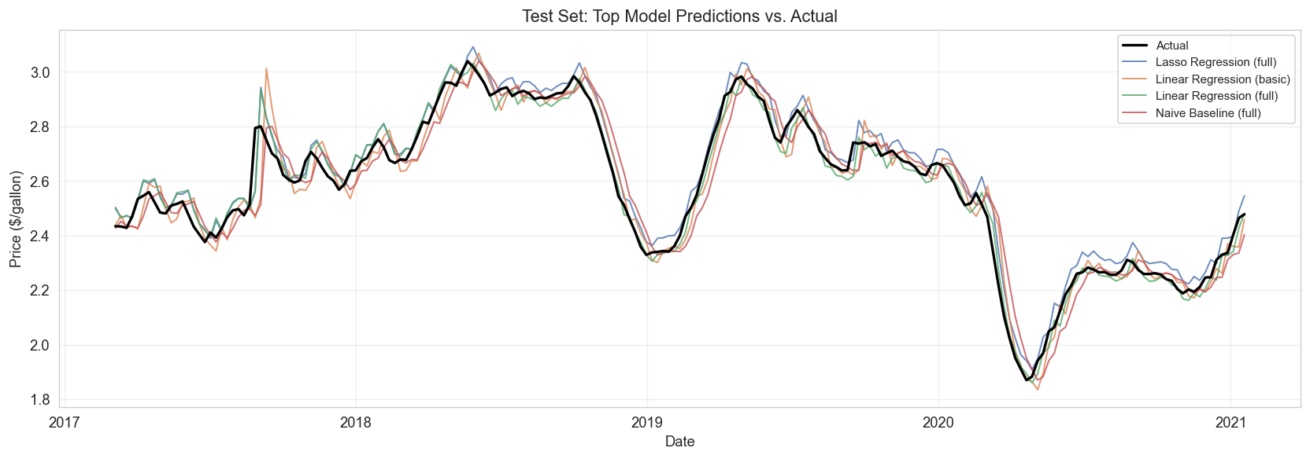
Figure 27: Error Distributions
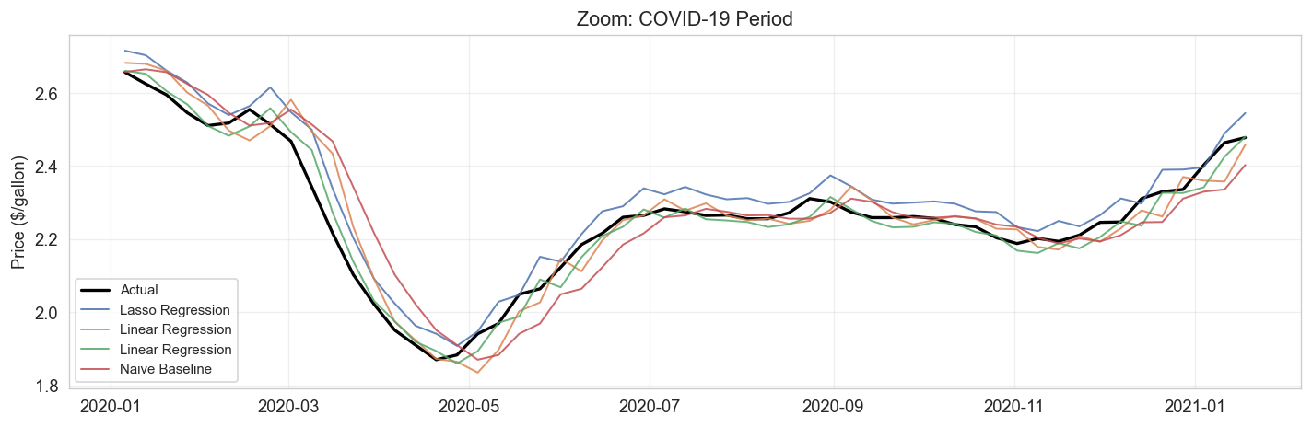
Figure 28: Actual Prices and Model Errors Over Time
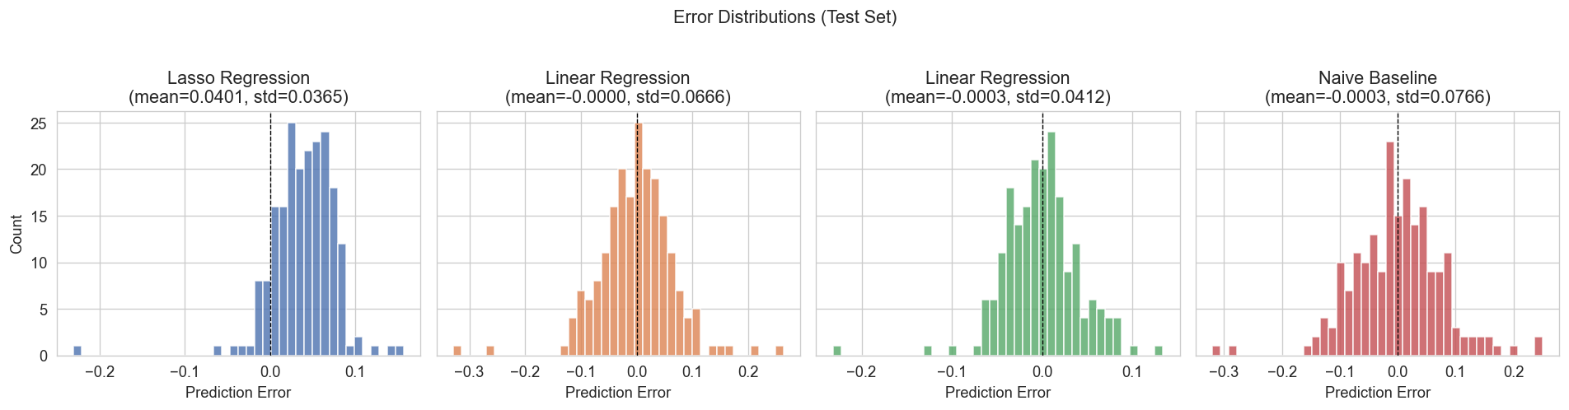
Figure 29: Actual vs Predicted Scatter (Best Model)

2.9 Zoom into Volatile Periods
Zooming into crisis periods reveals that all models lag behind sudden price movements, but recover quickly once prices stabilize.
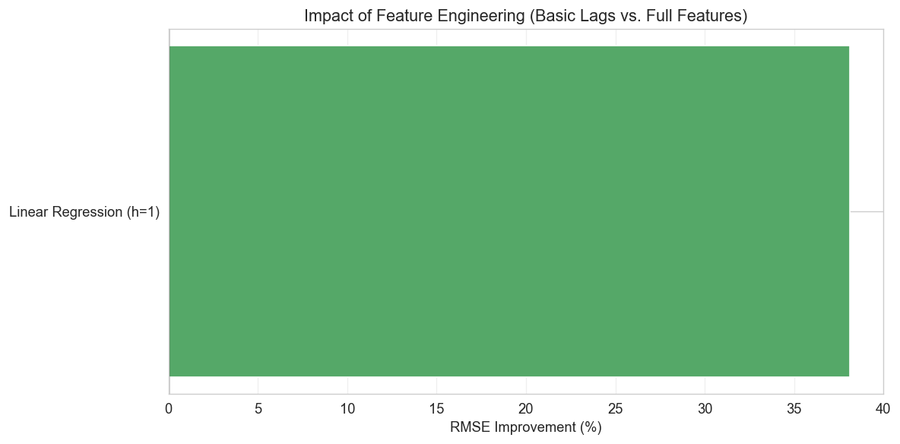
Figure 30: Zoom - COVID-19 Period
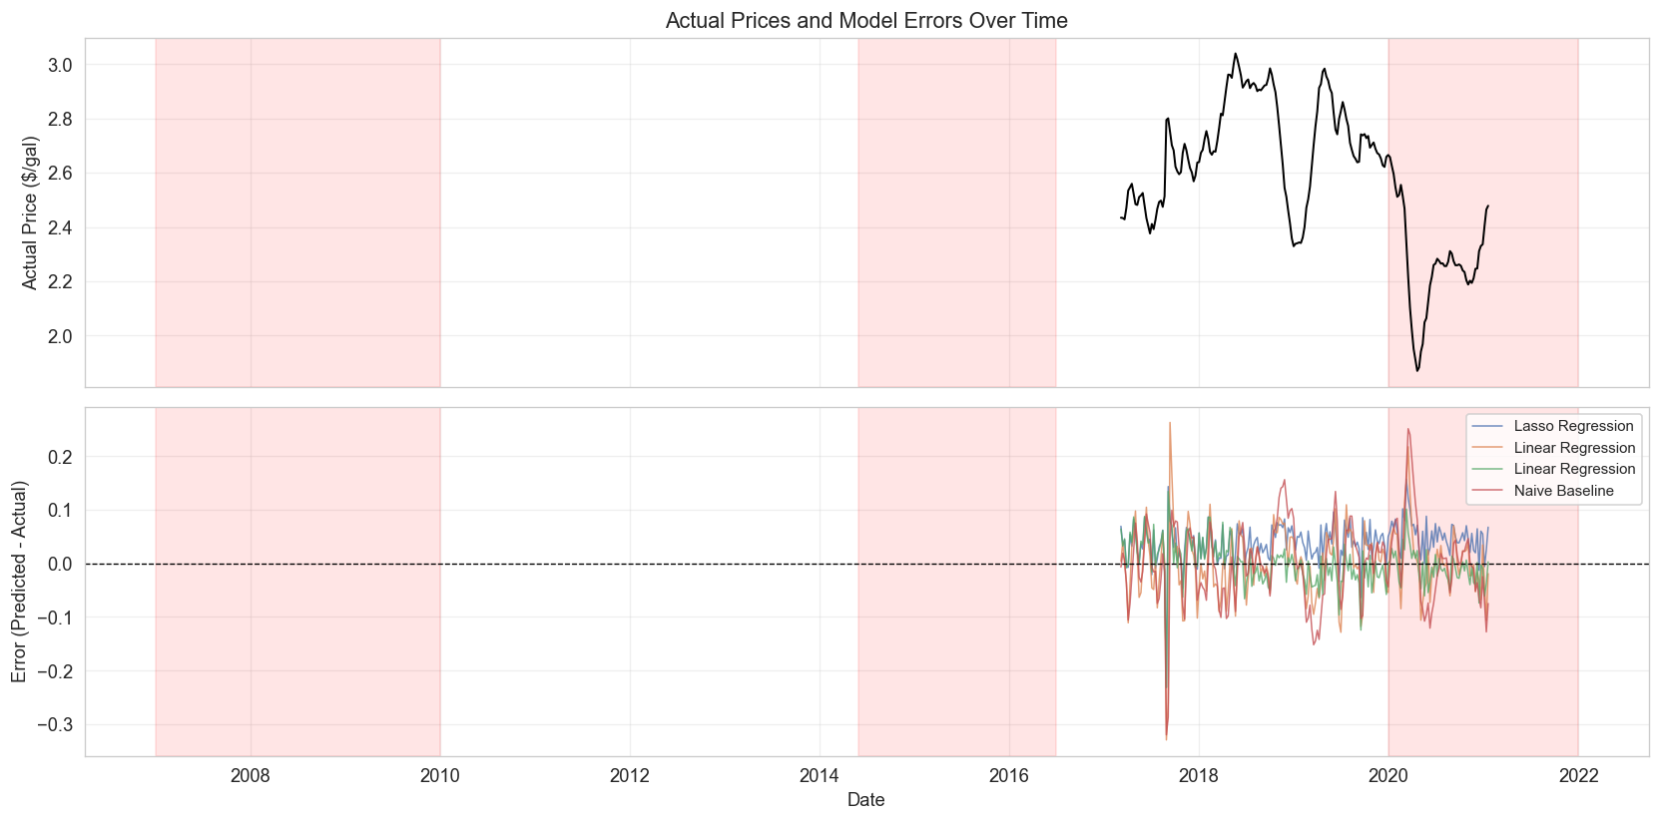
Figure 31: Zoom - 2008 Financial Crisis
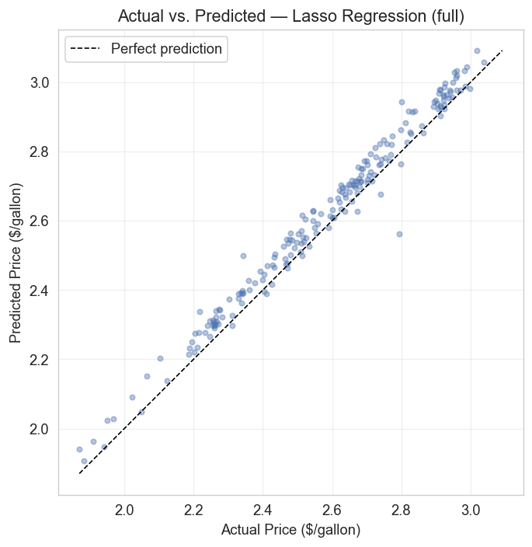
Figure 32: Zoom - 2014 Oil Price Crash

3. Regional Analysis
We test whether models trained on national data generalize across 5 PADD regions with different market dynamics and price levels.

3.1 Regional Price Overview
All regions follow similar long-term trends, but the West Coast consistently has higher and more volatile prices due to stricter fuel regulations.
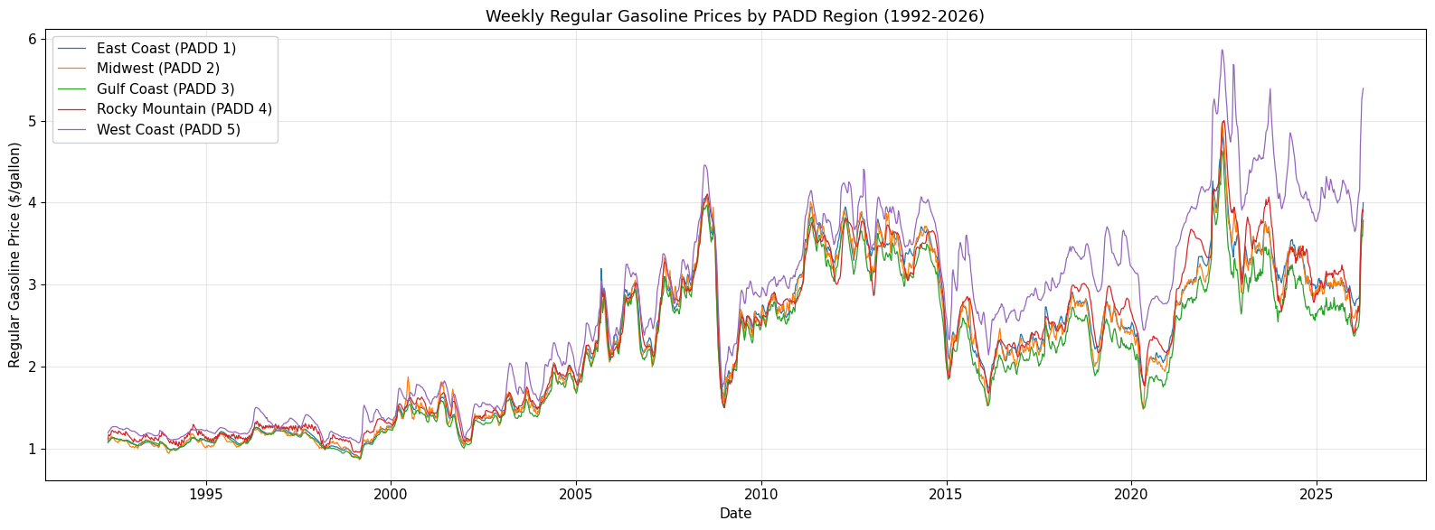
Figure 33: Weekly Gasoline Prices by PADD Region
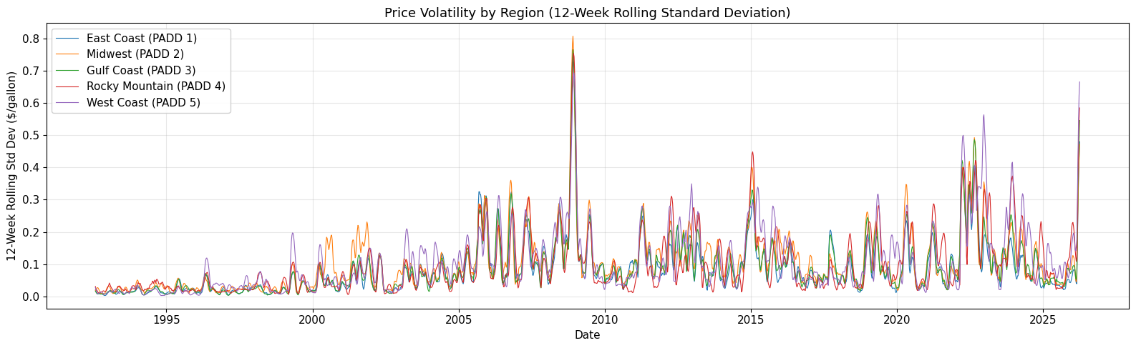
Figure 34: Price Volatility by Region
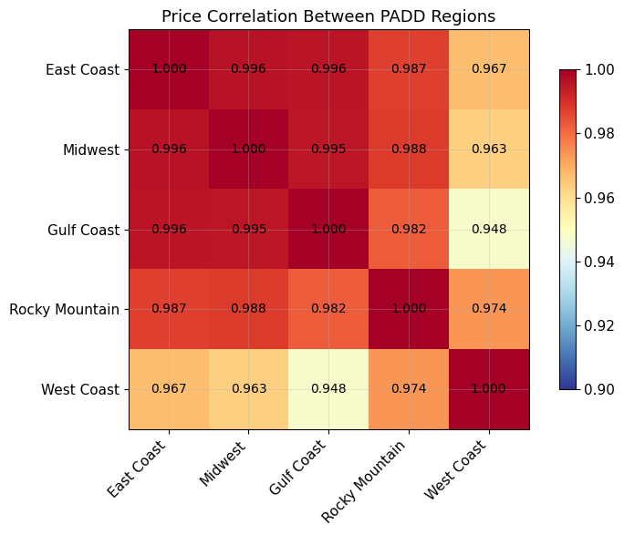
Figure 35: Price Correlation Between Regions

3.2 Regional Performance (Baseline / LR / XGBoost)
Linear Regression remains the best model in most regions. Performance varies, with West Coast being hardest to predict.
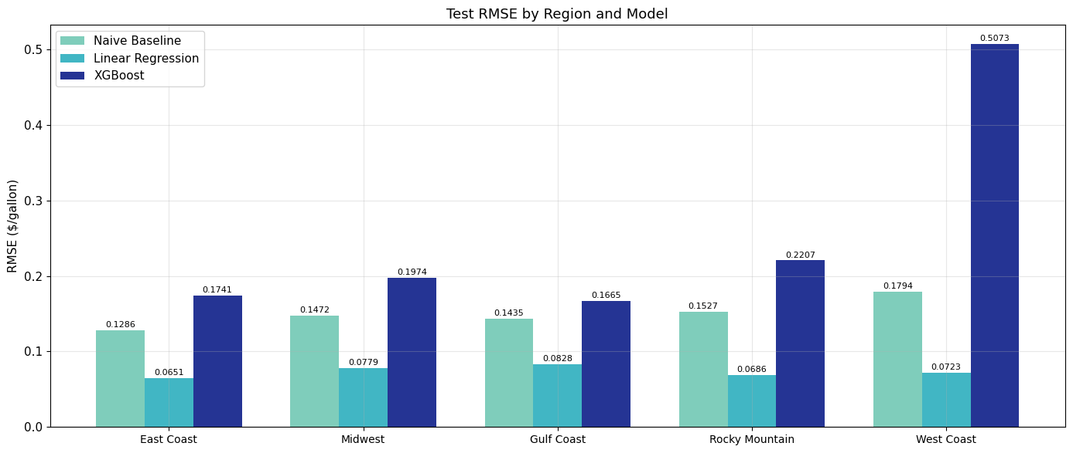
Figure 36: Test RMSE by Region and Model

3.3 Regional LSTM Performance
LSTM shows the same regional pattern: East Coast is easiest (MAPE=1.67%) and West Coast is hardest (MAPE=3.68%).
Region | RMSE | MAE | MAPE
PADD1 East Coast | 0.1024 | 0.0596 | 1.67%
PADD2 Midwest | 0.1178 | 0.0754 | 2.17%
PADD3 Gulf Coast | 0.12 | 0.0815 | 2.57%
PADD4 Rocky Mountain | 0.138 | 0.0862 | 2.34%
PADD5 West Coast | 0.2741 | 0.1783 | 3.68%
Table 5: LSTM regional comparison.
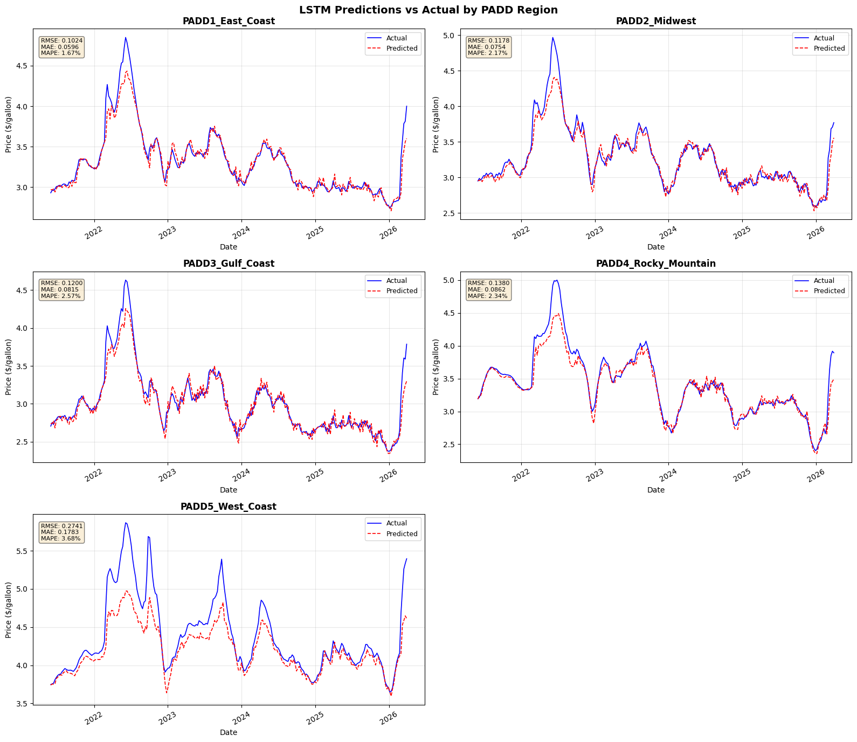
Figure 37: LSTM Predictions vs Actual by PADD Region

4. Geopolitical Event & Outlier Analysis
We examine how well models handle unprecedented price shocks by training on pre-event data and testing during the event period.

4.1 Outlier Detection
Using IQR and Z-score methods, we find that outlier weeks cluster heavily around geopolitical events (17-57% outlier rate) compared to normal periods (~5%).
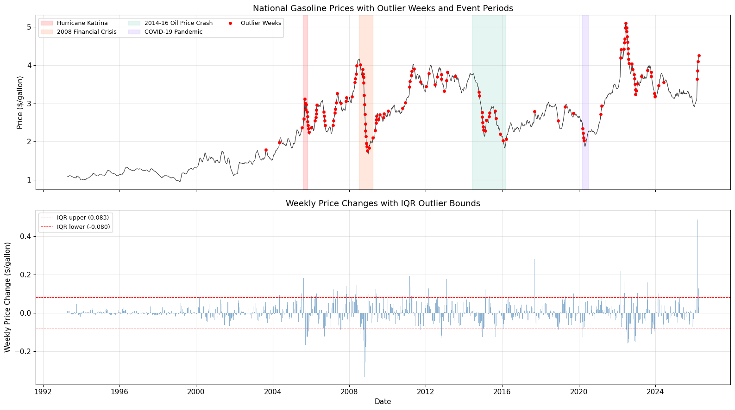
Figure 38: Gasoline Prices with Outlier Weeks and Events
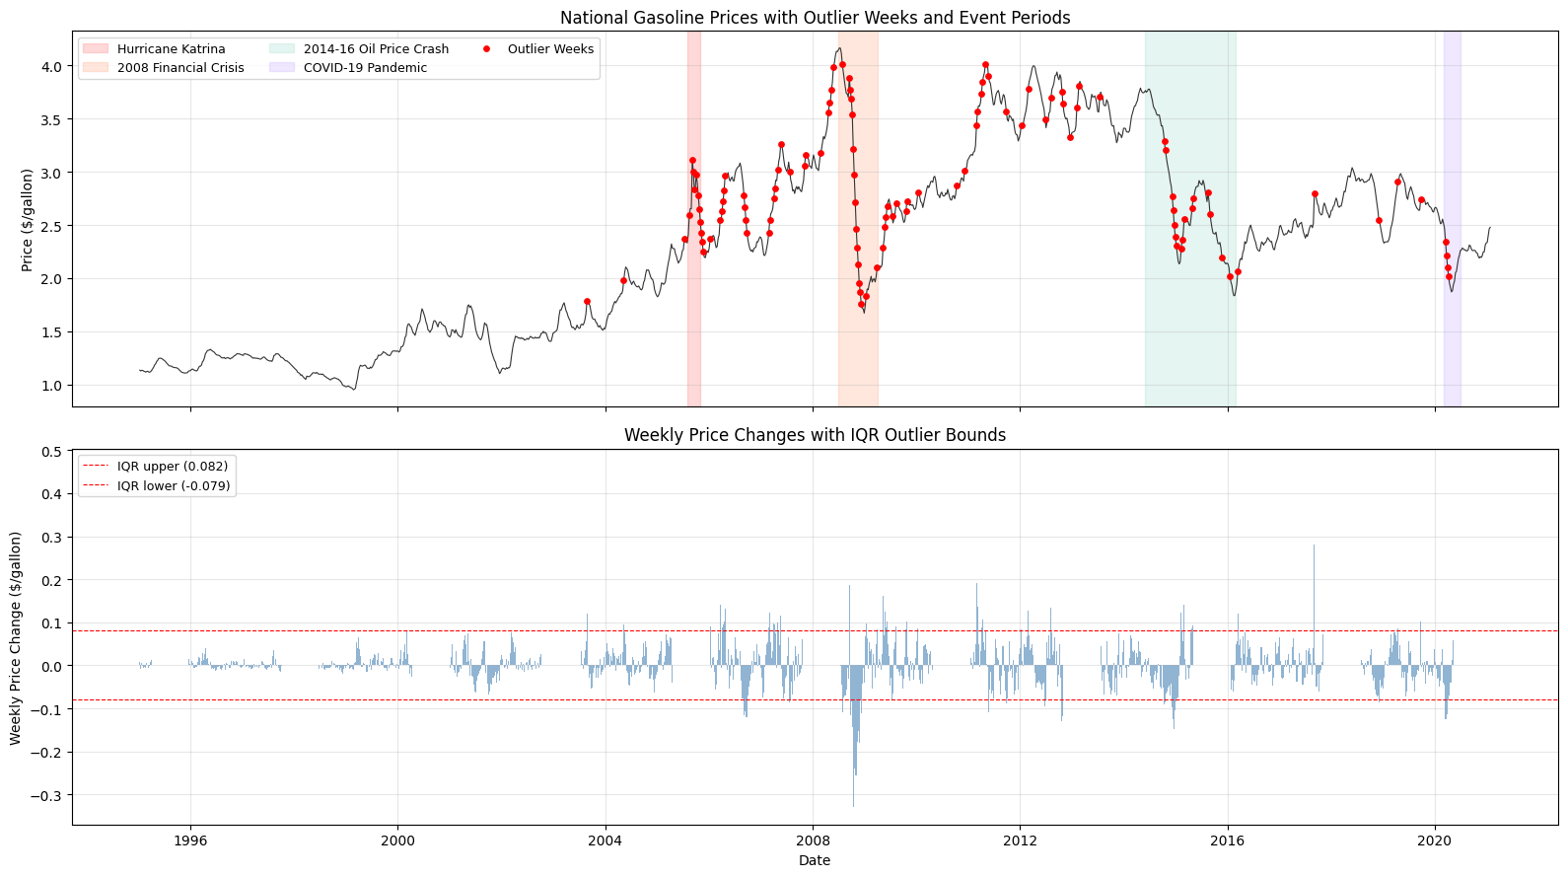
Figure 39: Weekly Price Changes with IQR Bounds

4.2 Event Impact - Baseline / LR / XGBoost
All models show amplified errors during price spikes. Linear models tend to be slightly more robust than tree-based models during sudden movements.
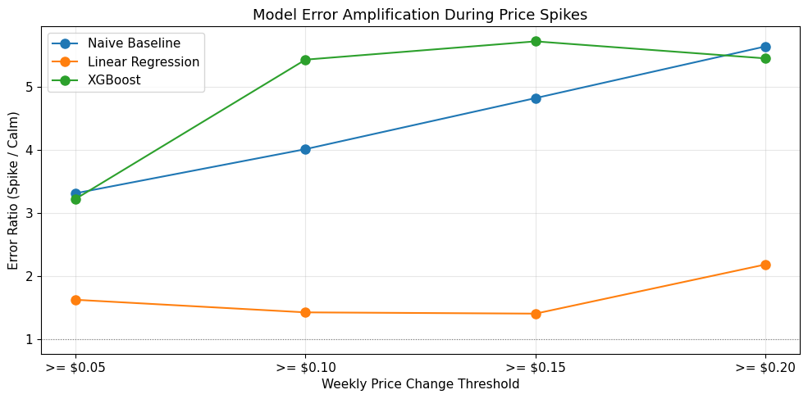
Figure 40: Model Error Amplification During Price Spikes

4.3 Event Impact - LSTM
LSTM struggles most with Hurricane Katrina (sudden spike, few test points) and the 2008 crisis (prolonged crash). Gradual events like the 2014-16 oil crash are easier to handle.
Event | Train Weeks | Test Weeks | RMSE | MAE | MAPE
Hurricane Katrina | 539 | 2 | 0.6458 | 0.6434 | 24.81%
2008 Financial Crisis | 692 | 27 | 0.2018 | 0.1421 | 7.18%
2014-16 Oil Price Crash | 1000 | 80 | 0.0531 | 0.0418 | 1.69%
COVID-19 Pandemic | 1300 | 6 | 0.0342 | 0.0283 | 1.32%
Table 6: LSTM event impact results.
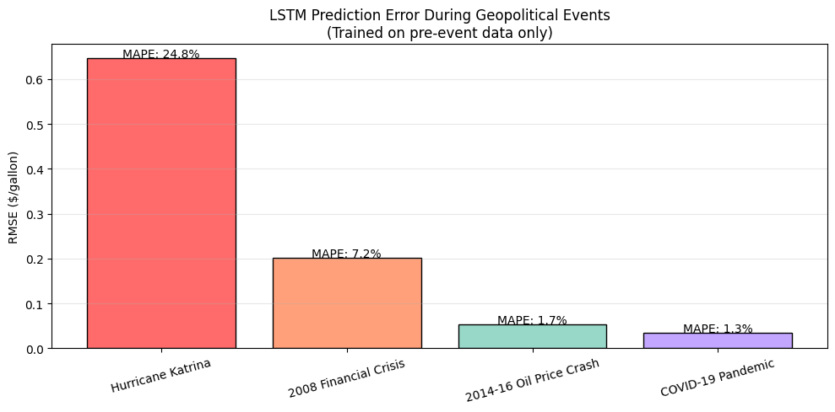
Figure 41: LSTM Prediction Error During Events

5. Concept Drift Analysis (2022-2026)
We test whether models trained on 1995-2021 data still work on recent 2022-2026 data, which includes the Russia-Ukraine war price spike.

5.1 Updated Price Data
Post-2021 prices show a dramatic spike in 2022 due to the Russia-Ukraine conflict, followed by a gradual decline back to pre-spike levels.
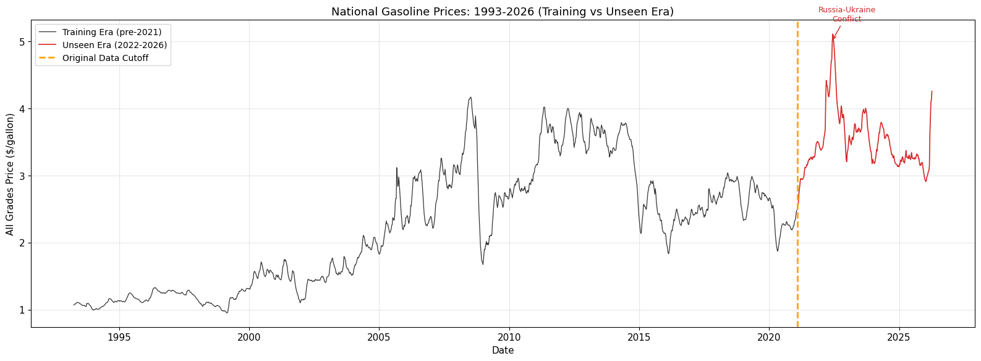
Figure 42: National Prices 1993-2026
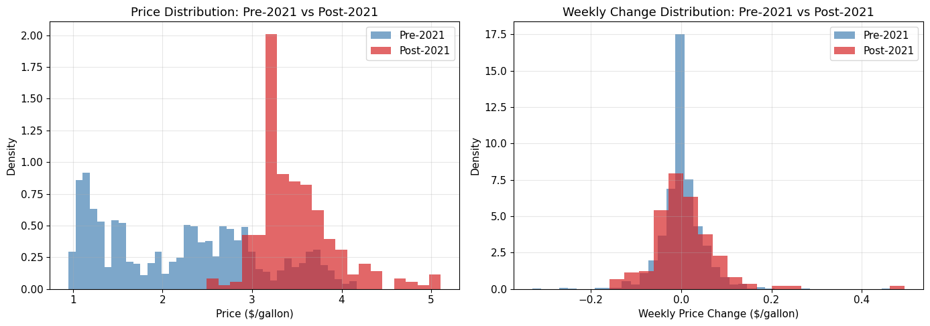
Figure 43: Price Distribution - Pre-2021 vs Post-2021

5.2 Concept Drift - Baseline / LR / XGBoost
Models trained on historical data still produce reasonable predictions on 2022-2026 data, though accuracy drops during the 2022 price spike.
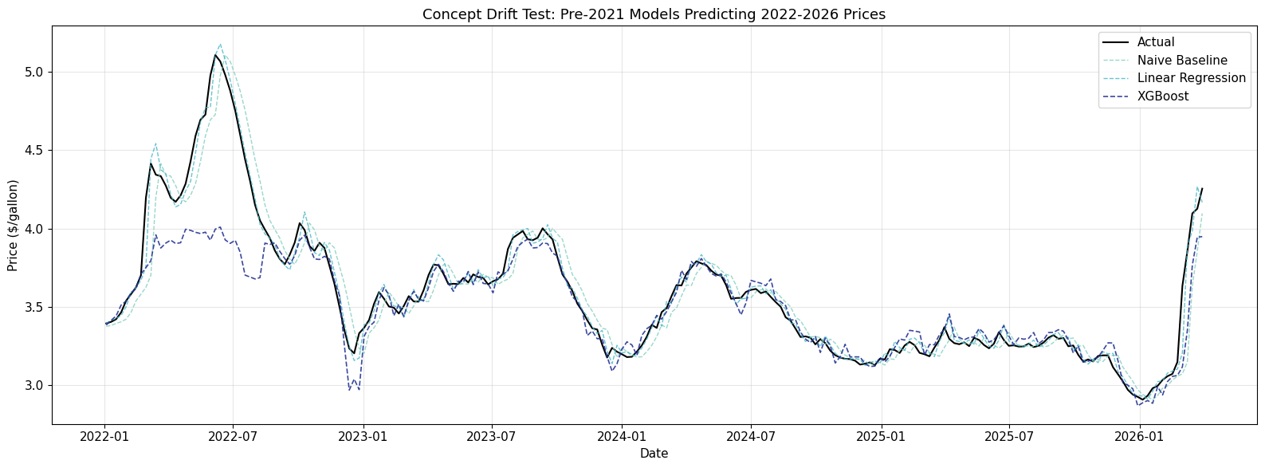
Figure 44: Pre-2021 Models Predicting 2022-2026

5.3 Concept Drift - LSTM
Retraining with data through 2024 improves LSTM RMSE by 16% (0.1124 to 0.0945), confirming concept drift exists but is manageable.
Scenario | RMSE | MAE | MAPE
No retrain (test 2022-2026) | 0.1124 | 0.0692 | 1.79%
Retrained (test 2025-2026) | 0.0945 | 0.0562 | 1.61%
Table 7: LSTM concept drift comparison.
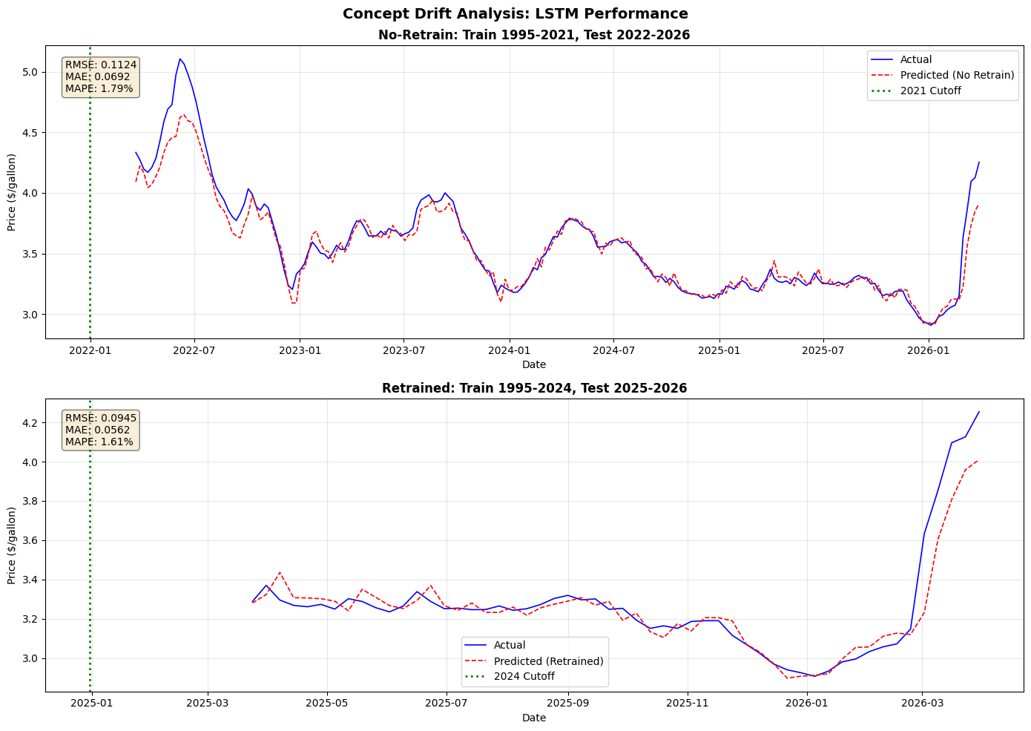
Figure 45: Concept Drift - LSTM Performance

6. Extended Analysis
This section covers four deeper analyses produced in notebook 07 that go beyond the aggregate RMSE/MAE/MAPE comparison in earlier sections: residual diagnostics per model, a detailed stable-vs-volatile breakdown, a unified feature-importance comparison across all model families, and a structured discussion of cross-region generalization.

6.1 Residual & Error Diagnostics per Model
Aggregate error metrics hide when and how a model fails. We computed per-model residual statistics (bias, standard deviation, skew, excess kurtosis, and the Ljung-Box p-value at lag 10) on the held-out test window for every h=1 full-feature model. The table below summarizes the 14 models ranked by test RMSE.
Model | RMSE | Bias (mean) | Std | Skew | Kurtosis (excess) | Ljung-Box p (lag 10)
Linear Regression | 0.0412 | -0.0003 | 0.0413 | -0.5769 | 4.5613 | 0.0000
Lasso Regression | 0.0543 | 0.0401 | 0.0366 | -1.9205 | 14.1485 | 0.8407
Naive Baseline | 0.0766 | -0.0003 | 0.0768 | -0.1908 | 2.0849 | 0.0000
XGBoost | 0.0772 | 0.0451 | 0.0628 | -0.5777 | 3.4375 | 0.0000
LSTM-B (h=64,L=1,s=12) | 0.0921 | 0.0590 | 0.0709 | -0.8065 | 4.9232 | 0.0000
GRU (h=64,L=2,s=12) | 0.0933 | 0.0553 | 0.0754 | -0.7262 | 4.0864 | 0.0000
LSTM-A (h=32,L=1,s=8) | 0.0999 | 0.0676 | 0.0738 | -0.4312 | 3.0051 | 0.0000
LSTM-C (h=64,L=2,s=12) | 0.1003 | 0.0582 | 0.0819 | 0.0067 | 2.8962 | 0.0000
Random Forest | 0.1065 | 0.0854 | 0.0638 | 0.1195 | 1.7364 | 0.0000
LSTM-D (h=128,L=2,s=12) | 0.1087 | 0.0771 | 0.0768 | -0.5590 | 4.1183 | 0.0000
Ridge Regression | 0.1119 | 0.1020 | 0.0461 | -1.4355 | 7.9837 | 0.0000
MLP-Medium | 0.1355 | 0.0394 | 0.1300 | 0.3120 | 0.0757 | 0.0000
MLP-Large | 0.1491 | 0.1105 | 0.1004 | 0.6700 | -0.1778 | 0.0000
MLP-Small | 0.1593 | -0.0971 | 0.1266 | 0.0954 | -0.1907 | 0.0000

Two observations stand out. First, Linear Regression is essentially unbiased (mean residual −0.0003 $/gal) and has the lowest residual standard deviation (0.0413), consistent with its best RMSE on test. Second, Lasso Regression is the only model with white residuals (Ljung-Box p = 0.84 at lag 10); every other model — including the NN sequence models — leaves residual autocorrelation at conventional significance levels, meaning there is still exploitable weekly structure in their errors that the model did not capture.
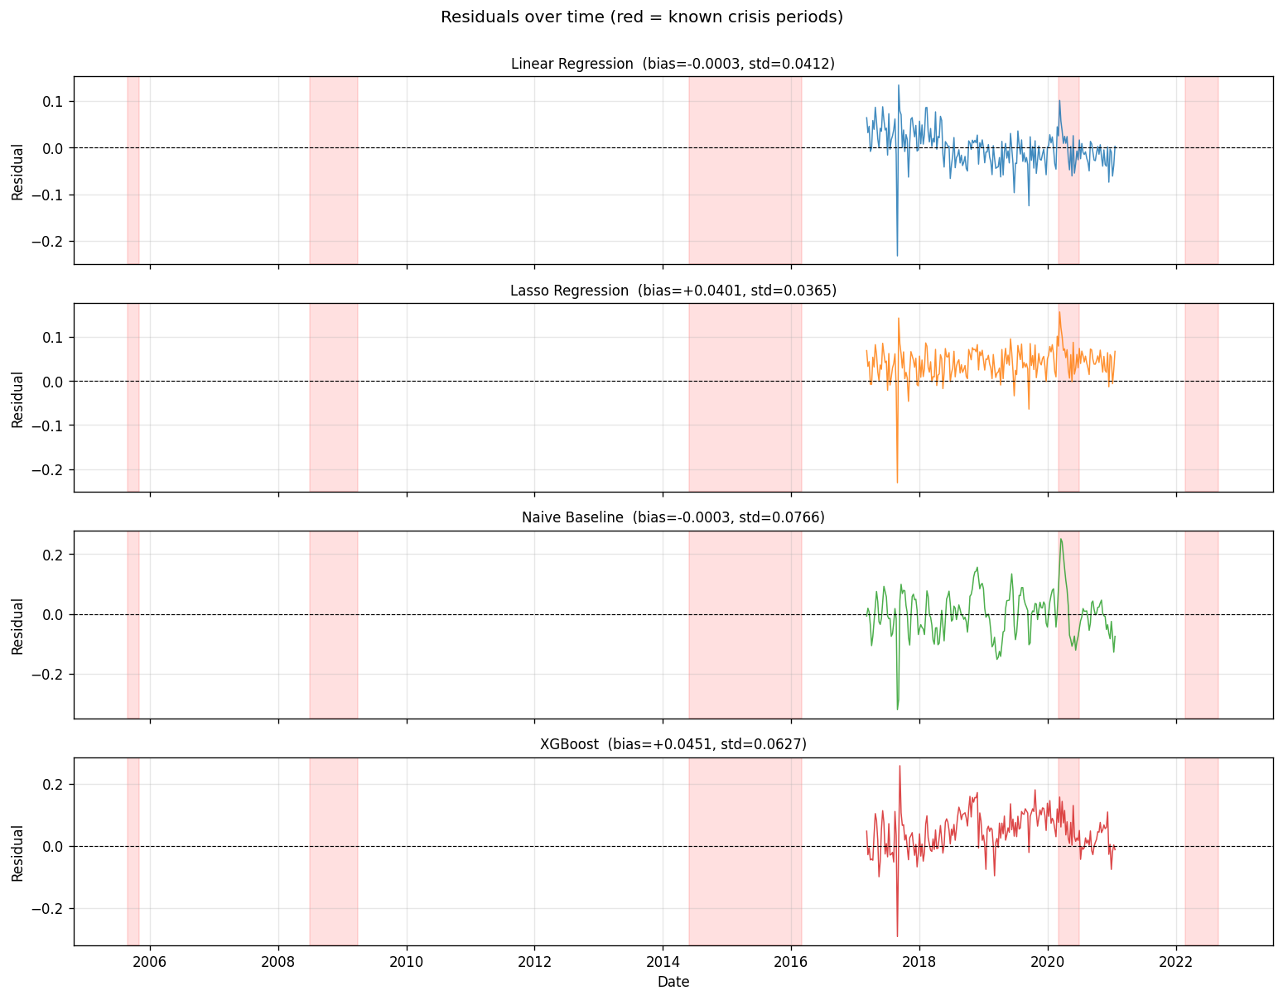
Figure 41: Residuals over time for the four lowest-RMSE models. Red shading marks the COVID-19 period, the only named crisis that overlaps the test window.
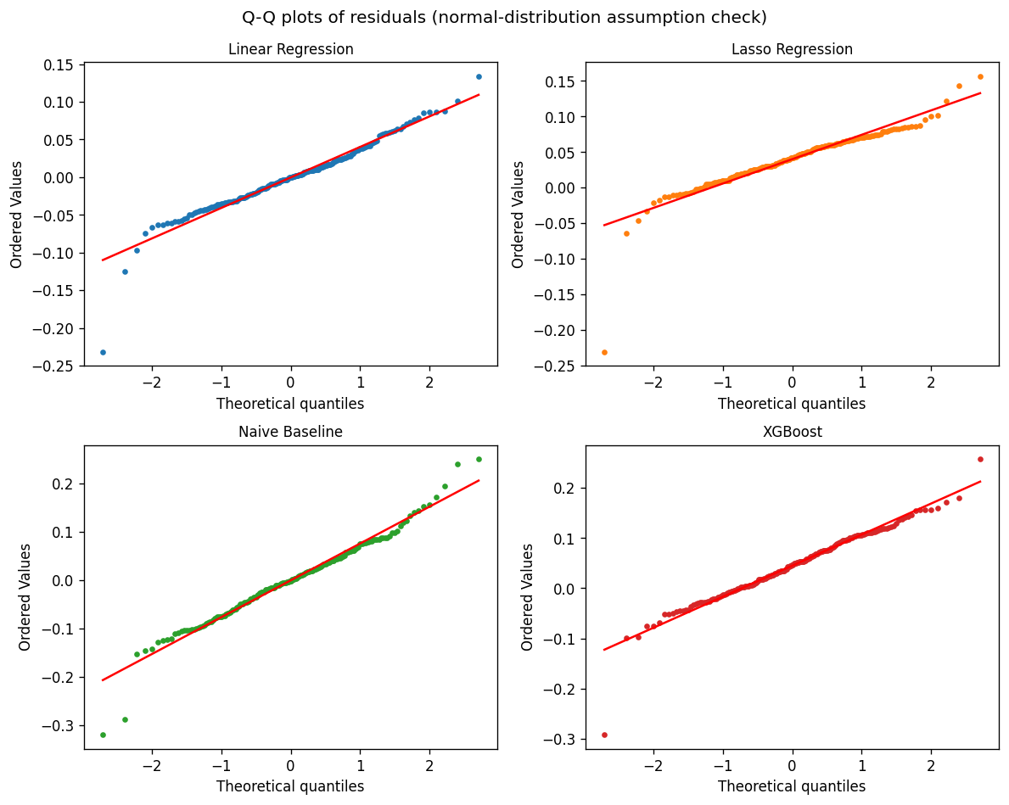
Figure 42: Normal Q-Q plots of test residuals, top-4 models. Heavy-tailed deviations at both ends indicate outlier weeks (dominant during COVID).
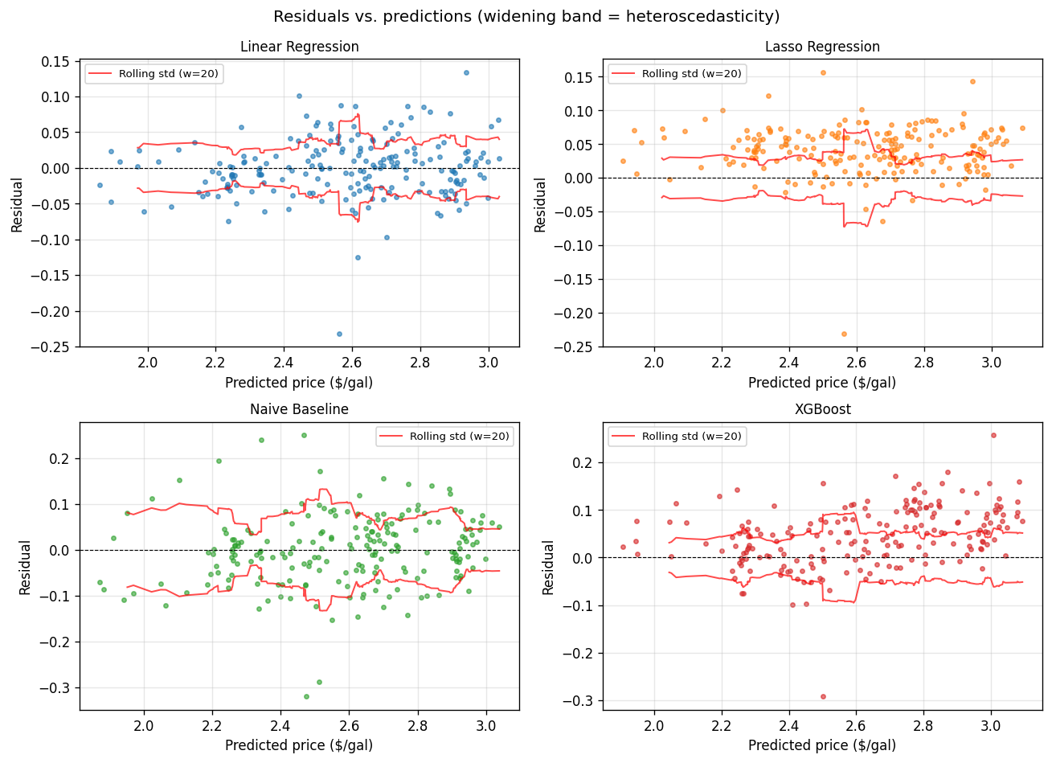
Figure 43: Residuals vs. predicted prices with a rolling-std band. For Linear Regression and Lasso the band is nearly constant, suggesting homoscedastic errors; tree and neural models show a widening band at higher predicted prices.
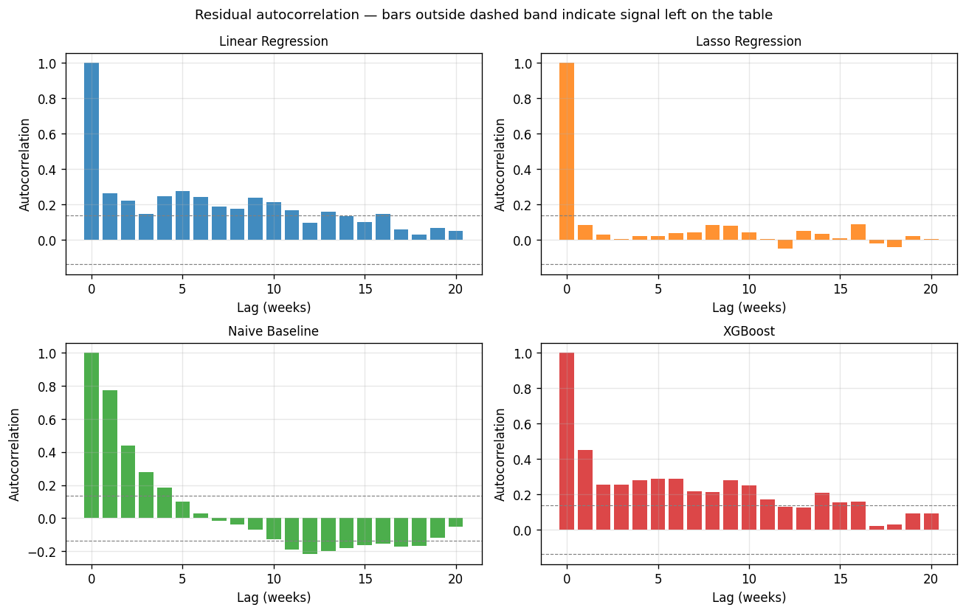
Figure 44: Residual autocorrelation function (lags 0–20). Bars outside the gray 95 % band indicate significant autocorrelation. Lasso is the only model with bars mostly inside the band.

6.1.1 Worst-Prediction Weeks
For the best model (Linear Regression), the ten test weeks with the largest absolute residuals are listed below. Most cluster in late-summer / early-fall 2017–2019, coinciding with Atlantic hurricane season; one week falls within the COVID-19 period (March 2020). This localized error pattern is not visible in the aggregate RMSE.
Date | Actual | Pred (Linear Regression) | Abs Error | Event
2017-08-28 | 2.7940 | 2.5619 | 0.2321 | —
2017-09-04 | 2.8000 | 2.9341 | 0.1341 | —
2019-09-16 | 2.7410 | 2.6163 | 0.1247 | —
2020-03-09 | 2.3430 | 2.4441 | 0.1011 | COVID-19 Pandemic
2019-06-24 | 2.7980 | 2.7014 | 0.0966 | —
2017-06-05 | 2.4790 | 2.5666 | 0.0876 | —
2017-04-24 | 2.5220 | 2.6084 | 0.0864 | —
2018-02-12 | 2.6760 | 2.7621 | 0.0861 | —
2018-02-05 | 2.7240 | 2.8095 | 0.0855 | —
2017-09-11 | 2.7500 | 2.8285 | 0.0785 | —

6.2 Stable vs. Volatile Deep Dive
The h=1 chronological test window spans 2017-03-06 through 2021-01-18. Of the five named crises we catalog (Hurricane Katrina, 2008 Financial Crisis, 2014–16 Oil Crash, COVID-19 Pandemic, Russia–Ukraine Spike), only COVID-19 overlaps the test window; the earlier events are handled in Section 4 via the retrain-before-event protocol. To produce a regime split that works on any held-out window, we added a data-driven label: the 20 % of test weeks with the highest 12-week rolling standard deviation of price are flagged as High Volatility (41 weeks). This gives us three regimes — Stable (157 weeks), High Volatility (41 weeks), and COVID-19 (18 weeks).
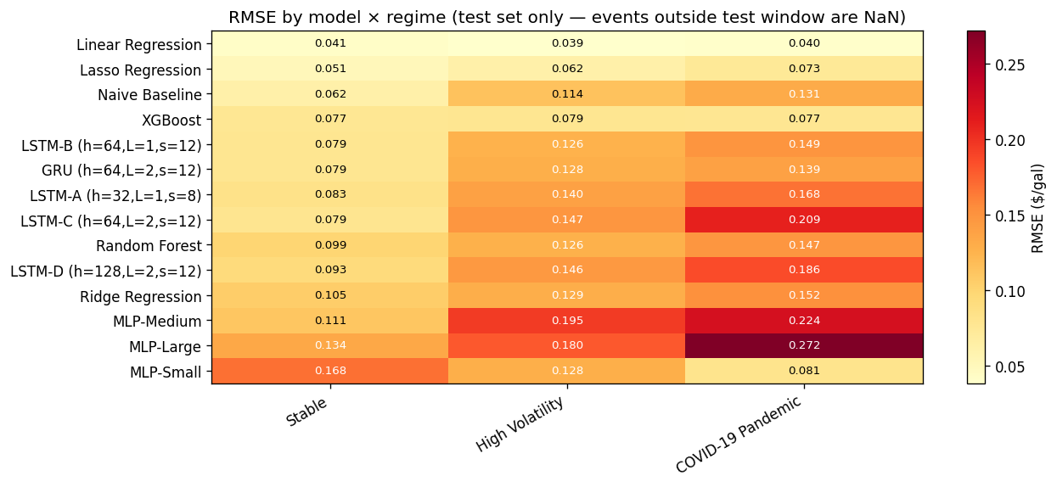
Figure 45: Per-model RMSE across the three regimes. Models are ordered top-to-bottom by overall test RMSE. Linear Regression and XGBoost are the only two models whose error is essentially flat across regimes; every other model worsens under COVID.

6.2.1 Model-Family Aggregation
Grouping by family produces a clean ordering. Classical models (Naive, Linear, Ridge, Lasso) have the lowest mean RMSE in every regime; Tree models (Random Forest, XGBoost) sit in the middle; Neural models (MLP, LSTM, GRU) have the highest mean RMSE and degrade the most under volatility.
Family | Stable | High Volatility | COVID-19 Pandemic
Classical | 0.0648 | 0.0856 | 0.0992
Neural | 0.1032 | 0.1487 | 0.1784
Tree | 0.0878 | 0.1024 | 0.1124

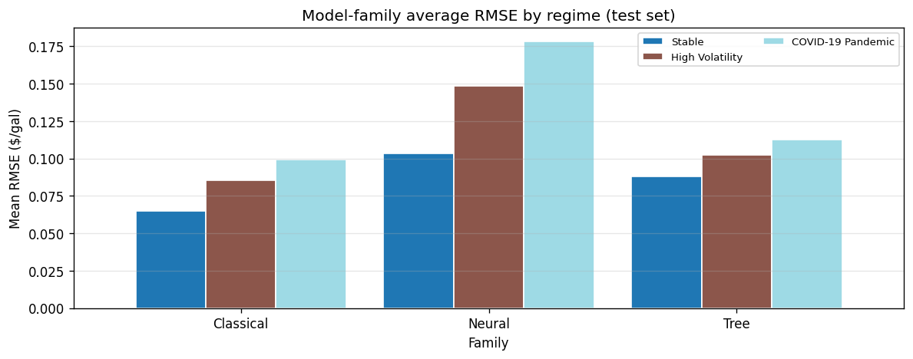
Figure 46: Mean RMSE by model family across the three regimes. The Classical / Tree / Neural ordering is preserved in every regime, and the gap between families widens as volatility increases.

6.2.2 Prediction Overlays During COVID-19
Zooming into the COVID-19 test window shows where the best three models diverge from actual prices. The plot includes a six-week buffer on either side of the official event period.
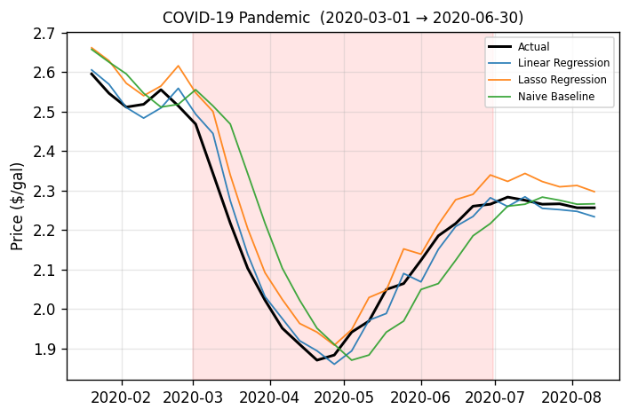
Figure 47: Top-3 models vs. actual prices during the COVID-19 period. The red shaded band marks the official event window (Mar–Jun 2020).

6.2.3 Degradation Ratio
We define the volatility degradation ratio as RMSE(volatile) / RMSE(stable), where volatile = High Volatility ∪ COVID. A ratio near 1 indicates a model that is roughly as accurate under stress as in calm periods. Linear Regression (0.98) and XGBoost (1.03) are the only models that meet this bar; every neural-network variant sits in the 1.4–1.9 range, consistent with their susceptibility to distribution shift.
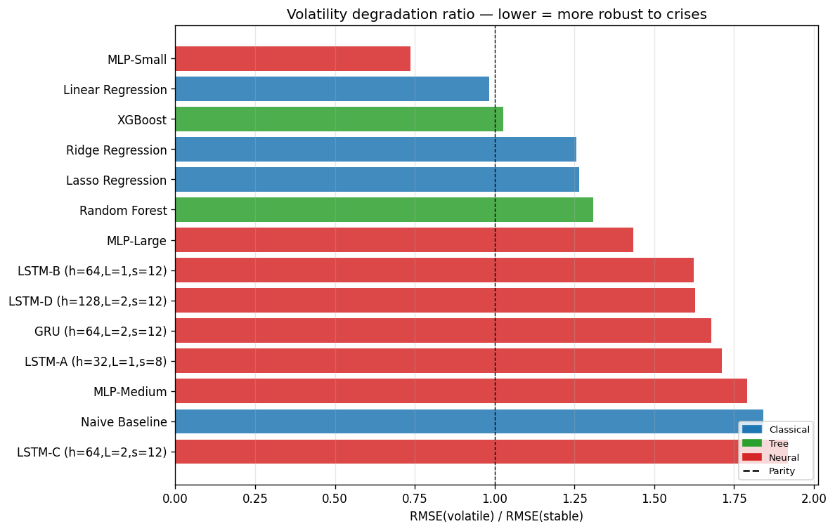
Figure 48: Volatility degradation ratio per model, colored by family. Bars close to the dashed parity line indicate volatility-robust models.

6.3 Feature Importance Across Families
Earlier notebooks reported family-specific feature-importance metrics — Linear / Ridge coefficients, Random Forest Gini impurity decreases, XGBoost gain. These are not directly comparable because each family uses a different definition. To put all models on one axis we computed permutation importance on the validation set: for each feature, we shuffled that column, re-predicted, and measured the increase in RMSE. This produces a Δ-RMSE value per (model, feature) pair that is directly comparable across Linear, Ridge, Lasso, Random Forest, XGBoost, MLP, LSTM-B, and GRU. For the sequence models we permuted the raw feature column before sequence construction, so the shuffle disrupts the feature’s entire time series in a principled way.
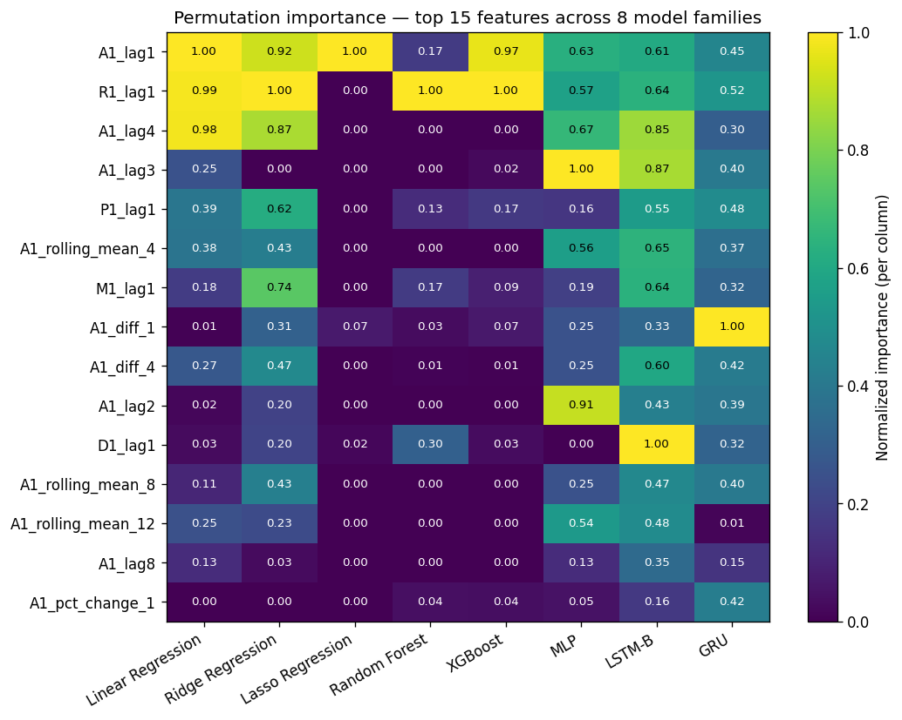
Figure 49: Permutation importance (Δ-RMSE) across 8 model families, top-15 features, normalized per column. Hotter cells = the model loses more RMSE when that feature is shuffled.

6.3.1 Universal Features
Three features appear in the top-10 of every single family: A1_lag1 (last week’s target price), R1_lag1 (last week’s Regular-grade price), and A1_diff_4 (the 4-week price change). This is the strongest universal finding in the study — regardless of whether the model is linear, tree-based, or a sequence neural network, short-horizon lag values of the target and the Regular-grade co-series carry the most predictive signal.

6.3.2 Family-Specific Signal
The per-category share of importance reveals how each family gets its signal. Lasso concentrates 91 % of importance on target lags, consistent with its L1 sparsity: it effectively collapses to A1_lag1. Random Forest and XGBoost lean heavily on cross-grade lags (85 % and 54 % respectively) — tree splits on R1_lag1 and other grade prices extract more information than direct target lags. Neural models are the only family that draws non-trivial importance from date/seasonal features (MLP 10.8 %, GRU 3.9 %), which is expected since weekly retail prices are nearly aperiodic.
Category | Linear Regression | Ridge Regression | Lasso Regression | Random Forest | XGBoost | MLP | LSTM-B | GRU
Cross-grade lag | 0.317 | 0.394 | 0.018 | 0.852 | 0.535 | 0.128 | 0.307 | 0.252
Date / seasonal | 0.001 | 0.004 | 0.001 | 0.003 | 0.004 | 0.108 | 0.010 | 0.039
Price change | 0.057 | 0.124 | 0.068 | 0.051 | 0.046 | 0.083 | 0.138 | 0.304
Rolling stat | 0.148 | 0.168 | 0.000 | 0.001 | 0.000 | 0.207 | 0.183 | 0.130
Target lag | 0.477 | 0.310 | 0.914 | 0.093 | 0.414 | 0.475 | 0.361 | 0.275

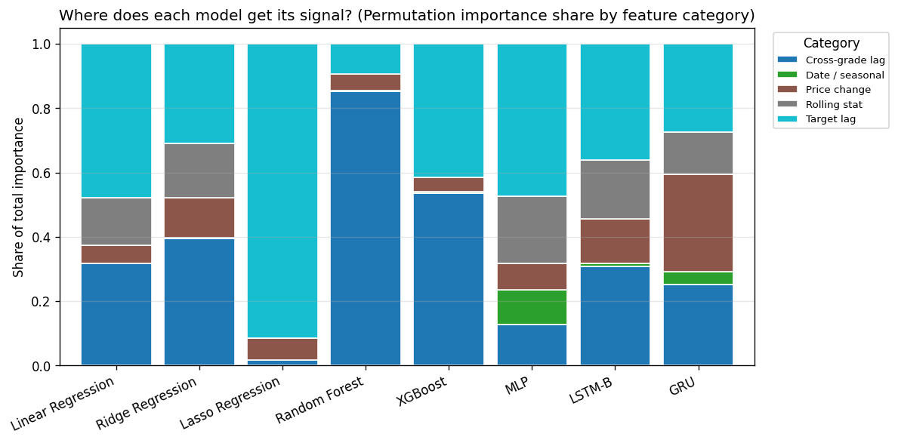
Figure 50: Share of total permutation importance by feature category, per model. Lasso collapses onto target lags; tree models rely on cross-grade lags; only neural models extract non-trivial signal from date / seasonal features.
A caveat: the Naive Baseline is excluded because it has no features. For LSTM-B and GRU, permutation importance on sequence inputs is not a fully standard metric; we permuted the pre-sequence column, which is the most principled variant but still implicitly mixes positional and feature effects. Attention-based attribution would be a cleaner future extension.

6.4 Cross-Region Generalization — Structured Discussion
Section 3 reported per-region model RMSE. Here we turn the numbers into a structured discussion of transfer: we train Linear Regression and XGBoost on the national All-Grades series (1995–2026), then apply them to the held-out test window of each regional series. The gap (RMSE_national − RMSE_own) / RMSE_own quantifies how much accuracy you lose, or gain, by substituting a national model for a region-specific one.
Region | LR (own) | LR (national) | LR gap (%) | XGB (own) | XGB (national) | XGB gap (%) | LSTM (own)
PADD1 East Coast | 0.0652 | 0.0651 | -0.1641 | 0.1629 | 0.1475 | -9.4460 | 0.1024
PADD2 Midwest | 0.0776 | 0.0794 | 2.4003 | 0.1870 | 0.1622 | -13.2352 | 0.1178
PADD3 Gulf Coast | 0.0830 | 0.0827 | -0.4063 | 0.1576 | 0.1257 | -20.2411 | 0.1200
PADD4 Rocky Mountain | 0.0688 | 0.0662 | -3.7848 | 0.2071 | 0.1962 | -5.2573 | 0.1380
PADD5 West Coast | 0.0726 | 0.0772 | 6.2712 | 0.4995 | 0.6380 | 27.7347 | 0.2741

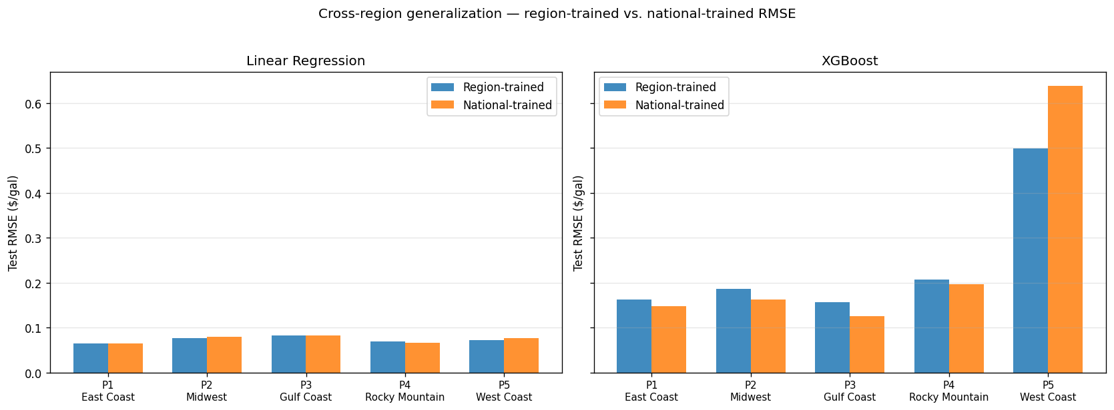
Figure 51: Paired bars — region-trained (blue) vs. national-trained (orange) test RMSE for LR (left) and XGBoost (right), across the 5 PADDs.
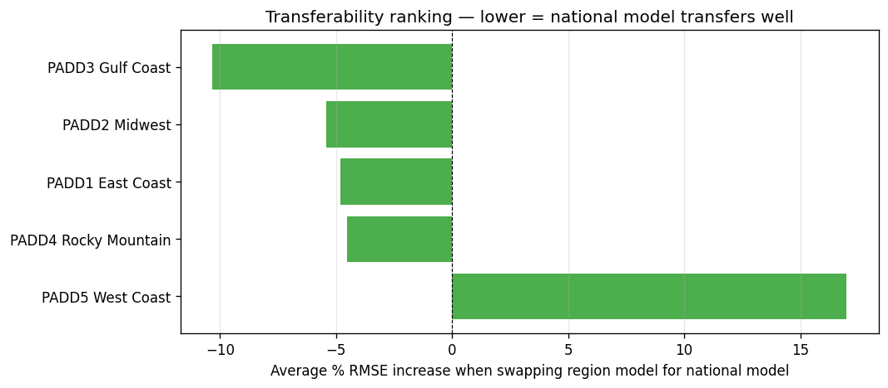
Figure 52: Transferability ranking — average of LR and XGBoost cross-region gap per PADD. Negative values mean the national model beats the region-trained one; positive means the region-trained is better.

6.4.1 Four Findings
Finding 1 — Linear Regression transfers nearly perfectly on PADDs 1–4.
The LR cross-region gap is within ±6 % on every region except West Coast. Weekly retail prices are dominated by short-lag momentum, and those dynamics are regime-invariant across the continental United States, so the linear model captures the shared structure and transfers cleanly.
Finding 2 — XGBoost actually benefits from national training on PADDs 1–4.
Counter-intuitively, national XGBoost beats region-trained XGBoost on East Coast (−9 %), Midwest (−13 %), Gulf Coast (−20 %), and Rocky Mountain (−5 %). The national series has more training samples (~1,700 vs. ~1,400 weeks) and more diverse price regimes, which helps the tree ensemble find more robust splits. The region-specific XGBoost effectively overfits its smaller local sample.
Finding 3 — West Coast (PADD 5) breaks the pattern.
It is the only region where both LR and XGBoost degrade under national training, and XGBoost degrades dramatically (+28 %). PADD 5’s own-trained XGBoost RMSE (0.50) is also about 2× worse than the other four regions. This reflects the well-known structural isolation of the California market: the CARB reformulated gasoline specification, limited pipeline access from PADD 3, refinery-outage sensitivity, and state-level tax dynamics. A national model averages over exactly the signals that matter for PADD 5, so adding national data hurts rather than helps.
Finding 4 — Model choice interacts with region choice.
For PADDs 1–4, use nationally-trained XGBoost: more data, better regularization, cleaner transfer. For PADD 5, use region-trained Linear Regression (test RMSE 0.073) — simpler, more sample-efficient, and less prone to overfitting the region’s idiosyncrasies. This is a concrete, actionable recipe that emerges only from the cross-region analysis.

7. Summary of Key Findings
1. Simple models win at h=1: Linear Regression with engineered features achieves the best test performance (RMSE 0.0412, MAPE 1.18 %), outperforming every neural and tree-based model.
2. Complexity pays off at h=4: MLP-Large wins the 4-week horizon (RMSE 0.147), a clean demonstration that non-linearity helps once the linear momentum signal decays.
3. Feature engineering is worth 38 %: basic-lag-only LR RMSE 0.0666 vs. full-feature LR RMSE 0.0412 on the same test window.
4. Three universal features: permutation importance across 8 families shows A1_lag1, R1_lag1, and A1_diff_4 appear in the top-10 of every single model family.
5. Lasso is the only model with white residuals (Ljung-Box p = 0.84); every other model leaves autocorrelated signal in its errors.
6. Volatility robustness splits by family: Classical 0.065 stable → 0.099 COVID, Tree 0.088 → 0.112, Neural 0.103 → 0.178. LR (0.98) and XGBoost (1.03) are the only models with degradation ratio near parity.
7. West Coast (PADD 5) breaks cross-region transfer: nationally-trained XGBoost beats region-trained XGBoost on PADDs 1–4 (−5 to −20 % RMSE), but fails on PADD 5 by +28 % due to CARB market isolation.
8. Concept drift is modest: LSTM trained through 2021 achieves RMSE 0.112 on 2022–2026; retraining through 2024 improves this to 0.095 (≈16 % gain).
9. Event shocks: demand shocks are learnable (COVID MAPE 1.3 %, 2014–16 oil crash 1.7 %); sudden supply shocks are not (Hurricane Katrina MAPE 24.8 %).
10. Complexity does not equal accuracy at this sample size (~1,300 weekly observations). Sample-efficient classical models dominate; neural models justify their complexity only at longer horizons.

