**2nd Lecture**

**2.1 Remote Sensing Images**

**Key Concepts**

Electromagnetic energy may be detected either:

* **Photographically**: Which uses chemical reactions on the surface of light-sensitive film to detect and record energy variations.
* **Electronically:** Which produces digital images.

**2.1.1 Digital Images**

* Digital images are represented using picture elements (pixels).
* A pixel is the smallest part of an image.
* Each pixel is assigned a digital number representing its relative brightness (i.e. the gray level or gray value).
* The gray level ranges from 0 (representing the darkest value) and 255 (representing the brightest value). Note that this range depends on the number of bit used to encode a pixel. 0-255 means 8 bits are used for encoding a pixel.
* All the pixels are combined together to give the image using a grid (pixel grid).

**2.1.2 Types of Digital Images**

1. Binary Image

Has only 2 gray levels, 0 and 255 (0, 255)



Fig. 1. Binary Image

1. Grayscale Image

Has a range of values from 0-255. Each pixel location can have any value between 0 – 255. (E.g. Images in a Black & White TV)



Fig 2: Grayscale Image Representation

In binary and grayscale images, you use one value to represent a pixel at every location.

1. Color Image

Has a range of values from 0-255. However, you use 3 values to represent a pixel at every location.



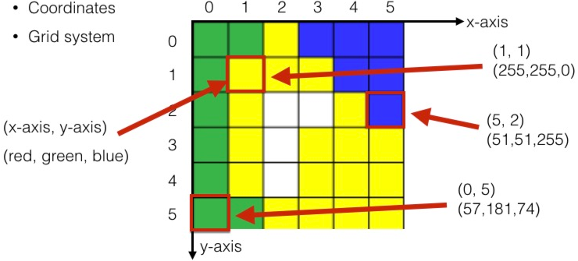

Fig 3: Color Image Representation

The computer displays each digital value as different brightness levels. Sensors that record electromagnetic energy, electronically record the energy as an array of numbers in digital format right from the start.

**2.2 Platforms for Remote Sensors**

Remote sensors need to be placed on a stable platform inside or outside the earth’s atmosphere to be able to collect and record energy emitted or reflected from a target. E.g. of such platforms are:

* Ground (see figure 4a)
* Aircraft
* Balloon
* Spacecraft
* Satellite

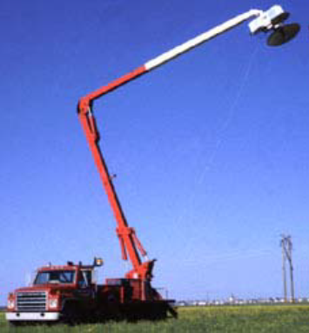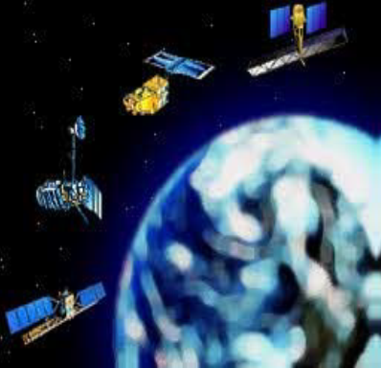

Fig. 4a: Ground Based platform. Fig. 4b: Satellite based Platform

The distance between the target and the platform (i.e. where the sensor is located) determines the **detail of information (about the target) obtained** and the **total area** imaged by the sensor. Sensors onboard platforms far away from their targets, typically view a larger area, but cannot provide great detail. Compare what an astronaut onboard the space shuttle sees of the Earth to what you can see from an airplane. The astronaut might see your whole province or country in one glance, but couldn't distinguish individual houses. Flying over a city or town, you would be able to see individual buildings and cars, but you would be viewing a much smaller area than the astronaut.

2.2.1 **Satellites**:

Theseare objects which revolve around another object - in this case, the Earth (see figure 4b). For example, the moon is a natural satellite, whereas man-made satellites include those platforms launched for remote sensing, communication, and telemetry (location and navigation) purposes. Because of their orbits, satellites permit repetitive coverage of the Earth’s surface on a continuing basis. Cost is often a significant factor in choosing among the various platform options.

**2.2.2 Components of a Satellite**

1. Power system (solar or nuclear) & rechargeable batteries for storage.
2. Antenna (receiving and transmitting) – For communication with the ground control crew
3. Altitude Control System (ACS) – That keeps the satellite pointed in the right direction.
4. Onboard Computer – To control and monitor the different systems.
5. Bus – A metal composite frame and body that holds everything together in space and provides enough strength to survive launch.

**2.2.3 Satellite Characteristics**

1. **Orbit:** Refers to the path followed by a satellite.

Types of Orbits

1. **Low Earth Orbits**: Satellites in this orbit occupy a region of space from about 180 km to 2000 km above the earth. Satellites close to the earth’s surface are ideal for making observations, for military purposes and for collecting weather data.
2. **Geo-Stationary Orbits**: Satellites at very high altitudes, which view the same portion of the Earth's surface at all times have **geostationary** **orbits**. These geostationary satellites, at altitudes of approximately 36,000 kilometers, revolve at speeds which match the rotation of the Earth so they seem stationary, relative to the Earth's surface. This allows the satellites to observe and collect information continuously over specific areas.



Fig. 5: Geostationary Orbit

E.g. include weather and communication satellites.

1. **Medium-Earth orbits**

Satellites here are in between the LEO and the geostationary orbits (i.e. from 2000 to 36000 km above the earth’s surface). Navigation satellites (for car GPS) work well at this altitude.

1. **Near-Polar Orbit:** The inclination of the path (of the satellite) is relative to a line running between the North and South poles. Many remote sensing platforms are designed to follow this orbit (basically north-south) which, in conjunction with the Earth's rotation (west-east), allows them to cover most of the Earth's surface over a certain period of time (see figure 6).



Fig. 6: Near Polar Orbit

Many of these satellite orbits are also **sun synchronous** which means that they cover each area of the world at a constant local time of day called **local sun time**. At any given latitude, the position of the sun in the sky as the satellite passes overhead will be the same within the same season. This ensures consistent illumination conditions when acquiring images in a specific season over successive years, or over a particular area over a series of days.

1. **Ascending and Descending Passes**

Most of the remote sensing satellite platforms today are in near-polar orbits, which means that the satellite travels northwards on one side of the Earth and then toward the southern pole on the second half of its orbit (see figure 7). These are called **ascending and descending** **passes**, respectively.

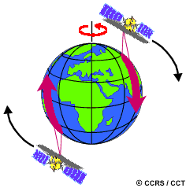

Fig. 7: Ascending and Descending Passes

If the orbit is also sun synchronous (i.e. covers each area of the world at a constant local time of day), the ascending pass is most likely on the shadowed side of the Earth while the descending pass is on the sunlit side. Sensors recording reflected solar energy only image the surface on a descending pass, when solar illumination is available. Active sensors which provide their own illumination or passive sensors that record emitted (e.g. thermal) radiation can also image the surface on ascending passes.

1. **Swath**

As a satellite revolves around the Earth, the sensor "sees" a certain portion of the Earth's surface. The area imaged on the surface, is referred to as the **swath.** As the satellite orbits the Earth from pole to pole, its east-west position wouldn't change if the Earth didn't rotate. However, as seen from the Earth, it seems that the satellite is shifting westward because the Earth is rotating (from west to east) beneath it. This apparent movement allows the satellite swath to cover a new area with each consecutive pass. The satellite's orbit and the rotation of the Earth work together to allow complete coverage of the Earth's surface, after it has completed one complete cycle of orbits.



Fig. 8: Swath

**2.2.2 Sensor Characteristics** – Spatial, spectral, radiometric and temporal resolution.

1. **Spatial Resolution**

Refers to the size ofthe smallest possible feature that can be detected in an image. Instantaneous Field of View (IFOV) is used to measure the spatial resolution of sensors. The IFOV is the angular cone of visibility of the sensor (A) and determines the area on the Earth's surface which is theoretically viewed by the Instrument from a given altitude at a given time (B). The size of the area viewed is determined by multiplying the IFOV by the distance from the ground to the sensor (C) (see figure 9). This area on the ground is called the **resolution cell** and determines a sensor's maximum spatial resolution. For a homogeneous feature to be detected, its size generally has to be equal to or larger than the resolution cell. If the feature is smaller than this, it may not be detectable as the average brightness of all features in that resolution cell will be recorded.



Figure 9: Spatial Resolution

Spatial resolution of a sensor can be **low (coarse)** or **high (fine).** Images where only large features are visible are said to have coarse or low resolution (e.g. sensors in commercial satellites).In fine or high resolutionimages, small objects can be detected (e.g. sensors in military satellites).

1. **Spectral Resolution:** It is the width of the spectral band and the number of spectral bands in whichthe image is taken. Narrow band widths in certain regions of the electromagnetic spectrum allow us to discriminate between the various features more easily. Consequently, we need to have more number of spectral bands, each having a narrow bandwidth, and these bands should together cover the entire spectral range of interest.



Fig. 10: Reflectance of Black & White and Color Films to Visible Light

As shown in figure 10, black and white film records wavelengths extending over much, or all of the visible portion of the electromagnetic spectrum. Its **spectral resolution** is fairly coarse, as the various wavelengths of the visible spectrum are not individually distinguished and the overall reflectance in the entire visible portion is recorded. Color film is also sensitive to the reflected energy over the visible portion of the spectrum, but has higher spectral resolution, as it is individually sensitive to the reflected energy at the blue, green, and red wavelengths of the spectrum. Thus, it can represent features of various colors based on their reflectance in each of these distinct wavelength ranges.



Fig. 11: Reflectance of different rock types at different wavelengths

As shown in figure 11, other more specific classes, such as **different rock types**, may not be easily distinguishable using either of these broad wavelength ranges and would require comparison at much finer wavelength ranges to separate them. Thus, we would require a sensor with higher **spectral resolution**.

* **Multi-spectral sensors:** Record energy over several separate wavelength ranges.
* **Hyperspectral sensors:** Detect hundreds of very narrow spectral bands.

1. **Radiometric Resolution**

Refers to a sensor’s sensitivity to the magnitude of the electromagnetic energy or its ability to discriminate very slight differences in energy. The finer the radiometric resolution of a sensor, the more sensitive it is to detecting small differences in reflected or emitted energy. Sensors use bits (which vary from 0 to a selected power of 2.) to represent captured image data. This range corresponds to the number of bits used for coding numbers in binary format. Each bit records an exponent of power 2 (e.g. 1 bit = 2*1 = 2). The maximum number of brightness levels available depends on the number of bits used in representing the energy recorded. Thus, if a sensor used 8 bits to record the data, there would be 2*8=256 digital values available, ranging from 0 to 255. However, if only 4 bits were used, then only 2*4=16 values ranging from 0 to 15 would be available. Thus, the radiometric resolution would be much less. Image data are generally displayed in a range of grey tones, with black representing a digital number of 0 and white representing the maximum value (for example, 255 in 8-bit data). By **comparing a 2-bit image with an 8-bit image**, we can see that there is a large difference in the level of detail discernible depending on their radiometric resolutions (see figure 10).

 

Fig. 10a and 10b: 2-bit and 8-bit imaged)

1. Temporal Resolution – Temporal relates to “time”. There is also the need to monitor the changing appearance of a feature (e.g. vegetation, crops, etc.) over time using remote sensing, collect images frequently but periodically and compare these multi-temporal images. The reasons for doing this vary. One may want to monitor the changes on the earth’s surface to know whether they are occurring naturally (e.g. changes in natural vegetation cover or flooding) or induced by man (e.g. urban development or deforestation). Other reasons include:

* Persistent clouds offer limited clear views of the Earth's surface (often in the tropics)
* Short-lived phenomena (floods, oil slicks, etc.) need to be imaged
* Multi-temporal comparisons are required (e.g. the spread of a forest disease from one year to the next)
* The changing appearance of a feature over time can be used to distinguish it from near similar features (wheat / maize).

.