DRESSMAKING & TAILORING
Drafting the “Jumpa” (Jumper Dress) — Bodice, Yoke & Short Sleeve

Measurement Key
Abbreviations used throughout this guide, with a sample measurement chart (in inches):
Code | Measurement | Sample
SH | Shoulder length | 16"
C | Collar length | 16"
CH | Chest | 35.5"
SL | Sleeve length | 10"
AA | Arm Around | 13"
DL | Dress length | 30.5"
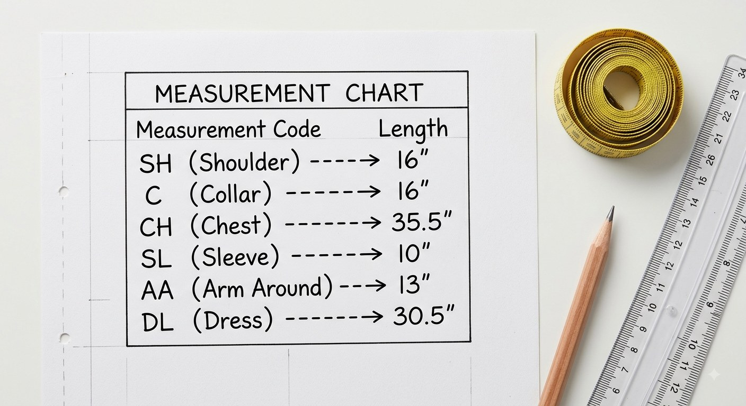
Fig. 1 — Measurement chart and codes used throughout this guide
Note: Take your own body measurements before drafting — the sample chart above is only an example of the format.

1. Drafting the Front Bodice
Neckline
1. Collar length ÷ 2, then divide that result by 3, minus 1/4" — this gives the vertical neck measurement.
2. Add 1/2" to the vertical neck measurement above to get the horizontal neck measurement.
3. Curve the neckline inward, 1" apart from the centre front and the shoulder line.
Shoulder
4. Shoulder length ÷ 2 for the vertical shoulder measurement.
5. Mark 2" inward and join it to the end of the neck point to form the shoulder line.
Chest & Armhole
6. Chest ÷ 4 for the horizontal chest measurement.
7. Chest ÷ 4 + 2" for the vertical chest measurement.
8. From the 2" inward mark on the shoulder line down to the chest line, divide the distance into 2 equal parts.
9. From that midpoint, mark 2cm (approx. 3/4") downward for the armhole line.
Body & Vent
10. From the top of the vertical chest line, mark 7" down along the dress length for the stomach line.
11. Mark the full dress length, then add 2" for the fold.
12. At your discretion, mark 2" to 7" up from the dress-length hem, lengthwise, for the vent line.
13. On the dress-length line, mark Chest ÷ 4 + 2" + 1/2" vertically.
14. On the stomach line, mark Chest ÷ 4 + 2" − 1/2" vertically.
15. Join the top mark on the chest line to the point on the stomach line, then continue up to the top of the dress length.
16. Draw a curve from the vent to meet the stomach line.
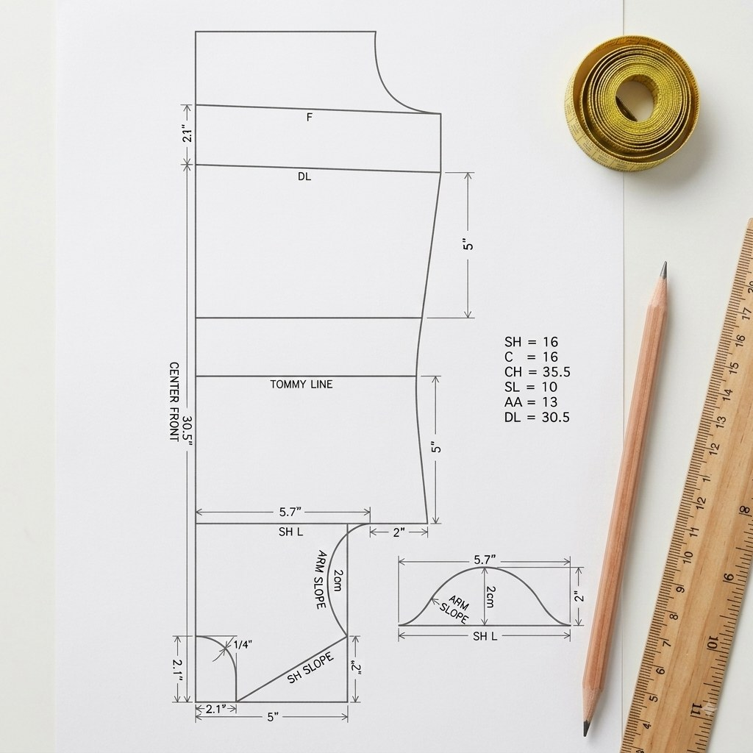
Fig. 2 — Front bodice, quick reference
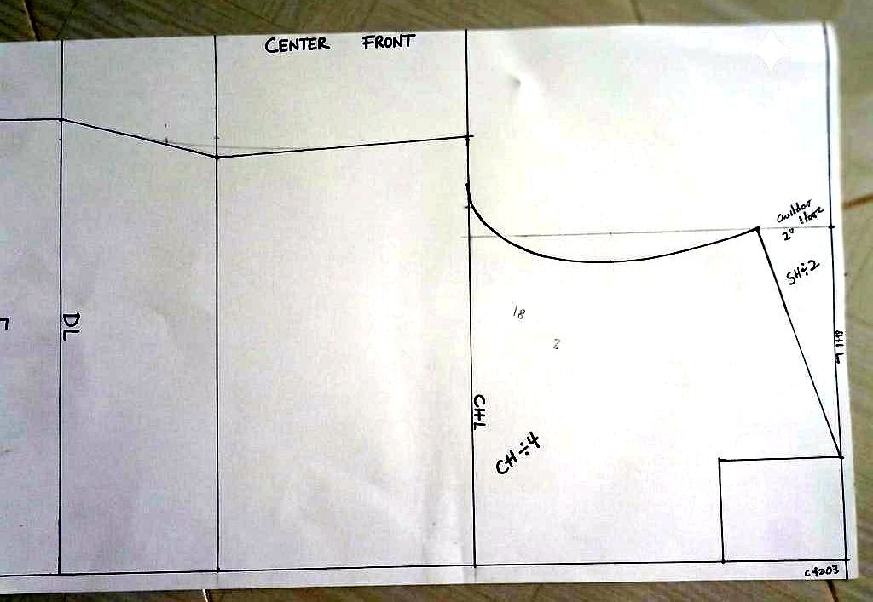
Fig. 3 — As drafted in our workshop
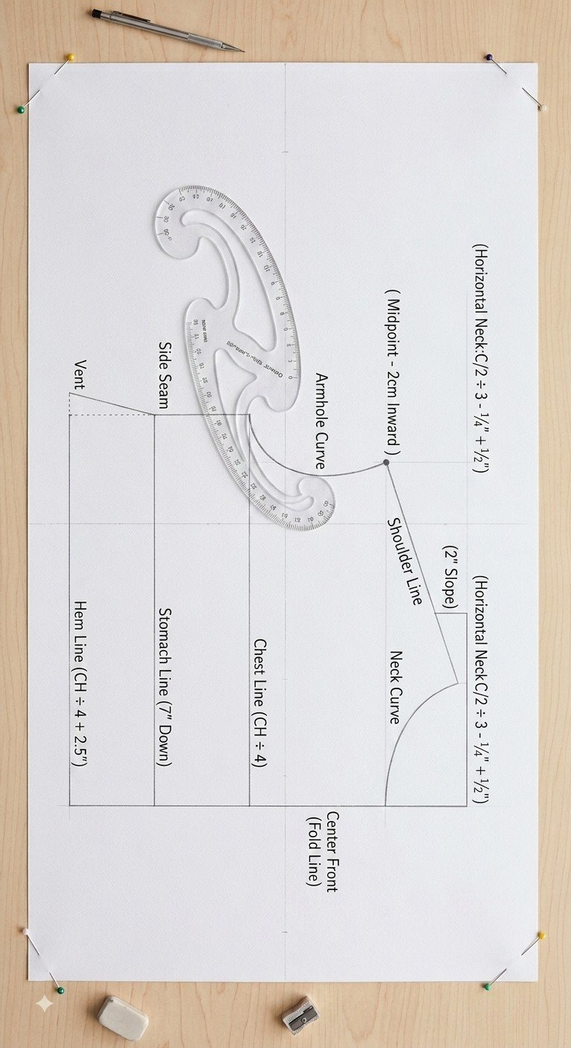
Fig. 4 — Shaping the armhole curve with a French curve ruler

2. Drafting the Back Bodice
1. Place the front bodice on the fabric on the fold. Measure 4" from the front bodice neckline outward on the fabric (on the fold) to draw a diagonal line to the shoulder line, then cut a little beyond the front bodice.
2. Measure 1/2" inward on the shoulder line of the front bodice.
3. Fold the measured 4" on the back bodice/panel onto the 1/2" inward mark on the front bodice/panel.
4. Make a notch at the points where the back and front bodice meet.
5. Mark 1cm upward from the midpoint between the shoulder line and the chest line, on the back bodice.
6. From the notch on the back bodice, draw a curve through the immediate edge of the shoulder-line end point of the front bodice, through the 1cm mark on the back bodice, to the chest-line end point — refreshing the armhole.
7. Mark 1/2" inward from the fold line on the back bodice.
8. Draw a curve from the centre-back mark to meet the notch marked earlier on the back bodice.
9. Cut along the curve drawn, from the centre-back neck to the notch.
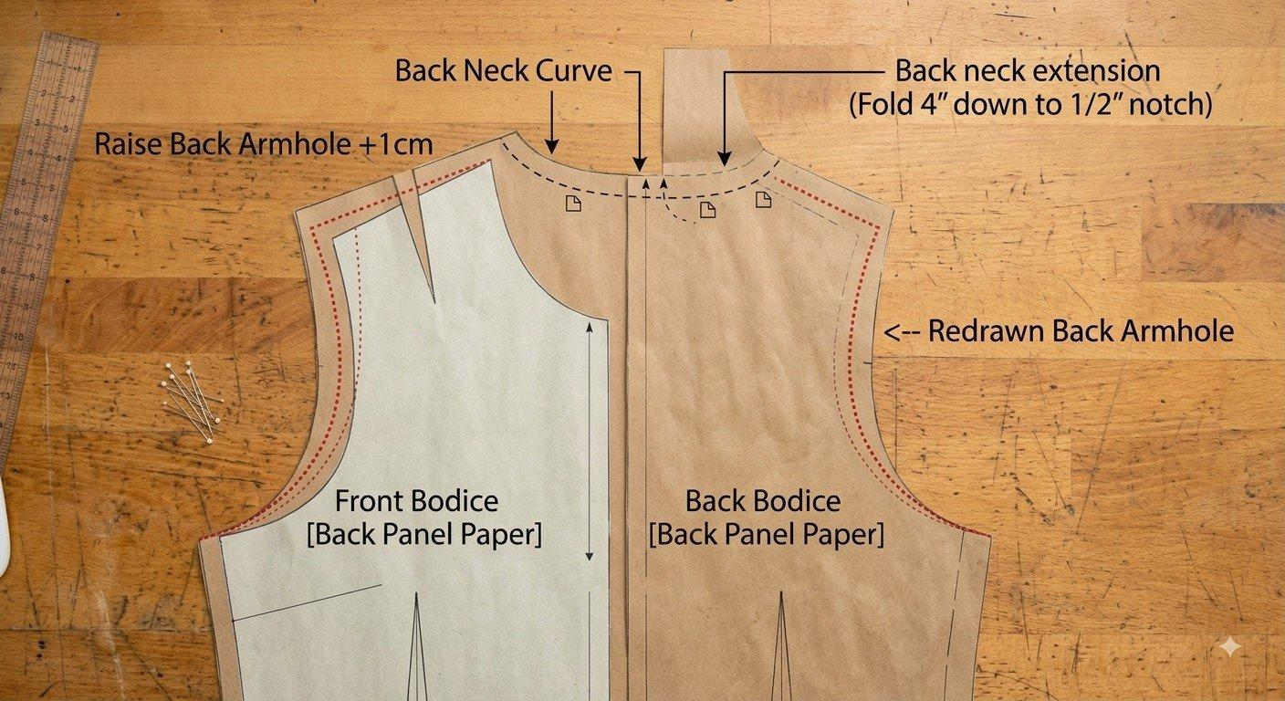
Fig. 5 — Back bodice, laid under the front bodice paper
Note: How to read this photo: the front bodice paper sits on top, the back bodice paper underneath. The red dotted line is the armhole after it's been raised by 1cm and redrawn — wider than the front armhole, to make room for the shoulder overlap. The black dashed curve at the neck is the back neck curve; the 4" fold marked there becomes a 1/2" notch once folded down. Where the two red lines meet at the shoulder is the notch — your matching point when you sew back to front.

3. Joining the Front Bodice to the Back Bodice/Panels
Front facing
1. Align the front panel and the front facing at the notch, and press.
2. Measure 1/2" along the neck curve and sew — backstitching at the start and end.
3. Notch along the joined front bodice and facing, close to the seam, without cutting through the seam.
4. Press the bottom of the front facing with dressmaker's glue to hold it in place against the front panel.
5. Press the front of the joined seam, making sure the notched neck flips onto the front facing.
6. Turn up the front facing to the back of the front panel and press.
7. Sew the front neck along the joint, backstitching at the start and finish.
Attaching the back panel
8. Align the front bodice/panel onto the back panel with the wrong side of the back bodice facing up.
9. Place the wrong side of the front bodice on the back panel — i.e., making sure the right side is facing up on the back bodice pieces.
Yoke
10. Measure a 1" fold at the bottom of the yoke and press with dressmaker's glue.
11. Place the right side of the yoke onto the right side of the front panel.
12. Align the right shoulder starting from the armhole (not the neck).
Note: The left side takes the zip for a male garment, and vice versa for a female garment.
13. Measure 1/2" on the aligned right shoulder, pin, sew, and press.
14. Mark 1/2" on the yoke along the neck and draw a curve.
15. Carefully flip the front panel out from under the yoke.
16. Align and pin the yoke to the back bodice.
17. Sew along the 1/2" neck mark, making sure it meets exactly the edge of the front panel at the right shoulder.
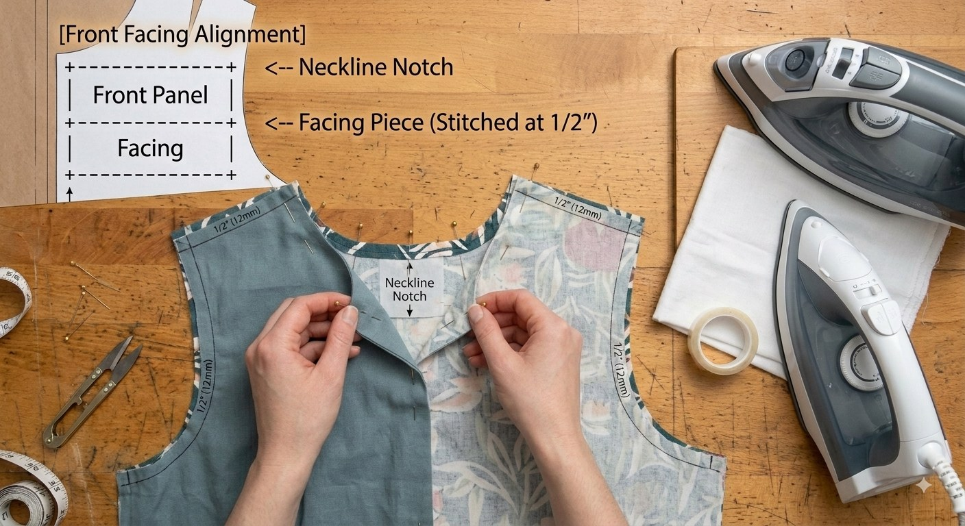
Fig. 6 — Pinning the facing to the front panel at the neckline
Note: How to read this photo: the small paper diagram (top left) shows the facing sitting directly behind the front panel, matched at the neckline notch. In the photo, both hands are pinning the facing piece to the front panel, right sides together, 1/2" from the raw edge — this is steps 1–2 above. The yoke steps (8–17) aren't pictured here since they build on this same facing seam, just at the shoulder instead of the neck — the same “pin at 1/2", sew, press” rhythm applies.

4. Cutting the Short Sleeve
1. Measure 6" to get the bicep line.
2. Secure a bi-fold (cross-fold) fabric and press.
3. Measure Sleeve length + 1/2" to get the hem line.
4. Measure 2" from the sleeve length for the fold.
5. On the hem line, measure Arm Around ÷ 2 + 1".
6. Diagonally, from the start of the centre front to the top of the bicep line, measure Armhole length − 1/2". Mark this and divide the armhole-length result into 3 equal parts.
7. From the first (bottom) mark on the armhole length, mark 2cm outward.
8. Use a French curve to join the second mark (from the centre-front line) through to refresh the edge line.
9. Join the second mark (from the centre-front line) to the third mark inward, using the French curve.
10. Join the top of the bicep line to the top of the hem line inward, with a slight curve, using the French curve.
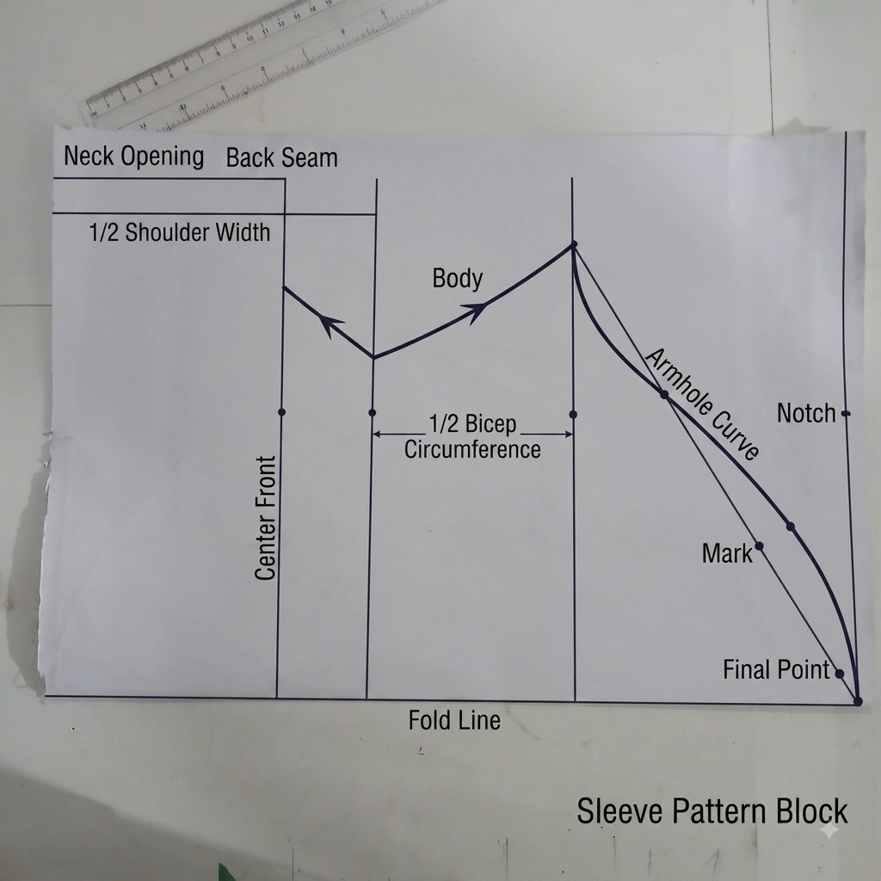
Fig. 7 — Sleeve pattern block, quick reference
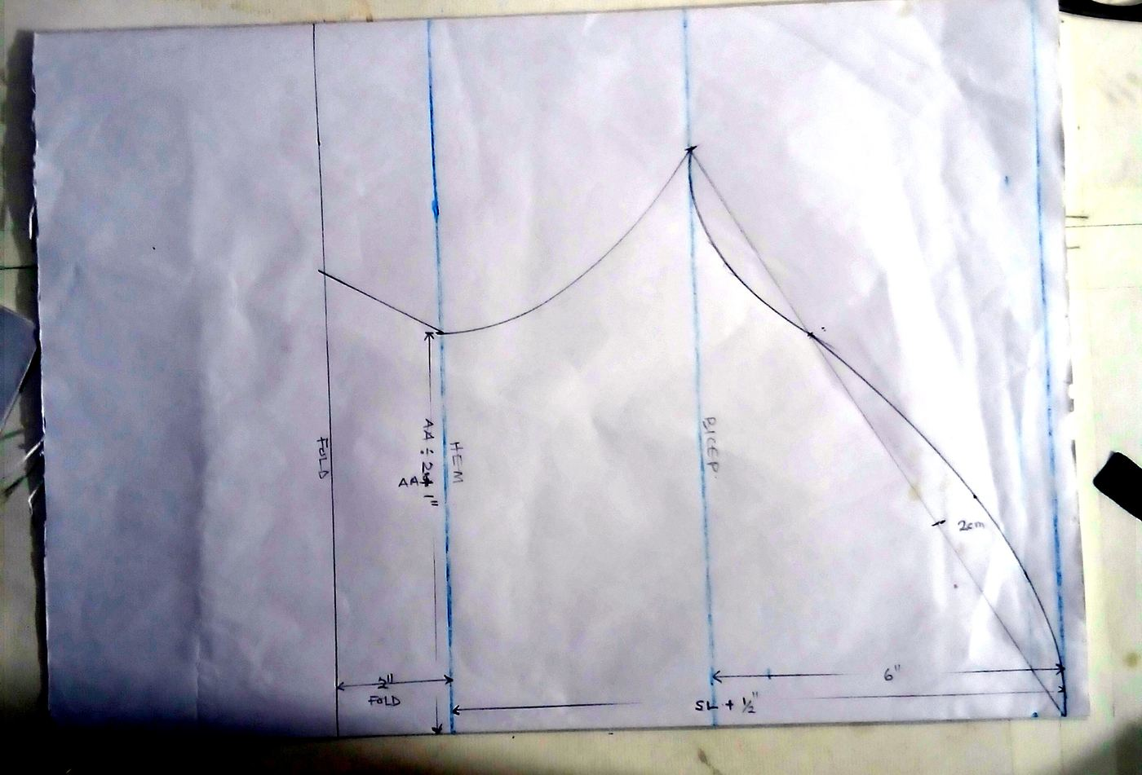
Fig. 8 — As drafted in our workshop
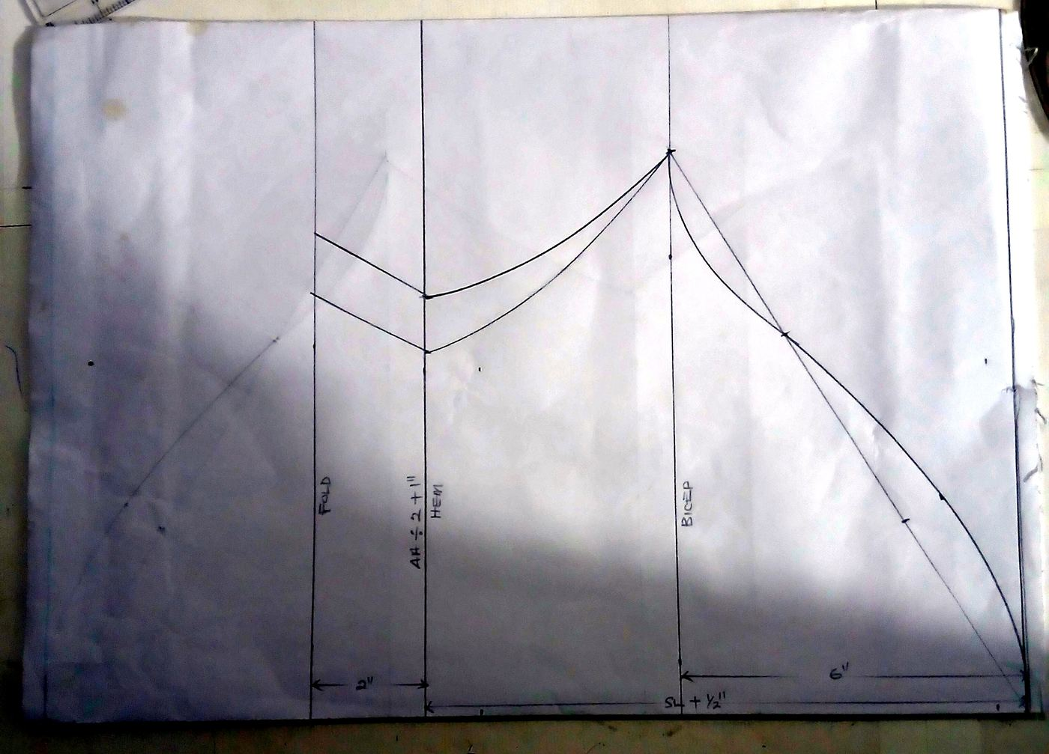
Fig. 9 — Alternate view

5. Cutting the Fabric
1. Fold your fabric so the centre front and centre back both sit on the fold, as marked on the paper pattern.
2. Lay the front bodice, back bodice, and sleeve pieces onto the fabric, matching each fold line to the fabric's fold.
3. Pin or weight the paper in place, then trace around each piece with tailor's chalk or a fading fabric pen.
4. Double-check every notch is marked on the fabric before you cut — these are your matching points at the shoulder, armhole, and neckline.
5. Cut along your chalk lines, cutting a little wide of the neckline and armhole curves so you have room to true them up before sewing.
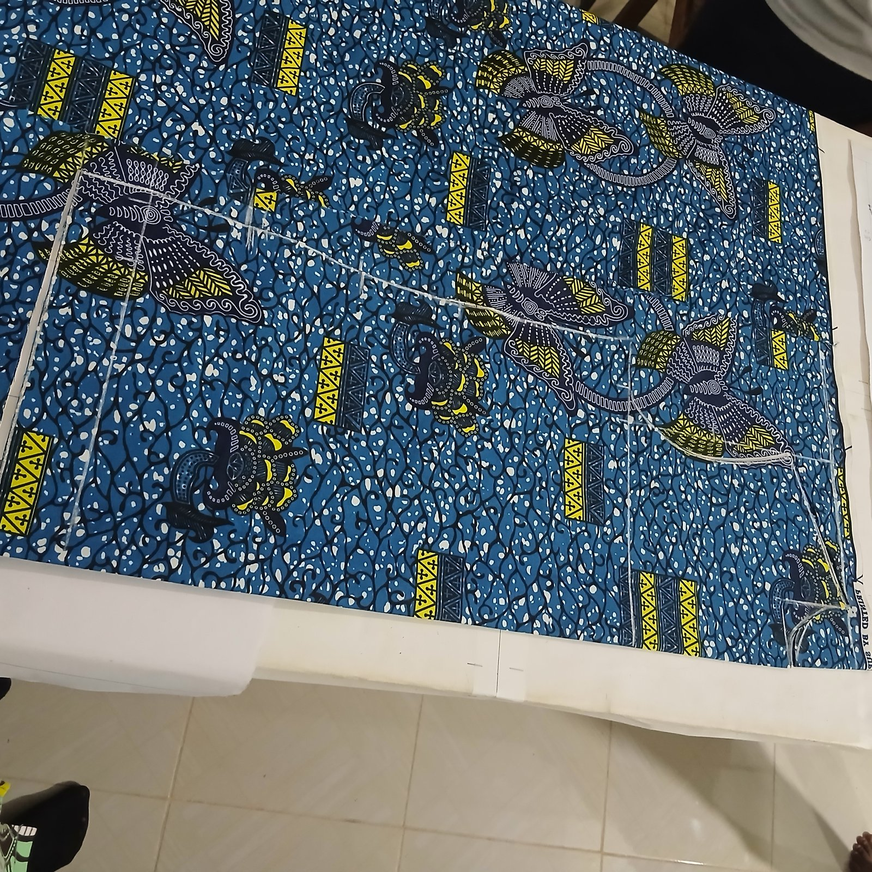
Fig. 7 — Front bodice chalked onto the fold
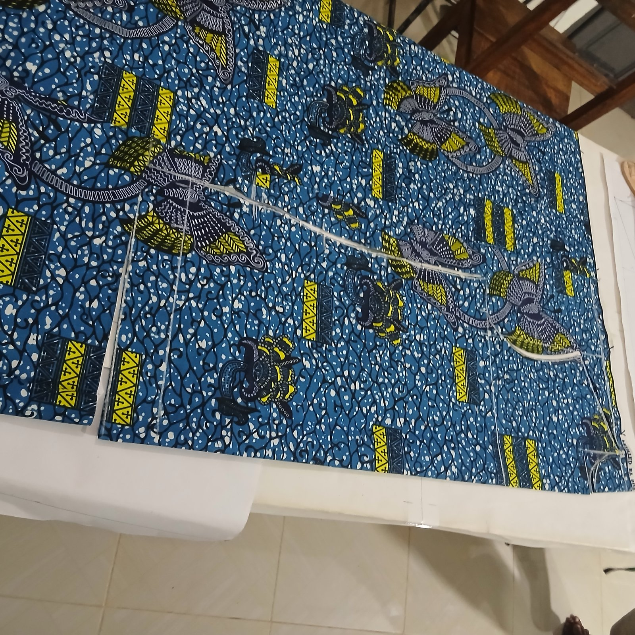
Fig. 8 — Marking the shoulder and armhole lines
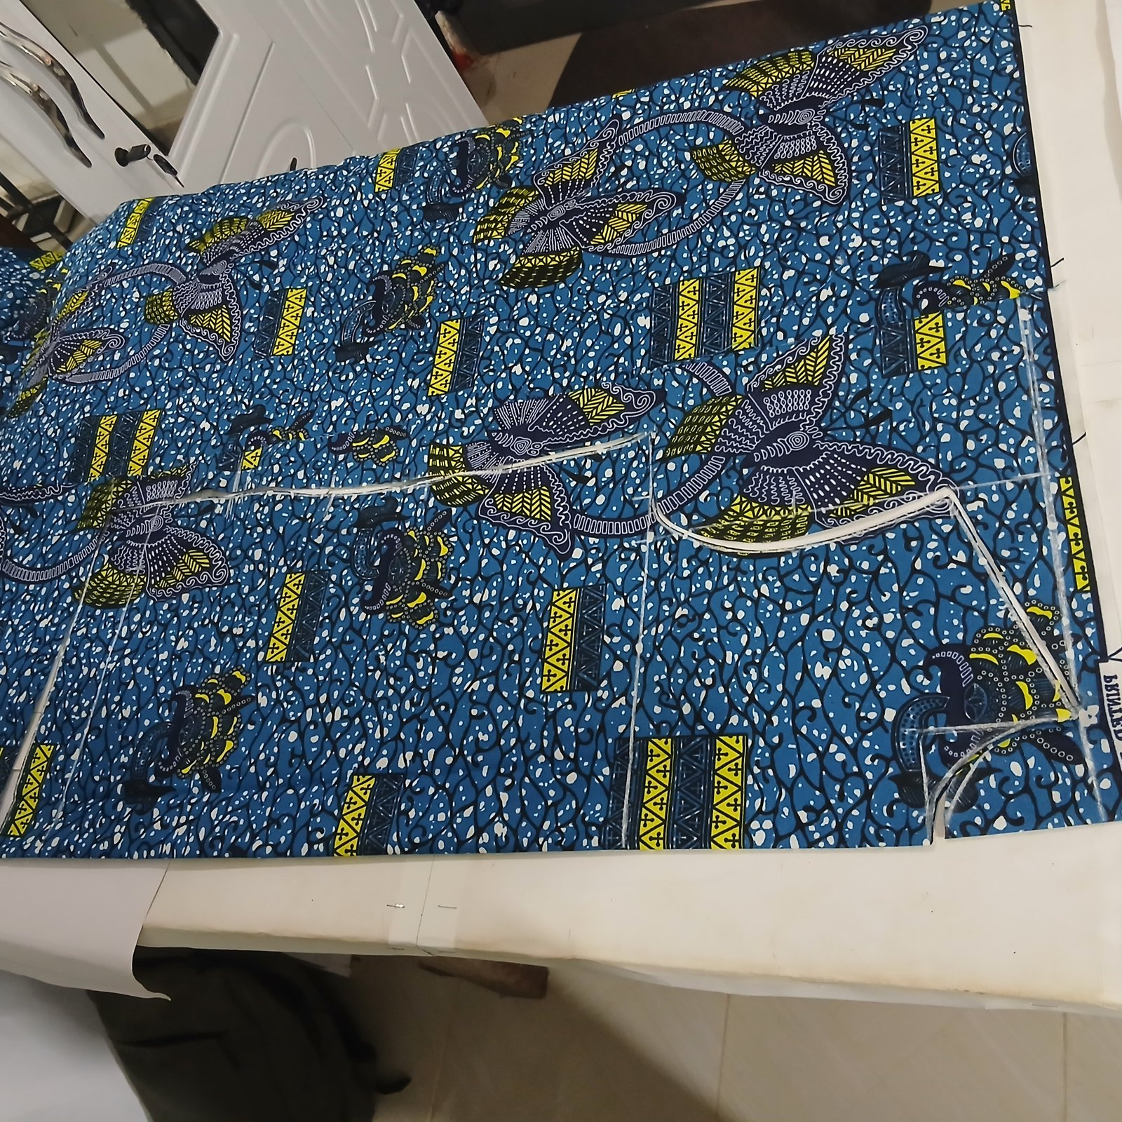
Fig. 9 — Ready to cut

6. Joining the Short Sleeves to the Armholes
1. From the wrong side, align the notches on the short sleeve with those on the back panel, and pin on the left and right. Repeat on the other side — make sure it matches at both ends, and don't forget the 1/2" caught section that secures the front panel.
2. Align the underarm (armpit) lines, the Arm Around endpoints, and the dress length, then pin — pinning along enough to hold the sides in place.
3. Mark 1" alternately at both sides, then stitch to complete the dress.
4. Neaten all the seam allowances.

How This Compares to Standard Pattern-Cutting Practice
•. Neckline formula checks out. Halving the collar and dividing by 3 is mathematically the same as the classic “neck size ÷ 6” rule used in standard block-drafting texts for front neck width — the −1/4" adjustment keeps it snug rather than gaping.
•. Armhole depth is within range. Chest ÷ 4 + 2" sits inside the accepted band (roughly chest/bust ÷ 4 plus 1.5–2") that standard blocks use for a semi-fitted garment.
•. No separate bust/waist dart. Fitted Western blocks (e.g. Aldrich-style) shape the waist and bust with darts; this draft is a direct, dartless cut — standard for loose-fitting garments like the jumpa, kaftan, and boubou styles common in West African tailoring. It trades close fit for drape and speed, by design rather than by omission.
•. Sleeve cap follows a recognised approach. Dividing the armhole length into three to place the cap curve points mirrors the AH÷3 logic used in formal sleeve-cap-ease calculations.
•. Where it differs from textbook notation: commercial patterns are usually drafted in one consistent unit and reference a printed measurement chart with abbreviations defined up front. This draft mixes inches and centimetres (e.g. the 2cm armhole and back-neck marks) — worth standardising to one unit for a repeatable, teachable version of the pattern.
Note: Drafted, photographed, and pattern-checked at the itrola true image workshop, Ghana — part of an ongoing series documenting the craft behind our Textiles pillar.

