TOKIO MARINE INSURANCE SINGAPORE LTD - MAS G1 Management Commentary
Insurance fund: SIF | Period reviewed: 2022 to 2024 | Prepared: 10 August 2026

Executive Summary
The operating result of TOKIO MARINE INSURANCE SINGAPORE LTD.'s SIF fund showed a significant improvement from S$8.7m in 2022 to S$48.6m in 2023, followed by a slight decrease to S$46.7m in 2024. The underwriting result trend improved from S$23.2m in 2022 to S$28.3m in 2024, indicating a 19.5% increase. This improvement was primarily driven by a recovery in investment income, which normalized from -S$14.5m in 2022 to S$24.9m in 2023, and further to S$18.3m in 2024. Despite this recovery, the investment income in 2024 declined by 26.5%, suggesting volatility. The most material cost pressure in 2024 was represented by combined management and distribution expenses at 14.9% of earned premiums, up from 10.9% in 2023. Management should closely monitor this expense trend to ensure it does not become a structural drag on underwriting margins.

KPI Overview
Metric | 2022 | 2023 | YoY | 2024 | YoY
Gross premiums | S$179.0m | S$180.4m | +0.8% | S$208.0m | +15.3%
Earned premiums | S$102.6m | S$105.1m | +2.5% | S$119.6m | +13.8%
Net claims incurred | S$48.8m | S$47.5m | -2.6% | S$52.3m | +10.1%
Management expenses | S$20.2m | S$21.0m | +3.9% | S$22.9m | +8.9%
Distribution expenses | S$10.4m | S$12.9m | +24.5% | S$16.1m | +24.9%
Underwriting result | S$23.2m | S$23.7m | +2.0% | S$28.3m | +19.5%
Investment income | -S$14.5m | S$24.9m | +271.7% | S$18.3m | -26.5%
Operating result | S$8.7m | S$48.6m | +456.4% | S$46.7m | -4.0%

Year-on-Year Commentary

2023 vs 2022
- The operating result increased by S$39.9m from S$8.7m in 2022 to S$48.6m in 2023. This increase was primarily driven by a S$39.4m rise in investment income, rather than changes in underwriting performance.
- Underwriting resulted in a S$0.5m decrease from S$23.2m in 2022 to S$23.7m in 2023. This slight movement was not significant enough to impact the overall operating result. Key contributors to the underwriting result included a S$1.7m increase in claims incurred and a S$1.2m increase in management expenses, both of which grew faster than earned premiums. Distribution expenses also increased by S$2.5m, contributing to the overall expense growth.

2024 vs 2023
- The operating result decreased by S$2.0m from S$48.6m in 2023 to S$46.7m in 2024. The primary driver of this change was the decrease in investment income of S$6.6m.
- Underwriting result improved by S$4.6m to S$28.3m, primarily due to a normalisation in investment income following a loss year in 2022. This improvement was partially offset by an increase in management expenses of S$1.9m and distribution expenses of S$3.2m. The most material cost pressure was represented by the rise in distribution expenses, which increased to S$16.1m, accounting for 13.5% of earned premiums compared to 10.1% in 2023.

Financial Movement Chart
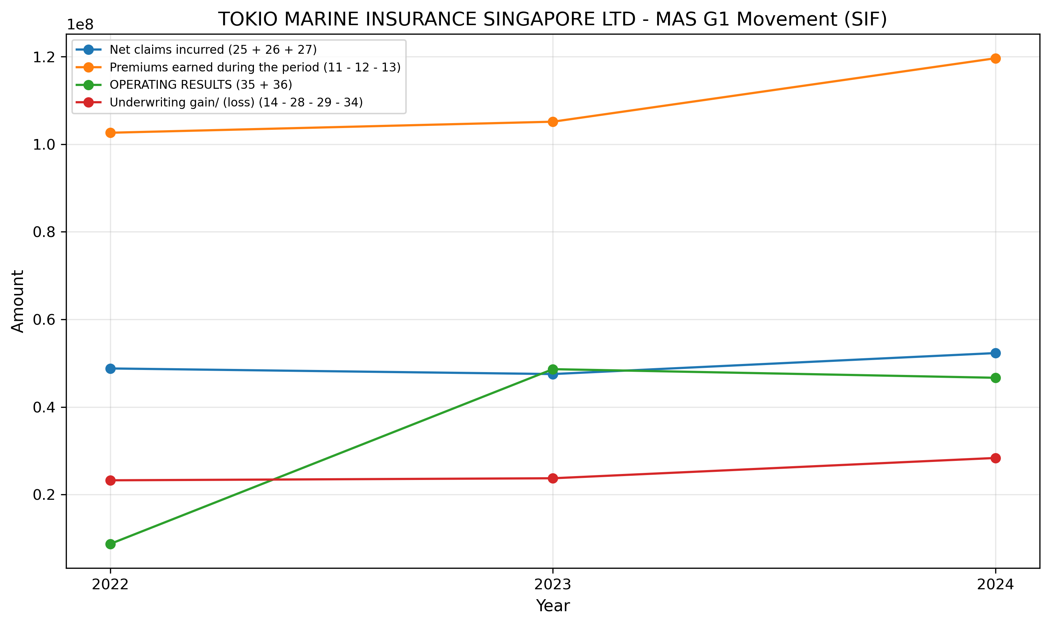

Management Review Points
- Earned premium growth of +16.6% over 2022 to 2024 outpaced net claims growth of +7.2%, from S$102.6m to S$119.6m and S$48.8m to S$52.3m respectively; monitor by line of business to confirm the margin trend is not narrowing.
- Distribution expenses rose from 10.1% to 13.5% of earned premiums (S$10.4m to S$16.1m); distribution expense growth of +55.4% exceeded earned premium growth of +16.6%, so management should assess whether this pressure is structural.
- Underwriting result of S$28.3m in 2024 should be assessed separately from investment income of S$18.3m when evaluating operating result quality; investment income moved from -S$14.5m in 2022 and has shown material volatility across the period.
- Validate all movements by line of business before external publication; the fund-level figures do not distinguish between lines and may mask offsetting movements.

Key Monitoring Areas / Emerging Risks
- Premium growth exceeded claims growth by +3.7% in 2024 (+13.8% vs +10.1%); monitor whether this spread is maintained as claims development matures.
- Distribution expense growth exceeded earned premium growth by +11.1% in 2024; if this trend continues it will compress underwriting margins regardless of premium volume.
- Investment income swung by S$39.4m between 2022 and 2023 (from -S$14.5m to S$24.9m); operating result sustainability should not be assessed without separating underwriting from investment contributions.
- Underwriting result represented 61% of the 2024 operating result; monitor whether the underwriting share of earnings continues to improve or whether the fund remains partially dependent on investment income.

Scope and Limitations
This commentary was generated by a Hugging Face instruction model (`Qwen/Qwen2.5-3B-Instruct`) using structured MAS G1 facts derived from the local workbook. It is intended as a management-ready draft and should be reviewed against detailed line-of-business analysis, reserving information, reinsurance arrangements, and management explanations before publication.

