Supplementary Information for

Leveraging Large Language Models for Redundancy-Aware Pathway Analysis and Deep Biological Interpretation

Yifei Ge^{1,2+}, Feifan Zhang^{1,2+}, Yijiang Liu^{1,2+}, Chao Jiang³, Peng Gao⁴, Nguan Soon Tan^{1,5}, Sai Zhang⁶, Yuchen Shen^{1,7}, Qianyi Zhou⁸, Xin Zhou⁸, Xiao Wang⁹, Chuchu Wang^{1*}, and Xiaotao Shen^{1,2,10*}
- Lee Kong Chian School of Medicine, Nanyang Technological University, Singapore, Singapore
- School of Chemistry, Chemical Engineering and Biotechnology, Nanyang Technological University, Singapore, Singapore
- Life Sciences Institute, Zhejiang University, Hangzhou, Zhejiang, China
- Department of Environmental Health and Department of Molecular Metabolism, Harvard T.H. Chan School of Public Health, Boston, MA, USA
- School of Biological Sciences, Nanyang Technological University, Singapore, Singapore
- ​​Department of Biomedical Informatics & Data Science, Yale University School of Medicine, Yale University, New Haven, CT, USA
- Centre of Biomedical Systems and Informatics, International Campus, ZJU-UoE Institute, Zhejiang University School of Medicine, Zhejiang University, Haining, Zhejiang, China
- Intelligent Medicine Institute, Fudan Microbiome Center, Fudan University Shanghai Medical College, Fudan University, Shanghai, China
- State Key Laboratory of Crop Stress Adaptation and Improvement, State Key Laboratory of Cotton Bio-breeding and Integrated Utilization, Henan Joint International Laboratory for Crop Multi-Omics Research, School of Life Sciences, Henan University, Kaifeng, Henan, China.
- Singapore Phenome Center, Nanyang Technological University, Singapore, Singapore

⁺ These authors contributed equally: Yifei Ge, Feifan Zhang, and Yijiang Liu.
* Corresponding authors: Chuchu Wang (chuchu.wang@ntu.edu.sg) and Xiaotao Shen (xiaotao.shen@ntu.edu.sg).

Table of Contents

Supplementary Method 1. Assessment of pathway redundancy

Supplementary Method 2. Construction of curated pathway datasets

Supplementary Method 3. General statistics

Supplementary Method 4. Detailed methodological validation of MAPA
Supplementary Figure 1. Redundancy within Gene Ontology and across metabolic pathway databases.
Supplementary Figure 2. Representative MAPA outputs generated from the package’s built-in example dataset.
Supplementary Figure 3. Example MAPA structured report.
Supplementary Figure 4. Pairwise correlation among different similarity metrics.
Supplementary Figure 5. Discriminative power of similarity metrics specifically for GO terms.
Supplementary Figure 6. Benchmarking MAPA against other pathway redundancy analysis tools on the curated dataset 1.
Supplementary Figure 7. Reproducibility for MAPA’s performance across independent runs on curated data.
Supplementary Figure 8. Shared age-related functional modules across diverse tissues.
Supplementary Figure 9. MAPA reveals biologically meaningful functional networks in age-dependent liver gene expression profiles.
Supplementary Figure 10. MAPA identifies biologically meaningful functional modules in the aging brain.
Supplementary Figure 11. MAPA identifies functional modules from age-related plasma proteomics and metabolomics data.
Supplementary Figure 12. Distribution of functional module count and size across tissues.
Supplementary Figure 13. Heatmap of Dysregulation Index for functional modules generated from age-dependent differentially expressed genes identified from bulk RNA-seq data across tissues.
Supplementary Table 1. Comparison of MAPA with existing pathway clustering tools.
Supplementary Table 2. The annotation results from five human experts.
Supplementary Note 1. Prompt engineering.

Supplementary Note 2. Sample preparation and analytical conditions for the case study
Supplementary Note 3. Key limitations of existing pathway similarity metrics.
Supplementary Note 4. Existing pathway similarity metrics.
Supplementary Note 5. Biological connections among GO:0098985, GO:0098978, and hsa04724.
Supplementary Note 6. Explanation for differences between ground truth and clustering result generated by louvain algorithm (similarity cutoff: 0.55).
Supplementary Note 7. R version and R packages used for data analysis in this study.

Supplementary Method 1. Assessment of pathway redundancy
To evaluate redundancy, we analyzed widely used pathway databases both within-database and across-database. Our within-database analysis focused on the Gene Ontology database. For the across-database comparison, we selected the metabolite databases KEGG, SMPDB, and Reactome.

Pathway redundancy within the Gene Ontology database
We assessed the internal redundancy within the human Gene Ontology database. GO annotations were retrieved from the org.Hs.eg.db R package (source data stamp: 2025-02-06). Semantic similarity scores between GO terms were calculated separately for the BP, MF, and CC sub-ontologies. This calculation was performed using the “Wang” method, which considers the topology of the GO graph structure, as implemented in the GOSemSim package. The distribution of these similarity scores was then visualized using histograms. To further visualize the redundancy structure of terms with high similarity, we constructed networks based on term pairs with a semantic similarity score greater than 0.9. The networks were built using the tidygraph package. Subsequently, we applied the Girvan-Newman community detection algorithm, via the igraph package, to cluster the terms into distinct modules. The final networks were visualized using the ggraph package.

Pathway redundancy across databases
To evaluate redundancy across KEGG, SMPDB, and Reactome metabolite pathways, we first retrieved the original datasets-acquiring human‐specific metabolite pathways from KEGG and SMPDB with the metpath package¹ and extracted Reactome human pathways from ChEBI to the all-pathways hierarchy file. After that, we harmonized all metabolite identifiers by mapping the native IDs, like ChEBI IDs, to HMDB IDs via the Tidymass MS1 metabolite database² and removed duplicate HMDB IDs. Finally, we quantified the similarity between pathways by calculating pairwise Jaccard coefficients on the resulting HMDB ID sets.

Supplementary Method 2. Construction of curated pathway datasets
Two curated pathway datasets were constructed to demonstrate the application of MAPA and benchmarking.

Curated pathway dataset 1
To provide a ground truth for evaluating MAPA’s ability to cluster functionally related pathways and separate unrelated ones, we constructed the curated pathway dataset 1. Functionally distinct GO terms were first selected from AmiGO2 as seed terms. For each seed, expected functional modules were expanded by including immediate “is a” or “part of” parent and child GO terms, as well as cross-referenced KEGG or Reactome pathways. When cross-references were unavailable, pathways with identical or synonymous names were manually identified in KEGG and Reactome. The final dataset (Supplementary Data 2) contained 12 expected modules, including 8 multi-pathway modules (3–7 pathways each) and 4 singletons, comprising 44 pathways in total (22 GO terms, 14 KEGG pathways, and 8 Reactome pathways). This dataset served as the ground truth for clustering evaluation.

Curated pathway dataset 2
Curated pathway dataset 2 focused on metabolic pathways to illustrate redundancy across databases. Pathway names from SMPDB, KEGG, and Reactome were matched using the Jaro-Winkler similarity metric with a cutoff of 0.85, followed by manual curation of unmatched entries. This procedure yielded 44 matched pathway pairs between Reactome and KEGG, 43 between SMPDB and Reactome, and 44 between SMPDB and KEGG, which together constituted curated pathway dataset 2 (Supplementary Data 2).

Supplementary Method 3. General statistics
All data processing, statistical analyses, and visualizations were conducted using R version 4.5.0 (https://www.r-project.org/) within the RStudio environment. A comprehensive list of R packages utilized in this study is provided in the Supplementary Note 7. Statistical significance was assessed using the Wilcoxon rank-sum test implemented via the ggsignif package and wilcox.test function. Multiple hypothesis testing was corrected using the False Discovery Rate (FDR) method (p.adjust function). Effect sizes were calculated to quantify the magnitude of the difference between groups. Specifically, we used the non-parametric statistic Cliff’s delta (δ), which ranges from -1 to 1, where 0 indicates stochastic equality and ±1 indicates complete dominance by one group³. Calculations were performed with the cliff.delta function from the effsize R package. Dimensionality reduction was performed using Principal Component Analysis (PCA) via the prcomp function and Uniform Manifold Approximation and Projection (UMAP) implemented through the uwot package. Figure icons were obtained from iconfont.cn and are used under the terms of the MIT License for non-commercial purposes (https://pub.dev/packages/iconfont/license).

Supplementary Method 4. Detailed methodological validation of MAPA
Evaluation of the biotext embedding similarity
To evaluate the effectiveness of the biotext embedding similarity implemented in MAPA, we benchmarked it against representative pathway similarity methods commonly used in pathway analysis. These methods were selected to cover distinct conceptual paradigms for defining pathway similarity (Supplementary Note 4).
First, we compared biotext embedding with component-based similarity approaches, which quantify similarity based on overlap in annotated molecular components (e.g., genes, proteins, or metabolites). These methods capture direct content overlap but are sensitive to pathway size and annotation density. We excluded component-based methods with highly redundant correlation profiles (Supplementary Figure 4) and retained the Jaccard index and overlap coefficient as representative approaches.
Second, we evaluated semantic similarity methods that leverage hierarchical relationships within controlled vocabularies. Such methods are widely used for Gene Ontology (GO) terms and quantify similarity based on shared ontology structure, but they are restricted to GO-based analyses and are not applicable to pathway databases lacking formal ontology representations.
To ensure a fair and comprehensive comparison, all similarity methods were applied to the same benchmark dataset (curated pathway dataset 1). Because semantic similarity methods are only applicable to GO terms, we adopted a two-stage evaluation strategy. In the first stage, the biotext embedding method and component-based methods were evaluated on the full dataset. In the second stage, non-GO pathways were excluded, and the biotext embedding method was compared with both component-based and semantic similarity methods on GO terms only. This design enabled direct comparison across general pathway collections as well as GO-specific contexts.

Evaluation of clustering methods
We benchmarked multiple clustering strategies on a curated pathway dataset 1 with known ground truth module assignments to evaluate their ability to identify functional modules. The dataset included pathways from GO and other databases, enabling assessment across heterogeneous biological contexts.
Three classes of clustering approaches were evaluated: graph-based community detection methods, distance-based clustering algorithms, and binary cut. For each method, parameters were systematically tuned, and for each target number of clusters as follows, the configuration yielding the highest ARI was retained to ensure fair comparison.

Graph-based methods For graph-based clustering, we constructed similarity networks by applying various cutoff thresholds (ranging from 0.2 to 0.9 in increments of 0.01) to filter edges based on pairwise similarity scores. We evaluated eleven community detection algorithms implemented in the igraph R package: fast greedy, Louvain, walktrap, InfoMap, label propagation, leading eigenvector, Leiden, edge betweenness, optimal, spinglass, and fluid communities. Most algorithms operated directly on similarity weights, while the edge betweenness algorithm required distance measures and used converted weights calculated as distance = 1 – similarity. These algorithms automatically determine the optimal number of clusters based on modularity maximization rather than allowing direct specification of cluster numbers. To enable fair comparison across methods with target cluster numbers ranging from 2 to 43, we systematically varied similarity cutoffs and retained only the result with the highest ARI score when multiple cutoffs produced the same number of clusters for a given algorithm.

Distance-based methods We applied multiple distance-based clustering approaches to the pathway similarity matrix. For hierarchical clustering, we converted the similarity matrix to a distance matrix using distance = 1 – similarity and systematically tested eight linkage methods (ward.D, ward.D2, single, complete, average, mcquitty, median, centroid) across all possible cluster numbers from 2 to 43 using the hclust function with cutree to obtain desired cluster counts. K-means clustering was performed on similarity matrices, directly specifying cluster centers from 2 to 43 with 50 random starts (nstart = 50) for robust optimization. For methods that do not allow direct cluster number specification—including HDBSCAN (with minimum points parameters from 2 to 43), Affinity Propagation (with preference values from 0.2 to 0.9), Mean-Shift clustering (with bandwidth parameters from 0.05 to 1.0), and Gaussian Mixture Models (with component numbers from 2 to 43), we systematically varied their respective parameters and retained only the configuration with the highest ARI score when multiple parameter settings yielded the same number of clusters.

Binary cut Binary cut clustering was performed using the simplifyEnrichment R package with systematic evaluation of cutoff values ranging from 0.5 to 0.95 in increments of 0.01. Since binary cut automatically determines the number of clusters based on the similarity structure rather than allowing direct specification, we applied the binary_cut function with try_all_partition_fun = TRUE across all cutoffs and calculated ARI scores against ground truth labels. When multiple cutoffs produced the same number of clusters, we retained only the result with the maximum ARI score to enable fair comparison with other methods across the target range of 2 to 43 clusters.

Clustering agreement with ground truth was quantified using the ARI, as implemented in the mclust R package. Statistical significance of performance differences between representative graph-based (Louvain) and distance-based (hierarchical clustering with ward.D2 linkage) approaches was assessed using paired permutation tests on ARI scores (9,999 permutations, α = 0.05).

Evaluation of confidence score specificity using randomized pathway modules
A negative control analysis was conducted using size-matched randomized pathway modules (curated pathway dataset 1). For each curated module, a random module was generated by sampling pathways from outside the original module. Real and random modules were processed using the same pipeline, and intra-module similarity and LLM-based module confidence scores were compared.

Evaluation of functional module interpretability using human expert annotations
To assess the interpretability of MAPA-generated functional module annotations, we performed a structured comparison with human expert annotations. Five domain experts with backgrounds in molecular biology, biochemistry, and/or computational biology independently annotated functional modules using the same pathway information and instructions provided to MAPA (Supplementary Note 7). Experts were permitted to consult literature and databases but were not allowed to use AI-based tools.
To enable quantitative comparison, annotation texts (module names and functional summaries) from both MAPA and experts were converted into text embeddings. PCA was applied to the embeddings for each module to visualize the semantic relationships between MAPA-generated and expert annotations.

Evaluation of MAPA’s reproducibility
Reproducibility of the MAPA workflow was assessed across 15 independent runs on curated pathway dataset 1. Clustering consistency was quantified using pairwise ARI. To evaluate annotation stability, LLM-generated functional summaries were converted into text embeddings, and pairwise cosine similarities were computed for annotations of the same functional module across runs (to measure consistency), as well as between different modules (to measure specificity).
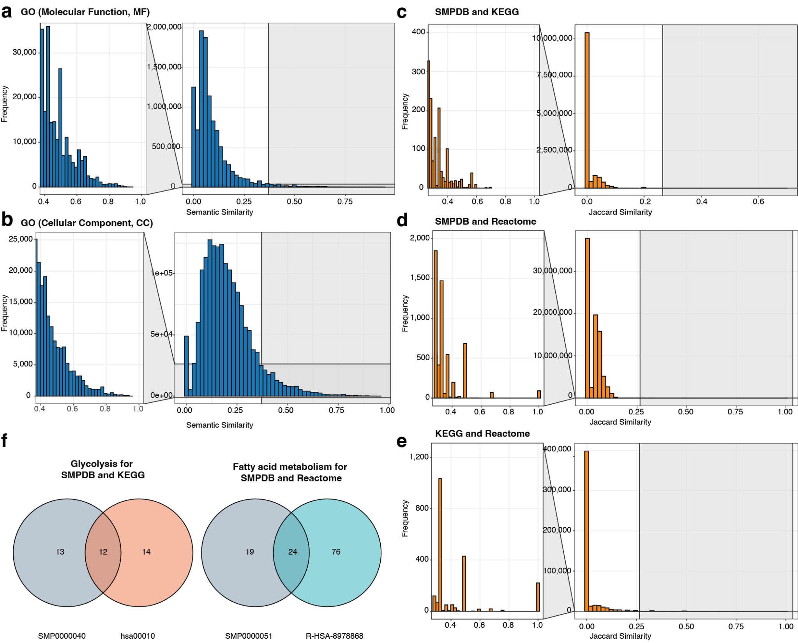

Supplementary Figure 1. Redundancy within Gene Ontology and across metabolic pathway databases. a,b, Histograms showing the distribution of pairwise Wang similarity scores for Gene Ontology (GO) terms within the molecular function (a) and cellular component (b) subontologies. A substantial proportion of GO term pairs exhibit high semantic similarity, indicating significant redundancy within the GO database. c-e, Histograms of pairwise Jaccard similarity scores for human pathways across different metabolic databases: SMPDB vs. KEGG (c), SMPDB vs. Reactome (d), and KEGG vs. Reactome (e). The presence of many pathway pairs with high similarity scores indicates extensive cross-database redundancy. f, Two representative biological processes represented by pathways from different databases that share many metabolites. Venn diagrams illustrating the overlap in molecular components for representative biological processes. Left: Glycolysis pathways from SMPDB (SMP0000040) and KEGG (hsa00010). Right: Fatty acid metabolism pathways from SMPDB (SMP0000051) and Reactome (R-HSA-8978868).

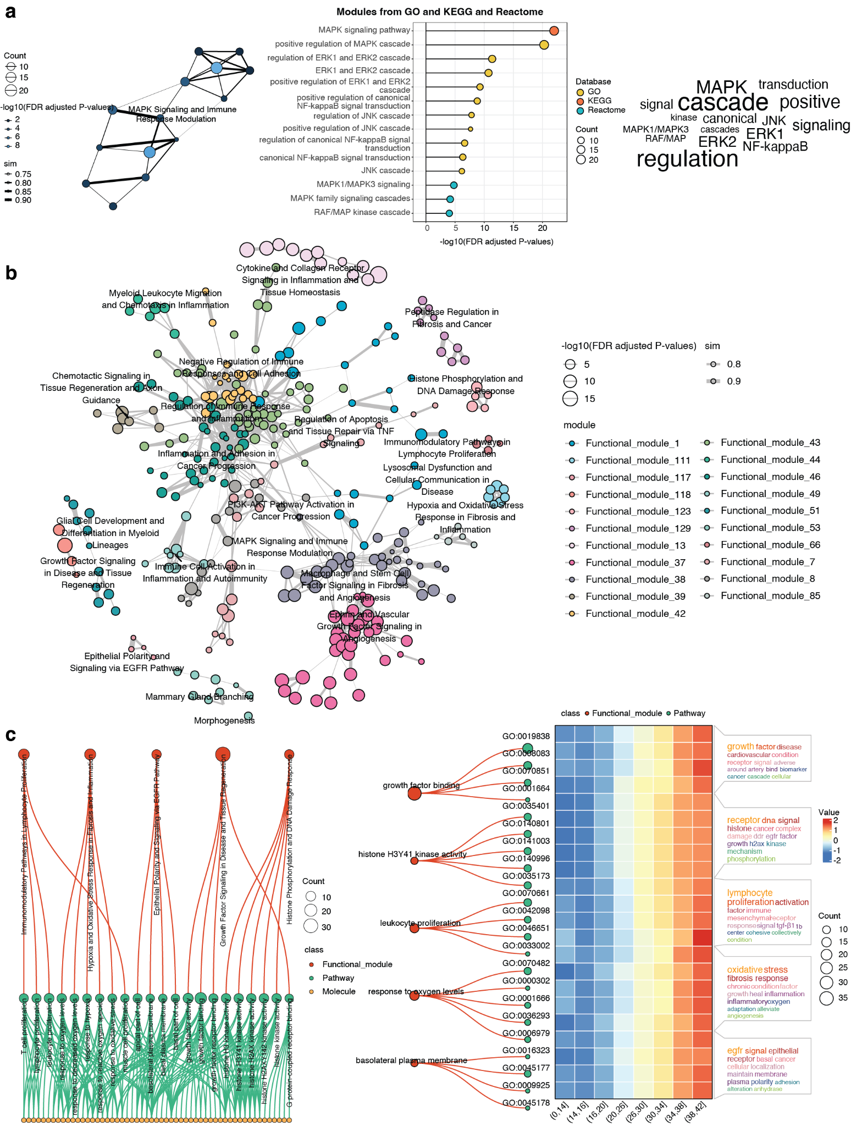Supplementary Figure 2. Representative MAPA outputs generated from the package’s built-in example dataset. a, Module detail view combining the intra-module network, pathway enrichment summary (GO/KEGG/Reactome), and a keyword cloud. b, Similarity network of functional modules (≥3 nodes) illustrating relationships among modules. c, Left, a multipartite graph linking molecules, pathways, and functional modules; right, an expression heatmap integrated with the relationship network and keyword clouds, jointly representing functional themes and expression patterns.

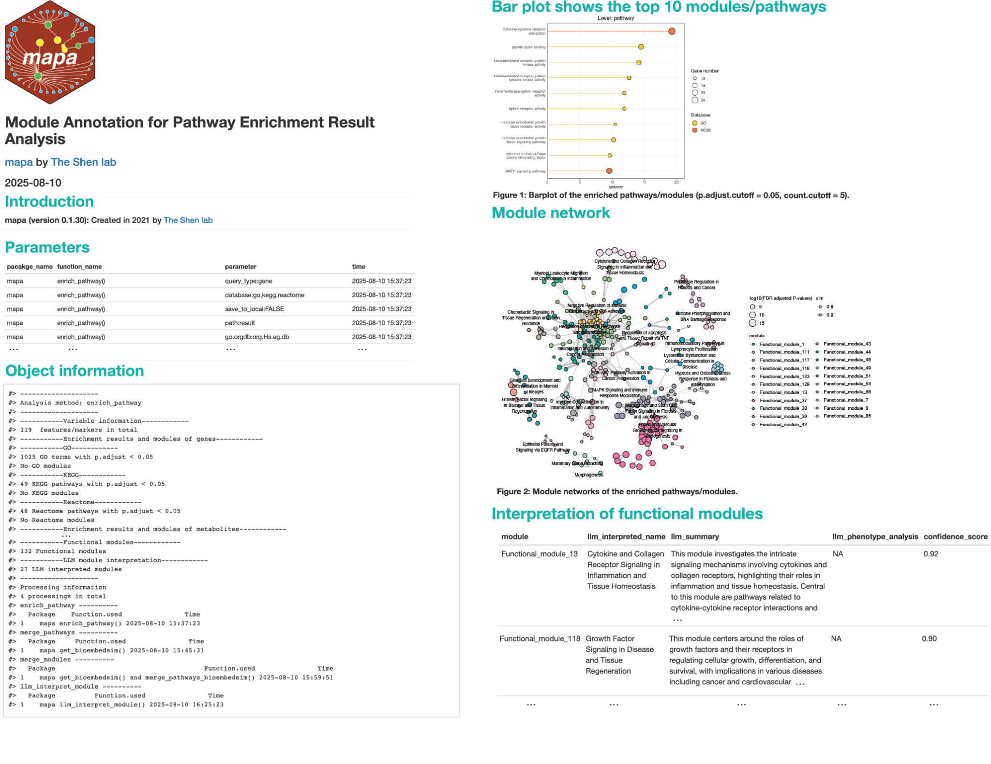

Supplementary Figure 3. Example MAPA structured report. The report compiles: (1) package version, and timestamps; (2) input parameters; (3) object information summarizing methods, databases queried, and processing steps; (4) bar plot of the top 10 enriched pathways or representative pathways from functional modules; (5) module network summarizing relationships among functional modules and enriched pathways; (6) an interpretation table listing module ID, functional name, summary, module-phenotype analysis, and confidence score generated by large language model (LLM).

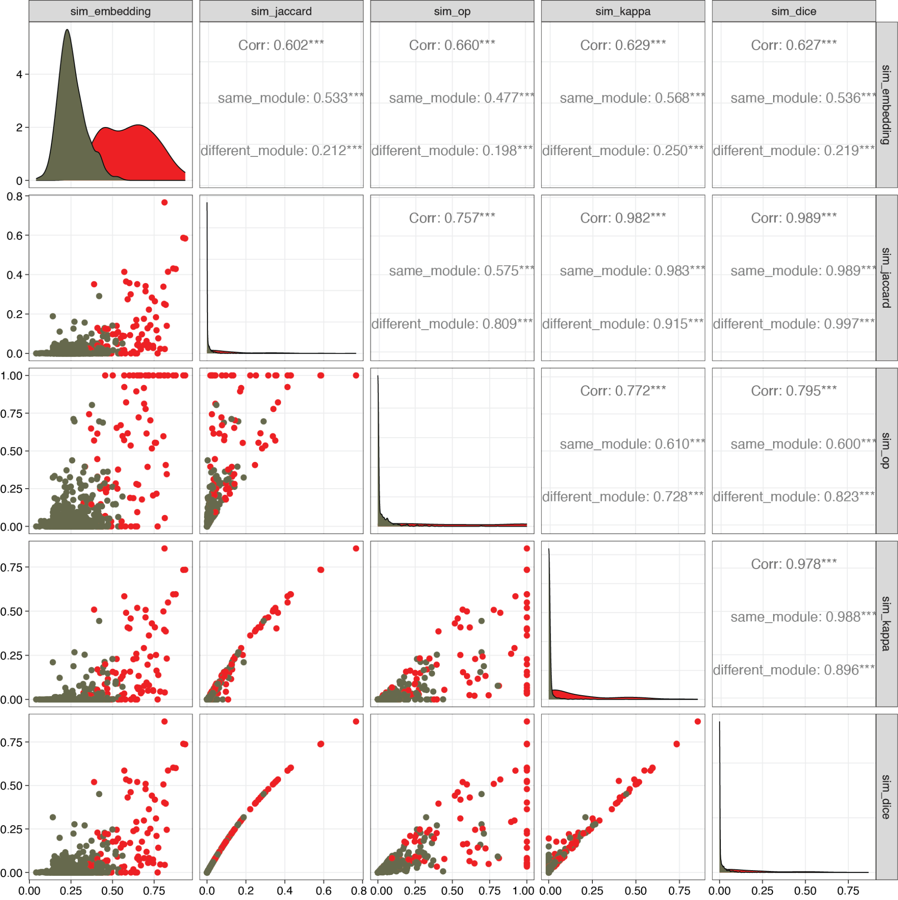

Supplementary Figure 4. Pairwise correlation among different similarity metrics. The scatterplot matrix compares five component-based similarity scores. Diagonal plots show the score distribution for each method, distinguishing between pairs from the same module (red) and different modules (dark grey). Off-diagonal plots show the pairwise correlations between metrics. Pearson correlation coefficients (Corr) are shown in the upper triangle, with asterisks denoting significance (*** p-values < 0.001). The Jaccard index, Cohen's Kappa, and Dice coefficient are highly correlated (r > 0.97).

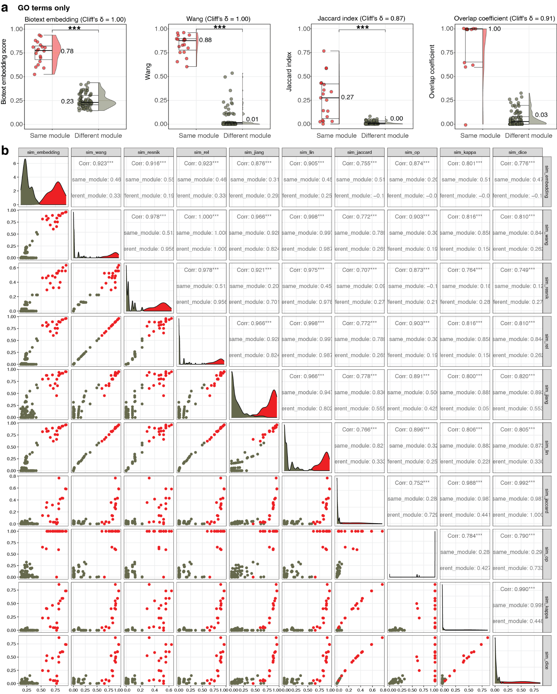

Supplementary Figure 5. Discriminative power of similarity metrics specifically for GO terms. a, Comparison of similarity scores for within-module (red) versus between-module (dark gray) GO-term pairs. Cliff’s delta (δ) quantifies separation. Biotext embedding achieves perfect discrimination (δ = 1.00, p < 0.001), outperforming Jaccard (δ = 0.87) and overlap coefficient (δ = 0.91). Wang semantic similarity also attains δ = 1.00 for computable GO term pairs but cannot be evaluated across GO sub-ontologies, resulting in substantial missing values and highlighting a practical limitation for cross-ontology comparisons. b, Pairwise correlation among similarity metrics. The scatterplot matrix compares biotext embedding, semantic similarity metrics specifically for GO terms (Wang, Resnik, Rel, Jiang, and Lin), and component-based similarity scores (Jaccard, overlap coefficient, Cohen's Kappa, and Dice coefficient). Diagonal plots show the score distribution for each method, distinguishing within-module pairs (red) and between-module pairs (dark gray). Off-diagonal panels show pairwise relationships; the upper triangle reports Pearson correlations (Corr) with asterisks for significance (*** p-values < 0.001). The similarity scores generated by Wang, Resnik, Rel, Jiang, and Lin methods are highly correlated (r > 0.97). The Jaccard index, Cohen's Kappa, and Dice coefficient are highly correlated (r > 0.98).

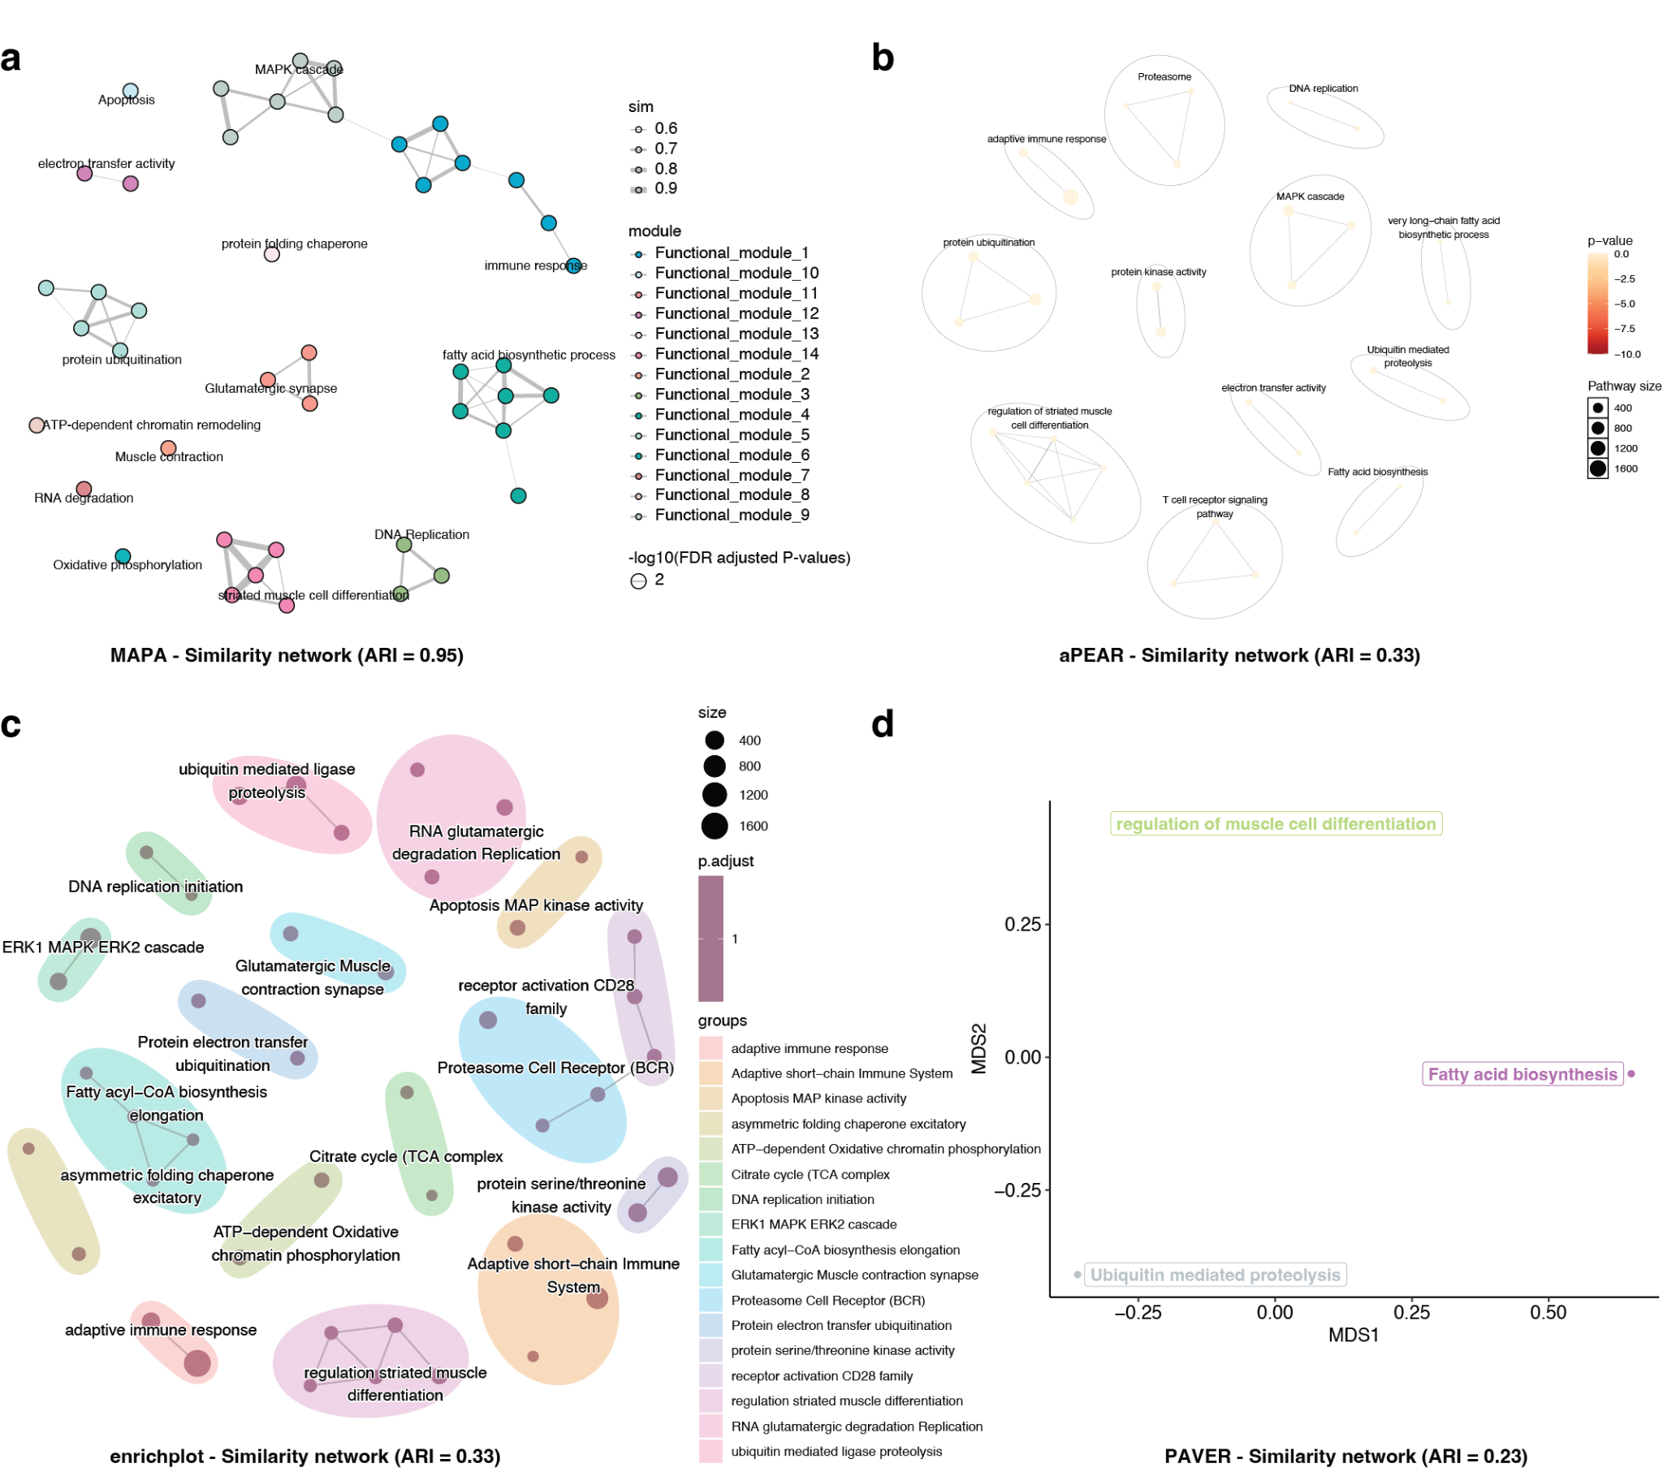

Supplementary Figure 6. Benchmarking MAPA against other pathway redundancy analysis tools on the curated dataset 1. Comparison of similarity networks from four tools for a set of pathways. Performance was measured by the adjusted rand index against a ground truth. a, MAPA similarity network achieving the highest accuracy (ARI = 0.95). Nodes (pathways) are grouped into distinct functional modules. Edges represent biotext similarity scores (> 0.55), and module labels are names generated by LLM. b, aPEAR similarity network showing significantly lower performance (ARI = 0.33). Edges represent the Jaccard index, and modules are labeled using the name of the most connected pathway in each module. c, enrichplot similarity network also demonstrates low accuracy (ARI = 0.33). Edges represent a Jaccard index > 0.2, and modules are labeled with the most specific shared terms. d, PAVER multi-dimensional scaling plot showing the lowest accuracy (ARI = 0.23). Nodes represent entire functional modules, which are labeled with the name of the most representative pathway with the highest cosine similarity to the cluster's average embedding.
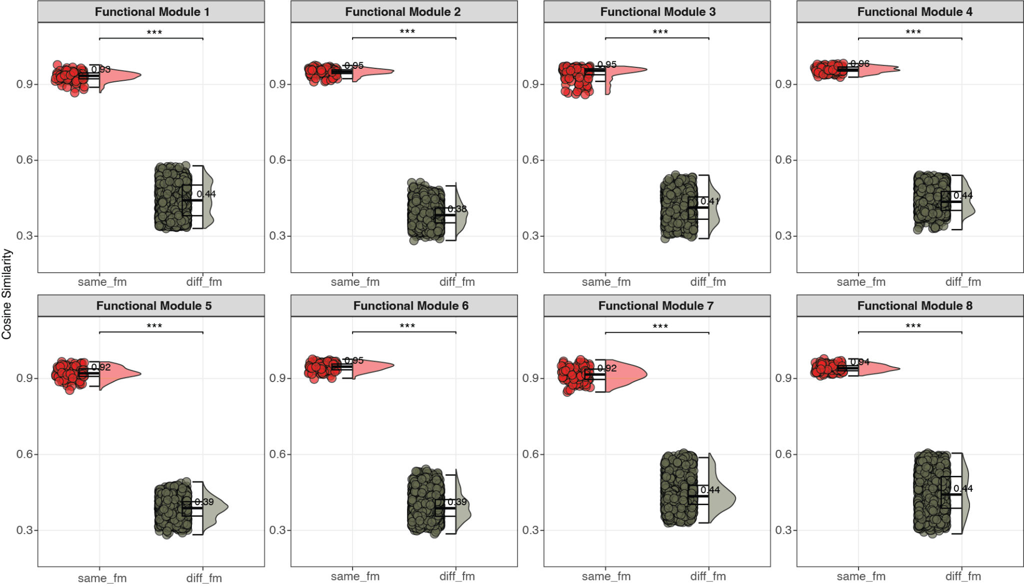Supplementary Figure 7. Reproducibility for MAPA’s performance across independent runs on curated data. The curated dataset 1 was processed through MAPA's clustering and LLM interpretation pipeline for 15 independent runs. Consistent clustering was observed across runs (ARI = 1, resulting in 14 functional modules). LLM-generated functional summaries were obtained for the 8 functional modules containing more than one pathway. For each of these modules, the pairwise cosine similarity of functional annotations across the 15 runs (same_fm) was compared to the cosine similarity of annotations between different functional modules across all runs (diff_fm). High cosine similarity (> 0.91) was observed for annotations of the same functional module across different runs, indicating strong reproducibility. In contrast, annotations between different functional modules exhibited low similarity. Statistical significance was assessed using a Wilcoxon test (*** p-value < 0.001).

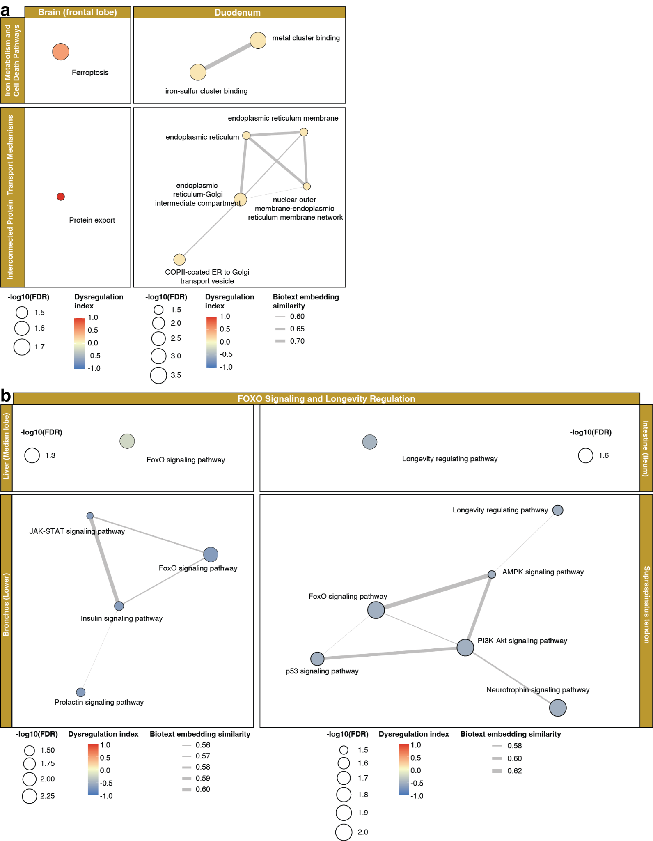

Supplementary Figure 8. Shared age-related functional modules across diverse tissues. Functional modules that are similarly regulated during aging in different tissues. Node size corresponds to significance (-log10(FDR)), and color indicates upregulation (red) or downregulation (blue). a, Upregulated functional modules shared between the brain (frontal lobe) and intestine (duodenum). These modules are primarily involved in iron metabolism, cell death (ferroptosis), and protein transport mechanisms. b, Downregulated functional modules related to FOXO signaling and longevity regulation. These changes are consistently observed across multiple tissues, including the liver (median lobe), intestine (ileum), bronchus (lower), and supraspinatus tendon.

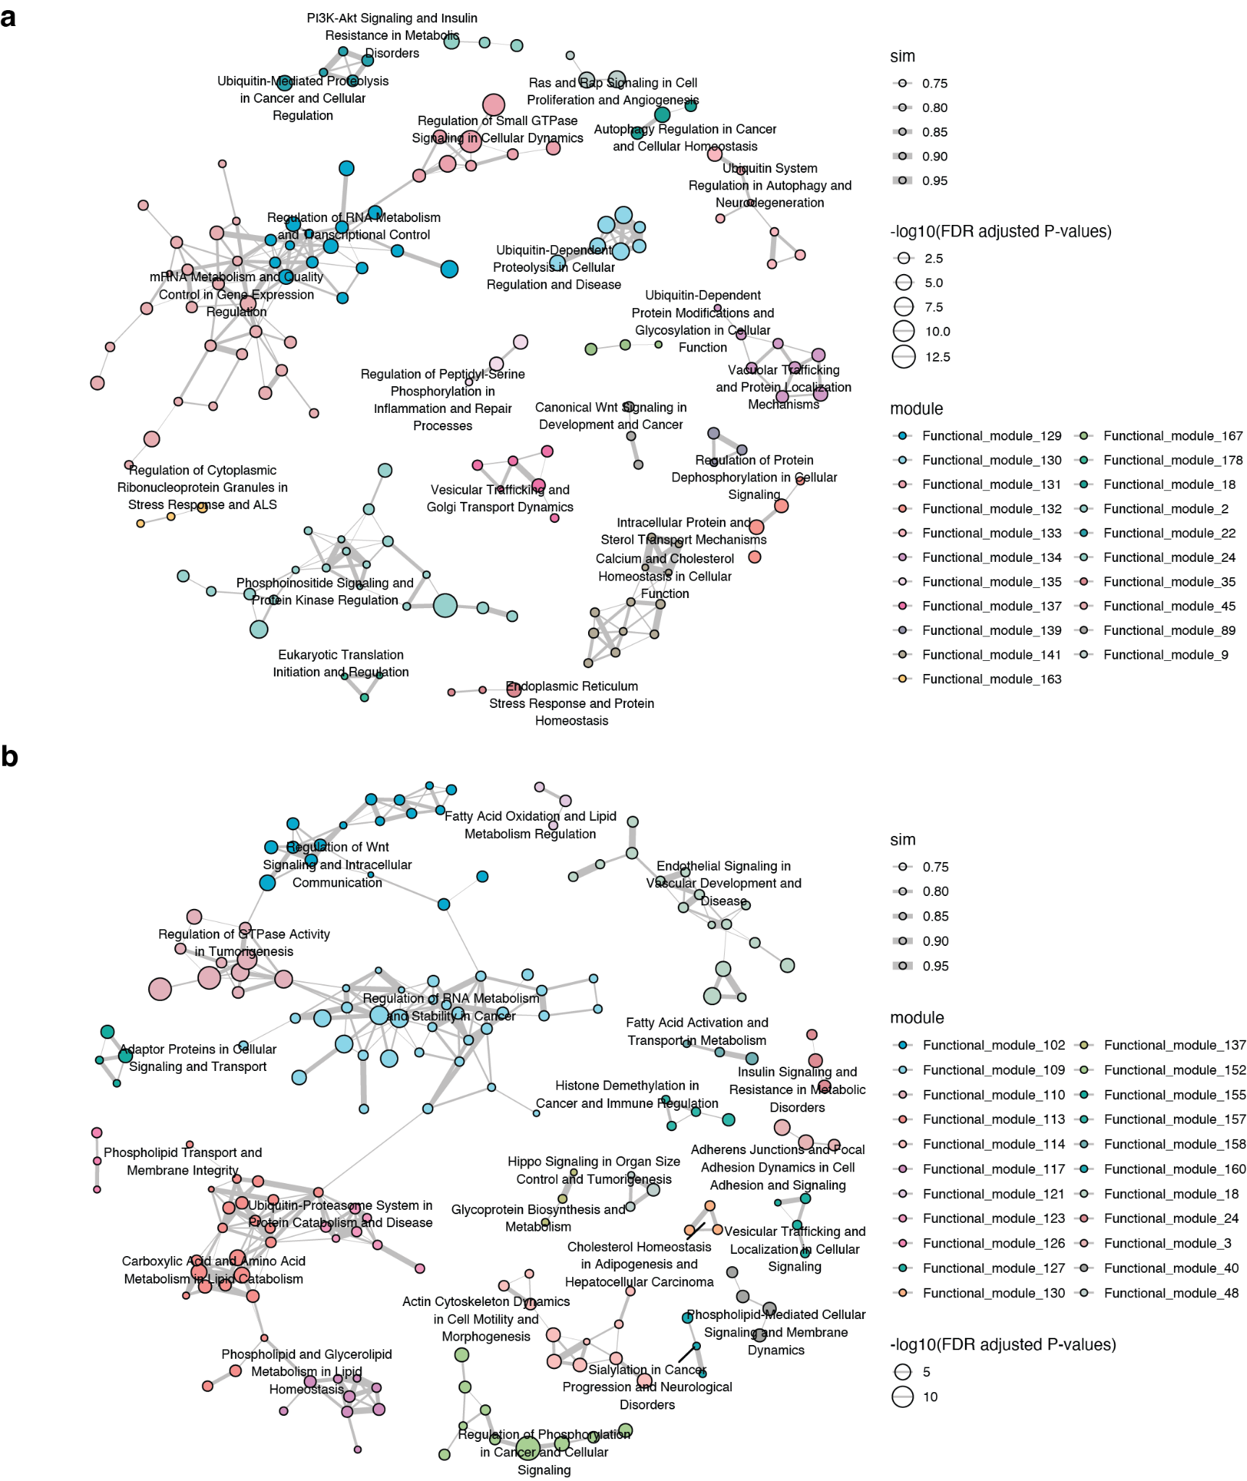Supplementary Figure 9. MAPA reveals biologically meaningful functional networks in age-dependent liver gene expression profiles. Functional module networks of upregulated (a) and downregulated (b) differentially expressed genes from an age-dependent liver snRNA-seq dataset⁴. The networks were generated using the MAPA workflow to provide a biologically meaningful view of the functional relationships between pathways. Each node represents an enriched pathway, where node size is proportional to the statistical significance (-log 10 FDR-adjusted p-value) and the edge width reflects the biotext similarity between connected pathways. a, Functional module network for upregulated genes (cluster U). MAPA successfully corroborates findings from the original study, identifying key functional modules associated with inflammatory and immune processes, such as “Regulation of Peptidyl-Serine Phosphorylation in Inflammation and Repair Processes” and “Ubiquitin-Dependent Proteolysis in Cellular Regulation and Disease.” b, Functional module network for downregulated genes (cluster D). Beyond replicating the original findings, MAPA identified a key module, “Carboxylic Acid and Amino Acid Metabolism in Lipid Catabolism,” which functionally connects lipid and amino acid metabolic processes. This highlights a more integrated view of metabolic dysregulation in aging, showcasing MAPA's power to reveal deeper functional connections missed by conventional analyses.

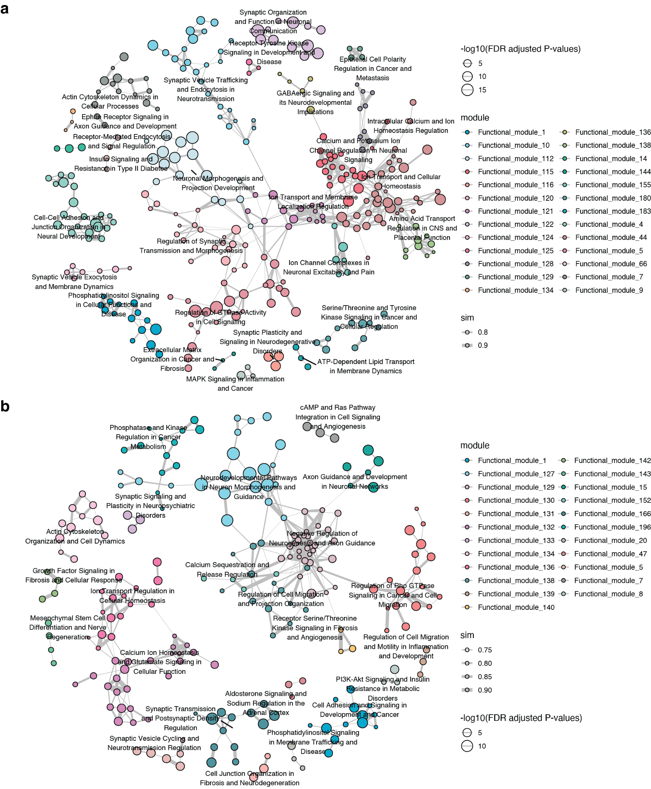Supplementary Figure 10. MAPA identifies biologically meaningful functional modules in the aging brain. Functional module similarity networks of upregulated (a) and downregulated (b) genes from an age-dependent brain snRNA-seq dataset⁴, generated using the MAPA workflow. a, Functional module network for upregulated genes (cluster U). The functional modules identified by MAPA support the findings of the original study. For instance, it uncovers a neuroinflammatory module (“MAPK Signaling in Inflammation and Cancer”) that reflects known age-related changes in the brain⁵. b, Functional module network for downregulated genes (cluster D). While consistent with previous findings on synaptic decline, MAPA synthesizes related concepts into a more informative module: “Synaptic Transmission and Postsynaptic Density Regulation.” This offers a more integrated view than a singular term like “neurotransmitter secretion,” as it explicitly links the process of synaptic transmission with the structural organization of the postsynaptic density, providing a more nuanced biological insight.

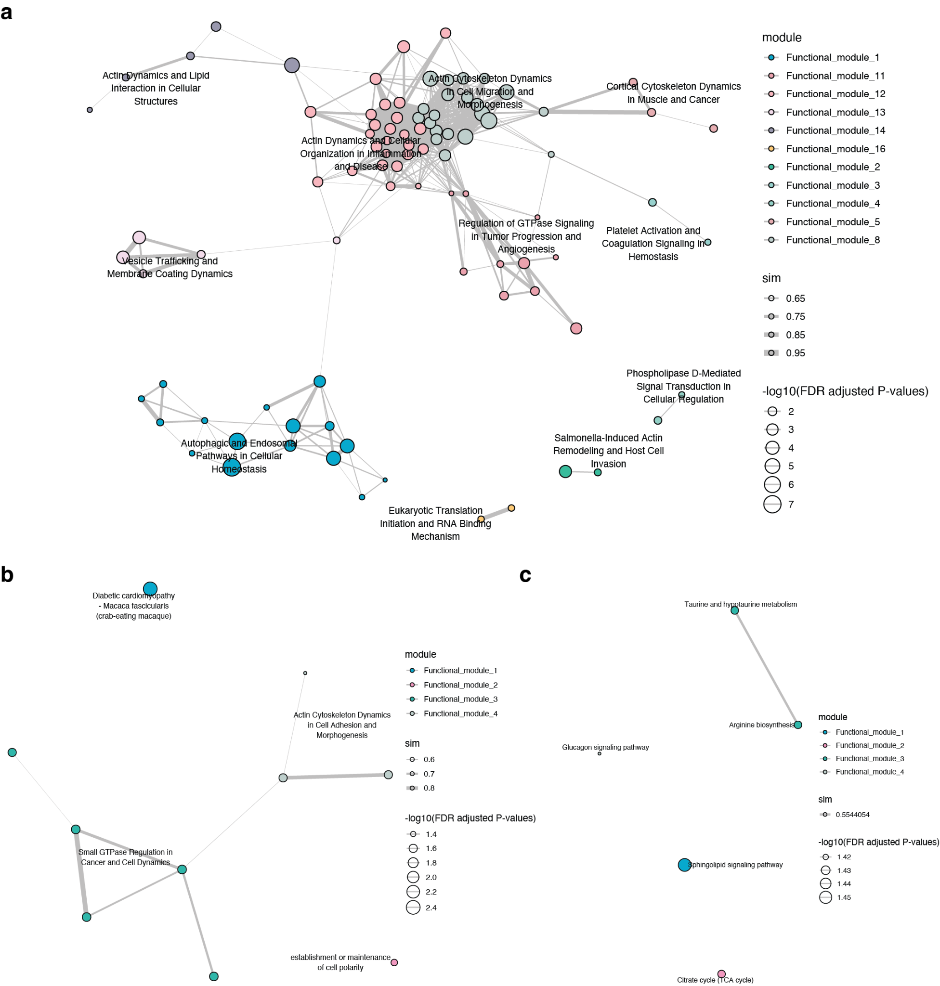

Supplementary Figure 11. MAPA identifies functional modules from age-related plasma proteomics and metabolomics data. MAPA was applied to lists of age-related plasma proteins and metabolites⁴ to construct functional module similarity networks. Network visualization is consistent with previous figures. a, Functional module network for downregulated proteins (cluster D). MAPA identified a key module, “Autophagic and Endosomal Pathways in Cellular Homeostasis,” which integrates pathways related to cellular protein and organelle degradation. This provides a unified view of declining cellular clearance mechanisms with age. b, The network for upregulated proteins (Cluster U). c, The network derived from both upregulated and downregulated metabolites.

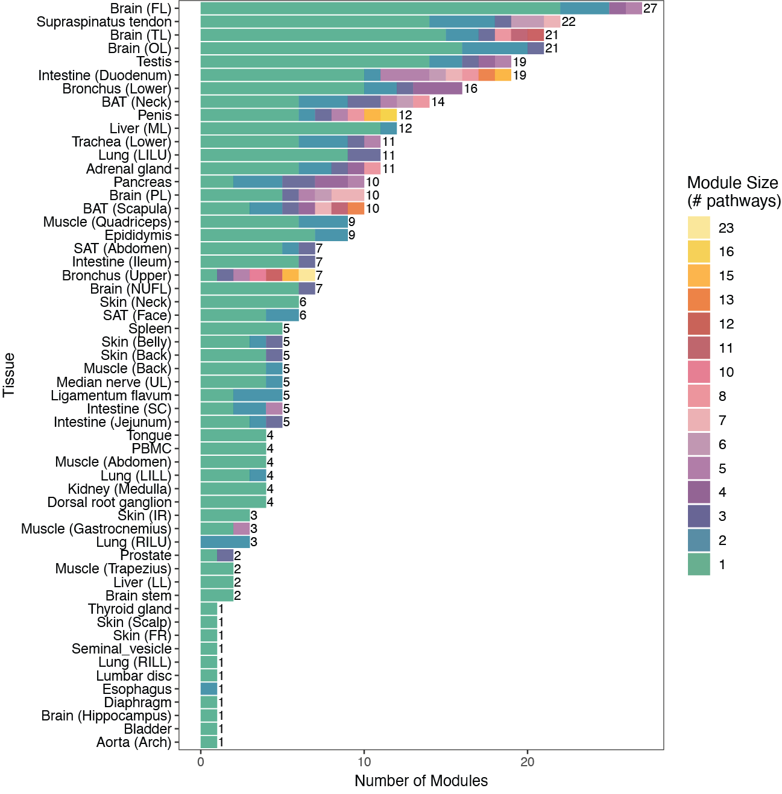

Supplementary Figure 12. Distribution of functional module count and size across tissues. The stacked bar chart shows the number and size of functional modules identified in 56 tissues. Each bar represents a tissue, with its length indicating the module count. The color corresponds to the module's size (number of pathways) as defined in the legend.

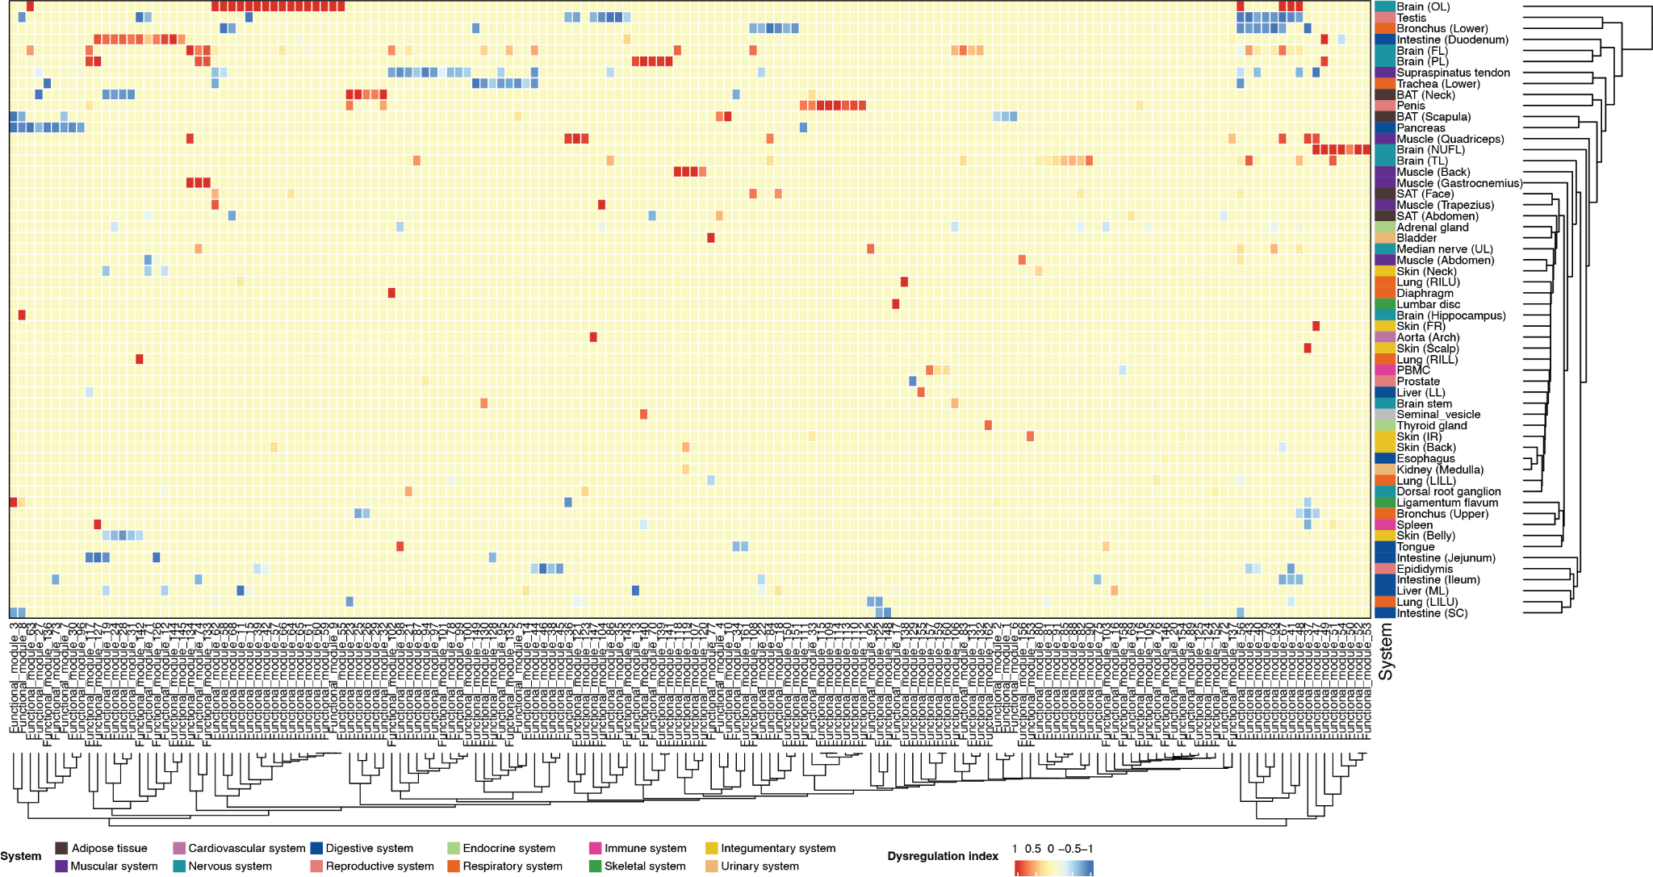

Supplementary Figure 13. Heatmap of Dysregulation Index for functional modules generated from age-dependent differentially expressed genes identified from bulk RNA-seq data across tissues. The heatmap displays the Dysregulation Index for 396 functional modules across 56 tissues (rows), with both axes organized by hierarchical clustering. The index color scale indicates each module's regulatory trend during aging, from downregulated (blue, -1) to upregulated (red, +1). Tissues are annotated by the physiological systems on the right, and functional modules are grouped into 162 meta-modules at the bottom. The visualization highlights conserved patterns of aging across diverse biological tissues.

Supplementary Table 1. Comparison of MAPA with existing pathway clustering tools. This table compares the features of MAPA with other popular tools for clustering and annotating enriched pathways.
Tools | Input - can accept a simple list | Pathway similarity calculation |  |  | Clustering methods | Annotation methods
 |  | Component-based similarity | Semantic similarity | Embedding-based similarity |  | Module name | Module summary
enrichplot | No  Requires pre-generated enrichment results from clusterProfiler. | Yes | Yes | No | A selection of standard algorithms (e.g., k-means, PAM) that require the user to pre-specify the number of clusters. | Yes  Selects top words based on word frequency within pathway names. | No
aPEAR | No  Requires pre-generated enrichment results from specific tools or in a strict format. | Yes | No | No | Limited choice of algorithms with fixed parameters (e.g., Markov clustering, hierarchical clustering with a fixed cutoff). | Yes  Selects a single representative pathway based on network connectivity (PageRank, HITS) or statistical significance (max |NES| or min p-value). | No
PAVER | No  Requires three separate inputs: enrichment results, a pathway ID map, and pre-computed pathway embeddings. | No | No | Yes | A single hierarchical clustering method | Yes  Selects a single representative pathway based on the highest cosine similarity to the cluster's average embedding. | No
MAPA | Yes  Accepts a direct list of gene, protein, or metabolite identifiers, automating the enrichment step. | Yes | Yes | Yes | Offers a suite of hierarchical, graph-based, and binary cut clustering algorithms | Yes  Provides two approaches: (1) Novel LLM-powered interpretation for module naming, and (2) Traditional selection of the most significant pathway. | Yes  LLM-powered interpretation based on both database knowledge and current studies from PubMed literature

Supplementary Table 2. The annotation results from five human experts.
Module | Expert #1 | Expert #2 | Expert #3 | Expert #4 | Expert #5
4 | Module name: Glutamatergic synapse  Module description: This module describes the neuron-to-neuron synapse that uses glutamate as a neurotransmitter, which results in excitatory postsynaptic potentials.  Confidence score: 0.95 | Module name: Excitatory neurotransmission via glutamate  Module description: Excitatory neurotransmission via glutamate is a form of synaptic signaling in the mammalian central nervous system (CNS), in which glutamate serves as the principal excitatory neurotransmitter. At glutamatergic synapses, glutamate is packaged into synaptic vesicles in the presynaptic terminal and released into the synaptic cleft upon neuronal activation. It then binds to ionotropic glutamate receptors (iGluRs) on the postsynaptic membrane, leading to fast excitatory postsynaptic potentials.  Confidence score: 0.95 | Module name: Glutamatergic Excitatory Synapse Module  Module description: This is a specialized glutamatergic synaptic transmission system featuring complete excitatory synapse machinery: glutamate release, ionotropic/metabotropic receptors, and glutamate-glutamine recycling. This module represents the fundamental excitatory signaling unit in the mammalian central nervous system.  Confidence score: 0.95 | Module name: Glutamatergic synapse pathway  Module description:  The overarching biological process is glutamatergic synaptic transmission, the principal excitatory signaling mechanism within the central nervous system, mediated by the neurotransmitter glutamate. The process begins with glutamate being packaged into synaptic vesicles within the presynaptic neuron. Upon neuronal activation, vesicles fuse with the presynaptic membrane, releasing glutamate into the synaptic cleft. Extracellular glutamate subsequently binds to postsynaptic receptors, including ionotropic (NMDA, AMPA, kainate receptors) and metabotropic glutamate receptors (mGluRs), propagating excitatory signals to downstream neurons. Precise regulation of glutamatergic signaling is essential for neuronal plasticity, learning, and memory formation. Dysregulation or aberrant modulation of this pathway is strongly associated with neurological and neurodevelopmental disorders, including autism spectrum disorder, intellectual disability, attention-deficit hyperactivity disorder, Down syndrome, Rett syndrome, and neurodegenerative diseases such as Alzheimer’s and Parkinson’s disease. Pathological changes in receptor activity, glutamate metabolism, and synaptic structure/function contribute significantly to these clinical outcomes. Adaptive homeostatic mechanisms, such as synaptic scaling and receptor trafficking (not detailed here), help maintain excitatory balance under physiological conditions.  Confidence score: 1 | Module name: Glutamatergic Synaptic Module  Module description: This module focuses on the mechanism underpinning action of glutamate, the principal excitatory neurotransmitter within the mammalian central nervous system. Glutamate mediates fast excitatory synaptic transmission through the activation of iGluRs, which function as ligand-gated ion channels. Concurrently, glutamate exerts diverse modulatory effects via mGluRs; notably, presynaptic mGluRs often serve to inhibit excessive glutamate release, providing crucial feedback regulation. The fidelity of glutamatergic signaling critically depends on the efficient clearance of synaptic glutamate, accomplished by EAATs. It predominantly located on astrocytes, thereby preventing excitotoxic neuronal damage resulting from glutamate accumulation. Collectively, iGluRs and mGluRs act in concert to fine-tune synaptic strength and plasticity. Furthermore, EAATs operate in conjunction with the glutamate-glutamine cycle to sustain glutamate homeostasis. Dysfunction within this intricate glutamatergic system, encompassing aberrant receptor signaling, impaired glutamate clearance, or disrupted cycling, is strongly associated with the pathophysiology of several neurological and psychiatric disorders, including epilepsy, schizophrenia, major depressive disorder, and Alzheimer's disease.  Confidence score:0.88
5 | Module name: Not Available  Module description: Not Available  Confidence score: | Module name: DNA replication initiation  Module description: DNA replication initiation is a tightly regulated and evolutionarily conserved process that marks the beginning of genome duplication. Across all domains of life, initiation involves a defined sequence of molecular events at specific genomic loci known as origins of replication. The process begins with the binding of origin recognition complexes or replication initiator proteins to the origin DNA. This is followed by the recruitment and loading of the replicative helicase, typically mediated by specialized helicase assembly factors. In eukaryotic cells, partial unwinding of the origin occurs at an adenine–thymine (AT)-rich region known as the DNA unwinding element (DUE), creating single-stranded DNA templates. Since DNA polymerases are unable to initiate DNA synthesis de novo, a short RNA–DNA hybrid primer is synthesized by the DNA polymerase alpha:primase complex. This primer provides the necessary 3’-OH group for DNA polymerases to begin elongation, thus enabling the establishment of the replication fork and progression of DNA synthesis.  Confidence score: 0.95 | Module name: DNA Replication Module  Module description: This module contains the core DNA replication machinery that duplicates the genome during S phase, including MCM helicases, primase polymerase complexes, DNA polymerases α, δ, and ε, the DNA sliding clamp, and enzymes that process Okazaki fragments, ensuring high fidelity synthesis.  Confidence score: 0.95 | Module name: DNA Replication  Module description:  The overarching biological process is DNA replication, a fundamental mechanism ensuring accurate duplication of genetic material prior to cell division. DNA replication comprises initiation, elongation, and termination. Initiation begins with origin recognition proteins binding specific DNA sequences, facilitating recruitment of DNA helicase to unwind the parental double helix and form replication forks. Single-strand binding proteins stabilize these separated strands, while topoisomerase prevents excessive supercoiling and DNA damage. Elongation involves synthesis of RNA primers by primase, allowing DNA polymerase to add nucleotides in a 5’ to 3’ direction. Leading strands are synthesized continuously, whereas lagging strands are synthesized discontinuously, forming Okazaki fragments. Subsequently, RNA primers are removed by DNA polymerase I (prokaryotes) or RNase H (eukaryotes), replaced by DNA nucleotides, and gaps sealed by DNA ligase, completing a continuous DNA strand. Defects or disruptions in replication fidelity are strongly linked to genomic instability, contributing to cancer, congenital diseases, and premature aging disorders. Specialized mechanisms, such as DNA damage tolerance and replication restart pathways (not detailed here), help manage replication under stressful cellular conditions.  Confidence score: 1 | Module name: DNA Replication Module  Module description: This module focuses on the molecular mechanism of DNA replication, encompassing three core phases: initiation, elongation, and termination. During replication fork establishment, DNA helicase (DnaB or MCM complex) unwinds the parental duplex DNA, facilitated by single-stranded DNA-binding proteins (SSB or RPA). Subsequently, continuous leading strand synthesis proceeds processively in the 5 to 3 direction, while lagging strand synthesis occurs discontinuously through the generation of Okazaki fragments by DNA polymerase. The process culminates in the excision of RNA primers by specialized nucleases (e.g., RNase H/FEN1) and ligation of adjacent DNA fragments by DNA ligase.The module particularly emphasizes the mechanism of replication initiation in eukaryotes, comparing the differences between unicellular eukaryotes (e.g., Saccharomyces cerevisiae) and multicellular eukaryotes. Unicellular eukaryotes utilize sequence-defined origins (e.g., ARS elements), whereas in metazoans, initiation site selection is governed by epigenetic determinants rather than specific DNA sequences. This was confirmed by Xenopus egg extract studies. Crucially, the dysregulation of DNA replication fidelity leads to genomic instability, which is the underlying cause of oncogenesis and hereditary disorders.  Confidence score:0.86
7 | Module name: Electron transfer flavoprotein complex through oxidative phosphorylation  Module description: The pathways involved all point to electron-transfer, and some descriptions of the involved proteins and mechanisms, which is oxidative phosphorylation.  Confidence score: 0.95 | Module name: Electron transport chain in oxidative phosphorylation  Module description: The Electron transport chain in oxidative phosphorylation refers to the coupled processes of electron transfer and ATP synthesis occurring in the inner mitochondrial membrane. Electrons derived from metabolic substrates are passed through a series of protein complexes, namely Complex I (NADH: ubiquinone oxidoreductase), Complex II (succinate dehydrogenase), the electron transfer flavoprotein (ETF) complex, Complex III (cytochrome bc1), and Complex IV (cytochrome c oxidase), ultimately reducing molecular oxygen to water. These redox reactions are coupled to the translocation of protons from the mitochondrial matrix to the intermembrane space, generating an electrochemical gradient (proton motive force). This proton gradient drives ATP synthesis via Complex V (ATP synthase), which phosphorylates ADP to ATP in a process known as oxidative phosphorylation. Flavoproteins such as the ETF complex facilitate electron transfer from fatty acid-derived acyl-CoAs to the ubiquinone pool, linking β-oxidation to the respiratory chain. Together, these steps constitute a fundamental energy conversion mechanism essential for aerobic life.  Confidence score: 0.95 | Module name: Electron Transport Module  Module description: This is a mitochondrial electron transport system centered on flavoprotein-mediated transfer in oxidative phosphorylation. The module’s electron transfer flavoprotein complex links fatty acid β-oxidation to the respiratory chain via ubiquinone, coupling fatty acid metabolism to energy production.  Confidence score: 0.90 | Module name: Adenosine triphosphate (ATP) synthesis  Module description:  The overarching biological process is aerobic energy conversion, coupling the electron-transport chain (ETC) to oxidative phosphorylation, generating adenosine triphosphate (ATP). Reduced cofactors (NADH and FADH₂) generated by upstream catabolic pathways donate high-energy electrons to the ETC at Complex I or II. Electrons travel sequentially through ubiquinone (Q), Complex III, cytochrome c, and Complex IV, where molecular oxygen is reduced to water. Each redox step pumps protons across the inner mitochondrial membrane in eukaryotes (or the plasma membrane in prokaryotes), establishing an electrochemical proton-motive force. ATP synthase (Complex V) harnesses this gradient, allowing protons to flow back into the matrix/cytosol and driving the phosphorylation of ADP to ATP. The resulting ATP supplies cellular energy for virtually every energy-demanding cellular process, linking diverse catabolic pathways to biosynthesis, ion transport, signal transduction, and mechanical work. Variations such as alternative oxidases or anaerobic electron acceptors (not detailed here) modify these core principles under specialized conditions.  Confidence score: 0.8 | Module name: Redox Phosphorylation Module  Module description: This module focuses on electron transfer and oxidative phosphorylation. Pathway 1 defines electron transfer activity as a directed movement of electrons between molecular entities, distinct from stochastic electron diffusion. Pathway 2 specifies the electron transfer flavoprotein (ETF) complex, a key electron carrier that shuttle electrons from acyl-CoA dehydrogenases to the ubiquinone (CoQ). Electrons subsequently traverse the inner mitochondrial membrane through the electron transport chain (ETC) complexes I-IV, culminating in the establishment of a proton gradient that drives ATP synthesis via complex V (ATP synthase). Throughout the module, the alpha and beta subunits of the ETF work together with the flavin adenine dinucleotide (FAD) cofactor to facilitate electron transfer. Complexes I-V in oxidative phosphorylation play a synergistic role in ensuring efficient energy conversion. Dysfunction in this module manifests clinically as the Inborn errors of metabolism, mitochondrial disorders and metabolic dysregulation.  Confidence score:0.88
8 | Module name: Adaptive immune response and regulation concerning T and B cells  Module description: All pathways are directly associated with the adaptive immune system, and T and B cell regulation and signaling, a clear call.  Confidence score: 0.95 | Module name:  Module description: Adaptive immunity refers to a highly specific immune response that plays a critical role in eliminating pathogens. This system relies primarily on B and T lymphocytes, which express diverse antigen-specific receptors capable of recognizing unique molecular features of foreign invaders. During infection, dendritic cells (DCs) act as peripheral sentinels that capture and process pathogens into antigenic peptides. These antigens are then presented to T cells via major histocompatibility complex (MHC) molecules. Upon recognizing a cognate antigen and receiving costimulatory signals, such as CD28 engagement with B7.1/B7.2, T cells become activated, initiating a cascade of intracellular signaling events. These cascades involve protein tyrosine kinases, phosphatases, GTP-binding proteins, and adaptor proteins, which together orchestrate T-cell proliferation, cytokine secretion, and differentiation into effector cells. B cells, which mediate humoral immunity, recognize antigens through their B cell receptor (BCR), a complex composed of membrane-bound immunoglobulin molecules and the signaling subunits Ig-α and Ig-β. Following antigen binding, signaling is initiated through the activation of key protein tyrosine kinases, including the SRC-family kinase LYN, SYK, and the TEC-family kinase BTK. Downstream signaling molecules such as phosphatidylinositol 3-kinase (PI3K) and phospholipase C-γ2 (PLC-γ2) are activated, ultimately leading to the expression of immediate early genes. These transcriptional changes promote B cell proliferation, differentiation, antibody production, and further immune responses. Together, the TCR and BCR signaling pathways are central to the adaptive immune system, coordinating the cellular and humoral arms to achieve a robust and specific defense against pathogens.  Confidence score: 0.95 | Module name: Adaptive Immune Receptor Signaling Module  Module description: Integrated T-cell receptor and B cell receptor signaling networks for antigen-specific immune activation. It shares common kinases (e.g., SYK, LYN) and effectors (e.g., PI3K). This module also includes CD28 costimulation for T cells and enables clonal expansion and immunological memory formation.  Confidence score: 0.85 | Module name: Lymphocyte activation and adaptive immune signaling  Module description: The module describes the overarching molecular and cellular mechanisms underlying the the antigen-specific activation of B and T lymphocytes, the central players of adaptive immune responses. While they share several fundamental signaling mechanisms, they possess distinct pathways that define their specialized functions. cell activation is initiated by the T cell receptor (TCR) recognizing peptide-MHC complexes. Notably, optimal T cell activation requires costimulatory signals, prominently regulated by the CD28 receptor superfamily. Other costimulatory signal include ICOS (Inducible T-cell COStimulator, pathway not included), which play a key role in T follicular helper cell differentiation and germinal center responses. B cell activation is driven by antigen binding to the B cell receptor (BCR). A hallmark of B cell activation is the CD40–CD40L interaction (pathway not described) with helper T cells, which is essential for isotype class switching, somatic hypermutation, and germinal center formation. B cells also uniquely respond to BAFF (B cell activating factor) (pathway not mentioned), which promotes peripheral B cell survival and maturation.  Confidence score: 0.7 | Module name: Adaptive Immune Response Module  Module description: This module describes the TCR and BCR signaling pathways and their essential roles in adaptive immunity. T-cell activation requires coordinated engagement of both the TCR and costimulatory molecules such as CD28 to initiate a series of signaling cascades. And finally it leads to T cell proliferation and effector functions. Conversely, B-cell activation is triggered by BCR signaling, which activates important downstream effectors such as PTKs and PI3K, to promote antibody secretion and provide humoral immunity. In this module, TCR and CD28 work together to regulate T cell activation. And BCR signalling activates downstream signalling pathways through molecules such as BLNK and PLCγ that regulate calcium release. Defects in these pathways—such as ZAP-70 deficiency impairing TCR signaling—manifest as primary immunodeficiencies, while dysregulation contributes to autoimmune disorders like systemic lupus erythematosus. Notably, mechanistic insights have enabled transformative immunotherapies such as CAR-T cells.  Confidence score:0.87
9 | Module name: Fatty acid biosynthetic process  Module description: This module concerns the process of fatty acid synthesis, possibly through the acetyl-CoA generated through the citrate cycle (TCA cycle).  Confidence score: 0.95 | Module name: Fatty acid biosynthesis and TCA cycle  Module description: Fatty acid biosynthesis is a fundamental anabolic process responsible for generating a wide spectrum of fatty acids, ranging from short-chain to long-chain species. These molecules serve as essential building blocks for membrane lipids, energy storage, and signaling. The biosynthesis process begins with acetyl-CoA, which is carboxylated by acetyl-CoA carboxylase (ACC) to generate malonyl-CoA. Fatty acid synthase (FASN) catalyzes the sequential addition of two-carbon units from malonyl-CoA to elongate the acyl chain, typically yielding palmitate (C16:0) as the primary product of de novo synthesis. Short-chain fatty acids (SCFAs), typically defined as fatty acids with fewer than six carbon atoms (e.g., acetate, propionate, and butyrate), can also be synthesized endogenously or produced by microbiota and contribute to host metabolism, particularly in energy regulation and immune modulation. Meanwhile, long-chain and very-long-chain fatty acids are generated through further elongation and modification of palmitate via elongases and desaturases. Although fatty acid biosynthesis occurs in the cytosol, its carbon source, acetyl-CoA, is primarily derived from the tricarboxylic acid (TCA) cycle. In nutrient-replete conditions, citrate is exported from mitochondria and cleaved by ATP-citrate lyase to regenerate cytosolic acetyl-CoA, linking mitochondrial energy metabolism with lipogenesis. Fatty acids are subsequently converted to fatty acyl-CoAs by acyl-CoA synthetases for incorporation into complex lipids or further metabolism. This module highlights the integrated biochemical pathways that govern the synthesis of both short- and long-chain fatty acids and their metabolic coupling with the TCA cycle via citrate-derived acetyl-CoA.  Confidence score: 0.9 | Module name: Fatty Acid Biosynthesis Module  Module description: Comprehensive fatty acid synthesis system from short-chain to long-chain fatty acids. Includes de novo synthesis via acetyl-CoA carboxylase/fatty acid synthase, elongation systems, and TCA cycle integration for acetyl-CoA supply. This module also produces fatty acyl-CoAs for membranes and energy storage.  Confidence score: 0.95 | Module name: Lipid metabolism  Module description: The overarching biological process is lipid metabolism, which covers both the catabolic and anabolic sides. Anabolic processes cover the synthesis and elongation of fatty acids of various chain lengths and the activation of fatty acids to CoA thioesters, an important step before they can be used in synthesis, degradation and incorporation into complex lipids. Catabolic processes include the TCA cycle, which provides the precursor (acetyl-CoA) for synthesis and being the endpoint of β-oxidation. Other catabolic processes beyond β-oxidation, fatty acids can be degraded through α-oxidation (for branched-chain fatty acids like phytanic acid) and ω-oxidation (a microsomal pathway that hydroxylates the terminal carbon to generate dicarboxylic acids for further oxidation). These alternative pathways (not described in this module) are particularly important when β-oxidation is impaired or when metabolizing structurally unusual fatty acids.  Confidence score: 0.7 | Module name: Fatty Acid Metabolism Module  Module description: This module describes the processes of fatty acid biosynthesis, elongation and catabolism.  Fatty acid biosynthesis initiates with the ATP-dependent carboxylation of acetyl-CoA to malonyl-CoA, catalyzed by acetyl-CoA carboxylase (ACC). Malonyl-CoA serves as the primary carbon donor for the cytosolic fatty acid synthase (FAS) complex, a multifunctional enzyme system that iteratively elongates the acyl chain through condensation, reduction, dehydration, and reduction cycles, culminating in the synthesis of saturated fatty acids, predominantly palmitate (C16:0). Subsequent elongation to very long chain fatty acids (VLCFAs) occurs on the endoplasmic reticulum membrane, mediated by membrane-bound enzyme complexes, with the elongation of very long chain fatty acids (ELOVL) family proteins conferring substrate specificity for distinct chain lengths. For catabolic utilization, long chain fatty acids are activated in the cytosol to fatty acyl-CoAs by acyl-CoA synthetases (ACSs). These activated fatty acids are then translocated into the mitochondrial matrix to undergo β-oxidation. This cyclic process sequentially cleaves two-carbon units as acetyl-CoA, which subsequently enter the tricarboxylic acid (TCA) cycle for ATP generation. The dysregulation of this module is the underlying cause of pathologies including obesity, type 2 diabetes and cardiovascular disease.  Confidence score:0.9
10 | Module name: MAPK-mediated apoptosis  Module description: MAPK appears to be involved in apoptosis both as an activator and an inhibitor. The pathways involved in this module are all about MAPK, kinases, and apoptosis, which makes senses.  Confidence score: 0.95 | Module name: MAPK/ERK-mediated cell proliferation and death  Module description: The ERK1/2 branch of the mitogen‑activated protein kinase (MAPK) cascade is a conserved signaling module that relays extracellular cues, such as mitogens, growth factors, and GPCR ligands, from the plasma membrane to nuclear and cytoplasmic targets. Sequential activation of Raf, MEK, and ERK drives transcriptional programmes that promote cell‑cycle progression, differentiation, and migration. In certain contexts, prolonged or dysregulated ERK activity instead engages apoptotic pathways by modulating key components of both the extrinsic (death‑receptor) and intrinsic (mitochondrial) routes, converging on activation of effector caspases‑3/7. Thus, ERK functions as a context‑dependent switch linking external stimuli to either cell survival and proliferation or programmed cell death.  Confidence score: 0.8 | Module name: MAPK-Mediated Apoptosis Signaling Module  Module description: This module links MAPK cascades to apoptotic pathways, with protein kinases acting as molecular switches that toggle between ERK1/2-driven survival and caspase-mediated death. The interplay between pro-survival MAPK signals and pro-apoptotic signals decides whether a cell proliferates or undergoes programmed death.  Confidence score: 0.80 | Module name: Cell Death, Proliferation and Differentiation  Module description: The overarching biological processes outlined in this module include apoptosis (programmed cell death), proliferation, and differentiation, three connected mechanisms basic to the determination of cell fate in the development of the organism, maintenance of the tissue, and development of disease. Apoptosis pathways emphasize the regulated balance between survival stimuli (e.g., NGF, IL-3) and death signals (extrinsic/intrinsic triggers), determining whether cells persist or undergo programmed elimination. Proliferation and differentiation of the cell are governed principally by the MAPK signaling cascades, in particular via ERK1/2, in response to extracellular stimuli (e.g., growth factors, cytokines, and mitogens). These signaling networks integrate diverse environmental signals to resolve the cellular outcomes. Main molecular mediators include protein kinases, which transduce and amplify signals to orchestrate these essential cellular processes. Dysfunction or misregulation within these integrated networks underlies numerous pathological states, including cancer, developmental abnormalities, and degenerative diseases. Adaptive regulatory mechanisms such as feedback loops, and cross-talk (not detailed here) then fine-tune these pathways to maintain cellular homeostasis and normal tissue function.  Confidence score: 0.6 | Module name: Apoptosis and MAPK Signaling Pathway Module  Module description: This module integrates main mechanisms of apoptosis and MAPK signaling pathways. Apoptosis, a genetically programmed cell death process, is primarily initiated via three distinct pathways: the extrinsic, intrinsic and granzyme B pathways. These pathways converge to activate effector caspases, notably caspase-3 and caspase-7, which execute the terminal stages of apoptosis by cleaving key cellular substrates. The module also describes the MAPK signaling cascade, a critical regulator of diverse cellular responses. This cascade transduces signals through major branches involving ERK1/2, JNK, p38 proteins and ERK5. The module emphasizes the importance of the critical balance between pro-apoptotic and anti-apoptotic signals that determine cell fate. For instance, TNF family can paradoxically initiate both anti-apoptotic (e.g., via NF-κB activation) and pro-apoptotic signaling cascades. Furthermore, the module highlights the context-dependent roles of specific MAPK pathways in apoptosis regulation: while the ERK1/2 cascade predominantly promotes cell proliferation and survival, both the JNK and p38 MAPK pathways can potentiate apoptosis under stress conditions. Dysregulation of apoptosis is a well-established hallmark closely associated with the pathogenesis of cancer, autoimmune disorders and neurodegenerative diseases. Similarly, aberrant activation or inhibition within the MAPK signaling network is implicated in numerous inflammatory conditions and tumorigenesis.  Confidence score:0.85
11 | Module name: Muscel cell differentiation  Module description: All pathways appear to be either about regulation or negative regulation of muscle cell differentiation, so this module should be about muscle cell differentiation.  Confidence score: 0.95 | Module name: Putative negative regulation of muscle cell differentiation  Module description: A process that most likely inhibits or attenuates the differentiation of relatively unspecialized cells into specialized muscle cells, particularly striated muscle cells such as those found in cardiac and skeletal muscle. Striated muscle is characterized by transverse banding patterns and includes voluntary and cardiac muscle types. The negative regulation may reduce the frequency, rate, or extent of this differentiation process.  Confidence score:0.9 | Module name: Striated Muscle Differentiation Module  Module description: This module is a regulatory network controlling striated muscle cell differentiation through coordinated positive and negative regulation. All pathways converge specifically on cardiac and skeletal muscle development, functioning as a molecular regulator to control differentiation timing and extent.  Confidence score: 0.95 | Module name: Myogenic Differentiation & Regulation  Module description: The overarching biological process described by this module is the differentiation of progenitor cells (myoblasts) into mature muscle fibers (myotubes), focusing specifically on striated muscle of skeletal and cardiac origin. This process is regulated by myogenic regulatory factors (MRFs), including MyoD, Myf5, myogenin, and MRF4. Their actions on muscle-specific genes lead to cell cycle exit, fusion, and formation of the contractile apparatus. Myogenic differentiation is a carefully regulated balance of positive and negative signals. Pro-myogenic signals promote differentiation, while inhibitory pathways, such as those involving Myostatin or Notch signaling, act as brakes to prevent premature or excessive muscle formation. This balance, when dysregulated, is implicated in a number of diseases, including muscular dystrophies, rhabdomyosarcoma, and sarcopenia.  Confidence score: 1 | Module name: Regulation of Muscle Cell Differentiation Module  Module description: This module focuses on the processes of positive and negative regulation of muscle cell differentiation, particularly differentiation into striated muscle cell. It details the specialization of precursor cells into rhabdomyoblasts and the underlying regulatory networks. A critical aspect of striated muscle differentiation involves extensive cytoskeletal reorganization, profound metabolic reprogramming closely linked to mitochondrial bioenergetics and dynamics, and the establishment of the contractile apparatus. Positive regulatory mechanisms facilitate the acquisition of myogenic characteristics by undifferentiated progenitor cells, driving them towards the mature striated phenotype. Conversely, negative regulatory mechanisms act to constrain or attenuate this differentiation program. The precise coordination of myogenesis is critically dependent on a network of key transcription factors (such as MyoD ,MRF4) and the integration of specific signaling pathways (notably the Wnt and the Notch pathway). Dysregulation of these finely balanced regulatory processes is etiologically linked to significant pathological conditions, including myotonic dystrophy and various forms of cardiomyopathy.  Confidence score:0.90
12 | Module name: Ubiquitination-mediated proteolysis  Module description: All pathways are concerning different processes of the ubiquitination-mediate proteolysis through proteosome, this is a clear call.  Confidence score: 0.95 | Module name: Proteasomal degradation via ubiquitination  Module description: Proteasomal degradation via ubiquitination is a major pathway for regulated protein turnover in eukaryotic cells. In this process, proteins destined for degradation are covalently tagged with ubiquitin, a highly conserved 76–amino acid protein, through the coordinated action of a three-enzyme cascade: E1 (ubiquitin-activating enzyme), E2 (ubiquitin-conjugating enzyme), and E3 (ubiquitin ligase). E3 ligases confer substrate specificity by recognizing and targeting specific proteins for ubiquitination. Polyubiquitinated proteins are subsequently recognized and degraded by the proteasome (the most common form is 26S), thereby maintaining proteostasis and regulating diverse cellular processes.  Confidence score: 0.95 | Module name: Ubiquitin-Proteasome Degradation Module  Module description: The complete ubiquitin-proteasome system for targeted protein degradation. This module encompasses E1-E2-E3 ubiquitin ligase cascades and 26S proteasome machinery. Specifically, it includes K48-linked polyubiquitin chains target proteins for degradation, regulating cell cycle, protein quality control, and stress responses.  Confidence score: 0.85 | Module name: Protein degradation by the Ubiquitin-Proteasome System  Module description: This module describes the Ubiquitin-Proteasome System (UPS), which is essential for the targeted degradation of most short-lived proteins within eukaryotic cells. The UPS maintains cellular homeostasis by precisely controlling the levels of key regulatory proteins, including cell-cycle cyclins and transcription factors, and eliminating misfolded or damaged proteins.  Target protein degradation occurs through ubiquitination, a multistep enzymatic process involving three distinct classes of enzymes. Initially, a ubiquitin-activating enzyme (E1) forms a thioester bond with ubiquitin, activating it. In humans, there are over 15 different E1 enzymes. Activated ubiquitin is subsequently transferred to a ubiquitin-conjugating enzyme (E2), of which approximately 30 variants exist, each capable of partnering with multiple E3 ligases. Finally, an E3 ubiquitin ligase facilitates the transfer of ubiquitin to a specific lysine residue on the target protein through the formation of an isopeptide bond. E3 ligases, the most diverse enzyme class within the UPS, confer substrate specificity, determining precisely which proteins are targeted for degradation. Substrate recognition by E3 ligases often relies on specific degradation signals or degrons within target proteins, which can be exposed by phosphorylation or other post-translational modifications.  Polyubiquitinated proteins are recognized and processed by the 26S proteasome, a complex responsible for unfolding substrates, removing ubiquitin tags for recycling, and ultimately degrading the proteins into small peptides. The UPS is dynamically regulated by deubiquitinating enzymes (DUBs), which can reverse ubiquitination and modulate protein stability.  Given its critical role in cellular regulation, dysregulation of the UPS has been implicated in numerous human diseases, including cancer, neurodegenerative disorders such as Alzheimer's and Parkinson's diseases, and immune dysfunction. Consequently, E3 ligases and the proteasome represent significant targets for therapeutic intervention.  Confidence score: 1 | Module name: Ubiquitin-mediated Protein Degradation Module  Module description: This module describes the process of ubiquitination and their key role in protein degradation. Ubiquitination attaches ubiquitin to target proteins through the E1-E2-E3 enzymatic cascade reaction, forming monoubiquitinated or polyubiquitinated chains that further perform various functions. The specific topology of the ubiquitin modification dictates the fate of the substrate protein. Notably, polyubiquitin chains linked through lysine 48 (K48) predominantly target substrates for degradation by the 26S proteasome. In contrast, chains linked through lysine 63 (K63) are primarily associated with non-proteolytic functions, including signal transduction pathways and DNA damage repair. E3 ubiquitin ligases confer substrate specificity to the entire ubiquitination machinery, thereby playing a pivotal regulatory role. Major classes of E3 ligases, such as CRLs and APC/C, are fundamental regulators of processes including cell cycle progression and immune responses. These complexes collaborate with substrate recognition subunits to ensure ubiquitination specificity.Ubiquitination and deubiquitinating enzymes work together to maintain protein homeostasis. Dysregulation of the ubiquitination is strongly implicated in the pathogenesis of various diseases, including cancer, neurodegenerative disorders, and immune dysfunctions.  Confidence score:0.84

Supplementary Note 1. Prompt engineering
Prompt design for literature reranking
System Message:
You are an AI tasked with identifying the most relevant and valuable articles for the given module.
User Message Template (example fields shown as placeholders):

The module is defined by the following pathways: {pathways}.
The module also focuses on the following molecules: {molecules}.
Below is an abstract or chunk of text. Please:
Rank its relevance to the module in terms of how well it aligns with the pathways and molecules.
Remove unrelated information such as author names, affiliations, and non-relevant metadata.
Return the cleaned text and assign it a relevance score (from 0 to 1, where 1 is highly relevant).
{chunk}
Please respond in the following JSON format:
{
"relevance_score": <score>,
"cleaned_text": "<cleaned text>"
}

Prompt design for Functional module annotation (example fields shown as placeholders)
## **Task Description**
You are an AI tasked with generating a **biological module name, a research summary, and a confidence score** based on the following information.

## **Your Task**
1. **Identify the core biological process** that describes this module.
2. **Analyze functional relationships** among {query_molecules}, considering:
- Shared pathways or mechanisms
- Synergistic/antagonistic interactions
- Disease relevance
3. **Avoid listing isolated {query_product} functions**; instead, group {query_product} with similar functions and analyze their collective roles.
4. **Name the module concisely**, ensuring it highlights a key biological process, disease association, or molecular mechanism rather than a generic term.
5. Assign a **confidence score (0.00 - 1.00)** This score reflects how strongly the input {query_molecules} and pathways overlap or converge on a single, coherent biological process.
For instance, if the pathways are highly related (e.g., serine-type endopeptidase inhibitor activity and endopeptidase inhibitor activity), the score should be high (close to 1.00).
If the pathways are largely unrelated (e.g., negative regulation of inflammatory response and camera-type eye development), the score should be low (close to 0.00).
Consider whether these pathways genuinely point to one biological theme, whether the {query_molecules} are meaningfully involved in those pathways, and whether literature or research supports a functional connection.
6. **Incorporate research insights**, ensuring the generated summary reflects findings from the provided literature (if provided).

## **Example Input**
The module is defined by the following pathways:

Transmembrane receptor protein kinase activity
(Catalysis of the reaction: ATP + a protein tyrosine = ADP + protein tyrosine phosphate.)
Transmembrane receptor protein tyrosine kinase activity
(Combining with a signal and transmitting the signal from one side of the membrane to the other to initiate a change in cell activity.)
Protein tyrosine kinase activity
(Catalysis of the reaction: a protein + ATP = a phosphoprotein + ADP.)
The module also focuses on the following genes and/or proteins:
transforming growth factor beta receptor 2, insulin like growth factor 1 receptor, EPH receptor A2, epidermal growth factor receptor, platelet derived growth factor receptor alpha, erb-b2 receptor tyrosine kinase 2, ret proto-oncogene, fms related receptor tyrosine kinase 4.

Below are related articles:

Title: Inhibition of DDR2 reveals kinase-dependent and kinase-independent functions.
Text: Tyrosine kinase signaling plays a crucial role in fibrosis. DDR2, a receptor tyrosine kinase, regulates fibroblast apoptosis and fibrosis progression. Inhibitors like WRG-28 block DDR2 activation, reducing fibrosis severity.

Title: Oncogene-driven receptor tyrosine kinase expression in cancer.
Text: Overexpression of receptor tyrosine kinases like DDR2, RET, and PDGFRA correlates with poor survival in neuroblastoma. The multikinase inhibitor sitravatinib effectively targets DDR2, RET, and PDGFRA, reducing tumor proliferation and metastasis.

## **Example Output**
{
"module_name": "Receptor Tyrosine Kinase Signaling in Fibrosis and Cancer",
"summary": "This module focuses on the role of receptor tyrosine kinases (RTKs) in fibrosis and cancer, particularly emphasizing pathways related to transmembrane receptor protein kinase activity. Key genes involved include DDR2, PDGFRA, RET, EGFR, and EPH receptors, which regulate cellular signaling in fibroblasts, neuroblastoma, and other disease contexts. The studies highlight DDR2’s central role in fibrosis through collagen autocrine signaling and its involvement in cancer progression. Inhibitors like sitravatinib and WRG-28 have shown promise in targeting DDR2 and other RTKs, affecting tumor growth and fibrosis progression. Additionally, DDR2-mediated PIK3C2α signaling has been implicated in fibroblast function and fibrosis, presenting a potential therapeutic target."
"confidence_score": "0.95"
}

## **Actual Input for Generation**
The biological module is defined by following pathways: {pathway_info}
The module also focuses on following {query_molecules}: {query_molecule_names}
Below are related articles: {combined_texts}

## **Final Output**
Please provide your response in **JSON format**, strictly following this structure:

{
"module_name": "Your concise module name here",
"summary": "A detailed, literature-integrated explanation of the module's function, key {query_molecules}, and relevant biological processes.",
"confidence_score": "A value between 0.00 and 1.00, based on {query_molecules}-pathway association and overall functional coherence."
}
When generating your answer, pay attention to the following:

module_name should be concise and descriptive, highlighting the core biological process or disease relevance.
summary should include:
The central biological function or process.
Key {query_molecules} and their roles within the identified pathways.
Insights from the provided articles or research (if provided).
confidence_score should reflect how well the {query_molecules} and pathways associated with each other and support a coherent biological process, with 1.00 indicating very high confidence and 0.00 indicating minimal or no overlap.

Prompt design for meta-module annotation
## Task Description
You will be given a meta-module containing multiple functional modules from different tissues. Your goal is to:

1. **Generate a concise, biologically meaningful meta-module name** (3-8 words)
2. **Provide a comprehensive summary** explaining the biological significance of this meta-module.

## Input Information Format
For each functional module in the meta-module, you will receive:
- **Module Summary**: Functional description of the module
- **Tissue**: The tissue where this module was identified

## Analysis Guidelines

### For Meta-module Naming:
- Focus on the **core biological process** or **pathway theme** shared across functional modules
- Consider **tissue specificity** if relevant (e.g., "Cardiac-specific", "Multi-tissue")
- Use standard biological terminology
- Keep it concise but informative

### For Summary Generation:
- **Identify common biological themes** across all modules in the meta-module
- **Mention key pathways or processes** represented in the meta-module
- **Consider cross-tissue communication** or shared regulatory mechanisms
- **Highlight their biological relevance**

## Output Format
Respond with a valid JSON object using exactly this format (no markdown, no code blocks, no additional text):

{"meta-module_name": "Your concise meta-module name here", "summary": "A comprehensive biological summary explaining the meta-module's significance, tissue patterns, and potential biological implications"}

Start your response directly with the opening brace { and end with the closing brace }.

## **Actual Input for Generation**
**Functional modules information in this meta-modules**:
{module_data}

## Example Analysis Approach
1. Read through all functional module summaries to identify common themes
2. Note tissue distribution
3. Consider biological relationships between tissues
4. Formulate a name that captures the essence of the meta-module
5. Write a summary that explains the biological story this meta-module tells

Please analyze the provided meta-modules and generate the meta-module name and summary following the guidelines above.

Supplementary Note 2. Sample preparation and analytical conditions for the case study
This dataset is from a previously published study4 investigating aging and metformin treatment effects in male cynomolgus monkeys across different age groups (3–5, 10–12, and 16–19 years). The detailed sample preparation and analysis conditions could be found in the previous study⁴. Briefly, the multi-omics data includes bulk RNA sequencing data from 79 tissues using the MGI DNBSEQ-T7 platform, plasma proteomics data using Data Independent Acquisition (DIA) on Thermo Scientific Q Exactive HF mass spectrometer, and plasma metabolomics data using UPLC-MS/MS on ACQUITY 2D UPLC system paired with Q Exactive mass spectrometer. Age-dependent molecular changes were identified using fuzzy c-means clustering (Mfuzz R package), revealing four distinct temporal patterns, including continuous upregulation (Cluster U) and continuous downregulation (Cluster D) with aging. For our analysis, we utilized the age-dependent genes, proteins, and metabolites from Cluster U and Cluster D as identified in the original publication⁴.

Supplementary Note 3. Key limitations of existing pathway similarity metrics
Multiple algorithms exist for computing pathway similarity, and they can be broadly classified into two categories. First, component-based similarity metrics, such as the Jaccard index⁶, overlap coefficient⁷, Dice Coefficient⁸, and Cohen’s Kappa⁹, quantify the degree of overlap in molecular components (e.g., genes, proteins, or metabolites) between pathway pairs. These methods are simple, interpretable, and applicable across different databases. However, they suffer from key limitations: they are highly sensitive to pathway size, often inflate similarity for large pathways, and disregard descriptive or contextual information¹⁰.
Second, semantic similarity metrics, including the Wang¹¹, Resnik¹², and Lin¹³ algorithms, leverage the structured hierarchy of ontologies such as the GO^{14,15}. These algorithms can capture nuanced parent-child relationships and broader biological context¹⁶. However, they are restricted to curated ontologies like GO and cannot be applied to general pathway resources such as KEGG and Reactome¹⁷. Furthermore, their dependence on static ontology graphs limits their adaptability to emerging biological knowledge and cannot be used across databases¹¹.
Third, text-based similarity methods, such as PAVER¹⁸, use text embeddings to represent pathways and compute pathway similarity. For example, while PAVER can capture semantic relationships and work across different databases, it has notable drawbacks. It relies on precomputed embeddings that may not include updates from the latest pathway databases¹⁸. Users can utilize the built-in precomputed embeddings, but these may be outdated. Alternatively, users must compute embeddings themselves, which requires technical expertise. This dependency on static embeddings and the complexity of generating updated embeddings limit the practical applicability of PAVER.

Supplementary Note 4. Existing pathway similarity metrics
Component-Based Similarity. These similarity metrics quantify the overlap between pathway/term components and enable cross-database similarity calculations¹⁹.
- Jaccard Index. The Jaccard Index is defined as:
$J(A, B) = \frac{|A ∩ B|}{|A ∪ B|}$,
where A and B are the number of molecules annotated to each pathway. This metric ranges from 0 (no shared components) to 1 (identical component sets). It emphasizes proportional overlap but can be biased toward larger pathways.
- Overlap coefficient. The overlap coefficient is calculated as:
$$O(A, B) = \frac{|A ∩ B|}{min(|A|, |B|)}$$
This measure corrects for differences in pathway size by normalizing the intersection over the smaller pathway. It is particularly useful for detecting high similarity between pathways of disparate sizes.
- Kappa coefficient. The Kappa coefficient is to quantify the degree of overlapping between pathways beyond what would be expected by random chance.
Given two pathways A and B with n total molecules annotated to them, construct a 2×2 contingency table:
 | In pathway B | Not in pathway B | Row total
In pathway A | a | b | a + b
Not in pathway A | c | d | c + d
Column total | a + c | b + d | a + b + c+ d
Where a, b, c, and d represent the counts for molecules, and n = a + b + c + d.
The observed agreement probability is:$p_{obs} = \frac{a + d}{n}$
The expected random agreement probability under independence assumption is:
$$p_{exp}=\frac{(a + b)(a + c)}{n^{2}} +\frac{(c + d)(b+d)}{n^{2}}$$
The final kappa coefficient is defined as: $K(A, B) = \frac{p_{obs}-{ p}_{exp}}{1 - p_{exp}}$
Kappa coefficient ranges from -1 to 1, where: 1 indicates perfect agreement between the two pathways’ component sets. 0 indicates the observed agreement is exactly what would be expected by chance. There is no real agreement, only random overlap. < 0 indicates the observed agreement is worse than what would be expected by chance. This suggests a systematic disagreement between the component sets.
- Dice coefficient. It is calculated by doubling the number of shared components and dividing by the total number of components in both pathways. The Dice coefficient is defined as:
$D(A, B) = \frac{2*|A ∩ B|}{|A| + |B|}$,
where A and B are the sets of molecules annotated to each pathway. This metric ranges from 0 (no common components) to 1 (identical component sets). The Dice coefficient is less sensitive to differences in set sizes than the Jaccard index but can still be influenced when there is a very large discrepancy between the number of components in A and B.

Semantic Similarity. These metrics quantify semantic similarities between GO terms within the same subontology. The semantic similarity metrics employed in this study include the “Wang” method (based on directed acyclic graph structure) and information content-based methods, as described below^{16,20}:
The “Wang” method quantifies similarity by considering the graph structure of GO, including the relationships between terms and their ancestors in the ontology. It calculates the semantic contribution of all ancestor terms shared between two GO terms, assigning weights based on proximity in the ontology graph. This method can capture subtle biological relationships not evident through component overlap alone. However, it is limited to GO-based analyses and cannot be applied to pathway databases lacking formal ontology structures (e.g., KEGG or Reactome)¹⁹.
In IC-based methods, each GO term t is assigned an information content $IC(t)=-logp(t)$, where $p(t)$ is the annotation-based probability of observing term t in the GO corpus (e.g., $p(t)=\frac{k}{N}$with k genes annotated to t and N the total genes annotated in GO). Because GO allows multiple parents, two terms (term a and term b) can share several ancestors; the key ancestor used by IC methods is the most informative common ancestor (MICA, term c), which is the common ancestor with the highest IC. All four methods below differ mainly in how they utilize $IC(a)$, $IC(b)$ and $IC(c)$.
- The Resnik method is defined as:
$sim(a,b)=IC(c)$.
It rewards pairs whose closest shared ancestor is very specific (high IC).
- The Lin method normalizes the Resnik’s similarity by the specificity of the query terms themselves,
$sim(a,b)=\frac{IC(c)}{(IC(a)+IC(b))/2}$​.
This ratio ranges from 0 to 1, and is high only when both terms are close to their MICA and have comparable specificity.
- The Rel method refines Lin by penalizing MICAs that are common in the corpus. It multiplies Lin’s similarity by a specificity factor $1-p(c)$,
${sim}_{Rel}(a,b)= {sim}_{Lin}(a,b)*[1-p(c)]$.
The effect is to keep similarities high only when the two terms share an informative and relatively rare ancestor; if the MICA is frequent, the factor shrinks the similarity accordingly.
- The Jiang method calculates similarity from the perspective of semantic distance. It first defines a distance metric $D(a,b)$ based on the IC of the two terms and their MICA:$D(a,b)=IC(a)+IC(b)-2IC(c)$. This distance value represents the amount of information required to transform one term into the other. The final similarity score is then derived as an inverse function of this distance,
$sim(a,b)=1-min(1,IC(a)+IC(b)-2IC(c))$.
This metric ranges from [0,1], where a smaller distance corresponds to higher similarity.

Supplementary Note 5. Biological connections among GO:0098985, GO:0098978, and hsa04724.
These three pathway identifiers represent closely related aspects of glutamatergic neurotransmission. GO:0098985 (asymmetric, glutamatergic, excitatory synapse) is a specialized subtype of GO:0098978 (glutamatergic synapse), both describing cellular components in the Gene Ontology. The KEGG pathway hsa04724 (glutamatergic synapse) describes the biological processes that occur at these synaptic structures. Despite originating from different databases, all three terms describe complementary aspects of the same biological process, glutamatergic synaptic transmission. This biological coherence underlies the high similarity scores produced by biotext embedding (0.64-0.74) and demonstrates the method's ability to capture functional relationships across database boundaries.

Supplementary Note 6. Explanation for differences between ground truth and clustering result generated by louvain algorithm (similarity cutoff: 0.55)
Difference1: The hsa04210 (Apoptosis) pathway failed to cluster with pathways in the expected Functional_module_10.
In the curated dataset, hsa04210 (Apoptosis) was expected to cluster with pathways in the MAPK signaling module. This is because hsa04010 (MAPK signaling pathway) and hsa04210 are documented in the KEGG database as related pathways, since MAPK signaling is a key upstream regulator of apoptosis. Typical members of MAPKs, such as C-Jun N-terminal kinase (JNK), p38 MAPK, and ERK1/2, can mediate both pro-apoptotic and anti-apoptotic processes, balancing cell survival and death²¹. However, our biotext embedding generated only moderate similarities (0.33–0.52) between hsa04210 and other pathways in this module. When we applied a similarity cutoff of 0.55, hsa04210 became a singleton, separating it from the other pathways. These moderate similarities occurred because the pathway descriptions provided by the databases hardly refer to the association between apoptosis and MAPK, instead putting emphasis on cell survival-related processes. This discrepancy demonstrates that MAPA's similarity threshold provides users with analytical flexibility. At a higher cutoff (e.g., 0.55), we obtain specific functional modules focused on survival, while lower thresholds capture broader functional themes encompassing general cell fate control. This allows researchers to tailor their analysis to match their specific research questions.

Difference2: hsa00190 (Oxidative phosphorylation) failed to cluster with its expected Functional_module_7.
The hsa00190 pathway was expected to cluster with GO:0009055 (electron transfer activity) and GO:0045251 (electron transfer flavoprotein complex). These processes are highly related, as they are functionally interdependent parts of cellular energy production. Specifically, electron transfer activity and the ETF complex directly power oxidative phosphorylation by moving electrons through the respiratory chain to create the proton gradient for ATP synthesis²².
Despite this functional link, hsa00190 failed to cluster with the two GO terms because it only achieved a moderate similarity score of approximately 0.4 with each. We hypothesize this low similarity is due to the brevity of the pathway's description (Oxidative phosphorylation), which provides insufficient semantic context for the text embedding model. This hypothesis is supported by observing other terms in the dataset with similarly moderate scores (~0.43). These terms typically fall into two categories: One is those with very short descriptions (e.g., hsa00062, “Fatty acid elongation”). The other one is those that share superficial keywords like “phosphorylation,” leading to vocabulary overlap without a highly functional connection (e.g., GO:0004672 (protein kinase activity)). These results suggest that the performance of the biotext embedding similarity might be influenced by text length and simple vocabulary overlap when calculating similarities between biological concepts.

Supplementary Note 7. R version and R packages used for data analysis in this study
R version 4.5.0 (2025-04-11)
Platform: aarch64-apple-darwin20
Running under: macOS Sequoia 15.6
attached base packages:
[1] stats graphics grDevices utils datasets methods base

other attached packages:
[1] paletteer_1.6.0 ggthemes_5.1.0 AnnotationHub_3.16.0 BiocFileCache_2.16.0 dbplyr_2.5.0 BiocGenerics_0.54.0
[7] generics_0.1.4 data.table_1.17.4 rio_1.2.3 lubridate_1.9.4 forcats_1.0.0 stringr_1.5.1
[13] purrr_1.0.4 readr_2.1.5 tidyr_1.3.1 tibble_3.2.1 tidyverse_2.0.0 mapa_2.1.0
[19] ggplot2_3.5.2 dplyr_1.1.4 masstools_1.0.15 massdataset_1.0.34 magrittr_2.0.3 r4projects_0.1.6

loaded via a namespace (and not attached):
[1] IRanges_2.42.0 R.methodsS3_1.8.2 dichromat_2.0-0.1 koRpus_0.13-8
[5] progress_1.2.3 vsn_3.76.0 Biostrings_2.76.0 vctrs_0.6.5
[9] ggtangle_0.0.6 digest_0.6.37 png_0.1-8 shape_1.4.6.1
[13] proxy_0.4-27 MSnbase_2.34.1 BiocBaseUtils_1.10.0 ggrepel_0.9.6
[17] koRpus.lang.en_0.1-4 parallelly_1.44.0 Rdisop_1.68.0 metid_1.3.1
[21] MASS_7.3-65 reshape2_1.4.4 foreach_1.5.2 httpuv_1.6.16
[25] qvalue_2.40.0 withr_3.0.2 sylly.en_0.1-3 xfun_0.52
[29] ggfun_0.1.8 MetaboCoreUtils_1.16.1 memoise_2.0.1 clusterProfiler_4.16.0
[33] gson_0.1.0 tidytree_0.4.6 lwgeom_0.2-14 GlobalOptions_0.1.2
[37] simplifyEnrichment_2.2.0 pbapply_1.7-2 R.oo_1.27.1 prettyunits_1.2.0
[41] rematch2_2.1.2 KEGGREST_1.48.0 promises_1.3.3 scatterplot3d_0.3-44
[45] httr_1.4.7 globals_0.18.0 rstudioapi_0.17.1 UCSC.utils_1.4.0
[49] units_0.8-7 DOSE_4.2.0 reactome.db_1.92.0 stars_0.6-8
[53] curl_6.2.3 ncdf4_1.24 S4Vectors_0.46.0 ggraph_2.2.1
[57] rtiktoken_0.0.7 polyclip_1.10-7 GenomeInfoDbData_1.2.14 SparseArray_1.8.0
[61] xtable_1.8-4 ade4_1.7-23 doParallel_1.0.17 evaluate_1.0.3
[65] S4Arrays_1.8.0 tmaptools_3.2 preprocessCore_1.70.0 hms_1.1.3
[69] GenomicRanges_1.60.0 ggwordcloud_0.6.2 colorspace_2.1-1 filelock_1.0.3
[73] NLP_0.3-2 readxl_1.4.5 later_1.4.2 viridis_0.6.5
[77] ggtree_3.16.0 lattice_0.22-7 MsCoreUtils_1.20.0 XML_3.99-0.18
[81] cowplot_1.1.3 matrixStats_1.5.0 class_7.3-23 pillar_1.10.2
[85] nlme_3.1-168 iterators_1.0.14 compiler_4.5.0 stringi_1.8.7
[89] sf_1.0-21 SummarizedExperiment_1.38.1 plyr_1.8.9 crayon_1.5.3
[93] abind_1.4-8 gridGraphics_0.5-1 graphlayouts_1.2.2 org.Hs.eg.db_3.21.0
[97] bit_4.6.0 pcaMethods_2.0.0 fastmatch_1.1-6 codetools_0.2-20
[101] slam_0.1-55 e1071_1.7-16 GetoptLong_1.0.5 tm_0.7-16
[105] mime_0.13 MultiAssayExperiment_1.34.0 splines_4.5.0 circlize_0.4.16
[109] Rcpp_1.0.14 cellranger_1.1.0 Rttf2pt1_1.3.12 rbioapi_0.8.2
[113] gridtext_0.1.5 knitr_1.50 blob_1.2.4 clue_0.3-66
[117] BiocVersion_3.21.1 mzR_2.42.0 AnnotationFilter_1.32.0 fs_1.6.6
[121] QFeatures_1.18.0 listenv_0.9.1 mzID_1.46.0 openxlsx_4.2.8
[125] ggplotify_0.1.2 pdftools_3.5.0 Matrix_1.7-3 statmod_1.5.0
[129] tzdb_0.5.0 tweenr_2.0.3 pkgconfig_2.0.3 tools_4.5.0
[133] cachem_1.1.0 RSQLite_2.3.11 viridisLite_0.4.2 rvest_1.0.4
[137] DBI_1.2.3 impute_1.82.0 graphite_1.54.0 fastmap_1.2.0
[141] rmarkdown_2.29 scales_1.4.0 grid_4.5.0 pbmcapply_1.5.1
[145] patchwork_1.3.0 BiocManager_1.30.25 Polychrome_1.5.4 graph_1.86.0
[149] farver_2.1.2 tidygraph_1.3.1 yaml_2.3.10 MatrixGenerics_1.20.0
[153] cli_3.6.5 writexl_1.5.4 stats4_4.5.0 lifecycle_1.0.4
[157] askpass_1.2.1 Biobase_2.68.0 BiocParallel_1.42.0 timechange_0.3.0
[161] gtable_0.3.6 rjson_0.2.23 textstem_0.1.4 parallel_4.5.0
[165] ape_5.8-1 limma_3.64.1 jsonlite_2.0.0 bit64_4.6.0-1
[169] yulab.utils_0.2.0 ReactomePA_1.52.0 zip_2.3.3 metpath_1.0.10
[173] GOSemSim_2.34.0 R.utils_2.13.0 lazyeval_0.2.2 shiny_1.10.0
[177] htmltools_0.5.8.1 affy_1.86.0 enrichplot_1.28.4 sylly_0.1-6
[181] GO.db_3.21.0 rappdirs_0.3.3 glue_1.8.0 factoextra_1.0.7
[185] httr2_1.1.2 XVector_0.48.0 qpdf_1.3.5 treeio_1.32.0
[189] MALDIquant_1.22.3 classInt_0.4-11 gridExtra_2.3 igraph_2.1.4
[193] extrafontdb_1.0 R6_2.6.1 cluster_2.1.8.1 Spectra_1.18.2
[197] stringdist_0.9.15 aplot_0.2.5 GenomeInfoDb_1.44.0 DelayedArray_0.34.1
[201] tidyselect_1.2.1 ProtGenerics_1.40.0 ggforce_0.4.2 xml2_1.3.8
[205] AnnotationDbi_1.70.0 future_1.49.0 KernSmooth_2.23-26 clusterSim_0.51-5
[209] furrr_0.3.1 affyio_1.78.0 fgsea_1.34.0 ComplexHeatmap_2.24.0
[213] RColorBrewer_1.1-3 rlang_1.1.6 extrafont_0.19 remotes_2.5.0
[217] rentrez_1.2.3 simona_1.6.0 PSMatch_1.12.0

References

1. Shen, X. et al. Metabolic reaction network-based recursive metabolite annotation for untargeted metabolomics. Nat. Commun. 10, 1516 (2019).
2. Shen, X. et al. TidyMass an object-oriented reproducible analysis framework for LC-MS data. Nat. Commun. 13, 4365 (2022).
3. Meissel, K. & Yao, E. S. Using Cliff’s Delta as a Non-Parametric Effect Size Measure: An Accessible Web App and R Tutorial.
4. Yang, Y. et al. Metformin decelerates aging clock in male monkeys. Cell 187, 6358-6378.e29 (2024).
5. Huang, P., Han, J. & Hui, L. MAPK signaling in inflammation-associated cancer development. Protein Cell 1, 218–226 (2010).
6. Kotu, V. & Deshpande, B. Chapter 4 - Classification. in Data Science (Second Edition) (eds Kotu, V. & Deshpande, B.) 65–163 (Morgan Kaufmann, 2019). doi:10.1016/B978-0-12-814761-0.00004-6.
7. Gu, Z. & Hübschmann, D. SimplifyEnrichment: A Bioconductor Package for Clustering and Visualizing Functional Enrichment Results. Genomics Proteomics Bioinformatics 21, 190–202 (2023).
8. Dice, L. R. Measures of the Amount of Ecologic Association Between Species. Ecology 26, 297–302 (1945).
9. McHugh, M. L. Interrater reliability: the kappa statistic. Biochem. Medica 22, 276–282 (2012).
10. Ballouz, S., Pavlidis, P. & Gillis, J. Using predictive specificity to determine when gene set analysis is biologically meaningful. Nucleic Acids Res. gkw957 (2016) doi:10.1093/nar/gkw957.
11. Wang, J. Z., Du, Z., Payattakool, R., Yu, P. S. & Chen, C.-F. A new method to measure the semantic similarity of GO terms. Bioinforma. Oxf. Engl. 23, 1274–1281 (2007).
12. Resnik, P. Semantic Similarity in a Taxonomy: An Information-Based Measure and its Application to Problems of Ambiguity in Natural Language. J. Artif. Intell. Res. 11, 95–130 (1999).
13. Lin, D. An Information-Theoretic Definition of Similarity. in Proceedings of the Fifteenth International Conference on Machine Learning 296–304 (Morgan Kaufmann Publishers Inc., San Francisco, CA, USA, 1998).
14. The Gene Ontology Consortium et al. The Gene Ontology knowledgebase in 2023. GENETICS 224, iyad031 (2023).
15. Ashburner, M. et al. Gene Ontology: tool for the unification of biology. Nat. Genet. 25, 25–29 (2000).
16. Yu, G. et al. GOSemSim: an R package for measuring semantic similarity among GO terms and gene products. Bioinformatics 26, 976–978 (2010).
17. Gu, Z. simona: a comprehensive R package for semantic similarity analysis on bio-ontologies. BMC Genomics 25, 869 (2024).
18. Department of Neurosciences, College of Medicine and Life Sciences, University of Toledo, Toledo, OH, USA et al. Interpreting and visualizing pathway analyses using embedding representations with PAVER. Bioinformation 20, 700–704 (2024).
19. Mazandu, G. K., Chimusa, E. R. & Mulder, N. J. Gene Ontology semantic similarity tools: survey on features and challenges for biological knowledge discovery. Brief. Bioinform. 18, 886–901 (2017).
20. Yu, G. Gene Ontology Semantic Similarity Analysis Using GOSemSim. Methods Mol. Biol. Clifton NJ 2117, 207–215 (2020).
21. Yue, J. & López, J. M. Understanding MAPK Signaling Pathways in Apoptosis. Int. J. Mol. Sci. 21, 2346 (2020).
22. Ahmad, M., Wolberg, A. & Kahwaji, C. I. Biochemistry, Electron Transport Chain. in StatPearls (StatPearls Publishing, Treasure Island (FL), 2025).

