Flocculation of Fine-Grained Cohesive Sediments Developing Multimodal Particle Size Distributions: Field Investigation and Mathematical Modeling

by
ABSTRACT
Multimodal particle size distributions (PSDs) of fine-grained cohesive sediments are common in a marine and coastal environment. Curve-fitting software in this research decomposed such multimodal PSDs into subordinate log-normal PSDs. The four modal peaks, consisting of four-level ordered structures of primary particles, flocculi, microflocs and macroflocs, were identified and found to alternately rise and sink in a flow-varying tidal cycle due to shear-dependent flocculation. The four modal PSD could be further simplified to be the two discrete size groups of flocculi and flocs for a practical purpose of modelling and simulation. Therefore, a two class population balance equation (TCPBE) with flocculi and flocs was developed to simulate flocculation involving multimodal PSDs. The 1-dimensional vertical (1-DV) TCPBE further incorporated the Navier-Stokes equation with the k-ε turbulence closure and sediment mass balance equation, and therefore it could reasonably simulate multimodal flocculation as well as turbulent flow and sediment transport in a flow-varying tidal cycle. The 1-DV TCPBE was concluded to be the simplest model that is capable of simulating multimodal flocculation in a turbulent flow field of a marine and coastal zone.

KEYWORDS
Cohesive Sediments, Flocculation, Multimodal, Particle Size Distribution, Population Balance Equations

1. INTRODUCTION
Fine-grained cohesive sediments undergo various physical, chemical and biological processes, while travelling from an upstream river to a downstream estuary or coast. The physical processes include advection, dispersion, sedimentation, flocculation, and so on. The chemical processes include chemical reactions occurring in solution and on sediment surface, and the biological processes involve various activities of microorganisms, plants and animals. Among many physical, chemical and biological processes, flocculation has been reported to be the most important process for determining the size, settling velocity and deposition rate of fine-grained cohesive sediment particles in a marine and coastal environment [Fettweis, 2008; Manning et al., 2006].
Flocculation is the combined process of particle size growth and decay by aggregation and breakage in a turbulent flow field, thereby determining the size and settling velocity of cohesive sediment particles [van Leussen, 1994; Winterwerp and van Kesteren, 2004]. A low turbulent flow enhances particle aggregation and increases the size and settling velocity of cohesive sediment particles, but a high turbulent flow enhances floc breakage and decreases the size and settling velocity. Moreover, flocculation in the marine and coastal environment develops a multimodal particle size distribution (PSD) with four-level ordered aggregate structures of primary particles, flocculi (a compound word of floc and nuclei), microflocs and macroflocs (Figure 1) [Fettweis et al., 2012; Lee et al., 2012].
Many mathematical models have been developed to simulate flocculation of cohesive sediments in a marine and coastal environment. Some flocculation models are realistic with substantial computations, whereas the others are approximate with relatively small computations. For example, a multi-class population balance equation (PBE) is realistic for simulating flocculation of many particle and floc size groups but mathematically complicated with many coupled differential equations [Verney et al., 2011; Xu et al., 2008]. A single-class PBE is mathematically simple and robust with only one floc size group but is not able to simulate flocculation involving multimodal PSDs, which hereinafter is referred to as multimodal flocculation. Therefore, a Two-Class PBE (TCPBE) consisting of the discrete size groups of flocculi and flocs was recently developed to simulate multimodal flocculation, specifically bimodal flocculation, with a minimum number of equations and computations [Lee et al., 2011].
To correctly simulate the fate of fine-grained cohesive sediments in a marine and coastal environment, a flocculation model must be solved in a coupled way with hydrodynamic and sediment transport models. For example, hydrodynamics controls flocculation kinetics for determining the floc size growth and decay rates by shear-dependent flocculation in a turbulent flow field. Flocculation kinetics then controls sediment transport since it determines the size, settling velocity and deposition rate of cohesive sediment particles. Hydrodynamics also controls sediment transport for determining advection and dispersion of cohesive sediment particles. Sediment transport gives a feedback to hydrodynamics, such as turbulence reduction due to stratification of the sediment concentration.
A 1-Dimensional Vertical (1-DV) TCPBE, combining the Navier-Stokes equation with the k-ε turbulence closure, sediment mass balance equation and TCPBE, was developed in this research to simulate the interactive processes shown in the above. The Navier-Stokes equation with the k-ε turbulence closure, sediment mass balance equation and TCPBE were used to simulate turbulent flow, sediment transport and flocculation kinetics, respectively. Overall, this paper will present the behaviors of multimodal PSDs of fine-grained cohesive sediments in a flow-varying tidal cycle and validate the capability of the 1-DV TCPBE for simulating multimodal flocculation and cohesive sediment transport.

2. MATHEMATICAL MODELS
2.1 Fluid Mechanics and Sediment Transport Equations
The Reynolds-Averaged Navier-Stokes (RANS) equations were used to simulate flow movement. For a 1-dimensional vertical water column, the RANS equations were simplified to a momentum conservation equation, neglecting advection, as shown in Equation (1). The equation incorporated the eddy viscosity but discarded the molecular viscosity because the former is several orders higher than the latter in a marine and coastal zone.

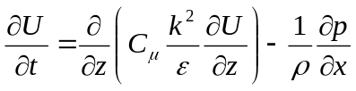 (1)

In Equation (1), U is the time averaged velocity component, t and z represent time and space, ρ is the fluid density, p is the piezometric pressure, C_{µ} is a stability parameter, k represents the turbulent kinetic energy and ε is the turbulent energy dissipation rate. The horizontal pressure gradient term (the last term of Equation (1)) is approximated by U*²/H, where U* and H are the measured friction velocity and water height, respectively. The friction velocity (U*) and water height (H) were available in this research for calculating the horizontal pressure gradient term. Other mathematical expressions of the horizontal pressure gradient term should also be applicable [e.g. Burchard, 1999; Houwman and Hoekstra, 1998; Luyten et al., 2002].
The sediment mass balance equation was used to simulate the 1-dimensional vertical transport of flocculi and flocs in the water column (Equation (2)). As shown in Figure 2, size-fixed flocculi and size-varying flocs approximate a bimodal PSD varying in time and space. To track the three time- and space-dependent variables, the number concentration of flocculi (N_{P}) and the size and number concentration of floc (D_{F} and N_{F}), the sediment mass balance equation incorporate three differential equations for the time rate of change of: the number concentration of flocculi in suspension (dN_{P}/dt), the number concentration of flocs in suspension (dN_{F}/dt), and the number concentration of flocculi bound in flocs (dN_{PF}/dt). On the right-hand side of Equation (2), the respective terms represent turbulence-mediated dispersion, gravity-driven sedimentation and flocculation kinetics. The flocculation kinetics (A_{i} + B_{i}) incorporates the two-class population balance equation (TCPBE) which is able to simulate bimodal flocculation (see also Section 2.3).

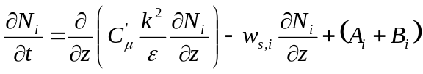 (2)

In Equation (2), N_{i} = N_{i} (z, t) represents the number concentration, the subscript i represents flocculi and flocs in suspension (N_{P} and N_{F}) and flocculi bound in flocs (N_{PF} = N_{C} × N_{F}), N_{C} is a floc size index representing the number of flocculi bound in a floc, C'_{μ} is a stability constant, (A_{i} + B_{i}) is the growth and decay rates of N_{i} by aggregation and breakage, and w_{s,i} is the settling velocity of flocculi or flocs.
The modified Stokes equation, including the use of fractal theory for floc packing and shaping and Schiller’s equation for a particle drag effect, was used to calculate the floc settling velocity (w_{s,i}) [Schiller, 1932]. The Richardson-Zaki equation was also included to calculate the correction factor (Φ_{HS}) for hindered settling in a highly concentrated near-bottom mud layer (Equations (3), (4)) [Richardson and Zaki, 1954; Toorman, 1999].

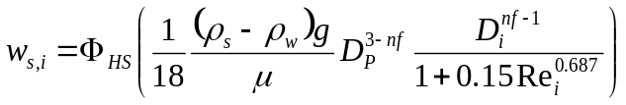 (3)
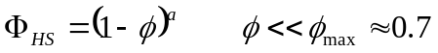 (4)

In Equations (3) and (4), ρ_{s} = particle density, ρ_{w} = fluid density, g = gravitational acceleration, μ = fluid viscosity, Φ_{HS} = correction factor for hindered settling, Φ = volumetric concentration of flocs (m³ Flocs / m³), and Re_{i} = Reynolds number of a particle or floc (= D_{i}·w_{s,i}·ρ_{w}/µ).
2.2 Turbulence Closure
The two-equation k-ε turbulence closure was selected to simulate fluid turbulence, which consequently controls turbulence-mediated sediment dispersion and flocculation (Equations (5), (6)). The two-equation model has the two differential equations for the conservation of the turbulent kinetic energy and its dissipation rate (k and ε) and incorporates the turbulent kinetic energy production and buoyancy destruction terms (P and G). Especially, the buoyancy destruction term (G) is incorporated to simulate the particle-fluid interactions, taking into account the damping effect of sediment stratification on fluid turbulence. The buoyancy by stable sediment stratification is known to destruct or damp flow turbulence [Burchard and Baumert, 1998; Rodi, 1980; Toorman, 2003].

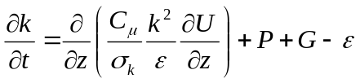 (5)
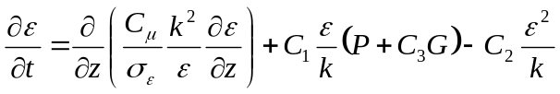 (6)

In Equations (5) and (6), model fitting coefficients have been found as σ_{k} = 1.0, σ_{ε} = 1.3, C₁ = 1.44, C₂ = 1.92 and C₃ = -1.4 [Burchard and Baumert, 1998; Conley et al., 2008].
The turbulent kinetic energy production term (P) and the buoyancy destruction term (G) are specified by Equations (7) and (8), respectively. The turbulent Schmidt number is closed with the Munk-Anderson damping functions, Equation (9) [Munk and Anderson, 1948]. The gradient Richardson number (Ri) is a dimensionless measure of the stability of stratification (Equation (10)). Under the stratification effect (Ri > 0), the damping effect on turbulence will be taken into account by the buoyancy destruction term (G) and the stability coefficient of eddy viscosity (C'_{µ}).

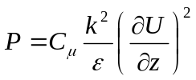 (7)
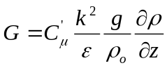 (8)
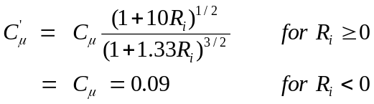 (9)
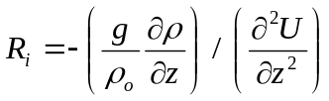 (10)

The boundary conditions of the time- and space-dependent variables are summarized in Table 1. The top boundary conditions of flow velocity (U) and turbulent kinetic energy and dissipation rate (k and ε) were treated as a closed boundary (i.e. zero-flux boundary), but the bottom boundary conditions incorporated the friction velocity (U*) describing flow over the rough bottom boundary. The top boundaries of the number concentrations of flocculi in suspension, flocs in suspension and flocculi bound in flocs (N_{P}, N_{F} and N_{PF}) were set to be a closed boundary, but the bottom boundaries were open for erosion and deposition, following formulation of shear-dependent erosion and continuous deposition (Equations (11), (12)) [Ariathurai, 1974; Le Hir et al., 2011; Winterwerp, 1998]. In the 1-DV TCPBE, both of flocculi and flocs are subject to deposition, but only flocculi are to erosion which may be referred to as entrainment or disruption [Winterwerp and van Kesteren, 2004].

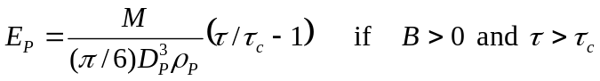 (11)
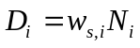 (12)

In Equation (12), the subscript i is P, F or PF, representing flocculi in suspension, flocs in suspension and flocculi bound in flocs, respectively. M is the empirical erosion parameter, τ is the bottom shear stress, τ_{c} is the critical shear stress for erosion. The denominator over M is used to convert the mass concentration to the number concentration. Erosion of flocculi (E_{P}) is effective only when a pool of erodible sediments is available on the bottom (B > 0) and the bottom shear stress is over the critical shear stress (τ > τ_{c}), according to the Ariathurai-Partheniades equation [Ariathurai, 1974].
2.3 Flocculation Kinetic Model
The two-class PBE includes size-fixed flocculi and size-varying flocs as building blocks and buildings, respectively, in order to simulate bimodal flocculation (Figure 2). The number of flocculi bound in a floc (N_{C}) is used as an index of floc size in the TCPBE. Because this new size index becomes one for flocculi (N_{C} = 1), it gives the simplicity of the TCPBE. The TCPBE incorporates three coupled differential equations describing the time rate of change of: (1) the number concentration of microflocs (dN_{P}/dt), (2) the number concentration of macroflocs (dN_{F}/dt), and (3) the total number concentration of microflocs bound in macroflocs (dN_{PF}/dt) (N_{PF} = N_{C} × N_{F}) (Equation (13)), and they were incorporated to the growth and decay rates (A_{i} + B_{i}) of Equation (2). The TCPBE was explained in depth by Lee et al. (2011).

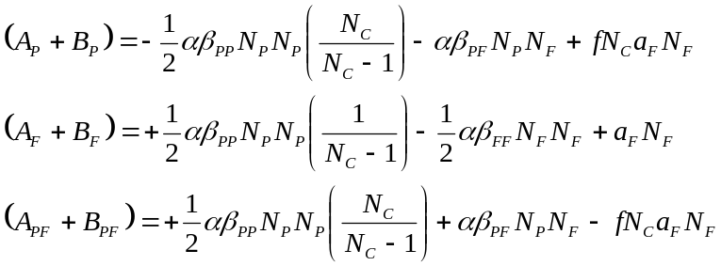 (13)

In Equation (13), f represents the fraction of flocculi generated by floc breakage. α is the collision efficiency factor, β is the collision frequency factor, and a is the breakage kinetic constant. The collision efficiency factor (α) is generally used as an application-specific fitting parameter and the collision frequency factor (β) is applied as a theoretical function correlated with Brownian motion, turbulent shear rate, and differential settling. Table 2 summarizes the aggregation and breakage kernels for the collision frequency factor (β) and the breakage kinetic constant (a) [Burd and Jackson, 2002; Lee et al., 2011]. The aggregation kernels consist of the theoretical functions of Brownian motion, differential settling and turbulent shear, but the breakage kernel is composed only of the shear-dependent breakage kinetics function.
2.4 Numerical Methods
The operator splitting algorithm and Gauss-Seidel iteration were applied to solve the nonlinear partial differential equations of the 1-DV TCPBE model (Equations (1) ~ (13)). According to the operator splitting algorithm, the flocculation kinetic equations (Equation (13)) were decoupled and solved explicitly in each time step, to cope with the complexity and nonlinearity [Aro et al., 1999; Winterwerp et al., 2006]. Each operator was solved using Gauss-Seidel iteration, in which the dependent variables are updated iteratively until satisfying the convergence limit in each time step. Then the converged values are used as the seeding values of the next time step (other iteration methods should also be applicable.).
Tide equations (Equations (14), (15)) fit to a time series of the measured friction velocity (U*) and water height (H) in a flood-ebb tidal cycle were used as the input of the momentum conservation equation for driving turbulent flow.

(14)
(15)

Note that the water height changes in the tidal cycle. To account for the water height change, the equally-spaced grid cells along the water column were set to change their size with increasing time and each transport equation (i.e. Equations (1), (2), (5), (6); X = U, N_{i}, k, ε) was corrected with an additional advection term (Equation (16)) based on the Arbitrary Euler-Lagrange (ALE) method [Huerta and Liu, 1988].

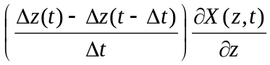 (16)

3. MATERIAL AND METHODS
3.1 Field Measurements
The study area is situated in the Belgian coastal zone facing the southern North Sea. The area is of interest due to the occurrence of a coastal high turbidity area. Measurements indicate variations in SPM concentration in the nearshore area of 20–70 mg l⁻¹ and reaching 100 to >3,000 mg l⁻¹ near the bed [Fettweis et al., 2010]. The SPM is characterized by the development of multimodal PSD [Fettweis et al., 2012; Lee et al., 2012]. A grain size analysis found that the suspended matters in the study area consist mostly of clay (41 %) and silt (57 %) with a small amount of sand (2 %) [Fettweis, 2008]. Therefore, flocculation was supposed to be the major contributor for developing a multimodal PSD of such fine-grained cohesive sediments. Tides are semi-diurnal with a mean tidal range at Zeebrugge of 4.3 m (2.8 m) at spring (neap) tide and maximum current velocities of more than 1 m s⁻¹. Tidal ellipses are commonly well-aligned with the coastline orientation. A tripod was deployed at about 1 km from the shore line in a water depth of 5.5 m below MLLWS (mean lowest low water at spring tide), and current velocity, turbulent shear, salinity, and suspended sediment data were collected in the field measurement campaign from 15/Apr/2008 to 30/Apr/2008. Sediment samples nearby the tripod show variable sediment characteristics (fine sand, silt/clay), with a D₅₀ grain size of the sand fraction of about 150 µm. The measuring instruments on the tripod were a 5 MHz SonTek^{R} Acoustic Doppler Velocimeter (ADV Ocean), a 3 MHz SonTek^{R} Acoustic Doppler Profiler (ADP), two D&A^{R} optical backscatter sensors (OBS), a Sea-bird^{R} SBE37 CT system, a Sequoia Scientific^{R} Laser In-Situ Scattering & Transmissometer 100C (LISST-100C), and two SonTek^{R} Hydra systems for data storage and batteries. The measured values from OBS, LISST and ADV were averaged over each 10 minute period and recorded. Two OBSs measured SPM concentrations at 0.2 and 2 m above the bed (mab). The ADV measured a time series of flow velocity and turbulent intensity at 0.2 mab. The respective U and V velocity components were projected to the along-shore axis directing to the northeast (65°) and the cross-shore axis directing to the southeast (155°) [Baeye et al., 2011]. The high frequency ADV (25 Hz) measurements permitted to decompose the velocity in terms of a mean and a fluctuating part and to calculate the turbulent kinetic energy (TKE) and the bottom friction velocity (U*) with the inertial dissipation method [Fettweis et al., 2010; Sherwood et al., 2006; Trowbridge and Elgar, 2001]. The LISST-100C which was attached to the tripod at 2 mab measured a size distribution of volume-equivalent spherical particles/flocs in 32 logarithmically spaced size groups over the range of 2.5 - 500 µm [Agrawal and Pottsmith, 2000].
3.2 Decomposition of a Multimodal PSD
The observed multimodal (4-peaked) PSD was assumed to be formed by overlapping four unimodal log-normal PSDs of primary particles, flocculi, microflocs, and macroflocs (Figure 1), and these data served as input to the selected software (DistFitTM; Chimera Technologies, USA) which performed the curve fitting analysis and the decomposition of the observed PSD into the subordinate log-normal PSDs (Equation (17)) [Lee et al., 2012; Whitby, 1978].

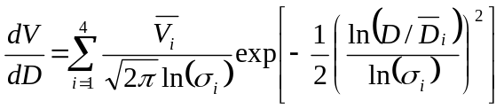 (17)

In Equation (17), V and D are the volumetric concentration and diameter of each size interval of the LISST-100C measured PSD. dV/dD is the normalized volumetric fraction by the width of the size interval and used for curve-fitting to a lognormal distribution [Hinds, 1999]. 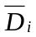 is the geometric mean diameter (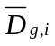), which is equivalent to the median diameter (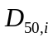) for a lognormal distribution [Weisstein, 2006], 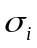 is the geometrical standard deviation, and 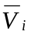 is the volumetric concentration of an i-th unimodal PSD. Equation (17) has twelve fitting parameters for , and of primary particles, flocculi, microflocs and macroflocs. Based on observation, the mean diameters of primary particles, flocculi, microflocs and macroflocs were limited to be 3, 15, 20 ~ 200 and 200 ~ 500 µm, respectively, in the curve-fitting analysis. The best-quality PSD provided parameter values (, and ) for the subordinate log-normal PSDs of primary particles, flocculi, microflocs and macroflocs. The resulting parameter values were then used as indicators of cohesive sediment flocculation and transport dynamics.
3.3 Model Calibration and Validation
The best-quality simulation of the 1-DV TCPBE, fit to the experimental data, was found while changing the adjustable fitting parameters of the collision and breakage efficiency factors (α and E_{b}), erosion constants (M and τ_{c}) and floc characteristics (ρ_{p} and n_{f}). However, the other kinetic and physicochemical constants and the initial conditions were fixed at the standard values, which have been found in the previous researches (Table 3) [Burchard and Baumert, 1998; Lee et al., 2011; Luyten et al., 2002; Winterwerp and van Kesteren, 2004]. The simulated results of the 1-DV TCPBE were compared with the experimental data from the field measurements.
4. RESULTS AND DISCUSSION
4.1 Field Observation on Multimodal PSDs
The flood and ebb tidal flows were nearly symmetric to each other during the entire measuring period, characterized by the same magnitude of flow velocities but the opposite direction toward or against the shore. The median floc size (D₅₀) and particle size distribution (PSD) of cohesive sediments varied in the flood-ebb tidal flows (Figure 3). D₅₀ increased to the maximum and PSDs skewed toward a larger size with a substantial amount of microflocs and macroflocs while passing the slack water (e.g. t = 7.00 and 14.50 hours). However, D₅₀ decreased down to the minimum and PSDs skewed toward a smaller size with a substantial amount of primary particles and flocculi around the peak flow (e.g. t = 4.33 and 10.17 hours).
Flocculation usually depends on fluid turbulent shear, and such shear-dependent flocculation has been reported to be the main contributor for determining D₅₀ and PSDs in a flood-ebb tidal cycle [Fettweis et al., 2006]. Under shear-dependent flocculation, a mild flow at the slack water enhances aggregation but reduces breakage, and a vigorous flow at the peak flow vice versa. This agrees well with the findings of this research in that sediments aggregated to large flocs at the slack water but flocs broke down at the peak flow. Besides the shear-dependent flocculation, one may also suspect that erosion at the peak flow might have affected D₅₀ and PSDs due to the influx of larger sandy particles from the seafloor. However, the peak flow, which is supposed to enhance erosion of sandy particles, instead decreased D₅₀ and skewed PSDs toward a smaller size, thereby pointing to floc breakage [Lee et al., 2012]. Also, considering that the suspended matters of the measuring site consisted mostly of fine-grained cohesive sediments (e.g. clay and silt) (see Section 3.1), erosion of large sandy particles might hardly affect D₅₀ nor PSDs.
The four modal peaks of primary particles, flocculi, microflocs and macroflocs alternately rose and sank, thereby resulting in different multimodal PSDs depending on fluid turbulence (Figure 3(c)). The peak flow raised the peaks of primary particles and flocculi (the first and second peaks from the left of a PSD) but sank the peaks of micro- and macro-flocs (the third and fourth peaks) (e.g. 4.33 and 10.17 hours), and the slack water vice versa (e.g. 7.00 and 14.50 hours). The respective modal peaks of primary particles and flocculi appeared at about 3 and 15 µm with a small variation between different PSDs. However, the modal sizes of microflocs and macroflocs varied in a wide range of 50 ~ 200 and 200 ~ 500 µm, respectively, because of floc size growth and decay by aggregation and breakage (see also Figure 1). These four-level ordered aggregate structures of primary particles, flocculi, microflocs and macroflocs are common in a marine and coastal environment [Lee et al., 2012; van Leussen, 1994]. Primary particles are known to be fine particles consisting of fragmented clay particles, organic and calcareous particles, picophytoplankton and bacteria. Often primary particles are smaller than the size range of the LISST 100C; these fine ‘out of range’ particles affect the entire PSD, with a significant increase of the volume concentration of the smallest two size classes [Andrews et al., 2010] explaining the rising tail in Figure 3c during peak flow (e.g. 4.33 and 10.17 hours). Flocculi, which are seldom broken down to the lowest-level primary particles, are regarded as the major building blocks of flocs rather than primary particles in a marine and coastal environment. Microflocs and macroflocs are built with flocculi and primary particles because of physicochemically and biologically mediated flocculation in the salt- and biomass-enriched sea water [Eisma, 1986; van Leussen, 1994].
4.2 Numerical Simulation of Multimodal Flocculation
The four-level ordered aggregate structures of primary particles, flocculi, microflocs and macroflocs may be further simplified to be the two-level structures of flocculi (primary particles and flocculi) and flocs (microflocs and macroflocs) for modelling and simulation [Lee et al., 2012]. The sharp peak of primary particles, which in reality consist mostly of out-of-range particles below the lowest measurable size, may be merged to the peak of flocculi. Furthermore, the settling flux analysis for multimodal PSDs revealed that the two discrete size groups of flocculi and flocs could approximate a continuous multimodal PSD with a relatively small error less than 9.5 % [Lee et al., 2012].
Therefore, the Two Class Population Balance Equation (TCPBE) with size-fixed flocculi and size-varying flocs has been proposed as the simplest model that is capable of simulating multimodal flocculation (see also Figure 2(b)) [Lee et al., 2011]. Sophisticated flocculation models with many discrete floc size classes [Verney et al., 2011; Xu et al., 2008] or a continuous size distribution [Maerz and Wirtz, 2009] would be more accurate and precise than the TCPBE for simulating multimodal flocculation. However, the TCPBE can be a practical alternative of such sophisticated models with less computational cost, considering that the two discrete size groups of flocculi and flocs can approximate a multimodal PSD. The TCPBE is at least better for simulating multimodal flocculation than many contemporary flocculation models with a single floc size group [Son and Hsu, 2009; Winterwerp, 1998].
The collision and breakage efficiency factors (α and E_{b}), erosion constants (M and τ_{c}) and floc characteristics (ρ_{p} and n_{f}) were selected as adjustable fitting parameters to find the best quality simulation. The collision efficiency factor (α) of the best quality simulation was 0.2 within the theoretical range between 0 and 1, and the breakage efficiency factor (E_{b}) was 3.0×10⁻⁵ close to 2.0×10⁻⁵ of the earlier 1-DV simulation of Winterwerp (1998). The empirical erosion constant (M) was estimated to be 1.0×10⁻³ kg/m²/s, which is a bit higher than the typical value of mud deposits (0.01×10⁻³ ~ 0.5×10⁻³) [Winterwerp and van Kesteren, 2004]. The critical shear stress for erosion was set to be 1.5 pa, which also is a bit higher than those of typical mud deposits (0.2 ~ 0.8) [Winterwerp and van Kesteren, 2004]. Considering the high erosion rate and critical shear stress, cohesive sediments at the measuring site seem quite resistant to erosion, but they seem subject to massive erosion after the threshold. The respective floc characteristic parameters of ρ_{p} and n_{f} were 1800 kg/m³ and 2.3. Especially, the fractal dimension in this study was the uppermost value of typical mud flocs (1.8 ~ 2.3), thereby indicating formation of dense and fast-settling flocs at the measuring site. All the other parameters of hydrodynamics, sediment transport and flocculation kinetics were fixed at the reference values as shown in Table 3 [Burchard and Baumert, 1998; Le Hir et al., 2011; Lee et al., 2011; Winterwerp and van Kesteren, 2004], but they would have to be closely investigated in the future research.
Simulations of the 1-DV TCPBE were done in flood-ebb tidal cycles, where a tide equation fit to the measured friction velocity (U*) and water height (H) were applied for driving turbulent flow (Figure 4a). In Figure 4b, the eddy viscosity of the best quality simulation became the maximum and developed an oval profile around the peak flow (e.g. t = 4.33 and 10.17 hours). However, it became the minimum and developed a skewed oval profile toward the bottom, right after passing the slack water (e.g. t = 7.00, 8.67 and 14.50 hours). Buoyancy destruction due to high-rate settling of large flocs and consequent stratification of the sediment concentration might cause turbulence reduction and skewed the eddy viscosity profile around the slack water. However, stratification of the sediment concentration and turbulence destruction in this numerical study were not as much as those of the earlier 1-DV simulations [Winterwerp, 2011; Winterwerp et al., 2006], probably because the bottom boundary of the 1-DV TCPBE was set to be open for erosion and deposition without full development of a highly concentrated near-bottom mud layer.
The simulated depth profiles of the suspended sediment concentration were shown to depend on fluid turbulence of the flood-ebb tidal cycle (Figure 4c). For example, the sediment concentration profile advanced toward a higher concentration while passing the peak flow (e.g t = 4.33 and 10.17 hours), but the profile retreated while passing the slack water (e.g. t = 8.67 and 14.50 hours). This indicates that a high turbulence around the peak flow would enhance erosion and resuspension, thereby bringing sediments upward into the water column. A low turbulence however would enhance flocculation, sedimentation and deposition, thereby bringing sediments down to the bottom. The sediment concentration profiles of the best quality simulation seemed reasonably fit to the measured data in a flood-ebb tidal cycle, but they had a lag behind the measured data, especially while approaching and leaving the slack water (e.g. t= 7.00 and 10.17 hours; see also Figure 5e). This will be more discussed later in this section.
The 1-DV TCPBE well simulated flocculation kinetics in a flow-varying tidal cycle. The simulated profiles of the mean floc size (D_{F}) kept close to the measured data, increasing at the slack water but decreasing at the peak flow (Figure 4d). More important is that the discrete peaks of flocculi and flocs in simulation could be an approximation of the measured multimodal PSDs (Figure 4e). Flocculi with a high concentration (N_{P} ↑) and flocs with a small size and low concentration (D_{F} ↓, N_{F} ↓) could approximate the measured PSDs skewed toward a smaller size at the peak flow (e.g. t = 4.33 and 10.17 hour), whereas flocculi with a low concentration (N_{P} ↓) and flocs with a large size and high concentration (D_{F} ↑, N_{F} ↑) could approximate the PSDs skewed toward a larger size at the slack water (e.g. t = 8.67 and 14.50 hour). Results from the 1-DV TCPBE simulation (inverse triangles) followed closely the measured and averaged trajectories of flocculi and flocs (circles) as shown in Figure 4e. In fact, the 1-DV TCPBE could approximately simulate a multimodal PSD with adjusting the two discrete peaks of flocculi and flocs, although it could not simulate the entire domain of a multimodal PSD.
The best quality simulation of the 1-DV TCPBE model was reasonably fit to the measured data in the entire measuring period, following the up-and-down patterns (Figure 5). A flocculi mass fraction (f_{p}) increased up to 70 % but a floc size (D_{F}) decreased down to 80 µm around the peak flow (Figures 5c, 5d). This indicates that a high fluid turbulence enhanced breakage over aggregation and produces a large amount of fragmented flocculi and small flocs. Around the slack water, a flocculi mass fraction (f_{p}) decreased down to 20 % but a floc size (D_{F}) sharply increased up to 200 µm, because flocculi aggregated to large flocs under a low fluid turbulence of the slack water. The 1-DV TCPBE model could simulate those up-and-down trends of the flocculi mass fraction (f_{p}) and floc size (D_{F}) during the entire flood-ebb tidal cycles, but it could not simulate the sharp increase of floc size up to 200 µm around the slack water (Figure 5c). According to Maggi (2009), biologically-mediated flocculation might accelerate floc size growth and develop the sharp increase of floc size around the slack water. The 1-DV TCPBE however did not incorporate the biologically-mediated flocculation, so that it might not be able to simulate the sharp peak of floc size around the slack water.
The 1-DV TCPBE model resulted in a lag of the simulated sediment concentration behind the measured, especially around the slack water (Figure 5e; see also Figure 4c). The measured sediment concentrations more quickly decreased and increased than the simulated, while approaching and leaving the slack water, respectively. In other words, sediments in measurement seemed to deposit on the bottom and erode into the water column more quickly than in simulation. Thus, one may suspect that cohesive sediments in the real measurements might involve something beyond flocculation, sedimentation, erosion and deposition, which were incorporated in the 1-DV TCPBE. The biologically-mediated flocculation discussed earlier could be a part of the missing processes of the 1-DV TCPBE in charge of the lag between the simulation and measurement, because it could rapidly enhance floc size growth and sediment deposition while approaching the slack water. And, what else is the missing process of the 1-DV TCPBE?
The 1-DV TCPBE cannot correctly simulate formation and disruption of the highly concentrated near-bottom suspension layer, which is expected to be formed during low-energy moments around slack water [e.g. Baeye et al., 2011]. The measurements, however, were carried out above this expected layer. Therefore, there is no direct evidence for the hypothesis. But the present model, like other currently used sediment transport models, applies no correction to the near-bottom boundary conditions for the turbulence model, resulting in an underestimation of turbulence damping, a wrong bottom shear stress estimation (based on traditional assumptions which ignore drag modulation) and subsequently wrong sediment fluxes in both horizontal and vertical direction (i.e. transport and erosion respectively). The model results can only be improved by including these phenomena, as proposed by Toorman and Bi (2012).
5. CONCLUSION AND RECOMMENDATION
Results from the field measurements and the curve-fitting analyses found that a multimodal PSD is comprised of the four-level ordered aggregate structures of primary particles, flocculi, microflocs and macroflocs. The four modal PSDs could be further simplified to be the two discrete groups of flocculi and flocs, which leaded to an idea for developing the Two-Class Population Balance Equation (TCPBE). The 1-DV TCPBE, combined with the Navier-Stokes equation with the k-ε turbulence closure and sediment mass balance equation, proved its capability of simulating multimodal flocculation and transport of fine-grained cohesive sediments in a marine and coastal environment. Especially, the discrete size groups (i.e. flocculi and flocs) of the 1-DV TCPBE were proven to be a reasonable approximation of a continuous multimodal PSD in modeling and simulation. In fact, the 1-DV TCPBE is promising for further application to a large-scale multi-dimensional simulation, because it is simple but able to simulate multimodal flocculation. However, the 1-DV TCPBE would have to include a high-resolution sediment-fluid interaction model, if it would be required to accurately simulate formation and disruption of the highly concentrated near-bottom mud layer.

ACKNOWLEDGEMENT

REFERENCES
Agrawal, Y., and H. Pottsmith (2000), Instruments for particle size and settling velocity observations in sediment transport, Marine Geology, 168, 89–114.
Andrews, S., D. Nover, and S. Schladow (2010), Using laser diffraction data to obtain accurate particle size distributions: the role of particle composition, Limnology and Oceanography: Methods, 8, 507–526.
Ariathurai, C. (1974), A finite element model for sediment transport in estuaries, PhD Dissertation, University of California, Davis.
Aro, C., G. Rodrigue, and D. Rotman (1999), A high performance chemical kinetics algorithm for 3-D atmospheric models, The International Journal of High Performance Computing Applications, 13(1), 3–15.
Baeye, M., M. Fettweis, G. Voulgaris, and V. Van Lancker (2011), Sediment mobility in response to tidal and wind-driven flows along the Belgian inner shelf, southern North Sea, Ocean Dynamics, 61(5), 611–622.
Burchard, H. (1999), Recalculation of surface slopes as forcing for numerical water column models of tidal flow, Applied Mathematical Modelling, 23, 737–755.
Burchard, H., and H. Baumert (1998), The formation of estuarine turbidity maxima due to density effects in the salt wedge. A hydrodynamic process study, Journal of Physical Oceanography, 28, 309–321.
Burd, A., and G. Jackson (2002), Modeling steady-state particle size spectra, Environmental Science and Technology, 36, 323–327.
Conley, D., S. Falchetti, I. Lohmann, and M. Brocchini (2008), The effects of flow stratification by non-cohesive sediment on transport in high-energy wave-driven flows, Journal of Fluid Mechanics, 610, 43–67.
Eisma, D. (1986), Flocculation and de-flocculation of suspended matter in estuaries, Netherlands Journal of Sea Research, 20, 183–199.
Fettweis, M. (2008), Uncertainty of excess density and settling velocity of mud flocs derived from in situ measurements, Estuarine, Coastal and Shelf Science, 78(2), 426–436.
Fettweis, M., M. Baeye, B. Lee, P. Chen, and J. Yu (2012), Hydro-meteological influences and multimodal suspended particle size distribution in the Belgian nearshore area (southern North Sea), Geo-Marine Letters, 32(2), 123–137.
Fettweis, M., F. Francken, D. Van den Eynde, T. Verwaest, J. Janssens, and V. Van Lancker (2010), Storm influence on SPM concentrations in a coastal turbidity maximum area with high anthropogenic impact (southern North Sea), Continental Shelf Research, 30, 1417–1427.
Fettweis, M., F. Francken, V. Pison, and D. Van den Eynde (2006), Suspended particulate matter dynamics and aggregate sizes in a high turbidity area, Marine Geology, 235, 63–74.

Hinds, W. (1999), Aerosol technology: properties, behavior, and measurement of airborne particles, 2nd ed., John Wiley & Sons, Inc., New York, NY.
Le Hir, P., F. Cayocca, and B. Waeles (2011), Dynamics of sand and mud mixtures: A multiprocess-based modelling strategy, Continental Shelf Research, doi:10.1016/j.csr.2010.12.009.
Houwman, K., and P. Hoekstra (1998), Tidal ellipses in the near-shore zone (-3 to -10 m); modelling and observations, Proceedings of the International Conference on Coastal Engineering, 26, 773–786.
Huerta, A., and W. Liu (1988), Viscous flow with large free surface motion, Computer Methods in Applied Mechanics and Engineering, 69, 277–324.
Lee, B., M. Fettweis, E. Toorman, and F. Molz (2012), Multimodality of a particle size distribution of cohesive suspended particulate matters in a coastal zone, Journal of Geophysical Research - Ocean, In Press, doi:10.1029/2011JC007552.
Lee, B., E. Toorman, F. Molz, and J. Wang (2011), A two-class population balance equation yielding bimodal flocculation of marine or estuarine sediments, Water Research, 45(5), 2131–2145.
van Leussen, W. (1994), Estuarine Macroflocs : Their role in fine-grained sediment transport, Universiteit van Utrecht, the Netherlands.
Luyten, P., S. Carniel, and G. Umgiesser (2002), Validation of turbulence closure parameterisations for stably stratified flows using the PROVESS turbulence measurements in the North Sea, Journal of Sea Research, 47, 239–267.
Maerz, J., and K. Wirtz (2009), Resolving physically and biologically driven suspended particulate matter dynamics in a tidal basin with a distribution-based model, Estuarine, Coastal and Shelf Science, 84, 128–138.
Maggi, F. (2009), Biological flocculation of suspended particles in nutrient-rich aqueous ecosystems, Journal of Hydrology, 376, 116–125.
Manning, A., S. Bass, and K. Dyer (2006), Floc properties in the turbidity maximum of a mesotidal estuary during neap and spring tidal conditions, Marine Geology, 235, 193–211.
Munk, W., and E. Anderson (1948), Notes on a theory of the thermocline, J. Marine Research, 3(1), 276–295.
Richardson, J., and W. Zaki (1954), Sedimentation and fluidisation, Part I, Trans. Inst. Chem. Engrs., 2, 35–53.
Rodi, W. (1980), Turbulence models and their application in hydraulics, IAHR State-of-the-Art Paper.
Schiller, L. (1932), Fallversuche mit kugeln und scheiben in Handbuch der experimental-Physik, IV., Akademische Verlagsgesellschaft Leipzig.
Sherwood, C., J. Lacy, and G. Voulgaris (2006), Shear velocity estimates on the inner shelf off Grays Harbor, Washington, USA, Continental Shelf Research, 26, 1995–2018.

Son, M., and T. Hsu (2009), The effect of variable yield strength and variable fractal dimension on ﬂocculation of cohesive sediment, Water Research, 43, 3582–3592.
Toorman, E. (1999), Sedimentation and self-weight consolidation: constitutive equations and numerical modelling, Geotechnique, 49(6), 709–726.
Toorman, E. (2003), Validation of macroscopic modelling of particle-laden turbulent flows, in Proceedings 6th Belgian National Congress on Theoretical and Applied Mechanic, Gent.
Toorman, E., and Q. Bi (2012), Ocean Dynamics, (This Issue).
Trowbridge, J., and S. Elgar (2001), Turbulence Measurements in the Surf Zone, Journal of Physical Oceanography, 31, 2403–2417.
Verney, R., R. Lafite, J. Claude Brun-Cottan, and P. Le Hir (2011), Behaviour of a floc population during a tidal cycle: Laboratory experiments and numerical modelling, Continental Shelf Research, 31(10), S64–S83.
Weisstein, E. (2006), Log Normal Distribution, MathWorld - A Wolfram Web Resources. [online] Available from: http://mathworld.wolfram.com/LogNormalDistribution.html (Accessed 22 March 2011)
Whitby, K. (1978), The physical characteristics of sulfur aerosols, Atmospheric Environment, 41, S25–S49.
Winterwerp, J. (1998), A simple model for turbulence induced flocculation of cohesive sediment, Journal of Hydraulic Engineering, 36(3), 309–326.
Winterwerp, J. (2011), Fine sediment transport by tidal asymmetry in the high-concentrated Ems River: indications for a regime shift in response to channel deepening, Ocean Dynamics, 61(2-3), 203–215.
Winterwerp, J., and W. van Kesteren (2004), Introduction to the physics of cohesive sediment in the marine environment, Elsevier B.V., Amsterdam, The Netherlands.
Winterwerp, J., A. Manning, C. Martens, T. de Mulder, and J. Vanlede (2006), A heuristic formula for turbulence-induced ﬂocculation of cohesive sediment, Estuarine, Coastal and Shelf Science, 68, 195–207.
Xu, F., D. Wang, and N. Riemer (2008), Modeling ﬂocculation processes of ﬁne-grained particles using a size-resolved method: Comparison with published laboratory experiments, Continental Shelf Research, 28, 2668–2677.

FIGURE CAPTIONS
Figure 1. A multimodal PSD and schematic diagrams of the four-level ordered aggregate structures of primary particles, flocculi, microflocs and macroflocs, modified from Lee et al (2011).

Figure 2. Schematic diagrams of (a) continuous particle size distributions and (b) discrete size groups of flocculi and flocs before and after flocculation, from (t₀, x₀) to (t₁, x₁). Figure 2(b) also represents the flocculation strategy of the TCPBE.

Figure 3. A time series of (a) the alongshore and crossshore flow velocities (U, V) at 2 m above the bottom (mab) and (b) median floc sizes (D₅₀) at 2 mab, during the time period of Julian day 133.57 ~ 114.03. (c) Particle size distributions (PSDs) at different time. The lines inside the envelope of a PSD represent the subordinate PSDs of primary particles, flocculi, microflocs and macroflocs, from the right to the left of a PSD.

Figure 4. A time series of (a) measured bottom shear velocities (U*) and water height (H) and their best-fit tidal equations, during the time period of Julian day 133.57 ~ 114.03. (b) Simulated depth profiles of eddy viscosities at different time. Simulated depth profiles and measured data of (c) suspended solid concentrations and (d) volume-mean floc sizes (D_{F}) at different time. (e) Measured and simulated particle size distributions at different time.

Figure 5. A time series of the measured and simulated (a) bottom shear velocity (U*), (b) water height (H), (c) flocculi mass fraction (f_{P}), (d) volume-mean floc diameter (D_{F}) and (e) suspended sediment concentration at 2 m above the bottom (C_{2mab}).

TABLE CAPTION

Table 1. Top and Bottom boundary conditions of the Navier-Stokes equation with the k-ε turbulence closure and sediment mass balance equation.

Table 2. Aggregation and breakage kernels of the 1-DV TCPBE, modified from Lee et al. (2011).

Table 3. Parameters and initial conditions of the 1-DV TCPBE for the best-quality simulation.

Figure 1

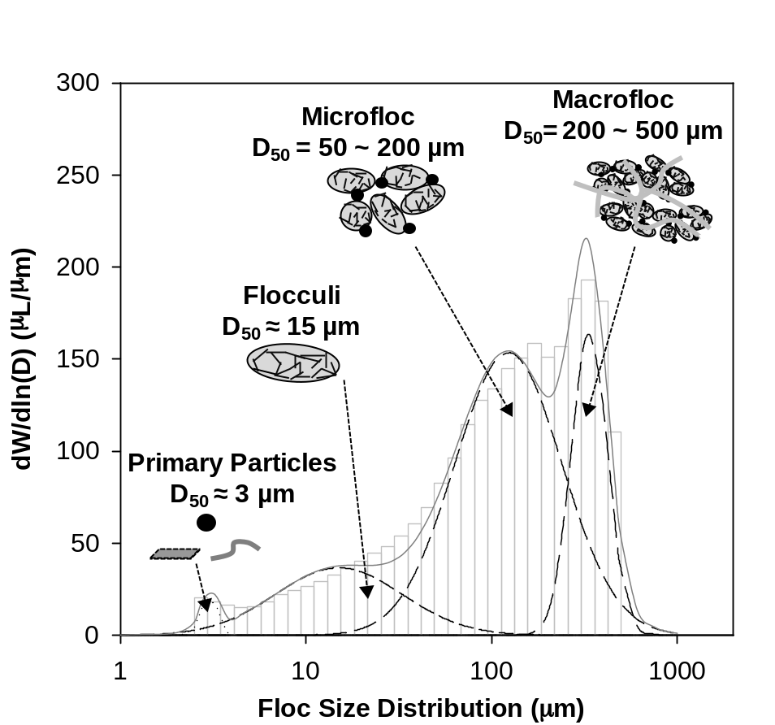

Figure 2

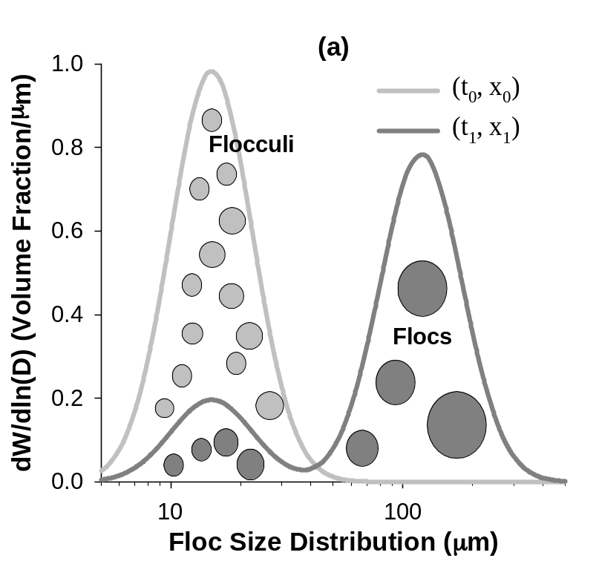
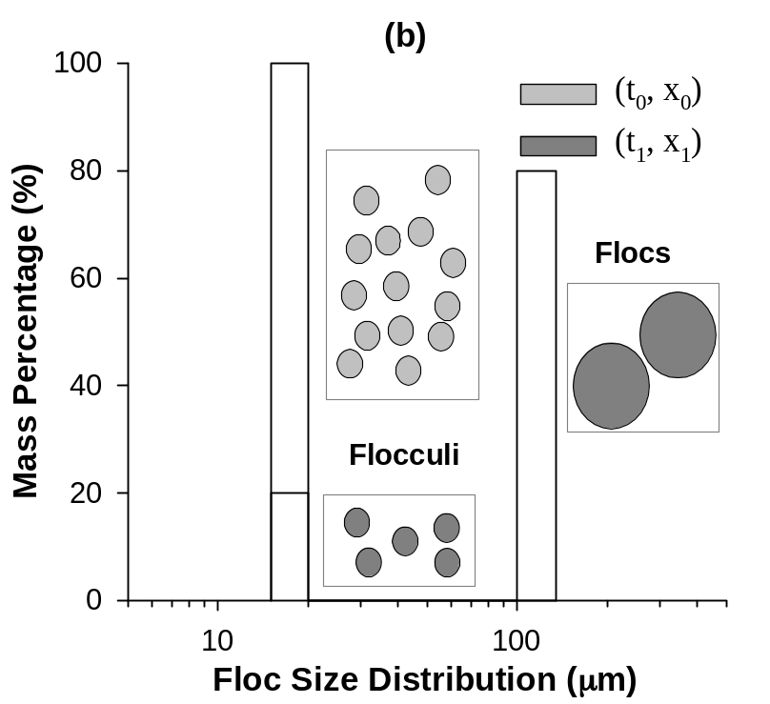

Figure 3
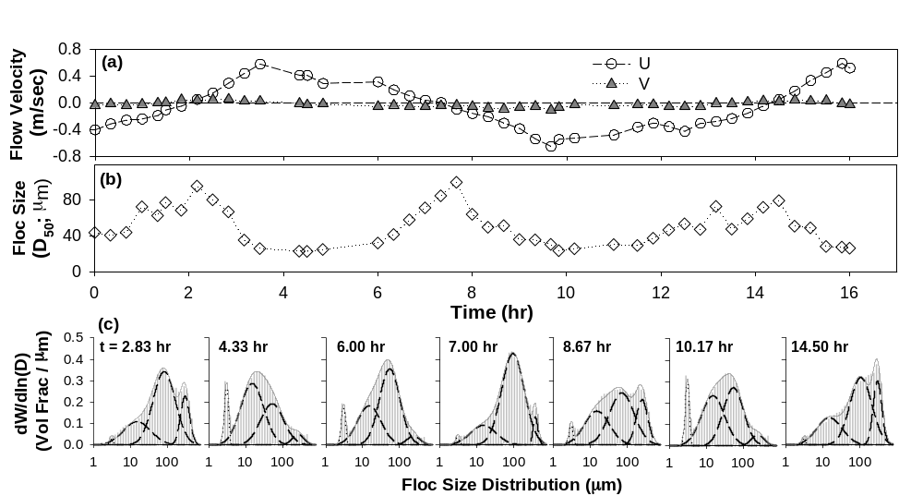

Figure 4.
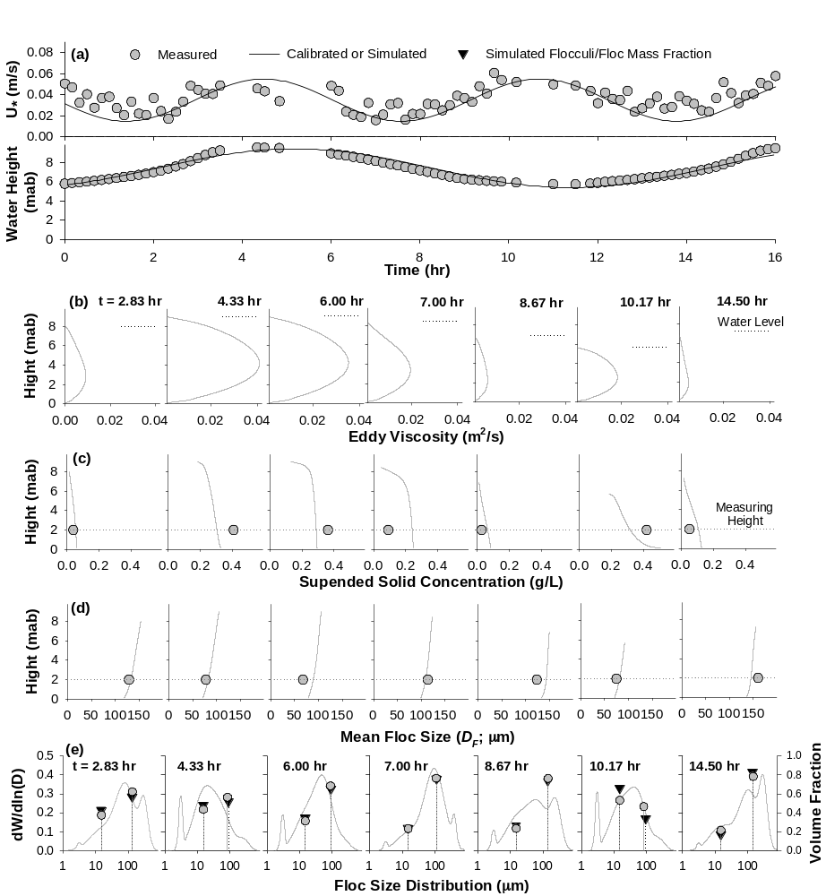

Figure 5.
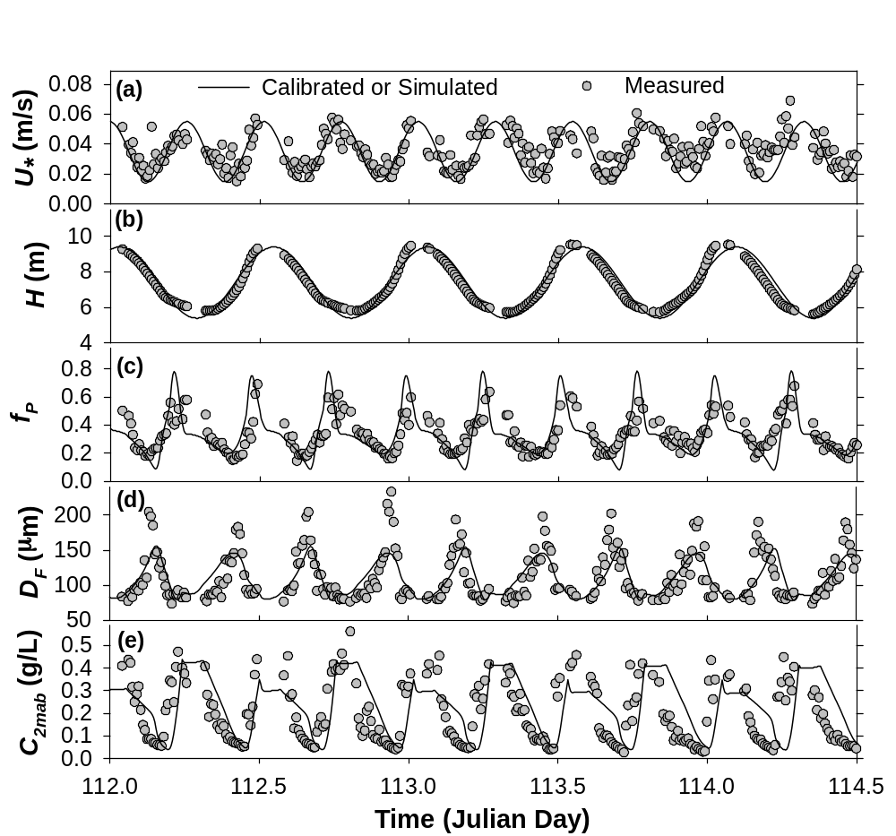

Table 1.

Boundary Conditions  at the Bottom | 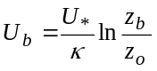 | 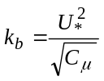 | 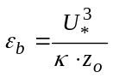 | 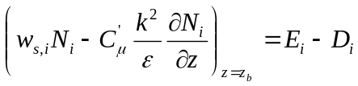
Boundary Conditions  at the Top | 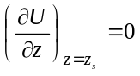 | 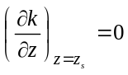 | 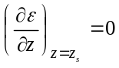 | 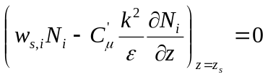

Table 2.

Aggregation Kernel | Breakage Kernel
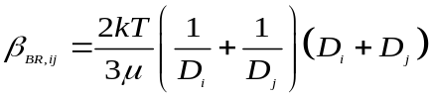  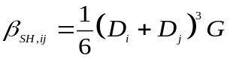  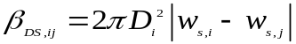 | 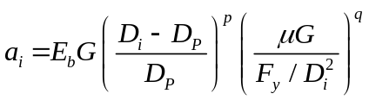
D_{i} = Diameter of a particle size class i  β_{BR} = Collision frequency factor by Brownian motion  β_{SH} = Collision frequency factor by fluid shear  β_{DS} = Collision frequency factor by differential settling  k = Boltzmann’s constant  T = Absolute Temperature (K) | p, q = Empirical parameters  μ = Absolute viscosity of the fluid  G = Fluid turbulent shear rate (/s)  w_{i} = Sedimentation velocity of size class i  E_{b} = Breakage efficiency factor  F_{y} = Yield strength of flocs (10⁻¹⁰ Pa)

Table 3.

Kinetic Parameters and Physicochemical Constants
Classification | Symbol | Value | Description
Flocculation  Kinetics | α | 0.2 | Collision efficiency factor [-]
Flocculation  Kinetics | E_{b} | 3.0e-5 | Efficiency factor for breakage [s^{0.5}/m]
Flocculation  Kinetics | F_{y} | 1.0e-10 | Yield strength of flocs [Pa]
Flocculation  Kinetics | f | 1.0 | Fraction of flocculi by breakage [-]
Flocculation  Kinetics | ª p | 1.0 | Empirical parameter of breakage kinetics
Flocculation  Kinetics | q | 3.0 - n_{f} | Empirical parameter of breakage kinetics
Turbulent  Flow | C_{µ} | 0.09 | Model fitting coefficients [-]
Turbulent  Flow | C₁ | 1.44 | Model fitting coefficients [-]
Turbulent  Flow | C₂ | 1.92 | Model fitting coefficients [-]
Turbulent  Flow | C₃ | -1.4 | Model fitting coefficients [-]
Turbulent  Flow | σ_{k} | 1.0 | Model fitting coefficients [-]
Turbulent  Flow | σ_{ε} | 1.3 | Model fitting coefficients [-]
Turbulent  Flow | κ | 0.4 | Von Karmen’s coefficient [-]
Turbulent  Flow | z_{o} | 0.001 | Bottom roughness length [m]
Turbulent  Flow | z_{b} | 0.01 | Distance from the bottom [m]
Erosion  Deposition | M | 1.0e-3 | Empirical erosion parameter [kg/m²/s]
Erosion  Deposition | t_{c} | 1.5 | Critical shear stress for erosion [pa]
Erosion  Deposition | B | 2.24 | Total mass of erodible sediments [kg/m²]
Sediment  Property | ρ_{P} | 1800 | Density of flocculi [kg/m³]
Sediment  Property | ρ_{w} | 1050 | Density of sea water [kg/m³]
Sediment  Property | D_{P} | 15.0 | Diameter of flocculi [μm]
Sediment  Property | n_{f} | 2.3 | Fractal dimension of flocs [-]
Sediment  Property | a | 4.0 | Exponent of Richardson-Zaki eqn [Pa]
Initial Conditions (at t = 0)
Sediment Concentration | c | 0.32 | Total mass conc. of sediments [g/L]
Sediment Concentration | ^{b} N_{PT} | 1.004e+11 | No. conc. of flocculi [/m³]
Seeding  Flocs | D_{F,0} | 100 | Diameter of seeded flocs [μm]
Seeding  Flocs | Frac_{F,0} | 0.1 | Mass fraction of seeded flocs [-]
TCPBE | N_{P,0} | (1- Frac_{F,0}) N_{PT} | No. conc. of flocculi [/m³]
TCPBE | N_{F,0} | (D_{F,0}/D_{P})^{-nf} (Frac_{F,0}) N_{PT} | No. conc. of flocs [/m³]
TCPBE | N_{PF,0} | (Frac_{F,0}) N_{PT} | No. conc. of flocculi bound in Flocs [/m³]
a p was set as 1.0 to narrow FSDs, instead of 0.5 of Winterwerp and van Kasteren (2004).
b 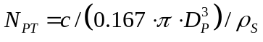, assuming that flocculi are spherical.

