**Index**

Provide Database Schema with SMS verification **2**

Provide a Diagram for how you would implement SMS verification **3**

Provide a data/system flow diagram for the login process **5**

Provide your approach for setting up a live video broadcast system **5**

1. **Provide Database Schema for user login and should include SMS verification :**

This is test project so I have created on offline project for sql and added the necessary columns to the table.

CREATE SCHEMA wordwide;

CREATE TABLE wordwide.table_user (

_id int NOT NULL AUTO_INCREMENT,

email varchar(50) NOT NULL ,

password varchar(100) NOT NULL , // It should be encrypted

create_date date NOT NULL ,

update_date date NOT NULL ,

country_code char(5) NOT NULL ,

phone_number char(16) NOT NULL ,

CONSTRAINT pk_table_user PRIMARY KEY ( _id ),

CONSTRAINT fk_table_user_table_sessions FOREIGN KEY ( _id ) REFERENCES wordwide.table_sessions( _id ) ON DELETE NO ACTION ON UPDATE NO ACTION

) engine=InnoDB;

CREATE TABLE wordwide.table_sessions (

session_id int NOT NULL AUTO_INCREMENT,

_id int NOT NULL ,

auth_token varchar(100) NOT NULL ,

verification_token varchar(6) NOT NULL ,

CONSTRAINT pk_table_sessions PRIMARY KEY ( session_id ),

CONSTRAINT pk_table_sessions_0 UNIQUE ( _id )

) engine=InnoDB;

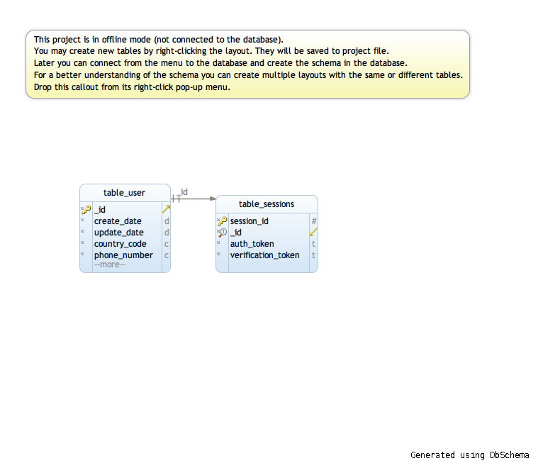

1. **Provide a Diagram for how you would implement SMS verification :**

App will contain SMS verification screen that should follow following set of rules :

1. App should detect the county automatically from telephony manager.
2. App should have separate screen to select county code.
3. App should validate phone number with lib phone number before sending it to server.
4. App should wait for verification code from server and auto detect in android but has to be filled in web or ios.

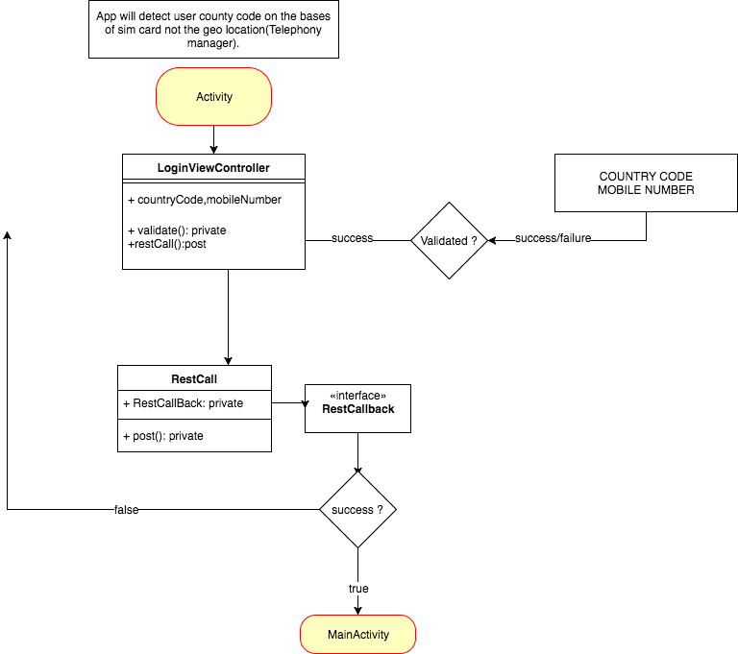

Server will follow following set of rules:

1. When server accept the phone number and county code at that time it will generate the user session and send verification code to the respective number.
2. If sms api return true (twilio), then record if the verification was success. If not we can try with some other api such as Nexmo.
3. **Provide a data/system flow diagram for the login process :**

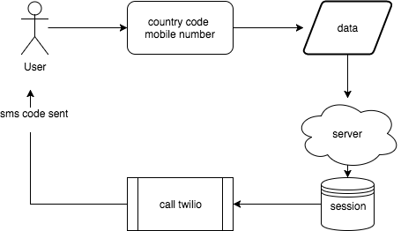

1. **Provide your approach for setting up a live video broadcast system :**

A. Users can live video stream from mobile devices

* App first connect custom camera for both android and ios.
* Camera should be capable of showing the video in landscape as well as portrait mode.
* When user click on start recording, app should setup rtsp stream to the server. The YUV data sent should follow a codec that need to be sent.
* Codec can be a H264 of some other format. Most famous formates are :
* **240p** (424x240, 0.10 megapixels)
* **360p** (640x360, 0.23 megapixels)
* **432p** (768x432, 0.33 megapixels)
* **480p** (848x480, 0.41 megapixels, "SD" or "NTSC widescreen")
* **576p** (1024x576, 0.59 megapixels, "PAL widescreen")
* **720p** (1280x720, 0.92 megapixels, "HD")
* **1080p** (1920x1080, 2.07 megapixels, "Full HD”)

In portrait mode yuv data should be portrait and in landscape data should be landscape. App can take help of libyuv for this. <https://chromium.googlesource.com/libyuv/libyuv/+/master>

B. Users can live video stream from mobile devices :

Application should contain a RTMP reader. The reader should be capable of reading any codec that we are supporting.

If we want to go with a paid thing, then their a lib available to do this for both Android and ios.

<https://www.vitamio.org/en/>

C. Include any third-party tools and technical specifications for your implementation

For streaming I have used following third party :

1. <https://github.com/fyhertz/libstreaming>
2. <https://chromium.googlesource.com/libyuv/libyuv/+/master>
3. <https://www.vitamio.org/en/>
4. https://www.wowza.com/