## Flowcharts

Login:

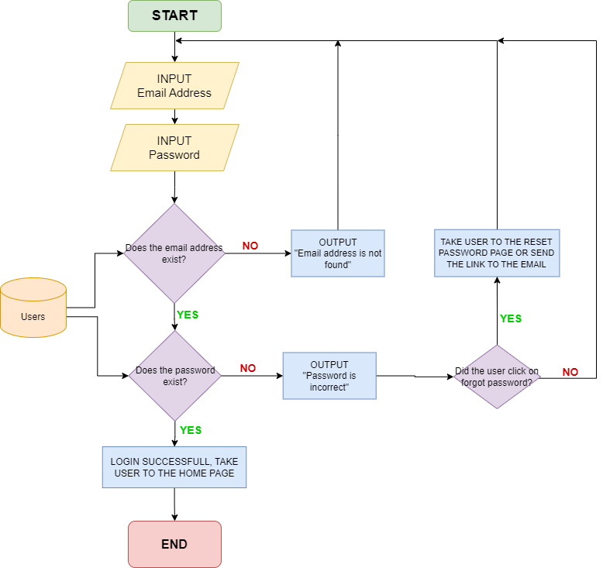

In the login process the user will need to enter their email address and password. The system will then first check if the email exists in the database, if the email is not found it will display an error message. If the email is found, the system then checks if the passoword matches with the email stored in the database. If it is not correct or not found, an error message will be displayed. If the user clicks on “forgot password” they will be taken to the reset password page or an email will be sent to reset it. If both email and password are wrong the user will have to register the account or re-enter the correct credentials. If both email and password does appeard to be correct, the user will be successfully logged in and directed to the home page.

**Register:**

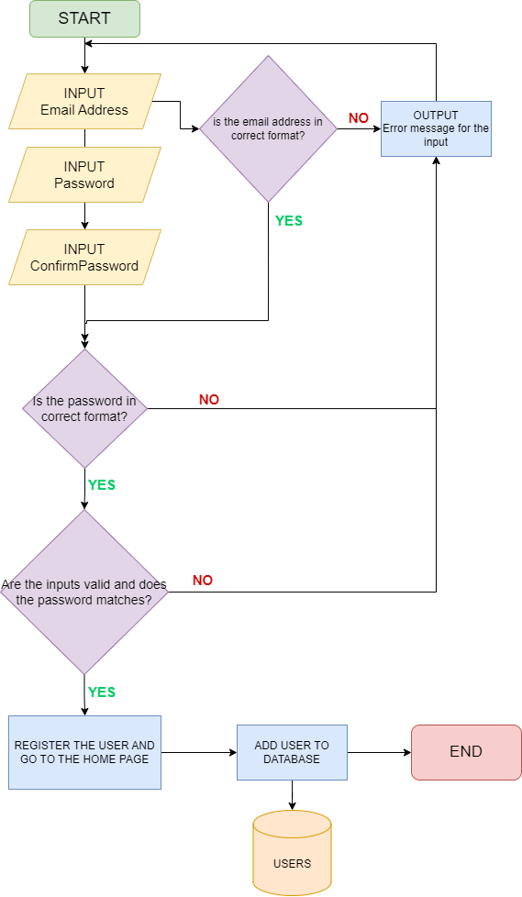

When creating an account the user will need to enter their email address, password and then confirm password (to check if it is a human). The system checks if the email and passowrd are valid and in correct reuired format. If either is incorrect an error message will be displayed and the user will have to enter correct detials. If everything is correct, the account will be created and users details will be saved in the database for future logins and the user will be taken to the home page.

**Booking consultation:**

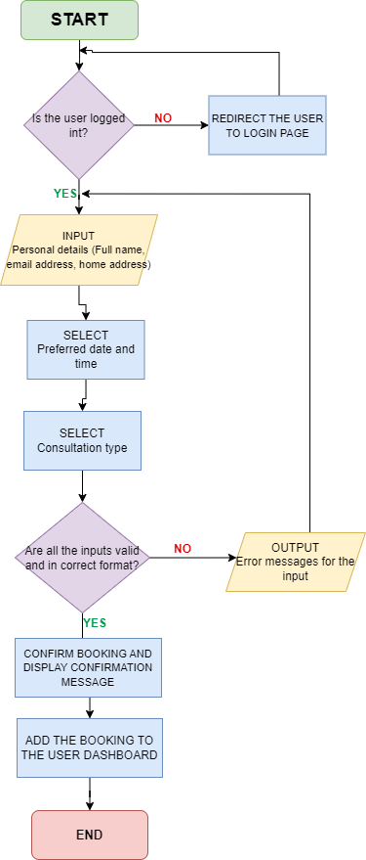

When a user wants to book a consultation, they will go to the booking consultation page. If the user is not logged in, they will first need to log in (so they can save their booking in the dashboard). If the user is logged in, they will need to fill in their personal details such as name, home address, email, phone number etc. After that, they will need to select their preferred date, time and consultation type. The system will then check if the inputs are in the correct format and valid. If any input is invalid or if any required filed is missing an error message will be displayed. If all the inputs are correct the booking will be confirmed and a confirmation message will appear. The booking will then be added to the user’s dashboard where they can track it or cancel it.

**Booking installation:**

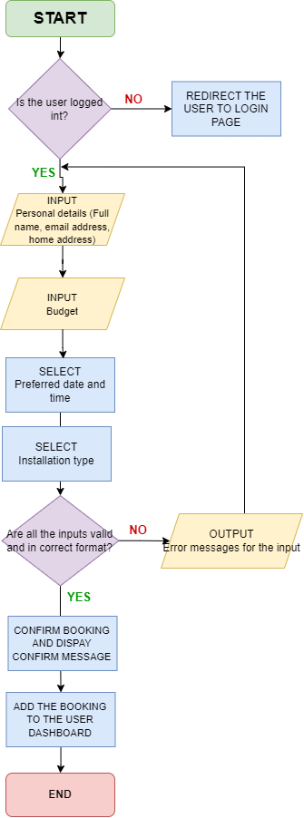

When a user wants to book a installation, they will go to the booking installation page. If the user is not logged in, they will first need to log in (so they can save their booking in the dashboard). If the user is logged in, they will need to fill in their personal details such as name, home address, email, phone number etc. After that, they will need to select their preferred date, time and installation type and add their budget. The system will then check if the inputs are in the correct format and valid. If any input is invalid or if any required filed is missing an error message will be displayed. If all the inputs are correct the booking will be confirmed and a confirmation message will appear. The booking will then be added to the user’s dashboard where they can track it or cancel it.

**Carbon footprint calculator:**

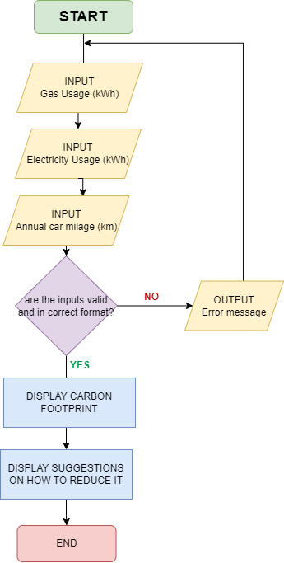

When a user wants to calculate their carbon footprint they will need to enter their gar usage, electrecity usage and annual car milage. The system checks if the inputs are valid and if all required fields are filled. If everything is correct it will calculate the user’s carbon footprint and display the results with tips and suggestions on how to reduce their footprint and the postivie impact they can make on the planet. If any input is missing or invalid an error message will be displayed.

## Database design

**Introduction to ASP.NET Core MVC and System Architecture**

ASP.NET is a framework used to build web applications. It uses MVC structure that divides the application into 3 parts: Model, View and Controller.

**Model:** represents the data and deals with logic**.**

**View:** is a frontend for the users to see the data and interact with it

**Controller:** is the brain behind all the requests or logic and connects the model with the view.

In this system models are used to store data and they help the system to fetch, store and manage information for users.

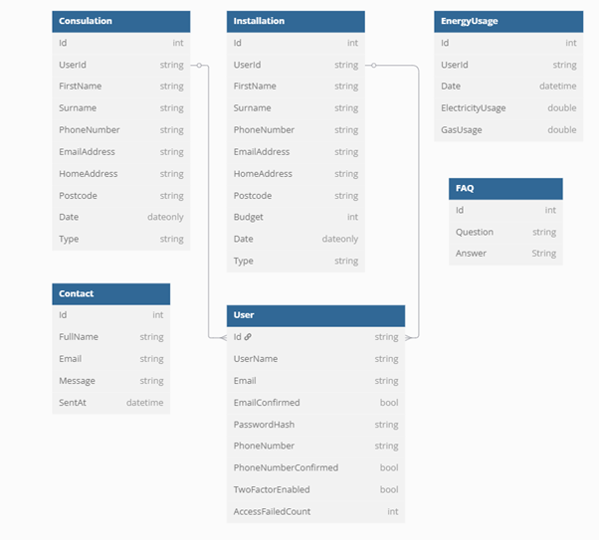

## Data dictionary

Consultation Booking

|  |  |  |  |  |
| --- | --- | --- | --- | --- |
| Filed Name | Data type | Validation | Required | Primary/Foreign key |
| Id | int |  | Yes | Primary key |
| UserId | String | Valid user reference | Yes | Foreign key |
| FirstName | String | Max length:100 | Yes |  |
| Surname | String | Max length: 100 | Yes |  |
| PhoneNumber | String | Valid phone format | Yes |  |
| Email Address | String | Valid email format | Yes |  |
| HomeAddress | String | Max length: 255 | Yes |  |
| Postcode | String | Valid postcode format | Yes |  |
| Date | DateTime | Must be future date | Yes |  |
| Type | string | Max length:50 | Yes |  |

Installation booking

|  |  |  |  |  |
| --- | --- | --- | --- | --- |
| Filed Name | Data type | Validation | Required | Primary/Foreign key |
| Id | int |  | Yes | Primary key |
| UserId | String | Valid user reference | Yes | Foreign key |
| FirstName | String | Max length:100 | Yes |  |
| Surname | String | Max length: 100 | Yes |  |
| PhoneNumber | String | Valid phone format | Yes |  |
| Email Address | String | Valid email format | Yes |  |
| HomeAddress | String | Max length: 255 | Yes |  |
| Postcode | String | Valid postcode format | Yes |  |
| Budget | Int | Budget value >=0 | Yes |  |
| Date | DateTime | Must be future date | Yes |  |
| Type | string | Max length:50 | Yes |  |

Energy Usage table

|  |  |  |  |  |
| --- | --- | --- | --- | --- |
| Filed Name | Data type | Validation | Required | Primary/Foreign key |
| Id | int |  | Yes | Primary key |
| UserId | String | Valid user reference | Yes | Foreign key |
| Date | Datetime | Must be a valid date and time | Yes |  |
| ElectricityUsage | Double | Value >=0 | Yes |  |
| GasUsage | Double | Value >=0 | Yes |  |

FAQ Table

|  |  |  |  |  |
| --- | --- | --- | --- | --- |
| Filed Name | Data type | Validation | Required | Primary/Foreign key |
| Id | int |  | Yes | Primary key |
| Question | String | Max length: 255 | Yes |  |
| Answer | String | Max length: 255 | Yes |  |

Contact Table

|  |  |  |  |  |
| --- | --- | --- | --- | --- |
| Filed Name | Data type | Validation | Required | Primary/Foreign key |
| Id | int |  | Yes | Primary key |
| FullName | String | Max length: 255 | Yes | Foreign key |
| Email | String | Must be a valid email format | Yes |  |
| Message | String | Max length: 2000 | Yes |  |
| SentAt | Datetime | Must be a valid datetime | Yes |  |

User Table