Alumni Web Portal, IIT-I

Software Requirements Specification

<Annotated Version>

*Submitted by*

Jaspreet singh

Swetha kondubhatla

Tilak lodha

Ajay kumar saini

*Supervised by*

*Abhishek Srivastsav, CSE dept.*

Table of Contents

Table of Figure(s) 4

1. Introduction 5

1.1 Purpose 5

1.2 Project Scope 5

1.4 References 6

1.5 Overview 6

2. Overall Description 6

2.1 Product Perspective 6

2.1.1 System Interface 6

2.1.2 User interface 6

2.1.3 Hardware Interface 6

2.1.4 Software Interface 7

2.1.5 Communication Interfaces 7

2.1.6 Memory Constraints 7

2.1.7 Operations 7

2.1.8 Site Adaption Requirements 7

2.2 Product features…………………………………………………………………………….

2.3 Product functions 8

2.3.1 Context Diagram 8

2.3.2 Use Case Diagrams 8

2.3.3 Use case descriptions /Introductions 13

2.4 User Characteristics 16

2.4.1 Students 16

2.4.2 System Administrators 16

2.5 Constraints 16

2.5.1 User Interface Constraints 16

2.5.2 Hardware Constraints 17

2.5.3 Software Constraints 17

2.5.4 Data Management Constraints 17

2.5.5 Operational Constraints 17

2.5.6 Site Adaptation Constraints 17

2.5.7 Design Standards Compliance 17

3. Specific Requirements 18

3.1 External interface 18

3.1.1 Web Server 18

3.1.2 PHP Application 18

3.1.3 MySQL Database 18

3.2 Functional Requirements 18

3.2.1 Use Case Scenario 18

3.3 Performance Requirements 25

3.4 Logical database requirements 25

3.5 Design Constraints 25

3.6 Software System Attributes 25

3.6.1 Reliability 25

3.6.2 Availability 25

3.6.3 Security 26

3.6.4 Maintainability 26

3.6.5 Portability 26

# Introduction

## Purpose

The software described in this document is the alumni website of IIT Indore. This document seeks to provide the Software Requirements Specifications for the Website. The purpose of this document is to record the requirements for the design and development of the alumni web portal (AWP).This is the annotated version (first version) of the website. There may be a need for future updates of the website. The document reflects the current requirements of the project as understood by the project team. This document presents an initial description of the various functionalities and services provided by the web portal. The document will also serve the basis for acceptance testing by the user as well as it will help the associated team to refer to the needs at any point of time to deliver the desired output.

## Project Scope

The scope of the website is to provide friendly set of web pages that are easy to navigate and at the same time provides sufficient depth and information they need.

The goal of website is to help the pass out batch students to maintain contacts with the college and keep them informed about the recent updates and achievement of the college. This encourages more students to join the alumni and know about their college. This website will enable alumni to socialize with their batch mates by viewing their profile, through discussion thread.

Benefits for using the site should include:

* Career information of all the members of alumni.
* Timely and up to date information that encourages readers to return to the site.
* Forum that helps the members to discuss the career doubts or ideas.

## References

IITI is younger in comparison to other IIT’s, so IITI do not have well structured Alumni relationship. Keeping that in mind we will refer the Alumni web portal of other IIT’s mainly IITB and IITK. Their web portal is quite well structured, so as reference they are ideal source and along with it we will incorporate the admin need to produce well structured web portal.

## Overview of Document

The next chapter, the Overall Description section, of this document gives an overview of the functionality of the product. It describes the informal requirements and is used to establish a context for the technical requirements specification in the next chapter. The third chapter, Requirements Specification section, of this document is written primarily for the developers and describes in technical terms the details of the functionality of the product.

Both sections of the document describe the same software product in its entirety, but are intended for different audiences and thus use different language.

# Overall Description

## Product Perspective

This product is an annotated version. This will be updated into its next version after necessary changes suggested by the user.

Website is aimed toward students who have completed their engineering at IIT Indore, looking for suggestions from their seniors and to maintain contact with the institute as well as with batch mates. There would be restriction on accessing the information related to alumni according to the user accessing the content.

Website should be user-friendly, ‘quick to learn’ for the above purpose.

#### 2.1.1 System Interface

Apache will be used as web server. The user inputs data via the web server using HTML forms. The actual program that will perform the operations is written in PHP.

#### 2.1.2 User interface

The new system shall provide a very intuitive and simple interface to the user and the administrator, so that the user can easily navigate through pages, assignments, groups and sub- groups, start discussion threads, blogs and the administrator can easily manage groups and revoke user permissions.

#### 2.1.3 Hardware Interface

##### a) Server side

The web application will be hosted on a web server which is listening on the web standard port, port 8080.

##### b) Client side

Monitor screen – the software shall display information to the user via the monitor screen

Mouse – the software shall interact with the movement of the mouse and the mouse buttons. The mouse shall activate areas for data input, command buttons and select options from menus.

Keyboard – the software shall interact with the keystrokes of the keyboard. The keyboard will input data into the active area of the database.

#### 2.1.4 Software Interface

a) Server side

An Apache web server will accept all requests from the client and forward it accordingly. A database will be hosted centrally using MySQL. b) Client side

An OS which is capable of running a modern web browser which supports JavaScript and HTML5.

#### 2.1.5 Communication Interfaces

The HTPP or HTTPS protocol(s) will be used to facilitate communication between the client and server.

#### 2.1.6 Memory Constraints

Memory constraints will come into play when the size of MySQL grows to a considerable size and according to current requirement it is not at all an issue to be worried about.

#### 2.1.7 Operations

The product shall have operations to protect the database from being corrupted or accidentally altered during a system failure.

#### 2.1.8 Site Adaption Requirements

Not applicable

## Product Features

Major features of the website include the following pages/subsections:

* Newsletter
  + Placement scenario: Displays news related to companies visiting IITI for placement, current placement statistics, etc.
  + Alumni’s news: Stuff related to alumni’s achievements, get together, etc.
  + Achievements of the college will be displayed on this portal so they can still connect to their very own IITI.
* Batches
* Pass out batches of the college.
* Each batch sub divided into the respective disciplines and each discipline displays the required information of students of that respective batch and respective discipline
* Gallery
* Displays the images of important activities like convocations, etc.
* Displays the group photos of each pass out batch
* Blog
  + Member can upload his/her blog in the website for the reference of other students
* Discussion Forum
  + It’s a platform where students can discuss their queries related to career.
* Contact us
  + Contains the contact details, address etc. of the alumni Cell for any queries or to share their experiences and success.

## Product functions

### Context Diagram

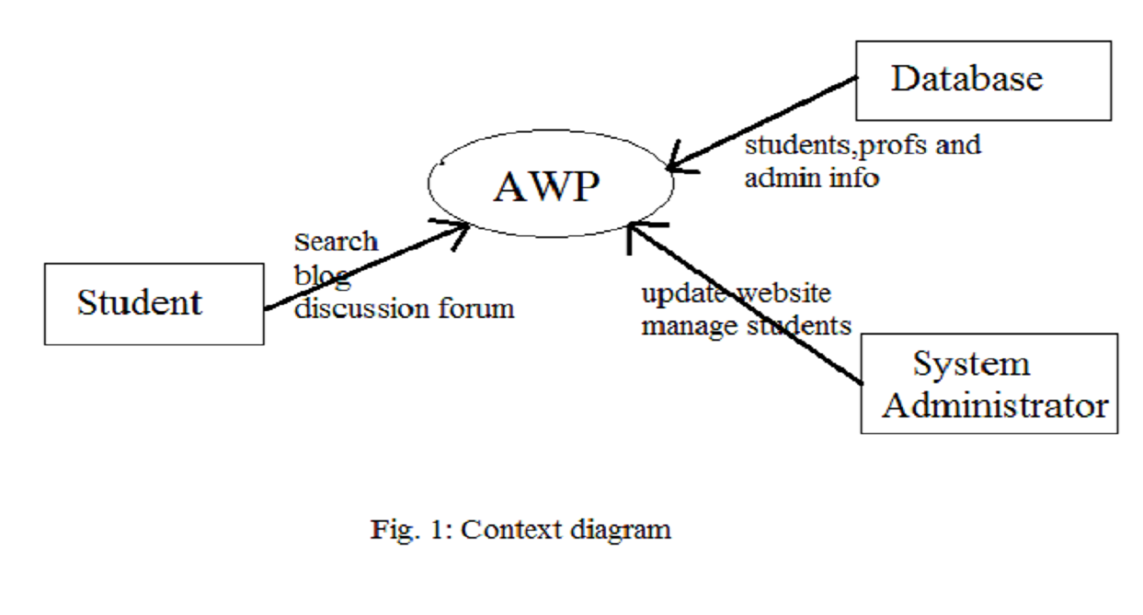

### Use case diagrams

#### User Login

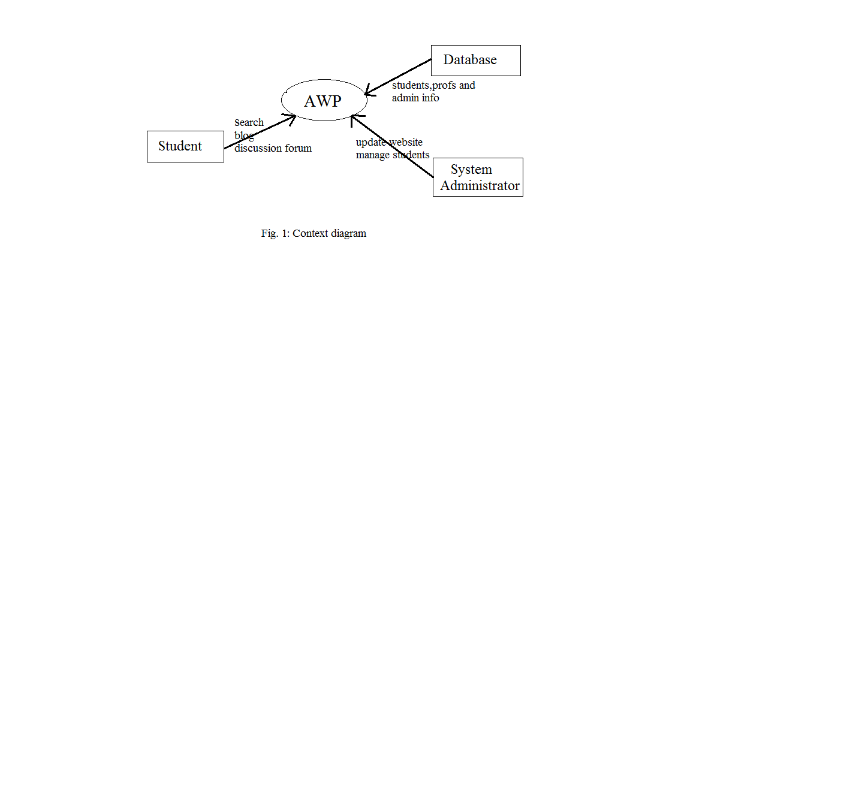

## user1

#### Discussion forum

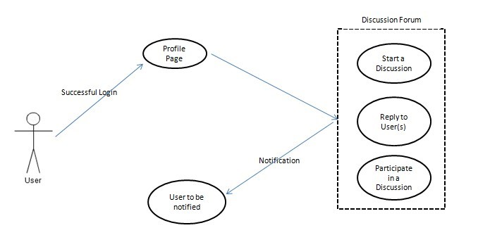

#### Search

#### Blogging

#### Common links

#### 2.3.3 Use case descriptions /Introductions

###### **2.3.3.1 Discussion Threads**

The system shall provide the functionality to start a discussion thread on any topic which is relevant to that context and allows the user to reply to any discussion thread on a group level or a personal level. This enables the alumni’s to interact with each other and get updated with the activities among alumni’s.

###### Reply to a thread on a group level

The user shall be provided with the functionality to post a reply to a particular discussion thread which can be read by entire group.

###### Reply to a thread on an individual level

The user shall be provided with the functionality to post a reply to a particular person who is the part of that discussion thread.

***2.3.3.2 Blogging***

The System shall provide the ability to the user to start a Blog and share the Blog content on a group level or individual level

The users will be able to start a blog on any topic and upload it on the portal for other users to view and give their comments. Alumni’s can share their experiences, success story or any technical stuff in this and all users including Alumni’s and others will have access to it i.e. it would be public.

***2.3.3.3 Search***

The system must be able to use search functionality as a way to navigate pages instead of using hierarchical links. Academic Portals can be difficult to navigate and requires too many clicks to be efficiently used. Too many steps to complete basic actions—such as submitting an assignment—lead to frustration on the part of the student. A search utility enables students to find what they are looking for quickly in addition to having a hierarchical approach to finding functions of the academic portal.

1. A user must be able to search through pages in the website

It should be present in the form of a search box and a “Search” button. When a user clicks a search result link, they should be taken to the page corresponding to the search result. In addition, the search page described above might allow for the possibility of searching the World Wide Web using a standard search engine such as Google.

1. The system must display a search box on every page after a user has logged in. Users should be able to search from any page.

***2.3.3.4Notifications***

Currently, there is no system that allows users to receive email notifications of changes to Portal pages (such as announcements).

1. The system must provide e-mail for notifications for pages.

For this requirement, page refers to any distinct page (e.g., a forum post, etc.). When a page is created, the user in the role of course administrator should be able to toggle whether notifications are turned on. By default, they should be turned on for announcements. If notifications are turned off, users in the capacity of student should be able to subscribe to notifications.

***2.4 User Characteristics***

#### 2.4.1 IITI Students

Students are the primary consumers of a Alumni Web portal. They can access information posted by other students and the newsletter. They can access the blogs and Alumni’s database but can contact the alumni’s only through mail. They can’t access their contact details straightaway and can’t view discussion threads.

#### 2.4.2 System Administrators

System administrators are primarily responsible for maintaining the web portal. They spend more time modifying the system’s configuration and making appropriate updates. They can add, delete, modify notifications ,news, photos. Alumni’s can only be registered if Administrator approves the registration. Once he approves it an auto-generated mail would be sent to the Alumni applied for registering.

#### 2.4.3 Alumni’s

They will have full access of web portal once they are signed in. They can access newsletter, post blogs, express their views in discussion threads, have access to contact details of Alumni’s and their career background.

## 2.5 Constraints

#### 2.5.1 User Interface Constraints

Using this system is fairly simple and intuitive. A user familiar with basic browser navigation skills should be able to understand all functionality provided by the system.

#### 2.5.2 Hardware Constraints

The system should work on most home desktop and laptop computers which support JavaScript and HTML5.

#### 2.5.3 Software Constraints

The system will be intended to run on Firefox 4 and above, Google Chrome 10 and above and Internet Explorer 8 and above.

#### 2.5.4 Data Management Constraints

System shall be able to interface with other components according to their specifications.

#### 2.5.5 Operational Constraints

The system is limited by its operating server in terms of the maximum number of users it can support at a given time.

#### 2.5.6 Site Adaptation Constraints

The component will be adapted to the overarching system at the conclusion of the system creation.

#### 2.5.7 Design Standards Compliance

The system shall be implemented in PHP.

# 3. Specific Requirements

## 3.1 External interface

#### 3.1.1 Web Server

* Apache will be used as web server:
* The user inputs data via the web server using HTML forms
* The web server executes the PHP as a module and PHP script retrieves the post data if available.
* The web server receives information back from the PHP script.
* The web server displays a HTML page as result to the end-user.

#### 3.1.2 PHP Application

The actual program that will perform the operations is written in PHP. All data will be stored in a database.

#### 3.1.3 MySQL Database

It’s an open source SQL database to store all data which communicates with the application on the server.

## 3.2 Functional Requirements

#### 3.2.1 Use Case Scenario

###### **3.2.1.1 Use Case Scenario 1 – User Login**

|  |  |
| --- | --- |
| **Purpose** | User logs in to system using existing profile. |
| **User** | A user with an existing profile. |
| **Input Data** | Profile username and password. |
| **Output Data** | Corresponding page data. |
| **Invariants** | Profile table data and user information. |
| **Pre-conditions** | User is not logged in to a profile, input profile exists in data base, user password matches profile |
| **Post-conditions** | User's computer has been supplied with appropriate cookie, page data is appropriate for selected profile |
| **Basic Flow:** | Webpage looks up profile data and returns the matching cookie. Webpage is updated to match new user data. |
| **Alternative Flow(s):** | Invalid password, invalid username, or mismatched username and password redirect to error message and previous page. |
| **Business Rules:** | This allows users to log in to their profile from anywhere. |

###### **3.2.1.2 Use Case Scenario 3 – Discussion Thread**

A user starts a discussion thread in a particular which, to which the group members are able to respond.

|  |  |
| --- | --- |
| **Purpose** | A user wants to start a discussion on a particular topic. |
| **User** | Any user of the academic portal. |
| **Input Data** | Title and body of the discussion and the group in which the user wants to have the discussion. |
| **Output Data** | A discussion thread to which other users are able to view and comment. |
| **Invariants** | The discussion data. |
| **Pre-conditions** | User is logged in and is a member of the group in which he wants to post. |
| **Post-conditions** | A discussion thread to which other users are able to view and comment. |
| **Basic Flow:** | User logs in, selects a group and submits the title and body of the discussion topic through a submission form. The data is then stored on the server and other group members will be able to view and respond. |

###### **3.2.1.3 Use Case Scenario 5 – Search Result**

A user wants to search for a topic using a keyword.

Search Result

|  |  |
| --- | --- |
| **Purpose** | A user wants to search for a particular keyword. |
| **User** | Any user of the academic portal. |
| **Input Data** | The keyword. |
| **Output Data** | Search Results. |
| **Invariants** | The user and the portal itself. |
| **Pre-conditions** | User is logged in. |
| **Post-conditions** | Search results. |
| **Basic Flow:** | User logs in, Enters the keyword in the search box, clicks the search button and gets the search results. |

###### **3.2.1.4 Use Case Scenario 6 – Blog Thread**

A user starts a blog in a particular subject, to which the members of the portal are able to respond.

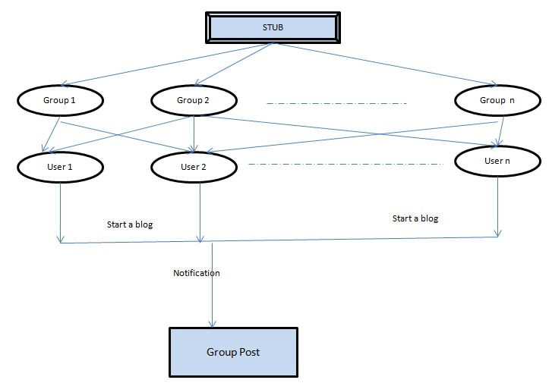

**Figure 11: Process flow diagram: Blogging**

**Blog Thread**

|  |  |
| --- | --- |
| **Purpose** | A user wants to start a Blog on a particular topic. |
| **User** | Any user of the academic portal. |
| **Input Data** | Title and body of the Blog and the forum in which the user wants to have the blog. |
| **Output Data** | Blog to which other users are able to view and comment. |
| **Invariants** | The Blog data. |
| **Pre-conditions** | User is logged in and is a member of the group in which he wants to post. |
| **Post-conditions** | A Blog to which other users are able to view and comment. |
| **Basic Flow:** | User logs in, selects a group and submits the title and body of the blog topic through a submission form. The data is then stored on the server and other group members will be able to view and respond. |

###### **3.2.1.5 Use Case Scenario 7 - Notifications**

A user wants to search for a topic using a keyword.

Notifications

|  |  |
| --- | --- |
| **Purpose** | To get notifications of replies to discussion threads, blogs and other messages. |
| **User** | Any user of the academic portal. |
| **Input Data** | User enables the notifications from settings. |
| **Output Data** | Notifications. |
| **Invariants** | The user and the portal itself. |
| **Pre-conditions** | User has chosen to receive notifications. |
| **Post-conditions** | User receives the desired notifications. |
| **Basic Flow:** | User enables the desired notifications from settings and receives notifications. |

###### **3.2.1.6 Use Case Scenario 8 - Gallery**

A user can browse the photos of their past memory.

Photo Galley:

|  |  |
| --- | --- |
| **Purpose** | To view images related to Alumni’s and college success. |
| **User** | Any user of the academic portal. |
| **Input Data** | By default available to all users. |
| **Output Data** | Images. |
| **Invariants** | The user and the portal itself. |
| **Pre-conditions** | User has chosen to receive notifications. |
| **Post-conditions** | User receives the desired notifications. |
| **Basic Flow:** | User browse through the images available on portal .Fetching of the images content would be done from server to the webpage and then user can see the image when the page loads. |

## 3.3 Performance Requirements

The system should support at least 200 concurrent users.

This statement provides a general sense of reliability when the system is under load. It is important that a substantial number of users be able to access the system at the same time, since an alumni’s portal is important to all. The times when the system will be under the most stress are likely during alumni’s meet. Therefore, it must be able to handle at least 200 concurrent users.

## 3.4 Logical database requirements

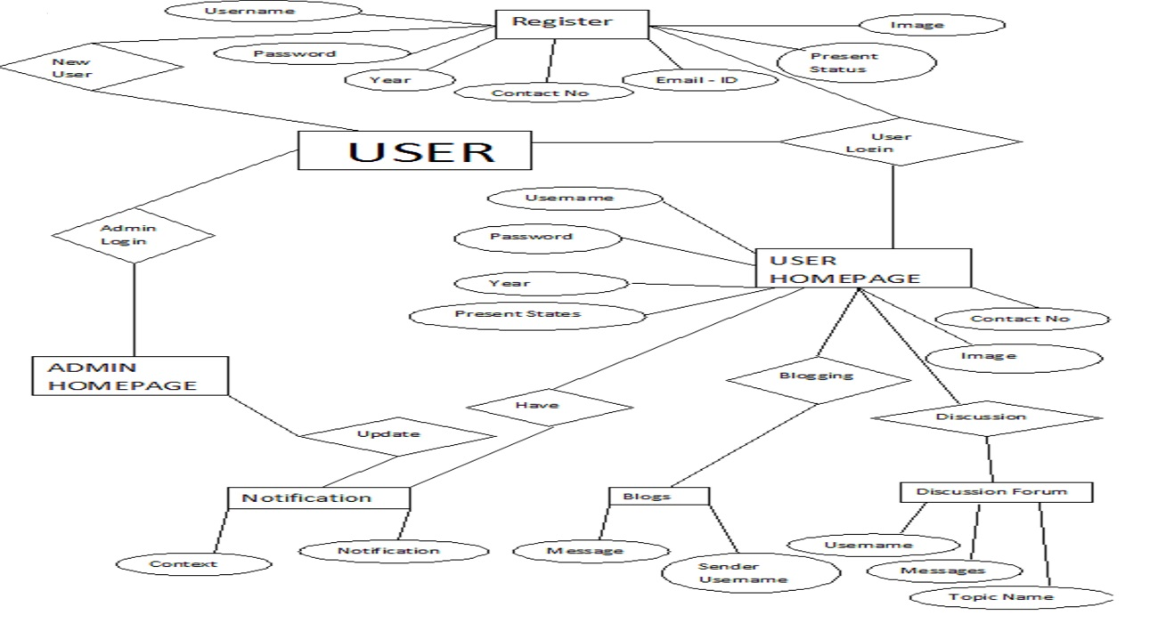

All data will be saved in the database: user accounts and profiles, discussion data, messages etc. (except files which are stored on the disk.) The database allows concurrent access and will be kept consistent at all times, requiring a good database design.

**User Name Data Entity**

|  |  |  |  |
| --- | --- | --- | --- |
| **Data Item** | **Type** | **Description** | **Comment** |
| Username | Text | Name of the username |  |
| Email Address | Text | Internet address of username |  |
| Password | Password | Password of username |  |
| Year | Date | Pass - out Year |  |
| Contact No | Number | Contact no of user |  |
| Present States | Text | Present state , position of alumni |  |
| Image | Image | Photograph |  |

**User Homepage Data Entity**

|  |  |  |  |
| --- | --- | --- | --- |
| **Data Item** | **Type** | **Description** | **Comment** |
| Username | Text | Name of the username |  |
| Email Address | Text | Internet address of username |  |
| Password | Password | Password of username |  |
| Year | Date | Pass - out Year |  |
| Contact No | Integer | Contact no of user |  |
| Present States | Text | Present state , position of alumni |  |
| Image | Image | Photograph |  |

**Discussion Form Data Entity**

|  |  |  |  |
| --- | --- | --- | --- |
| **Data Item** | **Type** | **Description** | **Comment** |
| Username | Text | Name of username |  |
| Message | Text | Message on Discussion Form |  |
| Topic Name | Text | Topic Name |  |

**Blogs Data Entity**

|  |  |  |  |
| --- | --- | --- | --- |
| **Data Item** | **Type** | **Description** | **Comment** |
| Sender Name | Text | Username who send message |  |
| Message | Text | Message on Discussion Form |  |

**Notification Entity**

|  |  |  |  |
| --- | --- | --- | --- |
| **Data Item** | **Type** | **Description** | **Comment** |
| Context | Text | Context of the notification |  |
| Notification | Text | Notification |  |

## 3.5 Design Constraints

1. The communication between the portal software and the database will be in SQL.
2. The portal layout will be produced with HTML/CSS.
3. The product will be written in PHP.
4. The output must be compatible with W3C XHTML 1.0
5. The source code must follow the coding conventions of PHP.
6. System administrators must have access to comprehensive documentation.

## 3.6 Software System Attributes

The software consists of the following elements:

1. The apache web server
2. The PHP application
3. The MySQL database
4. The database should remain consistent at all times in case of an error.

#### 3.6.1 Reliability

The reliability of the overall program depends on the reliability of the separate components. Moreover, backend and frontend are dependent on each other, so any loose coupling between will result in failure, that’s why it would be ensured that both are well supported by each other and work together in efficient way to produce the desired result.

#### 3.6.2 Availability

The system should be available at all times, meaning the user can access it using a web browser, only restricted by the down time of the server on which the system

runs. In case of a of a hardware failure or database corruption, a replacement page will be shown. Also in case of a hardware failure or database corruption, backups of the database should be retrieved with the MySQL server and saved by the administrator.

#### 3.6.3 Security

1. Passwords will be saved encrypted in the database in order to ensure the user's privacy.
2. The user's IP will be logged.
3. The system will be protected against vulnerabilities such as SQL injection attacks.

#### 3.6.4 Maintainability

MySQL is used for maintaining the database and the Apache server takes care of the site. In case of a failure, a re-initialization of the program is recommended.

#### 3.6.5 Portability

The application is Linux-based and should be compatible with other systems. Apache, PHP and MySQL programs are practically independent of the OS-system which they communicate with. The end-user part is fully portable and any system using any web browser should be able to use the features of the application. So, its totally portable.