Assignment 1:

By - Jaspreet Kaur

Index.html

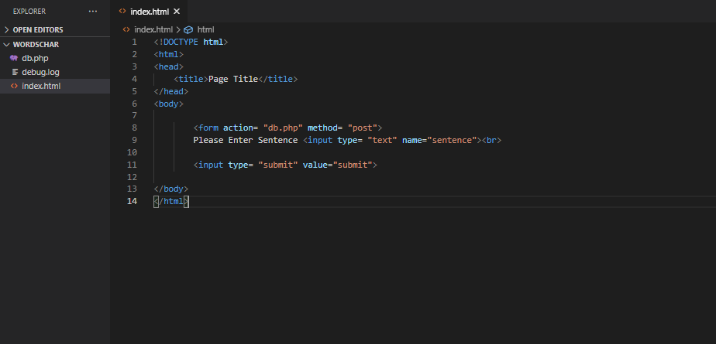

Db.php:

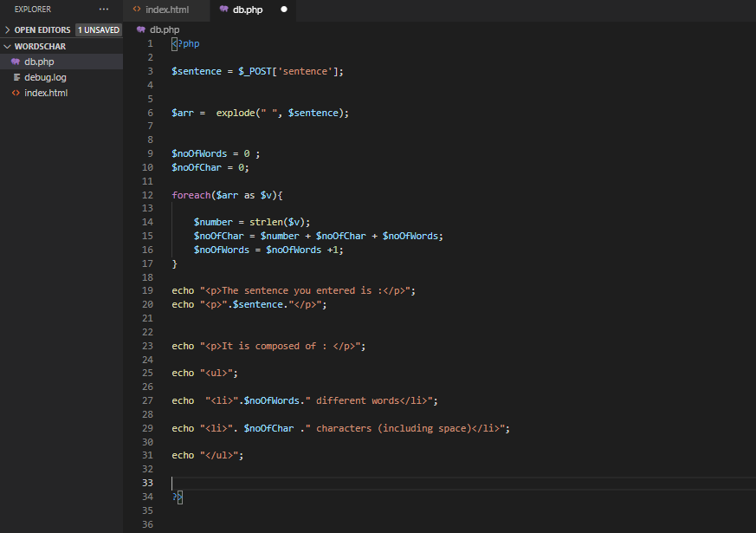

Debug.log:

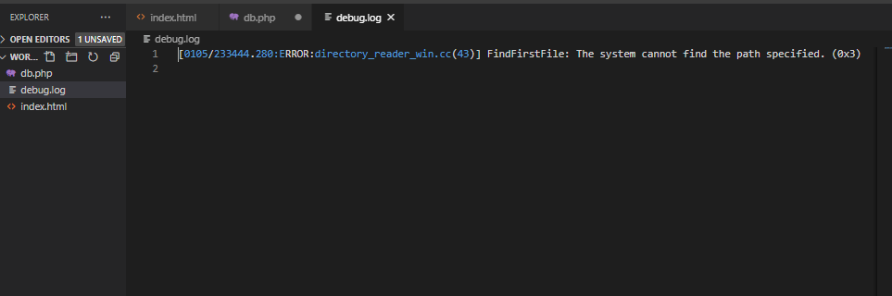

Output:

