**ASSIGNMENT 1**

**Submitted by:**

**Jaspreet Singh**

**Student ID: 22037442**

**Submitted to:**

**Professor: Nawaz Chowdhury**

**Subject: Computer environment and tooling**

**Course code: CSD113**

Honesty Statement: “I declare that this submission is my own work in compliance with Sault College Academic Policies.”

**Due date: 12 January 2024**

**Contents**

**Table of Figures** 4

Assignment Steps: 5

Step-1: 5

Step-2: 5

Step-3: 6

Step-4: 6

Step-5: 7

References: 8

# **Table of Figures**

Figure 1 5

Figure 2 Adding row output 6

Figure 3 running delete row 7

# Assignment Steps:

## Step-1:

In step 1, I add styling.

Figure

## Step-2:

In step 2, added table.

Figure

## Step-3:

Inserted rows.

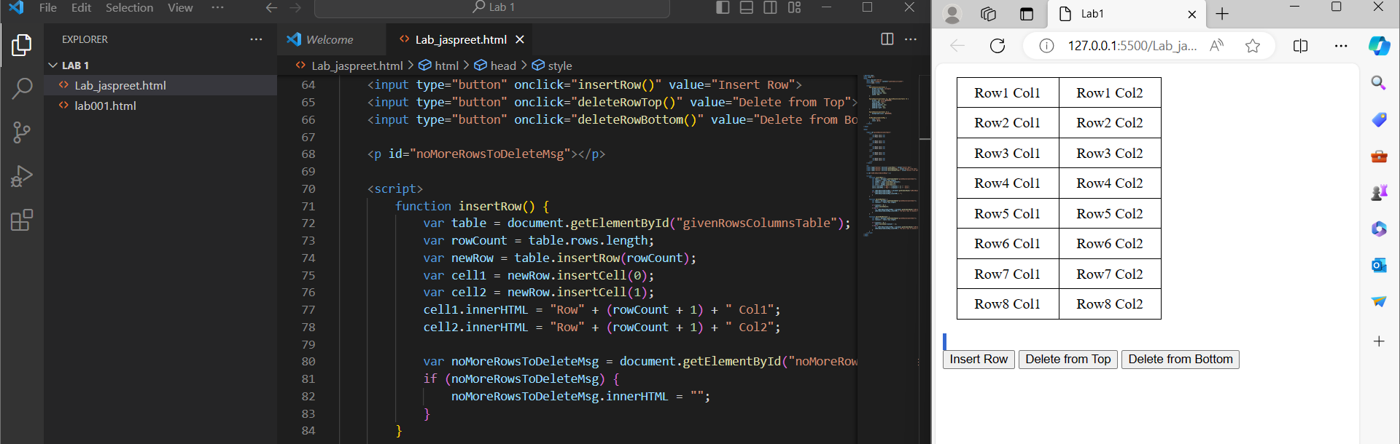

Figure 3

## Step-4:

Delete rows from top and bottom.

Figure 4

## Step-5:

Message shown.

# References:

1. (www.tutorialspoint.com, n.d.)<https://stackoverflow.com/questions/4724327/references-to-learn-html-js-for-non-technical-person>)
2. w3schools (2019). *CSS Styling Tables*. [online] W3schools.com. Available at: https://www.w3schools.com/Css/css_table.asp.