JASPREET SINGH

3153361

ASSIGNMENT 8

CAR RENTAL

PROJECT

CAR RENTAL

Table of Contents

1. Introduction 3

1.1 Purpose of this document 3

1.2 Scope 3

2. Background and Objectives 4

3. Milestones 4

4. Hardware & Software Requirement 5

5. Project Results 5

6. Screenshots 6

# Introduction

## Purpose of this document

The main purpose of this document is to provide software analysis , development ,testing with the final screenshots of this project. The document should provide them with the detailed explanation of final result of this project

## Scope

This document should provide the information of project set up, milestones, matrix to complete the project.

# 

# Background and Objectives

Car Rental project helps customers , registration of customers, , maintain rental date, car types and cars present with them

This project is put to use a lot of data will be collected in the repository. This data is not only the actual text stored in the source files, but also different kind of data such as information about who did changes to a certain file and which changes .

For management this information can be valuable for determining car rented out and customer details. To collect this data and to transform it into useable information.

This project will develop an abstraction for the data and the actual website will be developed . The data can be accessed by local GUI.

# Hardware/Software Requirements

**System Specifications Minimum Hardware Requirements:-**

* 4 GB Ram
* Hard disk 500 GB
* Microsoft Compatible 101 or more Key Board Software Requirements: -

**Operating System** :

* Windows 10
* Programming language: .NET
* Web-Technology: ASP.NET 4.5
* Front-End: ASP.NET MVC
* Back-End: SQL SERVER
* Web Server: IIS

If system, which is going to be developed, is complex in nature the goals of the entire system could not be easily comprehended. Hence the need for a more rigorous system analysis phase arose.

# Milestones

|  |  |  |  |  |  |
| --- | --- | --- | --- | --- | --- |
| **Id** | **Description** | **Finished week** | | **Metr** | **Rem** |
| **Plan** | **Actual** |
|
| 1 | Project preparations | 2 | 2 | 0 |  |
| 2 | Requirements analysis & definition | 4 | 4 | 0 |  |
| 3 | Implementation | 8 | 8 | 0 |  |
| 4 | Module testing | 01 | 01 | 0 |  |
| 5 | Integration | 01 | 01 | 0 |  |
| 6 | System testing | 01 | 01 | 0 |  |
| 7 | Project presentation & delivery | 01 | 01 | 0 |  |

# Project Results

|  |
| --- |
| **Requirement Description** |
| Login |
| Car Category |
| Car Types |
| Cars |
| Car Rental |
| Fine |
| Customer |
| Feedback |

# Screenshots

1. Login Screen of Car Rental

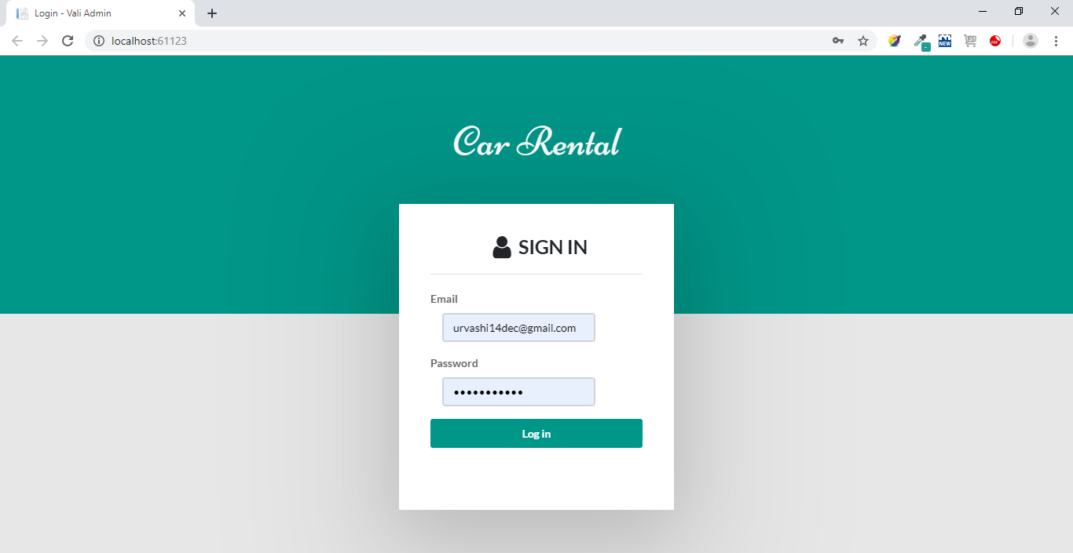

1. Dashboard Landing Page

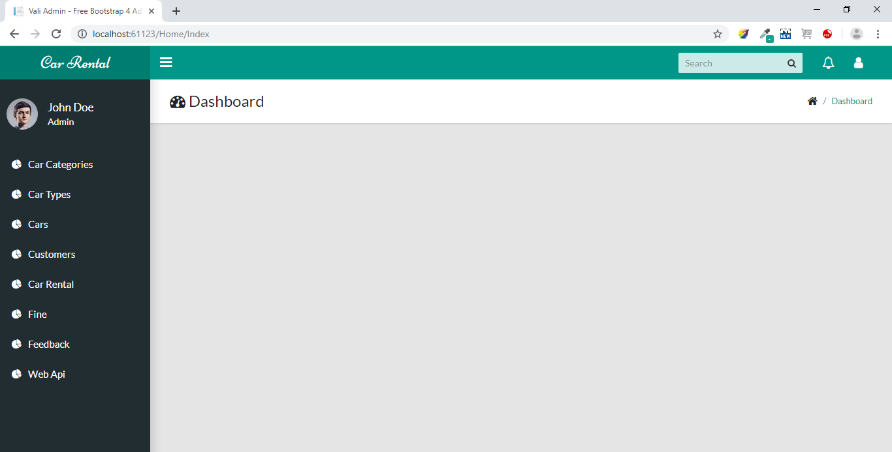

1. Car Categories List Screen

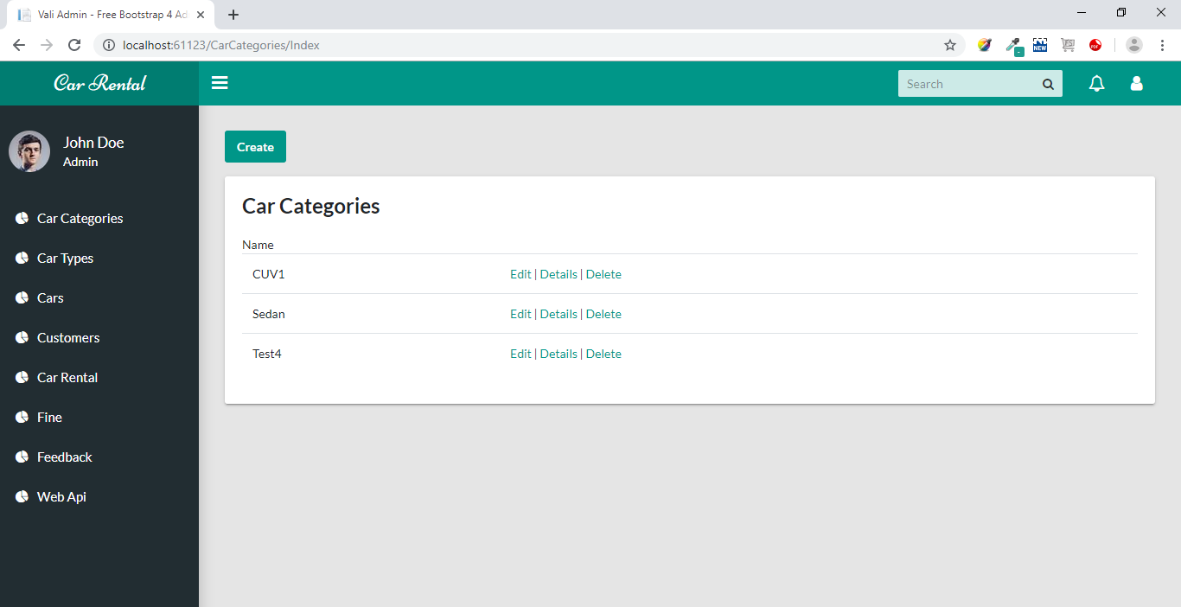

1. Edit Car Category Screen.

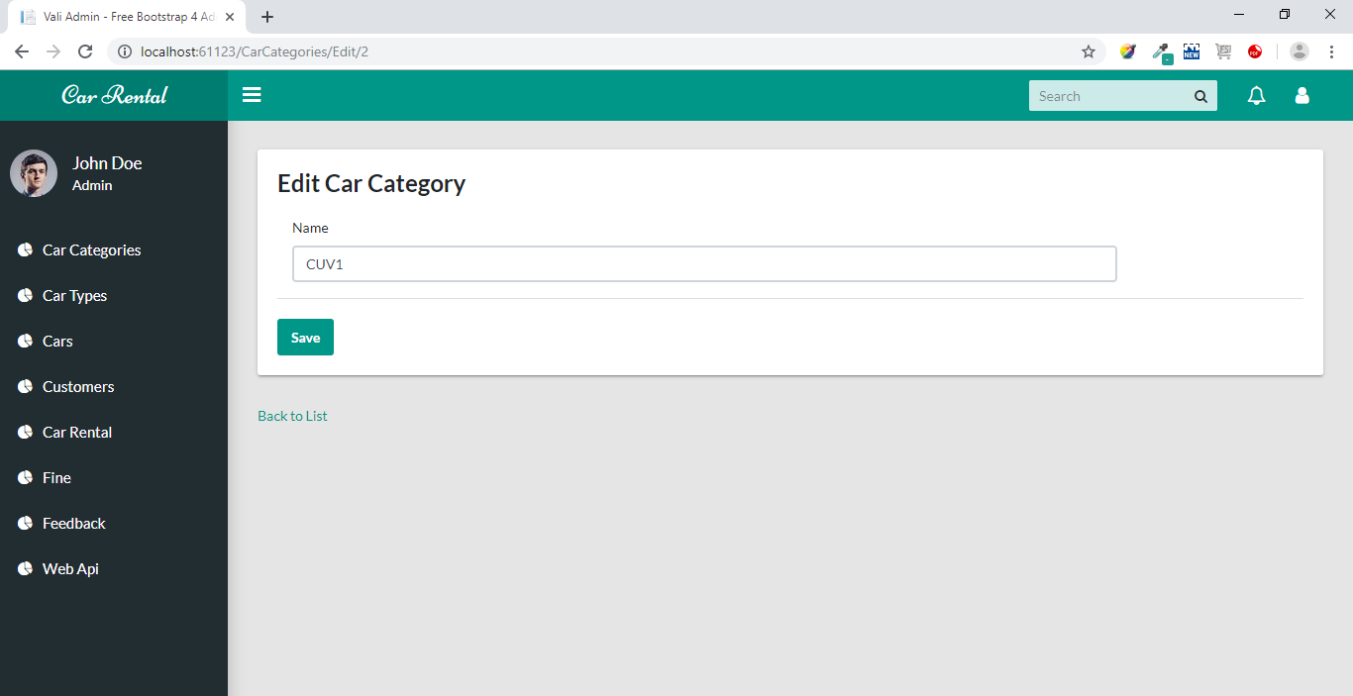

1. Detail of Car Category

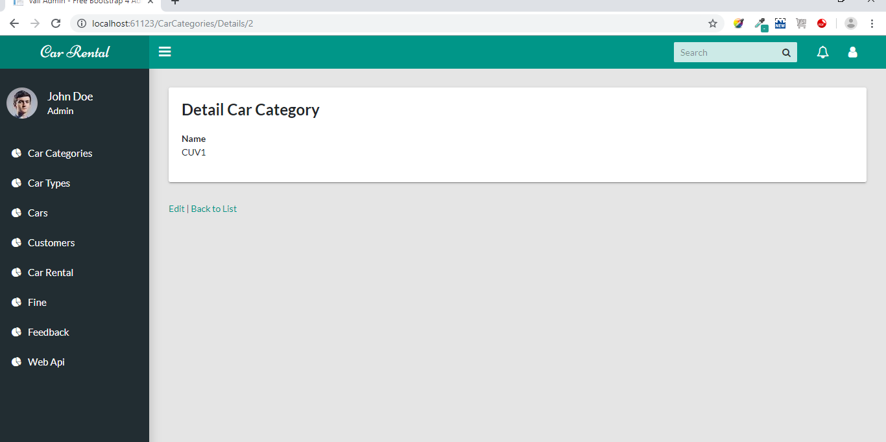

1. Show Car Type List

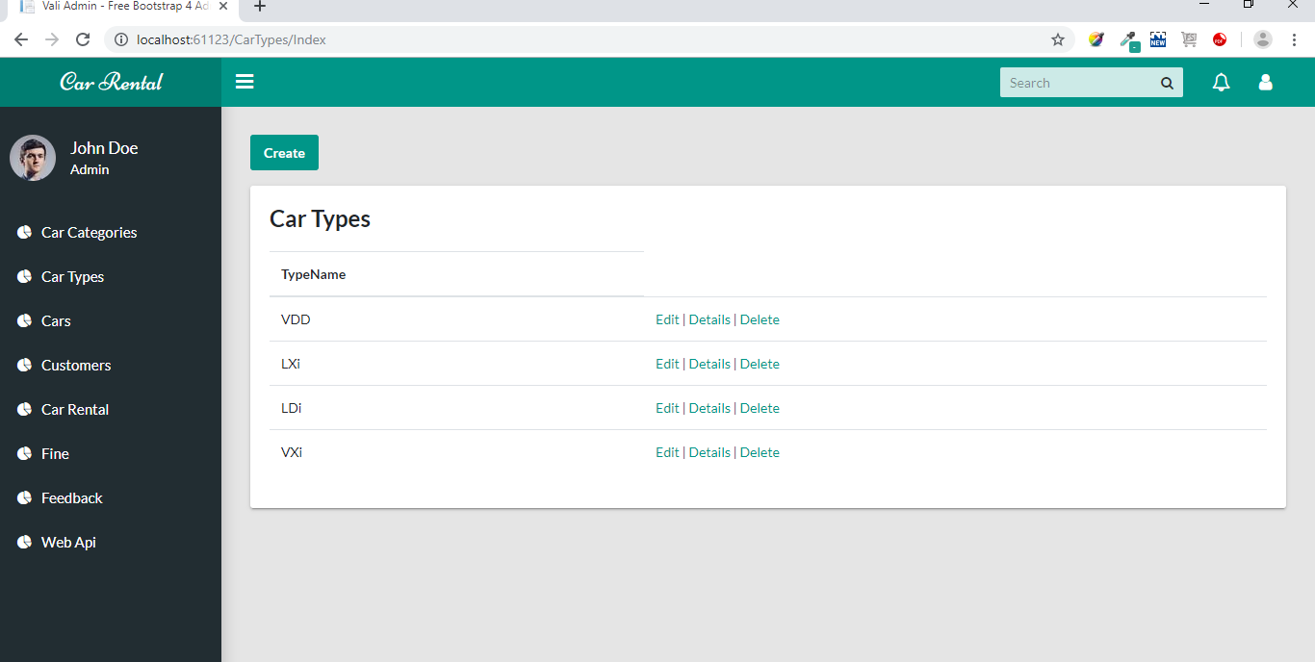

1. Edit Car Type Screen

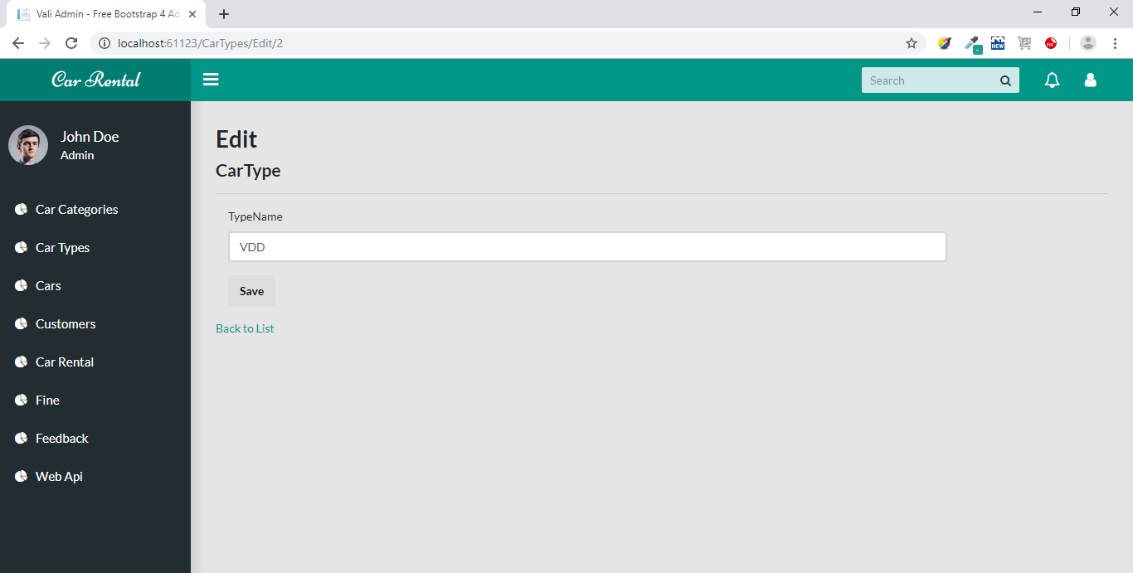

1. Delete Car Type Screen

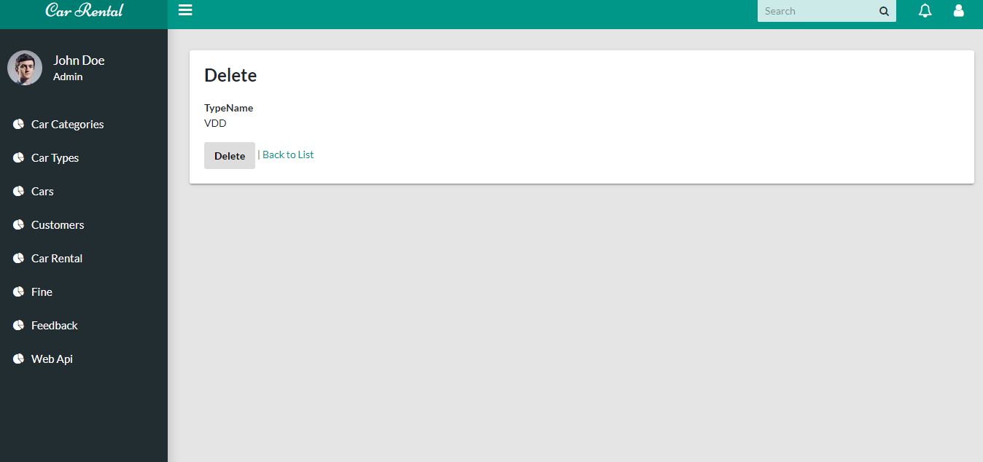

1. Car Screen List

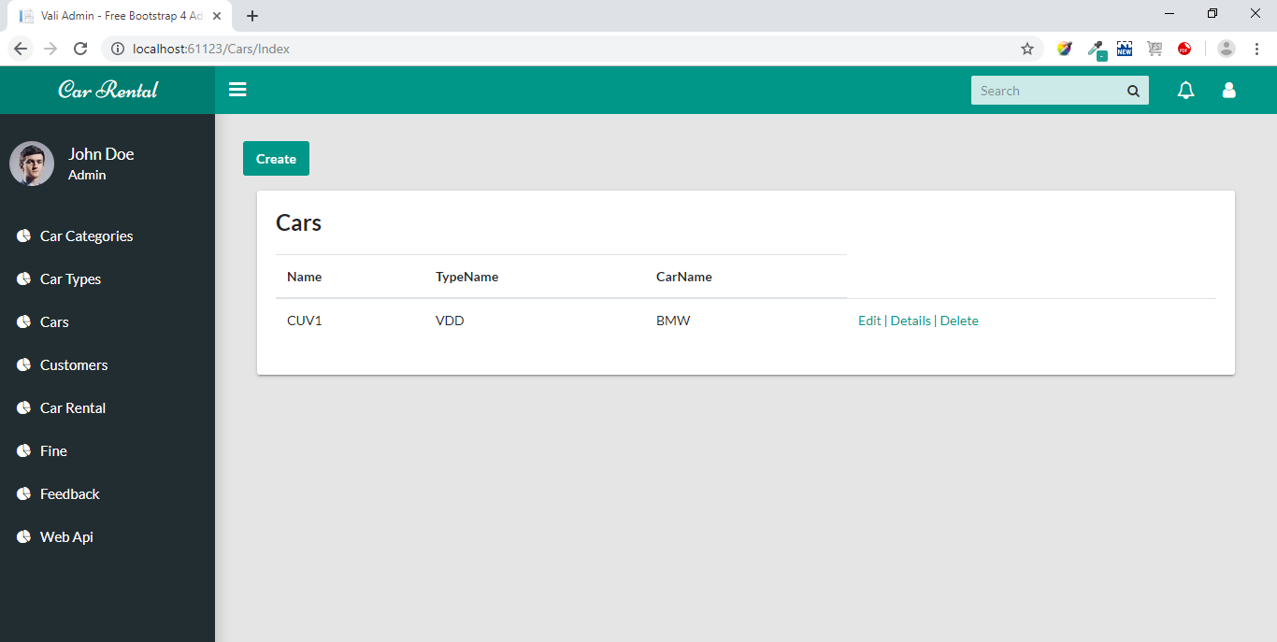

1. Screen for Car adding details

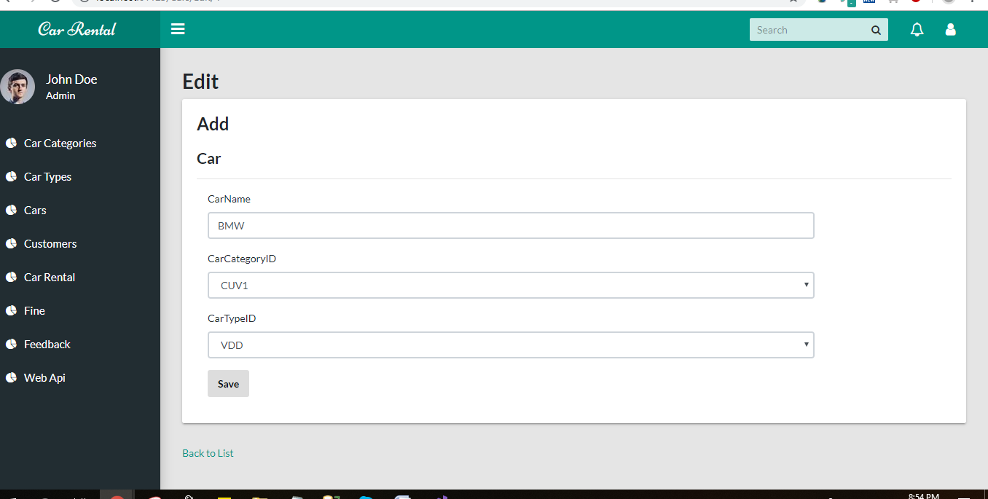

1. Show Customer Screen List

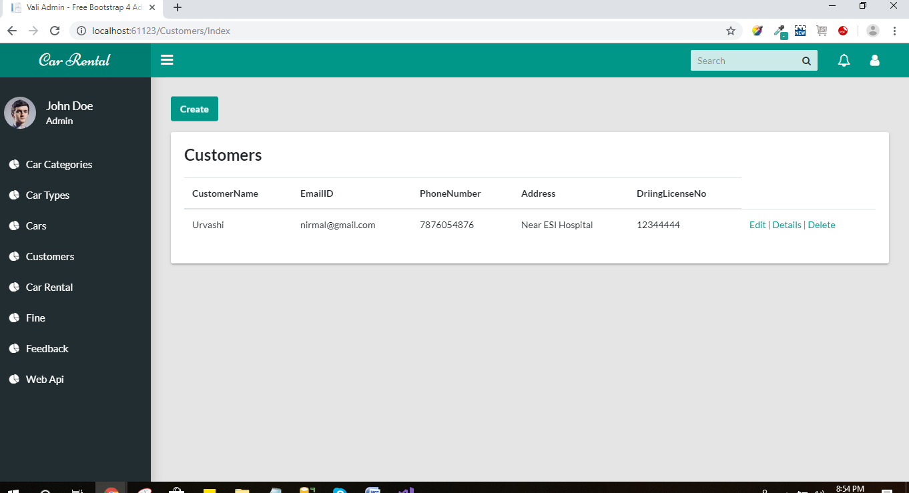

1. Edit Customer Screen

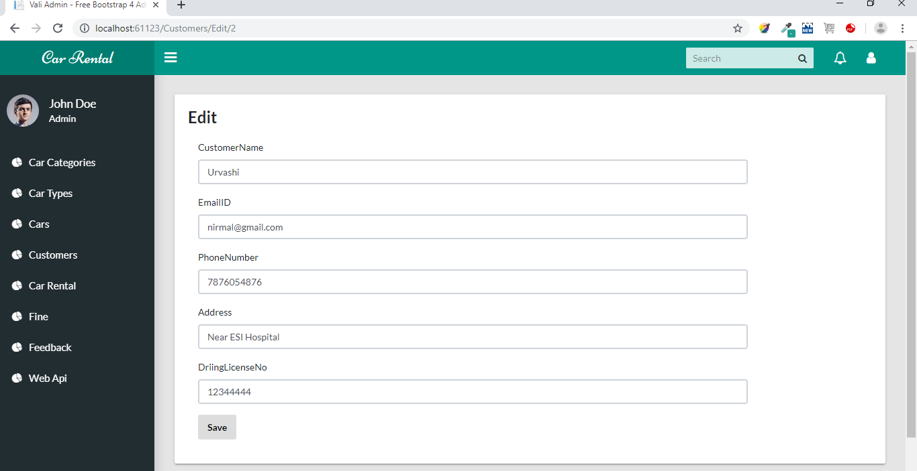

1. Delete Customer Record Screen

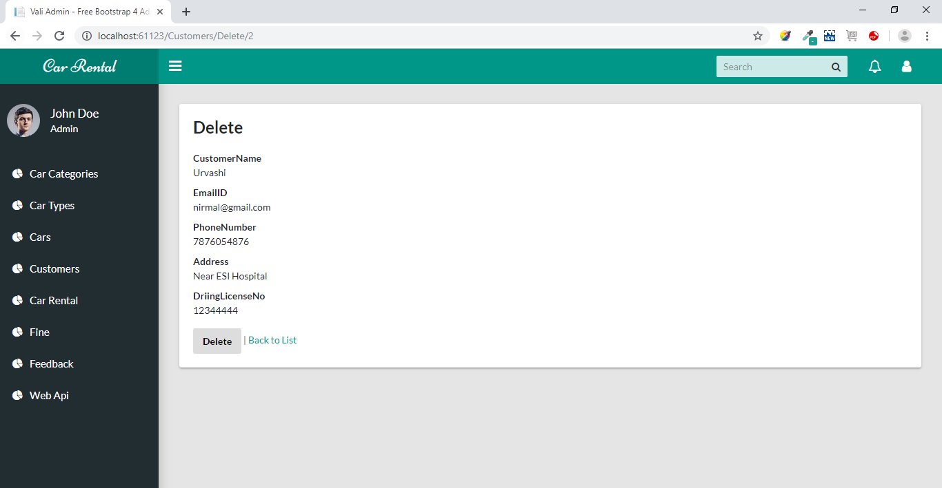

1. Show Car Rental List

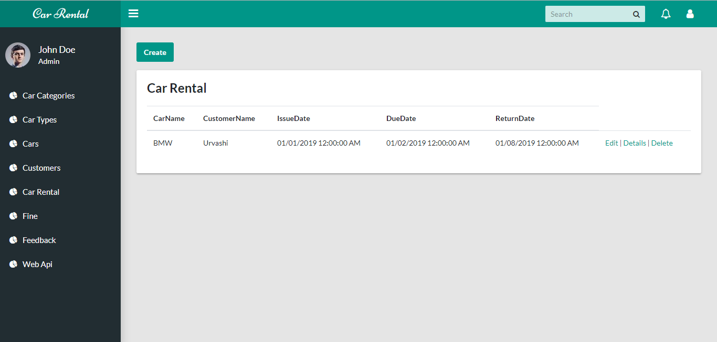

1. Show Car Rental Edit Screen

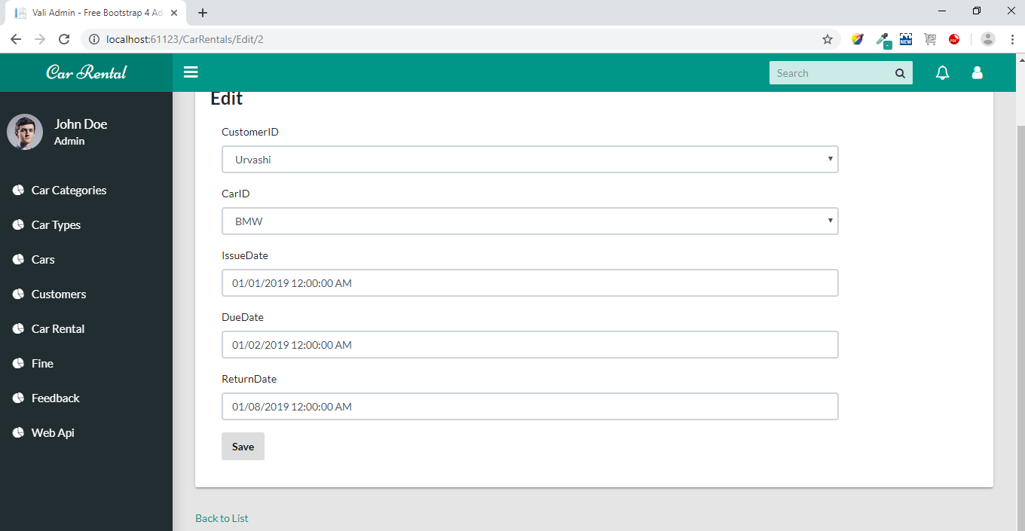

1. Delete Car Rental Details

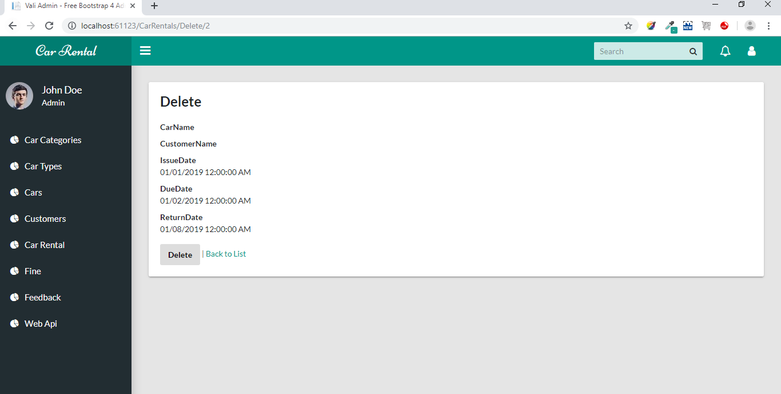

1. Car Fine List Screen

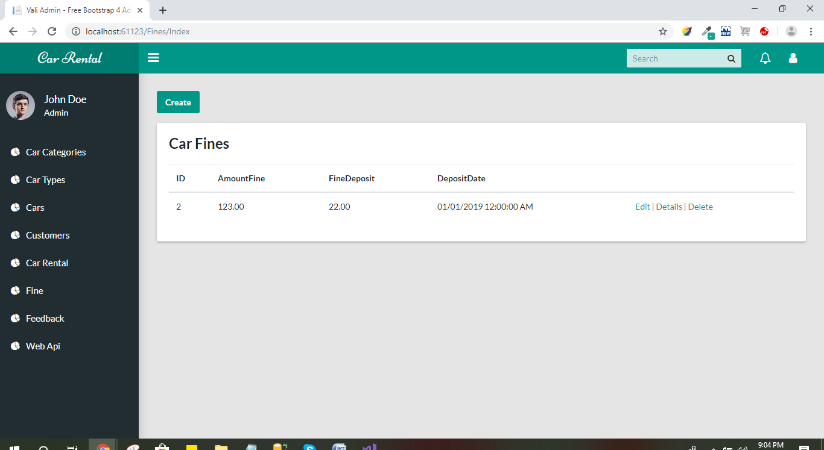

1. Car Fine Edit Screen

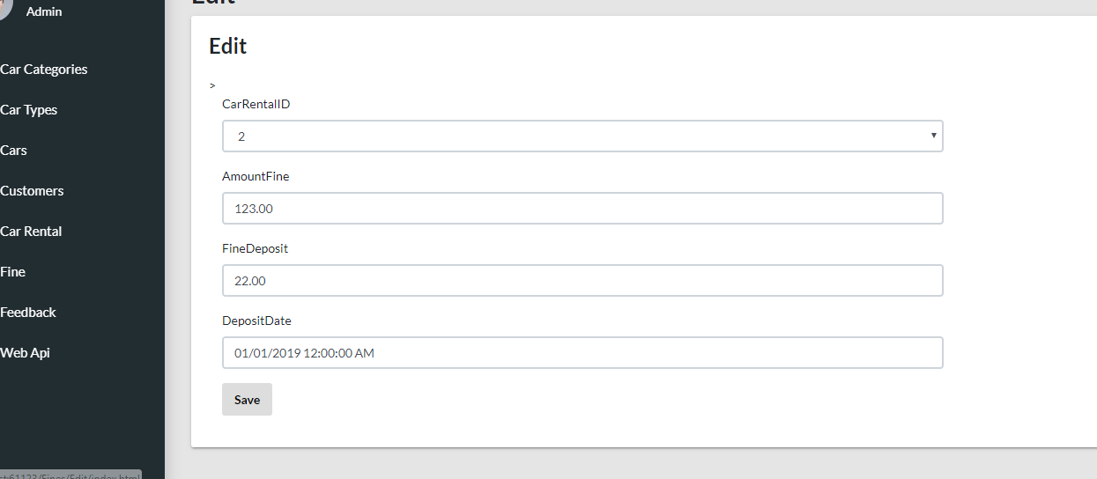

1. Customer Feedback List Screen

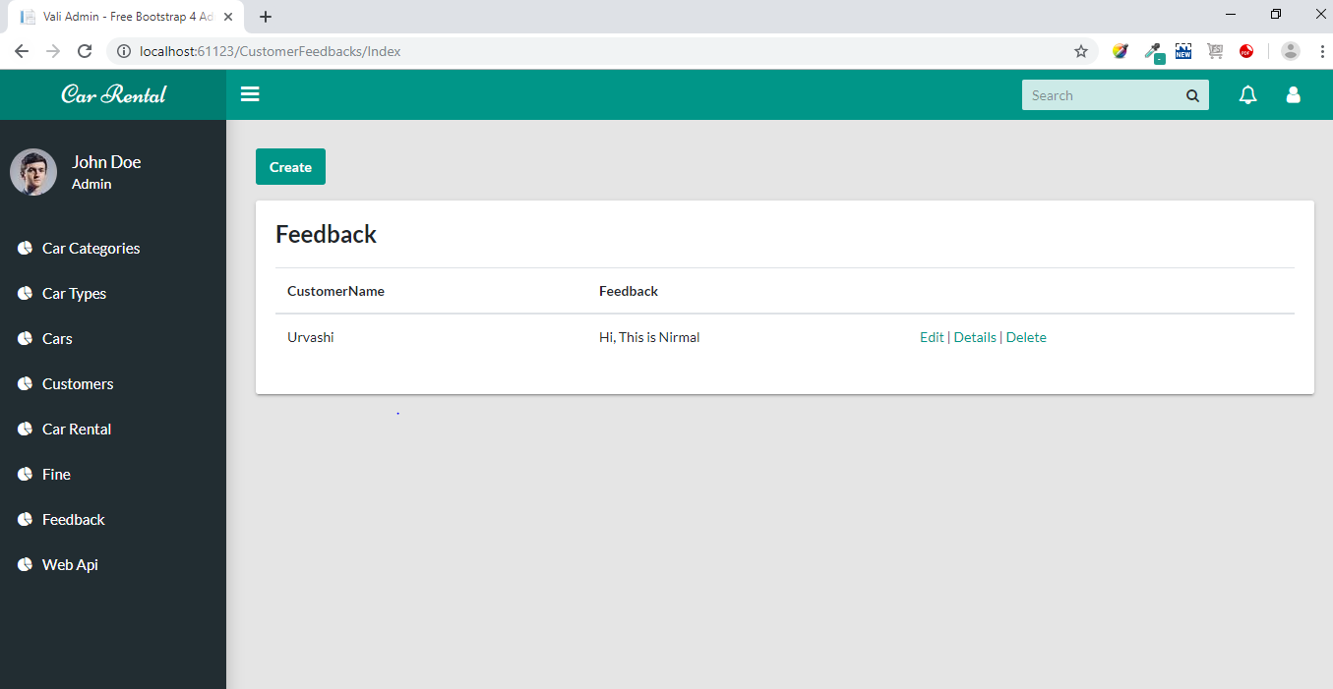

1. Add Customer Feedback Details

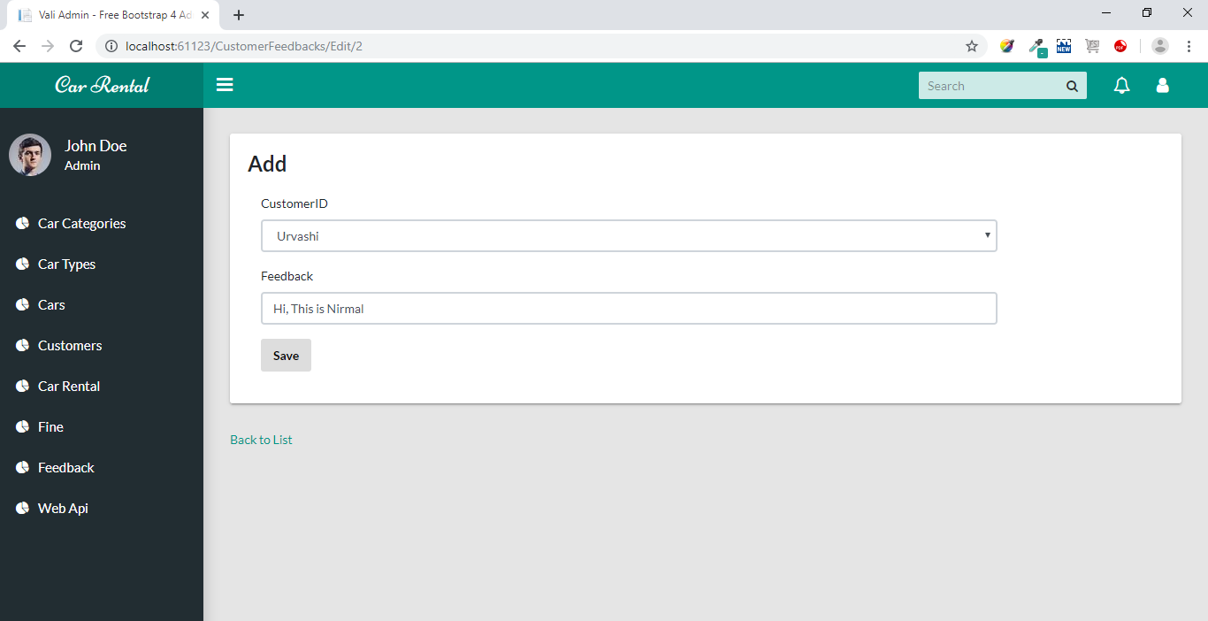

1. Web Api screen for 9th Assignment

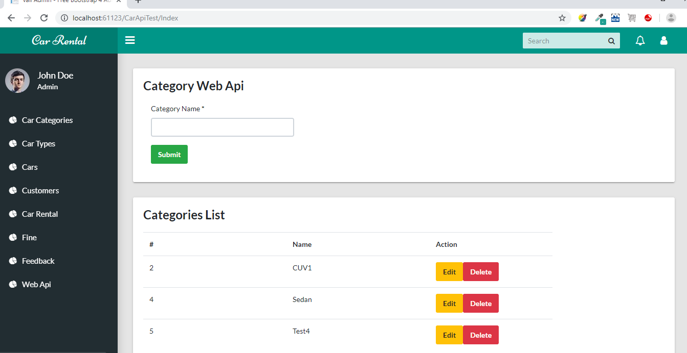

1. Edit Web Api Screen

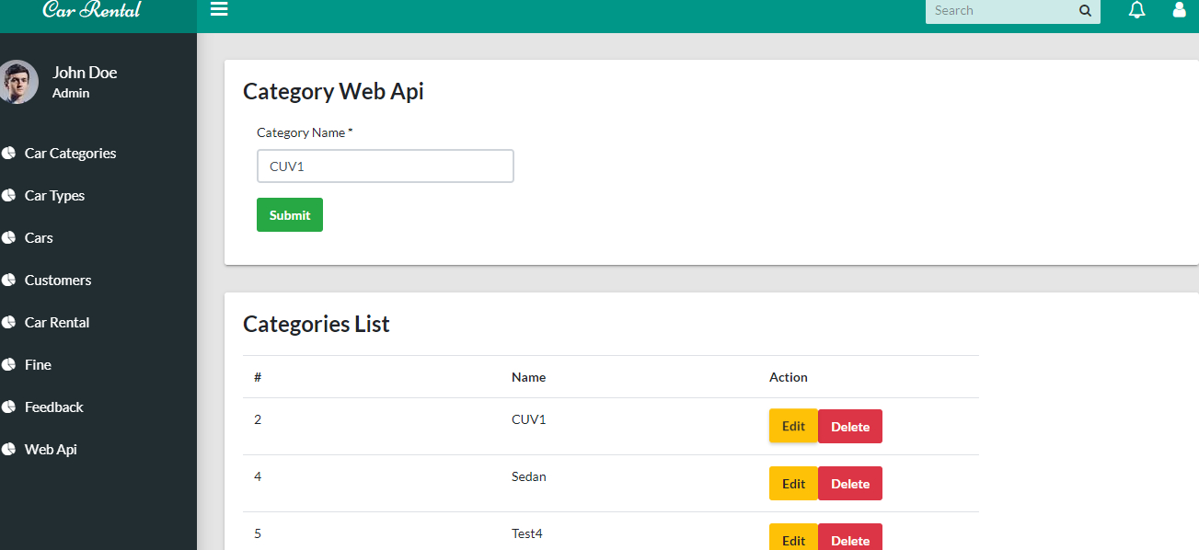

**Controller Screenshot**

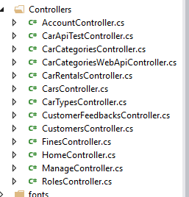

**Model Screenshot**

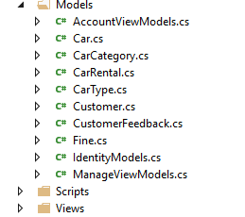

**View Screenshots**

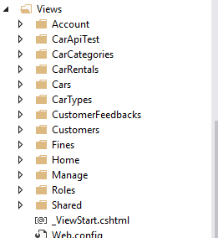

**App Start**

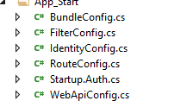

**Car Categories Controller Method**

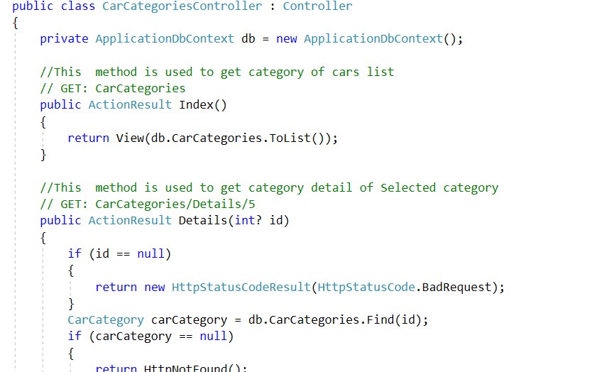

**Customer Feedback Controller Method**

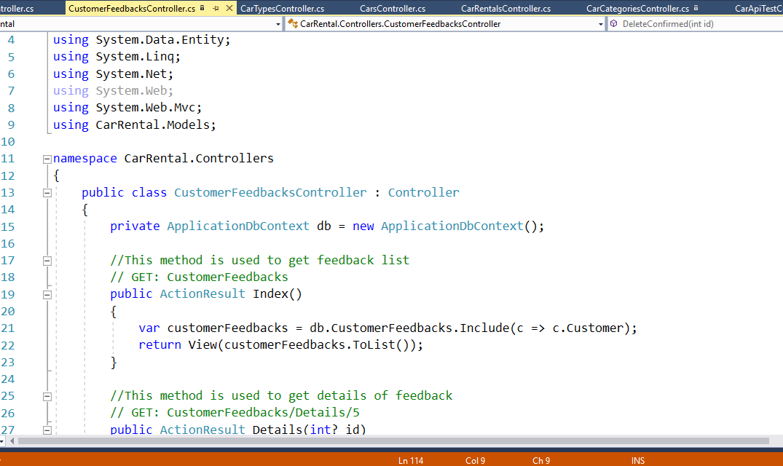

**Car Fine Controller Method**

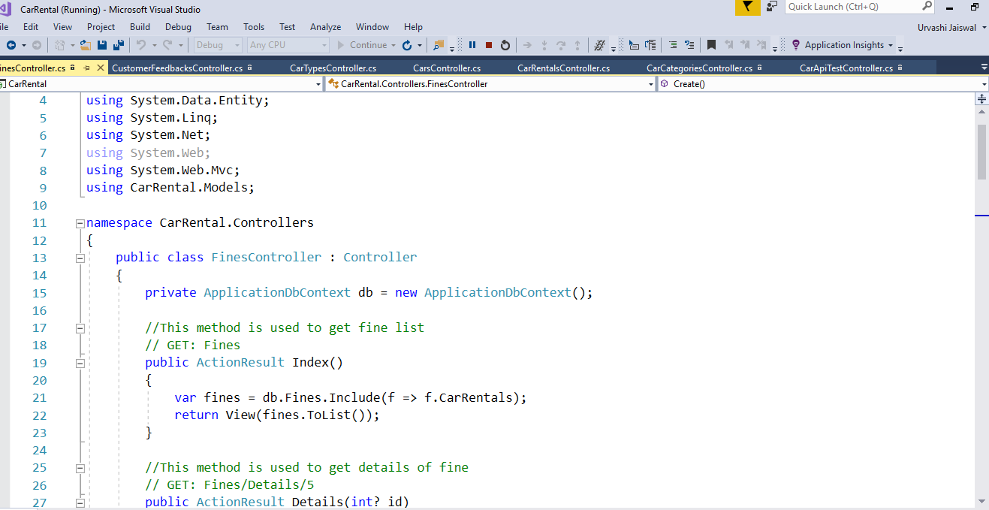

**Car Rental Controller Method**

