**ROAD BIKES**

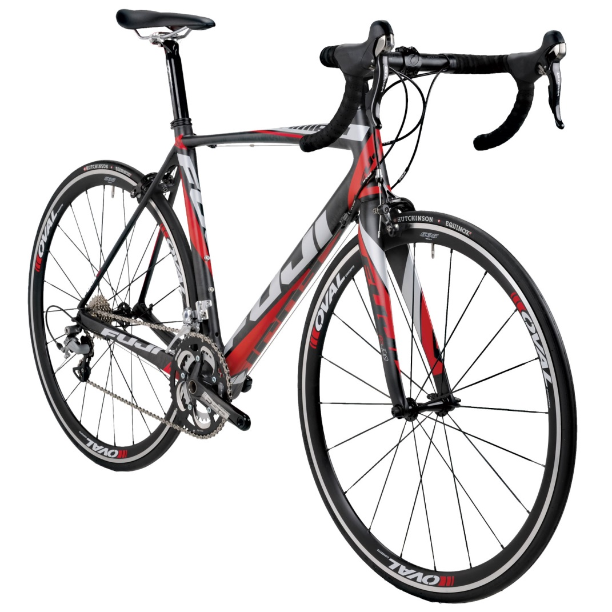

Fuji Altamira 2.0 LE Road Bike - Performance Exclusive

PRICE : RM 1,999.99

* Designed for precision handling and the ultimate level of performance
* A shorter headtube, which translates into a lower handlebar position for ideal aerodynamics and a race-appropriate body position
* FC-440 carbon fork with a tapered carbon steerer
* Shimano Ultegra drivetrain components feature flawless function and lightweight performance
* Bladed, low spoke count Oval 535 wheel set with Hutchinson Equinox 2 tires

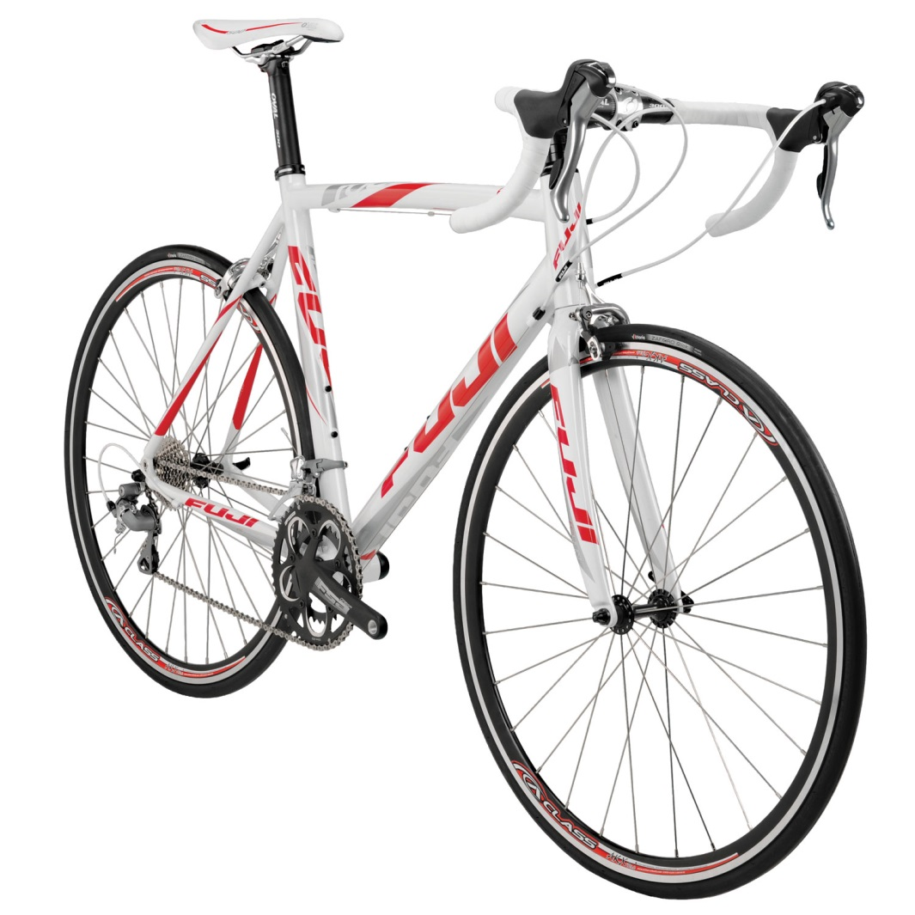

Fuji Altamira 3.0 LE Road Bike - Performance Exclusive

PRICE : RM 1,599.99

Features:

* Race geometry and comfort features for aerodynamics and efficiency
* A2-SL custom alloy hydroformed tubes increase the frame's durability
* Efficient and low maintenance Shimano Tiagra drivetrain
* Compact FSA Omega 50/34 crankset, Shimano 11/25 cassette combo

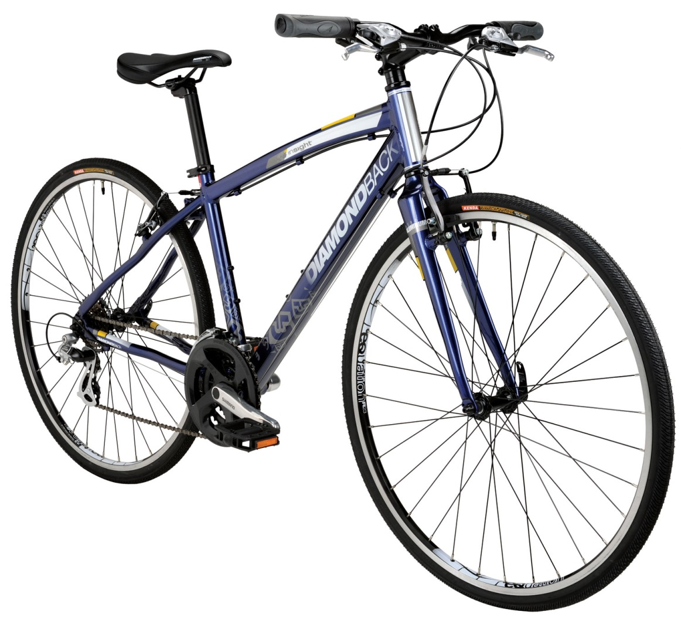

Diamondback Insight Flat Bar Bike - Performance Exclusive

PRICE : RM 349.99

* Low maintenance Shimano 21-speed drivetrain
* Ergonomic grips and dual density saddle provide tremendous comfort
* Efficent Integrated Aero fork
* Proven Diamondback proprietary components

**MOUNTAIN BIKES**

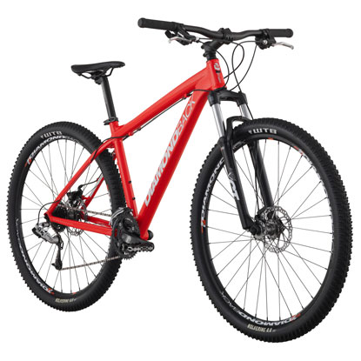

Diamondback Overdrive 29er Mountain Bike

PRICE: RM 374.99

* Angle of Attack -- Larger wheels decrease your angle of attack by allowing you to roll over obstacles easier and faster. Bigger wheel = smaller obstacle.
* Momentum -- A larger wheel enables one to carry momentum easier though obstacles.
* Surface Contact -- 29"wheels are less prone to sinking in soft material such as sand and mud due to the larger contact patch causing lower ground pressure. The longer contact patch increases cornering and straight line traction
* Stability -- The relative position of the bottom bracket/cranks to the axles in the wheels also means that your relative center of gravity is lower. This results in a feeling of riding "in" the bike rather than on top of it.
* Tire Clearance -- with more tire choices than any platform, the 29"wheel easily accommodates off road as well as commuting tires.
* Taller Riders -- 29" bikes tend to offer taller riders a more natural-feel and frame geometry.

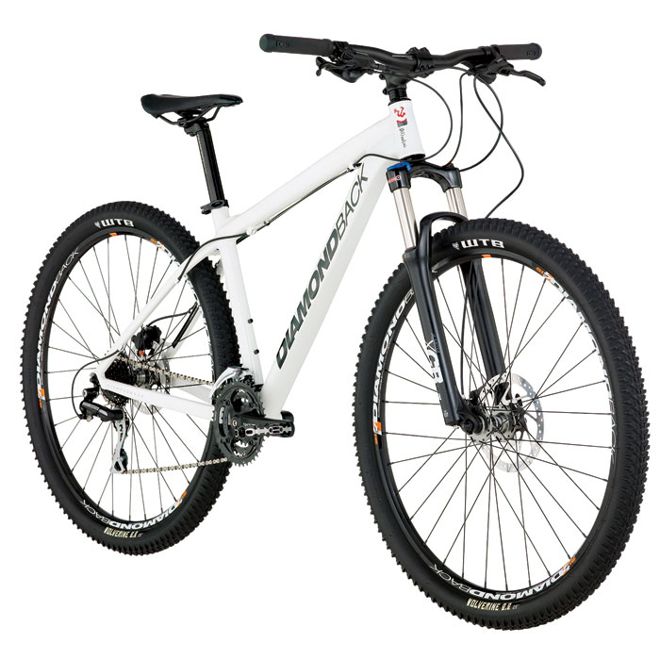

Diamondback Overdrive Sport Mountain Bike - Performance Exclusive

PRICE : $549.99

* Lightweight Overdrive 29" Butted 6061-T6 Aluminum frame
* SR Suntour XCR-LO 29 fork with of 100mm travel triumphs over obstacles
* Shimano 24-speed drivetrain provides more than enough gearing for hills and descents
* Shimano hydraulic brakes have superb stopping power and preserve the life of your wheels
* Diamondback proprietary components are dependable on the trail

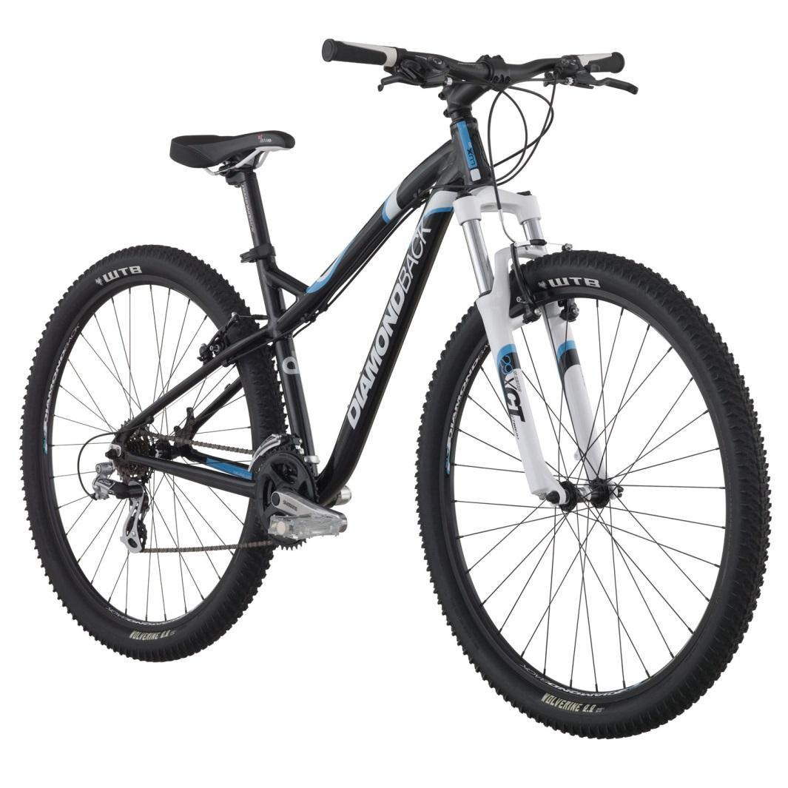

Diamondback Lux 29er Women's Mountain Bike

SALE: RM 399.00

* Lux 29er Women's Specific Butted aluminum frame
* SR Suntour XCT fork with soft springs and 80mm of travel
* Shimano Altus 21-speed drivetrain
* Devine women's-specific D2 Kraton grips and women's specific saddle

**BMX**

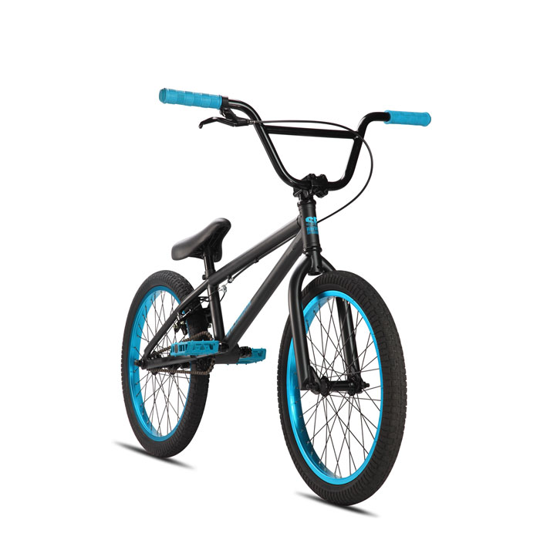

2013 SE Wildman BMX Bike

PRICE : RM 299.99

* New 2013 Frame Design with an American BB
* 3-pc Cr-Mo crank and 170mm arms
* SE Alloy wheels with semi-sealed hubs
* Lightweight SE Seat/Post Combo with Padding

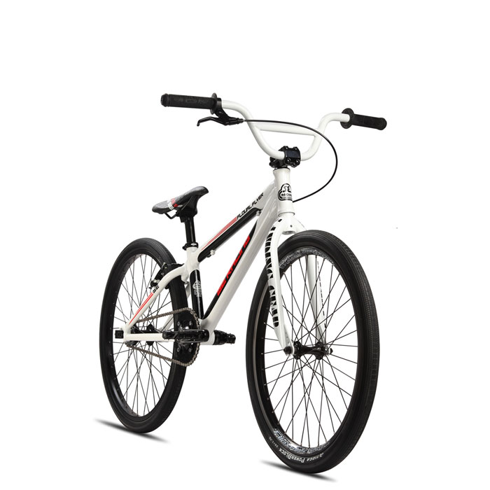

SE Bikes Floval Flyer 24" BMX Bike

PRICE : RM 519.99

* Retro look, designed with today's advanced technology and geometry
* White Skyway Tuff II wheels with red anodized hubs for custom look
* SE 3-piece Cro-Mo crank set can take a beating from the streets
* Lightning Blitz seat features a bottle opener for a cold summer soda

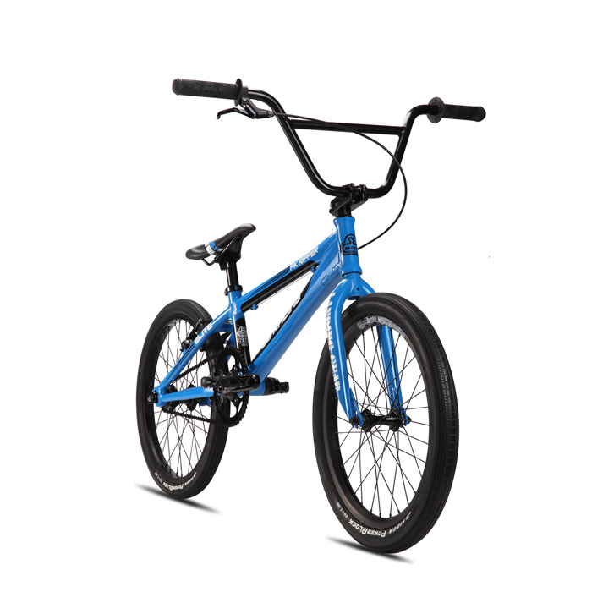

SE Bikes PK Ripper Elite BMX Bike

PRICE : RM 519.99

* New 2013 Frame Design made from Lightweight 6066 Aluminum Floval Tubing
* Full Cr-Mo Landing Gear fork with tapered legs
* Alex Supra doubelwall rims
* Includes Chain Tensioners and Race Plate

**FIXIE BIKE**

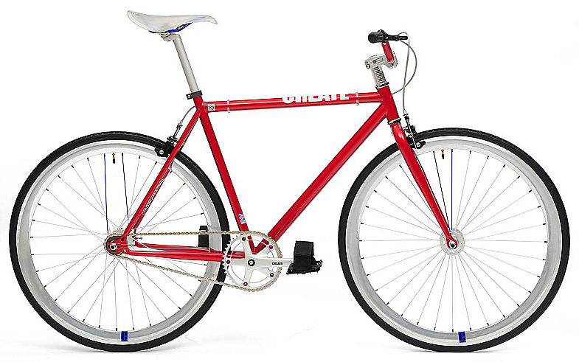

CREATE Original 2013 Fixed Gear Bike Red - 48cm

PRICE : RM 329.99

* Frame: Hi-ten steel, fully tig welded with track type rear drop outs.
* Forks: Tig welded hi-ten steel with straight blades and 1-1/8" steerer
* Handlebar & Stem: 400mm alloy semi-raised handlebar, Pro Max alloy A-head stem
* Brakes: Pro-Max 2 finger alloy levers and alloy calipers with transparent cable
* Wheels: Rear flip-flop alloy 17T hub (freewheel and fixed gear) sealed bearings and CREATE alloy rims
* Crank: 165mm alloy crank set, 44T with 5-bolt ring
* Bottom bracket: NECO sealed unit
* Pedals: CREATE one-piece type with nylon pedal straps

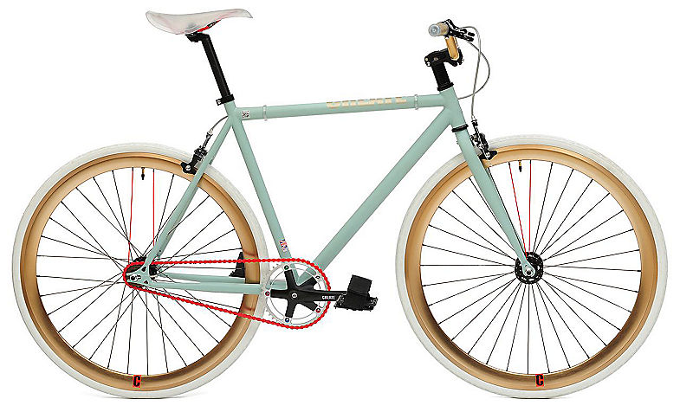 CREATE Original 2013 Fixed Gear Bike Green and Gold - 59cm

PRICE : RM 329.99

* Frame: Hi-ten steel, fully tig welded with track type rear drop outs.
* Forks: Tig welded hi-ten steel with straight blades and 1-1/8" steerer
* Handlebar & Stem: 400mm alloy semi-raised handlebar, Pro Max alloy A-head stem
* Brakes: Pro-Max 2 finger alloy levers and alloy calipers with transparent cable
* Wheels: Rear flip-flop alloy 17T hub (freewheel and fixed gear) sealed bearings and CREATE alloy rims
* Crank: 165mm alloy crank set, 44T with 5-bolt ring
* Bottom bracket: NECO sealed unit
* Pedals: CREATE one-piece type with nylon pedal straps

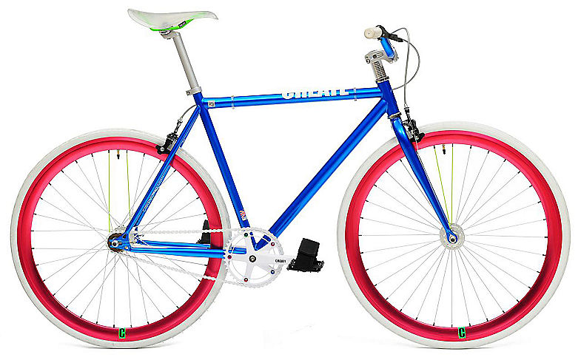 CREATE Original 2013 Blue Fixed Gear Bike - 59cm

PRICE : RM 329.99

* Frame: Hi-ten steel, fully tig welded with track type rear drop outs.
* Brakes: Pro-Max 2 finger alloy levers and alloy calipers with transparent cable
* Wheels: Rear flip-flop alloy 17T hub (freewheel and fixed gear) sealed bearings and CREATE alloy rims