DEFORMATION MONITORING OF ELANDSKLOOF DAM, WESTERN CAPE

K. T Moloi

School of Architecture, Planning & Geomatics

University of Cape Town

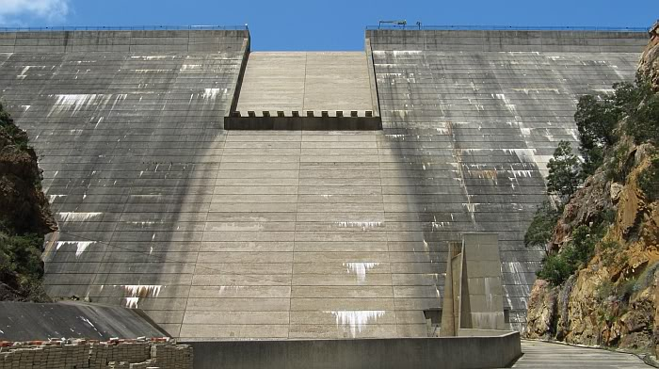

**ELANDSKLOOF DAM, WESTERN CAPE.**

***ABSTRACT***

*The Elandskloof dam situated in Western Cape was established in 1976 primarily for domestic water supply and irrigation. The dam continues to be functions, however over the past recent years the rainfall in the area has increased considerably and has resulted in rock and landslides significantly close to the dam itself. Due to such weather changes the dam is expected to endure deformation changes. To detect this deformation, geodetic deformation measurements were taken using numerical method procedures.*

**1 INTRODUCTION**

The detection and analysis of deformation in the context of Engineering Surveying methods requires a geodetic network linking the control points to the points on the objects expected to undergo deformation. The notion of using a geodetic method to monitor deformation of a dam was first proposed by H. Zolly (Rueger, 2006), former chief of geodesy at Swiss National Mapping. To monitor the Elandskloof dam, four reference points were used to measure the two object points situated on the dam wall, these measurements can either be angles, distances, directions or a combination of all any of the three. Once the measurements of the geodetic network is complete, an intensive numerical computation to those measurements follows.

The numerical method computation entailed the calculation of the parametric adjustment, parametric adjustment with conditions between the unknowns, free network adjustment and the S-transformation adjustment, using the same measured observations for each adjustment.

This paper focuses on the mathematical and programming facets of each of the four numerical adjustments, particularly the differences in compiling each adjustment. Furthermore, the paper will scrutinize the differences in result of each adjustment and reasons for those differences.

**2 BACKGROUND**

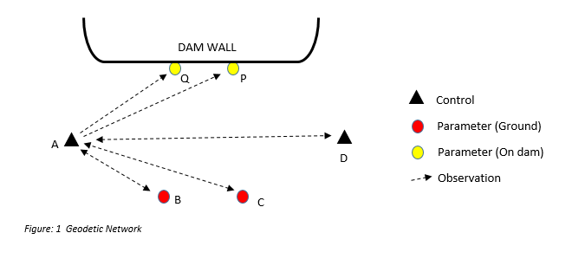

In order to provide reliable and optimum results and measurements derived from geomatics projects, it is imperative that all computations employ the least squares principle. The Least Squares principle states that a solution to an overdetermined problem should be such that the weighted sum of the squares of the discrepancies observed and most probable value should be a minimum. Figure 1 shows the geodetic network used for monitoring movements of the dam wall, the figure only shows the observations from control point A (due to visual ease), however points B, C and control point D are also setup points involved in the monitoring process. As already mentioned, the Least Squares principle requires overdetermined problem, and it is clear that the geodetic network used is an overdetermined problem and subsequently allows for the usage of the Least Squares principle.

The parametric case of adjustment relates observations and unknown parameters, in the case of the geodetic network in figure 1 it will relate the observed directions to the unknown co-ordinates of points B, C, P and Q. The fundamental concept of the parametric adjustment, as with all numerical adjustments, is to ensure that all observations are used when finding the most probable values for each of the unknowns. The parametric model expresses each equation in terms of its unknowns which are not directly measured, i.e relates observations to unknowns and it is of this relative ease of expressing parametric equations that parametric adjustments are preferred over other adjustments. In the parametric adjustment the known points (Controls points A and D) are not part of the adjustment and will subsequently remain the same even after the adjustment, meaning all the error will distribute accordingly around the points unknowns parameters B, C, P and Q.

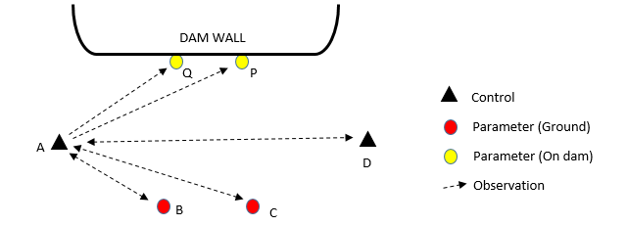

Figure 2 Parametric Adjustment with a condition between P and C

The Parametric Adjustment with conditions between the unknowns is of the same concept as the normal parametric adjustment, in addition however it has some condition(s) applied between the unknowns which are imposed on the adjustment (Ruther, 2000). This results in the formulation of observation equations of a similar nature to the parametric adjustment together with condition equations. The effect of these conditions to the final adjustment are such that even after the adjustment the condition between the unknowns must still be met, i.e if you apply a condition such that the distance between P and C must be 25 meters, even after the least squares adjustment and distribution of corrections, the distance between the two points will remain 25 meters. The Parametric Adjustment with conditions between the unknowns must will still satisfy the least squares principle whilst satisfying the conditions.

In the case of the Free Network adjustment none of the parameters are held fixed, and because of this we expected every point in the geodetic network is involved in the adjustment. The Free Network adjustment is deemed advantageous because even after the adjustment the geometry of the network remains unaltered (Papo, 1986). Attempting to solve the free network adjustment will be problematic because of the deficiency in the number of fixed points, this will result in a rank defect. Such a rank defect will result in singular normal equation matrix, making (ATPA)-1 mathematically impossible to compute because the determinant of the normal equation would be equal to zero. Because the geodetic network used for monitoring the dam is a triangulation network, it will have a rank defect of four (x, y, scale and orientation). From this we can deduce that the singular matrix will have as many eigen values equal to zero as its rank defect (Ruther, 2000) and it is this eigenvector method that will help compute the free network adjustment The usage of such network can be linked with the notion that some surveyors feel that connecting their work to some datum (constrain adjustment) “distorts” their observations (Schwarz, 1994).

It is often beneficial to be able to change the datum of some geodetic network from a free network to any combination of a minimum constraint you desire. Such convenience can be achieved by means of the S-transformation, which essentially allows you to dictate which points you intend on “fixing”- these “fixed” points will still appear in the solution vector, however will have infinitesimal corrections.

**3. METHODOLOGY**

Prior to calculating any computational processes, geodetic measurements had to be obtained. These geodetic measurements were direction observations from each ground point (Control and Free) to every other point in the network, which amount to 20 directions. To simplify the problem the unknown Zi parameter at each ground station was discarded entirely in each observation equation and consequently the A–Matrix, as the z-parameter is of no use in the deformation analysis itself.

The methodology of this paper will focus primarily on the application of least squares concepts into Python coding, the paper will focus on the aforementioned *Parametric, Constraint, Free Network and S-Transformation.*

**Parametric Adjustment**

Figure 2 shows how the parametric adjustment was formulated – 2 fixed points and 4 free points. Knowing that 20 observations were taken and that the 2D network has 4 free points, 2 on the ground and 2 on the wall, the computed dimensions of the A – matrix will be 20 X 8. The observation equation will be $\tan^{-1}{\frac{Y2-y1}{X2-x1} = ∅ }+V$, note for convenience Zi parameter has be excluded. The equation is however non-linear and has to be linearized such that F(Y) = F(Yo) + .X + …. We further differentiate each equation with respect to XBYB, XCYC, XPYP, XQYQ and the equation becomes:



Where ρ’’ is 206264.8’’ and is used to scale the linearized expression from radians to seconds and the expression z1’’ is eliminated, it is imperative to know that this equation can be modified to suit which points are fixed/free and consequently this linearized equation designs the shape of the A – Matrix. This A - Matrix, together with the L matrix and identity matrix P will provide the solution vector for the unknown coordinates B, C, P and Q. The code will iterate continuously until the solution vector converges, each of these iterations will add the correction (from X vector) to the corresponding unknown co-ordinate. For code-friendliness, the x-y co-ordinate file had an additional binary value column to determine whether the point was fixed or free.

**Parametric Adjustment with Conditions between the Unknowns**

The parametric adjustment with conditions between the unknowns is almost identical to the normal parametric adjustment, expect for the addition of condition(s) between the unknowns. The equation associated with these condition(s) between the unknowns is *Cx + w = 0,* whilst the observation equations $v = Ax – l$ remain unchanged. The constraint in this network was simply a distance between unknown co-ordinates B and Q. The determination of the design matrix C is similar to that of design matrix A, reasoning being that you also differentiate the constraint equation with respect to your unknowns.

This added condition equation must still satisfy the principal least squares method that VTPV = 0; to satisfy this condition $ø = V^{T}PV$ becomes $ø = V^{T}PV +2K^{T} (Cx + w)$

Without any derivation: $Q_{kk}= - {({CNC}^{T})}^{-1} Qxx = N^{-1} – E C N^{-1 } E = - N^{-1}C^{T}Q_{kk}$

Where $N = A^{T}PA$

These aforementioned submatrices will define our solution vector for the parametric adjustment with conditions between the unknowns $x = Qxx A^{T}Pl + E w$

**Free Network Adjustment**

The Free Network, as the name suggests, means every point in the geodetic network is not fixed. Similarly to how the program calculated the A – matrix for the Parametric Adjustment, the Free Network calculates it the same manner. Since every point in the geodetic network is now free, it means every x-y point will quantify a column in our computed A – matrix. The number of real observations remains the same as the number of observations in parametric adjustment (20). The L matrix is also calculated in the same manner as it is in the parametric adjustment. Due to the network having a datum defect as a result of not having a fixed scale or points, the ${A^{T}PA}^{-1}$ will be un-calculable (due to rounding-off errors the code did calculate ${A^{T}PA}^{-1}$. To remove this rank defect a set of pseudo-observations, which will not affect the final results, is added to the system of equations. The aforementioned pseudo-observations will result in the formulation of the GT matrix, which will be used to remove the rank deficiency of the normal equation.

To calculate this GT matrix the eigenvalues and eigenvectors of the ATPA were determined, the eigenvectors corresponding to the λ = 0 eigenvalues (linear dependency) are concatenated together and then transposed formulate the GT.

The GT is added to the normal equation to formulate a new normal equation; $Ñ=A^{T}PA+GG^{T}$. The solution vector X becomes $x= Ñ^{-1}A^{T}Pl$.

***S TRANSFORMATION***

The only procedure needed, other than GT and X matrix calculated in the free network, is the addition of the selective identity matrix. This identity matrix is similar to the general identity matrix, expect 1’s are only placed in diagonal positions of co-ordinate points you wish to fix. Figure 3 shows how this procedure is done.

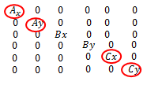 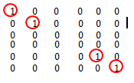

Figure 3: Selective Identity Matrix (Points A and C went from free to fixed)

The solution vector X for the S Transformation becomes: $X_{2}= X_{1}- {G(G^{T}I_{S}G)}^{-1}G^{T}I_{S}X_{1}$

Where X1 is the solution vector from the Free Network and IS is the Selective Identity Matrix.

***RESULTS AND DISCUSSION***

*Solutions Vector X*

[ 3.12342189e-04],

[ 9.25343877e-04],

[ -2.38308515e-05],

[ 5.67057657e-04],

[ 1.09256667e-04],

[ 4.08094190e-05],

[ -2.00348193e-03],

[ -1.14104197e-02]]

Figure 4: X matrix: Parametric Adjustment

[ -5.19320560e-16]

[ -9.22171988e-17]

[ -7.10394984e-15]

[ -9.75524117e-17]

[ 1.22172309e-15]

[ 1.01318922e-14]

[ 2.06388175e-15]

[ 1.44955821e-15]

Figure 7: X matrix: S Transformation applied

[ 9.66837287e-17]

[ -2.66713734e-17]

[ -1.80429030e-03]

[ 2.68364753e-03]

[ -5.83041792e-03]

[ -2.96444646e-02]

[ 1.77479809e-02]

[ 3.83982910e-04]

[ -7.27077284e-02]

[ 5.58058454e-03]

[ -9.64533358e-17]

[ 2.21177243e-17]

Figure 6: X matrix: Free Network

[1.63692688e-04 ]

[ -1.08145499e-03]

[ -2.94292569e-04]

[ -3.76415312e-04]

[ -4.68215844e-04]

[ -4.17393570e-04]

[ -2.54728800e-04]

[ -3.64509510e-05]

[4.86077077e-05 ]

[ -7.59520710e-04]

[ -9.82861829e-05]

[ -8.60868727e-04]

Figure 5: X matrix: Parametric with constraint between unknowns

Figure 4 shows the solution vector of the parametric adjustment, and as expected we had an 8X1 matrix, since the network had 4 free points and 2 fixed. Figure 5 also shows the solution vector of the same network, however this is a parametric adjustment with constraints between points C and P, thus the reason for the differences in solution vectors.

Figure 6 shows the X matrix of the Free Network, and as anticipated the dimensions of its solution vector is not 8X1 but 12X1 because it has included points A and D in the adjustment and made them free points as well. Figure 7 shows the S Transformation, using the aforementioned selective identity matrix, it is clear that that the first and last co-ordinate points have been ‘fixed’ as their corrections are much smaller than the rest of the corrections and approximate zero. This further proves how the S Transformation can convert a Free Network into a Minimum Constraint Network.

The above solution vectors simply show how each adjustment can be easily altered into another adjustment by applying certain mathematical conditions to the original adjustment.

**REFERENCES**

Rueger, J. 2006. Overview of Geodetic Deformation Measurements of Dams.

Papo, H. 1986. Extended Free Net Adjustment Constraints.

Schwarz, C. 1994. The Trouble with Constrained Adjustment.

Ruther, H. Engineering Surveying and Adjustment. University of Cape Town.