MERN Blogger Application - Project Documentation

# 📘 Project Overview

The MERN Blog Application is a full-stack blog management system built using the MERN stack (MongoDB, Express.js, React.js, Node.js).   
It supports multiple user roles including admins and regular users. The app allows authenticated users to create, edit, and delete blog posts,   
while the admin has access to content moderation, user activity logs, and a dashboard panel.  
This project emphasizes role-based access control, media uploads, and comment moderation, making it suitable for real-world blogging platforms and content management systems (CMS).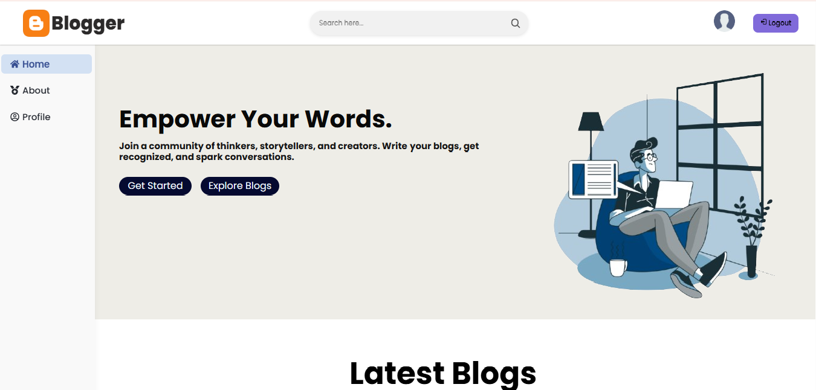 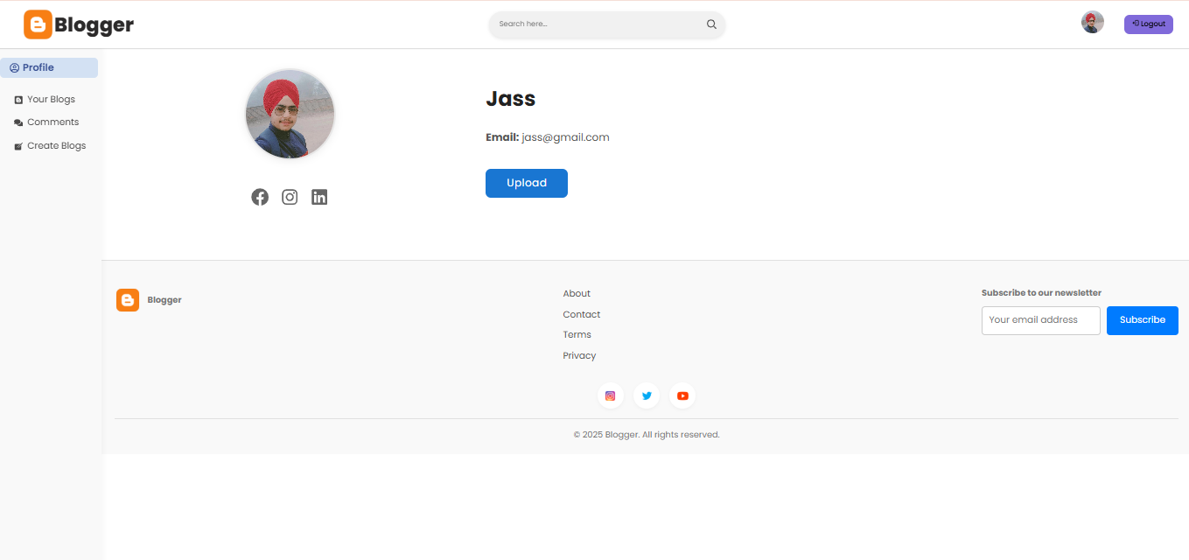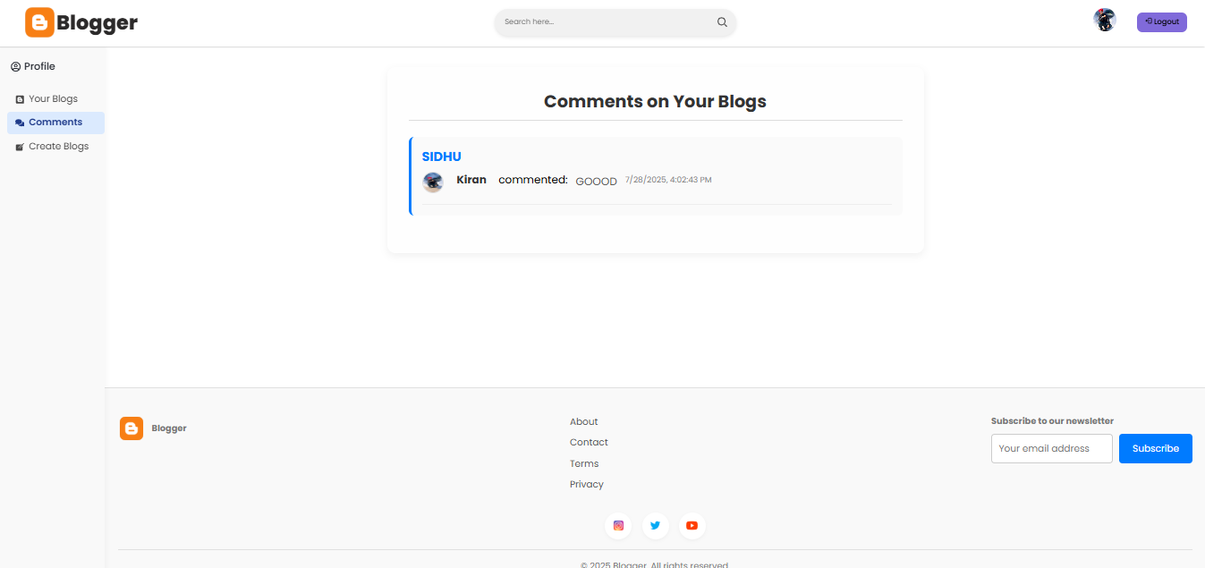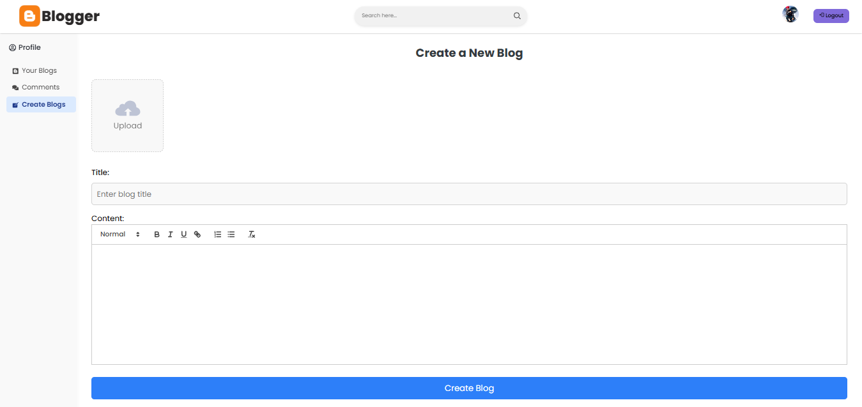

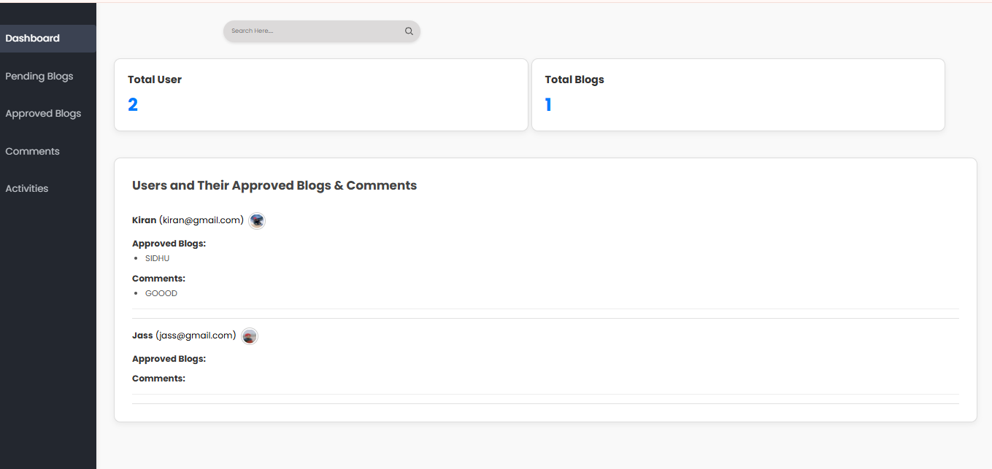

# 🎯 Scope

This project was built to:  
- Provide a modern blogging platform with user authentication and authorization.  
- Allow users to express ideas through blogs and interact via comments.  
- Provide admin tools to manage blogs, users, and activities efficiently.  
- Serve as a portfolio-grade MERN project for developers to demonstrate full-stack capability.

# ⚙️ Tech Stack

Frontend:  
- React.js (with Vite)  
- React Router DOM  
- Axios  
- Tailwind CSS  
- Framer Motion  
  
Backend:  
- Node.js & Express.js  
- MongoDB with Mongoose  
- JWT (JSON Web Token)  
- Multer  
- Cloudinary

# 🌟 Key Features

Authentication:  
- JWT-based login & signup  
- Role-based access: Admin . User  
  
Blog Features:  
- Create, edit, and delete blog posts  
- Upload blog cover images  
- View detailed blog post  
- Commenting system with approval-based moderation  
  
Admin Panel:  
- Review and approve/reject blogs  
- Delete blogs  
- Manage comments and users  
- View activity logs  
  
Other:  
- Modular structure  
- Blog status tracking (pending/approved)  
- Notifications via Toastify

# 🚀 How to Run the Project Locally

Backend:  
cd backend  
npm install  
Create a .env file with:  
PORT=3000  
MONGODB_URL=<your_mongodb_connection_string>  
SECRET_KEY=<your_jwt_secret>  
npm run dev  
  
Frontend:  
cd frontend  
npm install  
npm run dev  
  
Frontend .env:  
VITE_API_URL=http://localhost:3000/api/v1

# 📁 Folder Structure

Blog-App-main/  
├── backend/  
│ ├── controllers/  
│ ├── middleware/  
│ ├── models/  
│ ├── routes/  
│ └── index.js  
├── frontend/  
│ ├── src/  
│ │ ├── Components/  
│ │ ├── Pages/  
│ │ └── App.jsx  
│ ├── AdminPanel/  
│ └── vite.config.js

# 👤 Roles

User:  
- Register & log in  
- Post blogs  
- Comment on blogs  
  
Admin:  
- Approve/reject blogs  
- Monitor comments  
- Delete users/content  
- View system logs

# 📌 Notes

- Backend and frontend must run simultaneously.  
- Ensure Cloudinary credentials are correct for image uploading.  
- Comment system supports moderation.

# 📌 Author

This project was created by **Jashanpreet Singh**

📧 Email: [sjass5910@gmail.con]

📍 Location: Mohali, Punjab

🌐 GitHub: (https://github.com/jass424)