**Project : E-commerce Website – ‘J MART’**

**Developer Information**

* **Name: Jashanpreet Singh**
* **Contact Number: +91 7814725422**
* **Email: sjass5910@gmai.com**
* **GitHub: https://github.com/jass424**

**1. Introduction**

**1.1 Project Overview**

"J MART" is a modern, fully-featured e-commerce web application designed for selling apparel online. It provides a seamless shopping experience for customers and a robust management system for administrators. The platform is designed with a clean and intuitive user interface to cater to a wide range of users, from shoppers looking for the latest trends to business owners managing their online inventory and sales.

**1.2 Scope**

The primary goal of the J MART project is to develop a scalable and user-friendly online store that allows customers to browse products, add them to a cart, and make purchases. For the business, the project provides a comprehensive admin panel to manage products, view orders, handle user data, and configure site-wide settings like taxes.

**2. User-Facing Website Features**

The customer-facing side of J MART is designed to be engaging and easy to navigate.

* **Payment :** In this user can pay with convenience with some easy ways like, through upi, credit/debit card, on the other hand user can place the order through cod (Cash On Delivery) option, or the total will includes all things like taxes and discount all is managed by the admin.
* **Shipping :** In this process user can select the way of delivery for an instance, we have one-day delivery or regular delivery, while regular is free of tax and one is extra taxable.
* **My cart:** In this user can see their placed order and also the delivery process. So the user should be aware of his product is delivering to his home safely.

**2.1 Homepage**

The homepage serves as the main entry point for customers, showcasing new arrivals, popular items, and ongoing promotions.

* **Header and Navigation:** A clean header contains the "J" logo, navigation links (Shop, Mens, Women, Kids), and user action buttons (Login, Orders, Cart).
* **Promotional Banners:** Eye-catching banners like "NEW ARRIVALS ONLY" are used to draw attention to new collections.
* **Featured Categories:** Sections like "Popular In Women" and "New Collections" display a curated grid of products to encourage browsing.
* **Newsletter Subscription:** An email subscription form allows the store to engage with customers through newsletters and exclusive offers.
* **Footer:** The footer includes the "J MART" logo and links to important pages like Company, Products, Offices, About, and Contact. 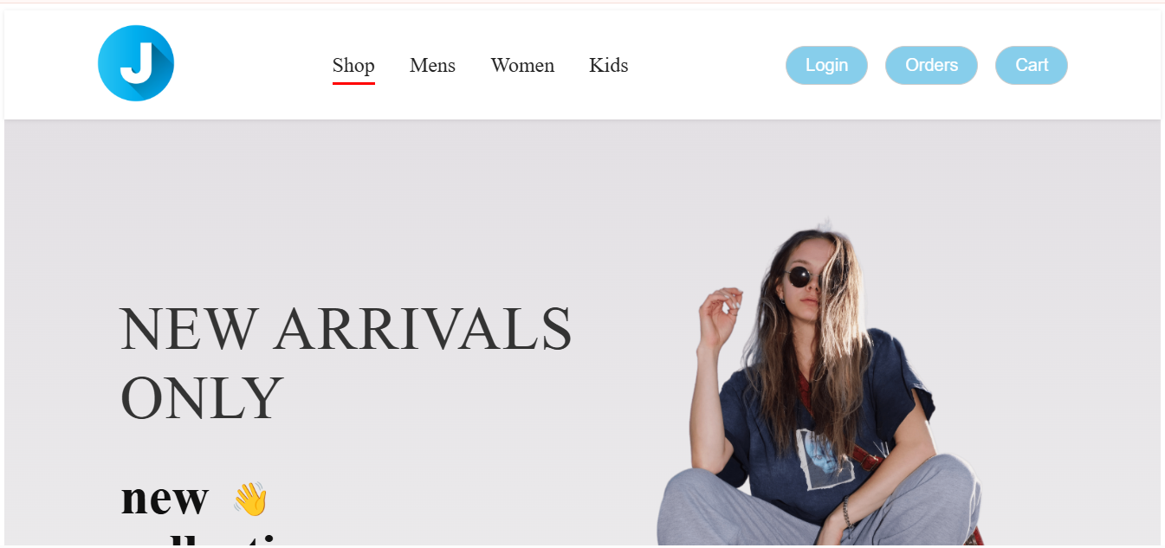

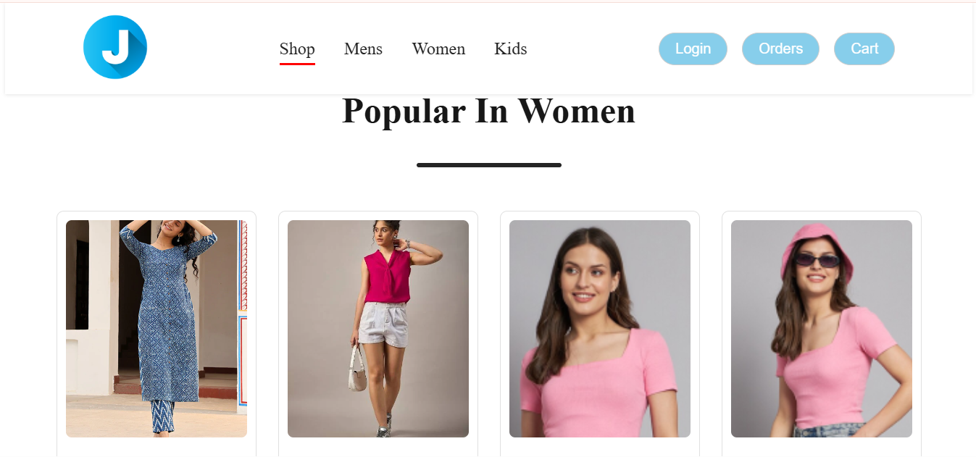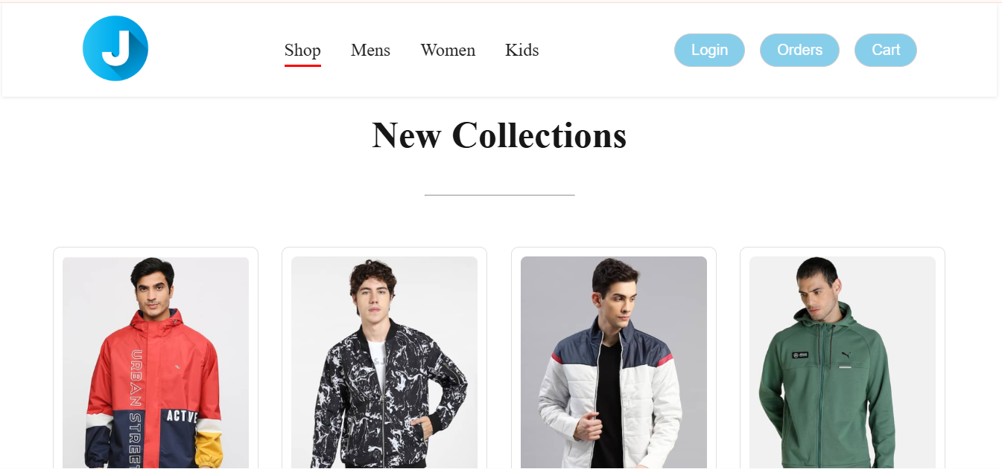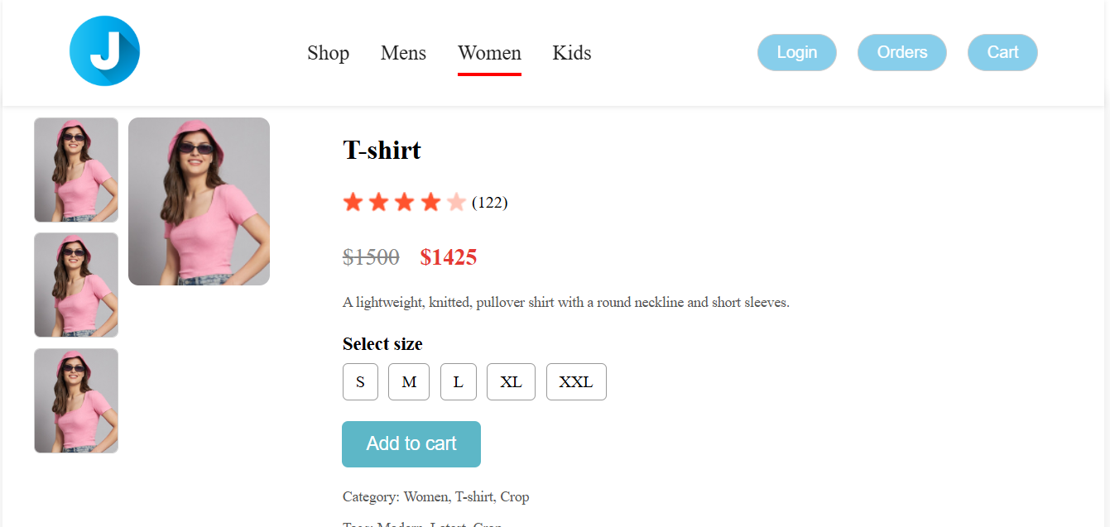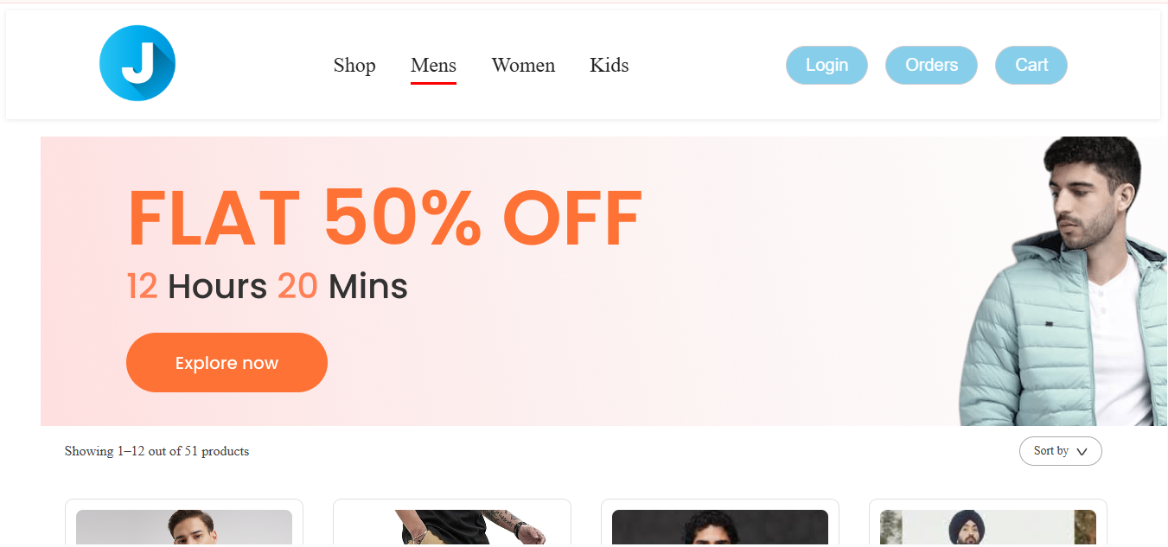

**2.2 Category & Product Listing Page**

When a user navigates to a specific category (e.g., Mens), they are presented with a list of all available products.

* **Sales Banners:** Category pages can feature time-sensitive offers, such as the "FLAT 50% OFF" banner with a countdown timer.
* **Product Grid:** Products are displayed in a grid format, showing a preview of the item. The page also indicates how many products are currently being displayed (e.g., "Showing 1–12 out of 51 products").
* **Sorting Options:** A "Sort by" dropdown allows users to organize products based on different criteria (e.g., price, popularity).

**2.3 Product Detail Page**

This page provides comprehensive information about a single product.

* **Image Gallery:** Multiple images of the product are available for users to view from different angles.
* **Product Information:** Displays the product name (e.g., "T-shirt"), customer ratings (e.g., star rating with review count), and pricing (including original and discounted price).
* **Size Selection:** Users can select their desired size from available options (S, M, L, XL, XXL).
* **Add to Cart:** A clear "Add to cart" button allows users to add the item to their shopping cart.
* **Description and Tags:** A short description and category/tags provide further details about the product.

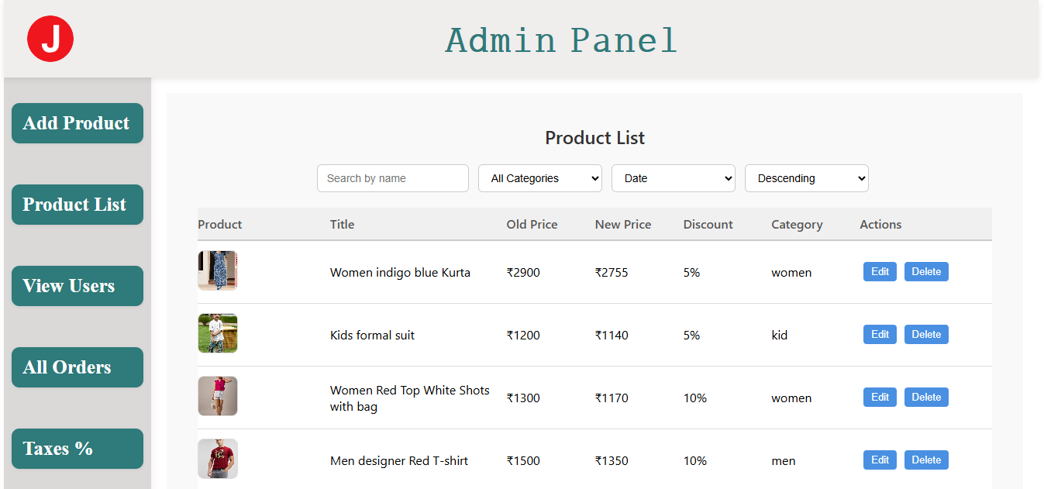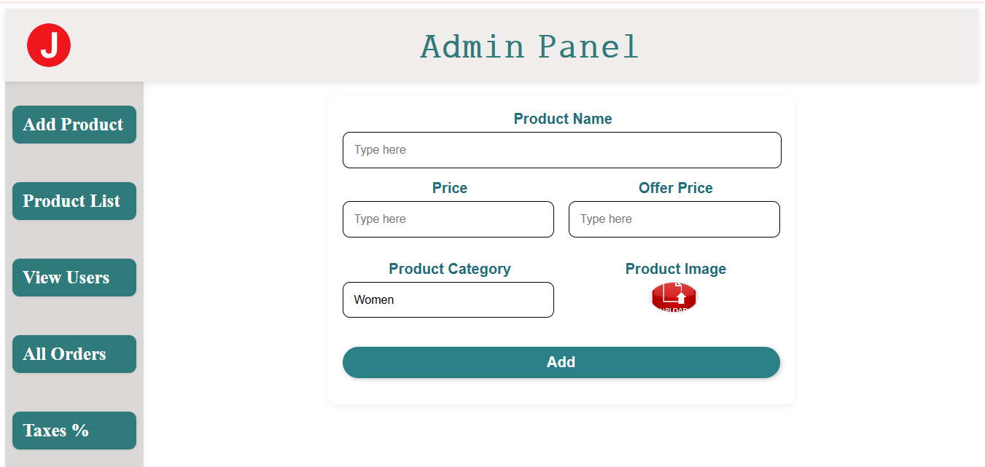

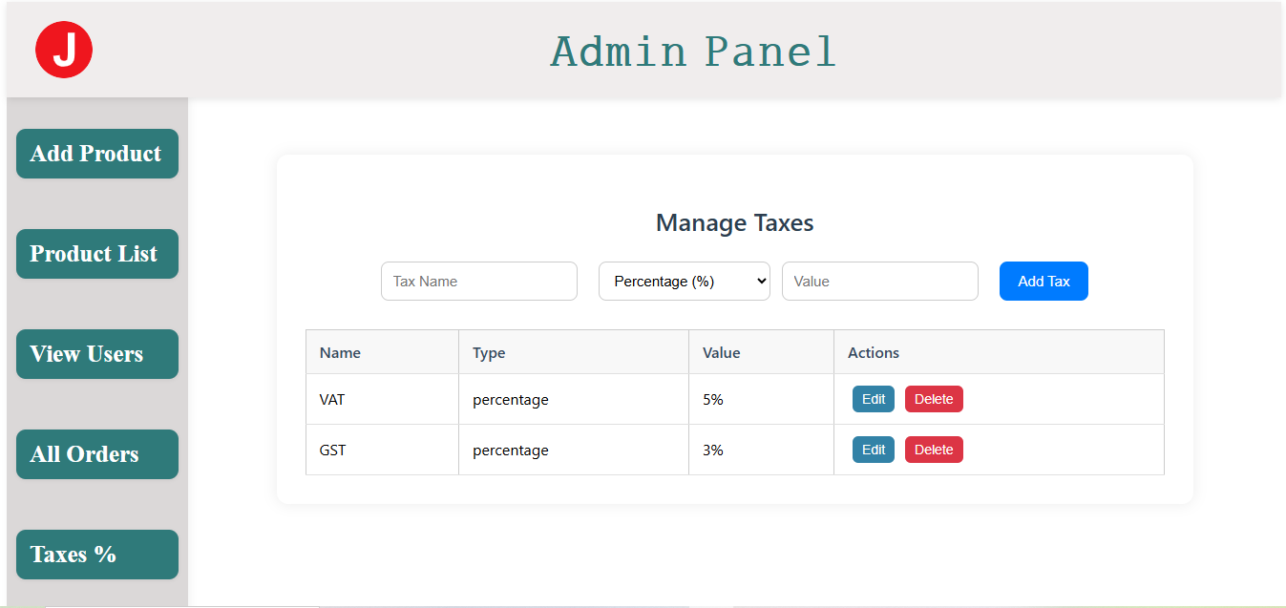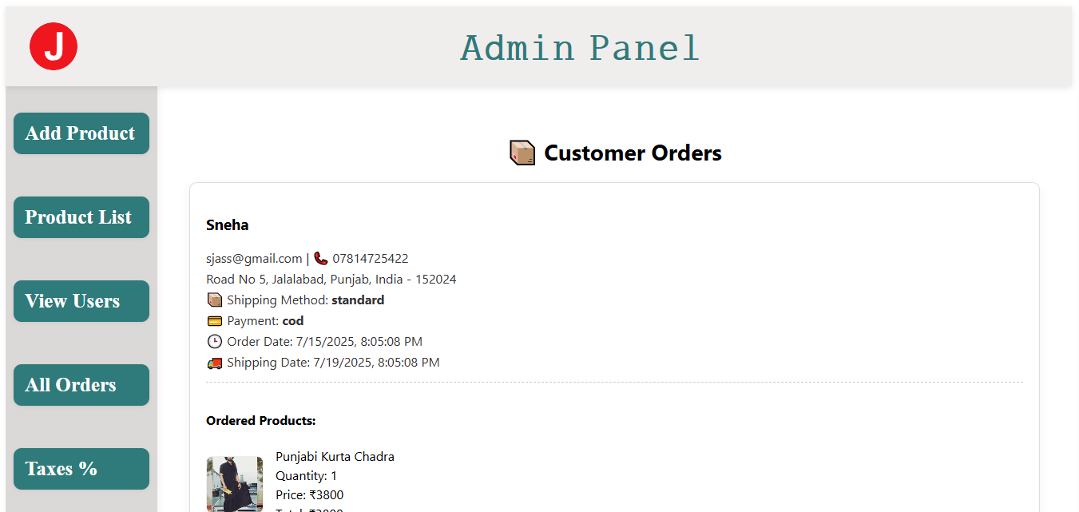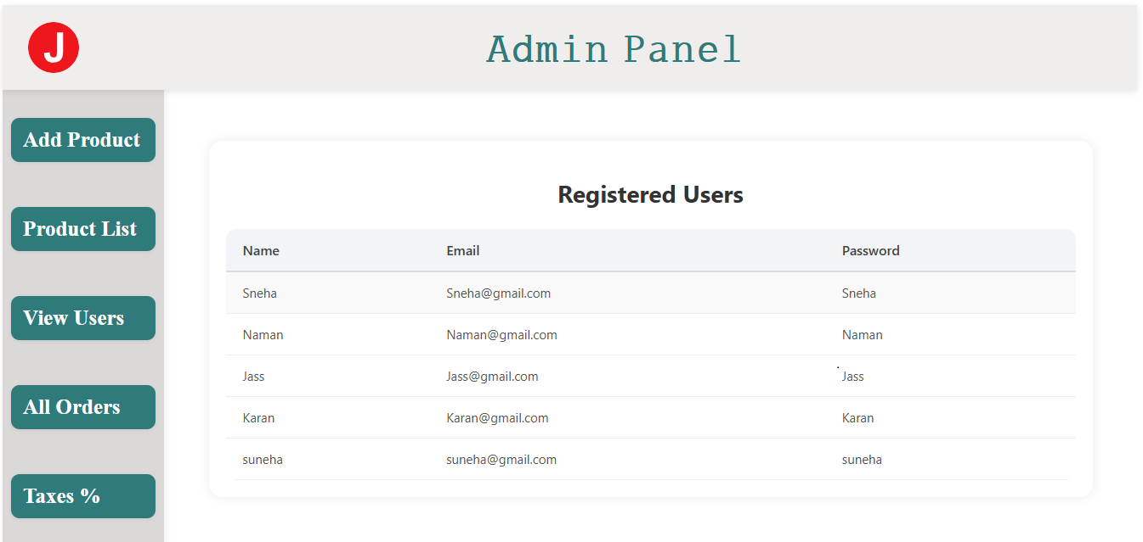

**3. Admin Panel**

The Admin Panel is the central hub for managing the entire e-commerce store. It is accessible only to authorized administrators, where admin can add, delete and edit the product name and admin can manage the taxes also admin can see the total user login and password for security purpose

**3.1 Dashboard and Navigation**

The panel has a simple, left-aligned sidebar for easy navigation between different management modules.

* **Navigation Links:** Add Product, Product List, View Users, All Orders, Taxes %.

**3.2 Product Management**

* **Add Product:** A form that allows the admin to add new items to the store.
  + **Fields:** Product Name, Price, Offer Price, Product Category (dropdown), and Product Image upload.
* **Product List:** A comprehensive table of all products currently in the store.
  + **Features:** Search functionality, filtering by category and date, and sorting options.
  + **Product Details Displayed:** Product image, Title, Old Price, New Price, Discount (%), Category.
  + **Actions:** "Edit" and "Delete" buttons for each product.

**3.3 User Management**

* **Registered Users:** A simple list of all customers who have registered on the website.
  + **Details Shown:** Name, Email, and Password (for administrative purposes).

**3.4 Order Management**

* **Customer Orders:** This section displays detailed information for each order placed.
  + **Customer and Shipping Info:** Displays the customer's name, email, contact number, and shipping address.
  + **Order Details:** Shows payment method, order date, and shipping date.
  + **Ordered Products:** Lists the products included in the order, along with quantity and price.

**3.5 Tax Management**

* **Manage Taxes:** An interface for setting and managing different types of taxes.
  + **Functionality:** Admins can add new taxes by providing a Tax Name, Type (e.g., percentage), and Value.
  + **Existing Taxes:** A table lists current taxes (e.g., VAT, GST) with their type, value, and options to "Edit" or "Delete" them.

**4. Conclusion**

The J MART e-commerce project is a complete and functional platform that successfully addresses the needs of both the end-user and the store administrator. With its modern design and comprehensive feature set, it provides a solid foundation for an online apparel business. Future enhancements could include advanced payment gateway integrations, a more detailed customer review system, and personalized product recommendations and totally managed by the admin panel.