**FINAL PROJECT REPORT**

**INFO-1113 (S10)**

**System Analysis and Design**

**Plan Easy Live Easy!!!!**

**Submitted by: -**

**Harneet Kaur (ID:100365644**

**Email: harneet239@gmail.com**

**Web URL:** [**https://sites.google.com/view/harneetkaur/home**](https://sites.google.com/view/harneetkaur/home)

**Git URL : https://github.com/harneet239/TestProject.git)**

**Jasdeep Kaur (ID:100359509**

**Email: jbaring8@gmail.com**

**Web URL:** [**https://sites.google.com/view/jasdeep-kaur**](https://sites.google.com/view/jasdeep-kaur)

**Git URL:** [**https://github.com/jassbaring/testproject.git**](https://www.google.com/url?q=https%3A%2F%2Fgithub.com%2Fjassbaring%2Ftestproject.git&sa=D&sntz=1&usg=AFQjCNFcf0bofISGjIrgz-vmJGOFcvw5Gg)**)**

**Jasjeet Kaur (ID:100363149**

**Email: mavijasjeet98@gmail.com**

**Web URL:** [**https://sites.google.com/view/jasjeet**](https://sites.google.com/view/jasjeet)

**Git URL : https://github.com/jasjeetmavi/testProject)**

**Baljinder Kaur (ID: 100362124**

**Email: baljinderkaursidhu74@gmail.com**

**Web URL:** [**https://sites.google.com/view/kaurb**](https://sites.google.com/view/kaurb)

**Git URL :** [**https://github.com/baljindersidhu74/Project_testing**](https://github.com/baljindersidhu74/Project_testing)**)**

**Submitted to: -Dr. Abhijit Sen**

**Date: - 29-Nov-2018**

Table of Contents

Cover Page 1

Table of Content 2

Executive Summary 3

Introduction 4

**Requirements**  5-18

Description 5

Use Case Diagram & Description 6-10

Class Diagram 11

Sequence Diagram 12

**Prototype** 13-17

1. Main Screen Tab 13
2. Reminder Tab 14
3. Text Notes Tab 15
4. Picture Notes Tab 16
5. Settings Tab 17

Relational Database Table(3NF) 18

Project Experience 19

Conclusion 20

Work Cited 21

**Executive Summary**

The mission of the developing Reminding and Task Scheduling app is to provide the reminders to an individual along with the picture and regular notes and even encourage them to do every task on time with lots of enthusiasm and the report below provides the overview of all these functions.

**Introduction**

Our application is **Reminding and Task Scheduling**. Now-a-days life is quite busy and everyone has to remember each and everything, which is not possible without the help of technology . Our main focus is to make people punctual and step towards their future goals with accuracy. If you are bad in time management; this app will help you to schedule your task and give you reminders before the task which will inspire you with some motivational thoughts so that you can live your life easily and better.

The project report on Reminding and Task scheduling basically covers the thorough description of all the functional and non-functional requirements and the various diagrams such as use-case diagram along the description , moreover, the sequence and class diagram. The display format of the app to the user is visualized through interface prototype. Futhermore ,the relational database in the access database is created with the particular relations normalized to third normal form. After that , the database is implemented by the access and the appropriate queries related it are created.

**Requirements**

**Description**

**FUNCTIONAL REQUIREMENTS:**

**Functional requirement** defines a function of system or its component, where a function is described as a specification of behavior between outputs and inputs.

Functional requirements may involve calculations, technical details, data manipulation and processing, and other specific functionality that define what a system is supposed to accomplish. Behavioral requirements describing all the cases where the system uses the functional requirements are captured in use case. The functional requirements are:

1. It will store the regular and picture notes.

2. It will also store the reminders added by the user.

3. It give remainders for the events added.

4. It provides motivational thoughts to the user along the reminders.

**NON-FUCTIONAL REQUIREMENTS:**

**Non-functional requirement** (NFR) is a requirement that specifies criteria that can be used to judge the operation of a system, rather than specific behaviors. They are contrasted with the functional requirements that define specific behavior or functions. The plan for implementing *functional* requirements is detailed in the system design. The plan for implementing *non-functional* requirements is detailed in the system architecture, because they are usually architecturally system requirements. The non-functional requirements are:

1.Get the reminders set by the user and display on the right time and date.

2. All the notes and reminders added are accessible by the user’s e-mail.

**Use Case Diagram**

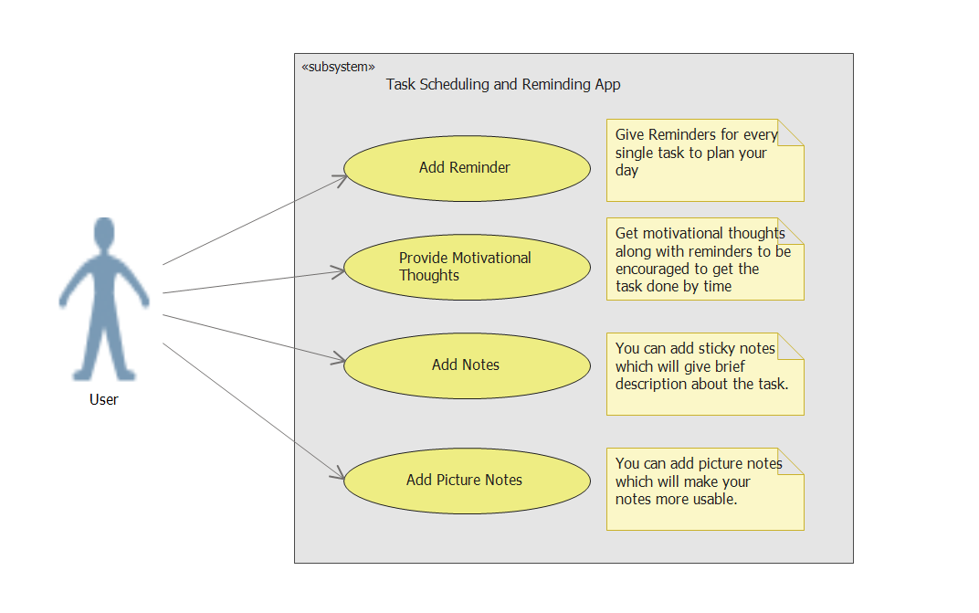

**Use Case Descriptions**

1. **(**Harneet Kaur)

|  |
| --- |
| Use Case Title: Add Notes |
| Primary Actor: User |
| Level: Kite (summary) |
| Stakeholders: User |
| Precondition: User must download the application |
| Minimal Guarantee: Alarm on time |
| Success Guarantees: Able to add sticky notes along with reminder |
| Trigger: User access the application |
| Main Success Scenario:   1. User opens the **Add Notes** tab. 2. User will able to type the detailed notes. 3. User will able to add their notes successfully. 4. User can access those notes anytime in the future. |
| Extensions:  1a. User do not able to open **Add Notes** tab.  1a1. User quits the app.  2b. If user do not able to type the notes.  2b1. User quits the app.  2b2. User can add just reminder.  3c. If user do not able to save the notes successfully.  3c1. Quit the app.  3c2. User can add another picture notes.  3c3. User can add just reminder.  4d. If user do not able to able to access the notes in future.  4d1. Quit the app. |

1. **(**Jasdeep Kaur)

|  |
| --- |
| Use case title: Giving motivational thoughts |
| Primary Actors: User |
| Level: Kite(summary) |
| Stakeholders: User |
| Precondition: Get the application from play store. |
| Minimal Guarantee: At least they will be able to get the reminders. |
| Success Guarantee: Along with reminders, Users will be able to get motivational thoughts. |
| Trigger: Users will be able to access the application. |
| Main Success Scenario:   1. Users will able to open the motivational thoughts tab. 2. Getting motivational thoughts for the scheduled tasks of the day. |
| Extensions:   1. Users will not able to open the motivational thoughts tab.   1a. Users will quit the app.   1. Users will not able to get the motivational thought.   2a. Users will quit the app.  2b. Users can try to use another tab  2c. Users can get the reminders without the motivational thought. |

1. (Jasjeet Kaur)

|  |
| --- |
| Use case title: Giving motivational thoughts |
| Primary Actors: User |
| Level: Kite(summary) |
| Stakeholders: User |
| Precondition: Get the application from any play store. |
| Minimal Guarantee: At least they will be able to get the reminders. |
| Success Guarantee: Along with reminders, Users will be able to get motivational thoughts. |
| Trigger: Users will be able to access the application. |
| Main Success Scenario:   1. Users will able to open the motivational thoughts tab. 2. Getting motivational thoughts for the scheduled tasks of the day. |
| Extensions:   1. Users will not able to open the motivational thoughts tab.   1a. Users will quit the app.   1. Users will not able to get the motivational thought.   2a. Users will quit the app.  2b. Users can try to use another tab  2c. Users can get the reminders without the motivational thought. |

**4.(Baljinder Kaur)**

|  |
| --- |
| **Use Case Title:** Add Picture Notes |
| **Primary Actor:** User |
| **Level:** Kite (summary) |
| **Stakeholders:** User |
| **Precondition:** User should download the application |
| **Minimal Guarantee:** Alarm rings on time |
| **Success Guarantee:** Able to add picture notes for tasks in future |
| **Trigger:** User must download the app |
| **Main Success Scenario:**   1. User opens the **Add Picture Notes** tab. 2. User search for the images from internet and add that image. 3. User adds picture and make notes along with that. 4. User can access these picture notes in future. |
| **Extensions:**  1a.Not able to open the Add Picture Notes tab.  1a1.User can add simple notes instead of picture notes.  2a.Not able to add images searched from internet.  2a1.User can simply add the image from own device.  3a. Not able to add pictures with notes.  3a1. User can simply add notes.  4a. Not able to access the picture notes.  4a1.User can access simple notes.  4a2.User can quit the app. |

**Class Diagram**

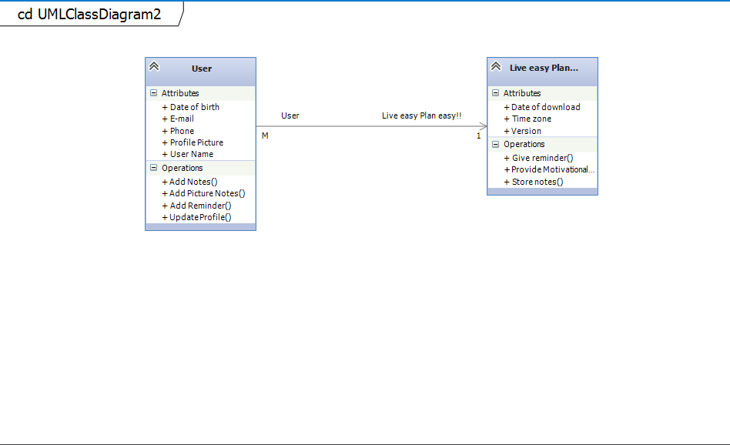

**Sequence Diagram for Adding Reminder**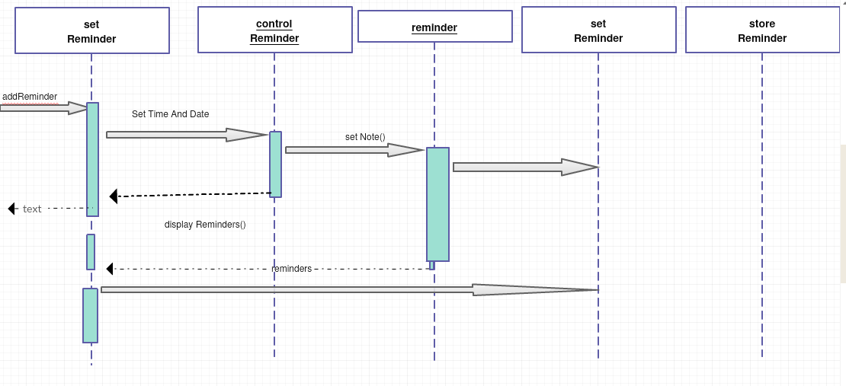

**Prototype**

**a.)Main Screen**



Plan Easy Live Easy!!

 

**Add Reminder Add Notes**

** **

**Add Picture Notes Settings**

**b.) Reminder Tab**





 



Plan Easy Live Easy!!



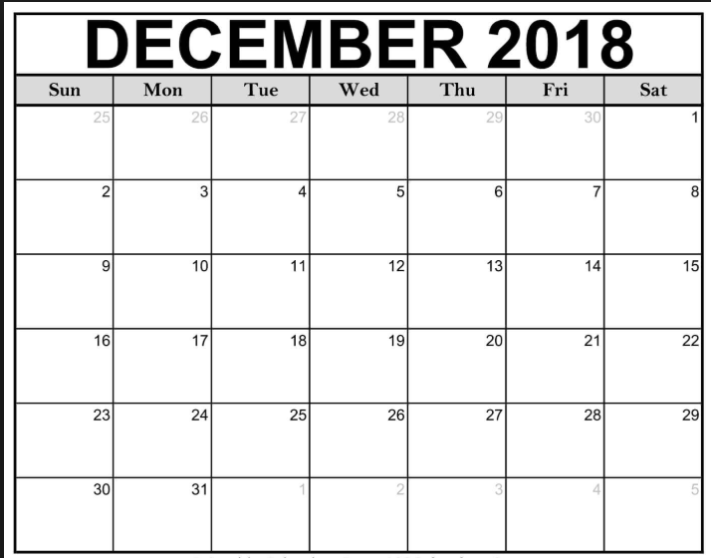

**c.) Text Notes Tab**







Plan Easy Live Easy!!



Take a note… 

Note 1

Note 2

**d.) Picture Notes Tab**







Plan Easy Live Easy!!



Search..  

Note 1

Note 2

**e.) Settings Tab**







Plan Easy Live Easy!!



**Change account settings**

**Change theme**

**Change color**

**Help**

**Relational Database System (3NF Table)**

2NF Table:-

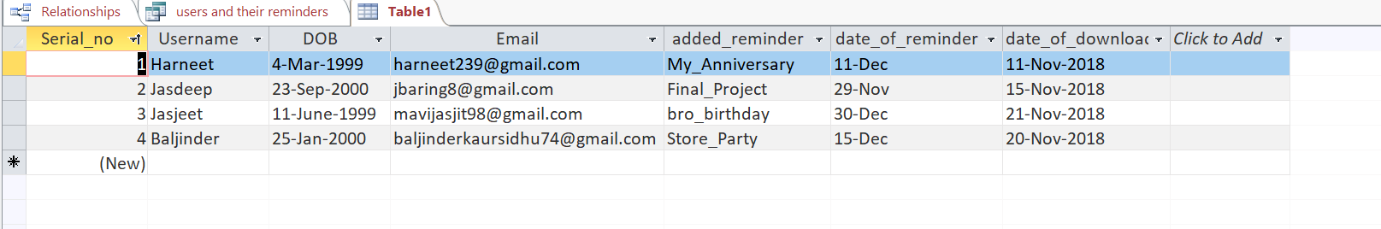

3NF tables created from 2NF:-

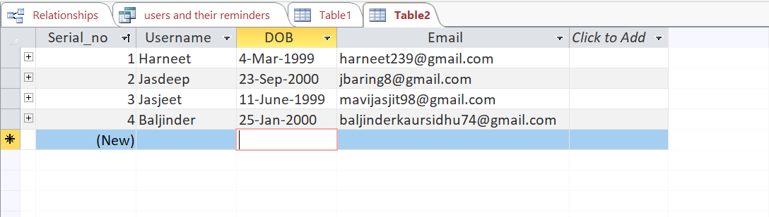

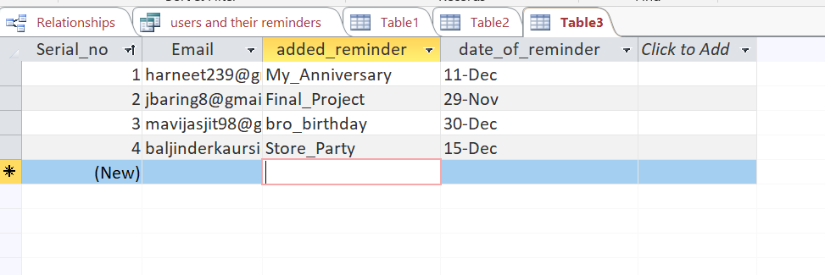

**Project Experience**

This Project was fun, and it gives us a chance to work together in a team. We all learned a lot from each other. Some of the things were quite easy but some of the things were difficult and need to be more focused. Some of the things were difficult to understand like:

* Making Relational Database table.
* Finding out functional and non-functional requirements.

All members worked very well and help each other.

**Conclusion**

Overall, this application came as an evolution in the time management system. And it is quite accessible to everyone. This application is very simple to understand and use. User can add multiple reminders, notes and picture notes which help them in time management.

**Work Cited**

<https://www.youtube.com/watch?v=QYFI-_X-XFI>

<https://youtu.be/MXkBUgs7z9g>

<https://en.wikipedia.org/wiki/Functional_requirement>

<https://en.wikipedia.org/wiki/Non-functional_requirement>