# Excel-Kickstart-My-Chart

Getting funded on Kickstarter requires meeting or exceeding the project's initial goal, so many organizations spend months looking through past projects to discover some trick for finding success. For this week's homework, you will organize and analyze a database of 4,000 past projects to uncover any hidden trends.

# Full Data

There are a few limitations with the data. It would be extremely helpful to see what competitors entered the market by year to determine how much of an effect that had in drop. Not having website traffic data is also limiting; daily traffic, the bounce rate and/or keyword strategy would be helpful in determining how easily a potential investor/entrepreneur is able to connect to website or how easily they were able to maneuver through the website.

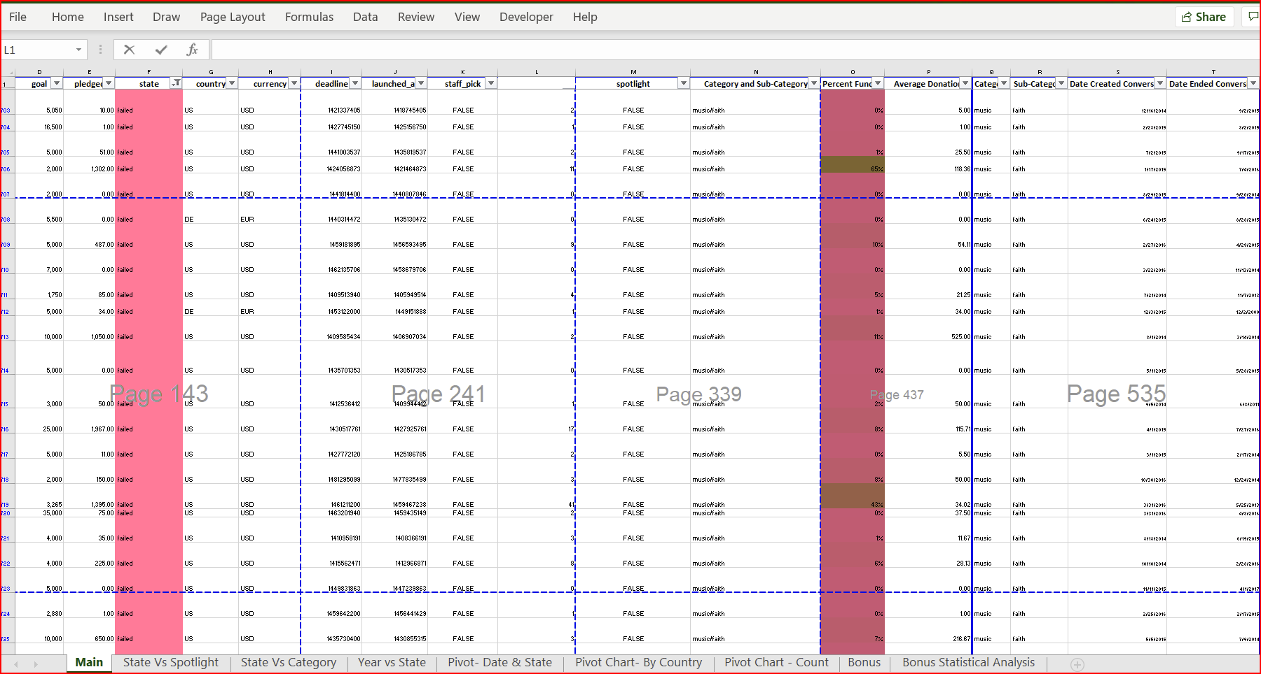

#Year Vs State

Creating a graph to look at Year vs State was helpful in creating a visual for overall success or loss throughout the years. The most concerning change observed is the huge drop in investments starting around 2016, which may be due to more competition entering the market. The 2nd most noticeable movement is the rise is failed campaigns starting in 2013, hitting peak in 2015, which is also the peak for success.

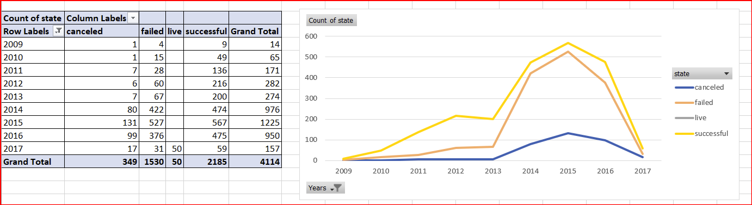

# Spotlight VS State

The # 1 deciding factor on success for any campaign seems to be dependent on whether they have a spotlight ad; staff pick did not seem to have a noticeable impact.

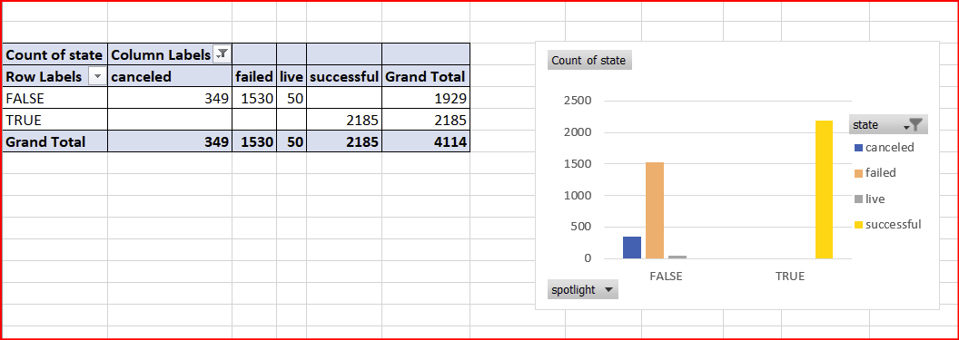

# Category Vs State

Creating a graph measuring each category’s success, failure, and cancels by year, was helpful in determining which category was the most impactful at different moments.

Most noticeable - Theater, the most backed category, had a significant drop from 249 in 2016 to 19 campaigns in 2017. Theatre accounts for almost 50% of the success in 2016, 53% in 2015 and 50% in 2014.

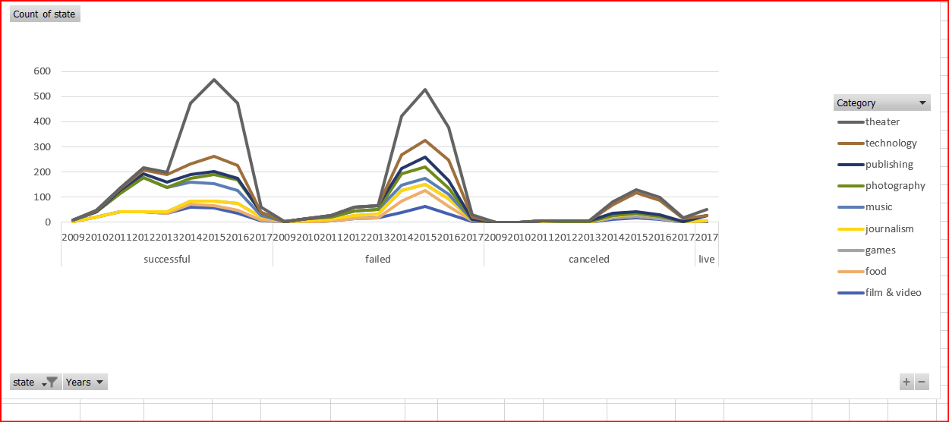

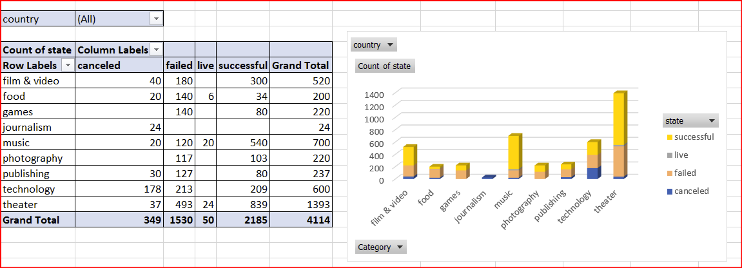

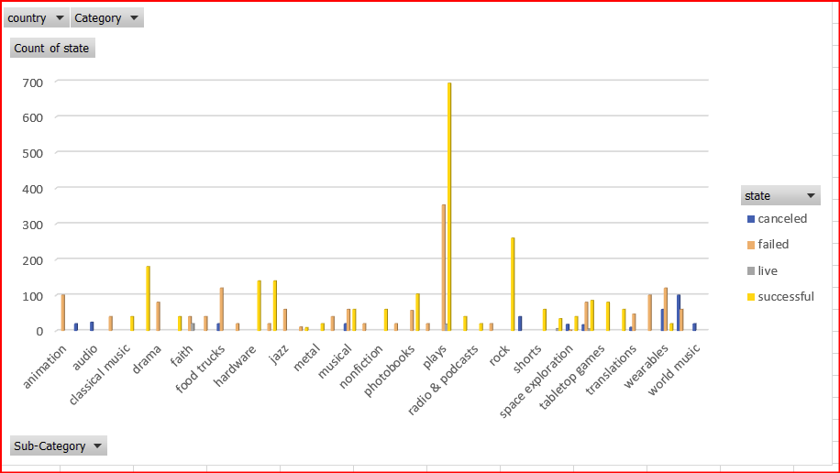

# Date & State

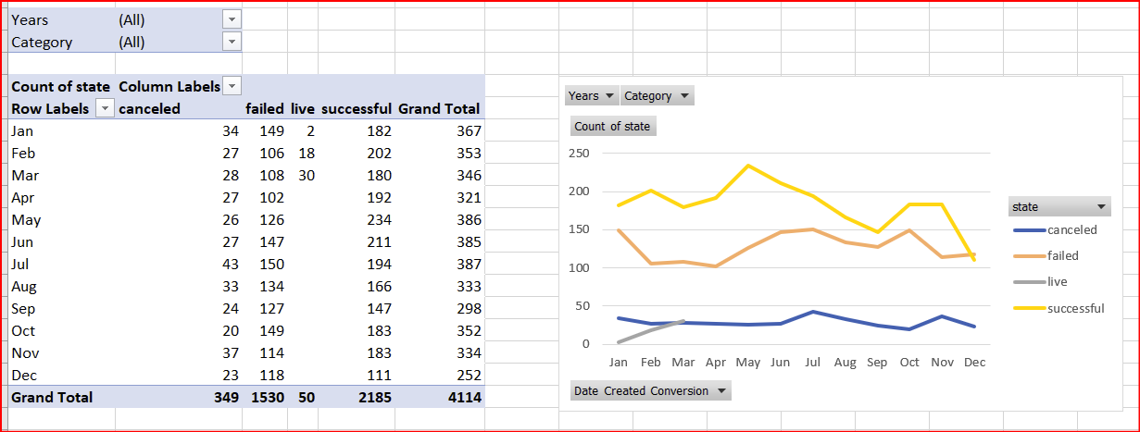# Statistical Analysis

