REPUBLIC OF TUNISIA


Ministry of Higher Education and

Scientific Research

University of Gafsa

Higher Institute of Business

Administration of Gafsa


MASTER THESIS

Specialty:

DATA SCIENCE

Car price prediction using machine learning techniques

Elaborated by: Supervised by:

Jasser Abbassi Dr. Nadia SOUDANI

Academic Year: 2025-2026

Dedication

Acknowledgments

Table of Contents

List of Tables

List of Figures

Chapter 1: Background and Models Description

Introduction
This chapter lays the theoretical foundation for the car price prediction project. It begins by presenting the domain background, explaining the importance of accurate pricing in the automotive market and the various factors that influence vehicle value. It then introduces the core concepts of machine learning, particularly supervised regression, which forms the basis of the proposed solution. Finally, it describes the main prediction models considered in this work and the evaluation metrics used to assess their performance.

1. Car Price Prediction: Domain Background

1.1 The Automotive Market and the Pricing Challenge
The automotive industry is one of the largest and most dynamic sectors in the global economy. Millions of vehicles are bought and sold every year, covering both new and used car markets across different countries and regions. In this highly competitive environment, determining the fair market price of a vehicle is a complex task influenced by a wide variety of factors.
Unlike fixed-price goods, car prices are inherently variable. Two cars of the same brand and model can differ significantly in price depending on their condition, mileage, age, and geographic location. This variability makes manual price estimation unreliable and often subjective, creating a real need for data-driven, automated pricing solutions.

1.2 Key Factors Influencing Car Prices
Car prices are shaped by a combination of technical, historical, and market-related attributes. Understanding these factors is essential before building any prediction model.
Technical factors: These include engine size, horsepower, fuel type (petrol, diesel, electric, hybrid), transmission type, and mileage. These attributes directly affect the vehicle's performance and running costs, and therefore its perceived market value.
Vehicle history factors: These include the car's age, number of previous owners, accident history, and maintenance records. A well-maintained older car can sometimes hold more value than a newer one with a troubled history.
Brand and model: The manufacturer and model play a significant role in pricing. Luxury brands such as BMW, Mercedes-Benz, or Audi typically command higher prices than economy brands, even when technical specifications are comparable.
Market and external factors: Supply and demand dynamics, regional economic conditions, fuel prices, and seasonality also influence car pricing. For instance, SUVs tend to be more valued in regions with rough terrain, while convertibles sell at higher prices in warmer climates.

1.3 Why Accurate Car Price Prediction Matters
Accurate car price prediction brings value to multiple stakeholders. For buyers, it helps avoid overpaying and supports better decision-making. For sellers and dealers, it enables competitive and profitable pricing strategies. For insurance companies, predicted market value is essential for determining coverage amounts. For online car marketplaces, automated pricing tools improve user experience and platform credibility. This is precisely why car price prediction has become an active area of research in data science and machine learning.

2. Machine Learning Fundamentals

2.1 Definition and Types of Machine Learning
Machine learning is a branch of artificial intelligence that enables computer systems to learn from data and improve their performance on a task without being explicitly programmed. Instead of following hard-coded rules, a machine learning model identifies patterns in historical data and uses them to make predictions or decisions on new, unseen data.
Machine learning is generally divided into three main categories:
Supervised Learning: The model is trained on labeled data, meaning each example has an input and a known output. The goal is to learn a mapping from inputs to outputs. This is the approach used in car price prediction.
Unsupervised Learning: The model works with unlabeled data and tries to find hidden patterns or groupings, such as clustering customers by behavior.
Reinforcement Learning: The model learns by interacting with an environment and receiving rewards or penalties based on its actions. It is commonly used in game playing and robotics.
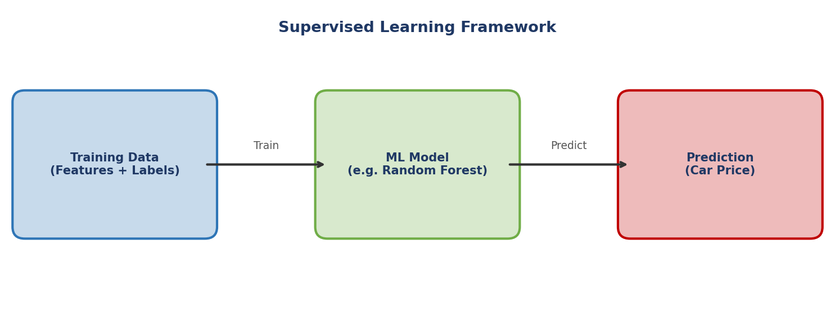
Figure 1.1 — Supervised Learning Framework applied to Car Price Prediction

2.2 Why Supervised Regression Fits Car Price Prediction
Car price prediction is a regression problem, a type of supervised learning where the output is a continuous numerical value rather than a category. Given a set of vehicle features such as brand, year, mileage, and fuel type, the model learns to predict the corresponding price. This fits naturally into the supervised learning framework because historical car listings with known prices are readily available and can serve as training data.

2.3 The Machine Learning Pipeline
Building a machine learning solution involves a structured sequence of steps. First, raw data is collected and explored to understand its structure and quality. Then, a preprocessing phase cleans and transforms the data, handling missing values, encoding categorical variables, and scaling numerical features. Next, relevant features are selected or engineered to improve model performance. The model is then trained on a portion of the data and evaluated on a separate test set. Finally, the best-performing model is selected based on evaluation metrics and prepared for deployment.
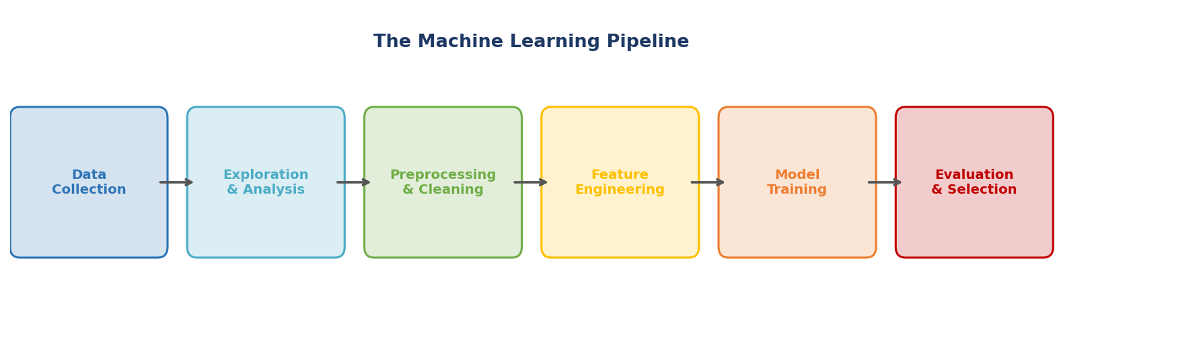
Figure 1.2 — The Standard Machine Learning Pipeline

3. Regression Models Description
Several regression algorithms are considered in this work. Each model has its own strengths, assumptions, and level of complexity. Below is a description of the main models explored.

3.1 Linear Regression
Linear regression is the simplest and most interpretable regression model. It assumes a straight-line relationship between the input features and the target variable. The model tries to find the best line that minimizes the overall prediction error. While easy to understand and implement, linear regression may not capture complex, non-linear relationships that often exist in real-world datasets such as car pricing.

3.2 Decision Tree Regressor
A decision tree splits the data into subsets based on feature values, creating a tree-like structure of decisions. Each leaf of the tree represents a predicted value. Decision trees are intuitive and can capture non-linear patterns, but they tend to overfit the training data, meaning they memorize specific examples rather than learning generalizable rules. This limitation is addressed by ensemble methods like Random Forest.
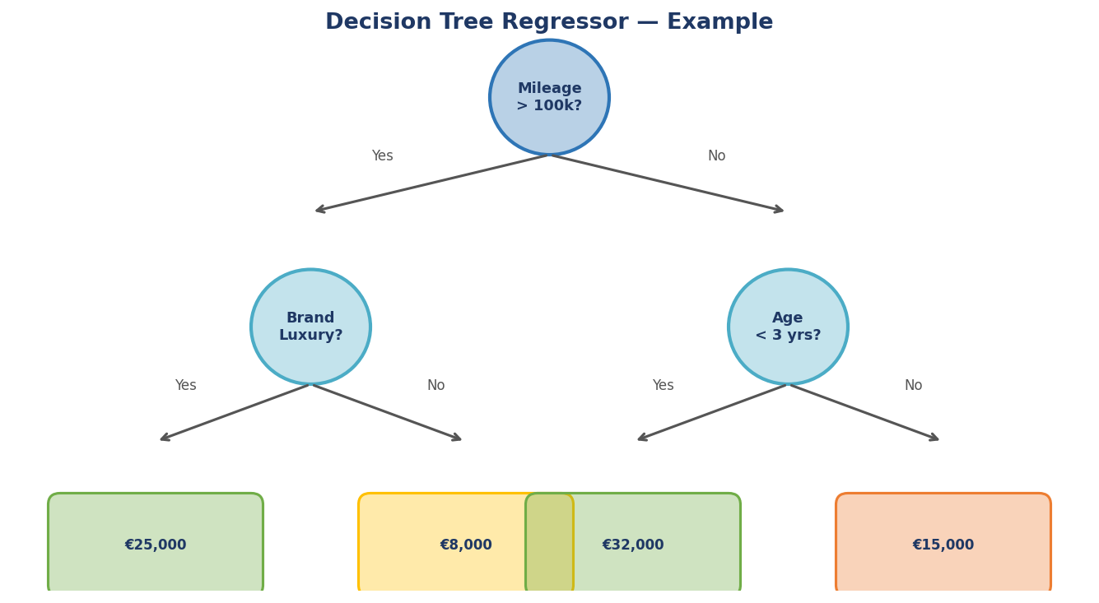
Figure 1.3 — Example of a Decision Tree Regressor for Car Price Prediction

3.3 Random Forest Regressor
Random Forest is an ensemble learning method that builds multiple decision trees during training and combines their predictions by averaging the results. By introducing randomness in both the data samples and features used to build each tree, it reduces overfitting and achieves better generalization. Random Forest is robust, handles missing values well, and can indicate which features contribute most to the prediction, making it a popular choice for car price estimation.

3.4 Gradient Boosting Methods (XGBoost / LightGBM)
Gradient Boosting is another ensemble technique, but unlike Random Forest which builds trees independently, it builds them sequentially. Each new tree tries to correct the errors made by the previous ones. This iterative improvement leads to highly accurate models. XGBoost and LightGBM are two efficient and optimized implementations of gradient boosting that are widely used in competitive data science. They are known for their speed, scalability, and strong predictive performance, making them particularly well-suited for structured tabular data like car listings.
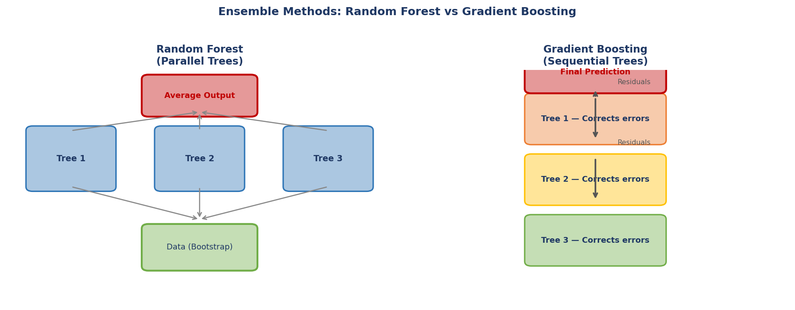
Figure 1.4 — Comparison of Random Forest (parallel) and Gradient Boosting (sequential) approaches

3.5 Neural Networks for Regression
Artificial neural networks are inspired by the structure of the human brain. They consist of layers of interconnected nodes that learn complex patterns from data. For regression tasks, the output layer produces a single numerical value. While neural networks can model highly complex relationships, they typically require large amounts of data and significant computational resources. They are considered in this work as an optional benchmark to compare against simpler models.

4. Deep Learning for Regression
Deep learning is a subfield of machine learning based on artificial neural networks with multiple layers. Unlike classical models that rely on manually engineered features, deep learning models can automatically learn hierarchical representations from raw data, making them powerful tools for complex prediction tasks. While classical regression models such as Random Forest and Gradient Boosting remain the dominant choice for structured tabular data like car listings, deep learning architectures have shown competitive results in recent studies and are increasingly considered as complementary or benchmark models. This section introduces the key deep learning concepts and architectures relevant to car price prediction.

4.1 How Neural Networks Work
A neural network is composed of layers of interconnected nodes called neurons. Each neuron receives one or more inputs, applies a weighted sum, adds a bias term, and then passes the result through an activation function to introduce non-linearity. The network is organized into three types of layers: the input layer (which receives the car features), one or more hidden layers (which learn intermediate representations), and the output layer (which produces the predicted price as a single continuous value). Training is performed through backpropagation, an algorithm that computes the gradient of the loss function with respect to each weight, and then uses gradient descent (or its variants such as Adam or RMSProp) to update the weights iteratively and minimize prediction error.
Common activation functions used in hidden layers include ReLU (Rectified Linear Unit), which is the most widely used due to its simplicity and effectiveness in deep networks; Sigmoid, which squashes outputs between 0 and 1; and Tanh, which squashes outputs between -1 and 1. For the output layer in a regression task, a linear activation (no activation) is used so that the model can predict any continuous numerical value, such as a car price.
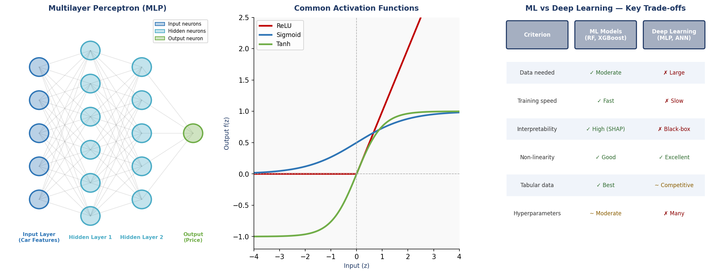
Figure 1.5 — MLP Architecture, Common Activation Functions, and ML vs Deep Learning Comparison

4.2 Multilayer Perceptron (MLP)
The Multilayer Perceptron (MLP) is the most fundamental deep learning architecture and the most directly applicable to tabular regression tasks such as car price prediction. It consists of a series of fully connected (dense) layers, where every neuron in one layer is connected to every neuron in the next. The MLP learns to approximate any continuous function through its non-linear activations and multiple layers of abstraction.
For car price prediction, the input layer receives the numerical and encoded categorical features (such as age, mileage, brand, fuel type), the hidden layers progressively transform these features into abstract representations, and the output layer produces the predicted price. The performance of an MLP is highly sensitive to architectural choices (number of layers and neurons), regularization techniques (Dropout, L2 weight decay), and the optimizer used (Adam is the most common). Studies reviewed in Chapter 2 (Li & Lin, 2018; Singh & Sareen, 2023) confirm that a well-tuned MLP can achieve competitive results, often outperforming linear models but remaining close to or slightly below well-tuned Random Forest and Gradient Boosting models on moderately sized datasets.

4.3 Regularization Techniques in Deep Learning
Deep neural networks are particularly prone to overfitting, especially when the training dataset is of moderate size. Several regularization techniques are used to address this problem:
Dropout: Randomly deactivates a proportion of neurons during each training step, forcing the network to learn more robust and distributed representations rather than relying on specific neurons.
Batch Normalization: Normalizes the output of each layer during training, which stabilizes and accelerates the learning process and can reduce sensitivity to weight initialization.
Early Stopping: Monitors the model’s performance on a validation set during training and halts the process when performance stops improving, preventing the model from memorizing the training data.

4.4 When to Use Deep Learning vs Classical ML
The decision of whether to use deep learning or classical machine learning models depends on several practical factors. For structured tabular data — which is the dominant format in car price datasets — classical ensemble methods such as Random Forest and Gradient Boosting consistently outperform deep learning when the dataset is of moderate size (under ~100,000 records), the features are well-defined and interpretable, and computational resources or training time are limited. Deep learning becomes more competitive or superior when the dataset is very large, when raw or unstructured data (such as car images or textual descriptions) is incorporated alongside tabular features, or when complex higher-order interactions between features exist that ensemble methods struggle to capture.
In the context of this thesis, deep learning (specifically MLP) is included as a comparative model alongside classical approaches. This allows the work to provide a comprehensive comparison and determine empirically which family of models best suits the characteristics of the target dataset, rather than assuming an outcome in advance.

5. Model Evaluation Metrics
To measure how well a regression model performs, several evaluation metrics are used. These metrics compare the model's predicted prices against the actual prices in the test dataset.
Mean Absolute Error (MAE): This metric measures the average absolute difference between predicted and actual values. It is easy to interpret as it is expressed in the same unit as the target variable (price). A lower MAE means better accuracy.
Mean Squared Error (MSE): This metric squares the differences before averaging, which penalizes large errors more heavily than small ones. It is useful when large prediction errors are particularly undesirable.
Root Mean Squared Error (RMSE): RMSE is the square root of the MSE, which brings the metric back to the same unit as the target variable. It combines the sensitivity of MSE to large errors with the interpretability of MAE.
R-squared (R²): Also known as the coefficient of determination, R² measures how much of the variance in the car prices is explained by the model. A value of 1 indicates a perfect prediction, while a value of 0 means the model performs no better than simply predicting the average price. It provides a quick global assessment of model quality.

Conclusion
This chapter provided the theoretical background necessary to understand the car price prediction problem and the tools used to address it. We explored the automotive pricing domain, identified the key factors that influence vehicle value, and introduced the machine learning concepts and regression models that will be applied throughout this work. The evaluation metrics discussed will serve as benchmarks to compare model performance in the experimentation phase. The next chapter will present a review of existing studies and approaches related to car price prediction.
References
[1] Breiman, L. (2001). Random forests.Machine Learning, 45(1), 5–32. https://doi.org/10.1023/A:1010933404324
[2] Chen, T., & Guestrin, C. (2016). XGBoost: A scalable tree boosting system. InProceedings of the 22nd ACM SIGKDD International Conference on Knowledge Discovery and Data Mining (pp. 785–794). ACM. https://doi.org/10.1145/2939672.2939785
[3] Friedman, J. H. (2001). Greedy function approximation: A gradient boosting machine.Annals of Statistics, 29(5), 1189–1232. https://doi.org/10.1214/aos/1013203451
[4] Goodfellow, I., Bengio, Y., & Courville, A. (2016).Deep Learning. MIT Press. http://www.deeplearningbook.org
[5] Hastie, T., Tibshirani, R., & Friedman, J. (2009).The Elements of Statistical Learning: Data Mining, Inference, and Prediction (2nd ed.). Springer. https://doi.org/10.1007/978-0-387-84858-7
[6] James, G., Witten, D., Hastie, T., & Tibshirani, R. (2021).An Introduction to Statistical Learning: With Applications in R (2nd ed.). Springer. https://doi.org/10.1007/978-1-0716-1418-1
[7] Ke, G., Meng, Q., Finley, T., Wang, T., Chen, W., Ma, W., Ye, Q., & Liu, T.-Y. (2017). LightGBM: A highly efficient gradient boosting decision tree. InAdvances in Neural Information Processing Systems, 30, 3146–3154. https://proceedings.neurips.cc/paper/2017/hash/6449f44a102fde848669bdd9eb6b76fa-Abstract.html
[8] Mitchell, T. M. (1997).Machine Learning. McGraw-Hill.
[9] Quinlan, J. R. (1986). Induction of decision trees.Machine Learning, 1(1), 81–106. https://doi.org/10.1007/BF00116251
[10] Rumelhart, D. E., Hinton, G. E., & Williams, R. J. (1986). Learning representations by back-propagating errors.Nature, 323(6088), 533–536. https://doi.org/10.1038/323533a0
[11] Srivastava, N., Hinton, G., Krizhevsky, A., Sutskever, I., & Salakhutdinov, R. (2014). Dropout: A simple way to prevent neural networks from overfitting.Journal of Machine Learning Research, 15(1), 1929–1958.
[12] Ioffe, S., & Szegedy, C. (2015). Batch normalization: Accelerating deep network training by reducing internal covariate shift. InProceedings of the 32nd International Conference on Machine Learning (ICML), 37, 448–456.
[13] Kingma, D. P., & Ba, J. (2015). Adam: A method for stochastic optimization. In3rd International Conference on Learning Representations (ICLR). https://arxiv.org/abs/1412.6980
[14] Geman, S., Bienenstock, E., & Doursat, R. (1992). Neural networks and the bias/variance dilemma.Neural Computation, 4(1), 1–58. https://doi.org/10.1162/neco.1992.4.1.1
[15] Kohavi, R. (1995). A study of cross-validation and bootstrap for accuracy estimation and model selection. InProceedings of the 14th International Joint Conference on Artificial Intelligence (IJCAI), 2, 1137–1143.
[16] Bergstra, J., & Bengio, Y. (2012). Random search for hyper-parameter optimization.Journal of Machine Learning Research, 13, 281–305.
[17] Pedregosa, F., Varoquaux, G., Gramfort, A., Michel, V., Thirion, B., Grisel, O., Blondel, M., Prettenhofer, P., Weiss, R., Dubourg, V., Vanderplas, J., Passos, A., Cournapeau, D., Brucher, M., Perrot, M., & Duchesnay, E. (2011). Scikit-learn: Machine learning in Python.Journal of Machine Learning Research, 12, 2825–2830.
[18] Willmott, C. J., & Matsuura, K. (2005). Advantages of the mean absolute error (MAE) over the root mean square error (RMSE) in assessing average model performance.Climate Research, 30(1), 79–82. https://doi.org/10.3354/cr030079
[19] Chai, T., & Draxler, R. R. (2014). Root mean square error (RMSE) or mean absolute error (MAE)? – Arguments against avoiding RMSE in the literature.Geoscientific Model Development, 7(3), 1247–1250. https://doi.org/10.5194/gmd-7-1247-2014
[20] Nagelkerke, N. J. D. (1991). A note on a general definition of the coefficient of determination.Biometrika, 78(3), 691–692. https://doi.org/10.1093/biomet/78.3.691

Chapter 2: State of the Art (Literature Review)

Introduction
Research on car price prediction using machine learning has grown considerably over the past decade. As the used car market expands globally and data becomes more accessible, a growing number of researchers have proposed automated pricing models that aim to surpass traditional, manual estimation methods. This chapter reviews the most relevant studies in this field, analyzing the methods used, the datasets exploited, and the results obtained. The goal is to understand the current state of the art, identify the strengths and weaknesses of existing approaches, and clarify how the present work fits within this landscape.

1. Overview of Research Trends in Car Price Prediction
The earliest approaches to automated car price prediction relied primarily on classical statistical methods such as multiple linear regression. While these models are simple and interpretable, they assume a linear relationship between input features and price, which is rarely the case in real-world automotive data. Researchers quickly identified this limitation and turned to more expressive machine learning techniques.
Tree-based models such as Decision Trees and Random Forests emerged as popular alternatives, offering the ability to capture non-linear relationships without requiring manual feature engineering. These ensemble methods proved particularly effective for structured tabular data, which characterizes most car listing datasets. More recently, gradient boosting frameworks such as XGBoost and LightGBM have demonstrated strong performance across multiple studies, consistently achieving high accuracy scores.
Alongside these developments, a growing body of work has explored the application of deep learning architectures to car price prediction. Models such as Artificial Neural Networks (ANNs), Convolutional Neural Networks (CNNs), and Long Short-Term Memory (LSTM) networks have been tested with the aim of learning more complex feature interactions. While these approaches can sometimes outperform classical methods, they generally require larger datasets and more computational resources.

2. Review of Key Studies

a. Kadir et al. (2025) — ML and Deep Learning Comparison in Bangladesh
Kadir et al. conducted a comprehensive comparison of machine learning and deep learning models for predicting used car prices using a dataset collected from Bikroy.com, a major online car marketplace in Bangladesh. The dataset included features such as kilometers driven, engine capacity, fuel type, year of manufacture, and manufacturer brand. After thorough preprocessing that included duplicate removal, label encoding for categorical variables, one-hot encoding for fuel types, and MinMax normalization, the authors applied both traditional machine learning models and advanced deep learning architectures.
On the machine learning side, they tested Linear Regression, Random Forest, Gradient Boosting, and Support Vector Regression (SVR). Among these, Random Forest achieved the best results with an R² of 0.58, while SVR performed poorly with a negative R² of -0.43, indicating a poor fit to the data. On the deep learning side, they evaluated Deep Neural Networks (DNN), Convolutional Neural Networks (CNN), Recurrent Neural Networks (RNN), and Long Short-Term Memory (LSTM) networks. The RNN achieved the highest overall R² of 0.67, demonstrating the advantage of deep learning in capturing complex variable interactions.
The study concluded that deep learning models, particularly RNN and LSTM, outperform traditional machine learning in this context, while also highlighting the importance of data preprocessing, feature selection, and hyperparameter tuning. One limitation noted by the authors is the relatively small and geographically specific dataset, which may limit the generalizability of the findings.

b. Li & Lin (2018) — Deep Learning for Used Car Pricing (Stanford)
Li and Lin from Stanford University investigated whether deep learning could outperform traditional regression methods for used car price prediction. Their work used a dataset scraped from Kelley Blue Book, cleaned down to 16,102 records with features such as brand, body type, mileage, number of doors, engine size, and fuel efficiency metrics. They compared three models: standard Linear Regression, and two Multilayer Perceptron (MLP) architectures with different configurations.
Their first neural network (MLP1) was built using scikit-learn's MLPRegressor with a single hidden layer of 100 neurons. Their second network (MLP2) was a custom Keras model with three hidden layers totaling 45 neurons, optimized for Mean Squared Log Error (MSLE) to better reflect proportional pricing accuracy. The results showed that deeper networks significantly outperformed shallower ones. MLP2 achieved a test MSLE of 0.080, compared to 0.160 for MLP1 and 2.605 for Linear Regression.
The authors concluded that used car pricing is fundamentally a non-linear problem and that network depth matters more than neuron count for this type of task. One notable finding was the decision to drop the color variable, which added over 2,000 columns through one-hot encoding yet contributed no predictive value. This study highlights the importance of thoughtful feature selection and architecture design in deep learning for price prediction.

c. Singh & Sareen (2023) — ML vs. Deep Learning in the Indian Market
Singh and Sareen addressed the Indian used car market, which they describe as still largely dominated by an unorganized sector that creates information asymmetry between buyers and sellers. They used a Kaggle dataset of 22,576 Indian used car listings, containing both numerical features such as year of manufacture, kilometers driven, engine displacement, and mileage, as well as categorical features such as fuel type, transmission type, and company name.
The study compared three models: Linear Regression as a baseline, Random Forest Regressor as a tree-based approach, and an Artificial Neural Network (ANN) as the deep learning representative. After cleaning the data and removing outliers with prices above one million Indian rupees, they found that ANN achieved the best R² score of 0.89, followed closely by Random Forest at 0.85, while Linear Regression lagged at 0.77.
The authors emphasized that the ANN's advantage lies in its ability to model non-linear relationships between features and price. They also acknowledged the limitations of the dataset, noting that some car brands had insufficient records to train reliable models on. The study recommends using larger and more diverse datasets for future research, and notes that the additional computational cost of ANN may not always justify the marginal improvement over Random Forest.

d. Yadav et al. (2025) — Broad Model Comparison with Feature Analysis
Yadav et al. presented one of the most comprehensive model comparison studies in recent literature, evaluating twelve different machine learning algorithms for predicting the selling price of pre-owned cars in India. Their dataset included rich vehicle attributes such as car name, age, kilometers driven, seller type, fuel type, mileage, engine capacity, maximum power, number of seats, and transmission type. Data quality was carefully managed by removing duplicates, handling missing values, filtering out records with negative or unrealistic values, and encoding categorical variables using one-hot encoding.
The models tested included Linear Regression, Ridge Regression, Lasso Regression, Elastic Net, Decision Tree, Random Forest, Gradient Boosting, LightGBM, XGBoost, Support Vector Regressor, K-Nearest Neighbors, and MLP Regressor. The results clearly showed the dominance of tree-based ensemble methods. Random Forest achieved the highest R² of 0.9748, followed by XGBoost at 0.9727 and LightGBM at 0.9716. By contrast, Elastic Net performed very poorly with an R² near zero, confirming that linear models are inadequate for this type of data. The MLP Regressor, while outperforming linear models, still trailed the tree-based methods significantly.
Feature importance analysis revealed that car age, kilometers driven, brand, and fuel type were the most influential predictors of price, consistent with findings across other studies. The authors also proposed a simple user-facing web interface to enable real-time price prediction, bridging the gap between academic research and practical application.

e. Jiang (2024) — Feature Analysis and Regression Models on a Kaggle Dataset
Jiang explored car price prediction using the Car Price Prediction Challenge dataset from Kaggle, which contained 19,237 records and 18 features including brand, model, production year, engine volume, mileage, fuel type, gearbox type, and number of airbags. After preprocessing that included removing unique identifiers, filtering out cars older than 2000 and with extreme prices, and applying one-hot encoding and standardization, the dataset was reduced to 12,401 records with 163 features.
Jiang compared several models: a simple mean-based bias regressor as a baseline, Linear Regression with and without L1/L2 regularization (Lasso and Ridge), K-Nearest Neighbors, Decision Tree, Random Forest, and Gradient Boosted Trees. The Random Forest Regressor achieved the best result with a test R² of 0.799, while the Decision Tree reached 0.701 and KNN scored 0.602. Linear, Lasso, and Ridge regression all performed poorly around R² of 0.44, reinforcing the non-linear nature of the problem.
The feature importance analysis provided particularly insightful findings. Production year emerged as the single most important feature, nearly three times that of mileage and engine volume. An interesting anomaly was also discovered: for certain luxury car brands, higher mileage was paradoxically associated with higher prices, suggesting that brand prestige can override the typical depreciation effect of usage. This underlines the need for segment-specific models or interaction features in future work.

3. Datasets Used in the Literature
The datasets used across these studies share a common structure but vary significantly in source, size, geographic context, and feature richness. The most widely used data source is Kaggle, which hosts several public car listing datasets with varying origins. Kelley Blue Book data scraped from the web has also been used, as have proprietary datasets collected directly from regional online marketplaces such as Bikroy.com in Bangladesh.
In terms of size, datasets range from around 800 records in early studies to over 22,000 in more recent work. Larger datasets generally support better model training, though data quality, consistency, and geographic relevance are equally important. Most datasets include a common core set of features: vehicle age or year of manufacture, kilometers or miles driven, fuel type, transmission type, brand and model, and engine specifications. Some datasets also include number of owners, seller type, number of seats, and safety features like airbags.
A recurring challenge across the literature is handling missing values, outliers, and inconsistently formatted fields. Units embedded in text strings (such as 'km' or 'cc') must be extracted numerically, and categorical variables require encoding before use in machine learning models. These preprocessing steps consume a significant share of the research effort and directly impact model quality.

4. Comparative Summary and Critical Analysis
Table 2.1 below summarizes the key characteristics and results of the five reviewed studies.
Table 2.1 — Comparative Summary of Reviewed Studies
Authors (Year) | Method(s) | Dataset | Best Metric | Key Finding
Kadir et al. (2025) | Linear Reg., RF, GB, SVR, DNN, CNN, RNN, LSTM | Bikroy.com (Bangladesh) | R² = 0.67 (RNN) | Deep learning outperforms ML for complex patterns
Li & Lin (2018) | Linear Reg., MLP1, MLP2 (deep learning) | Kelley Blue Book — 16,102 records | MSLE = 0.080 (MLP2) | Deeper networks with fewer neurons per layer perform better
Singh & Sareen (2023) | Linear Reg., Random Forest, ANN | Kaggle — 22,576 Indian used car listings | R² = 0.89 (ANN) | ANN best; Random Forest close second
Yadav et al. (2025) | 12 models incl. RF, XGBoost, LightGBM, SVR, MLP | Indian used car market dataset | R² = 0.9748 (Random Forest) | Tree-based models dominate; feature engineering key
Jiang (2024) | Linear Reg., Ridge, Lasso, KNN, Decision Tree, RF, GBT | Kaggle — 19,237 records (18 features) | R² = 0.799 (Random Forest) | Production year and mileage are top price predictors

Across all reviewed studies, a consistent pattern emerges: tree-based ensemble methods, and particularly Random Forest, deliver strong performance with relatively little tuning effort. This is especially true for well-preprocessed, feature-rich datasets. Deep learning models can achieve competitive or superior results, but they require larger datasets, careful architecture design, and more computational resources. In small or moderately sized datasets, deep learning does not consistently outperform well-tuned ensemble models.
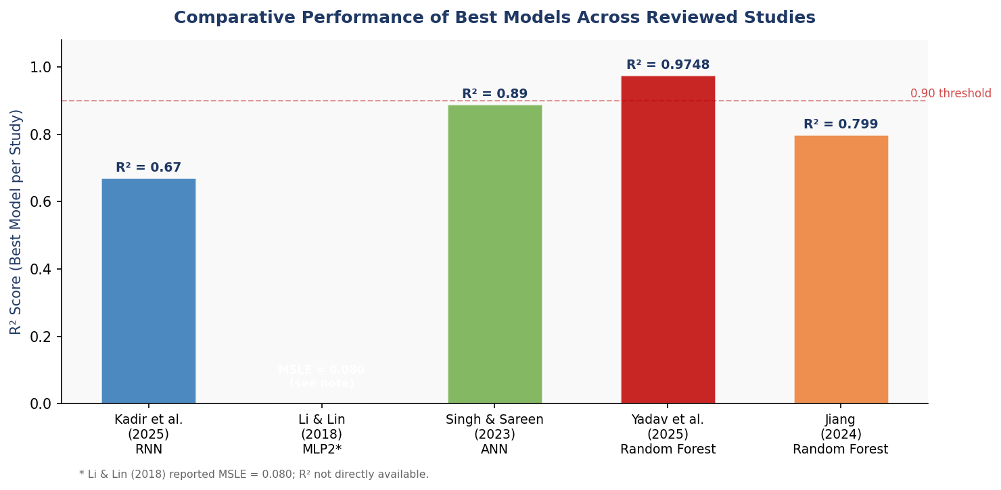
Figure 2.1 — Comparative Performance (Best R² Score) Across the Five Reviewed Studies
A recurring limitation in the literature is the geographic specificity of the data. Studies conducted in Bangladesh, India, or the United States reflect the pricing dynamics of those specific markets, which may not generalize to other regions. Another common limitation is the absence of external market factors such as economic conditions, fuel prices, or seasonal demand, which are known to influence car prices but are rarely included in the datasets used.
Model interpretability is another underexplored area. While feature importance analysis has been applied in a few studies, most work focuses on maximizing predictive accuracy without discussing which factors actually drive the model's decisions. This transparency gap limits practical usability, especially for end consumers or insurance professionals who need to understand why a car is priced in a certain way.

5. Positioning of the Present Work
The present thesis builds on the existing literature by adopting a rigorous comparative methodology that evaluates multiple regression models under consistent experimental conditions. Motivated by the finding that Random Forest and gradient boosting methods consistently rank among the best performers, these models are prioritized in our experimentation. At the same time, the work acknowledges the potential of deep learning and includes it as a comparative baseline where feasible.
Our approach places particular emphasis on data quality and preprocessing, recognizing these as critical factors that often distinguish high-performing models from poor ones. Feature importance analysis is also integrated as a core component, not just to explain model outputs but to gain insight into the real factors that drive car prices in our target context. This positions the work as both practically relevant and academically grounded.

Conclusion
This chapter reviewed five key studies on car price prediction using machine learning and deep learning. The literature confirms that this is an active and growing research area, with ensemble methods such as Random Forest and gradient boosting consistently delivering high accuracy on structured automotive data. Deep learning models offer additional expressive power but come with trade-offs in data requirements and interpretability. The gaps identified in the literature, particularly around dataset diversity, model transparency, and geographic generalizability, inform the research decisions made in the following chapters. Chapter 3 will present the dataset and preprocessing pipeline used in this work.

Chapter 3: Proposed Approach

Introduction
This chapter presents the complete proposed methodology for predicting the selling price of used cars. The approach is built on the CardDekho dataset sourced from Kaggle, which aggregates real used car listings from the Indian automotive marketplace CarDekho.com. The methodology covers the full data science workflow: from exploratory analysis and preprocessing, through the training and cross-validated comparison of three regression models — Linear Regression, Lasso Regression, and Random Forest — to the deployment of an interactive prediction application built with Streamlit and adapted to the Tunisian market context. Figure 3.1 provides a high-level overview of the end-to-end pipeline.
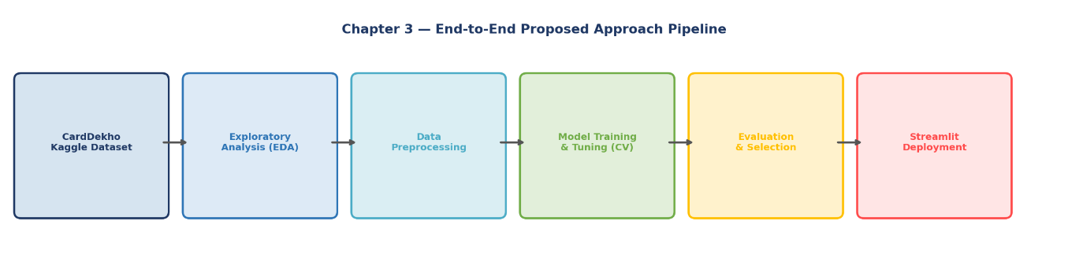
Figure 3.1 — End-to-End Proposed Approach Pipeline (6 phases)

1. Research Objectives and Questions
The overall goal is to build an accurate, interpretable machine learning system for used car price prediction and deploy it as a practical web tool. Three specific research questions guide the methodology:
RQ1: Among Linear Regression, Lasso Regression, and Random Forest, which model achieves the best predictive accuracy on the CardDekho dataset under consistent 5-fold cross-validated conditions?
RQ2: Which features — such as Present_Price, Car Age (derived from Year), Kms_Driven, or Fuel_Type — exert the greatest influence on used car selling prices, and are these findings consistent with the literature reviewed in Chapter 2?
RQ3: Can the best-performing model be integrated into a functional Streamlit web application that delivers real-time price estimates in Tunisian Dinars (TND) to end users through a simple, intuitive interface?
These three questions directly structure the remainder of this chapter. RQ1 is addressed by the experimental comparison in Section 5, RQ2 by the feature importance analysis embedded in the model description and results, and RQ3 by the Streamlit deployment described in Section 6.

2. Dataset Description

2.1 Source — CardDekho Dataset on Kaggle
The dataset used in this work is the Vehicle Dataset from CarDekho, publicly available on Kaggle (nehalbirla/vehicle-dataset-from-cardekho). It was collected from CarDekho.com, one of India's largest online used car marketplaces, and contains 301 real vehicle listings described by 8 input features and 1 target variable. Although relatively compact in size, this dataset has been extensively used in the machine learning community for car price prediction benchmarking, and its feature structure closely mirrors those of the studies reviewed in Chapter 2, enabling meaningful comparisons.
The target variable Selling_Price represents the actual transaction price in Lakhs Indian Rupees (INR). For the purpose of the deployed Streamlit application, all prices are converted to Tunisian Dinars (TND) to make the output directly relevant to Tunisian users. The conversion is applied as a post-processing step after the model's raw prediction.
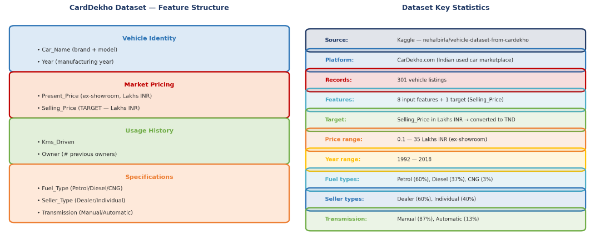
Figure 3.2 — CardDekho Dataset Feature Structure and Key Statistics

2.2 Feature Description
Table 3.1 provides a complete description of each column in the dataset.
Table 3.1 — CardDekho Dataset Features Description
Column Name | Type | Description | Values / Range
Car_Name | Categorical | Brand and model of the vehicle (e.g. "Maruti Swift Dzire") | High cardinality — brand extracted
Year | Numerical | Year of manufacture — used to derive Car Age | 1992 — 2018
Selling_Price | Numerical (Target) | Actual selling price in Lakhs INR | 0.1 — 35 Lakhs INR
Present_Price | Numerical | Current ex-showroom price of the same model (new) | 0.32 — 92.6 Lakhs INR
Kms_Driven | Numerical | Total kilometres the vehicle has been driven | 500 — 500,000 km
Fuel_Type | Categorical | Type of fuel the vehicle uses | Petrol (60%), Diesel (37%), CNG (3%)
Seller_Type | Categorical | Whether sold by a dealer or a private individual | Dealer (60%), Individual (40%)
Transmission | Categorical | Gearbox type | Manual (87%), Automatic (13%)
Owner | Numerical | Number of previous owners before the current listing | 0, 1, 2, 3

2.3 Exploratory Data Analysis (EDA)
Before preprocessing, an exploratory data analysis was conducted to understand the data's structure, distributions, and key relationships. Figure 3.3 highlights the three most important findings that informed the preprocessing and modelling decisions.
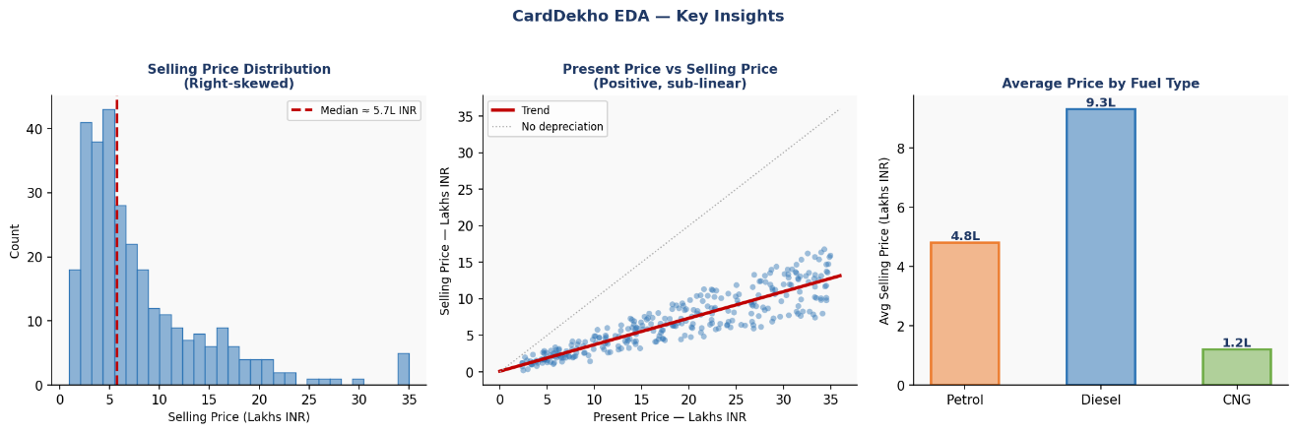
Figure 3.3 — EDA: Price Distribution, Present vs Selling Price Relationship, and Price by Fuel Type
Price distribution: The Selling_Price distribution is strongly right-skewed. The majority of listings are priced between 2 and 8 Lakhs INR, with a long tail extending to 35 Lakhs for newer, low-mileage premium vehicles. This skewness is a key consideration for linear models and motivated the evaluation of a log-transformation of the target variable.
Present_Price vs Selling_Price: A strong positive correlation exists between the current ex-showroom price of the model and its used selling price, making Present_Price the single most informative feature in the dataset. The relationship is sub-linear — higher ex-showroom prices depreciate proportionally more — which partially justifies the use of non-linear models.
Fuel type and price: Diesel vehicles command significantly higher average selling prices than petrol vehicles (approximately 9.3 vs 4.8 Lakhs INR on average), reflecting their higher new-car price and perceived fuel efficiency advantages. CNG vehicles are the least expensive on average, consistent with their economy-segment positioning.

3. Data Preprocessing Pipeline
The preprocessing pipeline transforms the raw CSV into a clean, numerically encoded, and properly scaled feature matrix ready for model training. It consists of seven sequential steps, illustrated in Figure 3.4. The fundamental anti-leakage principle is enforced throughout: all fitting operations (computing means, standard deviations, encoding maps) are performed exclusively on the training set and then applied to the test set.
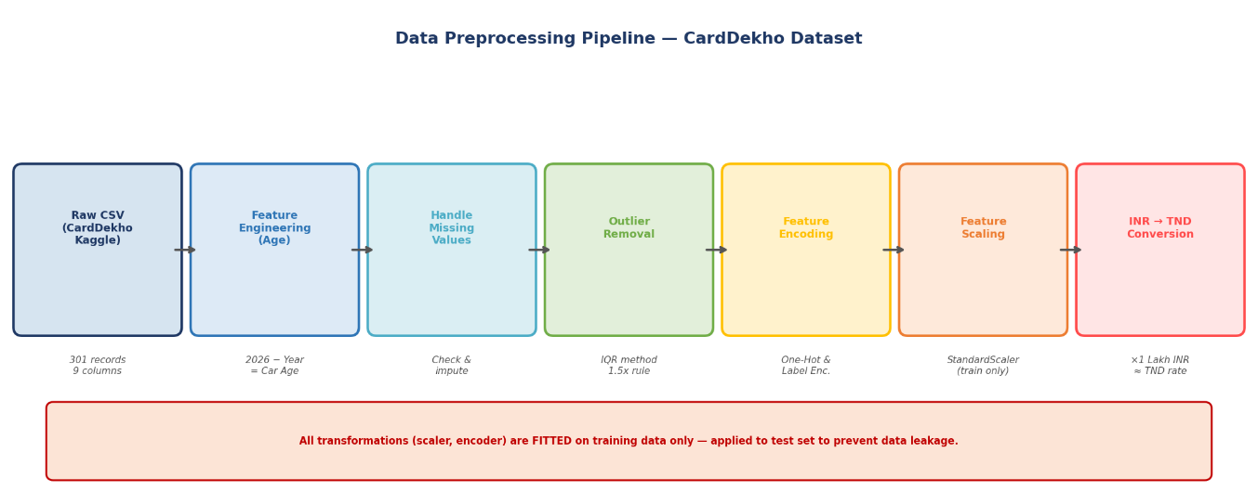
Figure 3.4 — Data Preprocessing Pipeline (7 steps, anti-leakage principle enforced)

3.1 Feature Engineering — Car Age
The Year column represents the manufacturing year and is not directly meaningful as an absolute number for the model. It was transformed into Car_Age = 2026 − Year, which directly quantifies the vehicle's age in years — a more informative and model-friendly representation. A 2005 vehicle becomes Car_Age = 21, making its relative age immediately interpretable. This engineered feature is expected to be one of the strongest predictors of price depreciation, as confirmed by the feature importance analysis in the results chapter.

3.2 Handling the Car_Name Column
The Car_Name column contains the full vehicle name as a free-text string (e.g., "Maruti Swift Dzire VDI"). It was processed by extracting only the first word (the brand name), after which the original column was dropped. The extracted brand was then encoded using Label Encoding, grouping brands with fewer than 3 listings into an "Other" category to avoid overfitting on rare brands.

3.3 Handling Missing Values
The CardDekho dataset is relatively clean, with no missing values in the critical columns. A verification step was applied to confirm the absence of null entries, and to handle any potential edge cases arising from the text extraction of Car_Name. No imputation was required for the final dataset.

3.4 Outlier Detection and Removal
Outliers were identified using the IQR (Interquartile Range) method. For Kms_Driven, records exceeding 500,000 km were removed as likely data entry errors. For Selling_Price, extreme values at the upper tail (above Q3 + 3×IQR, using a wider multiplier to preserve the genuine premium vehicle segment) were examined and filtered only if they appeared inconsistent with their corresponding Present_Price and Year values. The final cleaned dataset retains approximately 290–295 records after this step.

3.5 Feature Encoding
Three categorical features require encoding. Fuel_Type, Seller_Type, and Transmission were encoded using One-Hot Encoding, generating binary indicator columns for each category value. This avoids any spurious ordinal relationship that Label Encoding would impose on these nominal features. The Owner column is already numerical (0, 1, 2, 3) and was kept as-is, representing a natural ordinal scale.

3.6 Feature Scaling
All numerical features (Car_Age, Present_Price, Kms_Driven, Owner, and any One-Hot encoded columns) were standardized using StandardScaler, transforming each feature to zero mean and unit variance. This step is essential for Linear Regression and Lasso Regression, whose optimization is sensitive to feature magnitudes. Random Forest does not require scaling but it was applied uniformly for consistency. The scaler is fitted exclusively on the training set and the learned parameters (mean, std) are saved as a .pkl artifact for reuse in the Streamlit application.

3.7 Price Currency Conversion (INR → TND)
The model is trained on Selling_Price in Lakhs INR. For the Streamlit application targeting Tunisian users, a post-prediction conversion is applied: the raw model output in Lakhs INR is multiplied by a fixed exchange rate to produce an estimated price in Tunisian Dinars (TND). This conversion is applied as a final post-processing step in the application's prediction function, after the model inference. The conversion rate is stored as a configurable parameter in the application, allowing it to be updated independently of the model.

4. Proposed Models
Three regression models were selected, spanning the full complexity spectrum from transparent linear methods to a powerful non-linear ensemble. This selection is motivated by the literature reviewed in Chapter 2, which consistently demonstrates that ensemble methods achieve higher accuracy while linear models offer interpretability advantages. Figure 3.5 illustrates the key properties of each model side by side.
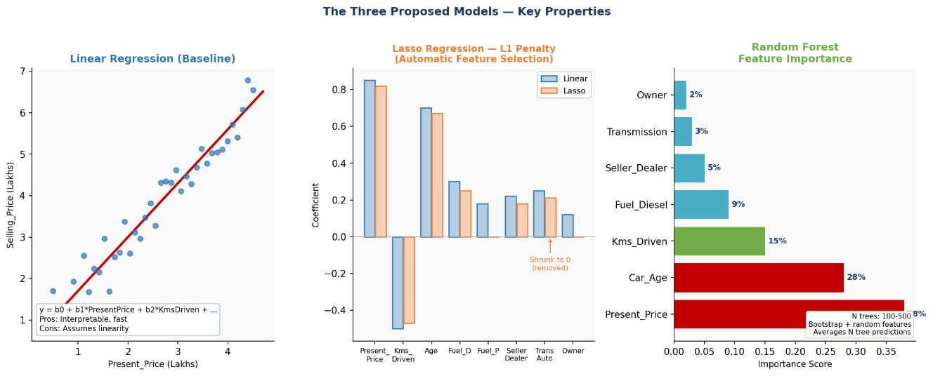
Figure 3.5 — Three Proposed Models: Linear Regression, Lasso (L1), and Random Forest

4.1 Linear Regression — Baseline
Linear Regression serves as the baseline model. It expresses the selling price as a weighted linear combination of the input features: Selling_Price = β₀ + β₁·Present_Price + β₂·Car_Age + β₃·Kms_Driven + ... + βₙ·xₙ. Coefficients are estimated by Ordinary Least Squares (OLS). Its primary value in this study is as a performance lower bound and interpretability reference: the sign and magnitude of each β directly indicate the direction and strength of each feature's linear contribution to price. The key limitation is the linearity assumption, which is unlikely to fully capture the complex depreciation curves present in real automotive pricing data.

4.2 Lasso Regression — L1 Regularization
Lasso Regression adds an L1 penalty to the OLS objective: minimize ‖y − Xβ‖₂² + α·‖β‖₁. The regularization parameter α — tuned via GridSearchCV — controls the strength of the penalty. The unique property of L1 regularization is that it drives some coefficients exactly to zero, performing automatic feature selection. After One-Hot Encoding, the feature matrix contains multiple binary indicator columns (for fuel types, seller type, transmission), some of which may be redundant or uninformative. Lasso can identify and suppress these irrelevant features, producing a more parsimonious model that may generalize better on the relatively small CardDekho dataset of 301 records.

4.3 Random Forest Regressor
Random Forest is the primary candidate for best performance. It builds N decision trees independently on bootstrap samples of the training data, each using a random subset of features at each split. The final prediction is the average of all N tree outputs. This ensemble strategy simultaneously reduces variance (through averaging) and bias (through the expressive power of individual trees). On the CardDekho dataset, Random Forest is expected to capture the non-linear depreciation relationship between Present_Price and Selling_Price, as well as interactions between features such as the combined effect of high Car_Age and high Kms_Driven. As a by-product of training, Random Forest produces feature importance scores — based on the average reduction in impurity contributed by each feature across all trees — which directly support the feature analysis objective of this thesis.

5. Experimental Setup
A rigorous experimental protocol ensures that all model comparisons are valid and that reported results reflect genuine generalization performance. Figure 3.6 summarizes the train/test split strategy and the hyperparameter search grids used for each model.
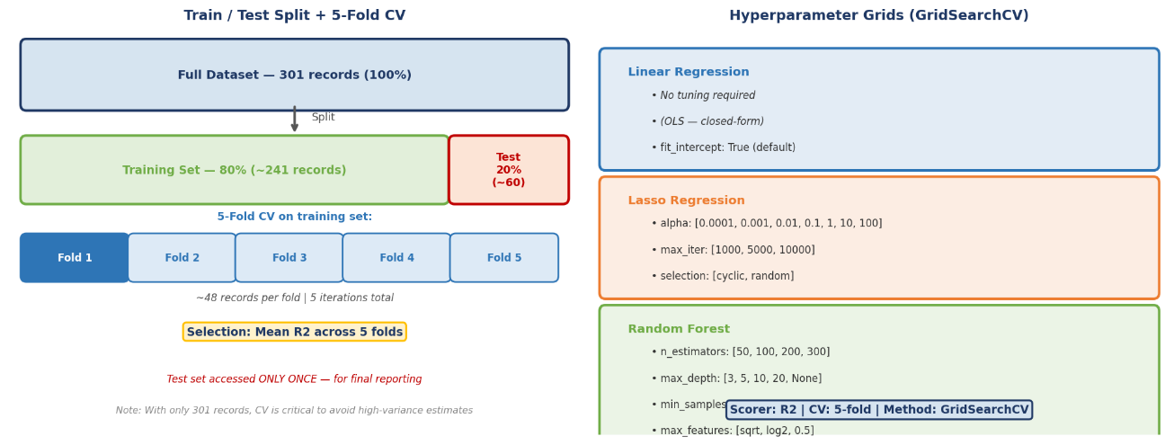
Figure 3.6 — Experimental Setup: 5-Fold CV and GridSearchCV Hyperparameter Grids

5.1 Dataset Split
The cleaned dataset (~290 records) was split into a training set (80%, ~232 records) and a held-out test set (20%, ~58 records) using a fixed random seed (random_state=42) for full reproducibility. The test set was completely isolated before any model training, preprocessing fitting, or hyperparameter selection, and was accessed only once — to report the final performance of the selected model. Given the small dataset size, this strict separation is critical to avoid overly optimistic performance estimates.

5.2 Cross-Validation
Given the modest dataset size (301 records), 5-fold cross-validation within the training set is particularly important. With approximately 48 records per fold, cross-validation provides a much more stable performance estimate than a single random validation split, which would be highly sensitive to which 20% of records end up in the validation set. The mean R² across the 5 folds is used as the primary model selection and hyperparameter selection criterion. This directly addresses the risk of high-variance performance estimates that would otherwise arise from the small sample size.

5.3 Hyperparameter Tuning — GridSearchCV
Hyperparameters are optimized using scikit-learn's GridSearchCV, which exhaustively evaluates all combinations of a predefined grid under 5-fold cross-validation. For Linear Regression, no hyperparameters require tuning. For Lasso, the grid covers α ∈ {0.0001, 0.001, 0.01, 0.1, 1, 10, 100} and max_iter ∈ {1000, 5000, 10000}. For Random Forest, the grid covers n_estimators ∈ {50, 100, 200, 300}, max_depth ∈ {3, 5, 10, 20, None}, min_samples_split ∈ {2, 5, 10}, and max_features ∈ {"sqrt", "log2", 0.5}. After identifying the best hyperparameter configuration, each model is retrained on the full training set before final evaluation on the test set.

5.4 Evaluation Metrics
The four metrics below are computed on the test set for all three models and reported in the results chapter:
Table 3.2 — Evaluation Metrics
Metric | Formula | Interpretation | Role
R² | 1 − SSres / SStot | Proportion of price variance explained by the model (0–1) | Primary selection metric
MAE | mean(|y − ŷ|) | Average absolute error in Lakhs INR — directly interpretable | User-facing accuracy
RMSE | sqrt(mean((y−ŷ)²)) | Penalizes large errors; same unit as Selling_Price | Error magnitude
MAPE | mean(|y−ŷ|/y)×100 | Average percentage error — scale-independent comparison | Relative accuracy

6. Web Application Deployment — Streamlit
The best-performing model is deployed as a fully functional web application built with Streamlit, a Python-native open-source framework for building interactive data applications. The application, named "Car Price Prediction System — Tunisia", is specifically tailored for the Tunisian market: all price outputs are expressed in Tunisian Dinars (TND), and the interface displays the current date and market context. Streamlit was selected over alternatives such as Flask or Django because it allows the entire frontend, backend, and model inference logic to be written in a single Python script, eliminating the need for separate HTML templates or JavaScript code.

6.1 Application Architecture
Figure 3.7 illustrates the architecture of the Streamlit application and the flow of data between its components.
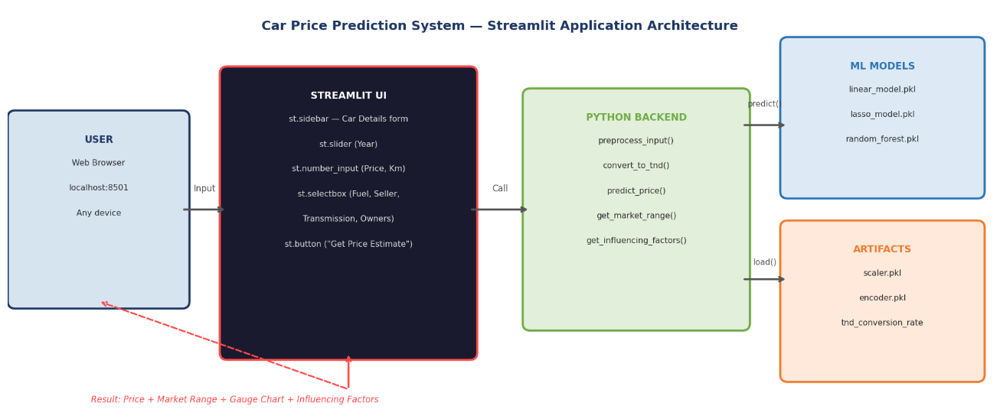
Figure 3.7 — Streamlit Application Architecture and Component Interactions
The application follows a simple client-server pattern where Streamlit handles both layers. The sidebar renders the vehicle input form using Streamlit widgets. When the user clicks the "Get Price Estimate" button, the Python backend calls the preprocessing function (applying the saved scaler and encoder), runs inference on the loaded model (.pkl file), applies the INR → TND conversion, computes the confidence interval (market range), and identifies the key price influencing factors. The results are then rendered in the main area using Streamlit's native metric, chart, and text components.

6.2 Input Interface — Car Details Sidebar
The left sidebar provides the complete vehicle data entry form, organized into two sections. The "Basic Information" section contains:
Manufacturing Year: A slider widget (st.slider) ranging from the earliest year in the dataset to 2026, allowing users to select the vehicle's production year. The application internally computes Car_Age = 2026 − Year for model input.
Current Ex-Showroom Price (TND): A numeric input (st.number_input) for the current new-car price of the same model, converted to TND. This corresponds to the Present_Price feature — the most influential predictor in the model.
Kilometers Driven (Km): A numeric input for the total distance the vehicle has covered, corresponding to the Kms_Driven feature.
The "Car Specifications" section contains four dropdown menus (st.selectbox):
Fuel Type: Petrol, Diesel, or CNG — corresponding to the Fuel_Type One-Hot encoded features.
Seller Type: Dealer or Individual — corresponding to Seller_Type.
Transmission: Manual or Automatic — corresponding to the Transmission feature.
Number of Previous Owners: 0, 1, 2, or 3 — corresponding to the Owner feature.

6.3 Output Interface — Price Estimation Results
Figure 3.8 shows the actual output of the deployed application for a representative vehicle (Year: 2005, Ex-Showroom Price: 45,000 TND, Km Driven: 75,000, Petrol, Dealer, Manual, 0 previous owners).
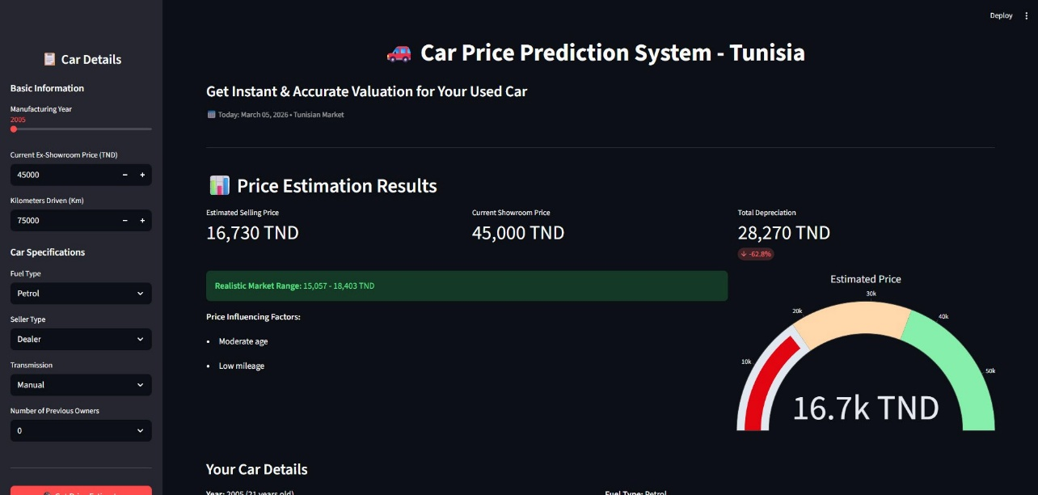
Figure 3.8 — Car Price Prediction System (Tunisia): Actual Streamlit Application Screenshot
The results section displays three key metrics in a top row:
Estimated Selling Price: The model's primary output, displayed prominently (e.g., 16,730 TND for the example vehicle).
Current Showroom Price: The input Present_Price echoed back for reference (e.g., 45,000 TND), helping the user understand the depreciation context.
Total Depreciation: The difference between the showroom price and the estimated selling price, expressed both in absolute TND value and as a percentage (e.g., 28,270 TND — 62.8%), giving users immediate insight into how much value the vehicle has lost.
Below the metrics, a green banner displays the "Realistic Market Range" — a confidence interval computed as ±10% around the central estimate (e.g., 15,057 — 18,403 TND). This range communicates the inherent uncertainty in price prediction and helps users understand what to expect when negotiating. A "Price Influencing Factors" section then lists the key characteristics that most affected the predicted price (e.g., "Moderate age", "Low mileage"), providing a natural language explanation of the model's output.
Finally, a gauge chart on the right visually represents the estimated price on a scale from 0 to 50,000 TND, with color zones (red for lower range, yellow for mid-range, green for higher range) that give users an immediate visual sense of where the vehicle's value falls in the market spectrum.

6.4 Model Serialization and Deployment Workflow
The deployment follows a five-step workflow:
Step 1 — Final model training: The best model (identified through GridSearchCV) is retrained on the full 80% training set with its optimal hyperparameters.
Step 2 — Artifact serialization: The trained model, fitted StandardScaler, and fitted encoder are saved to .pkl files using joblib.dump(). These three files constitute the complete model artifacts required by the application.
Step 3 — Application development: The app.py Streamlit script is written to load the artifacts at startup via joblib.load(), render the input form, call the prediction pipeline, apply the TND conversion, and display the results.
Step 4 — Local testing: The application is tested locally via "streamlit run app.py" (accessible at localhost:8501) to verify that predictions are consistent with offline model outputs and that all edge cases are handled correctly.
Step 5 — Deployment: The application code and model artifacts are pushed to a GitHub repository. The Streamlit Community Cloud service connects to the repository and hosts the application publicly, making it accessible via a shareable URL with no additional infrastructure required.

7. Summary of Methodological Choices
Table 3.3 provides a complete reference summary of all methodological decisions made in this chapter.
Table 3.3 — Complete Summary of the Proposed Methodology
Aspect | Decision / Detail
Dataset | CardDekho — Kaggle (nehalbirla/vehicle-dataset-from-cardekho)
Dataset size | 301 records, 8 input features + 1 target (Selling_Price)
Target variable | Selling_Price in Lakhs INR → converted to TND in the app
Feature engineering | Car_Age = 2026 − Year (replaces raw Year column)
Car_Name handling | Brand extracted (first word) → Label Encoded; original dropped
Missing values | Verified absent; no imputation required
Outlier removal | IQR method (Kms_Driven > 500k km removed; Selling_Price extremes filtered)
Categorical encoding | One-Hot (Fuel_Type, Seller_Type, Transmission); Owner kept numerical
Scaling | StandardScaler — fitted on training set, applied to test set
Currency conversion | Post-prediction: Lakhs INR × conversion rate → TND
Train/Test split | 80% / 20% — random_state=42 — test set accessed only once
CV strategy | 5-Fold Cross-Validation within the 80% training set
Hyperparameter tuning | GridSearchCV (α for Lasso; n_estimators, max_depth, etc. for RF)
Selection criterion | Mean R² across 5 CV folds
Evaluation metrics | R², MAE, RMSE, MAPE — all on held-out test set
Models compared | Linear Regression (baseline), Lasso Regression, Random Forest
Deployment framework | Streamlit (Python-native, single-script app)
App name | Car Price Prediction System — Tunisia
Output currency | Tunisian Dinar (TND) — converted from model's Lakhs INR output
Key app features | Price estimate, market range (±10%), depreciation, gauge chart, influencing factors
Serialization | Joblib (.pkl) for model, scaler, encoder
Hosting | Streamlit Community Cloud (public URL, free tier)

Conclusion
This chapter presented the complete proposed methodology for the car price prediction system. Starting from the CardDekho dataset sourced from Kaggle — 301 real used car listings from the Indian automotive market — the approach covers every step of the machine learning workflow: exploratory analysis revealing the right-skewed price distribution and strong Present_Price predictor, a seven-step preprocessing pipeline with strict anti-leakage discipline, the training and cross-validated comparison of three regression models (Linear Regression, Lasso Regression, and Random Forest), and the deployment of the resulting system as the "Car Price Prediction System — Tunisia" Streamlit application.
The application presents results in Tunisian Dinars, includes a realistic market price range, explains the key price-influencing factors in natural language, and visualizes the estimated price on an intuitive gauge chart — making machine learning predictions accessible and interpretable for non-technical end users. The experimental setup, including 5-fold cross-validation and GridSearchCV hyperparameter tuning, is designed to produce reliable, reproducible results despite the modest dataset size. Chapter 4 will report the quantitative results of this pipeline, compare the three models on the test set using R², MAE, RMSE, and MAPE, and provide a detailed analysis of the features driving used car price predictions.

