**Microprocessor and Microcontrollers**

**CSE2016**

ALCOHOL DETECTION

**REVIEW- 2+3**

**19BCT0082 JASSHU GARG**

**19BCT0123 JAIDEEP KHICHAR**

**1.Refined Problem Statement - What is your proposed work to qualify and quantify with survey results?**

* 1. **IOT Solution – Sensing / Actuation / Communication (3)**
  2. **Cloud and Analytics (2)**
  3. **UI (1)**

1. **Software Solution**
   1. **Data – dataset / database / files**
   2. **Algorithm** – Parameters and Operations - Mathematical Model
   3. **Programming Environment**
      1. **Platform Specifications – OS and specifications**
      2. **Programming Language – why?**
      3. **System Software – Compiler / Interpreter**
      4. **Packages**
      5. **Simulation / Emulation Tool and Packages**
   4. **Cloud Platform**
   5. Analytics
   6. Performance Metrics
   7. **Results – Tables and Graphs**
2. **Hardware Solution** 
   1. **Development Board Specifications**
   2. **Processing Element Specifications – MPU or MCU**
   3. **Peripherals or components (sensor / actuator / input / output / communication / others)**
      1. **Working Principle**
      2. **Interfacing**
      3. **Pseudo code or logic or actual code for read and write**
   4. **Actual hardware snapshots**
   5. **Circuit connection snapshots**
   6. Online simulation or emulation tool
   7. Results – Snapshots, Tables and Graphs
3. Cloud Platform
4. Analytics Platform
5. UI Design

**Refined problem statement**

Consumption of Alcohol is considered bad for our health, as it effects our body parts like liver, in addition to that, driving after alcohol consumption is effecting so many things in the world, a drunk driver who is effecting his/her body by taking alcohol also become a problem for other people and property. A drunk driver does not have enough control over mind to control the vehicle, which leads to accidents causing many deaths, damage of vehicles, damage of properties, in addition to that there can be traffic jams which waste time of millions more people in whole world.

**Proposed Work/Solution:**

The proposed solution to this problem is to develop a device which will detect the Alcohol consumption of the driver and if the limits are crossed in terms of alcohol content, then the device will turn off the vehicle to prevent road accidents happening due to alcohol consumption. initially we proposed a solution in which the device is itself informing a family member, helper or any friend , but in case there are other members in the vehicle who is not drunk , so he/she can drive the vehicle. So sending information unnecessarily is not efficient , and we proposed a new solution in which , if drunk driver is alone , driver can use a website for help where details of his close ones will be there and that will be maintained by an organization or a company which will provide a helper/driver to that drunk one in case there is no one from his provided list to help like if the person is in different city or state.

**UI**

User interface of the device with user is very simple . it will automatically detecting alcohol and process the data collected. And the results will be displayed on a LCD display .

The user will be using a website in case a help/assistance required in case of emergency. The user can log in just by his Mobile number and a button for asking for help will take the location of the device and send it to particular person.

**IOT Solution:**

The device uses an alcohol sensing sensor to detect the alcohol in the environment of alcohol and then processes the information provided by alcohol sensor which leads to further actions to prevent road accidents like breaking the ignition circuit of the vehicle.

**Cloud:**

Cloud storage in this project plays a role for the hosting of a website which will be used by driver in case he needs help in driving , this will also help the driver in case the driver has not consumed alcohol but some other things happened like driver is not feeling well and other reasons.

**ALGORITHM:**

1. When the drivers sit on its position in the vehicle i.e. Driver seat , the alcohol sensor will sense the alcohol in its surroundings and send the information to microcontroller
2. Next, the microcontroller will process the collected information from sensor and confirm if the consumed alcohol content is within limits or exceeding the limits
3. there will be display of the alcohol content on a LCD display
4. If the alcohol level is below the threshold amount of alcohol, then vehicle will function normally.
5. In case, the alcohol content is crossing the limits, then the microcontroller will take the action and break the vehicle’s ignition circuit.
6. In that condition, if there is any person from passengers eligible of driving the vehicle then that person can take the control
7. But in case there is no passenger, the driver has to either make a call to a friend, or there is another option, open a website (which will be owned by company or an organization) and there will be simple button for ‘HELP’, and the website will take geological coordinates of the device and information will be circulated to either the emergency contacts added by the user or in case any of the contact is not able to help then the organization will send a person for helping the drunk user.

**HARDWARE REQUIREMENTS :**

* POWER SUPPLY
* ALRDUINO UNO
* MQ3 ALCOHOL SENSOR
* DC MOTOR
* BUZZER
* LCD DISPLAY
* TRANSISTOR
* **Arduino UNO board** -It is an open source electronic platform based on easy to use hardware and software. It is used for sending receiving and processing the signal and it helps to rotate the dc motor and shows the display on the screen.
  + Features:
  + Microcontroller ATmega328
  + Operating Voltage 5V
  + Input Voltage 7-12V
  + (Recommended)
  + Input Voltage (limits) 6-20V
  + Digital I/O Pins 14 (of which 6 provide PWM output)
  + Analog Input Pins 6
  + DC Current per I/O Pin 40 mA
  + DC Current for 3.3V Pin 50 mA
  + Flash Memory- 32 KB (ATmega328) of which 0.5 KB used by boot loader
  + • SRAM 2 KB (ATmega328)
  + • EEPROM 1 KB (ATmega328)
  + • Clock Speed 16 MHz



* **DC Motor** –

DC motor is used as engine starter which would be connected to crank of the engine The speed of a dc motor is directly proportional to the supply voltage, so if we reduce the supply voltage, the motor will at half speed. The speed controller work by varying the average voltage sent to the motor. This voltage is depending upon the alcohol sensor (mq3). That means when the alcohol sensor sensed the alcohol percentage less than thresold, the motor will run. But if the sensor sensed the alcohol percentage above threshold, the motor will stop.



* **Buzzer/Alarm –**

A buzzer is a mechanical, electromechanical, magnetic, electromagnetic, electro-acoustic or piezoelectric audio signalling device. A piezo electric buzzer can be driven by an oscillating electronic circuit or other audio signal source. A click, beep or ring can indicate that a button has been pressed. A conventional Piezo bell works between 3 – 12 volts DC.



* **MQ3 Sensor –**

The Analog Gas Sensor-Mq3 Is Suitable for Alcohol Detecting the Sensor Can be used as a Breath Analyzer. It Has A High Sensitivity To Alcohol & Small Sensitivity To Benzene. The Alcohol Module Is Used To Sense The Alcohol. The Analog Output Of Which Is Applied To The Arduino Board. Resistance Value Of Mq3 Is Different Components.



* Jumper Wires – A jumper wire is an electrical wire or group of them in a cable with a connector or pin at each end , which is normally used to interconnect the components of a breadboard or other prototype or test circuit, internally or with other equipment or components.



* Arduino Data Port Cable -An Arduino serial port cable is used to burn the programming instructions in the Arduino board from computer.



* LCD Display -LCD (LIQUID CRYSTAL DISPLAY) screen is an electronic display module & finds a wide range of applications a 16*2 LCD display is very basic module & is very commonly used in various devices & circuits. These modules are preferred over seven segments & other multi segment LEDs.
* The Reasons being LCDs are economical, easily program & have no limitation of displaying special & even custom characters (unlike in seven segments). In this the LCD display is used to show the percentage of alcohol that the sensor has sensed.



**Circuit diagram**

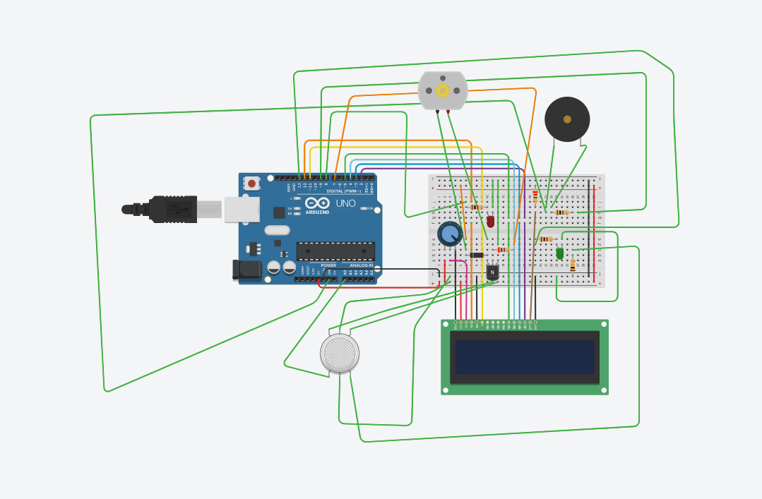

**FLOW CHART**

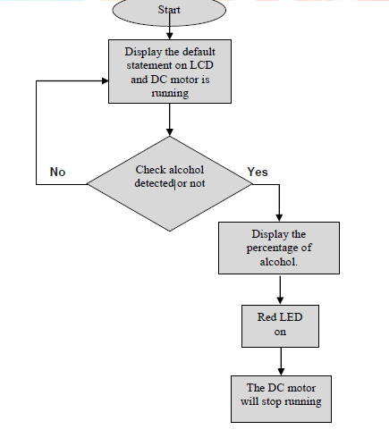

**Working of hardware**

* Dc motor:- Normally dc motor is in running condition . At that time green led glows & the % of alcohol is less than threshold . But when the % of alcohol will increase above threshold, then the motor will stop and red led will glow.
* MQ3 Sensor: -In this project the MQ 3 sensor is used as an alcohol sensor. It senses the % of ethanol molecule. When the % of ethanol will increase above the stated value, then it gives a signal to Arduino.
* Arduino board: - It is an embedded system which we used for controlling the whole section. According to the signal of MQ3 sensor it controls the working of dc motor. It also controls the LCD display module.

**Programming environment**

* Arduino IDE
* Embedded C Programming

**System Requirements:**

* Microsoft Windows Windows 7, Windows 8/8.1 and Windows 10 operating system.
* Microsoft .NET Framework 4.0 or higher.
* Intel Pentium / AMD Athlon processor or equivalent running at 1 GHz or more.
* 512 MB RAM (1 GB RAM recommended).
* 10MB free hard drive space or more (only for PROGRAMINO IDE for Arduino).

**Compiled/Interpreted**

The Arduino code is a working subset of the C/C++ programming language. The C/C++ programming language is a compiled one, not an interpreted language.

**Why this language**

**C** provides optimized machine instructions for the given input, which increases the performance of the **embedded system**. Most of the high-level languages rely on libraries, hence they require more memory which is a major challenge in **embedded systems**.

**Parameters:**

Alcohol content measured by MQ3 sensor is the only parameter which will be used by the software/Arduino Code which will process that information and take actions accordingly

**Program code:**

#include <LiquidCrystal.h>

LiquidCrystal led(12,11,5,4,3,2);

int value;

int redLed = 8;

int greenLed = 13;

int buzzer = 9;

int smokeA0 = A0;

// Your threshold value

int sensorThres = 500;

int motorPin = 7;

void setup()

{

led. begin(16, 2);

pinMode(redLed,OUTPUT);

pinMode(greenLed,OUTPUT);

pinMode(buzzer,OUTPUT);

pinMode(smokeA0,INPUT );

pinMode(motorPin, OUTPUT);

Serial.begin(9600);

}

void loop()

{

noTone(buzzer);

value= analogRead(smokeA0);

led.setCursor(1,0);

led.print(value/10);

led.print("% Alcohol");

int analogSensor =analogRead(smokeA0);

Serial.println( analogSensor); // Checks if it has reached the threshold value

if (analogSensor>sensorThres)

{

digitalWrite(redLed,HIGH);

digitalWrite(greenLed,LOW);

tone(buzzer, 1000, 200);

delay(200);

analogWrite(motorPin, 0);

}

else

{

digitalWrite(redLed, LOW);

digitalWrite(greenLed, HIGH);

//tone(buzzer, 1000, 200);

noTone(buzzer);

analogWrite(motorPin, 255);

}

delay(0);

}

**Online simulator for device:**

<https://www.tinkercad.com/>

**Circuit diagram**



**Components used**

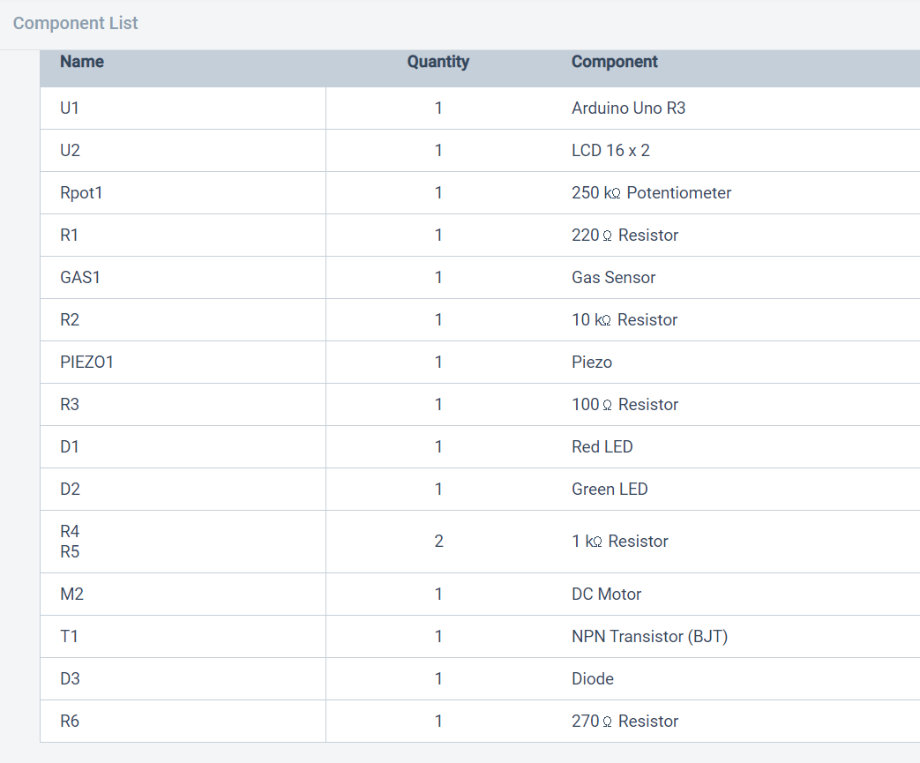

**Result:**

1. Red LED glowing when alcohol level Is more than threshold value
2. And, green LED is turned OFF
3. DC motor also stopped

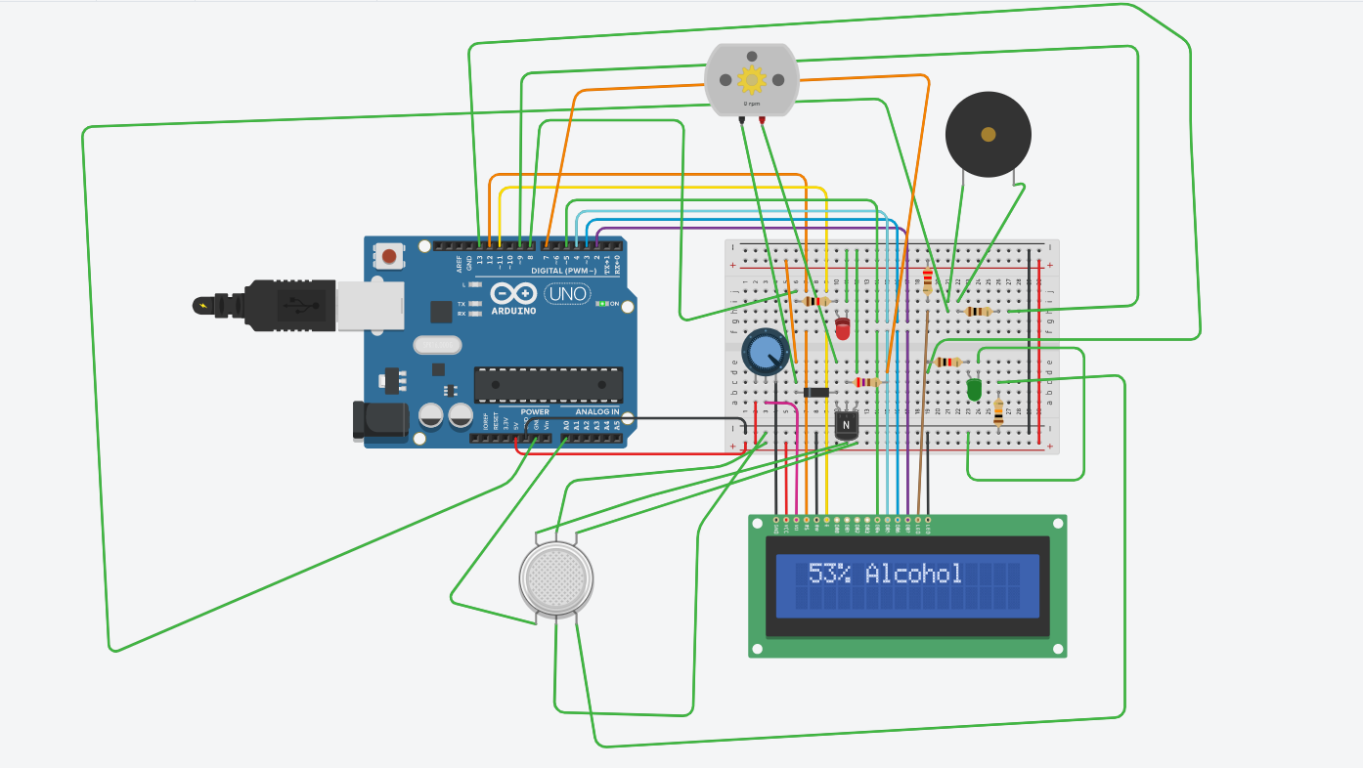

Green LED glowing when the alcohol content is less than thresold value(50%) and DC motor is also working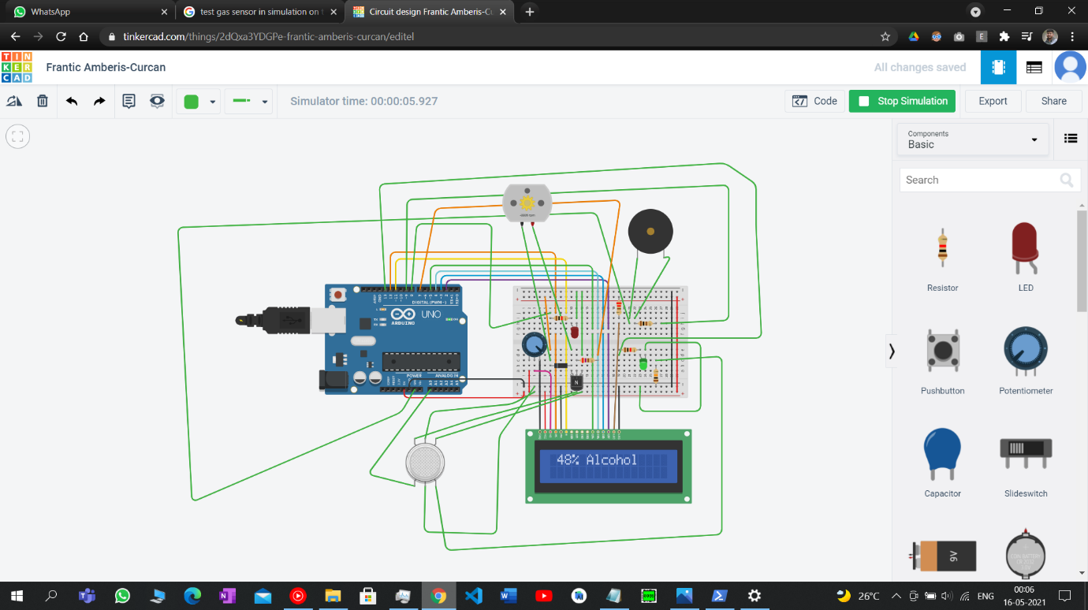

Red LED glowing when the alcohol content is more than thresold value(50%) and DC motor is also stopped working

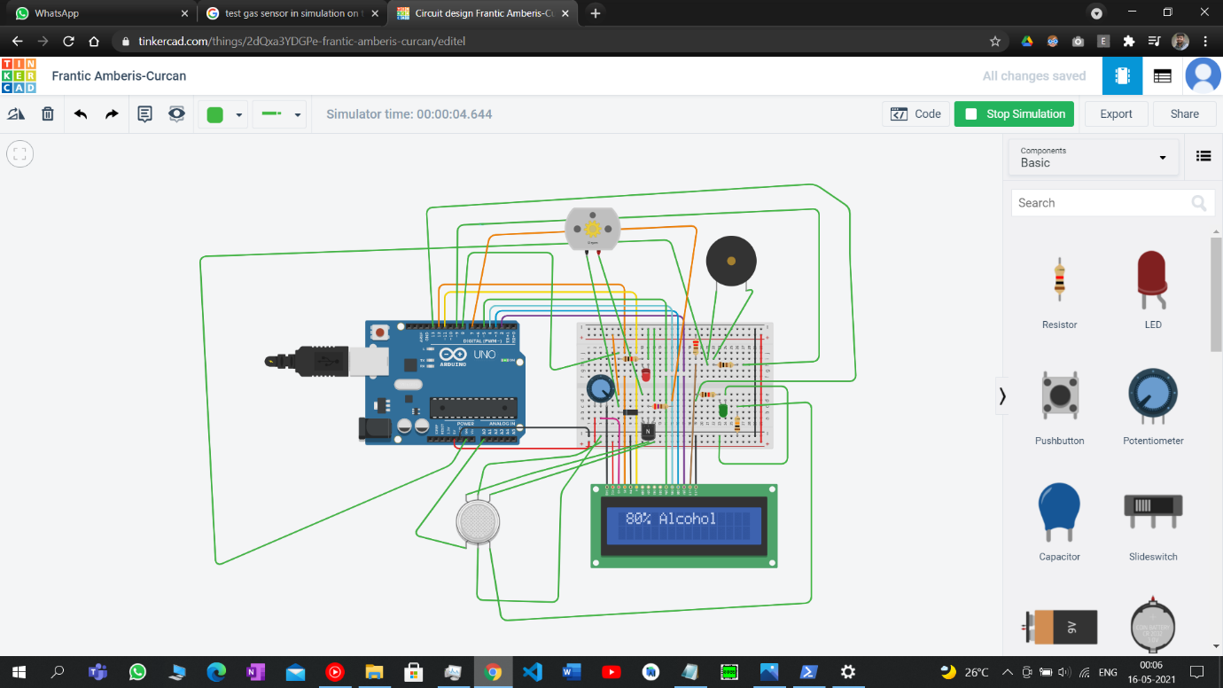

***SOFTWARE SOLUTION***

**Data:**

Details of the user are collected when they register

Basic details like name , email , phone number are collected and password for authentication

All details will be managed using MongoDB

**Database:**

In database, the schema of the information of the stored contacts will include their name, phone, id, age, vehicle information etc.

**Programming environment**

For website:

Any text Editor can be used.

* HTML
* CSS
* JS
* Node.js
* Express
* MongoDB
* In addition to these languages, Google maps API key is also required

**System Requirements:**

* Microsoft Windows 7, Windows 8/8.1 and Windows 10 or any other operating system.
* Microsoft .NET Framework 4.0 or higher.
* Minimum 2GB RAM
* Node modules required:
  + EXPRESS
  + MONGOOSE

**ALGORITHM:**

1. The user has to register earlier or before getting help.
2. At the time of emergency, user have to open the website
3. There will be only two buttons: Sign In and Sign Up
4. If user is new, then user have to register
5. If user has already registered then user can sign IN
6. When the user is Logged In his geological location will be tracked by the website automatically.
7. When the location is detected, there will be a button for HELP
8. When user click that button then the organisation/company have to send their service

**Cloud Platform**

A cloud platform refers to the operating system and hardware of a server in an Internet-based data centre. It allows software and hardware products to co-exist remotely and at scale.

There are many cloud platforms to host a website like AWS , google cloud services , digital Ocean and many more

Any of the above cloud service can be used to host a website

All the information will be saved into that platform only

Information of the users , and the log of the times when which user has asked for help and for which reason , which can be used for doing analysis or making statical reports like which are the major causes because which drivers also need assistance.

**Analytics Platform**

Analytics platforms, also known as business intelligence (BI) platforms, enable companies to gain visibility into their data through data integration, cleansing, blending, enrichment, discovery, and more. These tools are robust systems that sometimes require IT and data science skills to access and decipher company data through custom queries.

Analytics platforms offer a comprehensive look into a company's data by pulling from both structured and unstructured data sources through a series of detailed queries. Casual business users also benefit from analytics platforms with customizable dashboards and the ability to drill into particular data points and trends.

Automobile companies can pre-install this deivce into their vehicles.

Alcohol Brands can recommend this to their users to prevent loss of their customer’s life.

**UI Design:**

**About Hardware:**



**About the website:**

1. **Home page:** 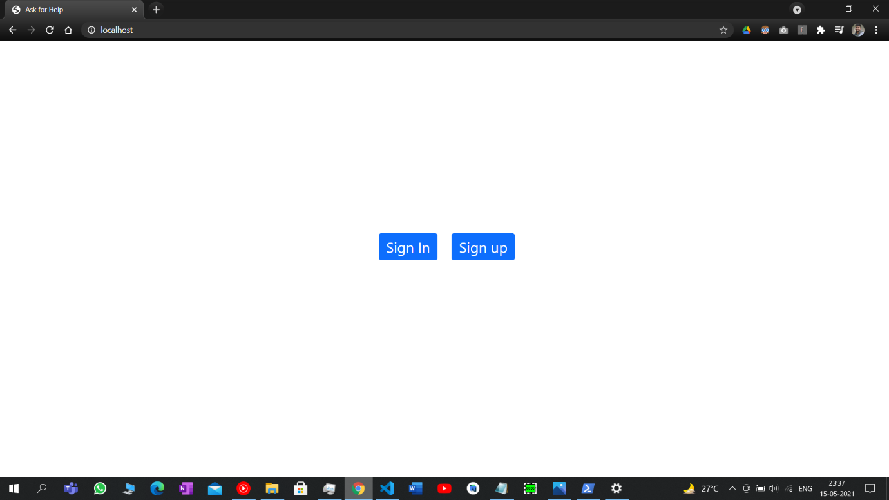
2. **Sign up page:** 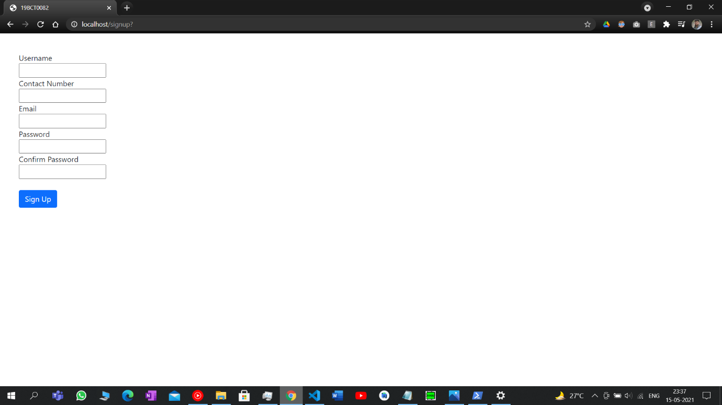
3. **Success of registering:**

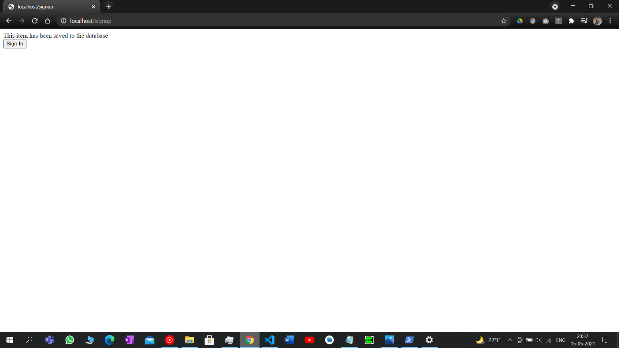

1. **Login page:**

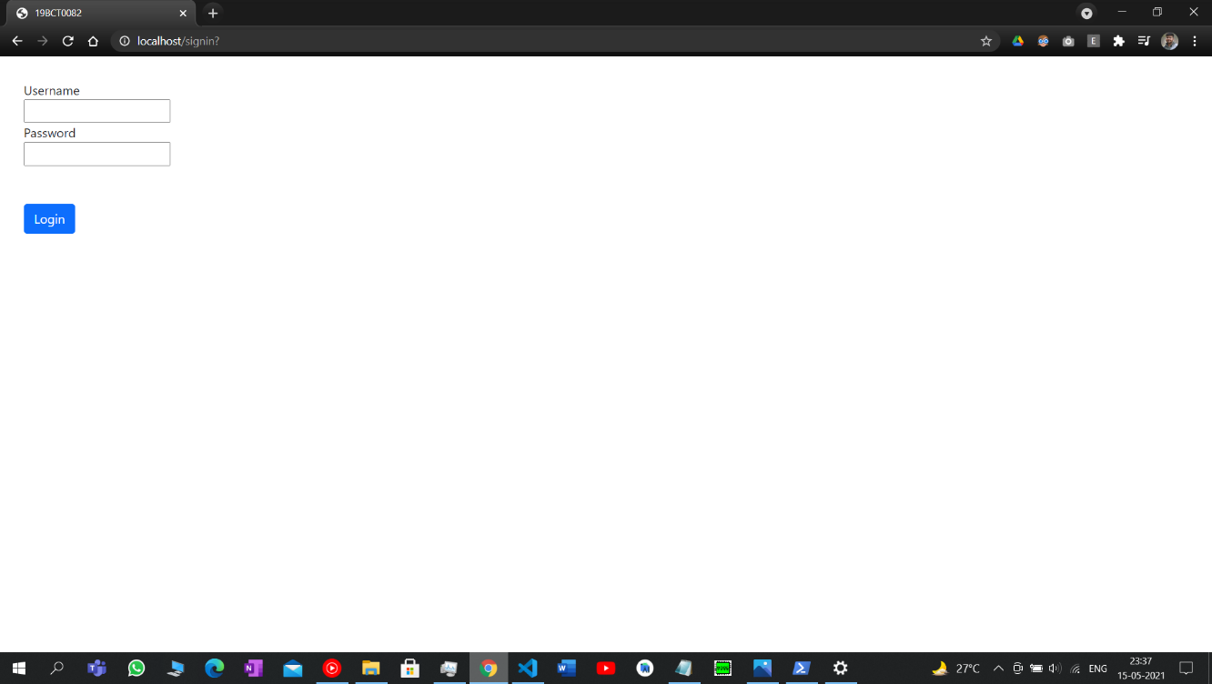

1. **Help page:**

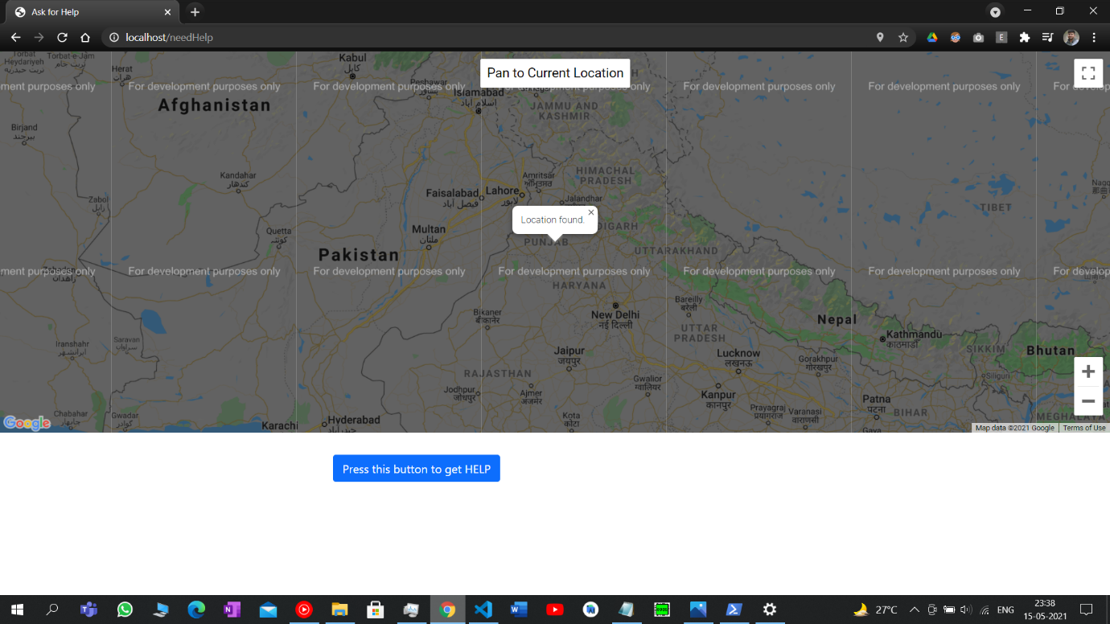

1. **Help sent page:**

