IoT-Enabled Door Lock System

*(IJACSA) International Journal of Advanced Computer Science and Applications, Vol. 10, No. 5, 2019* 445 | P a g e www.ijacsa.thesai.org

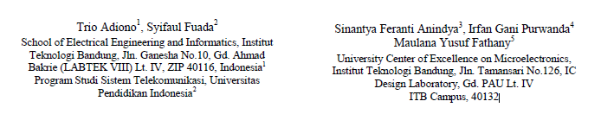

The aim of this research is to design a door lock system that **does not need manual input** from user for convenience purpose while also remaining secure.

* The system primarily consists **STM32L100 microcontroller** as its core, TIP102 transistor that controls 12 VDC solenoid, and **ZigBee module to communicate** with the smart home’s host and receive status regarding user’s GPS position.
* The system is tested by measuring the user’s distance from the predetermined location using GPS coordinate captured by an Android application, which serves to test whether the system is able to operate as intended and measure the device’s power usage.
* The test result shows that the device is able to work based on GPS coordinate data received, **using 42.3 mA and 587 mA current in idle and active modes,** respectively.

 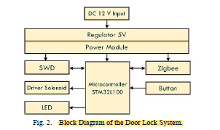 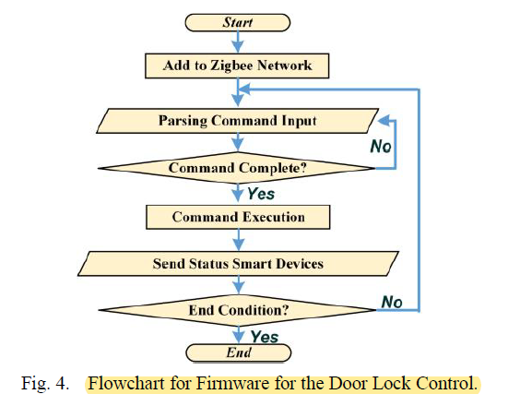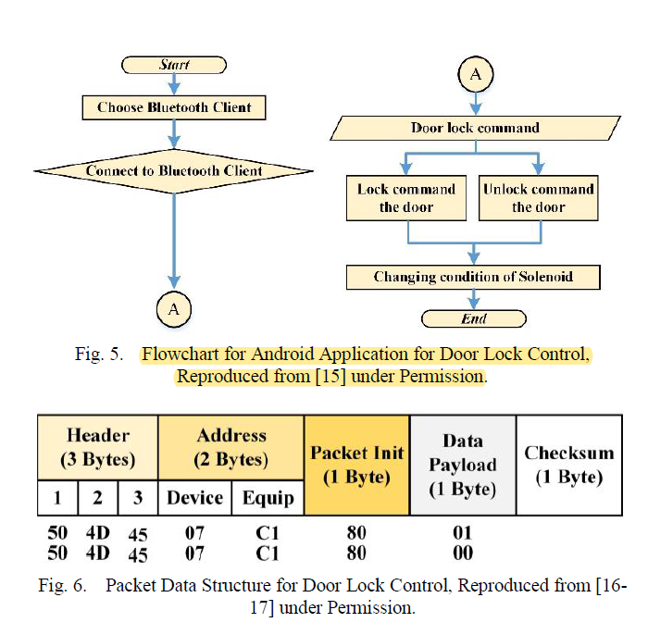

The specific structure of the message for door lock control (consisting the packet header, address, packet init, Data payload, and checksum).

Results:

*Functional Test*

The testing of the system is conducted on a door miniature. To test the door, user is required to stand within determined distances with the door. In this case, **the threshold is set to 10 meters from the door.** the door lock system that has been developed can work properly as expected. It can lock and unlock wirelessly.

*Power Measurement*

**To measure the power consumption, simply we used digital multi-meter to know the current flow during two conditions (idle and process)**.

*The power consumption in idle condition is 507.6 mW that obtained from 12 VDC * 42.3 mA, while in process condition is 7044 mW.*

**CONCLUSION**

* In this paper, a prototype of location-based smart door lock system is designed.
* The system utilizes the user’s GPS coordinate that is captured from a mobile application, which is then sent to a smart home system’s central host to enable or disable the door lock based on the user’s proximity to the door’s designated GPS coordinates.
* Based on the testing conducted, it can be concluded GPS coordinates can be used for controlling door lock.

However, further study is required to improve the quality of the system, whether in terms of power efficiency, area tracking and indoor accuracy, and further increase the security.