**Smart door system**



This project is about a smart door system using face recognition based on raspberry pi.

* It will verify the person identity that goes near to the camera within certain distance. Only the people who match the identity with database and key in the correct password have the right to entry.
* A mobile application telegram and image processing technique have been involved in this system
* Electric door lock solenoid.
* Web-based application that allows user to monitor home appliances using mobile devices
* This system includes remote control home appliances, security. Once all the appliances in home are automated and connected it important to consider issue of security authentication and access control.
* It can help to solve the issues like it can trigger the alarm and capture an image, send to owner when a stranger is detected in front of door. The theft will get alert so he got no time to start breaking the door and destroy the security system.
* Web server and wi-fi technology.
* **Arduino Wi-Fi module esp8266**. The data sent from mobile over cellular data/wi-fi will be received by wi-fi module connected to Arduino Wi-Fi module esp8266. Arduino Wi-Fi module esp8266 reads the data and decides the switching action of electrical devices connected to it through relays.
* **Blynk is a platform** with iOS and android apps to control Arduino, raspberry pi and the likes over the internet.

**Proposed system**

* The level of security can be raised by using face detection.
* lesser power consumption and more reliable standalone security device for both intruder detection and for door security.
* The proposed system is a distributed home automation system, consists of **Arduino micro controller, sensors and some electrical devices used in home.**
* **Wi-fi module is used to connect to the internet. Automation system can be accessed from the web browser of any local LAN using server IP, or remotely from any pc or device connected to the internet.**
* Instructions from an authorized device using a wireless protocol and a cryptographic key to execute the authorization process.
* Monitors access and sends alerts for the different events

**MATERIAL**

1. Raspberry Pi

2. Electromagnetic Lock

3. Wires (Male to Male)

4. Camera

5. Node MCU ESP8266

6. Blynk Application

7. Breadboard

8. LED, Fan and Sound

9. Relay Module

10. Wires (Male to Female)

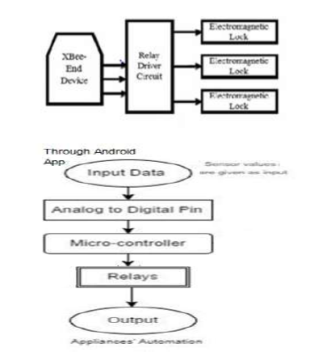

**Conclusions**

* The arrangement of a facial recognition system using raspberry pi can make the system littler, lighter and work successfully utilizing lower control use, so it is the computer - based face recognition system. Also, **send a security alert message to the authorized person utilities.**
* Open cv library which is a package in python to develop the image detection system
* This operations of calculating and sending the signals will be done by the raspberry pi 3.

**Future work**

* The inputs taken from the image detection program should be able to coordinate properly with the motors.
* Manage to make low cost, flexible smart home automation to adjust its environmental conditions and resolve its errors with energy saving