**Door-automation system using Bluetooth-based android for mobile phone**

Vol. 9, no. 10, october 2014 issn 1819-6608

Arpn journal of engineering and applied sciences

©2006-2014 asian research publishing network (arpn). All rights reserved.

[www.arpnjournals.com](http://www.arpnjournals.com)

Lia kamelia, alfin noorhassan s.r, mada sanjaya and w.s., edi mulyana

Sunan gunung djati state islamic university of bandung, indonesia

E-mail: liafandi79@gmail.com

Door locks automation system using Bluetooth-based android smartphone is proposed and prototyped

The hardware design for door-lock system is the **combination of android smart phone as the task master,** **Bluetooth module as command agent**

**Arduino microcontroller as controller centre** / data processing centre, and **solenoid as door lock output**

* This technology can be used to **monitor, alert and execute**, according to the desired functions.
* Bluetooth technology is available at 2.4ghz frequency, it also can link digital devices within a range of 10m to 100m at the speed of up to 3mbps .

**Background and related work**

* **low-priced, scalable**
* The use of the android platform using the java programming language for **smart home security system for the disabled and senior citizens**.
* The device is a system to lock and unlock the door. Rather than using a key, it **uses a command that is delivered digitally via Bluetooth** on smartphone and other mobile devices.
* The use of **electronic lock using Bluetooth** on android smart phones in addition to providing ease of use, also provide better security than conventional key.
* **Solenoid** **door** lock is the electronic device that made for door lock and often use for automatic door locks.

**Hardware architecture and implementation**

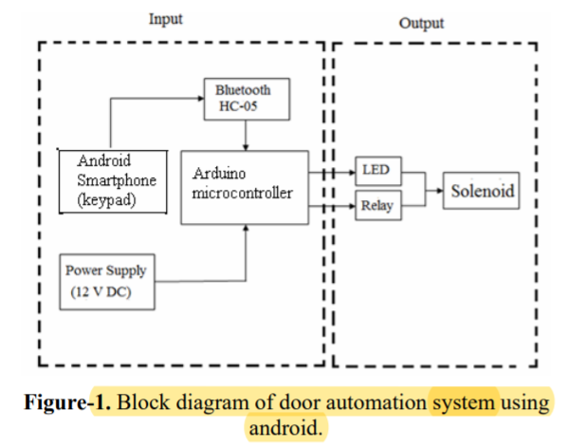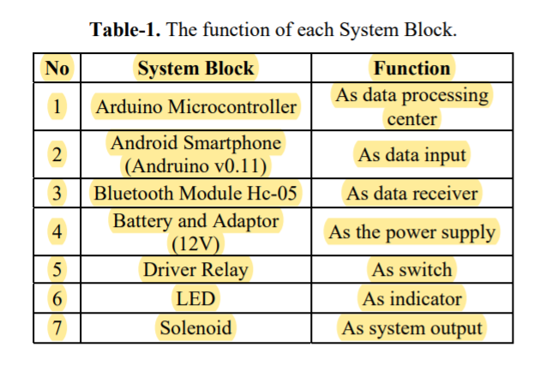

The mechanism of device is to input a digital

keypad on the software on android Smartphone first, if

there is a command that is controlled by the user, the data will be instantly sent via a Bluetooth network then the input received by the Hc-05 Bluetooth module that

connected to Arduino microcontroller.

Arduino microcontroller circuit serves as a data processor that controls the solenoid that previously connected to a relay that functions as an on / off switch.

Microcontroller is the central data in processing

system. Microcontroller Arduino has been equipped with an internal EEPROM, Flash memory, etc. This section will examine the input password, and give orders to the LED and relay.

**the power needed for the whole series is equal to 12 Volts DC**. **There are several components in the power supply circuit, such as transformers that serve for lowering the voltage. Capacitors are used as filters. And the last is the type LM7812 regulator IC that functions as a regulator of the power output by 12 Volt**

Relay has a function as an electronic switch. Relay will be active when given input from the microcontroller, and serves as a switch for the solenoid system.

In this research, we use the *electro mechanical solenoid 12 V with supply voltage to 12V from Adaptor. Solenoid connected to the Relay, Relay connected to the 5V pin of the Arduino Uno for supplying coil voltage and ground Relay to ground Arduino Uno pin.*

LED circuit serves as indicator for electric current. LED will turn on when current is passed from 12V DC solenoid in open-door condition, so the LED will be off when the system / solenoid current is not passed in the locked state.

**Experimental results**

* The testing process performed. The results of the test series show the minimum system of the Arduino microcontroller circuit system has a minimum value 9600 bits per second, with 8 data bits and 1 stop bits.
* The whole series in this study operate the power of 12 volts.
* Relay and solenoid used to open and lock the output.
* Bluetooth on android smartphone with Bluetooth module series HC-05 and the connection between keypad with microcontroller.

**Conclusions**

* they used solenoid door lock system as a prototype for indoor and outdoor key lock system.
* It also provides a security and easy for android phone/tab users.
* This project based on android and Arduino. So the implementation rate is inexpensive and it is reasonable by a common person.