VOL. 11, NO. 5, MARCH 2016 ISSN 1819-6608

ARPN Journal of Engineering and Applied Sciences

©2006-2016 Asian Research Publishing Network (ARPN). All rights reserved.

**SMARTPHONE ACTIVATED DOOR LOCK USING WIFI**



This paper describes the design and operation of a door locking using smartphone through Wireless Fidelity (Wi-Fi) technology.

* Programmed using Android, the smartphone can lock and unlock the door within WiFi range.
* Peripheral Interface Controller (PIC) is used as the main controller of the design.
* This design is able to work within **maximum range of 40 meters to 150 meters.** Smartphone activated door lock using WiFi has been designed, implemented and tested successfully.
* The Wi-Fi module and PIC are placed inside the home, apartment or building which is next to the door. The design will be managed through the Android application in the smartphone to unlock and lock the door automatically.

The proposed design is also user friendly, where there is a reset button inside house to allow user to exit the door during emergency situation.

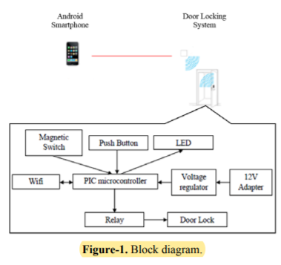

The block diagram consists of one transmitter and one receiver. Both of them are communicating using WiFi standard, which is IEEE 802.11. In this design, an **Android smartphone with WiFi access is functioning as the transmitter**. **The receiver parts consist of a PIC, WiFi module, relay, and solenoid door lock.** When the correct IP address and port number are received, the solenoid lock will be activated and it will unlock the door for 5 seconds. Besides, there is a reset button to unlock the door from inside the house. This is useful for emergency exit especially for home owner.

* Eclipse for building the Android application and C language for PIC to control the door locking
* **solenoid lock was chosen where the lock design is focused to an electrically operated door system that has high reliability**.
* The **frequency band for the chosen WiFi module is 2.4 GHz**.
* The door will unlock if it receives the correct password or the exit button is pressed. When the microcontroller detects the data ‘A’, the output pin D1 become high and the door is unlocked and the magnetic switch will be opened. After 5 seconds, the door will lock automatically and the magnetic switch will be touching each other.

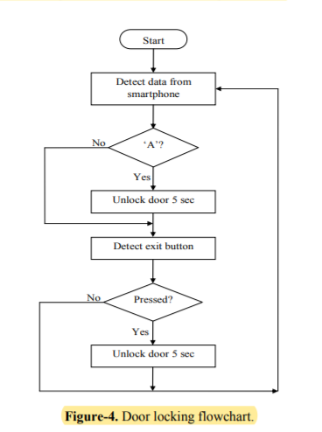

* The Android application interface is designed to allow user to key in the IP address and port number according the IP address of the WiFi.

if the exit button is pressed, the output pin D1 will also become high and that indicates the door is unlocked. Pin A1 becomes high when the door is open. At this time, pin B6 becomes high and pin B7 is low. Lastly, when the door is closed, pin D1 and B6 becomes low. **The purpose of the push button is to make sure people from inside the house can unlock the door without using smartphone especially during emergency situation.**

**Analysis** was conducted to test the performance of the design at indoor and outdoor Based on the graph for both measurements,

* as the distance is increasing, the delays are increased as well.
* For outdoor analysis, the connection between smartphone and WiFi is lost after 150 meters due to the WiFi limitation range
* while for indoor analysis, the connection between smartphone and WiFi is lost after 40 meters. Fewer obstacles observed for outdoor analysis which effects in better results compared to indoor analysis.
* Obstacles reduce the effectiveness of the WiFi transmission due to path loss. This design works better in less obstacles work environment.

**Conclusions**

* Smartphone activated door locking using WiFi has been designed, implemented and tested successfully.
* This design used a smart phone to lock and unlock door wirelessly using WiFi technology. In future, the existing relay can be replaced with solid state relay (SSR) to reduce the power consumption and increase the stability of the design.
* Furthermore, security features can be added to increase the efficiency of the design.
* Android application interface can be further enhanced to ease the user in case they could not remember the IP address and port number