**Smart Digital Door Lock for the Home Automation (zigbee)**

Yong Tae Park Pranesh Sthapit Jae-Young Pyun

Department of Information and Communication Engineering, Chosun University

Gwangju, South Korea

pyt@stmail.chosun.ac.kr, pranesh@stmail.chosun.ac.kr, [jypyun@chosun.ac.kr](mailto:jypyun@chosun.ac.kr)

978-1-4244-4547-9/09/$26.00 ©2009 IEEE

A digital door lock system is equipment that uses the digital information such as a secret code, semi-conductors, smart card, and finger prints as the method for authentication instead of the legacy key system.

* In our proposed system, a **ZigBee module is embedded in digital door lock and the door lock acts as a central main controller** of the overall home automation system.
* proposed system is the network of sensor nodes and actuators with digital door lock as base station.
* A door lock system proposed here consists of **RFID reader for user authentication, touch LCD, motor module** for opening and closing of the door, sensor modules for detecting the condition inside the house, communication module, and control module for controlling other modules.
* Status of individual ZigBee module can be monitored and controlled by the centralized controller
* it also allows users to remotely monitor the condition inside the house through Internet or any other public network.
* ZigBee modules accompanied by ZigBee relay module are attached to the major home appliances for controlling the power condition.
* ZigBee module includes RF communication module and is used in digital door lock and sensor nodes

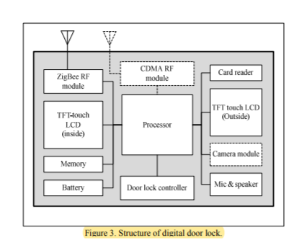

.

Our smart digital door lock

system operates over wireless sensor network. It is a network

of sensor nodes with digital door lock as sink node as shown

in Fig. 1. The smart digital door lock system can be divided

into five parts: the control module, the motor module, the

sensor module, the communication module and the I/O

module. The control module consists of MCU embedded in

the digital door lock, which is the brain of the system. The

locking operation is controlled by the motor module. The

communication module is for communication between devices

and the control module. The user can access to the door lock

system through I/O module. The I/O module includes RFID

reader and digital dialpad for authentication, TFT Touch LCD

for controlling individual device and displaying the relevant

information.

Once the user is authenticated by the system, user can

monitor and control the home appliances from the central

control panel. To interact with the visitor, the door lock is

equipped with camera module, microphone, and speaker. The

touch LCD is provided at the both sides of the door. Thus, user

can easily monitor and interact with visitor other side of the

door through these devices.

The main componets of ZigBee module are ZigBee transceiver

and MCU. The ZigBee transceiver utilizes the commercial RF

chip,which has a modem for implementing the medium access

control (MAC) and physical (PHY) layers of IEEE802.15.4

operating in 2.4 GHz. MCU is a controller, which controls a

ZigBee transceiver, and execute programs

The digital door lock is composed of a main processor,

a ZigBee module, door lock controller, CDMA module,

camera module, card reader, microphone, and speaker. The

control module is the brain of the system. The control module

performs two major functions. Firstly, it controls the door

lock. And secondly, it controls and monitors entire network.

Open/close button in door lock controller activates a digital

door lock for the open/close actions. The control module

controls the motor drive circuit which operates the motor as

actuator. Card reader is used for authentication though cards

and RFID tags. The touch LCD is used for entering and

changing the authentication password, changing the setting of

sensor nodes, and also for displaying relevant information on

the screen.

Smart digital door lock system works in two

communication modes: centralized mode and emergency

mode. In centralized mode, digital door takes the control of

overall communication in the network and sensor nodes act

accordingly as instructed by door lock. This type of

communication is generally done in normal situation when

everything is all right. This communication mode reduces

unnecessary communication between sensor nodes and central

controller and also saves energy consumptions.

On the other hand, when there is emergency situation such

as burglary or fire, the communication is in emergency mode.

Upon detection of the emergency mode by the sensor node, the

respective action is taken such as releasing water for fire,

turning buzzer on for burglary and immediately that event is

reported to the door lock without any initiation from door lock.

Door lock in turn reports the event to the end user through

SMS or MMS

*Smart Digital Door Lock System*

Once the person is authenticated through password or

RFID tag, the door lock is opened and the LCD displays the

status of different appliances in the home. User can choose to

change the current status of the appliances or leave them as it

is. For the convenience of the end user, our system can operate

in two operational modes: manual and automatic. Smart digital

door lock system can have three events: person entering the

home, person leaving, and the emergency situation

*Modes of Operation*

*1) Outgoing Event*

Fig. 5 shows the flow chart for outgoing event i.e., the case

of person leaving the home. As digital door lock is the last

thing user will encounter before leaving the house, when the

user presses the door lock button, door lock request all sensors

Figure 3. Structure of digital door lock.

Figure 2. ZigBee module connected to home appliances.

3

TENCON 2009

to send their fresh status and the touch LCD displays them on

the screen. Initially, the system enters into the manual mode. In

manual modes, users can choose from the menu which home

appliance to turn on/off manually. With manual mode in

operation, the users now don’t have to bother of checking the

status of individual home appliances physically. He can leave

everything as it is in his room and finally select which devices

to turn on or off from the door. If user finds that TV is on, he

can turn it off from the door.

If the user did not touch LCD screen for certain amount of

time after locking the door, then the system enters into

automatic mode. For automatic mode to work, we have to set

the priority setting of device beforehand. The priority setting

here means deciding which device should be on or off in the

absence of user. The device with priority 1 means it should

remain on and priority 0 means should be turned off. Therefore,

user decides which device should be turned on and off in his

absence through the touch LCD screen. This is one time

process but can be done any time when felt necessary.

Therefore, when the system enters into automatic mode, it turns

off all those devices which priority is 0 if it is still on. With the

implementation of this mode, now user doesn’t need to bother

about the power status of the devices in his room whenever he

leaves the home. He can leave lights and TV on when leaving

the home. Our system eventually switches them off.

*2) Incoming Event*

Fig. 6 shows flow chart for incoming event i.e., person

entering the home. Incoming event can also be operated in

manual and automatic mode. After being authenticated, the

system unlocks the door. Then the system requests the fresh

status of all devices and checks for the emergency situation.

If there has been some emergency situation, the corresponding

emergency message such as fire, burglary, and various other

alert messages are displayed on LCD. In other case user can

see the status of the room in the touch LCD. The current

environmental condition of home can be easily viewed in the

LCD. In the manual mode user can switch on/off the

individual device though the touch LCD. Suppose he finds the

room is hot, thus he can switch on the air conditioner though

the LCD.

If the user did not touch LCD screen for a certain amount

of time after unlocking the door, then our system enters into

automatic mode. Here also, for automatic mode to work, we

have to set the priority setting of devices. Priority here is not

the same with the priority used in previous outgoing event.

Therefore, the system stores two priorities information for

individual device. Here, the device with priority 1 means it

should be on and priority 0 means should remain off. This is

also one time process but can be done any time when felt

necessary. Therefore, when the system enters into automatic

mode, it turns on all those devices which priority is 1 if it is

still off. User can set priority of devices such as air conditioner

and TV to 1 so that they are on as soon as user is at home.

Figure 5. Flow chart for outgoing event.

Figure 4. Events in smart digital door lock system..

4

TENCON 2009

*3) Emergency Event*

The system may encounter emergency situation such as

burglary, fire and so on. Fig. 7 shows the flow chart of

emergency situation for both sensor nodes and digital door.

Fig. 7(a) is a flow chart for sensor node whereas the Fig. 7(b)

is for digital door lock. On detecting the emergency situation

by sensor node, the corresponding information is immediately

notified to the door lock. Also, at the mean time, the sensor

node triggers the actuators for handling the current emergency

situation. At the door lock side, after being informed about the

emergency situation, the door lock sends the SMS to the user

notifying about the situation. The system also triggers the

alarm. For example, sensor node, perceived when gas leaked,

transmits current situation through a door-lock, downs the

power of electric home appliances connected to nodes by

conveying a signal.

*4) Relay Node*

Using the smart digital home server, we expect that home

automation will be satisfied. But there is still a problem of RF

signal power attenuation frequently occurred at indoor

environment such as home or office. This unreliable RF signal

would be worse at home which micro-oven and consumer

electronics using similar frequency bands exist. In order to

support reliable RF signal transmission, we built ZigBee RF

repeaters which are arranged in the entrance of each room.

Also, these nodes can be used to lock and unlock the door of

each room.

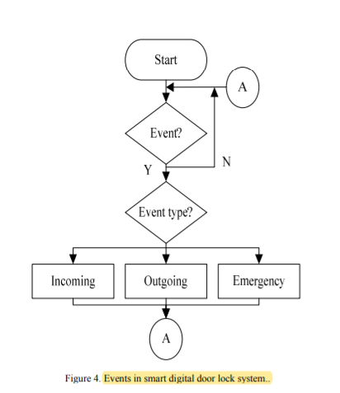

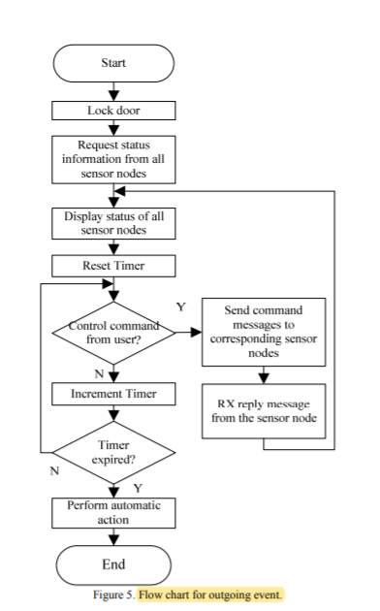

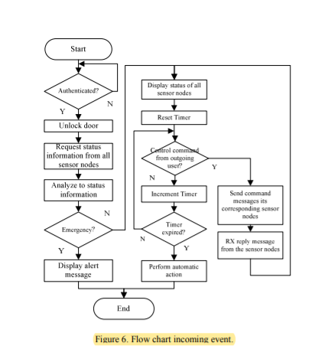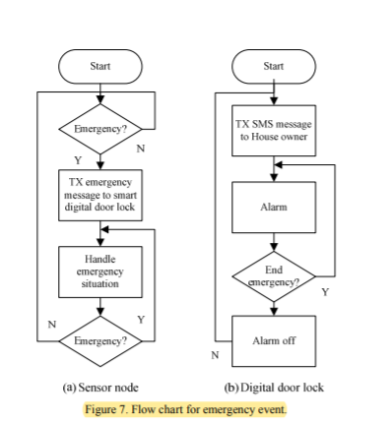

proposed system exploits the ZigBee’s full capacity for monitoring and controlling home environment and condition through the digital door lock.

Since proposed system is built over wireless sensor network, it is a cheap, flexible, and easily installable system without any overhead such as careful planning, cabling, and construction works.