Btech CSE | Data Structures and Programming in C++
PROJECT PROPOSAL

Project and Team Information
Project Title
Custom Version Control System (Mini Git)

Student / Team Information
Team Name:  Team ID: | CODE RUSHERS  DSCPP-III-2026-T358
Team Member 1 (Team Lead)  Student ID | Singh, Jasmeet  2510370305  2510370305@geu.ac.in  
Team Member 2  Student ID | Devraj Raushan  260211526  260211526@geu.ac.in  

Faculty: Prof. Dr. Deepak Arsani
Email: deepakarsani.cse@geu.ac.in

Project Description
Mini Git is a small or simplified version of Git in which Mini Git having the commands like add, commit, log, branch, and more. In this project we use some algorithm, DS, OOPs.
We take a basic idea of hashing — it gives a unique code to all the files, and same code have their same content, and it saves space.
We make this project to learn how Git is really work internally and to clear our concepts which we learn in classes — this is the only reason to make this project.
In this project we use CS topics like classes, hashing, trees, dynamic programming, and some more topics from CS:
- Hashing — giving each file its own special code
- Trees — storing how folders and files are arranged
- Graphs — keeping track of commit history
- Dynamic Programming — finding the difference between two files
In college these are usually taught as separate chapters with separate assignments. Here, all four end up working together inside one actual system, which honestly makes them click a lot better than any textbook example did.
To manage the code, we make classes — Blob, Tree, Commit, Repository.

State of the Art / Current Solutions
Git is a popular version control tool, and it is created by Linus Torvalds in 2005.
Git assigns a unique hash to every file, folder, and commit. That one design choice means identical content is never stored again.
GitHub, GitLab, and Bitbucket are different from Git, but they add some extra features like pull request, review, etc.
In real Git there is some advance tricks like:
- Packfiles — compress the data so it take less space
- Delta encoding — save only the changes, not whole file again
- Myers diff algorithm — a fast way to compare two files
We deliberately skipped implementing these in Mini-Git — our priority is keeping the system simple enough that anyone reading the code can follow what's happening.
Older tools like Mercurial and SVN are still around, but Git's branching & merging model turned out to be a lot more flexible.
Why does this matter for us? Because most people who use it never really see how it works inside — for them it's just a black box. But by building a simple version from the start, we can understand how Git really works.

Project Goals and Milestones
Our main goal here is to build a simplified version control system, Mini-Git, that mirrors how Git actually works internally. Under the hood we're relying on hash maps, trees, and graphs to store the data, and the whole thing is designed around OOP principles.
To keep progress trackable week by week, we've split the project into six milestones:
Milestone 1 — Object Model & Storage (Week 1-2)
This is where we design the Blob, Tree, and Commit classes and get the SHA-1 hashing system working. By the end of it, we expect init, add, and commit to actually be functional and saving data to disk.
Milestone 2 — History & Navigation (Week 3)
Next we build out the log command, which walks through past commits in the right order using their parent links.
Milestone 3 — Branching (Week 4)
Branch and checkout get added at this stage, letting a user create multiple branches and hop between them through the HEAD pointer.
Milestone 4 — Diff Engine (Week 5)
Here we implement diff, using either LCS or the Myers algorithm, to compare two file versions line by line.
Milestone 5 — Merge & Conflict Resolution (Week 6)
Three-way merge gets implemented at this point — we find the lowest common ancestor to figure out where branches diverged, and flag conflicts whenever changes overlap.
Milestone 6 — Polish & Evaluation (Week 7-8)
The last stretch is polishing the CLI, possibly adding a commit-graph visual if time allows, and writing up the final report covering all our design decisions and known limitations.
Final deliverable: a working CLI tool that supports init, add, commit, log, branch, checkout, diff and merge, plus a complete technical report explaining how we built it.

Project Approach
Our approach follows Git's own data model fairly closely. Blobs hold file content, trees represent folder structure, and commits capture a saved version of the project. Every file gets a SHA-1 hash, which makes it easy to identify uniquely.
For representing commit history, we went with a graph structure rather than a plain tree. The reason is that when two branches merge, the resulting merge commit ends up with two parents — a regular tree simply can't express that relationship, so a graph fits much better. We use BFS or DFS to walk through the history and locate the common ancestor whenever a merge is needed.
Use of OOP Concepts
We use OOP in C++ to keep the different parts of Mini-Git organized, with a separate class for each Git object — Blob, Tree, Commit, Branch, and Repository.
The Repository class handles the main operations while the rest of the classes manage their own piece of data. Between classes, objects, encapsulation, and composition, the codebase stays reasonably organized and easier to test piece by piece later on.
Main Algorithms
- Hashing identifies file content and doubles as a quick way to check whether it's changed.
- Diff will use either LCS or the Myers method to compare two files line by line.
- Merge uses a three-way approach, comparing changes from both branches against their common ancestor and inserting conflict markers like <<<<<<< / ======= / >>>>>>> whenever a conflict shows up.
- The Repository class ties together the main parts of the system — Blob, Tree, Commit, and Branch — while diff and merge logic stay in their own module so we can improve them later without touching the rest of the project.

System Architecture (High-Level Diagram)
The system breaks down into four main parts. At the top is the CLI layer, where the user types commands like add, commit, log, branch, or checkout.
From there the CLI layer passes the command on to the Repository Core, which is really the heart of the whole system — it's what actually handles add, commit, branch, and checkout.
Underneath, the Repository Core relies on two components: the Object Store, which holds blobs, trees, and commits, and the Diff/Merge Engine, which contains all the diff and merge logic.
Both of those components read from and write to the same Storage layer on disk, where the object files, refs, and HEAD pointer all get saved.
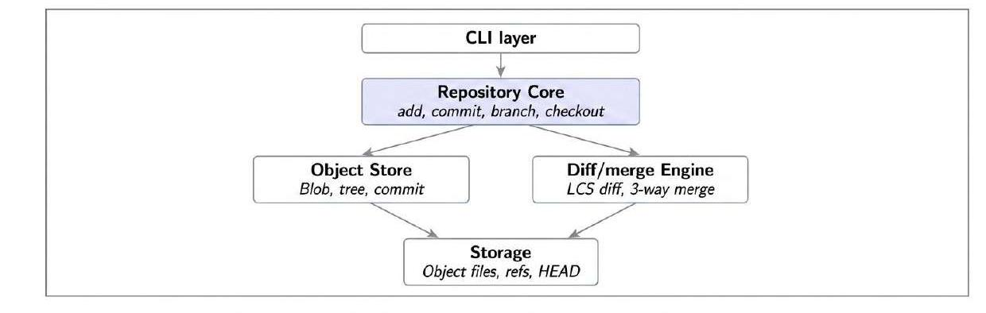

Platforms & Technologies
- C/C++ is our main language, mostly because it lets us handle memory management and hashing ourselves rather than leaning on some built-in function that hides the details.
- For hashing we're planning to use SHA-1, either write it ourselves in a small way or use the OpenSSL library, depending on time left.
- Compression will run through zlib, the same library real Git uses for its objects.
- Storage stays on the local filesystem, using the same folder layout Git uses under .git/objects.
- The CLI itself is entirely our own, covering the basics — init, add, commit, branch, merge, diff, and log.
- If there's time left over, we'd like to add a visualization layer too, either through Graphviz or a small web UI, just to show the commit graph visually.
- There's also a bit of irony here — we're using Git and GitHub to manage the very project where we're building our own version of Git.
- Testing will mostly rely on our own test cases, and possibly the Catch2 framework, with a focus on verifying that diff and merge behave correctly.

Project Outcome
By the end of the project, we're aiming to have a working command-line tool that mirrors how Git operates internally — storing content by hash, keeping history as a graph, and running diff and merge properly. More than anything, we want to demonstrate that we actually understand hash tables, trees, graphs, and dynamic programming, not just their textbook definitions, and that we can apply OOP ideas like composition and the strategy pattern in a real codebase.
Deliverables:
- A working CLI tool covering init, add, commit, branch, checkout, log, diff, and merge
- Source code with proper class design — Blob, Tree, Commit and Repository
- Commit graph visualizer, probably using Graphviz or D3.js
- A technical report that covers our architecture, the diff algorithm's complexity (O(ND)), how we compare against real Git, and where our version falls short
- Live demo showing branching, merging and conflict resolution on sample repo
- Test cases checking hashing correctness, merge conflict detection and diff accuracy on known cases

Assumptions
- Scope is limited to a single-user, local repository — there's no remote push/pull, no networking, and no support for multiple people collaborating
- Tracking happens only at the file level, and diff/merge assumes text files — binary diffing is out of scope
- SHA-1 is what we're using for hashing — we know it's considered weak by today's standards, but it's good enough here to demonstrate how content-addressing works (real Git itself is moving toward SHA-256)
- Packfiles and delta compression aren't implemented — objects are stored uncompressed to keep things simple
- Merge conflicts get resolved manually by the user editing the conflict markers — there's no automatic resolution
- We assume the filesystem stays stable during operation — concurrent access and file locking aren't handled
- It's command-line only — no GUI is needed for the core functionality to work

References
- Pro Git Book (official, free) — https://git-scm.com/book/en/v2
- Git Internals — Plumbing and Porcelain — https://git-scm.com/book/en/v2/Git-Internals-Plumbing-and-Porcelain
- Git Objects — https://git-scm.com/book/en/v2/Git-Internals-Git-Objects
- Git official documentation — https://git-scm.com/docs
- "Git from the Bottom Up" by John Wiegley — https://jwiegley.github.io/git-from-the-bottom-up/
- Git source code (GitHub mirror) — https://github.com/git/git

