Step-by-Step Data Analytics and Visualization with AWS
Amazon S3 → AWS Glue → Amazon Athena → AWS Lambda → Amazon S3 → Excel
This guide is designed for a short teaching video. It demonstrates how to upload a retail sales CSV file to Amazon S3, catalog it with AWS Glue, analyse it with Amazon Athena, and use AWS Lambda to run multiple Athena queries automatically and combine the results into one Excel-compatible CSV report stored in Amazon S3.

1. Learning Objective
By the end of this activity, students should be able to explain and demonstrate a simple cloud analytics pipeline using AWS storage, metadata/cataloguing, SQL analytics, and serverless automation to generate an Excel-compatible report.

2. Workflow
Retail Sales CSV → Amazon S3 → AWS Glue → Amazon Athena → AWS Lambda → S3 Report → Excel

3. Step 1 - Prepare the Sample Sales Dataset
Create a file named retail_sales.csv. The dataset contains order date, region, product category, product, quantity, unit price, and sales. This gives enough fields to demonstrate totals, grouping, and time-based visualization.
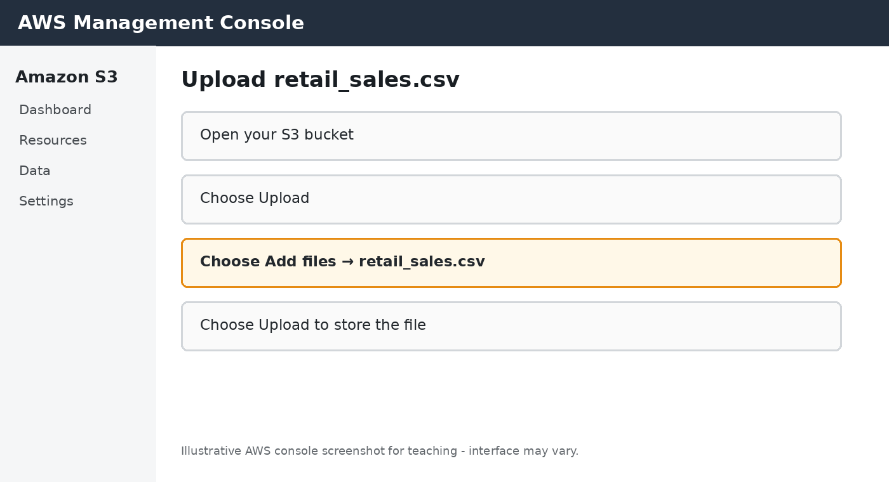
Illustrative screenshot - AWS console layout may change.

Video actions
- Open the AWS Management Console and search for Amazon S3.
- Create a bucket, or open an existing teaching/lab bucket.
- Create a folder named retail_order.
- Choose Upload → Add files and select retail_sales.csv.
- Choose Upload and confirm that the file appears in the bucket.

Suggested narration
First, we upload our retail sales CSV dataset to Amazon S3. S3 provides scalable cloud object storage and acts as the storage layer for our analytics workflow.

4. Step 2 - Catalog the Dataset with AWS Glue
AWS Glue can discover the structure of the CSV file and create metadata in the AWS Glue Data Catalog.
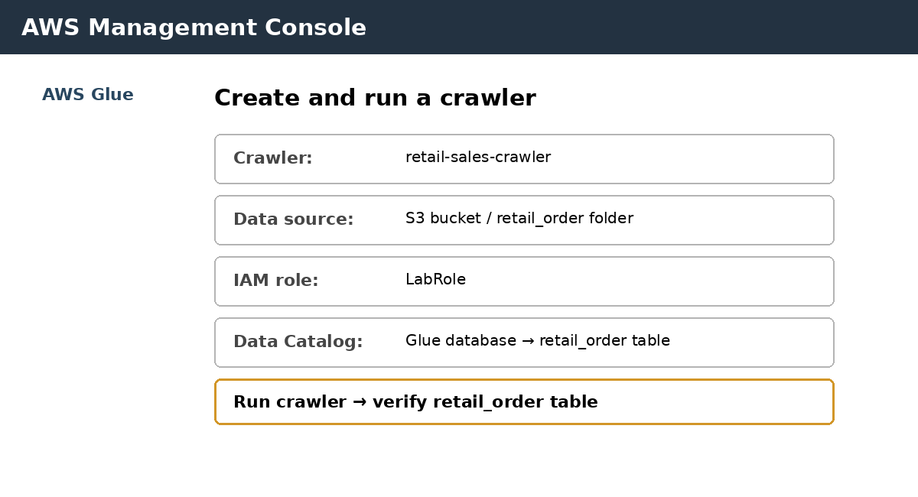
Illustrative screenshot - AWS console layout may change.

Video actions
- Open AWS Glue and select Crawlers.
- Choose Create crawler and provide a name such as retail-sales-crawler.
- Set the data source to the S3 retail_order folder containing retail_sales.csv.
- Select the existing LabRole IAM role.
- Choose or create a Glue database, then create and run the crawler.
- Open the Data Catalog table and verify the detected columns.

Suggested narration
AWS Glue scans the data stored in S3, identifies its schema, and creates a table in the Glue Data Catalog. Athena can then use this metadata to query the dataset.

5. Step 3 - Analyse the Data with Amazon Athena
Amazon Athena is a serverless interactive query service that can query data in S3 using SQL.
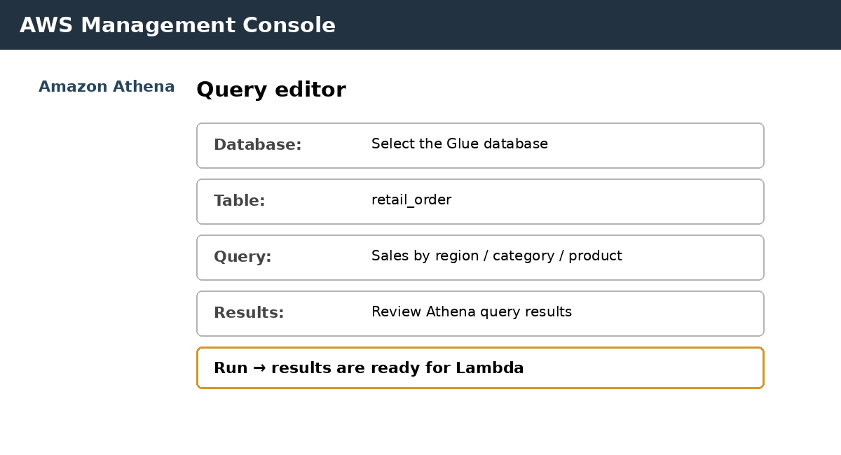
Illustrative screenshot - AWS console layout may change.

Video actions
- Open Amazon Athena and go to the Query editor.
- Select the Glue database created in the previous step.
- Select the retail_order table created by the crawler.
- Run a SQL query to calculate total sales by region.
- Review the query result and identify the region with the highest sales.

Suggested narration
Amazon Athena allows us to analyse the S3 dataset using standard SQL. In this example, we calculate total sales for each region.

6. Step 4 - Automate Athena Reporting with AWS Lambda
AWS Lambda is a serverless compute service. In this activity, a Lambda function named retail_report runs multiple Athena queries, combines the query results into one CSV report, and saves the report in Amazon S3. The CSV file can then be opened directly in Microsoft Excel.
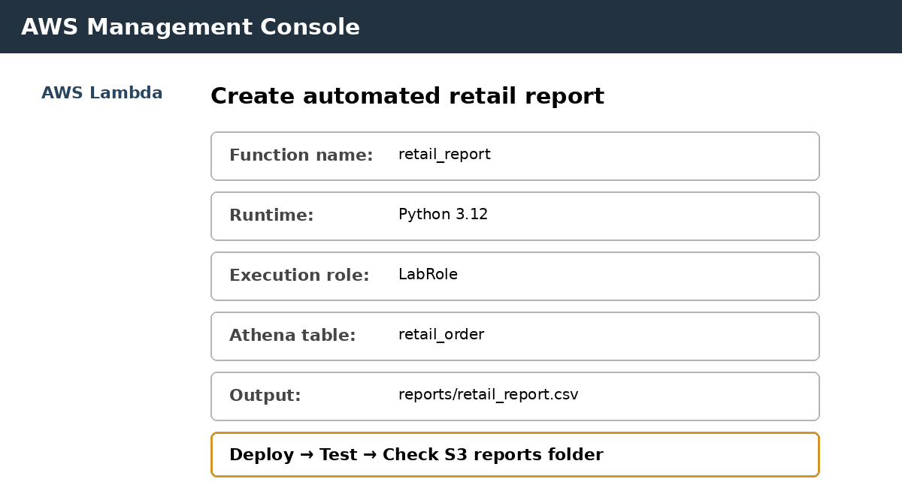
Illustrative screenshot - AWS console layout may change.

Video actions
- Open AWS Lambda and choose Create function.
- Choose Author from scratch and enter the function name retail_report.
- For Runtime, choose Python 3.12. Under Execution role, choose Use an existing role and select LabRole.
- Create the function, then open the Code tab and replace the default code with the Lambda script shown in Section 8.
- Update DATABASE and BUCKET in the script to match your Glue database and S3 bucket. The script queries the retail_order table.
- Choose Deploy, then create a simple test event using {}.
- Choose Test. Lambda runs the Athena queries and combines the results.
- Open Amazon S3 → your bucket → reports and download retail_report.csv. Open the file in Microsoft Excel.

Suggested narration
Finally, AWS Lambda automates the reporting step. The retail_report function runs multiple Athena queries, combines the results into a single CSV file, and stores it in Amazon S3. The report can be downloaded and opened in Excel without manually downloading each Athena result.

7. Athena SQL Examples
Total sales by region:
SELECT region,
ROUND(SUM(sales), 2) AS total_sales
FROM retail_order
GROUP BY region
ORDER BY total_sales DESC;
Total sales by category:
SELECT category,
ROUND(SUM(sales), 2) AS total_sales
FROM retail_order
GROUP BY category
ORDER BY total_sales DESC;

8. AWS Lambda Script - retail_report
- The following Python code uses boto3, which is available in the Lambda Python runtime. It does not require pandas or openpyxl.
- Output file: reports/retail_report.csv
- The CSV contains separate sections for Sales by Region, Sales by Category, and Product Sales.
- Before running, change DATABASE and BUCKET to your own values.
- Use the existing LabRole as the Lambda execution role in AWS Academy.
import boto3
import csv
import io
import time
athena = boto3.client("athena")
s3 = boto3.client("s3")
DATABASE = "YOUR_GLUE_DATABASE"
BUCKET = "YOUR_S3_BUCKET"
ATHENA_OUTPUT = f"s3://{BUCKET}/athena-results/"
queries = {
"SALES BY REGION": """
SELECT region, ROUND(SUM(sales), 2) AS total_sales
FROM retail_order
GROUP BY region
ORDER BY total_sales DESC
""",
"SALES BY CATEGORY": """
SELECT category, ROUND(SUM(sales), 2) AS total_sales
FROM retail_order
GROUP BY category
ORDER BY total_sales DESC
""",
"PRODUCT SALES": """
SELECT product, SUM(quantity) AS total_quantity,
ROUND(SUM(sales), 2) AS total_sales
FROM retail_order
GROUP BY product
ORDER BY total_sales DESC
"""
}
def run_query(sql):
response = athena.start_query_execution(
QueryString=sql,
QueryExecutionContext={"Database": DATABASE},
ResultConfiguration={"OutputLocation": ATHENA_OUTPUT}
)
query_id = response["QueryExecutionId"]
while True:
result = athena.get_query_execution(QueryExecutionId=query_id)
state = result["QueryExecution"]["Status"]["State"]
if state == "SUCCEEDED":
break
if state in ["FAILED", "CANCELLED"]:
reason = result["QueryExecution"]["Status"].get("StateChangeReason", state)
raise Exception(reason)
time.sleep(1)
return athena.get_query_results(QueryExecutionId=query_id)
def lambda_handler(event, context):
output = io.StringIO()
writer = csv.writer(output)
for title, sql in queries.items():
writer.writerow([title])
result = run_query(sql)
for row in result["ResultSet"]["Rows"]:
writer.writerow([x.get("VarCharValue", "") for x in row["Data"]])
writer.writerow([])
s3.put_object(
Bucket=BUCKET,
Key="reports/retail_report.csv",
Body=output.getvalue(),
ContentType="text/csv"
)
return {"statusCode": 200, "body": "retail_report.csv created successfully"}

9. Final Video Summary
End the video by displaying the complete pipeline and briefly explaining how each AWS service contributes to the automated retail report:
Service | Role
Amazon S3 | Stores the retail sales dataset and the generated retail_report.csv report.
AWS Glue | Discovers the schema and catalogs the dataset.
Amazon Athena | Analyses the S3 data using SQL.
AWS Lambda | Runs multiple Athena queries and combines the results into one Excel-compatible CSV report.

10. Sample retail_sales.csv Dataset
Copy the following data into a CSV file named retail_sales.csv and upload it to Amazon S3.
Order_ID | Order_Date | Region | Category | Product | Quantity | Unit_Price | Sales
ORD001 | 2026-01-05 | Sydney | Electronics | Wireless Mouse | 3 | 25.00 | 75.00
ORD002 | 2026-01-08 | Melbourne | Electronics | Keyboard | 2 | 45.00 | 90.00
ORD003 | 2026-01-12 | Brisbane | Office Supplies | Notebook | 10 | 5.00 | 50.00
ORD004 | 2026-01-18 | Sydney | Electronics | Monitor | 2 | 220.00 | 440.00
ORD005 | 2026-01-25 | Perth | Furniture | Office Chair | 2 | 180.00 | 360.00
ORD006 | 2026-02-03 | Melbourne | Furniture | Desk | 1 | 350.00 | 350.00
ORD007 | 2026-02-08 | Sydney | Office Supplies | Printer Paper | 8 | 12.00 | 96.00
ORD008 | 2026-02-14 | Brisbane | Electronics | USB Hub | 4 | 30.00 | 120.00
ORD009 | 2026-02-20 | Perth | Electronics | Webcam | 3 | 80.00 | 240.00
ORD010 | 2026-02-25 | Sydney | Furniture | Office Chair | 1 | 180.00 | 180.00
ORD011 | 2026-03-02 | Melbourne | Electronics | Monitor | 2 | 220.00 | 440.00
ORD012 | 2026-03-07 | Brisbane | Office Supplies | Notebook | 15 | 5.00 | 75.00
ORD013 | 2026-03-12 | Sydney | Electronics | Keyboard | 3 | 45.00 | 135.00
ORD014 | 2026-03-18 | Perth | Furniture | Desk | 2 | 350.00 | 700.00
ORD015 | 2026-03-23 | Melbourne | Office Supplies | Printer Paper | 10 | 12.00 | 120.00
ORD016 | 2026-04-04 | Sydney | Electronics | Webcam | 4 | 80.00 | 320.00
ORD017 | 2026-04-09 | Brisbane | Furniture | Office Chair | 2 | 180.00 | 360.00
ORD018 | 2026-04-15 | Melbourne | Electronics | Wireless Mouse | 5 | 25.00 | 125.00
ORD019 | 2026-04-21 | Perth | Office Supplies | Notebook | 20 | 5.00 | 100.00
ORD020 | 2026-04-27 | Sydney | Furniture | Desk | 1 | 350.00 | 350.00

11. Suggested Video Timing
- Introduction and dataset: 30 seconds
- Amazon S3 upload: 1 minute
- AWS Glue crawler: 1-2 minutes
- Amazon Athena analysis: 1-2 minutes
- AWS Lambda automated report: 2-3 minutes
- Final pipeline summary: 30 seconds
Note: The screenshots in this document are illustrative teaching mock-ups. The AWS Management Console interface and available services can vary by account, region, permissions, and AWS Academy environment.

