**Jaspreet Kaur**

**COMPTIA A+ (220-901) Training**

**Cert Prep: 1 Core Processing**

<https://www.linkedin.com/learning/comptia-a-plus-220-901-cert-prep-1-core-processing/primary-pc-components?u=26120234>

1. **The Visible Computer**
   1. **How computers work?**

What is computer?

An electronic device for storing and processing data (digital (0 or 1 or binary) information)

Computer is something that store data in hard drive, CD, external Hard drive, cloud server sitting somewhere in the world, and RAM (Random access memory).

We give input to the processor or CPU (Central processing unit) or brain of the computer, through mouse and keyboard to get an output. CPU does the processing or data manipulation to receive output.

Data manipulation is the process of changing data to make it easier to read or be more organized.

1. Storage
2. Input
3. Processing
4. Output
5. Storage
   1. **Primary PC (Personal Computer) components**
      1. System unit has all the storage which is motherboard, hard drive, RAM and CPU, optical drive which is a CD drive and network connections.
      2. System unit provides processing and storage.
      3. PC process input and gives output
      4. Monitor is used for displaying output.
      5. Everything other than system unit is a **peripheral devices which is input or output device.**
      6. Peripheral is monitor, keyboard, mouse, speakers, and scanner.
      7. Common **input** **device** include keyboard, mouse and scanner.
      8. Common **output** **device** include monitor, printer and speakers.
   2. **External connection**
6. We see a different kind of ports these days on the desktop computers and laptops.
7. **Universal Serial Bus (USB)** connector: Most common connector to transfer data between computer and another device.



1. **Ethernet connector** also known as **RJ-45**. Primarily used for wired internet connection or network connection. 8 pin ethernet connector.

1. **External SATA** or **E-SATA** connector: Design for external Hard Drive, use for removeable hard drive. Super fast connection.

1. **SPDIF (Sony/Philips Digital Interface) Connector**: Fiber optic inside cable. Used for all things audio.
2. **DVI (Digital Visual Interface)**: DVI is a primary video output for system, use with monitor or projector. Low quality video.

1. **HDMI (High-Definition Multimedia Interface)**: Use for television, blue ray player or home theater, Carry both Audio and video. High quality video.
2. **Mini Audio Jack**: connect to speakers or microphones or headphones.

1. **Power Connector**: Used to power the computer.

1. **Front panel Connector**
   1. On and off switch,
   2. USB ports for Flash drive
   3. Microphone and headphone jacks
   4. Firewire (use for a video camera) also similar to USB but it’s old will disappear in new computers.
2. Legacy port or old ports in older computers:

* 1. **Circle connector** are known as **PS2 connectors** for keyboard and mouse in the old days. They have been replaced by USB connectors.
  2. **Three type of D shaped sub connectors**
     1. **Serial connector** (9 pin **male connector** DV connector use for things like mice and printer)
     2. **Parallel port** (25 pin **female connector** use for printer)
     3. **VGA port** (3 row and 5 pins in each row) use for the video connector with projector and monitor
  3. **Inside the PC**
     1. Every PC case open in a different way.

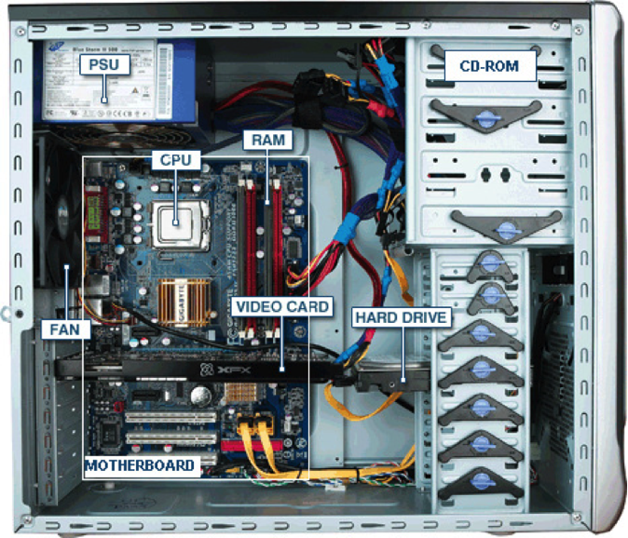

* + 1. Inside the system unit there is a Power supply Unit (**PSU**)
    2. **Motherboard** which has all things connected to it through the **data cable** such as RAM, CPU, Video Card, Hard drive, Heatsink
    3. **Heatsink or Fan** to cool the motherboard
    4. **Video card** or Graphic Card) for high quality video
    5. **RAM** (Random Access Memory) for fast memory
    6. **HD** (Hard Drive) for memory which is slow memory
    7. Hard drive connected to the Motherboard. (Hard drive had power connection and data connection)
    8. Other stuff connected to the data cable for example Optical Drive or CD, DVD, BLU RAY, E-SATA cables.

1. **Microprocessors**
   1. **What is a CPU?**
      1. CPU stands for (**Central Processor Unit**) Brain of the computer.
      2. A powerful calculator (Man couldn’t calculate) writing big documents, editing videos and it can make it all happen.
      3. **AMD** AND **INTEL** are two big companies 99.9% entire CPU market
      4. Every CPU has different size, physically different CPUs has to have different motherboard.
      5. Either one can Install Windows 10 operating system, same copy works for both and they speak the same language. Only because of different sizes it needs a different Motherboard.
      6. Both CPU made by different **Microarchitecture** with the different code name and with the one CPU CODE can make lot of different CPU model.
      7. For example like a car every manufacture company has different features. All cars do the same but have different ways of doing it.

**ASCII CHART (Binary Representation of all symbols)**

Operating Systems runs software on the hardware through the CPU,

**Microsoft**: Windows 7 or 8 or 10 operating system

**Apple**: Mac operating system

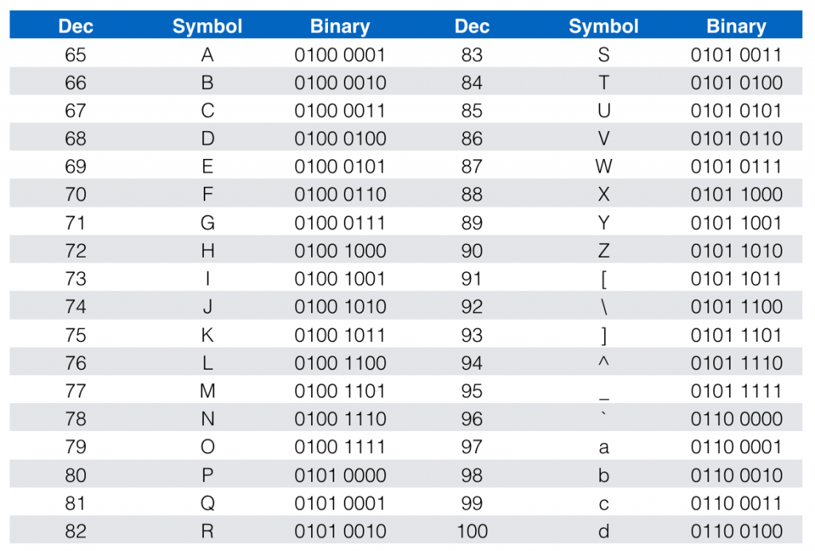

* 1. **CPU speeds and cores**
     1. Everyone want a fast speed computer these days.
     2. CPU come with rated speed or frequency.
     3. Speed is measured in Hertz (Hz) or cycle per second.
        + 1 Hertz (Hz) = 1 cycle per second or how many times a light blinks per second.
          1. If a light blinks 1 times per second, the speed is 1 Hz.
          2. If a light blinks 2 times per second, the speed is 2 Hz.
          3. If a light blinks 3 times per second, the speed is 3 Hz.
          4. 1.6 Gigahertz = 1 billion light blinks per second.

Gigahertz = 10^9 = 1,000,000,000

1.6 GHz = 1.6 * 10^9 = 1,600,000,000

So if a light blinks 1,600,000,000 times per second, the speed is 1.6 GHz

* + - * Also, you should know this:

K minute = 1000 minutes = 16 hr and 40 minutes

24 Hour = 24 hour * 60 mintues per hr = 1440

|  |  |
| --- | --- |
| **Prefix** | **Value** |
| Kilo | 10^3 = 10*10*10 = 1000 = Thousand |
| Mega | 10^6 = 10*10*10*10*10*10 = Million |
| Giga | 10^9 = Billion |
| Tera | 10^12 = Trillion |

* + 1. System crystal on the motherboard really is just a piece of port oscillating at a speed which pushes the CPU. The CPU speed listed on the CPU is not the speed that it runs at all the time, but it is the fastest that the CPU can run.

* + 1. The system crystal pushes the CPU.
    2. If the CPU runs at 1 Hertz, it will run very slow. You need to appreciate the CPU which has pass more the test, which will have higher speeds.
    3. Faster is expensive, CPU itself can run more faster than the motherboard.
    4. More expensive one have pass more test.
    5. Let’s say system crystal runs at slow speed than CPU. System crystal runs at 20 Megahertz (MHz) or (20 * 10^6). Let’s say internal circuitry on motherboard help the system crystal run at 200 Megahertz or (200 * 10^6). What is making the CPU runs at 1.6 GB hertz? You have something called a **multiplier** in the CPU which makes the motherboard fully utilize the CPU.

Say you have motherboard running at 200 MHz, and a CPU with a max of 1.6 GHz. Then you will have a CPU with a multiplier of 8.

200 MHz * 8 = 1600 MHz = 1.6 GHz.

Basically, to fully utilize the CPU, you have to buy the correct motherboard.

You can get even more speed out of the CPU rated speed by getting overclocking motherboards. **Overclocking** is pushing the CPU beyond its rated speed and if you do that you can damage the CPU so never do that. You can put your computer on fire.

* + 1. The fastest single CPU that we can run without putting it on fire right now is 3.5 GHz just because the technology is not that advanced. So what we do now is add multiple CPUs inside a single CPU called **multi-core CPU**.
    2. Multi-core CPU’s is like 8 CPU’s on one CPU. (**Multicore processing** include more then one CPU on single physical chip). Usually, you will in the market CPU’s with either 2, 4, or 8 cores or CPUs.
    3. Another technology called **hyperthreading** can double your cores. So if you have a Intel i7 CPU with physically 4 cores, it will actually have 8 core on one CPU.
    4. Intel has Core-i3, Core-i5, Core-i7 CPUs. The chart below shows the differences in all three CPU.

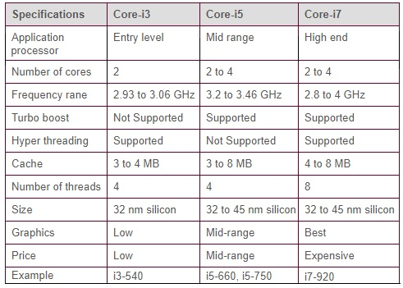

* + 1. Clock speed and cores are important part of your CPU. Always remember that the CPU itself is actually sold at a specific rated speed. That speed is driven by the **system crystal**, the system crystal pushes out a particular speed which is than multiplied internally in the CPU to get the full speed out of the CPU.
    2. Number of cores that you have in your CPU it depends how much **money** you got in your wallet.
    3. **Hyper-threading is only for Intel and it doubles your cores.**
  1. **CPU Caches**
     1. Cache memory is used a very **fast temporary storage** on a CPU.
     2. Hard drive is thousand time slow then the RAM.
     3. RAM is lot faster then the Hard drive but still quite slow then the CPU.
     4. We going to put a little static RAM (expensive) on the CPU. And we can speed things up. When we go to the CPU we going to grab the codes from RAM. Going to store it in the cache memory.
     5. The more cache you have hard is it to find stuff in it. Small cache are fast, big cache can hold more information.
     6. We going to store the code in cache.
     7. Modern CPUs use one or two levels of cache.
     8. The level 1 cache is the smallest and faster cache.
     9. The level 2 is about half of the speed of the level 1 and bigger.
     10. The level three is largest and the slowest cache. (Runs much faster the mother board itself.

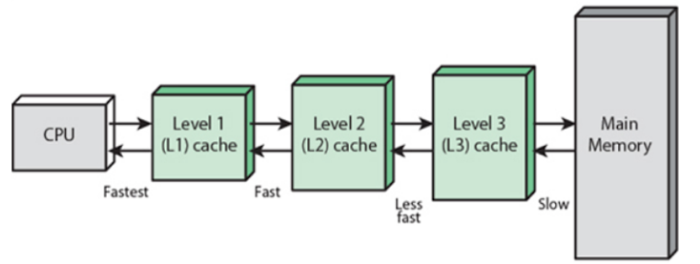

* 1. **32 bit vs 64 bit processing CPU**
     1. Typically CPU have 900 contact pins on it.
     2. CPU has to talk to RAM.
     3. Address bus are 32 bit or 64 bits for addressing memory.
     4. 32 wire or 64 wires are dedicate to the idea of addressing memory. If you have 32 wire can turn on and off points to different part of RAM. 4 billion and 64 bit = 2^32
     5. 32 wires, how many patterns of on and off can you do? 2^32 or 4 billion bytes or 4 Gigabytes of RAM.
     6. 64 wires can do more than 4, 8, 16, 32 GB RAM addressing.
     7. All Modern CPUS can hold 64 BIT operating system to take advantage of it.
     8. 64 BIT CPU enable you to use more then 4GB of RAM
     9. Use the system applied to check if your version of window support 64 Bit. (Start find computer right click and select property)
     10. Windows you can buy the Windows Operating System that is 32 bit or 64 bit version.
  2. **CPU extensions**
     1. CPU Extensions add functionality to the processor CPUs.
     2. Virtualization support enables CPUS to more efficiently run virtualized system. Create virtual machines inside another computer. There is a software called Virtualbox that you can install on your windows computer and in it you can create another computer that will run another windows operating system computer.
     3. GPU (Graphic processing unit) a video card can be external or into the CPU.
  3. **CPU sockets**
     1. We can always remove and upgrade the CPU from the Motherboard.
     2. CPU comes with a different sizes and shapes. INTEL CPUS use LGA (Land grid array) and AMD CPUS use PIN which is Pin Grid array)
     3. LGA 775 LGA stand for Land Grid Array and 775 the actually number of pins on it.
     4. LGA 1156
     5. LGA 1365
     6. LGA 1156 replace by 1155
     7. LGA 2011
     8. LGA 1150
  4. **Installing a CPU** 
     1. Start with the AMD 4100 and AMD 3 Motherboard, Make sure you have the Right CPU with the right sockets and the right speed for your particular motherboard.
     2. Be very carefully when you taking out the CPU, by touching any pin you can you can smoke it so very carefully and put it on the right way. You can only put the CPU only one way to make sure it drop down nice and pretty. It should be locked on place.
     3. Other part you have to deal with the fan, Usually CPU comes with a particular fan. There is a Thermal compound under the fan and the thermal compound do get attach with the CPU. If its Attach properly you can actually pick it up the whole thing.
     4. Then attach the CPU fan wire to the motherboard mark as CPU fan.
  5. **Cooling your PC** 
     1. Inside the computer these days is very hot place.
     2. We have CPU generating much heat, we got video card the Graphic prosess on which is generating heat and there are other many device that making heat. The bottom line we need a fan to keep things Cool
     3. We need CPU FAN, GRAPHIC Card FAN, CASE FAN.
     4. The more FANS you have the more noise you get. You need Fan to cool system down to RUN system better.
     5. How much fan we need = how much noise we can bare
     6. OEM FAN come with the CPU device.
     7. CASE Fan you can directly to the power plug
     8. Use a utility like speed FAN to control when your Fan spin up and how fast they can spin.
     9. Speed FAN works with any MOTHERBOARD you are using.
  6. **Liquid cooling** 
     1. A mount of liquid cooling put on the CPU. This mount got whols in and whole out around the Mount. Liquid goes through this mount taking the heat away and run out and cool its cycle around.
     2. Two type of Liquid cooling one PASSIVE LIQUID COOLING and ACTIVE LIQUID COOLING.
     3. Active liquid cooling works like a refrigerator built into your case.
     4. PASSIVE LIQUID COOLING mean the liquid goes through the big mount on the top of CPU it gets all heated up and runs into the radiator, the radiator cools it down some and then the pump pushes back around again.
     5. Liquid cooling system can be difficult to install but they cool you PC more efficiently then standards fan.

1. **RAM**
   1. RAM: Sticks and Speeds
      1. RAM ( RANDOM ACCESS MEMORY) where programs runs into your system, processing the system through the CPU any return data come back from the CPU to RAM and from there to the Hard drive.
      2. STICK of RAM how much ram capacity and how much speed it has.
      3. Two type of RAM DRAM (Dynamic RAM) AND SORAM (Synchronus DRAM) SD.
      4. SD RAM are much older RAM. Has 168 pin DIMM) DUAL IN – LINE MEMORY MODULE (DIMM), ( has 2 Knocks O)pins has both side has different JOB, they might look like at the same place but both have different JOB.
      5. SD RAM has a clock speed, Just like a CPU has a clock speed. So its important that you have a right speed for you motherboard. SD RAM pops up in printer these days.
      6. INTEL and other few companies got together and create a speed rating for RAM, they have name as call e.g. 66 MEGAHEARTZ Motherboard will call PC66. Or if you have a 100 megahertz will call PC 100.
      7. Modern Ram comes in the (Double data rate) DDR, DDR2 and DDR3. Verities.
      8. DDR(double data RAM) DDR SD RAM ( 184 PIN DIMM package) has single NOCH. IT took the motherboard speed itself and double the speed of RAM. DDR Speed then we have PC speed, you Take the motherboard speed which is 100 MHG and then you double that which is you DDR speed 200MHG then you take DDR speed 200MHG*8 += PC1600.
      9. DDR2( 240 pin DIMM) one NOCH but at the different place means have a different Motherboard. DDR2 clock doubling then DDR.

Take you mother board speed which is 100 MHG and the you double the speed which give you DDR speed 200 MHG and then you double that speed to get DDR2 speed which is 400 MHG and to get PC speed you need to 400*8= PC2 3200.

* + 1. DDR3 (240 DIMM same pin count as DDR2 slots are at the different place so different motherboard. Motherboard speed 100 MHG multiplie times *4 which is 400MHG now to get DDR3speed double that to 800 MHG so then take 800*8 and PC speed PC3 6400.

* 1. RAM capacity
     1. Different Ram sticks have different capacity depends on how much memory it hold. One DDR stick can hold half GB and other DDR stick can hold 1GB its written on the lable.
     2. Make sure your Motherboard can handle the amount of RAM you want to install.
     3. We must install the ram at the same capacity as motherboard speed.
     4. If you get 2 1gb ram stick it added to 2-RAM and if you have 2 2gn ram stick mean you have 4GB of Ram.
     5. Avoid mixing RAM sizes and speed it can cause stability issues.
  2. Other types of RAM

* + 1. RAMBUS RAM was the first Double data rate RAM but it was not popular for long.
    2. ECC AND PARITY RAM ARE SPECIAL VERIETIES OF RAM often use in server machines to increase stability.
    3. SODIUM RAM is used in laptop PCS and comes in several verities and capacities.
  1. Installing RAM
     1. Make sure your system can handle the memory you want to install.
     2. FIRMLY snap the RAM into Place , and it should not wiggle or move once its installed.
     3. If the system doesn’t BOOT the take the RAM out and try aagain to install it again.
  2. Troubleshooting RAM
     1. It can be mistake when you installing the RAM or adding Ram
     2. Use the system applet to check how much RAM windows can see on your system.
     3. Click on the Start button go to computer, right click on it and select properties. It will show you your system information for this particular system. It will show installed memory Ram, 16Gigabytes.
     4. If I have 8gb and I need to upgraded it to 16gb, then I need to add another 8gb stick to the motherboard.
     5. CPU-Z goes a lot further then just for CPU. CPU-Z is a powerfull tool that show how many RAM sticks are getting used and how much memory the computer is using
     6. SPD (serial presence detect) is a RAM feature called serial presence detect.
     7. Scary stuff is when Ram died, there is something called mean time between failures.(MTBF) it will take Decades before most RAM will fail on you. Give the Ram good electricity, don’t kick it, and you don’t cigrates smoke on it. Don’t make RAM unhappy. Coz when Ram get BAD your system get locks up, you get reboot , your screen freezes or stop moving completely. All these error point to bad RAM.
     8. You get two choices either you buy a new RAM and see if that fix it. Or you can use memory testing tools, the world is separated for those who have windows 7 and those who don’t, if you don’t then you have to turn to a wonderful powerfull and free tool its been around for a long long time, called MemTest86.
     9. Windows XP booting into MemTest86. Boot onto the Memtest86 .Memtest86 is very old and well updated program that does only one thing it test the memory.
     10. Memtest86 takes hours to RUN. It test the RAM very aggressively. You have to boot off. If he find anything he will report it you
     11. If you are with Windows7 it comes with the excellent memory testing tool.
     12. Windows 7 Go to control panel and go under administrative tool ND FIND WINDOWS MEMORY DIAGNOSTIC. Now just like memorytest86 it has to run its own. Instead of having TO BOOT IT we can just restart it and have it check the problem, Restart you computer, you will see similer result as memtest86.
     13. It don’t tell you which stick is bad it will just say A just try to change it to the new ram and see which one is bad.

Loaded: 42.58%

**0:20**

**0:45**

1. **BIOS (Basic Input/Output System)**
   1. What is the BIOS?
   2. POST
   3. System setup
   4. Troubleshooting BIOS