**Lab Manual 05**

**Subject: -Digital Signal Processing and Storage**

**Group Members: -**

**Student Name:** - Jaswinder Singh

**Student ID: -** C0747193

**Student Name: -** Mohpreet Kaur

**Student ID: -** C0749072

1. **Equation-01**



* **Convolution function: -**

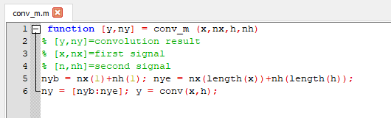

* **Equation-01 : -**

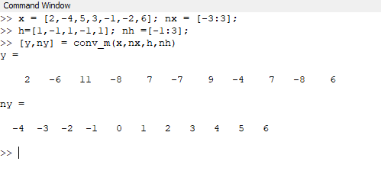

1. **Equation-02 : -**



* **Equation 02 solution: -**

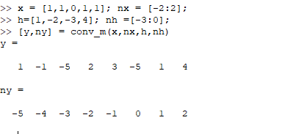

1. **Equation 03: -**



* **Step function: -**

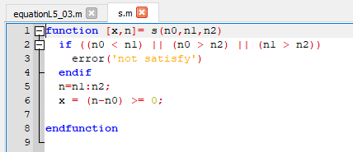

* **Equation 03 function: -**

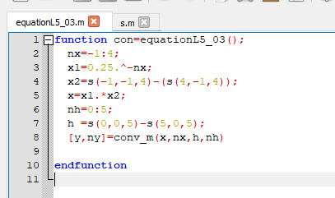

* **Output: -**

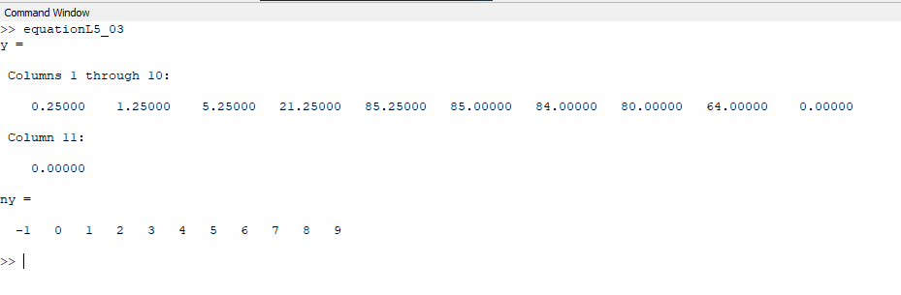

1. **Equation 04: -**



* **Equation 04 function: -**

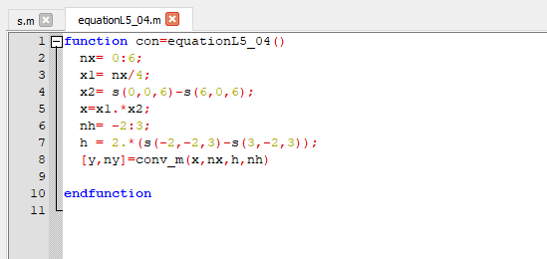

* **Output: -**

