**Lab Report 03**

**Subject: -Digital Signal Processing and Storage**

**Group Members: -**

**Student Name:** - Jaswinder Singh

**Student ID: -** C0747193

**Student Name: -** Mohpreet Sidhu

**Student ID: -** C0749072

1. Generate the following sequences using the basic Octave signal functions and the basic Octave signal operations discussed in this chapter. Plot signal samples using the stem function.



**Ans: -**

1. **Creating function: -**

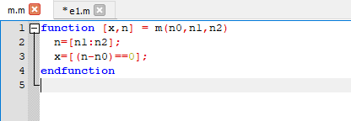

1. **Equation X1 in function: -**

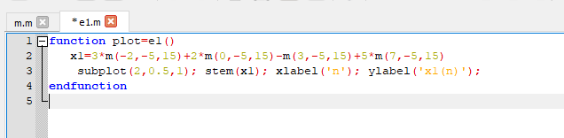

1. **Plot When we call e1 file: -**

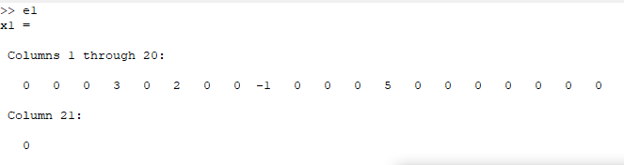

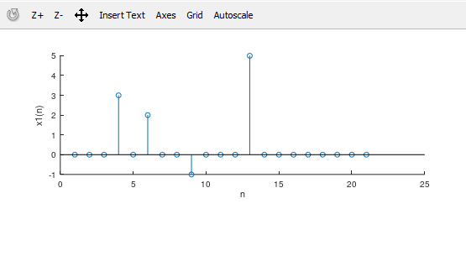

1. **Equation 2: -**



**Ans: -**

function plot=equation2()

n2= [-10:10];

x2 =zeros(1,length(n2));

for k= -5:5 x2 =x2+ exp(-abs(k))*m(2*k,-10,10);

subplot(2,1,1);

stem (n2,x2);

xlabel('n');

ylabel('x2(n)');

endfor

endfunction

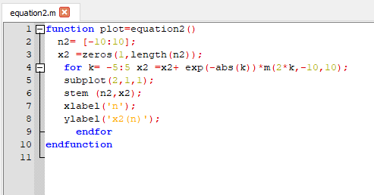

**Plot: -**

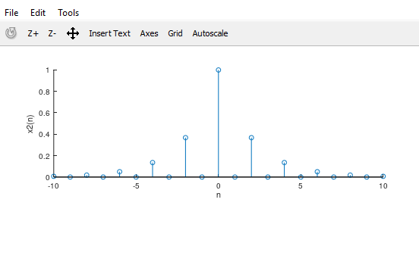

1. **Equation 3: -**



**Ans: -**

**Step function: -**

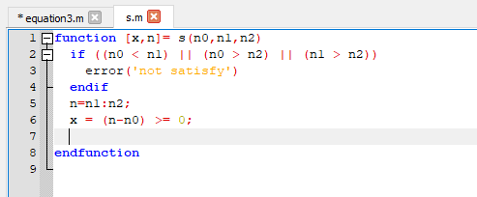

**Equation X3 in function: -**

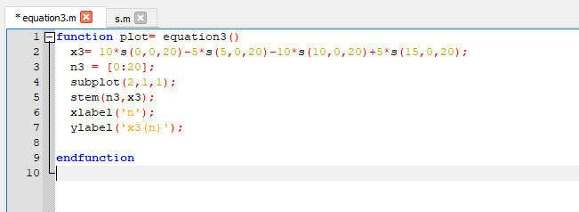

**PLOT: -**

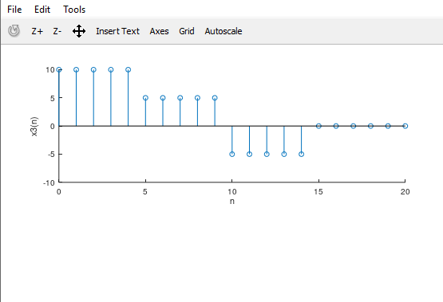

1. **Equation 4: -**



**ANS:-**

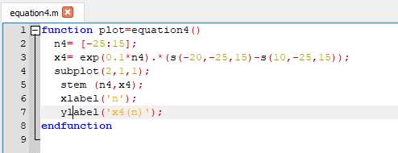

**PLOT OF EQUATION 4: -**

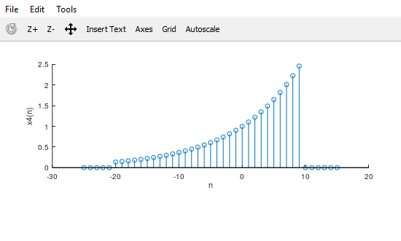

2. **Let x(n)={2, 4, -3, 1, -5, 4, 7}. Generate and plot the samples (use the stem function) of the**

**following sequences.**

1. **Equation 1: -**



1. **SIGSHIFT FUNCTION: -**

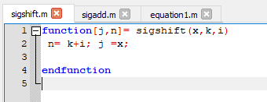

1. **SIGADD FUNCTION: -**

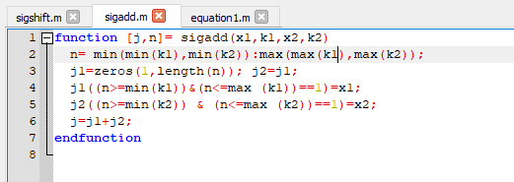

1. **Equation 1 : -**

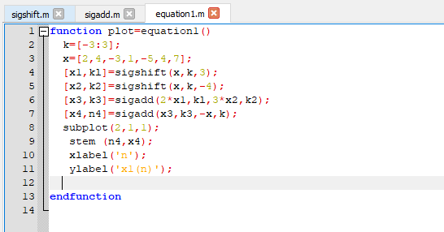

1. **PLOT: -**

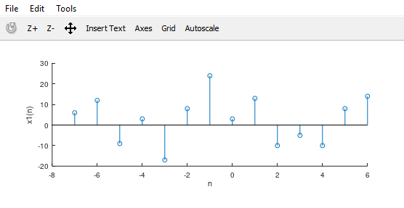

1. **Equation 2: -**



1. **SIGFOLD FUNCTION: -**

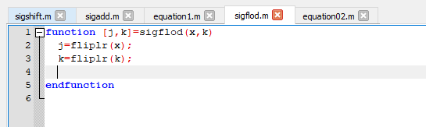

1. **Equation 2: -**

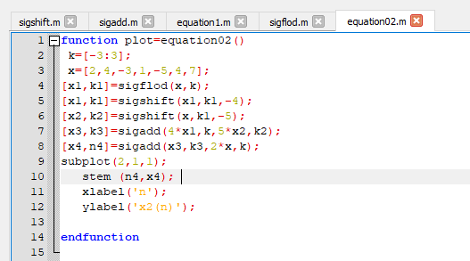

1. **PLOT: -**

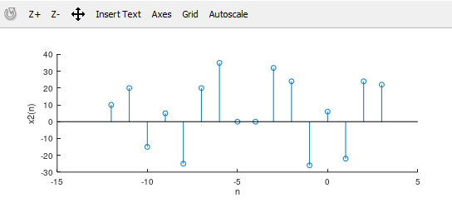

1. **Equation 03: -**



1. **Sigmult FUNCTION: -**

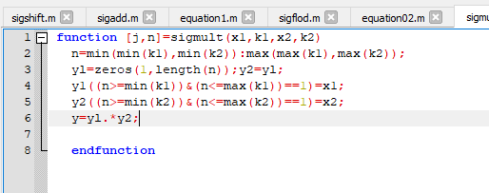

1. **Equation 03: -**

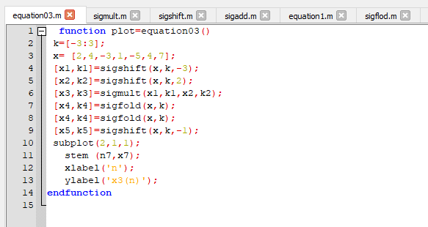

1. **PLOT: -**

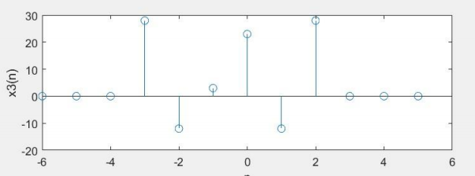

1. **Equation 04: -**



1. **Equation 04: -**

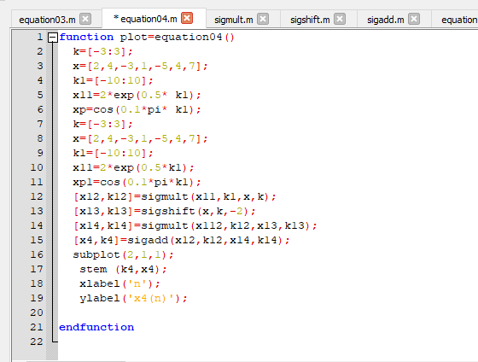

**b. ) PLOT: -**

