**Lab Report 03**

**Subject: -Digital Signal Processing and Storage**

**Group Members: -**

**Student Name:** - Jaswinder Singh

**Student ID: -** C0747193

**Student Name: -** Mohpreet Sidhu

**Student ID: -** C0749072

**Question 1:-**



* **Even Odd function: -**

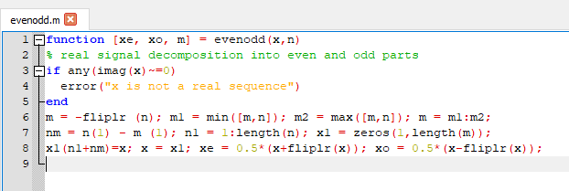

* Equation 1: -

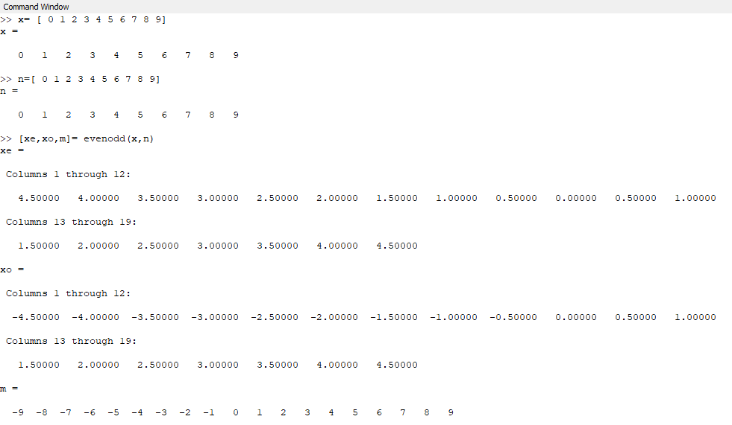

* **PLOT (stem(n,x)) : -**

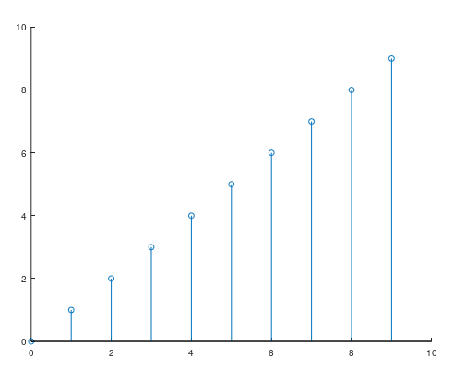

* **EVEN PLOT (stem(m,xe)) : -**

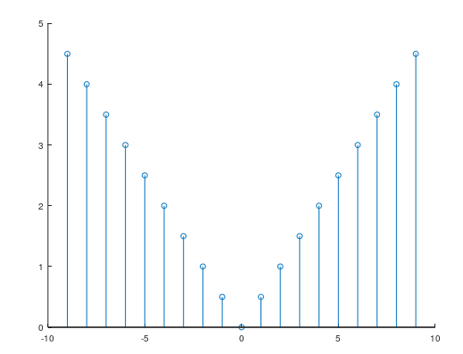

* **Odd PLOT ( stem(m,xo)): -**

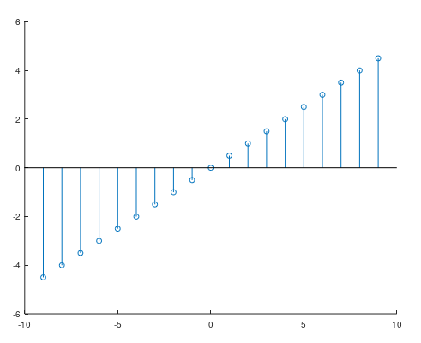

* **Equation 2: -**



* **Step Function: -**

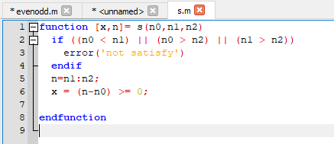

* **Equation 2: -**

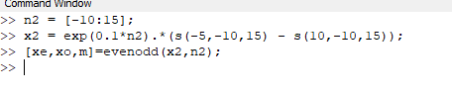

* **PLOT: -(stem(n,x)): -**

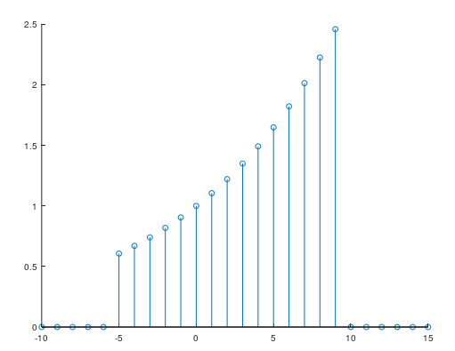

* **PLOT (EVEN): -stem(m,xe)**

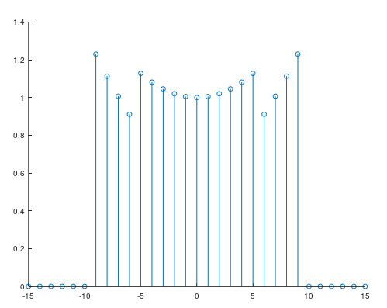

* **PLOT(Odd) : - stem(m,xo)**

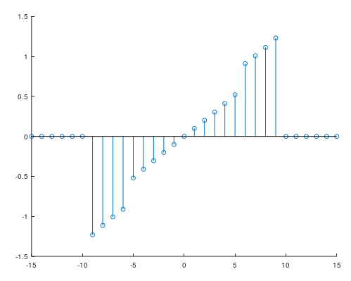

* **Equation 3: -**



* **Equation 03: -**

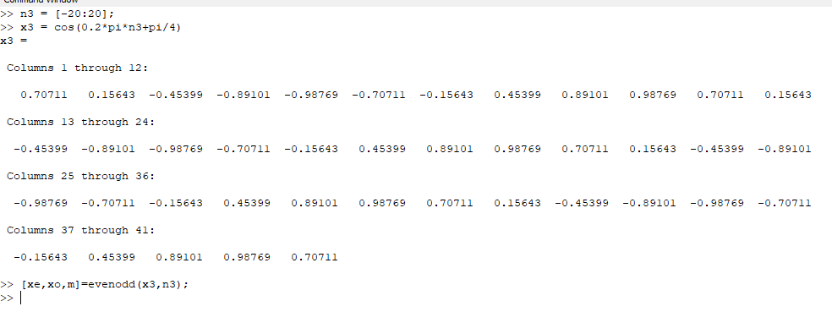

* **PLOT (stem(n3,x3) ) : -**

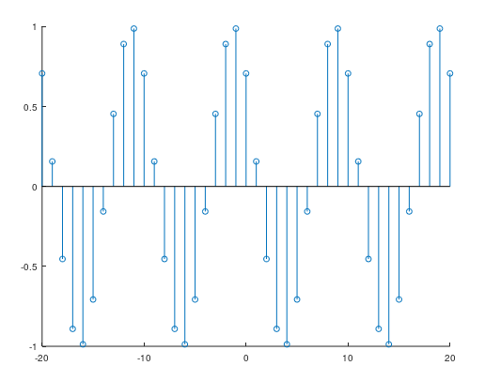

* **PLOT (EVEN): - stem(m,xe)**

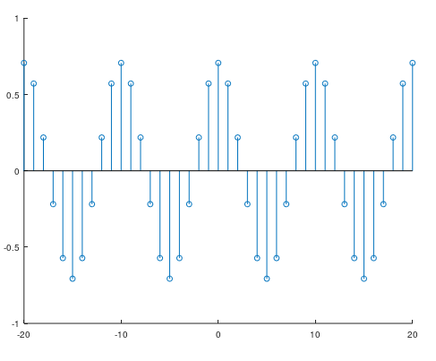

* **PLOT (Odd): - stem(m,xo)**

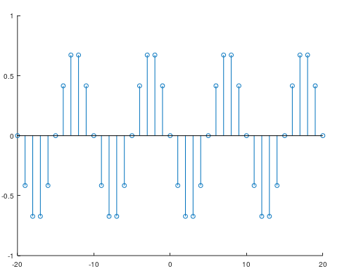

* **Equation 4: -**



* **Equation 4: -**

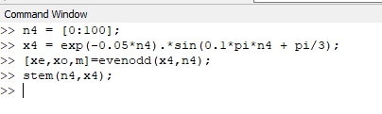

* **PLOT (stem(n,x): -**

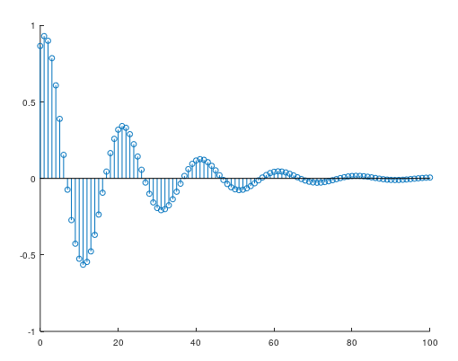

* **PLOT (even): - stem(m,xe)**

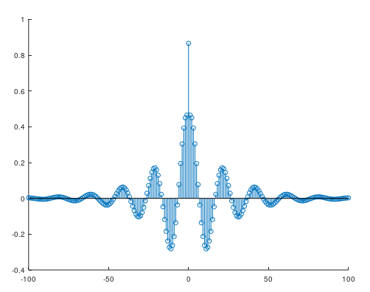

* **PLOT (Odd) : - stem(m,xo)**

