Introduction to R

Much material in these R-based lectures come from material provided by Arthur Li, City of Hope National Medical Center (used with permission), and some parts may have been derived from various online sources, such as “Advanced R”, by Hadley Wickham.

R language - Definition and Background

- Definition from Wikipedia®
- R is a programming language and software environment for statistical computing and graphics.
- The R language has become a de facto standard among statisticians for the development of statistical software.
- R is widely used for statistical software development and data analysis.

- History of R

- R is an implementation of the S programming language
- S was created by John Chambers
- Another commercial implementation of S language from Insightful Corporation is called S-SPLUS®
- R is named partly after the first names of the first two R authors (Robert Gentleman and Ross Ihaka)
- R is part of the GNU project. Its source code is freely available under the GNU General Public License

R System

- The R System consists of two conceptual parts:
- The “base” R sytem that you download from CRAN - This is what you want to install R for the first time Contributed packages.
- The “base” R system contains the base package which is required to run R and contains the most fundamental functions.
- The main installation will install R and a popular set of add-on libraries
- You can install hundreds of libraries from the Comprehensive R Archive Network (CRAN) or the Bioconductor
- Package installations
- To install a new package from the CRAN, you can use the install.packages function. For example, to install the “Epi” package, type
> install.packages("Epi")
- Alternatively, you can also click on the “Packages” tab from the toolbar in the R window, then click on “Install package(s),” then follow the remainder of the instructions
- Once a package is installed, it is stored on the computer’s hard drive
> library (Epi)

R front-ends

- R comes with basic facilities to edit and R programs.
  - The structure of these default front-ends varies by operating system (e.g. Windows, MacOS, Linux)
  - Many Alternative front-ends are available in the form of editors (e.g. Emacs) and Integrated Development Environments (IDE’s) (e.g. Eclipse, Rstudio).
- We will make use of the free open-source version of the Rstudio IDE (https://www.rstudio.com).
- Note that Rstudio is a front-end to R and is not the same thing as R!

Use R as a Calculator

- Of the many functions R can accomplish, it can even serve as a simple calculator. For example:
> 3*2+4
[1] 10
> 4^2+1
[1] 17
> log(2)+exp(5)
[1] 149.1063
- You type the command after the prompt >
- The second line is the output

Expressions and Assignments

- Commands in R are either expressions or assignments
- Commands are separated by either a semi-colon or a new line
- An expression command is evaluated and (normally) printed
> 5+2;

1+exp(2)

[1] 7
[1] 8.389056
- You can assign a value to a variable by using <- or =, but not < . When typing the name of an object, R will print this object or a short summary of the object. This is refers as auto-printing.
- You can also use the print function explicitly like the one below.
- An assignment command evaluates an expression and passes the value onto a variable, but the result is not printed.
> a = 5*pi
> a
[1] 15.70796
> print(a)
[1] 15.70796

Naming Conventions

- R names for objects can be made up from:
◦ upper and/or lower case letters
◦ digits: 0 to 9, in any non-initial position
◦ periods and underscores, usually used to separate words in names
- R names are case sensitive
- Avoid using system names such as
◦ c, q, s, t, C, D, F, I, T, diff, length, mean, pi, range, rank, time, tree, and var
◦ Using these names will probably prompt a warning message
◦ Sometimes, using these names will cause a computation error
- You are not allowed to use the following reserved words: FALSE, Inf, NA, NaN, NULL, TRUE, break, else, for, function, if, in, next, repeat, return and while

Vectorized Arithmetic

- A data vector is an array of numbers that can be constructed by using c(...)
- To construct vectors storing the weights and heights for a group of people, you can type the following command:
> weight = c(60, 72, 57, 90, 95, 72)
> weight
[1] 60 72 57 90 95 72
> height = c(1.75, 1.80, 1.65, 1.90, 1.74, 1.91)
- You can perform the calculations with vectors of the same length. For example,
> bmi = weight/height^2
> bmi
[1] 19.59184 22.22222 20.93664 24.93075 31.37799 19.73630
- It is also possible to perform the calculations with vectors of different lengths
- You have already used calculations with vectors of different lengths in height² since 2 is a vector with a length 1
- The shorter vector is recycled
- If the longer vector is not a multiple of the shorter vector, R will issue a warning message:
- longer object length is not a multiple of shorter object length
- To calculate the mean of the bmi, you can type the following
> sum(height)
[1] 10.75
> length(height)
[1] 6
> sum(height)/length(height)
[1] 1.791667
- Or you can simply type
> mean(height)
[1] 1.791667

1.3.5

Standard Procedures

- Suppose you would like to test the mean of the BMI of the above 6 people, equaling 22.5
- You can use the t.test function
> t.test(bmi, mu=22.5)
One Sample t-test
data: bmi
t = 0.3449, df = 5, p-value = 0.7442
alternative hypothesis: true mean is not equal to 22.5
95 percent confidence interval:
18.41734 27.84791
sample estimates:
mean of x
23.13262

1.3.6

Graphs

  - Suppose you would like to investigate the relationship between weight and height through a scatter plot; you can use the plot function like the one below:
> plot(height, weight)

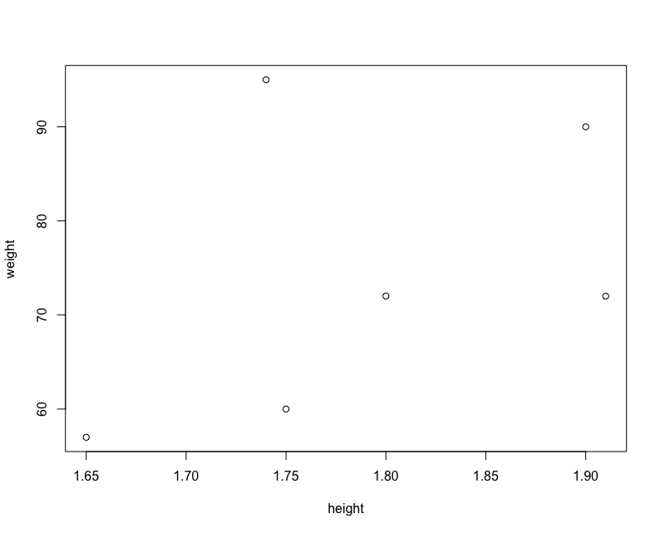

Miscellaneous Matters

  - Everything typed after # be ignored by R
> foo = 10 # foo is assigned with value 10
  - The previous command can be recalled with the up-arrow key

The “help” Function

  - You can use the help (?) function to read the description of the function. For example, help(var) or ?var
  - For operators, such as +, -, [, [[, you need to enclosed it in “”. For example,

> help(“+”)

- To find out the arguments of a function, we can use the args function. For example,
> args(var)
function (x, y = NULL, na.rm = FALSE, use)
NULL
- If we do not know the name of the function, we can use the help.search function. For example
> help.search("linear models")

An Overview of R Objects

Mode and Class

- Everything within the R language is an object
- The nature of R objects can be described by their own attributes. The number of attributes for each object vary
- When managing objects in R , it is critical and important to distinguish different R objects and to understand the difference between each object
- The two most important attributes of R objects are mode and class, which describe the characteristics of the objects
- You can find the mode of each object by using the mode function, which describes the data type or storage mode of an object. For example,
> n1 = c(1, 4, pi, 10)
> n1
[1]

1.000000

4.000000

3.141593 10.000000

> mode(n1)
[1] "numeric"

- The most commonly encountered modes are numeric, character, and logical
- The class attribute describes the data structure of an object
- The concept of class is closely related to objected-oriented programming
- You can find the class of each object by using the the class function. For example, the following command creates a matrix, n2 from n1, by using the matrix function

> n2 = matrix(n1, nrow=2)
> n2

[1,]
[2,]

[,1]
[,2]
1 3.141593
4 10.000000

> mode(n2)
[1] "numeric"
> class(n2)
[1] "matrix"
> class(n1)
[1] "numeric"

- Notice that the mode of n2 is still numeric. The difference between n1 and n2 is distinguished by their class. n1 is a one-dimensional vector, whereas n2 is a matrix
- Even n1 is a vector, but the class function does not return vector ; instead, it returns “numeric.”

Missing Values

    - NA is used for missing elements in numeric, character, and logical vectors
    - NA is not a value but a marker for a missing value
    - The missing values are sometimes intended or may result from computation or data type conversion, for example,
> c1 = c("A", "B", "C")
> as.numeric(c1)
[1] NA NA NA
Warning message:
In eval(expr, envir, enclos) : NAs introduced by coercion

- The is.na function can be used to indicate which elements of a vector are missing
- The length of the result from the is.na function is the same as its argument. For example,
> n4 = c(1, NA, 3)
> is.na(n4)
[1] FALSE

TRUE FALSE
- In general, operations on missing value(s) NA result in a missing value(s) NA
- Some functions have a na.rm argument. Setting the na.rm argument to TRUE will remove the missing values during operations
> sum(n4)
[1] NA
> sum(n4, na.rm=T)
[1] 4

Lab 1 Exercise

The data below report the immunization percent (the predictor variable, x) and death rate before age 5, per 1000 live births (the response variable, y) for 20 countries around the world.

- Get the data into R using whatever method you prefer.
- Obtain the means and standard deviations for these two variables.
- Produce a scatterplot of the data with the predictor variable on the x-axis and response variable on the y-axis. Is there a trend between these two variables? If so, describe the trend.
x y
40 165
54 85
85 9
95 43
81 94
26 226
90 7
95 9
83 12
83 145
85 11
83 6
65 51
98 18
47 189
74 90
75 10
97 12
79 35
91 27

Additional Lab Work

With the remaining lab time, please work on homework set 1 on your own or in small self-selected groups. If you have completed the homework, work through the Further Applications section of chapters 2 & 3. Ask the GTA questions as needed.

