H 524: Introduction to Biostatistics
Computing Handout 5: Comparing Two Means and ANOVA

In this lab we learn R procedures for obtaining confidence intervals and performing hypothesis tests for μ₁-μ₂ in the two-population setting. We then generalize to an analysis of variance (ANOVA) for comparing 3 or more means. The R commands used are

t.test() qqnorm() qqline() shapiro.test() aov() bartlett.test() pairwise.t.test() var.test() boxplot() mean() sd() length()

- Comparing two means: independent samples with summary statistics

Problem 11.8 in the textbook asks you to compare mean bone mineral content of babies from women who smoke to those who do not smoke. The data are provided in summary form, as is commonly done in scientific publications:

Group n Mean SD
Smoking moms 77 0.098 g/cm 0.026 g/cm
Nonsmoking moms 161 0.095 g/cm 0.025 g/cm

Let’s conduct a two-sided test for a difference in mean bone mineral content at significance level α=0.05

Ho: μ_{S}= μ_{NS} versus Ha: μ_{S}≠ μ_{NS}

and calculate a 95% confidence interval for μ_{S}- μ_{NS} .

Note that the problem states “Assume that the underlying population variances are equal.” The sample standard deviations (0.026 and 0.025) are very similar, which supports the equal population variance assumption. We’ll see how to test the equal variance assumption later in this lab.

R commands and output:

smokingmoms<-rnorm(77,mean=0.098,sd=0.026)
nonsmokingmoms<-rnorm(161,0.095,sd=0.025)
t.test(smokingmoms,nonsmokingmoms)

Welch Two Sample t-test

data: smokingmoms and nonsmokingmoms
t = 1.0677, df = 153.08, p-value = 0.2873
alternative hypothesis: true difference in means is not equal to 0
95 percent confidence interval:
-0.003128244 0.010486162
sample estimates:
mean of x mean of y
0.09854949 0.09487053

Statistics -> Summaries, tables, and tests -> Classical tests of hypotheses -> Two-sample mean-comparison calculator

Two-sample t test with equal variances
------------------------------------------------------------------------------
| Obs Mean Std. Err. Std. Dev. [95% Conf. Interval]
---------+--------------------------------------------------------------------
x | 77 .098 .002963 .026 .0920987 .1039013
y | 161 .095 .0019703 .025 .0911089 .0988911
---------+--------------------------------------------------------------------
combined | 238 .0959706 .0016407 .025312 .0927383 .0992029
---------+--------------------------------------------------------------------
diff | .003 .0035092 -.0039133 .0099133
------------------------------------------------------------------------------
diff = mean(x) - mean(y) t = 0.8549
Ho: diff = 0 degrees of freedom = 236

Ha: diff < 0 Ha: diff != 0 Ha: diff > 0
Pr(T < t) = 0.8033 Pr(|T| > |t|) = 0.3935 Pr(T > t) = 0.1967

The test statistic is t=0.8549, the reference distribution is t(236), and the p-value for the two-sided test is 0.3935. Therefore, we do reject Ho. There is no evidence from the data that a statistical difference exists between the population bone mineral content of babies from mothers who smoke and mothers who do not smoke. The 95% CI for μ_{S}- μ_{NS} corroborates this conclusion; it spans from -0.0039 to 0.0099 so the interval contains 0. Thus, even if we didn’t have the p-value we could come to the conclusion to not reject Ho.

R provides a lot of useful output here. It gives the mean, SE, and CI separately for each group and for the groups combined. The top two rows present one-sample estimates for μ_{S} and μ_{NS}. A point estimate and 95% CI for μ_{S} is 0.098 (0.092, 0.1039) and a point estimate and 95% CI for μ_{NS} is 0.095 (0.0911, 0.0989).

The t.test command can also run calculations for situations where the population variances are unequal.

2. Comparing two means: independent samples with raw data

We can also use R for comparing two means when we have the raw data. This is the more common scenario because it’s unlikely that you will only have summary statistics and not the raw data. Below is a data set from a study that compared change in heart rate over a short time period for people that drank caffeinated or decaffeinated coffee.

Caffeine Decaf
28 26
11 1
-3 0
14 -4
-2 -4
-4 14
18 16
2 8
2 0
18
-10

As always, we run an exploratory data analysis first. First, we make the caffeine and decaf variables in R, then code for exploratory statistics, then create boxplots to visually explain data, as shown in the code below:

caffeineHR<-c(28,11,-3,14,-2,-4,18,2,2)
decafHR<-c(26,1,0,-4,-4,14,16,8,0,18,-10)

L_cHR<-length(caffeineHR)
M_cHR<-mean(caffeineHR)
sd_cHR<-sd(caffeineHR)
min_cHR<-min(caffeineHR)
max_cHR<-max(caffeineHR)
L_dHR<-length(decafHR)
M_dHR<-mean(decafHR)
sd_dHR<-sd(decafHR)
min_dHR<-min(decafHR)
max_dHR<-max(decafHR)

Which produces the following output variables and responses from R:

> L_cHR
[1] 9
> M_cHR
[1] 7.333333
> sd_cHR
[1] 11.05667
> min_cHR
[1] -4
> max_cHR
[1] 28
> L_dHR
[1] 11
> M_dHR
[1] 5.909091
> sd_dHR
[1] 11.24682
> min_dHR
[1] -10
> max_dHR
[1] 26

Creating the boxplot:

boxplot(caffeineHR,decafHR, names=c("Caffeine", "Decaf"), ylab="Heart Rate")

The sample means are a little different (5.9 and 7.3), but are they different enough to confidently conclude that the population means are different? That’s the reason for running a t-test!

First note that the sample standard deviations are similar. We’ll take this as evidence that the population variances are equal. A formal statistical test for equal population variance is called the F-test of equal variance. The hypotheses are

Ho: population variances are equal [in symbols, σ₁² = σ₂²]
Ha: population variances are different [in symbols, σ₁²≠ σ₂²]

The code for F-test in R:
var.test(caffeineHR,decafHR)

producing:
F = 0.96647, num df = 8, denom df = 10, p-value = 0.9807
alternative hypothesis: true ratio of variances is not equal to 1
95 percent confidence interval:
0.2507134 4.1511226
sample estimates:
ratio of variances
0.9664726

All we care about is the p-value. Here, the p-value is 0.9807, so we fail to reject Ho. Additionally, the boxplots below show similar spread for the two groups. We therefore run a t-test assuming equal variance.

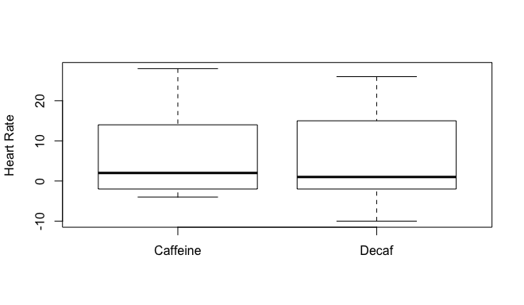

Based on the boxplots, the groups don’t appear to be too different. Before we run the t-test, we need to check one more condition, the normality condition. We need to do this here because the sample sizes are small. If we had large sample sizes from each group, the central limit theorem kicks in so we would not need to check normality (though it doesn’t hurt to check it anyway -- I always do). Since the sample sizes are small, we require the data from both groups to have normal distributions. If they don’t, we need to use something other than a t-test (turns out we would use a certain nonparametric test that we will learn in Chapter 13; more on this later in the quarter). We’ll consider two ways to check normality: normal quantile plots and the Shapiro-Wilk test. Note that the boxplots above also help to assess normality.

Normal quantile plots: If normality holds, the dots should fall along the straight line.

No caffeine group:
qqnorm(decafHR, xlab="Inverse Normal", ylab="Heart Rate")
qqline(decafHR)
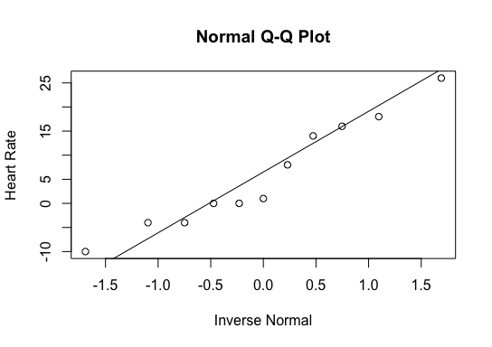
Caffeine group:
qqnorm(caffeineHR, xlab="Inverse Normal", ylab="Heart Rate")
qqline(caffeineHR)
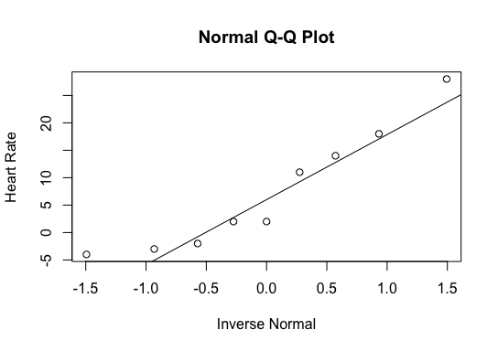

Based on these graphics, the normality assumption does not appear to be grossly violated for either group.
In general, the Shapiro-Wilk test provides a p-value for

Ho: data are from a normal population
Ha: data are not from a normal population

R commands: shapiro.test(decafHR) shapiro.test(caffeineHR)

> shapiro.test(decafHR)

Shapiro-Wilk normality test

data: decafHR
W = 0.94307, p-value = 0.5572

> shapiro.test(caffeineHR)

Shapiro-Wilk normality test

data: caffeineHR
W = 0.90034, p-value = 0.254

Just like with the F-test for equal variance, all we care about here are the p-values. The p-values are 0.62 and 0.27. We do not reject Ho in either case. Now, this does not mean that the data are normal, just that we don’t have evidence that they aren’t normal!

All conditions for use have checked out, so we can calculate a t-test and t-interval for comparing mean heart rate:

R commands
t.test(decafHR, caffeineHR)
mean(decafHR)-mean(caffeineHR)

Output:

Welch Two Sample t-test

data: decafHR and caffeineHR
t = -0.28438, df = 17.338, p-value = 0.7795
alternative hypothesis: true difference in means is not equal to 0
95 percent confidence interval:
-11.975047 9.126562
sample estimates:
mean of x mean of y
5.909091 7.333333
Statistics -> Summaries, tables, and tests -> Classical tests of hypotheses -> Two-group mean-comparison test

A point estimate and 95% confidence interval for μ_{NC}- μ_{C} is -1.42 (-11.97, 9.12). We are 95% confident that the difference in mean heart rate change between the decaffeinated and caffeinated groups is between -11.97 and 9.12. From this interval we would fail to reject Ho: μ_{NC}=μ_{C} versus the two-sided alternative at level α=0.05. This is confirmed by the p-value of 0.78 for the two-sided test.

- Comparing two means: paired data

The ttest() procedure can also be used to analyze paired data. Suppose the data below were reported from a “before-after” study of the effect of an anti-depressant on the well-being of depressed individuals, using a standardized "well-being scale" that sums Likert-type items to obtain a score from 0 to 20. Higher scores indicate greater well-being (the drug is having a positive effect). We reduce the problem to a one-sample problem by taking the difference: after score minus before score.

Before After
5 2
0 1
6 5
7 7
4 10
3 9
2 7
1 11
1 4

Code for difference variable:
before<-c(5,0,6,7,4,3,2,1,1)
after<-c(2,1,5,7,10,9,7,11,4)
difference<-after-before

Recall that for studies with small sample size, we require the data to be normally distributed as a condition for using the paired t-test. From the boxplot, there is no indication of non-normality. Also, a normal plot of the differences and the Shapiro-Wilk test do not indicate a violation of normality (output not shown). We can therefore proceed with a paired t-interval. Let’s get a 90% CI.

Code for boxplot:
boxplot(difference, ylab="diff")
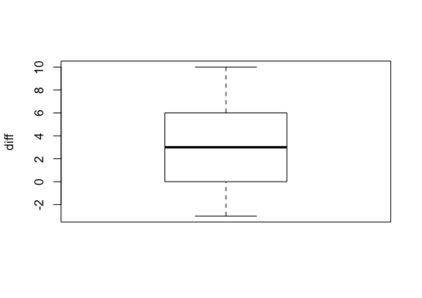
Rcommands and output:

t.test(after,before,mu=0,paired=T, conf.level=0.90)

Paired t-test

data: after and before
t = 2.1828, df = 8, p-value = 0.0606
alternative hypothesis: true difference in means is not equal to 0
90 percent confidence interval:
0.4442957 5.5557043
sample estimates:
mean of the differences
3

A point estimate and 90% CI for δ (the after-before population mean) is 3.00 (0.44, 5.56). From this interval we reject Ho at the α=0.10 level because 0 is not in the CI. The p-value of 0.06 would lead to the same conclusion, namely fail to reject Ho because the p-value is less than 0.10.

- Comparing k means -- ANOVA

We illustrate the R procedure oneway for the comparison of multiple population means using the weight loss data set from Notes 5. The data are tabulated below.

Diet Exercise Control
4.7 15.9 4.1
7.9 5.1 -3.7
0.5 6.7 -2.1
-2.1 19.1 7.7
7.1 9.2 5.92
7.9 7.7 -4.1
3.6 14.7 8.2
2.0
-4.4
-2.1

The goal is to test the null hypothesis
Ho: μ_{D} = μ_{E} = μ_{C}
versus the alternative hypothesis that at least one mean is different from at least one other mean. If Ho is rejected then we also want to compute Bonferroni adjusted t tests for
Ho: μ_{D}=μ_{C}
Ho: μ_{E}=μ_{C}
Ho: μ_{E}=μ_{D}
R commands and output:

bartlett.test() ; aov()

Produce summary stats; R code and output:
diet<-c(4.7,7.9,0.5,-2.1,7.1,7.9,3.6)
exercise<-c(15.9,5.1,6.7,19.1,9.2,7.7,14.7)
control<-c(4.1,-3.7,-2.1,7.7,5.92,-4.1,8.2,2.0,-4.4,-2.1)
> mean(summary1)
[1] 4.98
> sd(summary1)
[1] 6.287796
> length(summary1)
[1] 24
> mean(diet)
[1] 4.228571
> sd(diet)
[1] 3.868124
> length(diet)
[1] 7
> mean(exercise)
[1] 11.2
> sd(exercise)
[1] 5.330103
> length(exercise)
[1] 7
> mean(control)
[1] 1.152
> sd(control)
[1] 5.030964
> length(control)
[1] 10
> summary1<-c(diet,exercise,control)
> mean(summary1)
[1] 4.98
> sd(summary1)
[1] 6.287796
> length(summary1)
[1] 24

ANOVA R code and output:
weightloss<-data.frame(loss=c(diet,exercise,control),x=factor(rep(c("diet","exercise","control"),c(length(diet),length(exercise),length(control)))))

anovaexample<-aov(loss~x, data=weightloss)

summary(anovaexample)

bartlett.test(list(diet, exercise, control))

pairwise.t.test(weightloss$loss, weightloss$x, p.adj="bonf")

Df SumSq MeanSq Fvalue Pr(>F)
x 2 421.3 210.65 9.064 0.00145 **
Residuals 21 488.0 23.24
---
Signif. codes: 0 ‘***’ 0.001 ‘**’ 0.01 ‘*’ 0.05 ‘.’ 0.1 ‘ ’ 1

Bartlett test of homogeneity of variances

data: list(diet, exercise, control)
Bartlett's K-squared = 0.62678, df = 2, p-value = 0.731

Pairwise comparisons using t tests with pooled SD
(P value adjustment method: Bonferroni)

data: weightloss$loss and weightloss$x

control diet
diet 0.6281 -
exercise 0.0011 0.0397

The F statistic is F=9.06, with p-value=0.0015. Also, note that the mean square values are 210.65 and 23.24, which is what we got in lecture. Since the p-value is <0.05, we reject Ho. The mean weight change is not the same for the three groups. So the next step is to determine which groups are different and by how much. R provides Bonferroni adjusted p-values: diet and control are not significantly different (p=0.628), but exercise is significantly different from diet (p=0.04) and control (p=0.001).

Conditions for use

Independence: valid by design

Equal variance: R provides a test for this, called Bartlett’s test. The null hypothesis is that the population variances are all equal. The alternative is that at least one group has a different variance than at least one other group. For the weight loss data, Bartlett’s test gives p=0.731, so we fail to reject Ho and do not reject the equal variance assumption.

Normality: Small sample sizes were used for each group, so we need to check normality. We can use boxplots, normal quantile plots, and the Shapiro-Wilk test for each group. Normal plots look fine (not shown to save space). Boxplots are particularly useful, because you can look for symmetry and equal variance, and they also suggest which groups might be different. I always get boxplots when I run an ANOVA.

R commands for boxplot creation:
bp<-as.data.frame(weightloss$loss)
boxplot(bp[15:23,],bp[1:7,],bp[8:14,],ylab="loss",names=c("C","D","E"))
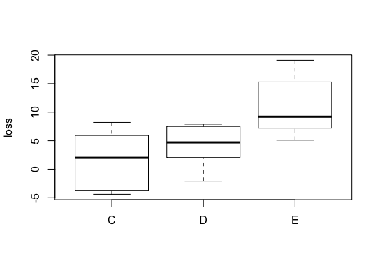
Pretty clear that exercise is effective for the sampled individuals. Diet and control don’t appear that different.

