Anorexia Treatment Study
Statistical Analysis Report
Date: November 2, 2025

Executive Summary
This report presents a comprehensive statistical analysis of a clinical study comparing three treatment approaches for anorexia nervosa: Control (no treatment), Cognitive Behavioral Therapy (CBT), and Family Therapy (FT). The study examined weight changes in 72 participants across these three treatment groups.

Key Findings
- Family Therapy showed the strongest results with a mean weight gain of 7.26 lbs
- CBT demonstrated moderate effectiveness with a mean weight gain of 3.01 lbs
- Control group showed a slight mean weight loss of -0.45 lbs
- Statistical analysis revealed significant differences between treatment groups (p = 0.0065)
- 76.5% of FT participants gained weight, compared to 62.1% in CBT and 42.3% in Control

Dataset Overview
The dataset comprises weight measurements from 72 participants with anorexia nervosa, distributed across three treatment groups. Each participant's weight was recorded before (pre-treatment) and after (post-treatment) the intervention period.

Sample Composition
Treatment Group | Sample Size | Percentage
Control | 26 | 36.1%
CBT | 29 | 40.3%
Family Therapy | 17 | 23.6%
Total | 72 | 100%

Descriptive Statistics

Pre-Treatment Weights
Group | Mean (lbs) | SD | Range
Control | 81.56 | 5.71 | 70.5 - 91.8
CBT | 82.69 | 4.85 | 70.0 - 94.9
Family Therapy | 83.23 | 5.02 | 73.4 - 94.2

Weight Change Analysis
Group | Mean Change (lbs) | SD | Range | % Gained Weight
Control | -0.45 | 7.99 | -12.2 to 15.9 | 42.3%
CBT | 3.01 | 7.31 | -9.1 to 20.9 | 62.1%
Family Therapy | 7.26 | 7.16 | -5.3 to 21.5 | 76.5%

Statistical Analysis

One-Way ANOVA
A one-way analysis of variance (ANOVA) was conducted to compare weight changes across the three treatment groups. The results revealed a statistically significant difference between groups:
- F-statistic: 5.4223
- P-value: 0.0065 (p < 0.05)
This indicates that there is a statistically significant difference in weight change between at least two of the treatment groups.

Pairwise Comparisons
Independent t-tests were conducted to identify which specific groups differed from each other:
Comparison | P-value | Significance
Control vs CBT | 0.0996 | Not Significant
Control vs Family Therapy | 0.0025 | Significant (p < 0.05)
CBT vs Family Therapy | 0.0612 | Not Significant
Key Finding: Family Therapy produced significantly greater weight gain compared to the Control group (p = 0.0025). The differences between Control vs CBT and CBT vs Family Therapy did not reach statistical significance, although both showed trends in the expected direction.

Visual Analysis
The following visualizations illustrate the treatment outcomes across all three groups:
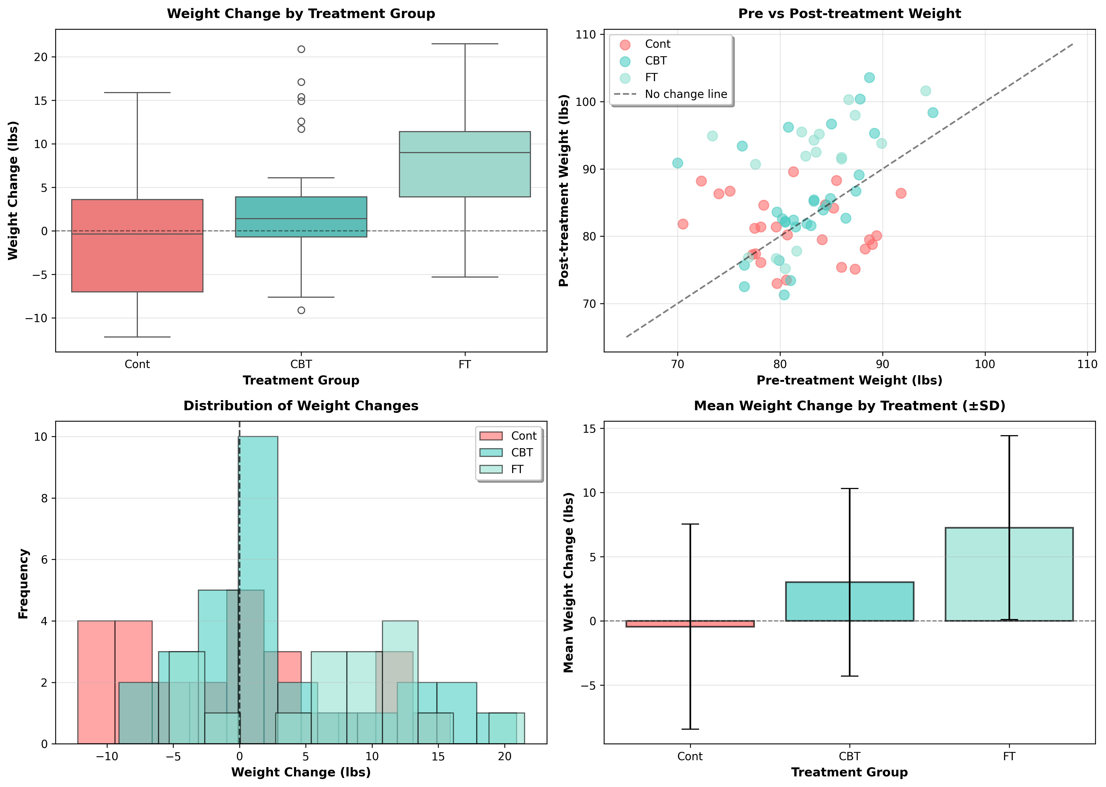
Figure 1: Comprehensive visual analysis of treatment outcomes
The visualizations above show:
- Top Left: Box plots demonstrating the distribution of weight changes, with FT showing the highest median gain
- Top Right: Pre vs post-treatment scatter plot with the diagonal line representing no change
- Bottom Left: Distribution of weight changes showing FT participants clustering toward positive changes
- Bottom Right: Mean weight changes with error bars, clearly showing FT's superior performance

Conclusions and Recommendations

Summary of Findings
This analysis of 72 participants across three treatment conditions reveals important insights into the effectiveness of different therapeutic approaches for anorexia nervosa:
- Family Therapy emerged as the most effective treatment, producing an average weight gain of 7.26 lbs with 76.5% of participants showing improvement. This difference was statistically significant when compared to the Control group (p = 0.0025).
- Cognitive Behavioral Therapy showed moderate effectiveness, with a mean weight gain of 3.01 lbs and 62.1% of participants gaining weight. While not statistically different from either group, CBT represents a middle ground between Control and FT.
- The Control group showed minimal improvement, with a slight average weight loss of -0.45 lbs, though with high variability (SD = 7.99). Only 42.3% of control participants gained weight.

Clinical Implications
- Prioritize Family Therapy: Given its superior outcomes and statistical significance, FT should be considered as a first-line treatment option for anorexia nervosa, particularly for younger patients where family involvement is feasible.
- CBT as Alternative: For cases where family therapy is not appropriate or available, CBT represents a viable alternative that produces positive outcomes for the majority of patients.
- Active Treatment Necessary: The Control group's poor outcomes underscore the importance of active therapeutic intervention rather than no treatment or monitoring alone.

Study Limitations and Future Research
- The Family Therapy group had a smaller sample size (n=17) compared to CBT (n=29) and Control (n=26), which may affect statistical power.
- Future studies should include longer follow-up periods to assess the durability of treatment effects.
- Investigation of moderating factors (e.g., age, illness duration, family dynamics) could help identify which patients benefit most from each treatment approach.
- Cost-effectiveness analysis would be valuable for treatment selection in resource-limited settings.

End of Report

