1.The Iris Dataset

Data:

o Iris dataset is a very commonly used data set to evaluate machine learning algorithms

o Dataset contains five columns that are

* Petal Length
* Petal Width
* Sepal Length
* Sepal Width
* Species Type

Iris is a flowering plant and it’s flower is shown in following figure

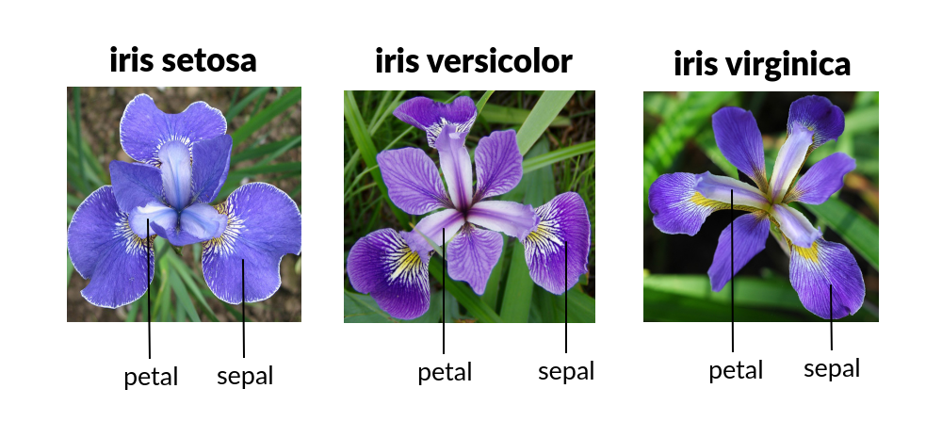

* 1. Preparing the Data:

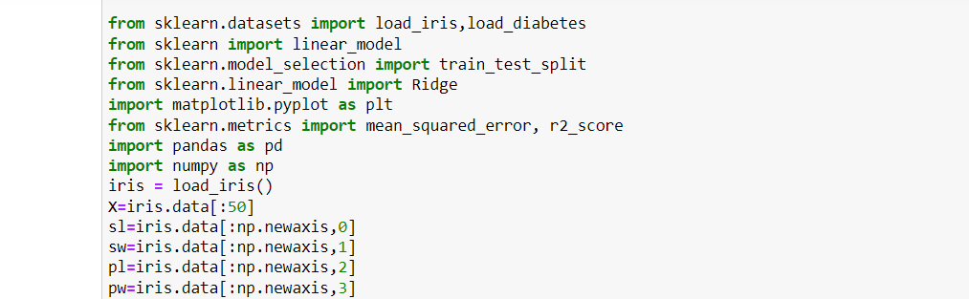

2.Regression:

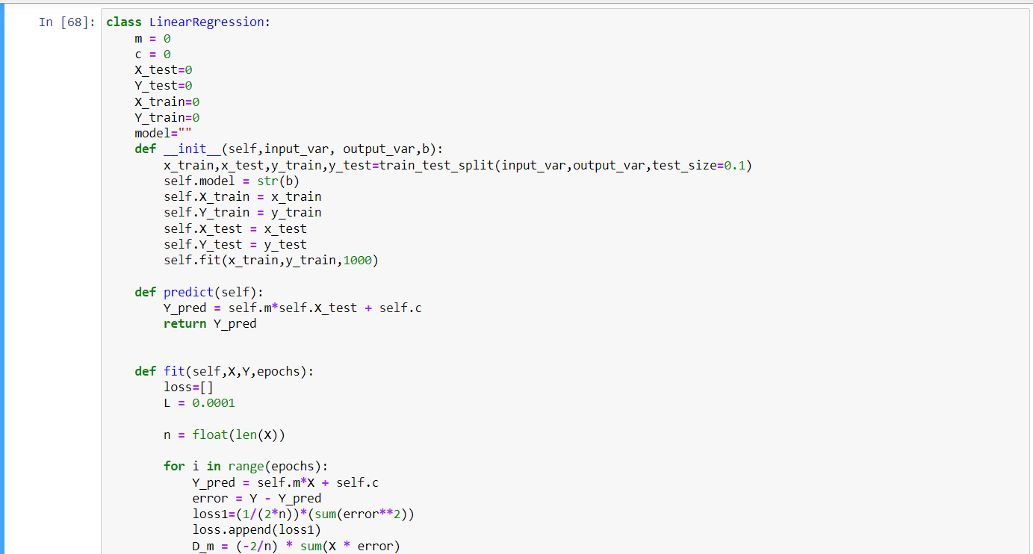

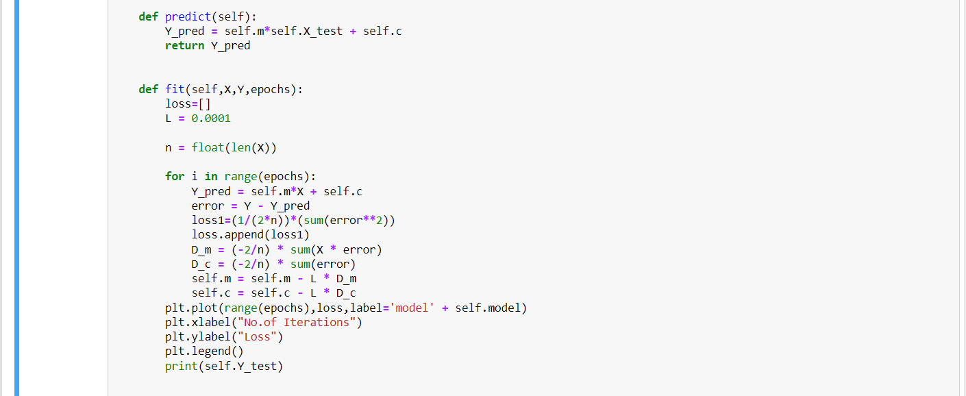

2.1 Model Definition:

Linear Regression in my implementation included fit and predict methods and my fit method also accepted 3 parameters

1.the input data

2.the target values

3. epoch size

The comparison of 6 model and the combinations I used:

Model 1:

Input variables: sepal_len

Target variables: sepal_wid

Model 2:

Input variables: sepal_len

Target variables: petal_len

Model 3:

Input variables: sepal_len

Target variables: petal_wid

Model 4:

Input variables: sepal_wid

Target variables: petal_len

Model 5:

Input variables: sepal_wid

Target variables: petal_wid

Model 6:

Input variables: petal_len

Target variables: petal_wid

2.3 Training and Testing

Using batch gradient descent with the batrch size 32 and also used mean square error

L2 regularization:

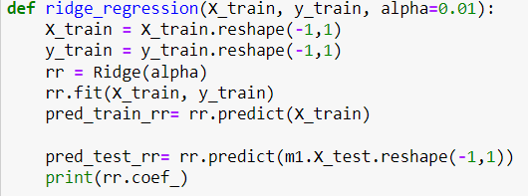

6 model comparisions:

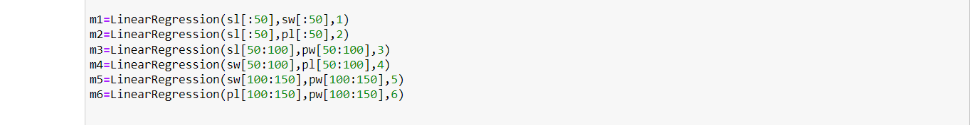

Output:

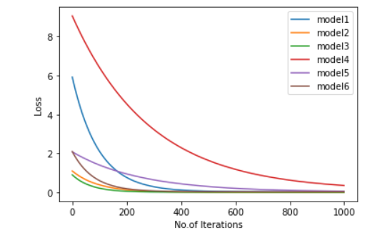

Comparison between the weights of my model and L2 regularization:

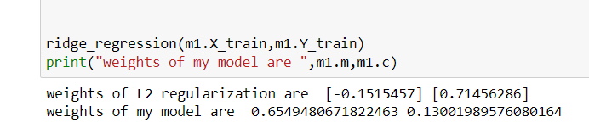

The mean squared error against the test dataset:

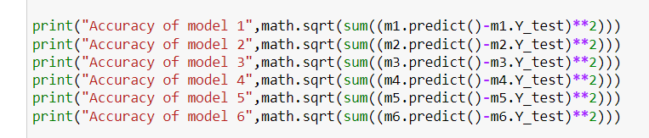

output

