**Adding new Storage account on existing Hdinsight cluster**

Here we are trying to add cispochdcluster Storage Account to poccluster

first check using zeppelin if cispochdcluster is accessible through hdinsight cluster



We can see it is not accessible

Go to poccluster and choose script action

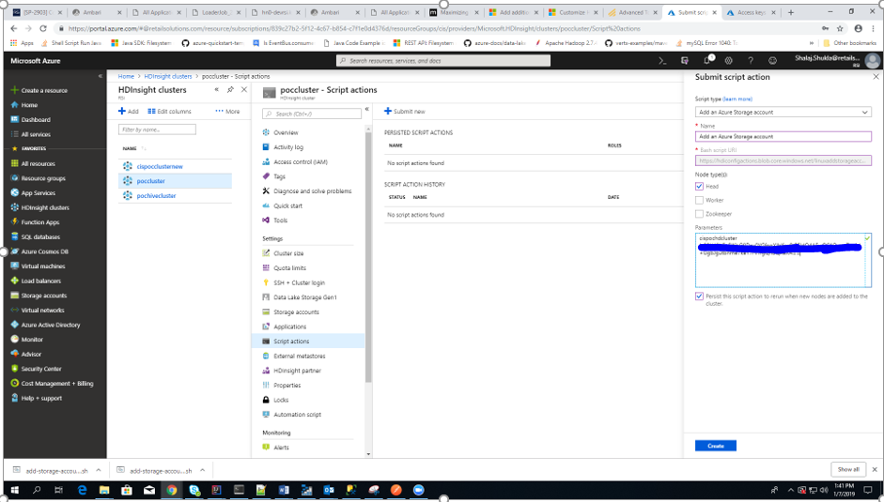

Click Submit New ()

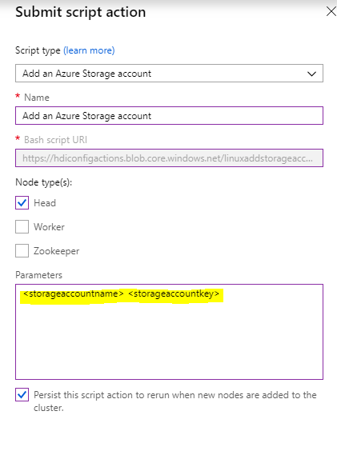

Select **Add an Azure Storage Account** from drop down, provide values for <storageaccountname> and <storageaccountkey> in parameters text box

and click create

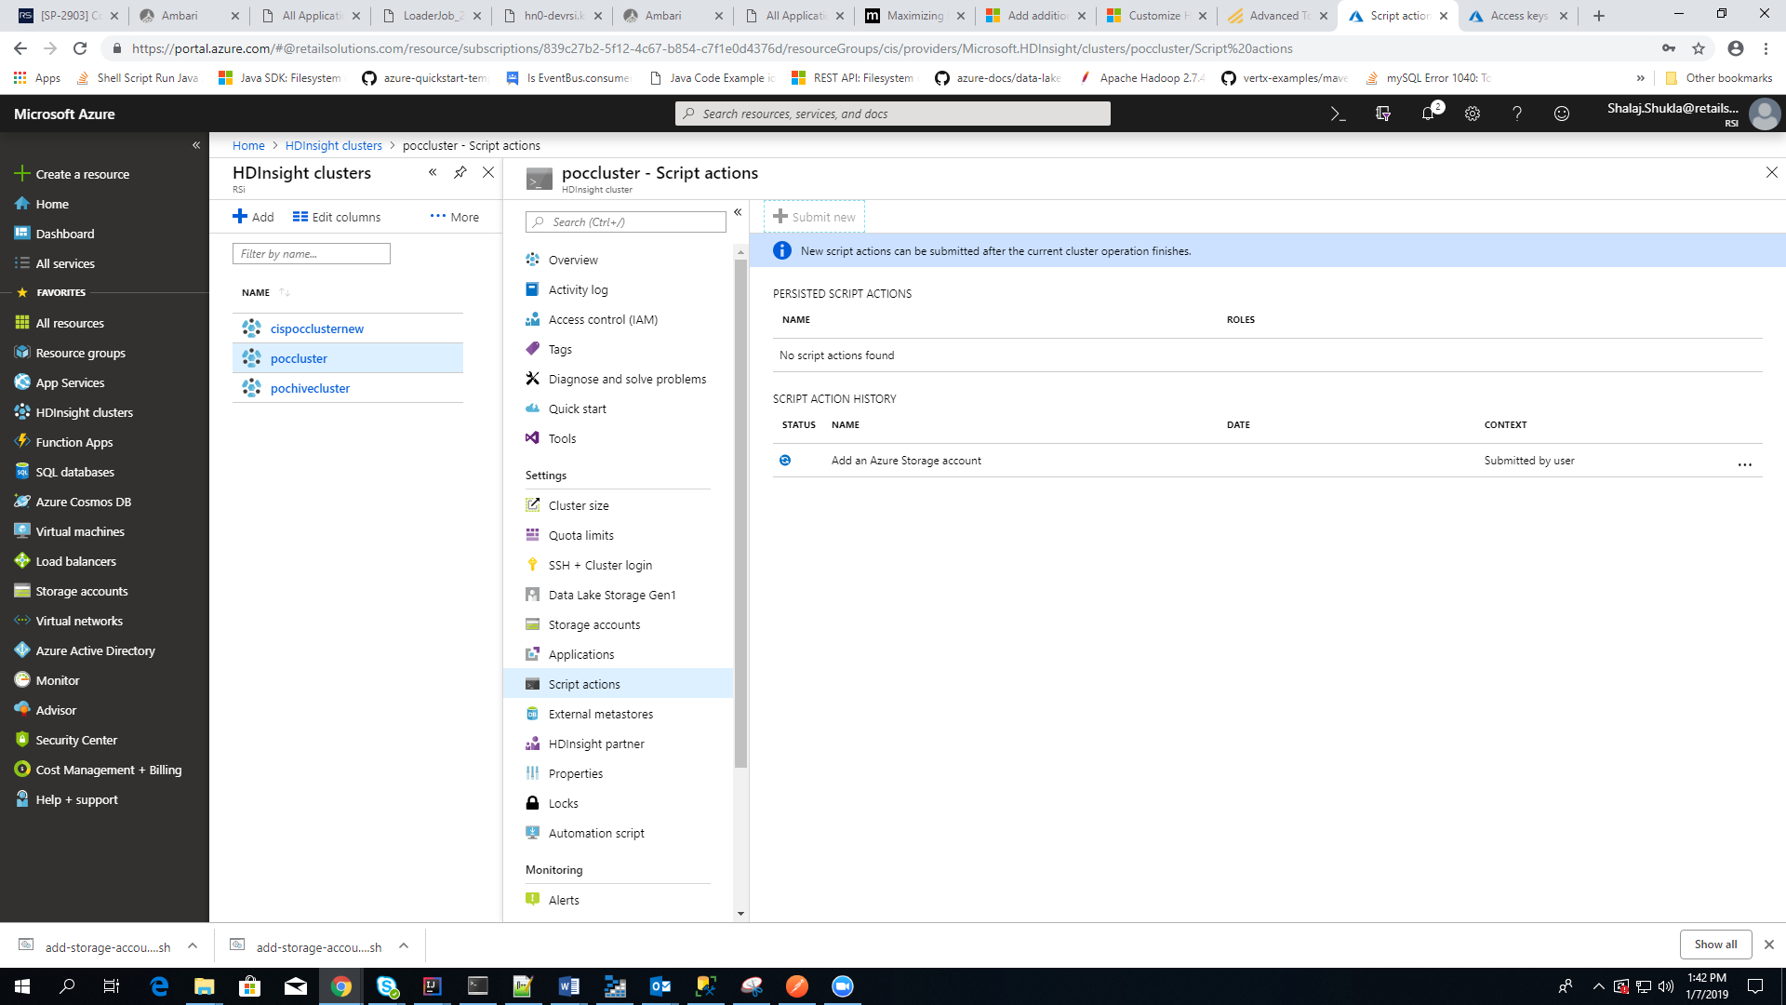

Wait for some time till it became green (success)

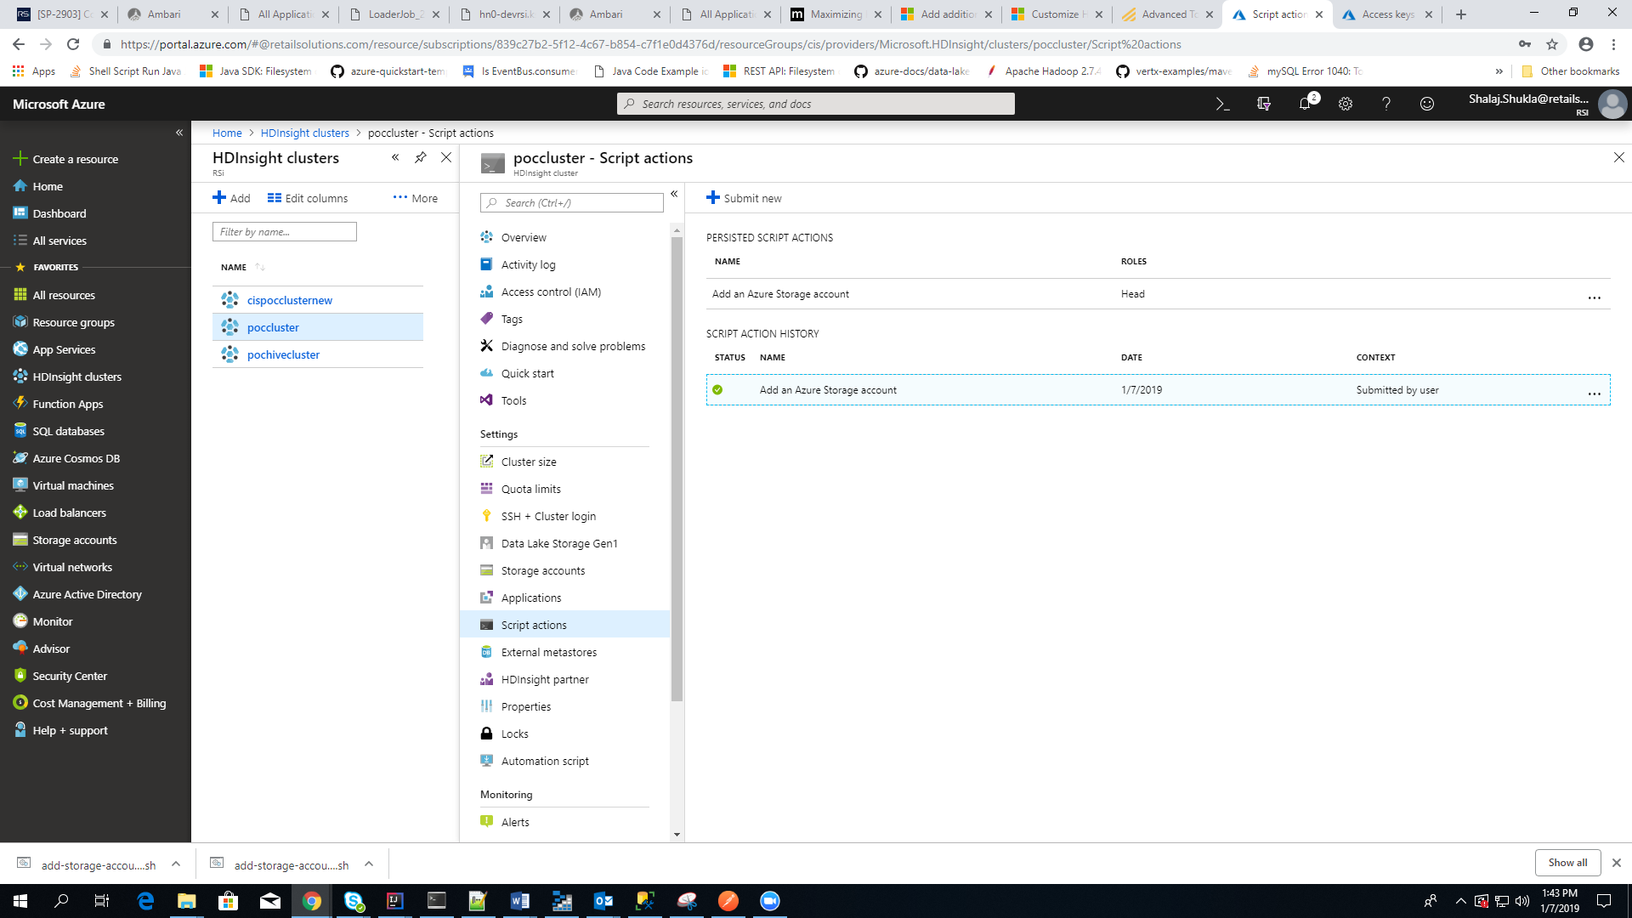

Restart all affected services from ambari

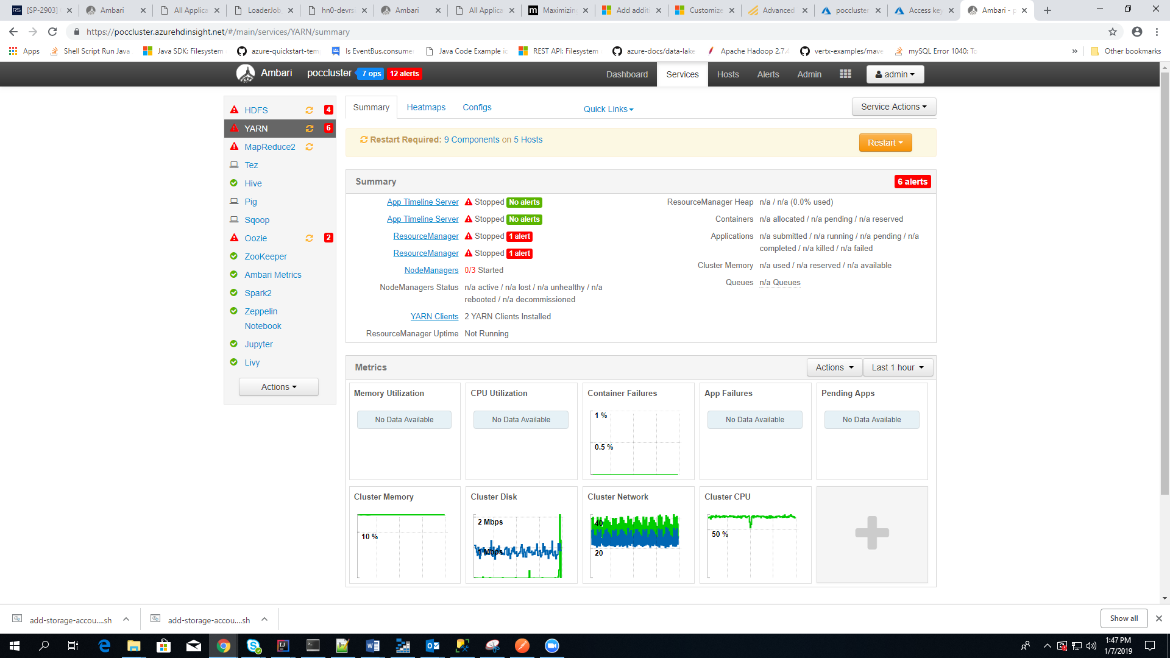

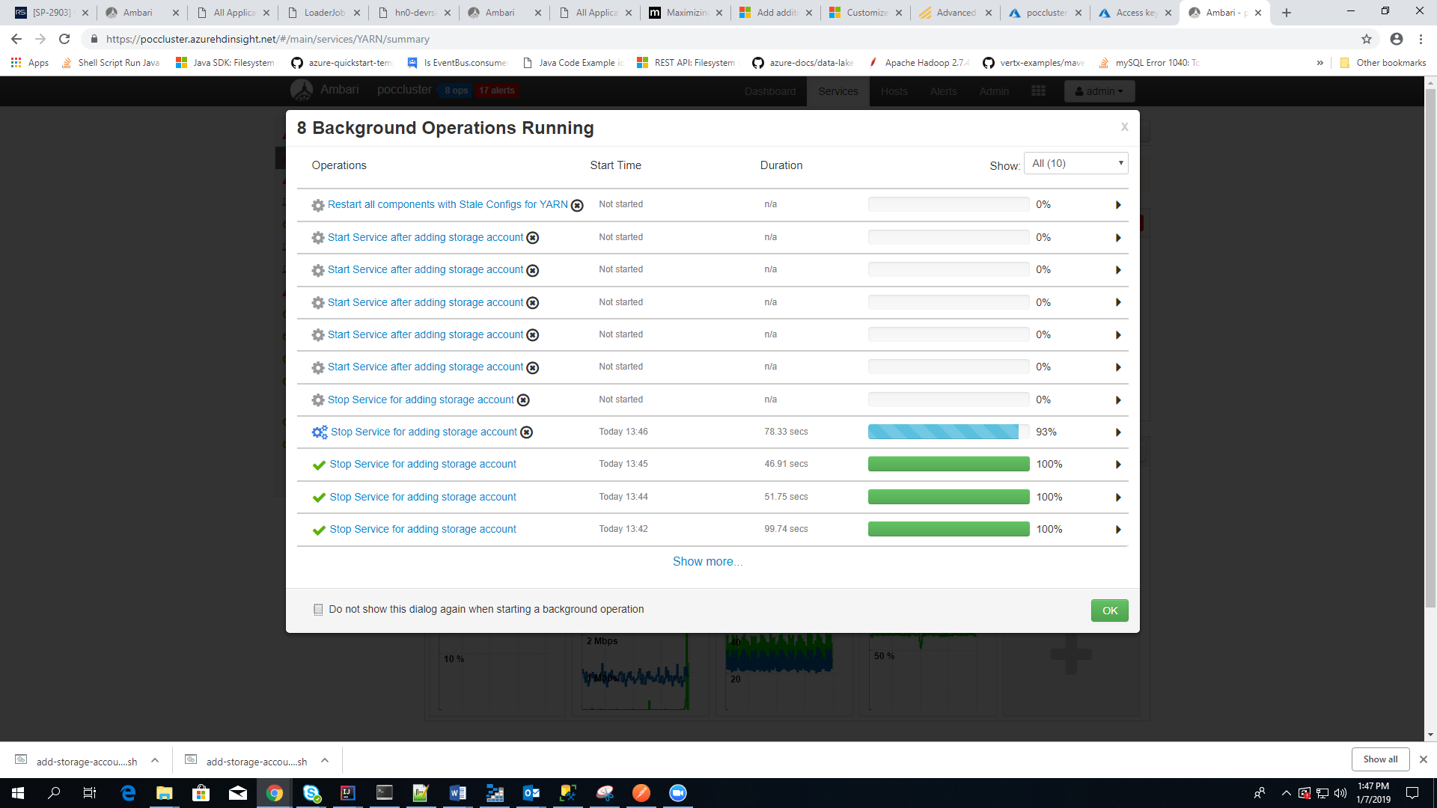

After restarting all affected service.

Now again try to read same file using zeppelin

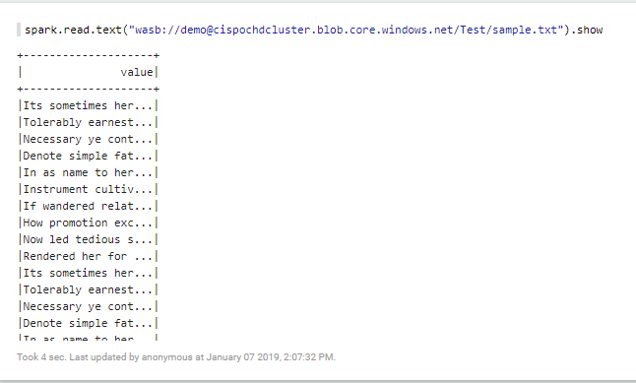

This time we are able to access it, it means storage account added successfully.