Parser for Nasdaq TotalView ITCH 5.0
Quanticks Capital Solutions

This project is meant for market data professionals and enthusiasts implementing NASDAQ TotalView ITCH 5.0 specification (http://www.nasdaqtrader.com/content/technicalsupport/specifications/dataproducts/NQTVITCHSpecification.pdf)

With a larger buffer size, the parser is capable of handling over 10 million msgs/sec on commodity hardware (8GB RAM/Win7 64)

Please build the files according to the following:

-Visual Studio 11 (2012)
-Get ITCH 5.0 file from: ftp://emi.nasdaq.com/ITCH/06022014.NASDAQ_ITCH50.gz
-Place file in "C:\ITCH5.0TestFeed\" or put in directory of your choice and change line 402 in NQTVDlg.cpp (“char strFileName[MAX_PATH] = {"C:\\ITCH5.0TestFeed\\06022014.NASDAQ_ITCH50"}”)
-To change the buffer size: NQTV.cpp Line 26 ("m_SOptions.dwBufferSize = 1000000")

Running the application:

-Click the \x64 executable
-When the dialog opens, click "Replay"
-Click "Start" Feed
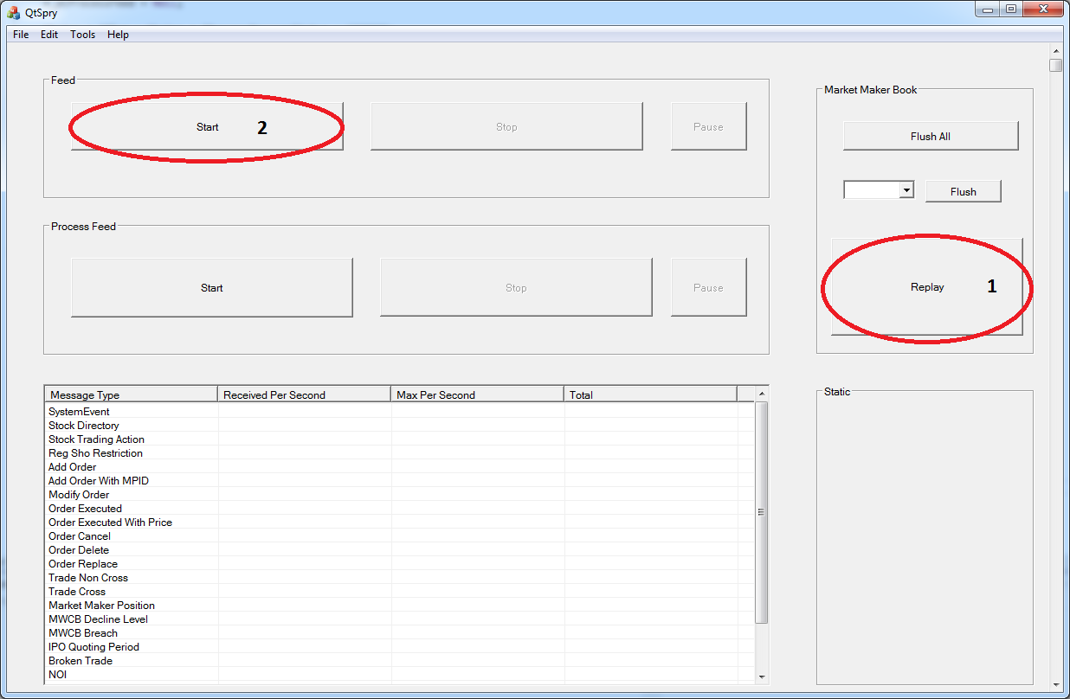

Note: The other buttons on the main dialog are place holders.

