**Ultrasonic Distance Meter**

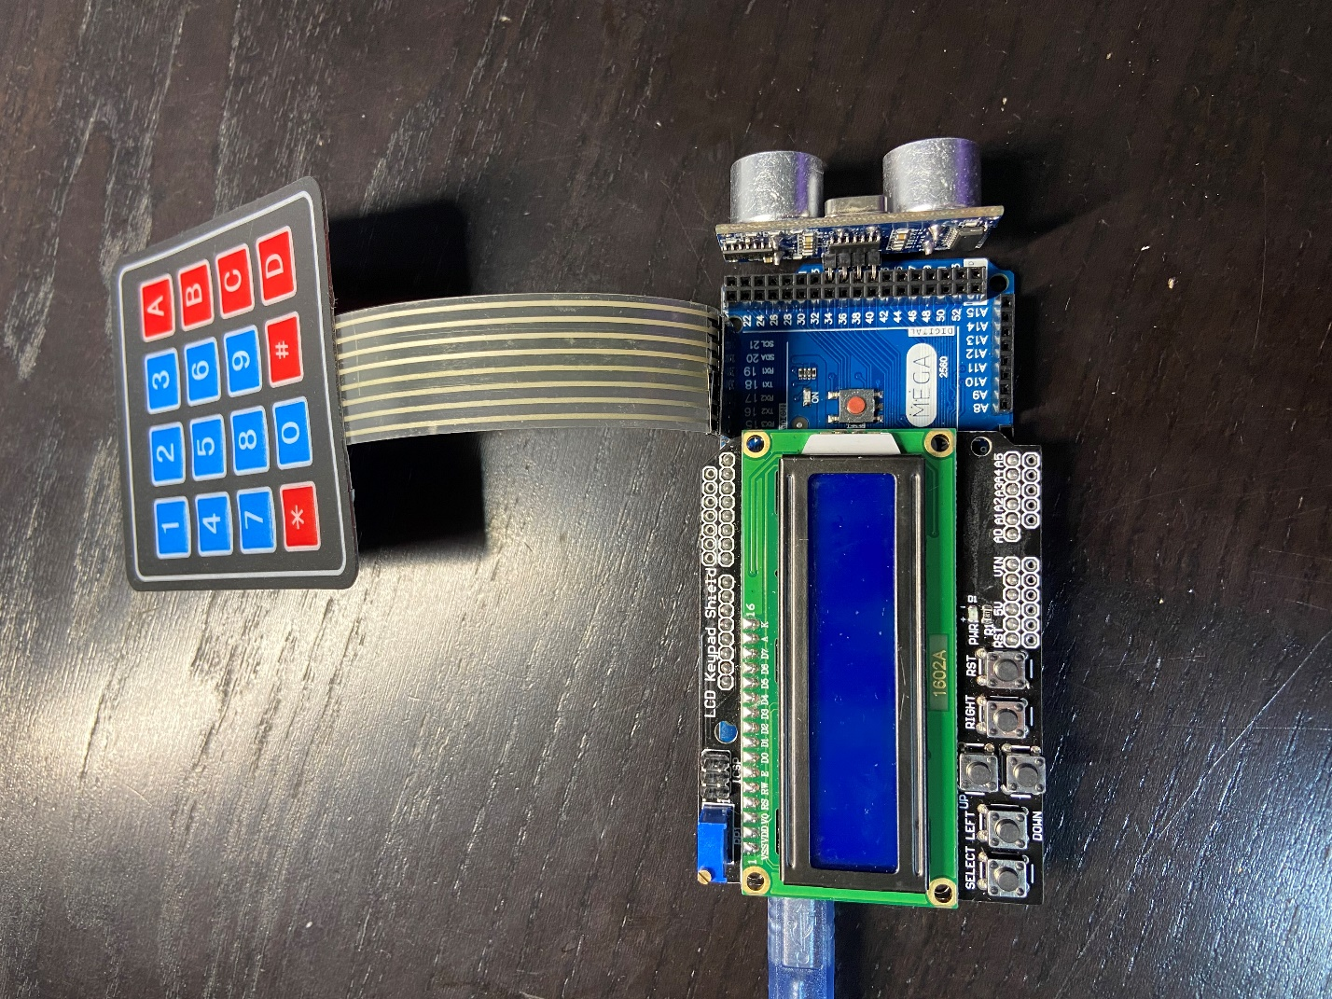By Jason Sun

**Introduction**

The ultrasonic distance meter is a measurement tool for distance. Using an ultrasonic sensor, it sends out sound waves and receive them upon waves hitting obstacles and bouncing back, measuring the duration. Then, the duration is converted into distance. The outputs are displayed on a LCD Display.

The meter has three operating modes: MEASURE, HOLD, & REFERENCE.

1. MEASURE simply converts the duration into distance and outputs the distance of an object away from the sensor (average distance calculated to ensure precision).
2. HOLD freezes the LCD screen and displays the last measured distance.
3. REFERENCE allows the user to input a total of 5 reference values via a keypad that can be used to compare with measured distances. While in MEASURE, if the measurement is near any one of the 5 references, the display will indicate the particular reference value.

Meter has 2 operational units: inches and centimeters.

**Operation**

On the integrated LCD Display, the UP button switches between the modes MEASURE, HOLD, REFERENCE. The SELECT button switches between the two units in any mode (defaulted at cm). In REFERENCE, the LEFT & RIGHT buttons switches between the 5 inputted reference values, and the DOWN key saves and stores the inputted reference at the current index of reference values.

The keypad is also to be used strictly in reference mode to input reference values.

**Features**

* Power Supply: 5V DC
* Integrated LCD Display
* keypad for reference value input
* Powered by USB input
* Units in inches & centimeters (centimeters default)
* 3 functional modes
* Reprogrammable

**Specifications**

|  |  |
| --- | --- |
| Dimensions | 10 x 5 x 3 (cm) |
| Components | Arduino Mega Microcontroller  LCD Display  Arduino 4 x 4 keypad |
| Effective Range | 3 to 500 (cm) |
| Error | Within 3-4 cm in its effective range |
| Operating Current | 10 – 20 mA |
| Ultrasonic Sensor Frequency | 40 kHz |
| Ultrasonic Sensor Voltage | 5V |

**Additional Notes**

* Measurements on soft materials such as soundproof panels or fabrics may be inaccurate due to the nature of the sound wave
* Angled measurements may be inaccurate
* Meter measurements to 2 decimal places